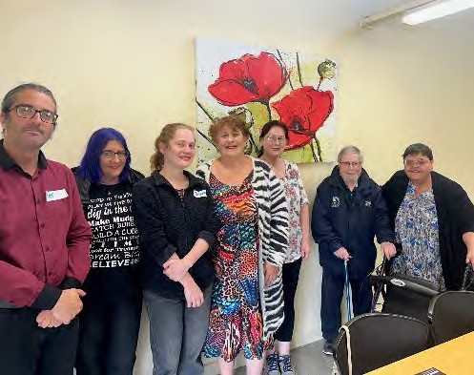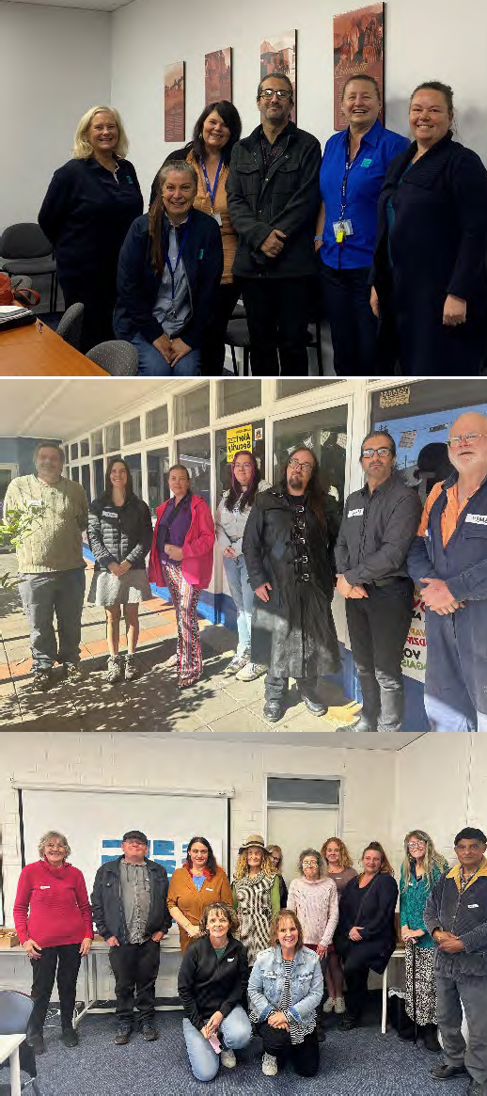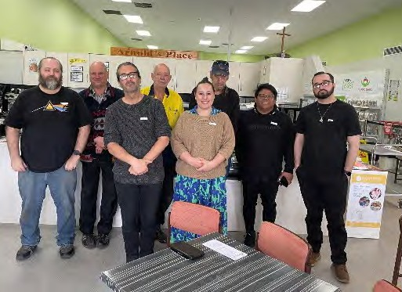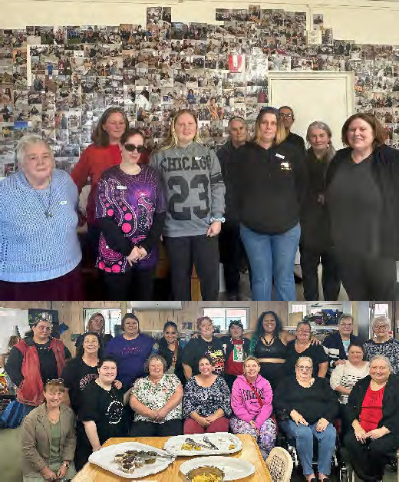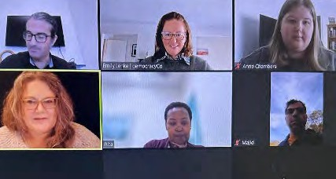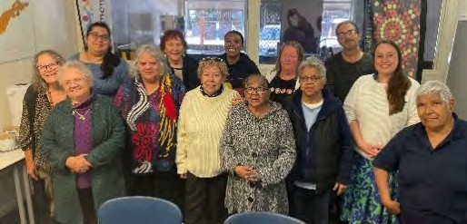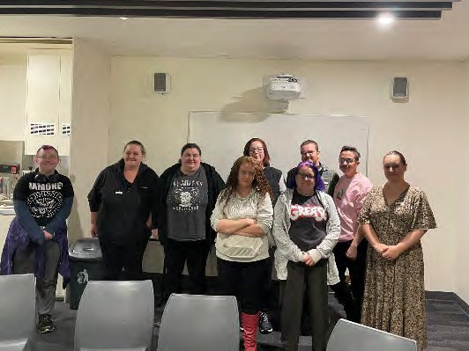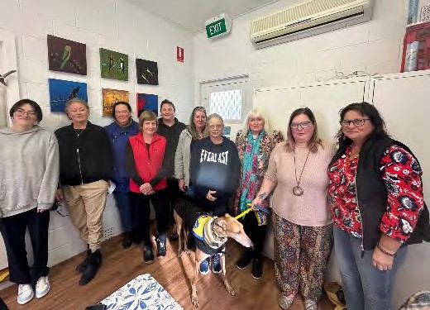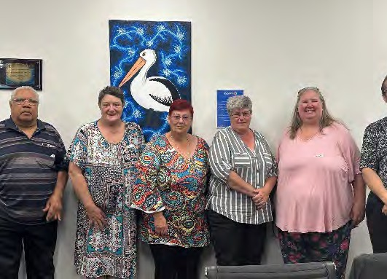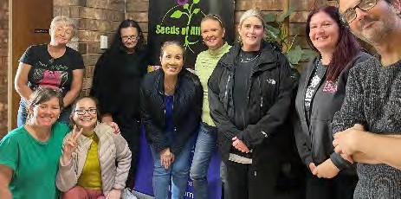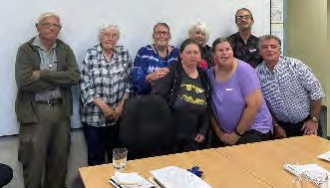
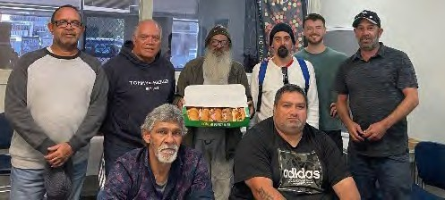
Food Security in South Australia
Lived Experience Report
June 2024


Food Security Conversations
During March – June 2024, SACOSS, supported by democracyCo conducted 21 facilitated conversations with people experiencing food insecurity across South Australia.

The conversations were held with the generous support of countless community groups and individuals, who worked hard to ensure that each conversation was well supported by people who were the experts in food insecurity – those who were experiencing it right now.

The conversations were held in the following places / with the following groups:

Ceduna Christie Downs Cooper Pedy Cooinda Elizabeth Gawler  Gepps Cross Goolwa Kilburn  DHS Lived Experience network | Mount Barker Mount Gambier Murray Bridge Online (x 2)  Playford Womens Shed  Port Adelaide Tiraapendi Wodli Men’s Group Port Adelaide Womens’ group  Port Pirie  Unley (at SACOSS) for anyone local to the area

Participants usually spent between 90mins – 3 hrs together, discussing food security challenges, ideas and needs.

The democracyCo team designed the process to begin by what was ‘true’ for participants – asking them to consider a range of issues under each of the 6 dimensions of food security.

Below is an overview of the participant demographics – which is in parts not fully accurate as some participants did not choose to share information about themselves.
Following the demographics, democracyCo have summarised the key findings, also inline with the 6 dimensions of food insecurity. At the back, individual reports are provided from each of the facilitated conversations – providing a full picture of what people said.

Food Conversation Demographics
Who participated, at a glance:

 | Total Participants | 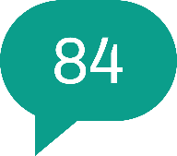 | Identify as having a disability
 | Born Overseas | 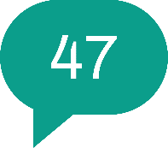 | Aboriginal and/or Torres Strait Islander  participants

Where participants, who were not born in Australia were born:
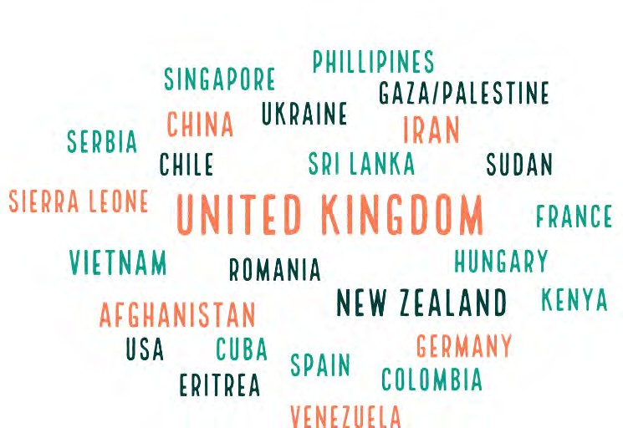

Age & Gender:
Age
41
9
31
43
41
51
18-24 25-34 35-44
45-54 55-64 65+
Gender
10
51
161
Male
Female
Gender Diverse

Employment:
Employment Status
90
81
80

70
66
60

50

40
37
34
30
29
25
20
10
8
0
Full time Part time or
casual
Unemployed Pensioner (age
or disability)
Carer
Studying
Retired

Key Insights
The best types of solutions are the ones we design ourselves, and where we can engage the broader community in them, wrapping the community around those who need it. Social connection, getting to know people locally - is the best thing we can enable for this to be a reality. Stronger communities will support all these support services to work better.

The below tables bring together the key insights that were heard from all of the conversations, organised using the six dimensions of food security.

Availability
People have sufficient quantity and quality of food available, supplied through domestic production or imports.
Challenges | What is Needed?
Locally Grown Food  - In regional and remote areas it can be difficult to get fresh food locally.  - People often don’t have the means or space to grow their own food. | Support including skills, spaces to grow things and financial support to get started.
Healthy Food  - Many people are struggling to manage complex physical and mental health conditions. This can restrict their ability to access and prepare healthy food, which then exaserbates their health issues, causing a downward spiral.  - Food support services often get leftover food that is close to its end of life. Vegetables and other foods offered are often very old/stale.  - Food support services often do not have food for special dietary needs such as gluten free, vegan or sensory foods.  - Many of the cheapest foods are high in salt, fat, sugar and preservatives. | More nutritious, options (especially fresh fruit and vegetables and proteins) for those accessing food relief.  Better supports for those experiencing health issues, to ensure they get the healthy food they need to recover or live as well as they can.  Making food preparation simple and easy for people who are struggling. Reducing the mental load. (e.g. pre- prepared meal packs that they can heat and eat, or are simple to prepare at home.)

Waste  - Supermarkets and other food businesses waste a lot of food and can be reluctant or find it difficult to donate it (especially with recent legislation changes around temperature control).  - There can be waste at the farm at end of season or if they cannot sell all their produce (especially if it is not perfect shape, look or size). | Supermarkets should be forced or incentivised to donate excess food.  Connect up the food system so food is not wasted at the grower stage.  Supply excess seasonal food to support services directly.

Access
People have both physical and economic access to food (personal or household financial means)
Challenges | What is Needed?
Cost of Living  - Everything is getting more expensive, including food and even working people are struggling now. This is even more pronounced in regional and remote areas.  - Older people, students, immigrants, people with complex health needs, disabilities and separated families are especially vulnerable.  - Many families are struggling to provide lunches that meet the guidelines for school and childcare.  - Some people have responsibility for extended family, large families or children over the age of 18, which can put extra pressure on families for food. Support and Government services often do not account for these extra people who need to be cared for.  - It can be difficult to find and afford appropriate foods for specific dietary needs such as gluten free, vegans or people with sensory issues. | Need to increase Centrelink payments and address cost of living pressures.  Food is a basic human need and should be prioritized first. Need fresh food available cheaply / affordably, including meat and proteins.  Tougher regulation – on supermarkets / price gouging of essential services.  Universities have a responsibility to do more to support International Students who are struggling to access enough healthy food.  Schools should all have breakfast and lunch programs, inclusive of everyone to reduce stigma. This would ease pressure on families.
Transport  - Many people do not drive due to medical or financial reasons. Others find it difficult to leave home due to anxiety, health or disability.  - Many have moved further away from major centres to access cheap housing, which further isolates them from food relief / support. | Assistance with transport (e.g. community buses), or delivery options for food support.  More local services so that people do not have to use transport as much.  Locate services near public transport and ensure disability access.

- Public transport can be slow and unreliable. Some cannot use public transport for health or safety reasons. It is then difficult to carry food home on public transport.  - Some have experienced discrimination using taxi services.  - In regional and remote areas transport can be especially difficult. | Create hubs where people can access multiple services in one place.
Finding Support Services  - There are many different services available, all operating at different times and offering different supports (e.g. food hampers, fresh food, hot meals).  - It is hard for people to find out about and keep track of the support services that are available. They are changing all the time and there is no easy way to find out about them all.  - Those who do not speak English well or who are illiterate find it especially difficult.  - Often, finding out about and connecting with services relies on having the internet and/or a phone. | Need for information and support at places where people go – libraries, community centres, local radio, community noticeboards.  Greater role for local government in coordination / liaison between services and also between people and services.  Address digital poverty to ensure that people can be well connected to support and services.  Local services should meet regularly and communicate with each other to share resources and keep up to date on what they are doing.
Using Support Services  - Access criteria and processes for food support can be difficult, demeaning and limiting.  - Some people do not meet the criteria and so fall through the cracks. Access to support often relies on being linked into Government systems.  - There can be limits on quantities of food or numbers of visits at support services. Families can be left without food if they need more support.  - Food support services tend to be open during Monday-Friday, 9-5pm or less often. People who are working can find it challenging to get to these services.  - Even the big supermarkets are only open until 5pm on weekends, limiting options to just expensive smaller stores. | Remove the barriers that prevent people from getting the support they need. Have more “no questions asked” food support services.  More “out of hours” options available for cheap, healthy food.  There are many benefits of a community support group / place that offers a variety of support. This enables people to access food support in context to their needs, and also gives them a sense of belonging. Community centres / women’s shed etc. People may be more likely to access food support if it is available “no questions asked” at a place they regularly visit for other purposes.

- Some people have experienced judgement a lack of compassion at support services from staff and volunteers.

Utilisation
People have appropriate food skills, knowledge, and preparation/cooking facilities.
Challenges | What is Needed?
Cooking Facilities  - Some homes/units (including student accommodation, but also general housing) do not have cooking facilities, or only have very small and basic facilities. Often they have very limited storage space.  - Sometimes rentals have these facilities but they are not being maintained by landlords and so become unusable.  - Homeless people often do not have access to cooking and storage facilities for food. They cannot make use of food at Foodbanks and similar services. | Secure and well-equipped housing enables people to be able to cook and store healthy food for themselves.  Student accommodation and rental properties should have minimum requirements for cooking facilities.
Cooking and nutrition knowledge  - Most people know what they should be eating, they just can’t afford to eat that way with the current cost of living crisis.  - Some people do not have the cooking and nutrition skills they need to have a healthy diet. | Facilities are needed to support cooking classes and food education programs.  We need to build skills in how to use food creatively.  Relieve cost of living pressures.

Agency
People or groups have the capacity to act independently, to make decisions.
Challenges | What is Needed?
Food Choice  - Many food support services do not enable people to make personal choices about the food they get. People have to just take what is there and can be judged if they don’t want something that is offered.  - Poverty reduces the food options that are available to families in supermarkets.  - The need to get food through support services gives families less autonomy over when are where they shop as they need to attend services when they are open. | There should be more social supermarkets. They are more empowering for people as they can shop according to their personal choice and without feeling judgement. They offer multiple benefits to the community including social connection, work skills, cheap healthy food and cooking skills.
Engagement and power  - Many people needing support feel disempowered by the systems and processes to access support. They feel they have to just take what they can get and that there are power relationships in play. | People want more engagement to enable them to have a greater voice in the policies and decisions of government.
Supportive Advocates  - People who are just trying to survive may not have the mental space to advocate for themselves.  - Many people may misunderstand the purpose of things like financial counselling or mandatory reporting by schools and services. This can lead to unnecessary stress, distrust and feelings of shame. | A need for help to try and access concessions / support.  Clearer messaging about what a financial counsellor can offer to someone struggling (especially their advocacy role for the person).  More open messaging about why mandatory reporting exists, when it is happening and what it means for families.
Action, not talk  - Many people are frustrated by many years of talk about the cost of living crisis and poverty. They feel that Government know what the problems are, they are just failing to fix them. | Get on with taking meaningful actions to address the issues.

Sustainability
Food system practices that contribute to long-term regeneration of natural, social and economic systems, ensuring the food needs of the present generations are met without compromising needs of future generations.
Challenges | What is Needed?
Food Support Services  - Many food support services rely on volunteers and donations to deliver their services to the community.  - Volunteers are getting older and there are very limited people who can replace them due to work demands and reductions in the capacity of people on Jobseeker to use volunteer hours to fulfil their obligations.  - Food at support services can be limited and supply can be irregular / unreliable. | There should be a focus on finding ways to support and encourage volunteering.  Volunteering should count towards more of younger people’s Jobseeker obligations.  Food support services need more reliable and consistent support than the current donation model.

Stability
People are protected from crisis and shocks, which ensures the other dimensions are attainable at all times.
Challenges | What is Needed?
Support Access  - Support services are not open every day. | Access to community services (of all types) out of hours to support many people in emergency / crisis
Complex personal challenges  - Many community members were battling huge personal challenges, including trauma, complex family dynamics, health issues or substance abuse, impacting on their ability to manage a healthy diet on a low income. | Cultural awareness – do cultural awareness training. Recognise the trauma that many Aboriginal people have experienced. Support opportunities for people to come together and have a yarn.
Importance of community / social structures  - Family and community are picking up the burden when there is not adequate support available.  - People without family or community supports were often more heavily impacted when they experienced challenges.  - People needed places to belong and get support. | We need to build community so that they can work together to support each other. Community is often a lifeline for people when they are struggling.  Community and service groups need to be able to expand their impact and also maintain services consistently.

Other Issues
Other key insights which emerged during the conversations.
Challenges | What is Needed?
Stigma / judgement  - There is a lot of self and external judgment and shame around needing to access support for food.  - There is a strong narrative of deserving and undeserving poor and assumptions made about why people are in the situation they are in.  - This impacts on the likelihood of people to access support (especially for men) and their wellbeing when they do.  - Some cultures stigmatise people who admit to struggling. People in this situation would rarely ask for support from services, even when they desperately need it.  - Some cultures or community sectors look after their own community (sometimes without having many resources themselves e.g. refugees), rather than seeking external support. | “No questions asked” access to cheap food is important for people’s dignity and wellbeing.  Respect, dignity and compassion – from all people to all people, especially from leaders.  People need to see people like them accessing services, either in advertising for services or by being introduced to a service by someone they trust / know.
Discrimination  - Food support services are often run by religious organisations, which can be problematic for people from other cultures / religions or for the LGBTQI+ community. | The need for safe support services – including for those accessing them but also those volunteering. This might mean non-religious services, or it might mean tougher rules, so people are protected from discrimination at services.
Wellbeing  - Being unable to afford food diversity or treats can be an isolating and negative experience, which impacts on people’s wellbeing. | People should be able to enjoy food and cooking. It is an important social experience.

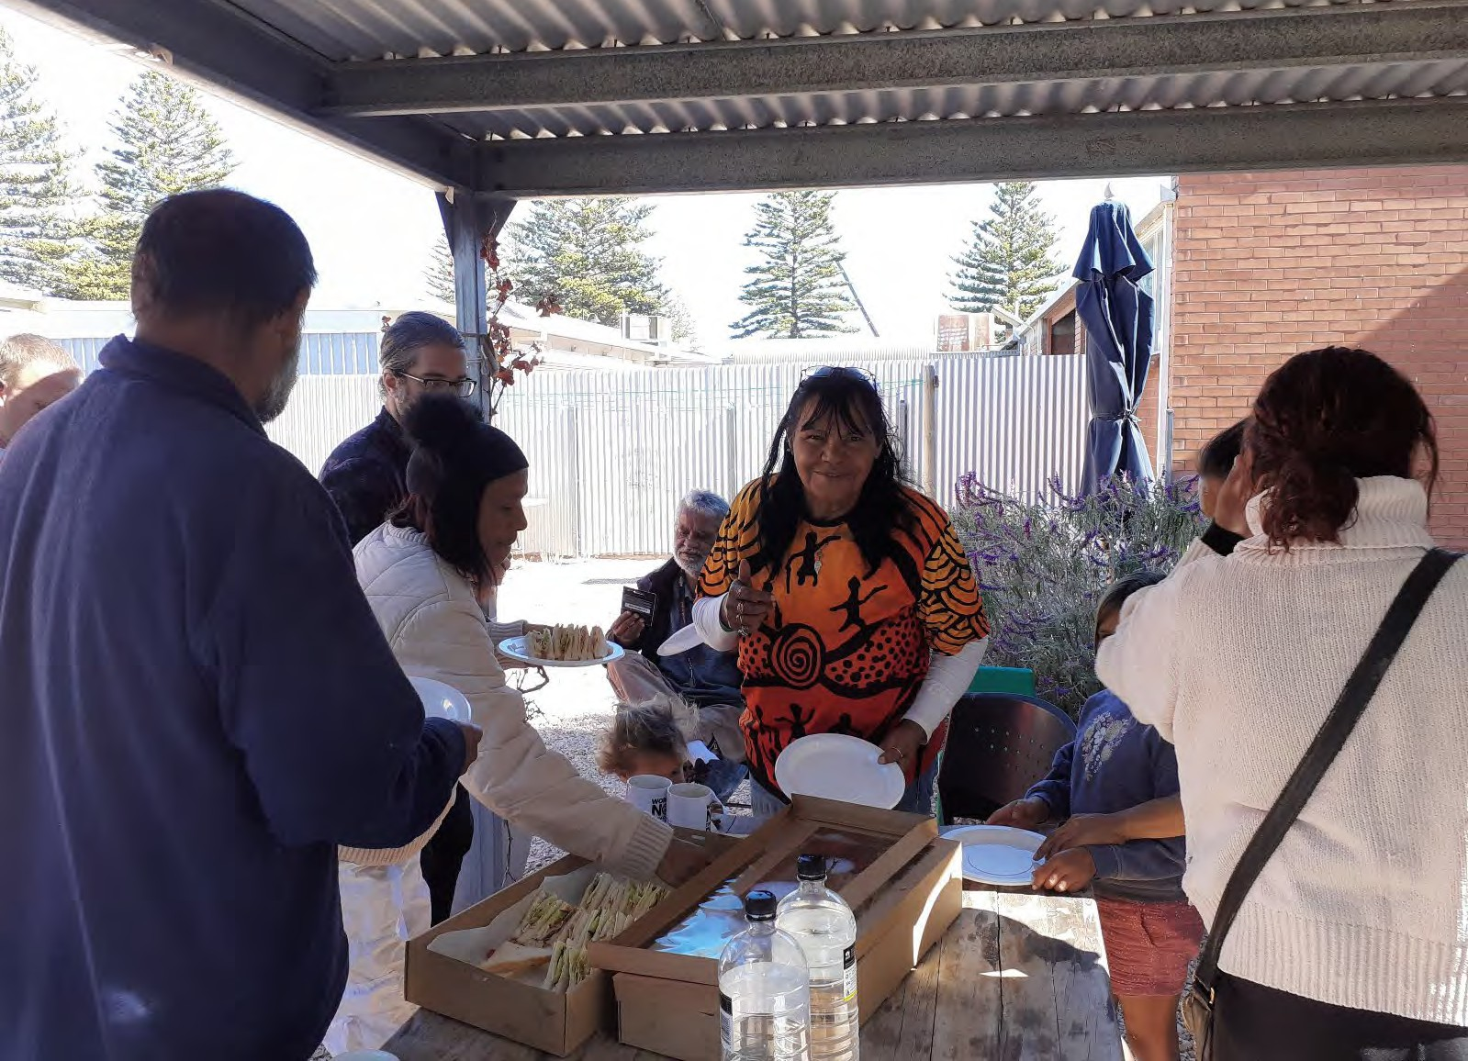

Food Security in Ceduna

Lived Experience Report


28th May 2024

Ceduna 28th May 2024
Who participated, at a glance

Total number of participants | 14
Number of people who were not born in Australia | 0
First Nation participants | 13
People who identify as having a disability | 1

Age | 18-24 | 25-34 | 35-44 | 45-54 | 55-64 | 65+
 | 2 | 4 | 3 | 4 | 0 | 1

Gender | Male | Female | Gender diverse | Prefer not to say
 | 4 | 10 | 0 | 0

Employment Status | Full-time | Part- time/casual | Unemployed | Pensioner (Age or disability) | Carer | Studying | Retired/ no longer  working
 | 0 | 0 | 13 | 1 | 0 | 0 | 0

Key insights
- Places to shop for food are very limited, especially in more remote areas. Prices are expensive and food is often not very fresh. Cost of living increases are making it even harder to access fresh, healthy food.
- Cultural responsibilities to support extended family members can put extra pressure on families.
- It is difficult to manage health conditions without access to fresh, healthy food.
- There are no communal cooking and food storage facilities for those experiencing homelessness. Facilities are needed to support cooking classes and food education programs.
- Many community members were battling huge personal challenges, including trauma, complex family dynamics, and substance abuse, impacting on their ability to make manage a healthy diet on a low income.
- Support services in Ceduna are very limited, and not available every day. Food at services was
often not very fresh and often very limited.
- Transport options to food places can be very limited and there are very limited delivery options for food.

“This is the worst it’s even been”
“I can’t afford to eat properly, can’t afford to see a dietitian”

What’s happening in this community right now?
Our community is being impacted in the following areas right now:

Issue | Lived Experience reflections of the issue
Access to food | There are only two supermarkets and a butcher in town and they are considered expensive for people on very low incomes. In more remote communities, access is even more limited and expensive (although they reported some progress as food had started to be subsidised).
Being able to afford food | Cost-Of-Living pressures: remoteness increases high cost of fresh food. Increases to other living expenses were increasing the challenge.
Healthy Food | Their inability to access enough healthy food was making it harder to manage ongoing health issues like diabetes and low iron.  Even supermarket food was often not very fresh.
Homelessness / having a home | The local Council is regarded by many community members experiencing hardship as being hostile to homeless people, with reports that public BBQ and cooking facilities on the foreshore that were used by some homeless people (all of whom would have been Aboriginal) had been removed, to facilitate moving homeless people away from the shore. This was a blow to these people.  There are no suitable communal facilities in Ceduna for cooking and storing food, which then impacts on the types of food people could eat and their health.  There is very limited emergency accommodation – some were resorting to providing tents for people.
Knowing how to cook / knowing what is healthy | None of the community services in town have capacity or kitchen facilities large enough to be able to run community cooking and food education programs. Red Cross were interested, but did not have a suitable facility. Centacare did not have capacity or a suitable space. One of the schools had a substantial kitchen, but there were questions about how community access could be granted.
Wellbeing | Many community members were battling huge personal challenges, including trauma, complex family dynamics, and substance abuse, and this impacted their shopping/spending patterns, and made it harder for them to plan around how they managed their (very low) incomes, make choices about healthy, affordable food
Digital exclusion | Many community members struggled to access the online world, because of limited data and digital skill, and were reliant on word-of-mouth, or their case-worker/support-worker, to provide info about existing services.  Several older people did not have an e-mail address, reflective of very limited interaction with online portals/services.
Confusion / stigma | Aboriginal Drug and Alcohol Council (ADAC) runs a free breakfast program that supported some people, but others felt they would not be eligible for the program, because they were not clients (this was not the case), or felt uncomfortable accessing food relief from ADAC, because of stigma related to alcohol/drug use.

 | ADAC may have previously had a community garden, but again, people were unsure of this, and whether this would have been open to the wider community, or simply ADAC clients
Support services | The low cost of food at Foodbank was appreciated, but there were concerns about the quality of fresh food that was available there. Some had felt unwell after consuming food from there.  Some people who were diabetics were concerned about not being able to access healthy food at Foodbank, and having to eat processed foods.  There is virtually no out of hours food relief support or emergency food support. Foodbank is open only limited hours, 3 days a week.  One local church kept a pantry of emergency food, donated by church members, accessible by visiting the home of the local pastor. This was appreciated but supply was often limited and unreliable.  School breakfast programs were appreciated, but they did not offer much support for lunches. School holidays were stressful times for some families, with extra pressure to provide food. Foodbank do offer some help with this, with a dedicated free shelf for parents during school holidays.
Community/family support | For many Aboriginal communities, there is an expectation of deep family support, extending to relatives. This support can be both a critical safety-net, and an important part of wellbeing (some people spoke about how much they valued large family cook-ups).  It can also be a source of huge stress and frustration. It meant that people would often run out of food, fairly quickly and unexpectedly, because of relatives showing up.  Some people felt that family support networks were not as strong as they previously were
Transport | Ceduna Aboriginal Corporation runs a community bus, connecting from some nearby communities, e.g., Koonibba, but it is not seen as particularly reliable or frequent.  Foodland offer food delivery – though only within the Ceduna township. There is a cost, which for some people, would have been prohibitive.  Centacare have some programs that provide home visits, and support people to go shopping, but eligibility for these supports are very limited.

What’s needed to support people experiencing food insecurity
What is needed How could it be delivered?
Adequate community facilities for people who are homeless/in insecure housing to be able to cook and store food | Many community members felt that communal kitchen facilities would be very useful (particularly for those who did not have these facilities, such as homeless people – see below)

Community food education, classes for cooking on a budget, skills that many people had missed out on developing, because of poverty, trauma, dislocation, etc. | Providing classes on basic food skills, e.g., cooking and preparing food, making healthy choices.  Ways of practising/learning Aboriginal styles of cooking
An increase to income support payments, .e.g., JobSeeker, Pensions
Extended opening hours for local Foodbank – extra staff/volunteers to allow at least full-time opening hours – and more broadly, other food relief options for after-hours/weekends
Better community transport and food relief delivery services
Locally based services we access:
- Some people reported that the local Centrelink office had a budget recipes cookbook that it provided to community members
- Local church emergency pantry
- Foodbank
- School breakfast program
- Ceduna Aboriginal Corporation community bus
- Centacare programs (but limited)
- Aboriginal Drug and Alcohol Council runs a free breakfast program

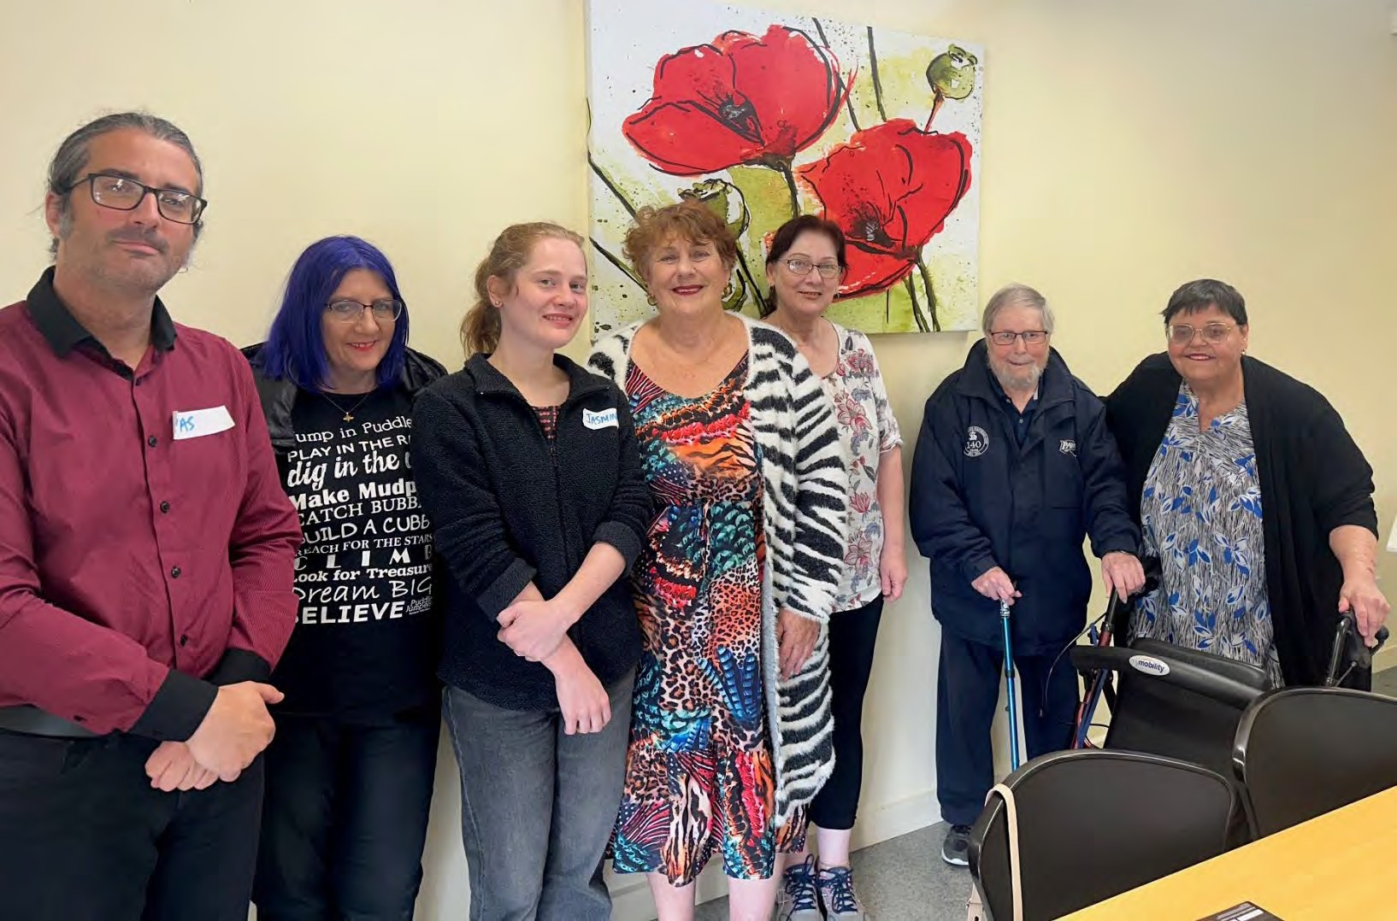

Food Security in Christie Downs

Lived Experience Report

29th April 2024

Christie Downs
Who participated, at a glance
Note: some participants chose not to complete the demographic data form.

Total number of participants | 6
Number of people who were not born in Australia | 0
First Nation participants | 0
People who identified as having a disability | 6

Age | 18-24 | 25-34 | 35-44 | 45-54 | 55-64 | 65+
 |  | 1 |  |  | 2 | 3

Gender | Male | Female | Gender diverse | Prefer not to say
 | 1 | 4 | 1

Employment Status | Full-time | Part- time/casual | Unemployed | Pensioner (Age or disability) | Carer | Studying | Retired/ no longer  working
 |  |  |  | 6 | 1 | 1

Key insights
The best types of solutions are the ones we design ourselves, and where we can engage the broader community in them, wrapping the community around those who need it. Social connection, getting to know people locally - is the best thing we can enable for this to be a reality. Stronger communities will support all these support services to work better.

Specifically, things that should be supported included:
- Volunteering. We need to strengthen the culture around volunteering and getting people back to volunteering. It’s time for our community to give back, do things for each other…. we need local people who are willing to step up and do things for the community. Barriers to be overcome
include attitudes / other commitments / recognition of volunteers and also covering their costs. Often a simple thankyou is all that’s to recognise them and fill their cup
- Basic Income. Focus needs to be on income equity / income parity – and reducing wealth
inequality
- Support. Helping people know where to get help. Removing barriers to getting there and accessing the food (eligibility)
- Stigma. Inspired by how stigma around mental health has been nearly eliminated, we need to remove the stigma around food insecurity. This is impacting so many people it’s very commonplace.

“I live from fortnight to fortnight - and have to decide if I can afford medication / doctor to see / electricity bill / food. I try to eat one good meal a day, sometimes when I am depressed, I just don’t eat, I make choices to eat versus taking my medication”

“The third time I went to Foodbank, they said “now you need financial counselling”
..this is humiliating, I am not bad at managing money, I just don't have enough of it. So many assumptions are made about what the community needs- in relation to food and poverty in general… no programs are for people my age (25-34)... we should not be excluded from things because you have assumed something about me.”

What’s happening in this community right now?
Our community is being impacted in the following areas right now:

Issue | Lived Experience reflections of the issue
Wellbeing | Loneliness and isolation is one of the hardest parts - if you are isolated, how do you access support, and who knows that you need help?  Shame / embarrassed to ask for help - these are often the people who are isolated and really struggling. You question your need - and then that prevents you from going to services - it is humiliating.
Hunger | Children going to school hungry. This is very concerning. I have seen kids going through bins on a bin day.
Having a place to buy food / access | Issues about getting to a food relief space - how do people who are housebound get there to access food? Heart and Soul is the only service that delivers.  We are seeing more and more people who are needing support. Now seeing 300 people /day and in 2018 we were seeing 20-30 people. People are being knocked back by other organisations.  Some people do know how to ‘play-off’ services – and are taking support from those who actually need it - we’re seeing people who queue up who don’t need support - but we try not to worry about this.
Being able to afford food | People’s incomes are too low - cost of living is going up too much, too quickly. If I had an extra $100/week, the quality of the food I could prepare would be exponentially different, it would be amazing. You need more money to have extra food / quality food. Low income is affecting everyone… we’re lucky we have our own home but our income is too low.

Support | So many people don’t know where to access food relief - who can support us? It’s hard to get information and “ask Izzy” doesn’t help all the time.  There are a lot of things available in my area which are exclusive for me, I might not be able to get them.  We rely on word of mouth which can often be wrong.  Many people don’t have access to internet / computer, so information on websites is not solving the problem. This makes a big difference to people’s ability to get support.
Accessing food during emergencies  / crisis times | We see a lot of people in crisis.
Having enough food | I live from fortnight to fortnight - and have to decide if I can afford medication / doctor to see / electricity bill / food. I try to eat one good meal a day, sometimes when I am depressed, I just don’t eat, I make choices to eat versus taking my medication
Ability to make choices about food / healthy food. | Ability to make choices about food - Specific dietary needs are hard to accommodate  - makes this very difficult for people who need special diets to access the right kind of food. Free stuff is bread - so sometimes people will make these choices which limit.  Just once I would like to be able to get seasonal produce, fresh herbs - difference and diversity would be amazing.
Being judged / assumptions being made about me | When I have been there 3 times, they have said “now you need financial counselling” - this is humiliating, I am not bad at managing money, I just don't have enough of it. So many assumptions are made about what the community needs- in relation to food and poverty in general… no programs are for people my age (25-34) ... we should not be excluded from things because you have assumed something about me. People in poverty aren’t bad with money - they just don’t have enough of it.
People who are not in need accessing food relief. | We do see people who get government support, but don’t spend their money wisely…and then they come and get food support / seeking help - when they might not really need it. Addiction / gambling etc can be part of the problem, but also  peoples priorities and choices…

What’s needed to support people experiencing food insecurity

What is needed | How could it be delivered?
Getting people to place where they can either get a meal, or access food relief.  Need to connect the dots for people – perhaps do some journey mapping for people who are experiencing food insecurity to help consider the best supports needed – proximity to home, getting there, carrying shopping home…these are all really difficult when you rely on public transport. | Community bus - could this go out and take people to places where there are meals available.  Drive through pickups - we pack bags of food; people drive in and collect a bag. This was really popular but doesn’t happen anymore.
Breakfast / lunch clubs - I didn't experience this as a kid. While we support this idea, we are worried about the impacts of bullying for kids who access this type of support. Need this to not be an isolating experience for people, pointing out their poverty. | Breakfast club open to ALL kids a couple of times a week at all schools.
Helping people to learn ‘how to make a meal out of nothing’.... need to teach people how to make nutritious food out of nothing | Skills / classes available in community centres.  Printed out cookbook / ideas book. Older people in nursing homes - could they help / get involved in writing down recipes
Standard eligibility process - which eliminates service providers judging people for their financial competency.  There is a system flaw here - can we standardise it in a way that doesn’t assume you need financial help. What can be put in place that stops me from telling my story all the time to people I don’t know. | Need to educate the broader community about what’s going on for some people in the community - so they are aware, and don’t automatically judge.
Better use of precious resources. | Can we systemise the effort - small groups doing things that duplicate effort  - can we find a way to make the money go further… cooperative social models.

Locally based services we access:
- Puddle Jumpers - Puddle jumpers is great.
- Oasis
- People’s Pantry
- Foodbank - Foodbank is good - get a variety, can get fresh food. There is choice there. But I do think its judgemental - they assume you're not managing money well (this is demonstrated by how you access it).

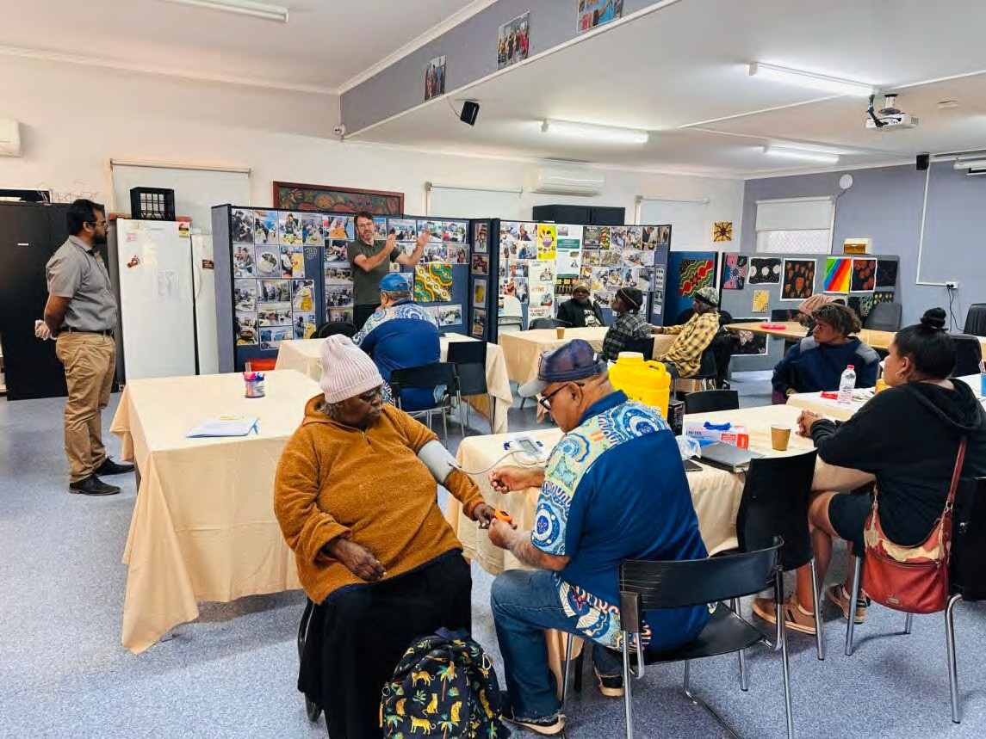
Food Security in Coober Pedy

Lived Experience Report
10th May 2024

Coober Pedy
Who participated, at a glance
Note: The demographic data collected for this workshop is an estimate only – as many participants had very limited English.
This session took place at the Umoona Tjutagku Health Service Drug & Alcohol centre while a free breakfast service was being provided. There were some service workers there as well as clients. People were coming in and out during the session, and health checks were being performed at the same time. Language was a large barrier (many of the clients did not speak English). All were Aboriginal, except for some of the health service workers who were Sri Lankan migrants. Comments made by the service workers are included below in italics
Total number of participants | 14
Number of people who were not born in Australia
First Nation participants | 14
People who identified as having a disability

Age | 18-24 | 25-34 | 35-44 | 45-54 | 55-64 | 65+
 |  | 1 | 5 | 3 | 4 | 1

Gender | Male | Female | Gender diverse | Prefer not to say
 | 8 | 8

Employment Status | Full-time | Part- time/casual | Unemployed | Pensioner (Age or disability) | Carer | Studying | Retired/ no longer  working
 |  | 1-2 | Majority

Key insights
- Secure housing – including short-term accommodation (hostel / shelter) for the large numbers of transient / temporary people that come to Coober Pedy and need to stay overnight. This will help people spend less money on alcohol and more on food.
- Availability of lower-cost food options. Currently the only places to buy fresh food are the IGA in
Coober Pedy, petrol stations and roadhouses (more expensive), and some community stores (e.g. APY Lands). Some larger communities (e.g. Oodnadatta) lacking community stores is a problem.
- Ability to get to and from Coober Pedy is an important factor, because people need to come here
to access services, but they can get stuck or spend all their money.

“Sometimes there’s family and personal things, like alcohol and drugs. So it’s good to come places where you can get food.”

“I’m a single mum with 3 kids, I’ve been waiting for a house, homeless. I was able to get into a place for 6 months through Centacare Catholic Country though.”

What’s happening in this community right now?
Our community is being impacted in the following areas right now:

Issue | Lived Experience reflections of the issue
Being able to afford food | Food in the supermarket is too expensive. Especially meat and bread. The IGA is the only place you can get food.
Having a home / homelessness | The biggest thing is housing! People can’t find houses to live in.  I’m a single mum with 3 kids, I’ve been waiting for a house, homeless. I was able to get into a place for 6 months through Centacare Catholic Country though.  There are a lot of people in town temporarily, because people come in from everywhere. There is nowhere to go for temporary accommodation. We need a hostel or something.  The services are alright, but the big thing is housing, people need somewhere to live. I come down from Oodnadatta. There’s a lot of people young and old come in to town, and they’ve got to stay here. There’s nowhere to stay so they stay on the street you know.
Emergency / crisis times | You can come here for a breakfast. You can also go to the charities. There’s no shame in asking for help!  In the past the Red Cross would give out boxes of food and food vouchers. They closed down maybe mid-last year here.  AMYAC have provided help. Umoona Community Council provide help. There are other charities in town too.
Knowing how to cook | We run healthy cooking program for the women’s’ group.
Having a place to buy food | People come into Coober from everywhere. APY, Mimili, Marla, Oodnadatta, everywhere. From outstations. It’s the only place where you got a supermarket.

Food is a lot more expensive in Oodna. Costs twice as much maybe [as Coober Pedy]. Since the Community shop closed in Oodna, the only place you can get food is the roadhouse. It costs more money. So people come from Oodna to Coober, it is maybe 200km. Come and stay for one night, stay with family or stay on the street. Petrol costs a lot! I work on a cattle station so I can do it, but if you got no money it’s hard.
You come with someone else. People come in from the [APY] Lands too. There’s nothing much there. You have to go to Coober.
The supermarket has everything, it’s really good but it’s expensive.

Having a place to store / prepare food | If you’re on the street you got no fridge, you can’t get anything that needs a fridge.
Ability to make choices about food | The IGA is the only place to get food. And some takeaways
Support | Sometimes there’s family and personal things, like alcohol and drugs. So it’s good to come places where you can get food.
Belonging
Coober Pedy is very mixed. Everyone from everywhere is here. People stick to their
communities and groups but there is no problems between groups.
The police are OK

“The services are alright, but the big thing is housing, people need somewhere to live..”
What’s needed to support people experiencing food insecurity

What is needed | How could it be delivered?
Food relief & | We don’t have a food bank or anything here.
distribution to
remote places | It would be good if you could get some of the food out to the community, out in the
 | Lands and the outstations.

Places to buy affordable food | Coober Pedy is OK but if you live somewhere else, there’s no shops. Need more community stores (especially in more remote communities) so people can get  affordable food
Access to homes /
hostels
What we really need here is a hostel so people can have a roof over their head when
they come to town. Otherwise, they will just stay out on the street and [makes

drinking gesture], spend all their money. They go, spend all their money, and they end up in hospital. Then when they are better they come out and do it again. Over and over. It’s what they know. I was taught to go into the bush and work. But these ones, they drink and they got no food. So they will hit someone and go to prison, because there they get a feed and a blanket.

Sometimes we ask people ‘Why do you drink’? It’s because they have no place to go when they are in town. It’s too hot in summer or too cold in winter to sleep when they’re on the street, there’s nowhere to stay so drinking is the only thing to do. They don’t eat much during the weekend if they are here in town. Once they get paid they spend it on grog. Drinking and fighting, but then they are hugging each other again.

Well planned health  and support services | They built a new dialysis centre but it’s in the wrong spot. It should be in front of the  hospital, at the health service, not in between 2 bottle shops and pubs..

Locally based services we access:
- The supermarket [Coober Pedy IGA] has everything you need. People come from everywhere to come to town and buy their food and do whatever they need to do.
- Umoona
  - We can always come here for breakfast, it’s good to have this place. You can come and hang around, there are activities going on
  - This service runs every day. Sometimes there are 40 or 50 people coming in, this week there’s been about 15 every day.
  - At Umoona there is a community garden where they grow some different things for the community, like tomatoes and eggplants, chilis and herbs. There are good things going on there.
  - They have Meals on Wheels for old people.
  - Umoona (Community Council) has a Return to Country program. People come here from the Lands or outstations on payday and they spend most of their pay on grog, and they can’t get back home. So this program helps them get back.
- At the School they have a breakfast club. My kids can go there if we have no food at home. [Do many kids use this?] Yeah, I reckon there are lots! Also the Clontarf Academy do afternoon programs, after school.

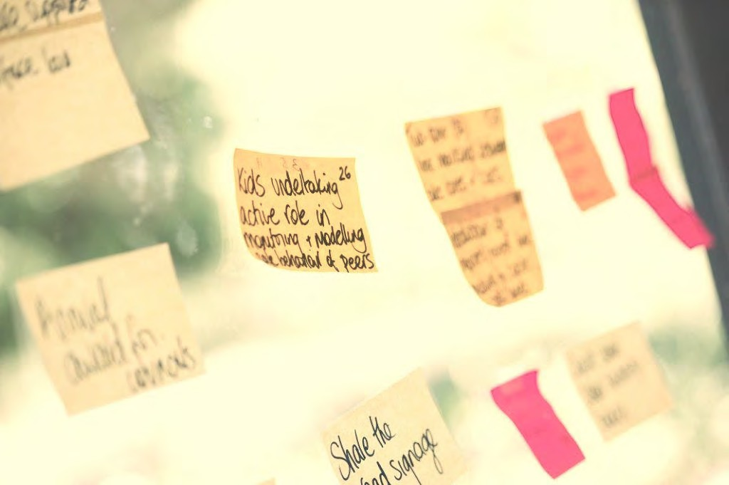

Food Security in Sturt
Cooinda Neighbourhood Centre Refugees and Migrants

Lived Experience Report

20th May 2024

Cooinda, Sturt
Who participated, at a glance

Total number of participants | 13
Number of people who were not born in Australia | 13
First Nation participants | 0
People who identify as having a disability | 1

Age | 18-24 | 25-34 | 35-44 | 45-54 | 55-64 | 65+
 | 0 | 2 | 3 | 3 | 5 | 0

Gender | Male | Female | Gender diverse | Prefer not to say
 | 3 | 10 | 0 | 0

Employment Status | Full-time | Part- time/casual | Unemployed | Pensioner (Age or disability) | Carer | Studying | Retired/ no longer  working
 | 0 | 2 | 10 | 1 | 3 | 13 | 0

Key insights
- Need for locally available cheap food options for fresh foods.
- Better information to help people find and access support services and cheap food options.
- Controlling rents and quality of housing would improve people’s ability to afford and cook healthy food at home for their families.

“Everything’s too expensive for new people in Australia, impossible to get a house”
What’s happening in this community right now?
Our community is being impacted in the following areas right now:

Issue | Lived Experience reflections of the issue
Being able to afford food | Things are very expensive. There is nothing locally that is very cheap - much more expensive in the South than in the North. We only have ALDI and sometimes Woolworths. The petrol to get to places for cheap food is very expensive.  We have very high rents, in homes that aren’t healthy. Trying to find a rental in a good location is hard. The landlords won’t fix homes. They are not forced by govt to renovate these old homes. Living with mould and dirt that is exasperating or causing health issues.  All participants were on Centrelink or pension or casual employment.  When I lived in WA there were cheap shops that were open 24 hours a day. Over here, if you need something after hours there is only petrol stations open and they are very expensive.

Having a place to prepare / store food | There is no kitchen in our house, the gas is not working. It’s a very small house. I cook at another house with family but at my house the only thing you can do is just fry an egg. Trying to find another rental but it has been too hard. Landlord will not fix this home. We’ve been to the tribunal but they threaten to make us homeless if we complain.
Choice | Prefer to be able to choose and compare at the supermarket, rather than have something delivered I didn’t choose. Sometimes the quality is not there. Prefer to be able to get my own things, not have someone do it for me.
Healthy food | It is too expensive to buy healthy food.  We eat what we can with this situation. We know what to eat but we don’t have money to buy healthy food.  I need good food for my daughter and husband who is very sick.  Lack of quality food seen as a barrier to recovery – one person spoke about their husband, in his 70s, whose recovery has been slowed down by lack of nutritious, fresh food
Transport | Some rely on public transport, some drive. Many are traveling across town to find places with cheaper foods.  There were some who even avoided using public transport (either due to social anxiety, not understanding how it worked or language barriers), and relied on services that were very local - within walking distance.  Some people have health issues so they can’t travel across town to get cheap food. Or they are caring for sick family.
Eating food I like/need | Easy to find food that we like to eat, so long as we can get fresh fruit and veg. It is easy enough to find the fresh food we need to make the meals we want to make; it is just expensive in many places.  For people of Muslim background, it was noted that it was much easier to obtain halal meat from butchers and other stores in the northern suburbs, than in the somewhat less diverse southern suburbs (and where there were halal options, down south, these were reportedly more expensive than what was available in the north of Adelaide)
Trauma | Some refugees do not want to go places where other people are as they are dealing with trauma.
Support | My kids access church and there is a small food shop there but it’s not healthy, fresh food.  None of the participants had been to foodbank.  Centrelink do not help people to find support. For one participant, Centrelink said to go to some place in the city for free food. But when we looked at the date on the food it was all expired.  One was given access to food support once but couldn’t go again. It was restricted to just one visit.  We don’t hear about charity places.

Knowing what is out there | Friends, word of mouth to find out about cheaper markets to source food. Many found it hard to find places for cheap food.  Found out about Cooinda through TAFE> Our course is part time, fits around family.
Growing your own food | No local community garden. I would like to garden if there was something local. No space at our home to garden. We have no yard.

What’s needed to support people experiencing food insecurity

What is needed | How could it be delivered?
A local food support place here would be better. | Maybe at the Cooinda Centre
Fresh, healthy food to cook with. | Tomato, onion, bread. Any fruit and veg. Provide fresh food, not packaged foods.
Share local services via Facebook, WhatsApp group. People you know sharing information.
A cheap box of food delivered to our house would be better for some people, rather than having to travel.
Locally accessible cheap shops/services/ markets so you can walk there.
Cheaper rent would help.
Govt should force landlords to change carpets and paint properties.

Locally based services we access:
- The Prospect Sunday market is good value
- Every 2 months go to Elizabeth to get meat $5/kg. Much cheaper than here.
- Pooraka farmers market for veg and fruit. But far away. Lots of petrol.
- Indian shop in area is cheaper than other supermarkets.
- Council and TAFE are a good support. They held some Gaza and Afghani refugees meetings to support their needs and connect them.
- We all help each other if someone is struggling. We don’t try to find support elsewhere.
- Some people had received advice about cheap places for purchasing food from their local church.

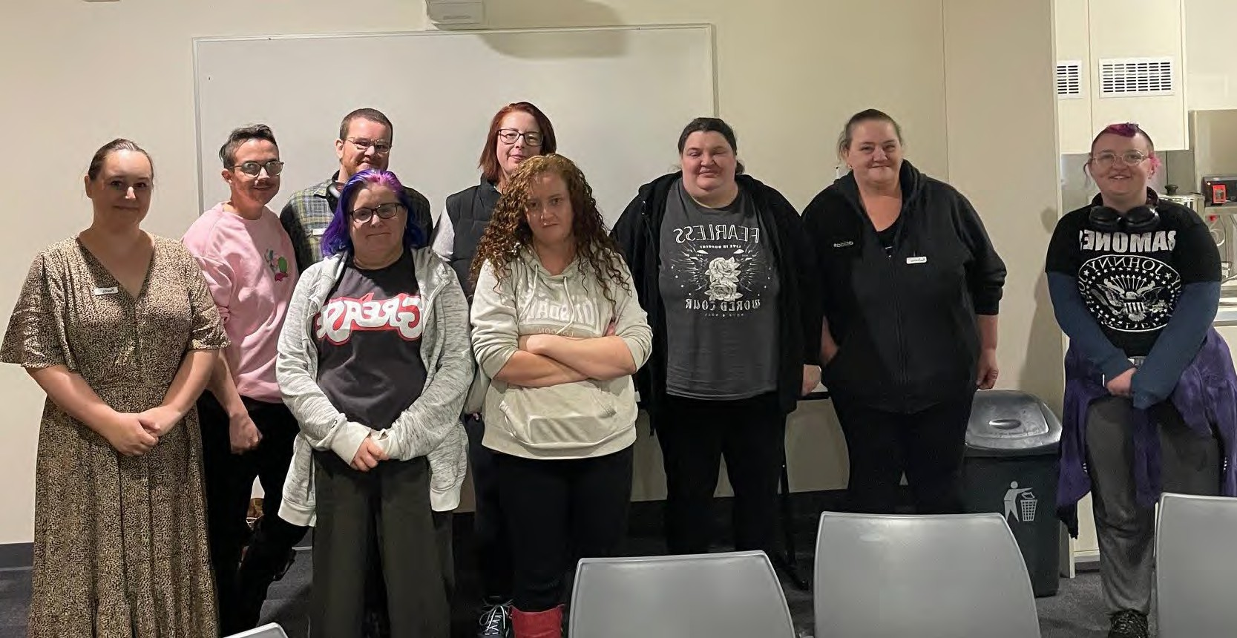

Food Security in Elizabeth

Lived Experience Report

2nd May 2024

Elizabeth
Who participated, at a glance
Note: some participants chose not to complete the demographic data form.

Total number of participants | 11
Number of people who were not born in Australia | 0
First Nation participants | 1
People who identify as having a disability | 11

Age | 18-24 | 25-34 | 35-44 | 45-54 | 55-64 | 65+
 | 1 | 3 | 3 | 3 | 1 | 0

Gender | Male | Female | Gender diverse | Prefer not to say
 | 2 | 8 | 3 | 0

Employment Status | Full-time | Part- time/casual | Unemployed | Pensioner (Age or disability) | Carer | Studying | Retired/ no longer  working
 | 0 | 0 | 5 | 1 | 3 | 2 | 1

Key insights
  - Cost of living: Everything is getting more expensive and even people who have never been poor before are struggling now.
  - Health Complications: You need healthy food to avoid or better manage chronic illness, but this is unaffordable. Then as your health suffers, you are less able to work and support yourself, which makes you more poor and even less able to afford healthy food.
  - Judgement: There is a lot of self and external judgment and shame around needing to access
support for food. There is a strong narrative of deserving and undeserving poor and assumptions made about why people are in the situation they are in.
  - Inappropriate foods: Foodbanks often don’t have appropriate foods for vegans, celiacs, or people
with sensory issues. Vegetables and other foods offered are often very old/stale.
  - Religious run supports: People may not wish to attend a religion backed support system, especially the LGBTQI+ community. There should be other options for these people.
  - Understanding the supports available: It is hard to find out and keep track of the services that are available out there. They are changing all the time and there is no easy way to find out about them all. Often finding out about services relies on having the internet.
  - Transport: It can be difficult to get to foodbanks and there are not many that deliver. Public
transport is difficult, especially with disabilities and fuel is expensive. If you do not drive or have caring responsibilities then it is really hard. You can’t walk to services and then carry home heavy food.

“You get what you get…you should be thankful for anything…People in poverty deserve to be fed good healthy food no matter what. Giving people crappy, shitty food is not sustainable. It’s not sustainable, it’s not suffice (sic)…it’s disgusting…That judgement, oh give that to them, that’s for the poor. No, that’s not fair. That’s disgusting. That kind of mindset – give that to them, they deserve that.”
“Let’s face it, when you’re not feeling well within yourself, the last thing you’re going to do is want to prepare a proper food, even if you have that option because you’re tired, you’re literally exhausted from just trying to survive. So you’re gonna do what’s quick and easy.”

What’s happening in this community right now?
Our community is being impacted in the following areas right now:

Issue | Lived Experience reflections of the issue
Being able to afford food | Cost of living crisis, rent, electricity has doubled. End of last year to now my electricity bill has doubled. One the rent has gone up. Only left with a small amount after paying bills. Weighing up what things I pay for.  If you are fortunate to have a car, then you have to pay petrol too and that is expensive.  Even struggling to put money onto my metro card. Having to work out what’s more important.  Op shops are very expensive now.  Medication rates have gone up. Some are in shortage so need to go to compounding pharmacy so it’s more expensive. Some medications are not on PBS.  I am on medication that literally keeps me alive. There is a 6 month wait through royal Adelaide to get the script cheaper.  I am on medication that can only be made at QEH and one at Flinders. They were couriering it to me during COVID, but they’re going to stop it now. It’s a long way to drive to Flinders to get my medication with fuel so expensive.  Have to go through a private paediatrician for my kids.  Skyrocketing food prices. You can’t buy a substantial meal for a family under  $10.  We’re not stupid, we know what we need to eat but we can’t buy it. Often have found that things at foodbank are actually cheaper at the supermarket.  There are a lot of people who are newcomers to poverty.  Feel like you’re being penalised if something is on sale and you don’t have the money to stock up at the time. We are at the mercy of sales.  Keeps coming back to the money we get. People think it’s our own fault but it’s not. Don’t judge, help us.  New people are putting extra pressure on the systems people have been using to survive.

Emergency / crisis food | Sometimes you literally don’t have a dollar to contribute. Emergency situations you need free stuff.  You might have 3 months with no payment, you can’t access services. If you don’t have a support network then you are in trouble.
Safe food | Children have food sensory issues so what they will eat is very limited.
Healthy food | It costs govt more to put me in hospital if I can’t have my medication but at least in hospital I get fed.  Impacts on heath complications. Can’t afford to be on the diet I need to be to get healthier. Can experience judgement from doctors who say it is a you problem if you don’t follow their instructions for diet.  Medications impacting teeth – which then impacts your food choices. The waiting lists for dentists and services are really long.
Accessing Support | There are choices but people don’t know about the choices.  People who haven’t previously been food insecure don’t know what is available. No one stop shop to find out. There is ask izzy but then you have to navigate that.  Extremely difficult to keep track of what is out there. Can’t find food resources if you don’t have internet.  Word of mouth mostly to find out. Don’t find govt agencies very helpful. Find a lot on Facebook. But if you don’t have transportation, some options are very limited and time based.  Often luck of the draw that you find out about things.  A lot of people in the community are funny about reaching out to churches. Especially LGBTQI. They can be judgy.  First time I got help with food I remember clearly when I was 11.  Lot of shame. Few people who will not do it as they don’t feel shame. It might not be them judging me but I’m judging himself.  Brother couldn’t bring himself to ask for help. What if someone else needs this more than me?  Overthinking what I was wearing to make sure I didn’t look like I didn’t need it.  Deserving and undeserving poor. So deeply ingrained.  Financially counselling isn’t helpful when you’re already doing everything you can. Some in the group have seen counsellors and they couldn’t do more than what they were doing.
Eating food I like/need | It is impossible at food relief places if you have certain food needs as you can’t have most things there.  I’m vegan and so there was very little at the place I could eat. I couldn’t even reach their $40 target, as there wasn’t enough things I could eat. I ended up buying some mince for someone else just to get to the target.  I have fussy autistic children who may not eat what I cook so I feel it is better to leave it for someone else who can actually use it.

Multiple people with different dietary requirements in our household. Providing three different meals a night and going without the nutrients I need as the others won’t eat it.
Coeliac friendly donated food isn’t available
Nutrition | I have had scurvy and malnutrition. I eat what I can afford but it doesn’t have the nutrients I need. Usually what I can afford is full of carbs to fill you up.  If kids don’t have food they can’t learn property.
Being able to access food | People who are disabled, to access help with food there are too many steps. Getting to Anglicare and going to food banks without a car. Trouble on public transport due to not being steady.  Direct to boot in food places during covid you still had to have a car.  You could walk to the places but then you have to carry a heavy box of food. Couldn’t get out of the house as I was a carer.  Can be people who take advantage of the systems and resell food. Can be a safety risk if you get things from these people on say marketplace.
Wellbeing | When you don’t feel well, the last thing you want to do is prepare good food. You will do what is quick and easy.  When I have enough spoons I make bulk meals and put them in the freezer but other days I don’t have enough spoons.  It is a vicious cycle if you can’t afford food, then you get unhealthy and can’t work.  When you’re in poverty you don’t feel like you fit in with other people. There are social implications.  You get great at telling stories to survive (e.g. telling friends you have study on a day when they want to meet for lunch but you can’t afford to).  Discrimination against the area. (especially in Media)
Gowing my own food | Growing food: water costs.
Places to store food | Don’t have freezer to store things. No pantry. Very small unit and kitchen. Very hard to prepare food.  Tiny ex Raf property. Have found some small appliances lately for free. Only had a stovetop. Don’t have cupboards.  Storage when you are disabled can be extra challenging. I need a cupboard at my level, so I don’t need to bend down. Making my kitchen accessible for me is a long process. Half my cupboards in my kitchen are unusable.  Food storage in summer is worse as food goes off faster, especially if your house isn’t well insulated.

What’s needed to support people experiencing food insecurity
What is needed | How could it be delivered?
Some food banks should deliver to people who can’t pick food up.
There could be a booklet to tell you about all the services and resources that are out there. | Job network provider. They could share it with you when you get a pension, or the council could share it, or in shopping centres. Places where it’s not noticeable if you pick it up so its not shameful.
Less discrimination
Something in schools - information and meals. But they are overwhelmed. | Our school was very helpful when we were facing homelessness. They kept an eye on my kids and asked if there was anything they could do for us.
More community gardens
School canteens – not every school has a canteen.
Payments above the poverty line. Freeze on rent increases. Living wage. | Not keeping pace with increased costs.
Sanitary stuff for girls (not food but this sits in your food budget).
Helping the barriers for employment. Lifting people from low income jobs to higher income jobs. | If you are lifted, you can then help other people. If you work on these other barriers then it impacts on everything else.  Getting a hand up. If you’re not focusing on getting food you can focus on lifting yourself.

Locally based services we access:
- Job provider has a little shelf of food and things you can take if you need it. Appreciate that it is on a shelf so you can just take it, you don’t have to ask.
- Heart and Soul do deliver. $15 including delivery. You get a box of fruit and bread and veg.
- Church - the haven. They do an outreach program on Friday nights.
- NQR - stuff is not out of date.

- Rene Wholesavers, sends out emails to let people know what is on special .
- Community gardens around but not well advertised - need to more and well known
- Our high school year level coordinator has a stash of resources so that if someone needs food they can give them something.

Other things we do:
- We get things on special as much as possible. Keep meticulous spreadsheets.
- Catalogue shop as much as I can. Sit and write my list.
- I visit shopping centres where there are multiple shops so I can buy the different things that are on special. Buy in bulk if I can afford it.
- Pissed complaints Centrelink number.

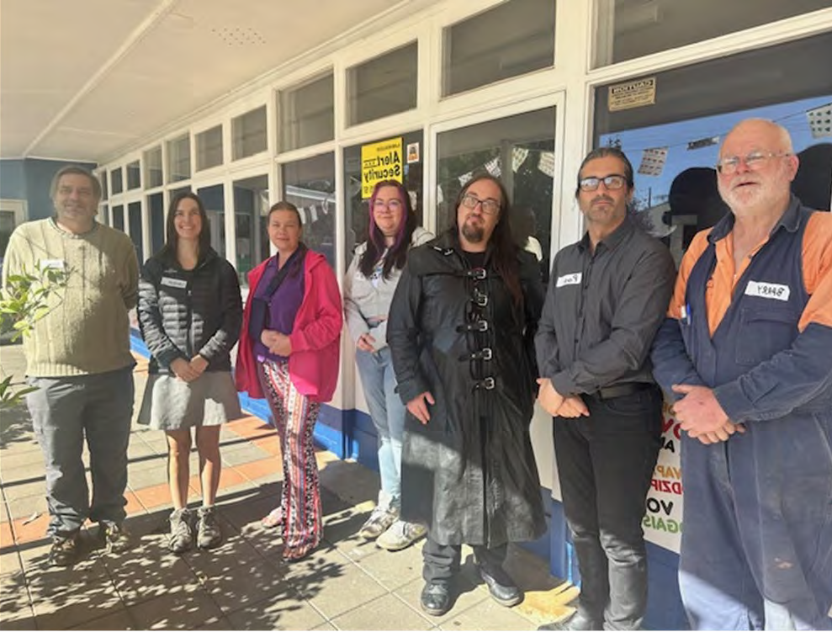
Food Security in Gawler

Lived Experience Report

30th April 2024

Gawler
Who participated, at a glance

Total number of participants | 8
Number of people who were not born in Australia | 0
First Nation participants | 0

Age | 18-24 | 25-34 | 35-44 | 45-54 | 55-64 | 65+
 | 1 | 1 | 2 |  | 2 | 2

Gender | Male | Female | Gender diverse | Prefer not to say
 | 3 | 5

Employment Status | Full-time | Part- time/casual | Unemployed | Pensioner (Age or disability) | Carer | Studying | Retired/ no longer  working
 | 1 | 2 | 2 | 4 |  |  | 1

Key insights
- Healthy Food. Being able to get fresh food cheaply / affordability. Including meat and proteins.
- Support. Knowing where to go for support and knowing what is available. List of resources. Consistency of support rather than the randomness.
- Ability to tailor support. Services having information about me and my needs, without having to prosecute those needs every time.
- Accessing support. Make services close to public transport so it is accessible for everyone. Wheelchair access.

“Makes it tough when I can’t get what he needs. He’s a growing boy and needs food. If he doesn’t eat then he gets sick and it impacts his learning. He has some support at school which is good.”

“Meat is especially expensive. Healthy food in general is expensive. Food that tends to be on special at supermarkets tends to be processed foods like chips.”

“Have a bunch of volunteers who collect and drop-off the food to places. But don’t have enough volunteers to pick and drop off the stuff. Some food is going to waste in these gardens as there are not enough volunteers to move it around”

What’s happening in this community right now?
Our community is being impacted in the following areas right now:

Issue | Lived Experience reflections of the issue
Being able to afford food | Lots experiencing affordability issue. In our experience ⅗ or 60-80% are experiencing food insecurity. Everyone on Centrelink. In the supermarket people are telling you that they can’t believe the prices.  Markets have decreased in Gawler and don’t have food markets anymore. Lions market is only once a month now. It cut out a lot of the cheaper options.  After pay gift cards to pay for fuel or food. Building up debt.
Emergency / crisis food | Work for local MP and we have people come to our office all the time looking for access to services and food. Number is going up in the last year.
Influencing decision makers
Safe food | At the church here the food only lasts a couple of days and some days they don’t have anything.
Healthy food | Council fought against a community garden in Gawler. We finally have one but it’s not accessible to most people. In one location they said it was a floodplain. In another they said it is contaminated soil. They don’t even check it out, just shut it down.  Down south they seem to have more community hubs that support people but not so much here.  There are support places for men or older people but there aren’t a lot of places for people who aren’t old or super young. Civic centre was supposed to be this.  Hardly any vegan options too.
Support | Knowing what supports are available is an issue.  Foodbank on peachy road don’t have a phone number - difficult when you are trying to deliver food to them.  Couldn’t get in contact with Salvos for 3x days and then found out that they had run out of funding. I could have been accessing other services.  Primarily women who seek help (80% at Ucare).

Eating food I like
Nutrition | Nutrition, auto immune conditions, should be eating a mediterranean diet but it’s hard to get what I need. I need gluten free but that’s very expensive. Makes it really difficult to afford. Trying to make sure I’m eating all the things I should be eating. It’s not even cheaper to make it home as the flours are expensive too and the recipe may not work.  Need to make trade-offs to make things stretch further. Eat a lot of rice as I can get big bags of it.  My daughter insists that I have a can of Sustagen handy so if I’m not eating well in a week I can rely on that.  2x kids partial custody, one is vegetarian, one is autistic and has sensory issues. Currently eating out of a food bank. Can’t plan in advance when I don’t know what will be at the foodbank. Still have to go to Coles and woolies but can’t go there before.  Don’t have long to use food from the Foodbank as it’s often older veg. Have a disability and it takes up my whole day working it out.  I am on Newstart and own my own home. Better off than renters. At the end of the week it’s not what I want to eat, its what I can afford. Not enough markets around where you can buy seconds fresh.  Meat is especially expensive. Healthy food in general is expensive. Food that tends to be on special at supermarkets tends to be processed foods like chips.  Autistic son who only eats a small number of things. The things he eats are usually not on special and not available at Foodbank. Partner has diabetes which is new. I have a bowel condition and eat gluten even though I shouldn’t as I need to look after my family first and can’t afford to eat gluten. My son doesn’t go to school all the time as he can’t always get there. Makes it tough when you can’t get what he needs. He’s a growing boy and needs food. If he doesn’t eat then he gets sick and it impacts his learning. He has some support at school which is good. Supermarkets have some programs in place but they tend not to include specialist items. At Ucare we put things like gluten free aside in a freezer but sometimes we have a glut and sometimes we have nothing.
Being able to access food | People need to travel to Daveron park and Elizabeth to get services and cheap food. Some agencies used to get deliveries but you have to plan ahead of time.  I take stuff to foodbank with leftover food at the market garden.  Unpredictability is a problem.

Too far to travel to other markets. Cost of fuel is high.
Free community bus you need to book and it often doesn’t show up and only services Gawler area. Often get a lot of complaints. Think it is the booking system. People don’t know that you can fill out a form to come to your door rather than the closest bus stop.
Sometimes I just walk to the shops but that doesn’t work in some weather. It’s about 20 minutes for me. Heavy things you then have to carry home if something is on special.
Complex issue as its not just about food being available, but the transport to get to it too and other things.
All I can afford is to drive a couple of days a week. Trains are unreliable with strikes. Buses are early or late or they drive past.

Wellbeing | Pride gets in the way too.  Don’t want to have the conversation out loud in the open over and over again.  Sometimes get judged as my disability isn’t visible. It’s tricky to have to explain things over and over.  Embarrassment at having access services
Getting food from where its grown to where its needed | Have a bunch of volunteers who collect and drop off the food to places. But don’t have enough volunteers to pick and drop off the stuff. Some food is going to waste in these gardens as there is not enough.  Local community advocacy. Our family have experiences in the past with food poverty. Interested in putting together alternative systems.
Growing my own food | Often don’t have space at home anymore to grow veg or can’t afford the water to grow them.  Have had workshops to teach people to grow things, but then people lose motivation to keep it going.  Sometimes people don’t have the time and energy to grow things as there is so many other things draining people.  Landlord issues not fixing things puts more pressure on budget.  Love growing pumpkins as you can store them a long time and can do so many things with it.  When renting I knew when my lease is up and so could plan my plantings around then.  Getting potting mix is a struggle as it is heavy. Getting it started can be a hurdle.

What’s needed to support people experiencing food insecurity

What is needed | How could it be delivered?
Extra money
Program to take leftover food from gardens so its not wasted. Connecting gardens with agencies to get the manpower to make it happen. | Connect with northern volunteers Potentially schools
People who got fines used to be able to do community service to pay them off.
Would be cool to have a lot more community gardens. Sharing amongst the community. | Need to be lots of little gardens so they are very accessible.
Council in Gawler have a responsibility to support people. It is part of their remit to assist all levels and aspects of community. | Could help connect food that is locally available to people who need it.
Food cart idea needs an ongoing steward to look after it.
Community groups for all ages to come together.
Not a lot of support for people with disability, chronic illnesses or allergies. | For example - for a disabled person who can’t cook for themselves. Or safe foods that autistic people tend to like. Usually chicken breast.
Would be good to have some specific areas in food banks that tailor to allergies. | Ideally having a one-off general conversation around what people require and then keeping that on record so they don’t have to repeat each time. Stamp on card so they can get specific needs met that aren’t available to everyone.  Apps to help manage your profile
Needs markets with cheap fresh produce. Seasonal.
Volunteers to help people set up gardens. Ideas for portable garden options.
Encourage people to be able to do things for themselves.

Locally based services we access:
- Service Care,
- UCare,
- Salvos,
- St Vinnies de Paul

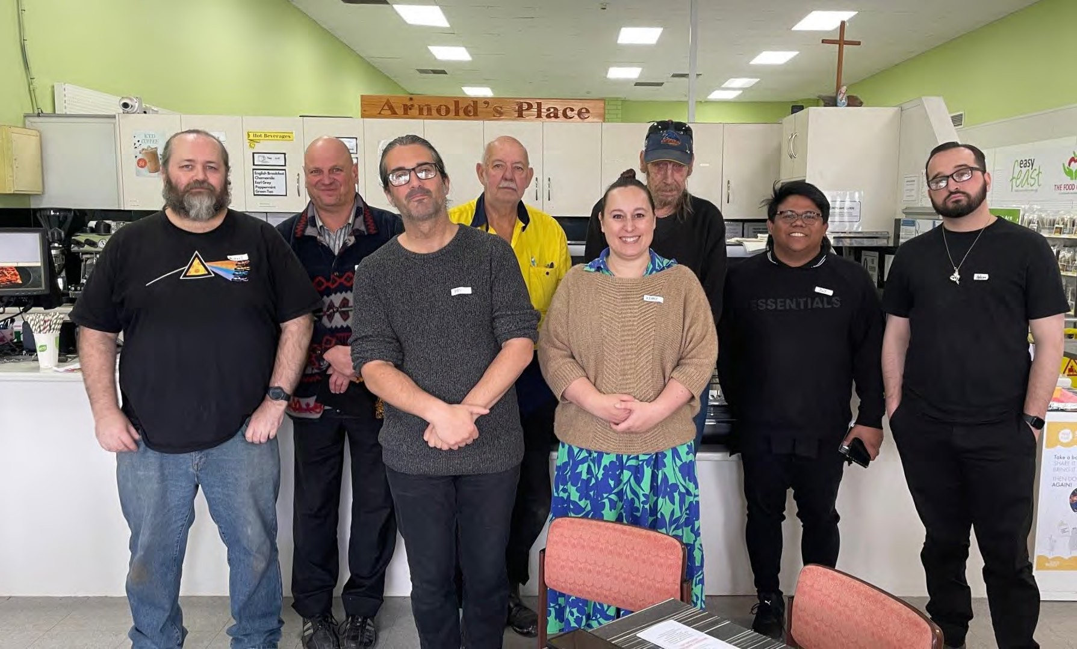
Food Security in Gepps Cross

The Food Centre Volunteers
Lived Experience Report

4th June 2024

Gepps Cross – The Food Centre
Who participated, at a glance

Total number of participants | 9
Number of people who were not born in Australia | 3
First Nation participants | 0
People who identify as having a disability | 2

Age | 18-24 | 25-34 | 35-44 | 45-54 | 55-64 | 65+
 | 0 | 2 | 1 | 2 | 1 | 3

Gender | Male | Female | Gender diverse | Prefer not to say
 | 9 | 0 | 0 | 0

Employment Status | Full-time | Part- time/casual | Unemployed | Pensioner (Age or disability) | Carer | Studying | Retired/ no longer  working
 | 1 | 0 | 4 | 2 | 0 | 0 | 4

Key insights
- Food support services often rely on volunteers but volunteers are getting older – who will replace them? The need is only going to increase for these services. There should be a focus on finding ways to support and encourage volunteering.
- There should be more social supermarkets. They are more empowering for people and they can
shop with choice and without feeling judgement. They offer multiple benefits to the community including social connection, work skills, cheap healthy food, cooking skills.
- There is not enough support available on weekends or that can be delivered to you.
- Create hubs where people can access multiple services in one place.
- No questions asked access to cheap food is important for people’s dignity and wellbeing.

“I like coming down here. You meet nice people. I appreciate the people who volunteer here. The food is the best. Prices are so reasonable. You wouldn’t get better prices anywhere….and it’s got the grocery shop, the op shop, all in one place. I really enjoy it.”

What’s happening in this community right now?
Our community is being impacted in the following areas right now:

Issue | Lived Experience reflections of the issue
Being able to afford food | The prices of food, cost of living and inflation. This is even affecting the middle class or “working poor” now.  A lot of people can’t afford food, especially elderly people. There is not enough support for people to help them get by.
Healthy Food | Some people need education so they understand what is healthy, especially people with kids.  It is getting expensive to buy healthy food – or there is a perception that it is.
Having a home / homelessness | There is not enough shelter and housing. A lot of homelessness.
Emergency / crisis times | People in emergency situations don’t have anywhere to go. They can’t feed themselves good food and get sick and end up in hospital.
Having a place to buy food | There are not enough food shops like the Food Centre. This is the only one in SA – possibly in Australia.
Having a place to prepare / store food | Student accommodation near Modbury Hospital had just one shared kitchen between 30 apartments. They had just a little bar fridge in each room.
Transport | Not everyone has transport to get where they need to go. It is very hard for old people or people in wheelchairs to get to multiple different places to access the services they need.
Support services | There is not enough support around Adelaide, especially south of the city.  Many organisations only look at one aspect of the problem, instead of providing services to meet all needs together.  Foodbanks provide only limited and unpredictable foods.  People can be very uncertain about coming in the door to food services. No services are available on weekends.  There are very few services available that deliver cheap food to you. Meals on Wheels is expensive and limited in who can access it. Coles and Woollies charge for delivery.  Younger people don’t even have the access to free public transport or taxi vouchers that older people get.
Men accessing services | There is a lot of pride that stops men accessing services. There is less of a concern about accessing the social supermarket as it is more like a normal shop.
Volunteers | It is very hard for younger people to volunteer (at a food service). Most need to work full time. Those who aren’t working, you can only use 10 volunteer hours per month towards your job searching requirements and often you are forced to do work as places that are not meaningful to you and are a long way away.  Food services rely heavily on volunteers but they are getting old – who will replace them?

What’s needed to support people experiencing food insecurity

What is needed | How could it be delivered?
Setting up another one of these Food Centres in the South. Maybe even one in the Hills. | We need a lot more organisations like we have here at the food Centre in Adelaide. A lot of people who come here have nowhere else to go.  Include a support network in the centre. Local to where they are.
Important that you don’t feel judged when you access a service. | When they first drop in to the Food Centre they’re unsure if they can shop here. Anyone can shop here. Once they are reassured they are happy to shop here.
Need to expand the cafe into the op shop space as it gets packed out.
Connect to different services in one hub. | Access in one location. Makes it easier for older people or people with a disability. So you only have to visit one place.
Ideally this place could open 7 days a week. But it would need more government support so that it can be run 7 days without exhausting the existing staff.
Help people to volunteer. There should be a greater contribution allowed on your jobsearch effort for volunteer time you spend.
Locally based services we access:
The Food Centre - Social supermarket:
- Cafe, supermarket, op shop. Kitchen, meals prepared here. People can get experience as a Barista, kitchen prep, food handling, customer service.
- There is a BBQ here every Wednesday.
- Easy feed meals that make it easy to make healthy choices. Everything you need to cook a healthy meal for the whole family (recipe and ingredients).
- We check our prices against the supermarket every week. We can consistently say that across everything we are 20% cheaper on average.
- It is a social thing for us. A community centre. Volunteering here is a really safe place.
- The public feel more empowered here. They can make choices about their food needs. People don’t have to justify themselves to shop here.
- People come from all over as there isn’t much around in other areas.
- People find out about what we have here through word of mouth. When they are connected into different systems they hear about us. This is very effective.

- Working poor are more comfortable to shop here. That type of client will come here.
- You have the choice of what you buy. You can get the food you want to eat.
- The Supermarket will accept food vouchers. They have collaborated with other services to give people vouchers to the supermarket here rather than big corporate vouchers.
Northpark shopping centre church have a free lunch every Tuesday. No govt support given to them. Once a month, different businesses cook for them.
Freds vans.

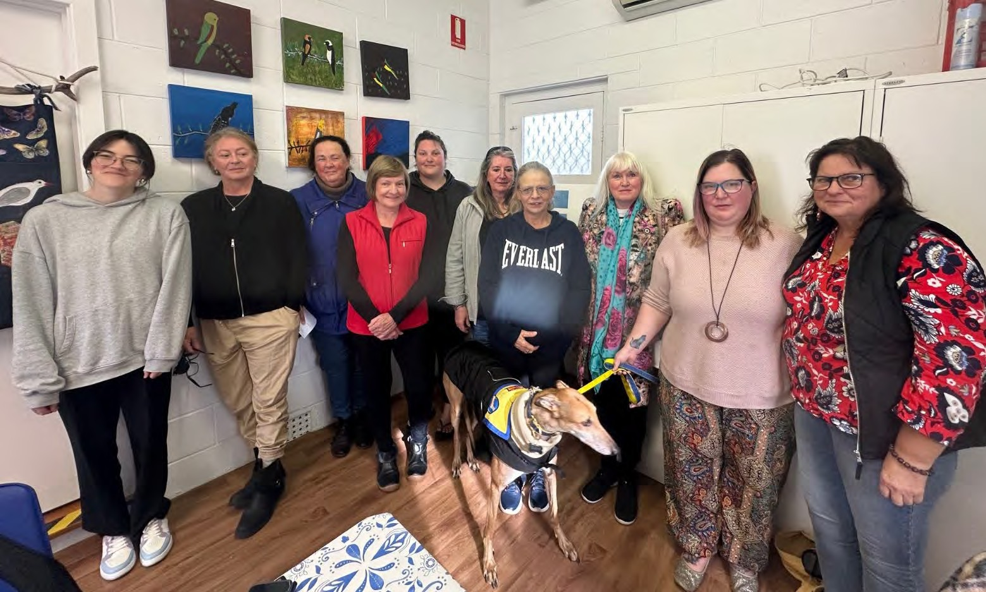

Food Security in Goolwa

Lived Experience Report
23rd May 2024

Goolwa
Who participated, at a glance
Note: some participants chose not to complete the demographic data form.

Total number of participants | 11
Number of people who were not born in Australia | 3
First Nation participants | 0
People who identified as having a disability | 5

Age | 18-24 | 25-34 | 35-44 | 45-54 | 55-64 | 65+
 |  | 2 | 1 | 1 | 3 | 4

Gender | Male | Female | Gender diverse | Prefer not to say
 |  | 11

Employment Status | Full-time | Part- time/casual | Unemployed | Pensioner (Age or disability) | Carer | Studying | Retired/ no longer  working
 | 1 | 2 | 1 | 3 | 1 | 2 | 5

Key insights
- information and knowledge – Need for information and support at places where people go – libraries, community centres, local radio.
- Transport – a barrier for people in regional communities, lack of transport means isolation and exclusion
- Supermarkets & waste – very distressed knowing what is being discarded when that food could go to great use in the community
- Stigma and being judged – service providers (people and the ‘system’) being judgemental
- Importance of community / social structures – lifelines, places of belonging and support. They need to be able to expand their impact and also maintain services consistently.

“Why can’t we buy what you’re going to chuck out.”
“I have so many food intolerances, it impacts my sense of belonging - I can’t partake in eating food in social settings, because I don’t know what’s in it. excludes me a bit… puts me off, I feel like a burden to society”
“Men doing it tough, men more isolated. Women talk, men don’t. Older men mostly in Goolwa are impacted - we see men who have lost their wives, and they know nothing.
Pride in the olde regeneration is a barrier”.

What’s happening in this community right now?
Our community is being impacted in the following areas right now:

Issue | Lived Experience reflections of the issue
Being able to afford food | Can’t afford anything - especially fruit and vegetables  Supermarket specials are not specials and are forcing people to spend more money. We are experiencing increased delivery fees from supermarkets.  Local [farmers] Markets are expensive too - charging more than the supermarkets - want to support them but much more expensive.  It’s a vicious circle - crime and safety is a big issue here for vulnerable people.
Healthy Food | I am compromising my health for affordability and what I can access. We live in a coastal town - why don’t we have a fish shop.  Want to be able to buy good quality fish / meat that smells fresh, and also a fruit and veg shop.
Safe food | Organic food is what I want to consume. I am worried about pesticides / increased preservatives / GM foods – but organic is always more expensive.
Knowing how to cook | We have been learning cooking at the community centre, encourages me to cook more. Always hard to cook just for myself. We try things that we normally wouldn’t this makes a difference to how I feed myself and my family. Also shows the kids that food can be great to share – it’s a great way to socialise
Having a place to buy food | Are supermarkets aware of people in need? Especially not, it seems with meat. I work at Woolworths and was shocked to find that they don't donate / share excess food.  Why can’t we buy what you’re going to chuck out?  They are price gouging - they need to be punished for it.
Having a place to prepare / store food | I needed to have a shoulder replacement 18months ago and couldn’t afford to prepare food - I didn’t get support for 8 weeks, it took that long for support to kick in. I eventually got meals on wheels - I am very happy with that - there is no way I can afford to buy this.  I don’t have a big freezer (only a small freezer on top of my bar fridge, so only limited  places to store food. Can’t buy in bulk, limits my options.

Ability to make choices about food | Very rare that we can access cheap Asian / international products and ingredients in a region - very hard to get here. Choices and variety is nearly impossible here in regional areas
Belonging | I have so many food intolerances, impacts my sense of belonging - I can’t partake in eating food in social settings, because I don’t know what’s in it. excludes me a bit… puts me off, I feel like a burden to society.  Having kids at school - we find our situation is marginalising our kids as there is a difference in their lunchbox to other kids. They also don’t ever eat out. The differences exclude my kids and this is an issue which I don’t want my kids to find themselves in.
Wellbeing | Safety is a big issue here - and if you feel safe, you don’t suffer as much - an extra thing to worry about, can’t be going shopping when the bargains are out late at night when you don’t feel safe.
Packaging | Are producers increasing the weight through packaging to be able to charge more?
Housing | We have experienced a huge spike in rental prices as well as in rates – massive increases, which is pushing housing out of the realm of affordability for many.
Transport | We have few options for transport – to other towns to sources food. If we do go to Victor Harbor we have to spend an entire day there.
Men and food security | Men doing it tough, men more isolated. Women talk, men don’t. Older men mostly in Goolwa are impacted - we see men who have lost their wives, and they know nothing. Pride in the older regeneration is a barrier.
Agriculture | Worried about our practices and how they are global. Need to focus on building thriving local ag economies.  Support bartering / different types of economies.  so much wastage in our country - that shouldn’t be happening

What’s needed to support people experiencing food insecurity

What is needed | How could it be delivered?
Cooking and food swaps | Weve talked about it through the community centre - cooking together and then sharing food / swapping. Community lunches are great - support people who are rough sleeping, and also great social connection
Community garden with a community kitchen adjacent. | The current community garden is right out the back of Goolwa - not really accessible to anyone.  We want to grow a big collective community garden, where we can all help and grow and share the produce from it.
Supporting women who are struggling | There are many women who are fleeing violence or trying to manage families on their own. They are very isolated. One of the many things we need to do is to help people with the skills and also the will to cook good food.
Transport | Transport is a huge barrier for us. community bus that can be used to move people and also food. Can we use the train - victor and Mt Barker.
Access to GP / nutritionists etc | Access to GP’s / nutritionists and dieticians that can help us find services / access food we need.
Ability to provide tailored support to men | Men’s sheds - need to make sure they have information to support men in need.
Accessible Information | GP surgeries - instead of days of our lives playing on the TV (this is lazy!) they should have information.  Need to create community awareness about the problem. For the people who perhaps can help / support others. Need a deeper understanding about our own community.
Make a difference, make changes to our loves | Don’t say, do! Advocate for more income support.
Invest in community building | State government should be investing more in community centres so they can do the role they are perfect for - we feel comfortable here, we know we can get the support here that we need. We need to be investing in creating communities - where people

can benefit from being part of a community that works - need to bring generations together to learn from each other - we need to go back to where we came from, and pass on wisdom and knowledge and skills.

Eligibility requirements to access food relief. | People don’t go to foodbank as there is shame / stigma associated. Three Angels has an op-shop - so it’s not shameful to walk in.  Intrusive when I go to places - people asking me for information, and digging into why I am here. Not justifying why I am there. It matters who is serving me - people who understand what I’ve been through, they’ve been through what I’ve been through.  relief and rescue, rather than kindness and compassion. Power dynamics at play.

Locally based services we access:
- Goolwa foodies - they pick up surplus bread / baked goods and its distributed around. You never see a gluten free loaf of bread / dark rye etc, but it is a good service.
- The Community centre is a great place to come to support us, and all our needs.
- Three angels in Victor is an Op-shop and food relief through the church. Open twice a week. Anyone can access food.
- Food pantry associated with the church - is great value.
- Whalers - fresh fruit and vegetables, not always the best quality but it’s free. Salvos at Victor is the best.
- Heart and Soul stopped delivering to Goolwa – it would be great to have this back.

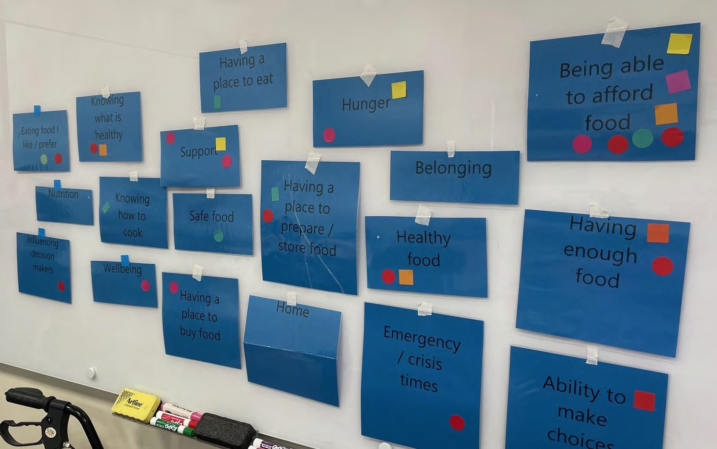

Food Security in Kilburn

Lived Experience Report

21st May 2024

Seeds of Affinity – Pathways for Women group
Who participated, at a glance

Total number of participants | 10
Number of people who were not born in Australia | 0
First Nation participants | 2
Identify as having a disability | 4

Age | 18-24 | 25-34 | 35-44 | 45-54 | 55-64 | 65+
 | 0 | 0 | 2 | 4 | 2 | 0

Gender | Male | Female | Gender diverse | Prefer not to say
 | 0 | 10 | 0 | 0

Employment Status | Full-time | Part- time/casual | Unemployed | Pensioner (Age or disability) | Carer | Studying | Retired/ no longer  working
 | 1 | 2 | 4 | 2 | 0 | 0 | 0

Key insights
- Cost of living – everything is getting more expensive and even working people are struggling now. There needs to be a higher basic income level.
- Foods to meet special needs diets can be hard to get at support services.
- Support services can feel very judgemental. The process to get support can be difficult and intrusive. They make assumptions based on your history. There should be more “no questions asked” services.
- The quality of food through support services can be poor.
- Supermarkets should be forced or incentivised to donate excess food.
- We need to build community so that they can work together to support each other.

“Of course people are shoplifting if they can’t afford food and supermarkets are making big profits.”

“The questions they ask at those agencies make you feel less than. Then they offer financial counselling which is insulting. I know how to manage my money, there just isn’t enough of it.”

What’s happening in this community right now?
Our community is being impacted in the following areas right now:

Issue | Lived Experience reflections of the issue
Being able to afford food | It all comes down to money. Petrol, electricity, food has gone up so much. There are extra costs for medications if you have a disability.  People are going without heaps of stuff already – healthcare and dental and still struggling.  When you’ve unemployed you have access to a lot of things but if you’re just on a low income you’re not eligible for those things and you’re really stuck.  The people that I’m talking to who are looking for help now are not people on jobseeker. They are people who are working. The working poor.  Of course people are shoplifting if they can’t afford food and supermarkets are making big profits.  Fruit and vegetables are expensive. The price of the snack foods and lunches that you should be putting into lunchboxes for kids is expensive.
Equity | The electricity bonus was given to everyone. It is not a fair system for all.
Safe food | Have seen gluten free bread at the Foodbank.
Ability to make choices about food | Cultural foods are often not available in foodbanks. There is also often not the types of foods that kids like to eat. It can be hard to convince a kid to eat something they don’t want to.
Having a place to prepare / store food | At emergency housing and motels there is often no access to cooking equipment. Sometimes not even a microwave.
Belonging | When you go to prison you lose all your relationships.  Who you find at the counter of a service or centre can make a difference to how welcome you feel. You might not feel that you belong somewhere.
Support | Systems with foodbank can be difficult. They are lovely but the process is hard. You have to be referred to them after being assessed.  Finding the time to go to foodbank when you are working full time is hard. Things are open business hours. It’s first in, best dressed – if you get there late, then the good stuff is gone. Some stuff is out of date and the fruit and veg is not the nicest.

Questions are intrusive and make people feel shame. The assumption that people need financial counselling is insulting. It feels like you are being interrogated – you feel like you’d rather go without than being made to feel less than.
Without seeds we would be in trouble.
One service run by Anglicare was very judgemental and there are limits on how often you can access it (clothing service).
Salvos are also judgemental – they supplied my house and from the day I met them they made assumptions about me.
There is a lot of power relationships through these services. You are walking in vulnerable and then get an overwhelming sense of judgement.
It is hard to know what services are out there.
Food waste | When I worked at a buffet, there was good, leftover food but we couldn’t package it up and donate it as it had already been served. Weren’t able to provide to Freds van etc.  ALDI have stopped donating food. Supermarkets do not want to spend the time to sort and donate food.
Transport | It’s hard to get home again from food places without a car. These services are often pushed out further into the suburbs and can be hard to get to.
Reporting | In the past when I accessed food services it got reported to child services. I think it was through the salvation army. The intake information was passed on. I was not told that it would be passed on, I found out later. Some people would avoid accessing services because of things like this.
Judgement | People might look at your clothing and think you don’t need support. They do not understand how quickly things can change for people – or that your clothing might have come from an op shop!  Buy swap sell groups can be problematic. Sometimes people can say horrible things or check out your profile and question your need. There can be information overload in Facebook groups when you are already swamped. You need to have good capacity to do all the things you need to do to get by, but you might be managing grief etc.

What’s needed to support people experiencing food insecurity
What is needed | How could it be delivered?
Supermarkets need to be held accountable. | Government could make rules that they can’t throw out good food. Government could support those places to have motivation to not throw out food.
Increased Centrelink payments. More money. Rent caps. Universal basic income. Matched to CPI increases. | Break down the gap between rich and poor. If you have a liveable income you won’t need the charities. They are really under the pump.
Prices of food being dropped.
Need to be more places across Adelaide where there are no questions asked to get help. Less hoops to jump through. | There should be people at support places who have actually experienced what people are experiencing so they can empathise to know the experience.
Petrol vouchers to help with transport.
Education about poverty to help people understand.
More widespread local services would be good. A place in every suburb.
Something like a payment plan for things (bulk buying) so it’s not a lump sum. | Potential in the future to set up Buying bulk through Seeds. Food co ops. To get the buying power.
Community gardens. Port Adelaide used to have a good garden but its gone now. | Will be setting up a community garden at Seeds.
People need to rally together to pressure the government to make change.
Life skills | There would be a lot of generations out there that are not getting the wisdom of cooking, budgeting, little tips to save. Councils, community centres could offer this. Other women.
Bring back the Community mindset, look after your neighbour. That would help.  It fills your soul to give back. | Once you feel a part of community, you won’t take from it.

Locally based services we access:

- Seeds gives relationships back to people who have been in prison. They help with clothes, food, support. We used to go back to prison as that is where our sense of community was.
- Threads Together
- Heart and soul. Delivered to me by support workers.
- School and university breakfast clubs.
- Women’s Hive.
- Pathway Community Centre donate all the food that Seeds get. Whatever comes into their centre goes straight out to where it is needed. They are not judgemental. They process food 7 days a week. They are all volunteers. It is good food, fresh - they go through it and chuck out the bad stuff.

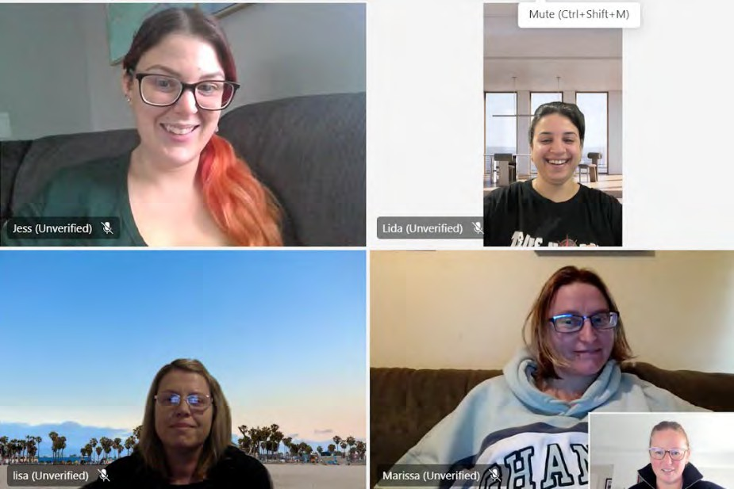

Food Security
DHS Lived Experience Network

Lived Experience Report

7th June 2024

South Plympton & online 7th June 2024
Who participated, at a glance

Total number of participants | 9
Number of people who were not born in Australia | 2
First Nation participants | 0
People who identify as having a disability | 0

Age | 18-24 | 25-34 | 35-44 | 45-54 | 55-64 | 65+
 | 1 | 3 | 3 | 2 | 0 | 0

Gender | Male | Female | Gender diverse | Prefer not to say
 | 1 | 7 | 2 | 0

Employment Status | Full-time | Part- time/casual | Unemployed | Pensioner (Age or disability) | Carer | Studying | Retired/ no longer  working
 | 0 | 4 | 1 | 2 | 3 | 6 | 0

Key insights
  - The way we support feeding kids, especially at school could be transformed. Schools should all have breakfast and lunch programs, inclusive of everyone to reduce stigma. This would ease pressure on families.
  - Cost of living is impacting even working people. Older people, students, immigrants and separated families are especially vulnerable.
  - It is very difficult to manage special dietary needs as food is expensive and support services often don’t have the types of foods needed.
  - Shame and judgement impact on the likelihood of people to access support and their wellbeing when they do.
  - Support services can be very limited in how much support they are able or willing to provide. Families can be left without food if there is only limited food available or limited visits allowed.
  - Many people do not have their own transport or find it difficult to attend shops and support services due to disability or anxiety. There should be transport support and delivery options.
  - There is a lot of food waste at supermarkets and other businesses that sell food. Rules should be created to divert food to people who need it.
  - Being unable to afford food diversity or treats can be an isolating and negative experience, which impacts on people’s wellbeing. People should be able to enjoy food and cooking.

“In one of my houses, the kitchen faced the sun and heated up quite a bit. The landlord wasn’t fixing air con for a while and our bananas were liquifying.”

“I had a friend whose social worker reported them for accessing heart and soul while also taking money out of their bank account for veg and shopping. They questioned the need to do both and assumed they were spending the money on drugs or something.
But my friend was using the cash to buy the things they needed for their diet that didn’t come in the heart and soul box.”

“School says you need to bring fresh fruit - but I can’t do that. I can’t remember the last time I didn’t buy home brand. I am good with budgeting, but I am spending all of my income at once.”

“noticed such a large spike in shoplifting - If I saw a mum stuffing formula into her bag, I am not going to tell anyone. I can see why they need to do this - there is no other choice.”

“You can’t compare the taste of cheap stuff with the more expensive (normal stuff) - home brand vs premium brands. Ingredients is lower quality and less likely to be local.”

“I am preparing this food, and crying in the kitchen because I can’t give them the foods I want to - I can’t help them learn how to do this, because I can’t afford the good food in the first place which gives them examples of how to make meals with different ingredients.”

What’s happening in this community right now?
Our community is being impacted in the following areas right now:

Issue | Lived Experience reflections of the issue
Access to food | Kids can be very unpredictable with how much they want and need to eat. They go through growth spurts and sometimes want to eat everything in the house. It is hard to afford growth spurts. Sometimes kids will eat more with food insecurity as they don’t know when food will be available.  Feeding pets is another challenge. Pets are family for a lot of people.
Being able to afford food | Cost of living is at an all-time high – even people who are working full time are struggling. The cost of food is going up in huge leaps. Support benefits are not changing fast enough.  Vulnerable people are getting pushed back more and more.  It’s difficult for parents that go through separation. On Centrelink payments, until you move out of living together, one parent often only gets a small amount and has to try and live off that. If you’re not on good terms to share the money it can be hard. Parenting allowance goes to just one parent and they might not share it with the other.  Even for working parents, separation often causes financial stress. Older people are often asset rich and cashflow poor.  For students and immigrants, expenses can be quite high and they do not always get government help.  Usually food comes last in your money priority as you feel like it’s the thing you can control. I have noticed a large spike in shoplifting.
Safe Food | The need to buy special dietary food for children which is expensive.  Food support places rely on donated food and they often don’t have the foods I need for my son.  In our family, 3 of the kids are neuro divergent. They like to eat different things to each other. We can’t afford to cook several different meals so we have to eat whatever we can all agree that we can live with – but not what we like.
Healthy food | Having to replace fresh fruit and veggies with frozen foods.  A child with a disability – need to buy healthy food to manage allergies, but find it difficult.  It is cheaper to get a bag of muffins than a punnet of strawberries. The cheaper stuff is higher processed and high in salt and sugar. Kids are definitely missing out on the nutrition they need.  Using more rice and pasta to bulk out meals as you can’t afford to give bulk with healthy foods.
Autonomy / choice | We are being forced to buy home brands to afford food and am losing choice in options.

 | You can’t compare the taste of cheap stuff with the more expensive (normal stuff) - home brand vs premium brands. Ingredients is lower quality and less likely to be local.
Schools | Our school is really good. They won’t take food away from kid’s lunch boxes if it doesn’t meet their guidelines.  They have a breakfast club and they have a fridge for people who need lunch too. They are really good at connecting families with supports if needed.
Knowing how to cook / knowing what is healthy | Older people mostly know how to cook, but they can have difficulty cutting things.
Having a place to store/prepare food | Students often don’t have space to store things. It can be hard to buy in bulk if you don’t have storage space – either to store ingredients or the prepared food.  Big families struggle to have space to store enough fresh food in their fridge or freezer. They then need to manage the logistics of storing food day to day and plan accordingly.
Young People | I had the experience of aging out of a youth community group and not being referred on to other services. I was just told I couldn’t attend anymore, but not told where I go for support.  There is a kids group for up to 12 years old. They supply food for the kids while they are at the group and if they know that a family is struggling, they can help adults access services and can vouch for them so that they get support.  Sometimes people keep their kids home from school as they don’t have food for lunch. Sometimes if parent doesn’t have enough they won’t eat so their kids can.  Families struggle in the school holidays.  No refrigeration for lunchboxes at school. Need the stuff with the preservatives to make sure it is ok to eat.
Shame / stigma / judgement | Some people won’t go to Emergency Relief for the shame of it.  The big thing is shame and access - are they going to ask me lots of questions? What do I need to bring? People like to know beforehand what they need to take. The places they like to go have less eligibility requirements.  Sharing your problems with others is always stressful. You blame yourself. Men especially don’t like asking for help. People will say “you're not a man, you can’t feed your family’. I often ask for help without telling him. Men feel like they are letting their family down.  Some charities are really judgemental.  In our cultural community (Afghan), struggling is not acceptable - nobody knows, they are very judgemental, and I now don't spend much time with them. I don’t want to be seen there - as I am worried and my husband is worried about being seen there.
Support services | One person related a story from interstate where their friend who had allergies was told by a food support service that if they were desperate enough, they would just eat the food that was there and push through.

There are a lot of hoops you have to jump through to access support services. This is not good. Having to constantly explain yourself.

As a big family, support services often question your need, especially when you need so much food for a big family and there are often restrictions on how much you can take. We have visited Anglicare and Food Banks. There was a food service at my primary school too but they said she was taking too much. My mum has now decided it is too hard to use services. The only place we are getting support right now is through the NDIS. My mum is non-white. I don’t think they would ask those questions of a white person.

You can often only access food support for the people on one Medicare card, but bigger families, or people with longer names might be on multiple cards.

On the other side, some people take more than they need from services (some can be hoarders) and the food can go to waste.

If you have a difficult experience at a support service, there are complaint numbers that you can call and there is the SACAT Ombudsman for crisis. But when people are fighting for survival they probably won’t have the energy to advocate for themselves. Maybe if you have a lot of confidence and know the system you might complain, but most wouldn’t. People are more likely to avoid the service if they are made to feel bad.

People only get a certain amount/visits to food support services. What do you do if you have run out of food after those times? Some allow you to come back if you see a financial counsellor, but it makes you feel like shit to have to do that. They are making assumptions about you.

Some people don’t realise that the financial counsellors are not only examining your finances but they can also advocate on your behalf (e.g. for payment plans with utility providers). So they can support you to avoid things like having your power cut off. There should be more awareness shared about everything they can do for you.

The school my kids go to is very open about their requirement to report certain things to Government. I don’t mind them reporting it if we know it is happening and they are open about it. So long as they can see you seeking support, they are happy.
Many people wouldn’t understand that just because something gets reported, it doesn’t mean it is automatically deemed a child protection issue. This is an important message that they need to inform people more about what it actually means.

Foodbank can be more expensive that the shops.

Vegetables usually at end of life at support services - so could improve this.
Support / information  / knowledge about where to go | People who are immigrants don’t know the system. It’s hard enough for people who have always lived here, but new immigrants would find it very difficult to find support.
Emergencies | In some instances, you can’t access support until you have seen a financial counsellor, however the wait to see a counsellor can be weeks or more. If they need food today, they can’t wait that long. They could require you to book an appointment with the financial counsellor and then you can access the service in the meantime while you wait for that appointment.

Community/family support | Systems often don’t recognise that you can have extended family/friends staying with you that you need to feed (one participant had ten people in her home for a while).  Lots of community food groups stopped during COVID and many have not restarted.
Transport | This is one of the biggest issues. If people don’t have money, they don’t have transport. Many don’t have a car. Some people have mobility issues, especially older people. There are also people with anxiety who can‘t deal with a shopping centre, or people with little kids. Food delivery is important for these people.  There are some community buses to help people get from their home to the supermarket, but some people wouldn’t know about it. Many would assume it was for older people and it may be in some areas. It would vary council to council.  There are a lot of people who pick up food for other people and distribute it out into the community.  Some taxis refuse fares – either is somewhere is not far enough or too far away.  I’d love to go the markets, but can’t get there - I am legally not allowed to drive due to medical reasons.
Food waste / supermarkets | Some places have rules that all food has to go in the bin. Staff can lose their job if they give it away.  Whether a business donates food or not can be down to individual managers and sometimes when a manager changes, it can impact on donations.  Bakers delight choosing a few things to donate but throwing out lots. They had excuses about dairy.
Complex health needs | As a nurse, I see many people presenting with mental health issues who can’t afford to buy basic food, can’t feed their family. I always try and help them - not within my scope of practice, so I can give them the information they need.
Wellbeing | When my kids see someone with food they like I want to provide this for them but I can’t. It makes them feel excluded. He is stressing about it and mentally this is draining on him.  Other kids will bring in different brands (which my kid wants), which creates tension here for me and my family. It is great to teach kids about money but continuously saying no is not a good experience.  We eat the same foods, food isn’t enjoyable – it’s a stagnant thing we do to survive. We can’t afford to try new foods and can’t teach kids to cook new meals as we can’t afford the ingredients. Can’t enjoy cooking.
Influencing decision makers | We are all watching society fall further into poverty – government are just watching it happen.

What’s needed to support people experiencing food insecurity

What is needed | How could it be delivered?
Needs to be some systems in place for larger families.
Every school has a breakfast and lunch club. Make it well known that it is for everyone. | Takes the stigma out of attending the club. Lunch and breakfast in programs at every school.  We need to see a system where hot meals are provided to kids. Also at childcare.
“No questions asked” support is an important part that enables people that you wouldn’t ever get through other services. | This could be having food available to take at community groups, where people might be coming in for another reason and the food is just there for them to take what they need.  At support services, it would be good to not be questioned every time you go. Just accept that people need food.
Funding for food cooking programs.
Donating the scraps that are inedible to farms. | To avoid so much going to waste
Laws that make sure that excess food has to be given away to homeless.
Delivery options and localised services. More funding for places like heart and soul. | To support people who don’t have good access to transport or who find it difficult to leave home.
More community gardens.
Growing more herbs on verge - most councils don’t let you. | Growing food around the neighbourhood that anyone can pick.
Fridges for lunches at schools | So you can send food that doesn’t have so many preservatives in it.
There definitely needs to be better information and support around. | More information in an available and accessible way to allow people to get help / ask for help. So much shame in our community about asking for help, if you are not doing as well as others, you will be judged by others.  Facebook / buy nothing groups are so helpful.  Community centres / community noticeboards / community libraries are where people go to access. Schools can also put things in their newsletters.
Sharing food when its in surplus | Need to find a way to share food when It is in season - need to find systems that work locally.

More variety in cheaper foods.  Need to change the balance so the cheap foods are the fresh and raw ingredients, not the processed foods. | Needs to be govt focussed.  Fresh fruit and veggies and meat a priority for all families - to give families the best chance.
Capping profit and stopping major price hikes. | Need to make big players accountable. Need to put a cap on the profit margins that the big players can have.  Rules around how much a product can be hiked up.
Transport support | Would use better, more direct public transport options.  OR can we get the food to where people are…. instead of moving
People with disability | People who have disabilities MUST have access - they cant choose certain things - they need good quality food to deliver nutrients to their bodies / muscles.  More support for nutritious food for people with disabilities.
Dietary needs | food relief places don't cater for dietary / allergy needs
Locally based services we access:
- We have a wellbeing program at my kids school.
- Heart and soul, do deliver. You can get the delivery fee waived. They do a pantry as well as the free boxes. Great for people who can’t drive
- There are some community buses
- There are places you can go to take a meal from the fridge - pay it forward at cafes.
- Grow free carts
- Food cooking program.
- Church on a Friday night has food they put out.
- Spare fridge for lunches at our school and the breakfast. Always food in there. Should have something at every school.
- Daycare they would put the leftovers in the fridge for people to take home.
- U-care Gawler. Fruit and veg and bread every day. Can get support from them every 3 months for other stuff.
- Kids school do groups/clubs during lunch so nobody ever has to be alone.
- Many families in family by family are being offered food vouchers to attend.
- Anglicare have sometimes given me a foodbank voucher and then a Coles voucher as well so I can get what I need for my son’s diet needs.
- food waste is starting to be managed better - I access Oz harvest - but it can be a blood bath in there when food is dropped off.
- NQR - great options for snacks. Pennywise Spending.
- Guardian gifters of Adelaide Facebook page and also buy nothing Facebook pages.
- Breakfast bellies is another one - relationships with bakers etc. Eases financial burden.
- Family by Family
- Community centres - everyone is struggling, sad thing to bond over, but it can help to release stigma. Often have op-shops and food avail.

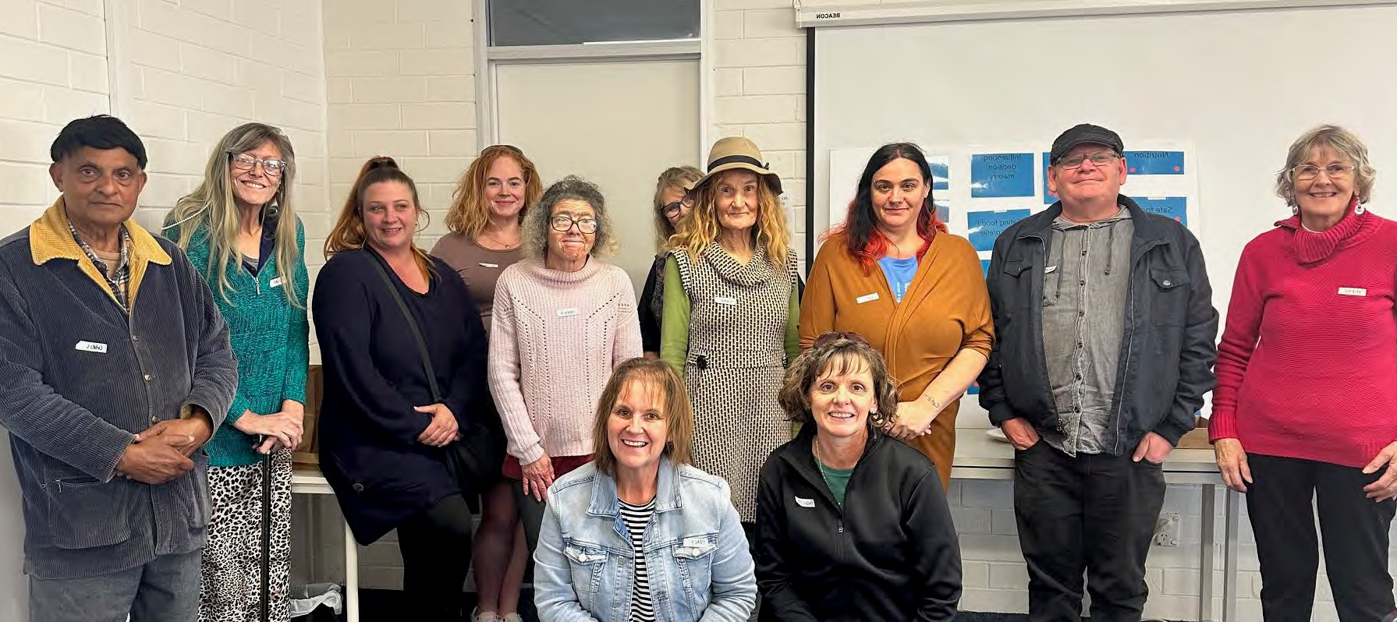

Food Security in Mt Barker

Lived Experience Report
10th May 2024

Mount Barker
Who participated, at a glance
Note: some participants chose not to complete the demographic data form.

Total number of participants | 16
Number of people who were not born in Australia | 3
First Nation participants | 0
People who identified as having a disability | 4

Age | 18-24 | 25-34 | 35-44 | 45-54 | 55-64 | 65+
 |  |  | 2 | 8 | 2 | 3

Gender | Male | Female | Gender diverse | Prefer not to say
 | 3 | 12

Employment Status | Full-time | Part- time/casual | Unemployed | Pensioner (Age or disability) | Carer | Studying | Retired/ no longer  working
 | 1 | 3 | 3 | 5 |  |  | 2

Key insights
- Quality of food nutritionally - good food = good health. People need more access to healthy proteins, the system is lacking in this. There needs to be more support funnelling into community pantries for low cost items that are quality items
- Small, regional and isolated communities - services more accessible for people in small
communities where they live to access cheap housing. The distance means they can’t access options for food support – and as a consequence become further impacted and isolated.
- The number of people in need – this has increased massively, so has disability - so we need to
better support the volume and those with disability. Food is a basic human need and should be prioritized first.
- Income support - the current support is simply not enough.
- Barriers / hoops we have to jump through - “it just depletes you” “I am life weary”
- Eligibility limits / criteria which mean people fall through the cracks…I don’t qualify for many things.

“What is available for my family is highly processed foods - sugars and salt. We need more meat and fresh food available.”

“Degrading and condescending to be asked to do financial counselling when I don’t need it. I don’t need to learn how to manage my money - I do this really well and

prioritise the limited amounts I have (for rent / power / water etc)… and then the rest is for food.”

“People with mental health issues also find it very hard to reach-out / ask for help… and this makes it so much work.”

What’s happening in this community right now?
Our community is being impacted in the following areas right now:

Disability pension/ carer – “our family payment is not enough for growing boys…. its way too minimal - the money doesn’t go far enough, and its also very hard work - stressful… very consuming for us.”
Connectivity of issues with housing / poverty
Families with mortgages are feeling isolated - cant even get to where I need to buy
food / access food relief in a town like Mt Barker.
The basic cost of living issues have a direct relationship to food insecurity. Everything is costing more. Pricing in supermarkets have increased a lot in the last 12 months. There are limited options in Strath - cost of transport to get to where to buy food
limited options on the shelves.
Being able to afford
food
Lived Experience reflections of the issue
Issue

Having a place to buy food
Very limited options to get to places to source food especially in places such as Strathalbyn & Milang - tyranny of distance.

Having a place to
store / prepare food
Lots of people experiencing homelessness. I have no facilities to cook.

Ability to make choices about food
We are always having to make do with what is there - no options for choice…

Emergency / crisis food
Relationship breakdowns / DV - when women leave a situation, they don’t know where to go, or what to access. A lot of the opening hours don’t match when people need to leave.
Financial breakdown between partners – issues in the processing of single parenting payment can take many months.

Healthy food | Organics / non chemical / gluten free food is really expensive to access, as to is food appropriate for vegetarians / vegans - we really struggle.  What is available for my family is highly processed foods - sugars and salt. We need more meat and fresh food available.
Eligibility criteria | It is degrading and condescending to be asked to do financial counselling when I don’t need it. I don’t need to learn how to manage my money - I do this really well and prioritise the limited amounts I have (for rent / power / water etc)… and then the rest is for food.
Digital poverty | This is a huge barrier for so many people – we lose out on so many opportunities in society because we cant afford internet access. Libraries are OK - but its still isolating.

“the hoops we have to jump through…it just depletes you - I am life weary”
What’s needed to support people experiencing food insecurity

What is needed | How could it be delivered?
Transport | More transport / consistent bus services, more of the ‘on-demand’ bus services.  Free community delivery for food would be great.
Supermarkets | Need to be able to access reduced items in home delivery - would be great to be able to buy reduced items that I could then get delivered. Also need to remove minimum amount for supermarkets for delivery to open this up to people in need.  Also need to stop the price gauging of supermarkets - very vulnerable people are being impacted here.
More services like heart and soul | This works really well, no limit on ordering.  Can only order one box - which might not support large families.
Accessing food relief | Need to remove the requirement to conduct financial counselling….  ALTHOUGH we learnt through the session that financial counsellors act as advocates for people - and can help people to access reductions in power bills – which is great! Nobody knew that in the room today. Given that, the group discussed how people can be connected to a counsellor without the degradation attached to it.

Food carts / Pantry clubs | While good, the nature of how they work is very opportunistic - needs better distribution mechanisms to ensure those really in need can get it. How they work needs to be fairer and more equitable.  Things like pantry clubs work better than the drop off and rush… we need a way to make this work 7 days a week, not just within work days.
Men | so many assumptions made about women’s / children’s needs to access food… Men sometimes are seen as piss weak / shameful for being in this position but have equal needs. Often a hidden part of the community.
Breakfast club at schools | This is so important and needs to be available for all children, not just for those who need – to ensure kids in need don’t get targeted for it.
Support for people fleeing relationships | Emergency payment / gift cards  Somewhere to go to / contact - even in the middle of the night. Most emergencies are outside of business hours - that’s why its so bad, because you know that you can’t access support.  People with mental health issues also find it very hard to reach-out / ask for help… and this makes it so much worse.
Older people | We need to find a way to support older people with dignity / food and housing.
Concessions / discounts / gift cards | Can government look at ways to support people who are in poverty with paying for transport so they can get to services.
Dietary requirements  / health needs | Need to find ways to support peoples health needs / dietary needs  Need to know how to get the right nutrition - and how to cook to maximise the nutritional benefits of food. Also important to teach people to grow food / preserve food.
Community Garden | Need more of them in close proximity to people with a BBQ - where you can cook.
Support | Need to not be judged, just need to be heard.  There is not as much support for people in country areas - limited options to access support, and the costs of providing this.  Sometimes services are not within your catchment area - eligibility makes people fall between the cracks.

Lots of people are moving to regional areas as they cant afford to live in the city - which makes them isolated and unable to access support – and tips them into being food insecure.

Medical vs Food | Very expensive to access, people need to buy less food to access medical help - and have to go without food to do this.  Paying the gap as an upfront payment for my medical costs really impacts people who are in our situation. “I had to pay a $69 gap, which meant that I missed out on  food for 2 weeks.”

Navigating the system
I can communicate very effectively with services, but many people cannot - this makes their access for support very difficult.
Navigating the system is geared towards those who are successful at it / know how the system works - very unfair…

Locally based services we access:
- Pantry Club (Strathalbyn)
- Heart and Soul - Heart & soul is a great service - $15 for fruit and veg / bakery items.
- Hungry no More - totally free
- Salvos
- *Food Pantry – which is open on a weekend
- Hurling Drive
- Foundation One
- *Jade Brooke - LOVE OUT LOUD - she helps on weekends - makes a huge difference on weekends / out of hours.

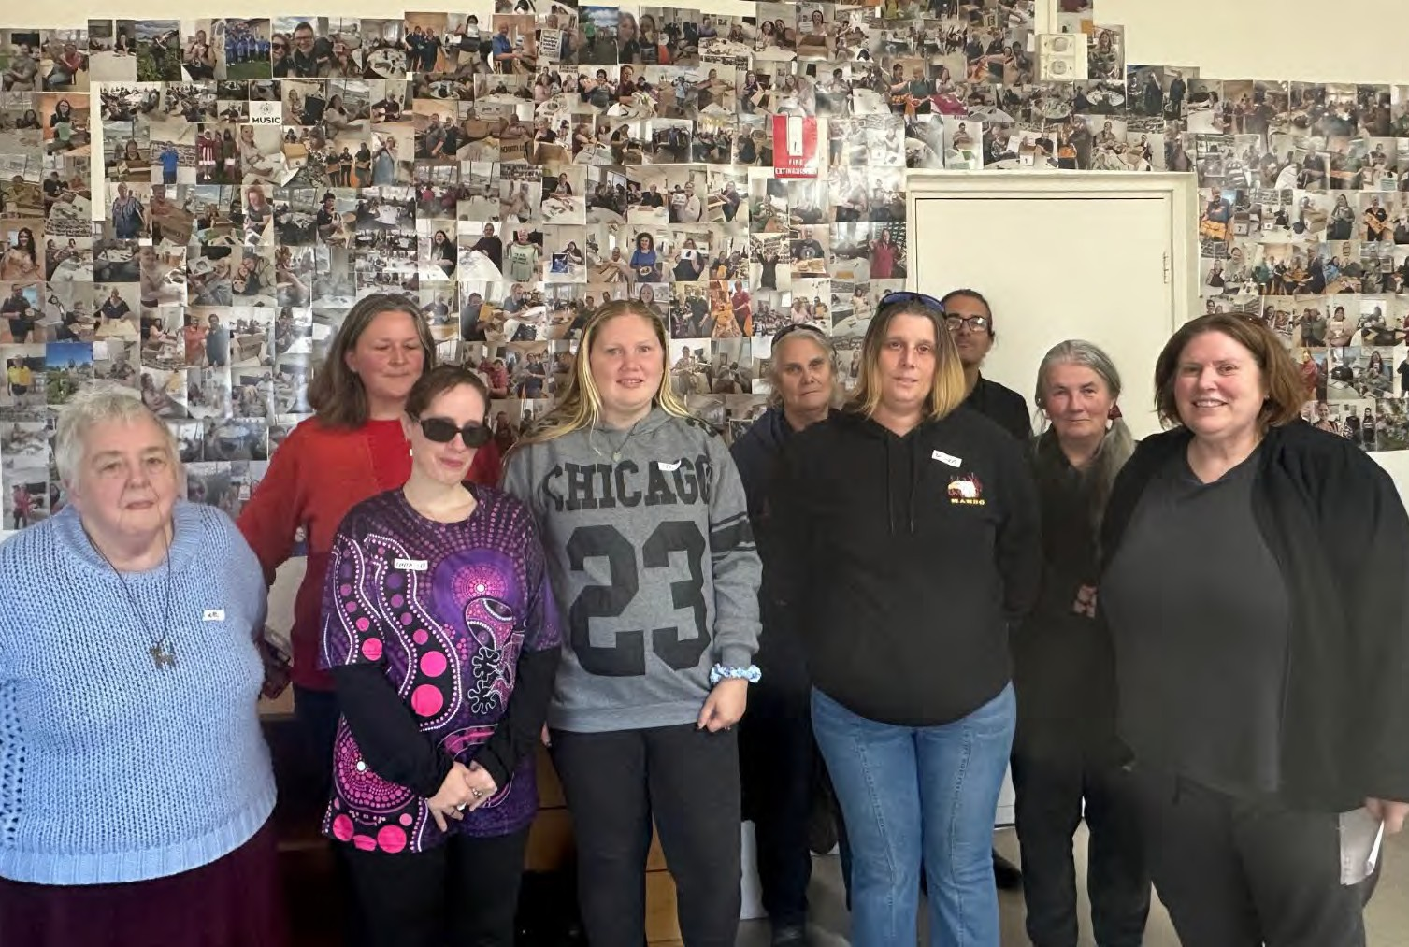

Food Security in Mount Gambier

Lived Experience Report
16th May 2024

Mount Gambier
Who participated, at a glance
Note: some participants chose not to complete the demographic data form.

Total number of participants | 11
Number of people who were not born in Australia | 2
First Nation participants | 3
People who identified as having a disability | 6

Age | 18-24 | 25-34 | 35-44 | 45-54 | 55-64 | 65+
 |  | 2 | 3 | 2 | 3 | 1

Gender | Male | Female | Gender diverse | Prefer not to say
 | 1 | 10

Employment Status | Full-time | Part- time/casual | Unemployed | Pensioner (Age or disability) | Carer | Studying | Retired/ no longer  working
 |  |  | 3 | 7 | 2 | 1 | 1

Key insights
- Access to good, cheap fresh food
- Emergencies – access to community services (of all types) out of hours to support many people in emergency / crisis
- Transport – if we can solve the transport issue, we can solve so many other things
- Tougher regulation – on supermarkets / price gouging of essential services
- Support to grow our own food as a region – we want to do it, just don’t have the means or the spaces.

“I have stopped budgeting - how can you get more out of something that's not there”
“why should we have to ring someone in Adelaide when we are the second largest city in SA?”
“I have a rare adrenal cancer that I found about – I was told I was going to die. Instead of doing what the system wanted me to do, I didn’t like the death sentence they gave me, and I decided to do this alternatively… I have been successful and have shrunk my adrenal tumour…But this has come at great cost to me and my son. I had to totally change everything I eat, I pretty much eat meat and vegetables and that’s it. My son eats what I call s**t, so I can eat good food. He eats all the carbs and cheap food – I have to make a choice. All I want to do is be alive and see my son grow up to be an adult, but all I can do is feed him rubbish so I can eat the good things to stay alive.
Its cruel.”

What’s happening in this community right now?
Our community is being impacted in the following areas right now:

Issue | Lived Experience reflections of the issue
Being able to afford food | The group agreed that prices / cost of living is the major contributor to food security. Many of them shared that bills (rent / electricity etc) are more important than food - my rent is going up by $45/week.  Those with the pension shared frustration that it doesn’t go far – they are “lucky to have $50 a fortnight for food”.  Many cant afford the food they need for their special dietary requirements - bread I have to eat under doctors orders is $7. Cant afford meat. Getting red meat is nearly impossible. I supplement them with iron tablets.  Many shared experiences of Foodbank prices increasing, making foodbank no longer n option – it also has less range and quality than Coles.  Some budget – and shared the following:  - “I budget everything - and have to start shaving to find a way through.”  - “I have stopped budgeting - how can you get more out of something that's not there – its like polishing a turd.”  Some have found ways through the affordability issue: “I stopped eating meat and went fully vegetarian a few years ago which has helped. I find creative ways to stretch my food so it goes further.”
Having enough food | People spoke of there being a mismatch between where the food is, and where its needed – where its grown and distributed to, how easy it is for us to access it.
Healthy food and lack of nutrition | Many spoke of their worries of not having nutritious food – and the impacts on their health.  They all have had challenges accessing fresh food, meat and other healthy foods on an ongoing basis – “junk food is all I can find and afford.”  One shared her challenges with cancer - feeding herself well and in the meantime, sacrificing her sons health by feeding him high cards / sugars (junk) so she can stay alive.

Emergency / crisis times | Lots of people asking for food donations on Facebook - who are doing it tough… but you have to be really brave to do this. Many community members jump into action which is great to see.  Many people in the room shared experiences of being without food during emergencies – and reflect on the need to be able to access to support 24/7 not just within work hours
Transport | All participants had daily challenges getting to where they can buy food / access food relief.  “Cant get to foodbank. RedCross can only access with age / disability”  “Millicent has no public transport. Red Cross is $25 each way and have to book 3 days in advance. No taxis out of 10-3pm.”  “Don’t have on-demand buses” “Price of fuel is so expensive “
Having a place to buy food | Foodbank is a fair way out of town - 4-5kms from the CBD.  Transport – many people cant get to Food Bank – as they cant drive there.
Ability to make choices about food | When I go to Foodbank I cant access the food I need – there is simply no choices for me there and for my needs.  Many in the room shared impossible choices – choosing food / medication over each other: “I can’t afford medication - so don’t buy it anymore, so I can afford to buy food.”  I am very fussy. Junk food is cheaper to buy and I can make this last a week – and I cant do that with fresh food.
Support | All participants had experiences of judgement and assumptions. “I try and go to the same places so they get to know me - I wear my aboriginal t-shirts and I get treated so badly… I also get judged on my choices – I might be wearing a new jumper or a pair of sunglasses and people say – why do you have that when you cant afford to buy food! It’s the first piece of clothing I have been able to afford for 4 years”.  Most support is centralised - why should we have to ring Adelaide when we are the second largest city in SA?  When I want simple help with a service I get the third degree… no judgement here in AC. Discriminated at Centrelink when people don’t even want to understand me and what’s happening to me.

Belonging | If you are not from this town, you are always judged, and excluded
Wellbeing | All people confirmed that food insecurity is severely impacting on their wellbeing and mental health:  “I am fulltime anxiety / depression – as a consequence of this challenge.”  “Its overwhelming to get to the checkout and be told I don’t have enough food.” “With Mental Health issues - if you cant get the right nutrition, it makes it worse…”
Influencing decision makers – esp. with regional insights | Participants wanted to tell government “you need to listen to us”. “If you do things, you need to think about people who are in regions. Once you are out of Adelaide it seems like nobody matters”
Lack of volunteers | The system is breaking down - losing volunteers.
Pet food | Struggling to pay for pet food.
Men and food security | The group noticed the lack of men in the room. When asked why they said it was  largely “due to shame and embarrassment”. They also noted that women tend to do the emotional labour on these sorts of issues.

What’s needed to support people experiencing food insecurity

What is needed | How could it be delivered?
Iron substitutes distributed to people | Participants don’t ever see being able to afford meat, so were looking for substitutions nutritionally that could replace meat
Connect people to food | Food safety regulations have restricted peoples access to food – and this is really hurting people.  There is no food shortage - need to connect people who are wasting food with people who need it.  New York has a good model, so does Melbourne – Cheaper buy Miles. https://www.cheaperbuymiles.com/
Growing food locally | opportunity for regions to grow their own food to service their local communities Local markets that sell fresh foods- supporting the growth of local food economies.

Support for growing our own food - to pay for water / potting mix / buying plants. Skill share / older people - can see lots of benefits and opportunities with this.
Community (?) is going to do this in Millicent - and also plant fruit trees.
Would love Council/Local Government to think about how this could work to support community

Prices & competition | Government need to support / clamp down on retailers who are price hiking.  It would also be helpful to have more competition in regional towns so we don’t have to always take the price we are given.
Community helping community | I will put myself out to try and help others - before I help myself.  if you need help, you cant rely on people who are not in need themselves – they simply are not connected to the problem.
Fruit tree maps | A map / log of fruit trees in communities, so people can go and help themselves when its in season.

Locally based services we access:
- AC Care is great - in Millicent and Mt Gambier.
- The community house has a transport service that goes to Foodbank.
- NO services are open on weekends - including Foodbank.
- “Millicent shares a plate” - volunteers making a meal at the RSL
- Sunset kitchen - once a week can get food, no questions asked
- Salvation army BBQ’s – though not sure if they still have them.

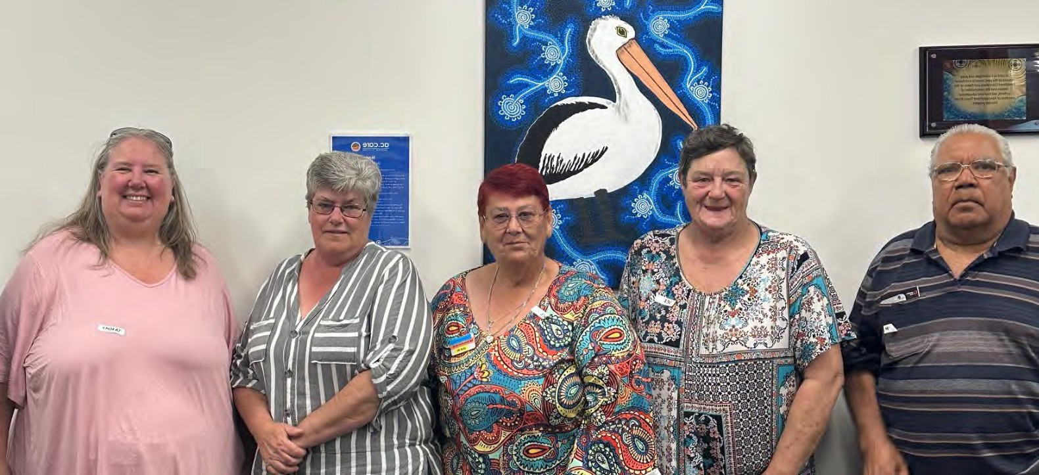

Food Security in Murray Bridge

Lived Experience Report
13h May 2024

Murray Bridge
Who participated, at a glance
Note: some participants chose not to complete the demographic data form.

Total number of participants | 8
Number of people who were not born in Australia | 1
First Nation participants | 1
People who identified as having a disability | 4

Age | 18-24 | 25-34 | 35-44 | 45-54 | 55-64 | 65+
 |  |  | 2 | 1 | 3 | 2

Gender | Male | Female | Gender diverse | Prefer not to say
 | 1 | 7

Employment Status | Full-time | Part- time/casual | Unemployed | Pensioner (Age or disability) | Carer | Studying | Retired/ no longer  working
 |  | 2 |  | 7 | 3 | 1

Key insights
- cost of living is pushing people into food insecurity
- Seeking help - feeling safe to say I need help / having a place to go (knowing where to go)
- Transport in a rural community is so challenging - you can only go shopping if you have a car.
- Impossible choices - having to choose between food / medical needs is a choice we shouldn't have to make. Food is the most necessary as its the most basic human right.
- Nutritious option - more available fresh food at low cost
- Kindness & compassion - welcoming / kind open arms when I go into a support place
- information board in a central place, which is up to date (weekly) and easy for all people to see at all time.

“It’s very difficult to get vegetables, fresh vegetables. You have to get there at the crack of dawn and be there for the first few hrs. The unhealthy food is the food we can rely on.”

“when people know a bit about me and our situation it relinquishes their judgement and enables them to let it go… Nobody wants to be in the position where we are, struggling & budgeting every single cent… and the kinder people are the better!”

“Some places I stopped going to as I felt judged….”

What’s happening in this community right now?
Our community is being impacted in the following areas right now:

Issue | Lived Experience reflections of the issue
Being able to afford food | Meat / protein in general is very expensive. I bought up 13 kids on mince and its now so expensive and we can’t afford protein anymore – as a consequence our health is being impacted.  Cost of living in general - everything is going up. General basics has gone up ridiculously. Supermarkets make it work – when specials come back to full price the following week, they are often more expensive than before being on special.  Coles / Foodbank not much difference between them in price…. not worth going to Foodbank sometimes. Foodbank expiry dates are much shorter, so many times it’s not worth it.
Support / knowing what’s available | I have lived here for 4 years – and only last week got a list with everyone on it – I didn’t know this existed… Welcome to Murray Bridge book from the local Council used to be a good source. AC Care was the only place that had this list.  Word of mouth is usually the only way that we can connect and find out what’s available.
Wellbeing | I don’t go to the doctors anymore to say how bad I feel as I don’t want to be on a mental health plan….. I often go and sit down by the river - but I largely manage it alone and in private.  I talk to friends who are in situations like me!  I used to volunteer but I cant do this anymore as I cant afford to get there. This was so important - its where I had friends and was doing meaningful work.

I am 81 - I still seem to manage. I am single now. I grew up in the mission in Quorn, and then went to Eden Hills - gave me a good foundation. I am resilient I suppose, I have worked out how to do life!

Being food insecure creates a lot of stress - isolates people - which makes our wellbeing even worse. I don't want to go out - don’t leave the house, when I do leave the house, I am exposed and more vulnerable. Also, things can go wrong – I am safe at home, but I am isolated and my wellbeing is suffering.

Influencing decision makers | Government have been talking about cost of living for years - its all talk, not enough action, people are frustrated and we are really doing it tough. Need to cut out the talk-fest and act quicker
Having a place to store / prepare food | I have been a mum of 13 kids, with all their mates - used to cook like crazy – would share leftovers and reheat it, but I live in a bus now and cant freeze / store food…
Ability to make choices about food | I experience overwhelm with all the brands and choices… it can be really confusing.  We have to take what we can get. This creates lots of stress on people - the workers in these stores have rules - and when you have a big family it creates a tension between them and us… Need to remove the limits on what I can buy especially when there is a big family. (I also don’t like being followed around, watched by people when I am shopping for my large family)
Healthy food / nutrition | It’s very difficult to get vegetables, fresh vegetables. You have to get there at the crack of dawn and be there for the first few hrs.  The unhealthy food is the food we can rely on. All we can access normally is lots of crap - high sugar, high salt, processed foods. Bulk chips and nuggets is cheaper and much less nutritious  Dinner packs are good for people who cant cook. They've gone up in price, but are a great way for people to access food especially if they cant cook.  Skill building / cooking – we are not sure what’s around for people who need to learn how to cook on a budget.
Belonging | When people know a bit about me and my situation it relinquishes their judgement and enables them to let it go… Nobody wants to be in the position where we are  struggling, budgeting every single cent… and the kinder people are the better!

“…having to choose between food / medical needs is a choice we shouldn't have to make. Food is the most necessary as its the most basic human right.”
What’s needed to support people experiencing food insecurity

What is needed | How could it be delivered?
Information | Needs to be in various places.  When changing address (moving to a new area), there should be some resources available through service SA.  Information board in a central place, which is up to date (weekly) and easy for all  people to see at all times of the day / night.
Transport | You can only go shopping if you have a car. Would be great to have a delivery option for people. Dial-a-ride is good - need more of them with more options, so you can get around better.
The right people in financial planning roles & being able to access them quickly. | Financial counsellors are beneficial - especially when they have great networks and knowledge. And when they have a good reputation - and can advocate for me to reduce my costs of living. They can link people to other things.  But they have to be able to develop trusting relationships, and not be judgy. Need to ensure these people are kind.  Also need to be able to access them quickly - wait times are ridiculous
Sense of community | We are losing our sense of community / our sense of kindness… our communities are changing which is also making our situation worse – as we are judged and marginalised. Having a community that accepts all, and is kind is what we need.  Community centres are good - but also can be isolating / judgy. Neighbours and friends  Op shop is a place like this - where we include people like family.
Community gardens / free fresh locally grown food | We need more of them – as growing food for people who are food insecure is too expensive to do yourself (costs of water / potting mix). But being able to have a community garden, maybe grown by people who can afford it but accessible to all would be ideal.
Community Centre | I would use the community centre more if I didn’t have to pay for services it provides.
Promotion of supports | Letterbox drop / Internet / info board / newsletters - need to promote these services in various ways, not just through the internet.

Customer service people at the desk (of AC Care, Council, other support services) should know what’s happening, so they can pass on information.

How to cook on a budget | Would love to have a free resource available which helps people with ideas and knowledge on how to store food / freeze food, how to cook on a budget /  economically, how to preserve, how to use spices to create tasty food cheaply.

Locally based services we access:
- AC Care
- St Johns Op Shop and meals
- Foodbank
- Community garden in Bremer Drive

Another supplementary issue – wellbeing and access to local sport.
A participant raised the issue of sporting club amalgamations in the local community, which have come about as a consequence of financial issues. What this is leading to in Murray Bridge is families and young people falling out of regular sport, as they cant afford to travel the huge distances to get to games. This is increasing isolation and also impacting on people’s wellbeing.

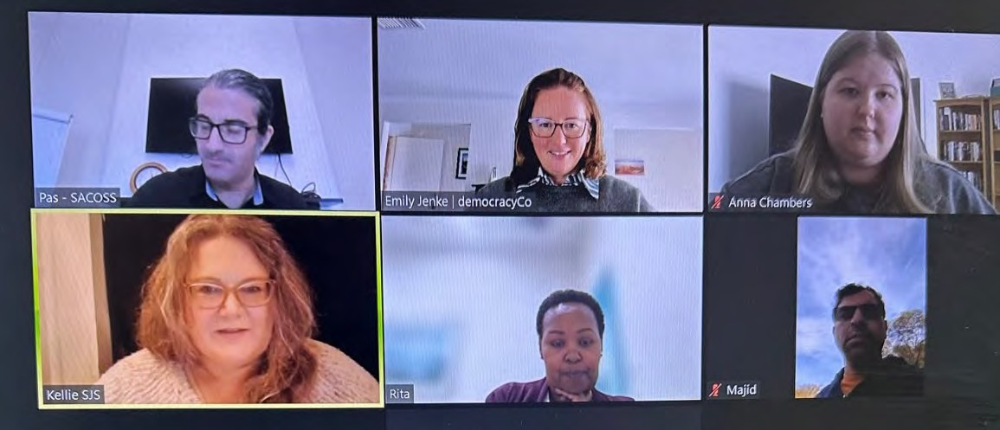

Food Security SA (online)

Lived Experience Report
24th May 2024

Online
Who participated, at a glance
Note: some participants chose not to complete the demographic data form.

Total number of participants | 6
Number of people who were not born in Australia | 1
First Nation participants | 2
People who identified as having a disability | 2

Age | 18-24 | 25-34 | 35-44 | 45-54 | 55-64 | 65+
 |  | 1 | 1 | 4

Gender | Male | Female | Gender diverse | Prefer not to say
 | 2 | 4

Employment Status | Full-time | Part- time/casual | Unemployed | Pensioner (Age or disability) | Carer | Studying | Retired/ no longer  working
 | 2 | 2 | 1 | 1 | 2 | 1

Key insights
- Raise the rate & address rising costs – need to increase Centrelink payments to enable people to actually survive & actively address cost of living pressures.
- More engagement – people want a greater voice in the policies and decisions of government
- Respect, dignity and compassion – from all people to all people
- Housing – stability and access to a home is directly related to food security and food access.
- Choice – we should be able to feed our families healthy food, food they need to grow and thrive like anyone else.

“Everything has gone up - power bills have gone up, and so money is not available to do shopping - not much left.”
“I worked as a kitchen hand in an aged care facility - had to put so much food in the bin, perfectly good food, sometimes prepared meals and sometimes fresh food - I was throwing 20kg bag of food out - it was heart breaking.”
“Fast food is not cheap - it’s often more about access to these foods. When I think of my nephews - indigenous young fellas, they don’t have the knowledge to secure fresh food to bring home, prepare, cook… for them it’s a trip to fast food places so they can eat & fill up”.

“The people you encounter in the system is full of people who don’t care - you get bounced around. There is not a central place you can go to - you have to actively seek and seek again.”
“Important to mention suicide rates - they are 3 times higher for people in the jobseeker bracket - this is horrendous and a disgrace to be so poverty stricken in a resource rich country”
What’s happening in this community right now?
Our community is being impacted in the following areas right now:

Issue | Lived Experience reflections of the issue
Having enough food | I feel bad identifying this - we have enough and my children have enough - its more about having enough of the right types of food to give the kids - making my pay last to have enough fruit and vegetables to eat and providing a balanced meal for my kids.  I didn't grow up in Australia and have seen scarcity of food. There is enough food here in Australia but at the same time it’s not in the right places.  Scarcity - I have a son who a young adult - I have managed to get him on his own two feet, he is adopted… I have indigenous family and would like to mention the issues of living rural - we have access issues and pay more.
Being able to afford food | Everything has gone up - power bills have gone up, and so money is not available to do shopping - not much left - some items have increased by $2. We need to see payments increased to enable us to catchup and buy the basics.  We have to be very careful what we spend on groceries. My son is on the NDIS and is about to reach an age where he is not eligible for support - so we will stop doing therapies. It will cut into our electricity / rent.  I worked as a kitchen hand in an aged care facility - had to put so much food in the bin, perfectly good food. sometimes prepared meals and sometimes fresh food - I was throwing 20kg bag of food out - it was heart breaking.  Costs have made me forego other things that I know I need. I look for cheaper options (i.e. canned vegetables and meat and fish)... have had to make those compromises. I am only feeding myself - I can only imagine how hard it is for small families.

I am a primary producer, and have the means to grow things - I know what I can use to supplement fresh food in casseroles safely.

My son is non-verbal and we are struggling financially on bills - we need organic food for him. We go to the supermarket generally, sometimes we go to foodbank / hub but we can never find organic food there.
Healthy food | My young son has lots of food aversions - really hard to feed him food that is healthy. Fruit and veg is going up - mouldy/rotten produce at premium prices. I like to introduce my son to foods that he is interested in eating - so he develops his tastes  Fast food is not cheap - it’s often more about access to these foods. When I think of my nephews - indigenous young fellas, they don’t have the knowledge to secure fresh food to bring home, prepare, cook… for them it’s a trip to fast food places so they can eat - bulk up.  You make sacrifices for fresh fruit and veg over more inferior quality foods based on money.
Safe food | There are health risks of using not fresh food - how can we supplement freshness with other alternative sources.
Having a home / housing and homelessness | I have people who want to live in my stables.
Emergency / crisis times | Emergency housing only can have for 3 months - this is not secure, after that had to move to transition housing - month by month. Very stressful, transitionary.  No matter where you go in the chain, local rep, services - if you are a forthright woman, you will seek support. Others who are less forthright fall away, don’t have the ability / support to seek what they need. So many people get shuffled around and compromised.  People lacking transport / rural areas have so many barriers.  If you are in the govt system, the people you encounter is full of people who don’t care - you get bounced around. There is not a central place you can go to - you have to actively seek, and seek again

Belonging | I was an international student at the time covid hit - I wasn't a resident, but had been working and paying taxes - but wasn't eligible for support… No way to go back home during covid -experiencing hardship, minimal supports in place. I was isolated and alone - there was no support out there, I had to figure out how to move forward. I had supports from my church.  Important to mention suicide rates - they are 3 times higher for people in jobseeker bracket - this is horrendous and a disgrace to be so poverty stricken in a resource rich country.
Support | Facebook page is very active.  When something is working, it inevitably gets ruined - we had a food pantry which kept getting vandalised and it got removed. Hard for people to go and seek help - an anonymous option for people to go to.  I have noticed that some places ask for ID - I have encountered going into a place to get some food and being loudly questioned in front of everyone else - no respect or dignity or privacy. Was very shaming to have this happen, I never went back.  minimal questions need to be asked - need to respect people's dignity when they are accessing this support.  I am a victim of DV - and can’t revert to my maiden name, and can’t prove who I am - so therefore I can’t get support. It’s just awful.
Wellbeing / belonging | Our mental state is related to our physical state - stress when I have to try and live day to day.  Its really hard going to the doctor, and I know what I should be eating, but I can’t afford to do that. Hard to consider your own health and accommodate for all of these things.
Food hub delivery (regional areas) | The food hub were getting food delivered in goodwill, but were charging us.

“I have encountered going into a place to get some food and being loudly questioned in front of everyone else - no respect or dignity or privacy. Was very shaming to have this happen, I never went back.”

What’s needed to support people experiencing food insecurity

What is needed | How could it be delivered?
Food waste regulations | It would be amazing if there was regulation where supermarkets were not allowed to throw food in the bin, and instead required to provide food to people in need.
Cost of living | We need to lower the costs of electricity and other bills (rental) so we have money available to provide the food we need for our families. We don’t have solar panels on the roof - so we haven’t even got the chance to reduce the costs of living  Concessions need to be looked at and increased.  Raise the rate.
Dignity and respect | When you live in a regional community, the stigma is large. You also get lumped into assumptions… many people are turning to drugs, which gets labelled as mental health. Everyone is a tax payer - we are raising young tax payers - so we all need to be seen as equal. When you access a community centre you are outing yourself - don’t want someone to help me, want to help myself.  Those providing for others need to have extra compassion / awareness and understanding of what people need.
Capping rental costs | Nerve racking in case we need a new bond for a new rental. Very scary hoping we can stay and have security.
More housing | Need to have more housing being built for people - if we have more stock, it could give people a home, which is a start for food security. Although these new houses are cold in winter, hot in summer, awful places to live. People cant afford to live there comfortably. Need to see houses built for our climate.
Eligibility criteria for support | Remove eligibility criteria - where you have to share all your life details. More anonymous food pantries will make a world of difference as they allow you to keep your dignity.
More engagement | More conversations like this - real people’s faces, real people's story. We need to be making policy with government

Locally based services we access:

- Food Hub - has been a change recently where supermarkets are no longer able to donate food which is frozen before the best before - so we cant get meat. We used to get low grade meat at OK price now to no meat.
- Food pantry at Hallett Cove -they are very busy, I am not as desperate as others.
- Food pantry run by Anglicare - was great until vandalised and then disappeared

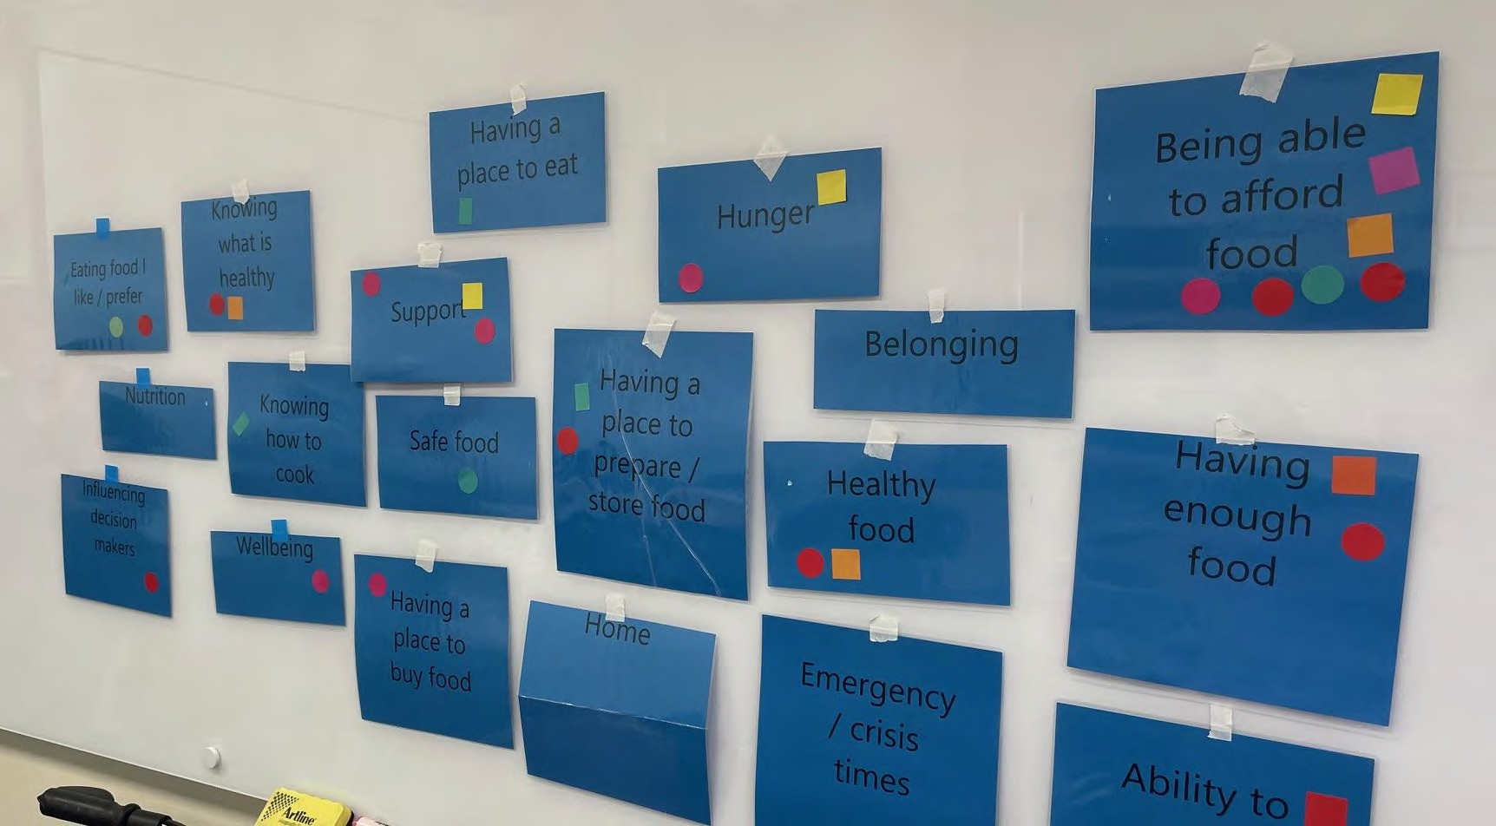

Food Security

Online – Mixed Areas
Lived Experience Report

31st May 2024

Online 31st May 2024
Who participated, at a glance

Total number of participants | 10
Number of people who were not born in Australia | 3
First Nation participants | 0
People who identify as having a disability | 4

Age | 18-24 | 25-34 | 35-44 | 45-54 | 55-64 | 65+
 | 0 | 4 | 1 | 0 | 2 | 1

Gender | Male | Female | Gender diverse | Prefer not to say
 | 0 | 6 | 2 | 0

Employment Status | Full-time | Part- time/casual | Unemployed | Pensioner (Age or disability) | Carer | Studying | Retired/ no longer  working
 | 0 | 3 | 3 | 0 | 0 | 2 | 0

Key insights
- Even working families with two incomes are struggling to put food on the table now. Demand is growing for support services.
- Fruit and vegetables at support services are often old and wilting. There are limited options at services for special dietary needs e.g. coeliac.
- There are no support services available on weekends or after hours for people who are working.
- Homeless people have nowhere to cook or store food. Some people on lower incomes can only afford homes that do not have proper cooking facilities.
- Many people feel judged and shamed for having to access food relief. There is still a lot of stigma about people experiencing difficulties.
- Food relief services have unstable and unpredictable supply channels.
- The systems to access food support can be complicated and difficult.
- It is very difficult to find out about what services are out there for support – especially if you don’t have access to the internet.
- Travelling to access food relief and other services was a significant obstacle for many on low incomes, particularly those who had to rely on public transport.

“It feels like something is taken away from you as a human being if you can’t cook a proper meal. It is isolating. I’ve never had a friend over for a meal.”

“Many people are worried about judgement when they access services. There is still a lot of stigma about people experiencing difficulties. The way we support should be with respect.”

“Sometimes, the only way to ensure my kids having healthy meals, is for me to go without”

“It really is demoralising, that you have to struggle to have a healthy diet”

“When we first started the program at the childcare centre there was a stigma attached to using it, but now it is embedded in the culture of our service people are more comfortable.”

What’s happening in this community right now?
Our community is being impacted in the following areas right now:

Issue | Lived Experience reflections of the issue
Having enough food | We run a food program at our childcare centre once a week, providing food to families, but once a week doesn’t seem to be enough anymore. Some of our educators are needing to now use the program themselves.
Being able to afford food | Since COVID there has been a lot of vulnerability at the childcare centre. Even many homes with 2x incomes are struggling. Many are having to prioritise housing and essential medications over food.  Parents skipping meals to make sure that their children are fed.  The time and emotional labour to go through catalogues each week is huge.  Some people can’t even afford the very cheap meals that services like Baptist care offer.
Healthy Food | Our child’s childcare is very strict on what can go in a lunch box. We prioritise his meals first and then use whatever is left over for us.  Having access to healthy food is impacting on people’s ability to learning and study (including for adults in higher education).  Many people needing support have health complications.  Fruit and vegetables at support services can be old and sometimes left out in the sun to wilt.
Safe Food | People with dietary challenges e.g. coeliac, there is limited food available at food hubs and safe foods are expensive at supermarkets.  Sometimes the only options left at food hubs are sugary processed foods which is problematic for people with health issues.
Knowing how to cook / knowing what is healthy | If people are very young when they leave home, they may not learn how to cook or what is healthy. There might be lots of people out there who have never learned about nutrition.
Emergency / crisis times | Baptist Care offer emergency relief vouchers but they rely on funding and this is quite limited. Currently people can only access emergency vouchers 3x times per financial year.  Emergency assistance is open only on weekdays when people are working. There needs to be something available on a weekend.
Language barriers | People who are not fluent in English can find it harder to access services and may be more reluctant to access them.
Having a place to prepare / store food | Homeless people have nowhere to cook or store food.  As a single person, renting along, the types of places that someone can afford to rent now often don’t come with a full kitchen. Without a proper place to prepare food, it impacts on my ability to have friends over for a meal. It is isolating.
Shame / stigma | Many people feel judged and shamed for having to access food relief. There is still a lot of stigma about people experiencing difficulties.

 | Some had difficult experiences with volunteers at services, others found the eligibility rules and processes made them feel demeaned.
Support services | You cannot assume that everyone is being protected by the safety net of Centrelink. Some people fall through the gaps in the system and so they miss out on the extra supports available to people on Centrelink.  Much of the support that is available is not relevant for homeless people as they can’t prepare and store the food they would be given. They have no shelter. People are not very aware of the needs of homeless people and their complex situations.  My University does not offer much support. They have just a very basic breakfast club, but it’s not really healthy food.  The food we get into the childcare centre is different every week. Usually fresh fruit and veg and bread, but other things can be random e.g. meat, slabs of coke.  At the mental Health service, we see different ebbs and flows of food coming from support services. We have to top up what we can’t get through Coles, but that eats into our budget for other things. We get Government funding, but they don’t increase it at the rate that the prices are going up.  Baptist care run a Food hub outlet supplied by Oz Harvest, Foodbank and Second Bite. The Supply is not stable and fluctuates day to day. We guarantee support to the people who need to access our services so sometime we need to ask Coles and Woollies for extra support.  Food hubs can have limited fresh, healthy food. It often runs out quickly and there are restrictions on staple foods. Restrictions often do not take into account larger families.  There can be a long wait in line at support services to get food, even if you get there early. You have to wait exposed to weather and hot/cold temperatures, which is a challenge for people with health issues or children. This is especially stressful for people with limited transport options.  Many services require you to have been referred or you can’t access them. Working through the systems to get support can be difficult.  There are no support services for a hot meal in the South.  There are very few mobile food relief services or services with delivery options.  Some had given up on accessing food relief services and were instead relying on informal supports from family and friends.
Community/family support | We moved to escape family violence and are now much further away from our family supports.
Wellbeing | Access to some treats in life is important for wellbeing. You need something to look forward to.
Knowing what support is out there | It is very difficult to find out about what services are out there for support. It is especially hard if you don’t have access to the internet.
Transport | Travelling to access food relief and other services was a significant obstacle for many on low incomes, particularly those who had to rely on public transport.

Housing is cheaper in rural areas but everything else is way more expensive, especially transport costs, with longer distances and less public transport options.

People are catching the bus for 2+ hours to get to support services (metro area).
Access to waste food | The food safety act has just changed with tighter rules around temperature control. This has impacted food support services as there is a lot more regulation to go through and businesses are less willing or able to donate food because of this.
Community gardens | One participant tried to start a community garden in Port Noarlunga but experienced pushback from the Council and would have been required to use their own money to start the garden.

What’s needed to support people experiencing food insecurity
What is needed | How could it be delivered?
An increase to incomes, e.g., JobSeeker, other Centrelink payments
There needs to be another level of relevant support for people who are homeless or living in emergency accommodation.
Communal cooking spaces for people who are homeless.
Ensuring stable, secure, adequate housing for all, with adequate food cooking and preparation facilities | e.g., community kitchens and pantries, were identified as very useful
More dignified ways of accessing food relief, | e.g., voucher systems, where people can shop at regular stores, instead of at charities. The way we support should be with respect.
Use basic English at food services and have signs in different languages.
We need a better strategy to ensure regular and reliable supply of food to support services.
Access to decent food services that are free during the weekend would be amazing. | Foodbank hubs are sitting there on the weekends unused. They could extend into the weekends.

Connections between the outlets and the big suppliers like foodbanks could be better. | There could be an operator in the middle who knows the demand and supply (not amount but timing) so that providers get what they need when they need it.
Things outside of the CBD to get hot meals. | Something about having hubs in the geographic areas so people don’t have to travel so far.
More mobile food relief services, including options for door-to-door service, for people unable to leave their homes, and get to a food relief service
With our mental health services we are looking to get out into the community. We could have something like a caravan or a food truck that can go into to different areas. | Could include social workers or counsellors in the van. Getting out and educating people on mental health and where to go to get support.  Relaxed, have a meal. Not to dictate to them how they should live, just to support. Sometimes they just want to be heard. Food is about your heart and communication and love and grounding.
Caps on prices of fruit and veg at supermarkets. there is only so far, the food can stretch.
If we are thinking about a Sugar tax - we should also think about a discount on fresh fruit and veg. Why wouldn’t we do that? | To keep people well. We spend way too much on medications.
Education on how to prepare food would have been good for myself when I was younger - programs on cooking and nutrition for those who need it. | Need to know why people don’t prepare food for themselves. Should be more education in schools to help kids understand this from a young age. Needs to come back into the school system. Food education as a young adult.
Consistent obligations for not only supermarkets, but farmers and growers, to donate surplus, unused stock to food relief services | Huge potential for other services. Foodland, every food business to be part of food support. It is more practical with bigger food businesses. More accessibility to food that’s being thrown out.
Community services all sit in silos. We are having a pilot in Port Adelaide and getting services together to have an expo. | Councils have a role to play in this. We are big on being local and having local mini expos.  If we all stood together once or twice a year. One big expo centrally and smaller local ones. The govt could support. If we as workers don’t know how to find people - how can the public find this?
Community gardens supported by councils. Growing and learning. Cooking classes. A lot of community options where we go back to grass roots, Putting this back into our own hands. | No shopping centre in some towns at all. A community garden would make a big difference.

Locally based services we access:
- Baptist care and Westcare do breakfast and basic lunch every day. Every Wednesday there is a hot meal free. Every other day $2-$5.
- Early learning centre, we get food in every week for our families from Second bite. We also provide breakfast and afternoon tea for kids.
- I am from Diamond House Port Adelaide - a mental health service. We use a food service - Second Byte. 10 years ago we used Foodbank but they still charge, particularly for meat. Second Bite is free. Highly recommend, they are amazing. We provide a meal every day. We go and collect it. Take out for the kitchen so they can create the meals. Then have a market day with whatever is left. Participants, volunteers and staff can take.
- Puddle jumpers. At least you are there with people in a similar position to you.
- We get a lot of support from families who give excess food from their gardens to the hub.
- used to live in mile end, still a part of thriving community network within suburb connected through Facebook group. Those suburbs tend to do better with food when they are connected and share food.
- Meal delivery through Hello Fresh as part of NDIS support. A game changer for this person to allow them to get healthy food delivered to their home. This supported their ability to make choices about their food, and to choose foods that suited their dietary needs.

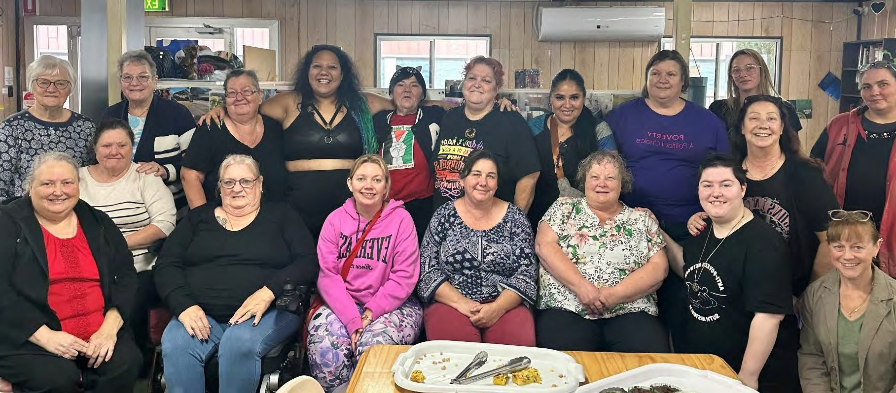

Food Security in Playford

Lived Experience Report from the Playford
Women’s Shed

9th May 2024

Playford Women’s Shed
Who participated, at a glance
Note: some participants chose not to complete the demographic data form.

Total number of participants | 36
Number of people who were not born in Australia | 7
First Nation participants | 0
People who identified as having a disability | 10

Age | 18-24 | 25-34 | 35-44 | 45-54 | 55-64 | 65+
 | 2 | 0 | 3 | 5 | 7 | 3

Gender | Male | Female | Gender diverse | Prefer not to say
 | 0 | 36

Employment Status | Full-time | Part- time/casual | Unemployed | Pensioner (Age or disability) | Carer | Studying | Retired/ no longer  working
 |  | 6 | 5 | 5 | 2 | 3 | 4

“We want to go back to living, not surviving.”

Key insights
- Cost of living – the price of living is a direct reflection on our capacity to afford food. Basic living income above the poverty line. Royal commission into poverty and then implementation of the recommendations.
- Education / meal planning / creativity around food - while we lower prices, we need to build skills in how to use food creatively.
- The system makes assumptions / Categorising people - not categorising people - creates a system that results in the have’s and have nots - equality in food / income. Don’t lump everyone in the same basket, people are individuals. Social experiment for them to live how we try to live.
Those comments around if you just tried harder that are really damaging. Blaming and guilt instead of solutions.
- Leaders need compassion - Understanding from the top down and compassion.
- Transport – access to food relief and also supermarkets is impossible if people don’t drive. Better public transport supports equity in society.

“When people are depressed they make poor choices, which amplify the problem. If you don’t want to cook - then you eat rubbish. We need good nutrition for wellbeing.
When kids don’t eat properly - they don’t learn well. People cant work well.”

“Trapped in a vicious cycle, of guilt and stress. Stress affects your wellbeing. If you’re having food stress it impacts your health. If you fix the root causes you fix wellbeing.”

“Food insecurity used to be something that happened to people occasionally, every now and then. Now it is relentless, all the time”
“I can’t afford meat, so it’s cheaper to have an iron transfusion every few years than to eat meat.”
““Sometimes, I won’t eat, to put my kids first”
What’s happening in this community right now?
Our community is being impacted in the following areas right now:

Issue | Lived Experience reflections of the issue
Being able to afford food | Rent keeps going up but pensions don’t go up with CPI. Wages don’t go up but everything else goes up.  I am a fulltime carer which means I cannot work at all – and the carers support I get is simply not enough to love on.  Price of food is ridiculously high as they want profit. Producers are not getting the money, it is going to the supermarkets.  Value for money: Prices are sky high but size has gone down and nutrition has gone down. The water that comes out of the mince woolies is terrible. They pump it full of fillers and water so it is cheaper for them.  Independence is important for wellbeing. My niece lost her job and had to move back home. It is soul destroying. It doesn’t take much to find yourself in a position where you have nothing.  Huge anxiety about expensive and rising renting costs (and housing costs, generally – most of the group were renters, but there was 1 mortgagee), many were spending over half their income on housing (so experiencing ‘housing stress’), e.g., a Disability Pensioner, battling cancer, on $550 a week, paying $450 a week in rent  Soaring housing costs were having predictable effects on people’s ability to purchase food  High housing costs had led to overcrowding for some (for 1 person, there were up to 8 people sharing a home) -Comments about digital exclusion, people being unable to afford decent phones, data, difficulties accessing online government portals, e.g., Centrelink/MyGov
Having enough food | Physically feel better when you eat well but you can’t afford to eat better.

Paying more for your health because you can’t eat what you need. Can’t afford meat, so it’s cheaper to have an iron transfusion every few years than to eat meat.
Shouldn’t be needing to make those choices. Dietary needs when medications, and health concerns are combined can be tricky. I can’t eat some things or take some medications as my kidney can’t process them. I don’t want to end up on dialysis
Belonging | I’ve had pressure from the school community (notes home in lunchboxes) that kids shouldn’t be eating things I’ve sent but it’s all I can afford. There should be a more supportive system through the school. It makes you feel like crap.
Ability to make choices about food | When people are depressed, they make poor choices, which amplify the problem. If you don’t want to cook - then you eat rubbish. We need good nutrition for wellbeing. When kids don’t eat properly - they don’t learn well. People cant work well.  Schools are dictating what can be sent to school- if the parent can’t afford to buy the food which is allowed, what do you do? I have had to send my son to a better school so he doesn’t get bullied, and now go without other things, including food.  I have really hard choices to make: while i am thinking about food, my house is falling down around me… so I have really hard priorities – do I fix the house or do I eat?
Emergency / crisis food | Things happen to people which result in unintended consequences… eligibility criteria for support needs to ensure that its trauma informed and reflecting people’s circumstances
Safe food | I have been hearing people share experiences of dumpster diving - really worried about this, its not safe and we need to be very careful to ensure safe food is eaten by people.
Healthy food
I have to have certain foods - which I can’t afford. I make sure the family is fed, and I
go without. These foods are so much more expensive - and we often choose not to have them. I have had to move to vegetarian / vegan for my health.
People with complex dietary needs (people who were gluten-intolerance or lactose- intolerant, people with allergies or complex sensory preference) found navigating food choices – both at supermarkets, and in the charity sector – a complex process,
with limited options, and additional expenses
“Some foods will literally make me sick…and it is hard to afford the food I can safely eat.”
“Everything gets more expensive, with a food intolerance.”

We can’t make good choices / healthy choices - and we cant do what the country is asking us to – to be healthier. Its simply out of reach. Junk is cheaper than healthy food. Packaged food lasts longer. These are the decisions you have to make. If I get paid fortnightly then I need food to last the fortnight. Living in my car I need certain foods. Some things I can’t keep.
Support The people who are in place to help often don’t understand the impact of just telling me I should eat better. It’s really damaging. I know I should but I can’t afford to and there is a lot of shame in being told these things.

We need supportive environments as a group – its nice to know you are not alone.

Knowing where I can go to find support I need - without judgement. PWS has been a godsend. Second bite has made a huge difference.

Opening hours / access / having to make appointments to access basic support – there are too many hoops to jump through.

Those of us who are not on Centrelink, suffer the most - as we don’t get any discounts / concessions… we get punished for having a job. Haves and the have nots - discriminatory approach for people in need.

I want to be able to get information - some basic recipes to help me best use the food I have.

Part of support is having a coffee with friends - can’t afford to do that anymore.

So many people who don’t know where to go - we should know how to find the information we need.

People with larger families felt that rigid, one-size-fits-all rules around how many food items they could buy/take at foodbanks/other food relief services were unfair, and disadvantaging them (and felt judged, if they needed large amounts of food)

Limits around number of visits were seen as frustrating (e.g., local Anglicare reportedly limits requests for food assistance to 1-2, per month)

Some services were far more flexible about number of visits (e.g., Encounter in Evanston has no limits on number of visits, and has no other eligibility requirements, e.g., no need to show Health Care Card, or demonstrate need in other ways) (Encounter received some positive feedback, as did the – not very well-known –

Playford Community Fund, administered by the City of Playford, which provided grants for food, appliances, furniture, and clothes [Health Care Card needed])

Some people reported being turned away, for not meeting eligibility conditions - Some reported trying to give feedback, after having difficult or unpleasant experiences at food relief services, but feeling like they had no voice, no way of shaping how service operates

Couple of people who had experienced food insecurity were also volunteers at services, spoke about huge strain volunteers were under, how volunteers were getting burned out, impacting how they engaged with community members
Nutrition | Always hardest food to find fresh fruit and vegetables on special, rarely the stuff that is discounted  And fresh fruit/vegetables always the hardest food to find at food relief centres  Comments about fresh food being wilted, not very fresh, questions asked about how fresh food is being stored at charities’ warehouses You have to watch what you are buying to keep within your budget.  It’s not even real food, it’s often processed. Some has been stored so long that the nutrition is gone.
Being able to access food | Delivery services cost more to get things outside of work hours. Having to make a choice to cut work hours to get to the supermarket on time or is it better to just pay the extra and get it delivered?  Transport to get to different places can be difficult. Driving is expensive, if you even have a car. Public transport can be difficult and impossible if you have a disability.
Being able to store / prepare food | Some people reported limit fridge/freezer space, making it hard for them to buy in bulk/buy food they could keep long-term  Others mentioned missing important utensils (which they could not afford because their incomes were so low).
Wellbeing | Wellbeing is impacted by having enough food. It’s a vicious cycle.

Some days I get to the supermarket and I think I can’t do this and turn around and leave. It’s depressing. People talk to me in the supermarket about how expensive things are and how they can’t afford them.
Not being able to eat properly doesn’t only affect your physical health but it affects your mental health.
Hardly anyone bulk bills anymore. Have to prioritise the things you need.
Food system | Supermarkets are terrible.  Some people reported knowing people in their community who had limited cooking skills, limited skills around keeping ovens cleaned/properly maintained, other related skills  People unsure what local options there were for cooking classes, learning other food skills  Some cooking education programs for children and young people, people felt there were less options for older people needing to build these skills, or not sure how to find out info about these options
Knowing how to cook
Digital poverty | Many people are in digital poverty and can’t check online to see where things are on special or where services are.
Pet food | I have pets, and also need nutrition - but I want to keep them as they are important family members… cant access affordable nutritional pet food. They are not disposable. They are family members for me and are so important for my wellbeing and my mental health. I had these pets before I fell into food insecurity.
Transport | Many people shop-hop, go from supermarket to supermarket, looking for discounted fresh food – but this depends on having transport and mobility  Farmers’ Markets’ identified as being sources of cheaper fresh food – again, limited transport options a barrier for many, with many being car-less/unable to afford drive much  Even if someone can catch public transport to a food relief centre, bringing back bags of food on the bus/train may be difficult, particularly if they have health issues

One person reported that their nearest Foodbank – in Davoren Park – was a bus, a train, and a lengthy walk for them (they had chronic health issues that would impact their ability to walk non-short distances)

Another person spoke about their mother’s challenges accessing food relief – they are battling an agoraphobia – were frustrated by lack of options for food-relief delivery (Heart’n’Soul appear to be the only option in the sector

Encounter food relief volunteers previously ran delivery service, but costs were too high, and could not survive on gold-coin donations [which, in any case, not all customers could/would make])

“I used to cry because I couldn’t afford to feed my kids, but now I am here at the Playford Women’s Shed, in a supportive environment, and I know I can do it.”
“They expect you to share your whole story every time.”
“There are times where I’ve had to just eat noodles and bread, I pay for it later, with my health.”
“Being budget-friendly and nutritious, at the same time, is hard.” “They get fresh food on Sundays, already getting wilted, on Mondays.”

What’s needed to support people experiencing food insecurity

What is needed | How could it be delivered?
Places where I belong | The Playford Women’s shed is a model which should be implemented more. When asked why the women’s shed was good participants said it was because they were non-judged, welcomed. It help with a range of things.  Creates a sense of belonging. I can access food and support. It gives me security and friendship  I used to cry because I couldn’t afford to feed my kids, but now I am here and I know I can do it. This is the only place where it doesn’t matter if you’re not a citizen, not working….
Community gardens / grow free carts. People having access to be able to garden. | Where you can get fresh fruit and veg and its free. e.g. Joe’s connected gardens (who also have a grow free cart and post on their Facebook when they put things out there.  Can’t afford to buy raised beds. Something to subsidise people on low incomes to grow food and help pay for water.
Nutrition in schools | Hot meals provided to all kids in schools, to remove the stigma of those who need it.  High school student mentioned the lack of work their school does to prepare students for ‘real world’ with key life skills, like food handling, as well as being aware of and knowing how to interact with essential government and community services  Schools have a breakfast program, but reliant on volunteers, so not always reliable  Lack of lunch programs criticised, seen as a gap  “I’ve gone to school on an empty stomach”
Cheaper fruit and veg | They dump so much food. What they donate is just a token gesture. There has to be some sort of legislation or taxation to disincentive to dump. Or incentive to donate. France cited as an example. Penalised with huge fines. Could be penalties and incentives.
Information | Recipes – how to preserve and store food on a budget.  Food preparation, nutrition, now to do this on a low budget. Creativity / base knowledge of how to preserve etc. Reduce waste / using food when its in season.  Need to teach home etc again, and budgeting. Council website could be very helpful sources of info

Celebrate culture | We need our women leading learning about food - connecting people to culture and our shared identity. Showcase different cultures in hubs like this…
Food being moved around the system | Need a better system for a larger range of food to come in - which supports our choices / nutritional needs.  Insurance problems with food being wasted at a large scale
Northern compost network for compostables. | Zero waste is a great network.
There should be a resource that compares prices between the different supermarkets.  Like the petrol apps. | Access to know prices and specials. Most of us know what is good to put in our bodies but we don’t have all the information at hand to know where to go.
Get the decision makers to see if they can make it on our budget and get it to stretch. | It’s easy to look at statistics on paper but try it yourself. Help us.
People often don’t know what they’re entitled to. People who are not tech savvy. It is almost impossible to eyeball somebody. Centrelink page is terrible to navigate. Can’t ring anyone anymore to get help. | Share resources.  If you have people who are computer savvy who can help you or advocate for you. Nobody talking you through your problems.

Locally based services we access:
- Playford Women’s Shed
- Butchers at Cavan
- Second Bite
- Join APN (Anti Poverty Network). We often get to speak to senate inquiries, interviews. Making them aware of what is happening for us.
- If it wasn’t for second bite or places like the Playford women’s shed I’d be in trouble. The Playford Women’s shed is so great at helping without feeling judged.

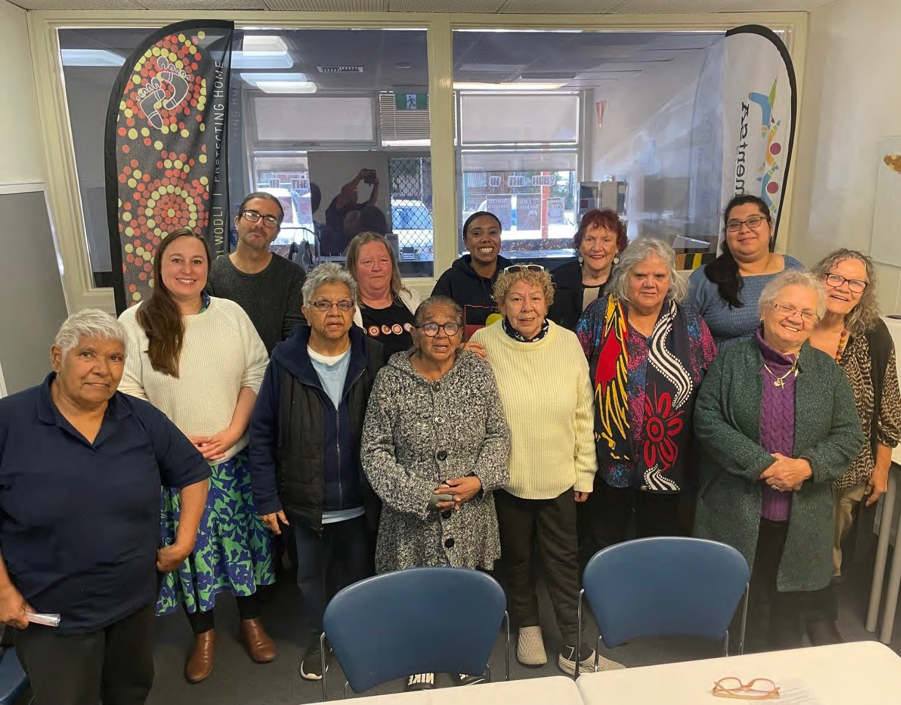
Food Security in Port Adelaide – Women’s Group

Lived Experience Report

21st May 2024

Port Adelaide Women’s Group
Who participated, at a glance

Total number of participants | 12
Number of people who were not born in Australia | 1
First Nation participants | 12
People who identified as having a disability | 1

Age | 18-24 | 25-34 | 35-44 | 45-54 | 55-64 | 65+
 | 0 | 2 | 2 | 1 | 0 | 7

Gender | Male | Female | Gender diverse | Prefer not to say
 | 0 | 12 | 0 | 0

Employment Status | Full-time | Part- time/casual | Unemployed | Pensioner (Age or disability) | Carer | Studying | Retired/ no longer  working
 | 1 | 0 | 1 | 9 | 1 | 0 | 7

Key insights
- Adults are going without food to make sure that children get fed.
- Many grandparents are trying to look after their grandchildren, while on the pension.
- Cost of living is making it difficult for even full-time working families to get by. Family and community are picking up the burden when there is not adequate support available.
- People do not have access to the healthy food they need to support their complex health needs.
- Experiencing judgement (and racism) at services, school, and getting transport.
- There are barriers to access at support services, including the need to explain why you need support and the need to be linked in through Government systems. There are also limits on amount of support you can get.

“There is an unwritten rule among Aboriginal families that the children eat first. If there is only 10x weetbix left, the adults don’t touch it. It is for the children. The adults will go without. These are the ways we cope to have enough food.”
“I am supporting family in Alice Springs too. My kids can’t look after themselves when they are just 18. Families are picking up the costs for kids struggling.”
“They always ask why you are accessing the service. Sorry Business should not need to be explained.”

What’s happening in this community right now?
Our community is being impacted in the following areas right now:

Issue | Lived Experience reflections of the issue
Having enough food | Adults caring for children are going without food to make sure children get fed. Don’t like the attitude beggars can’t be choosers. 40 years ago kids were going to school with no food and it’s still happening. Nothing has changed.
Being able to afford food | People are not just caring for their own young children, but also extended family and young adult children.  Things are really expensive and even those working full time are struggling to make ends meet. They are relying on family and friends to get through and those who don’t have those supports are in trouble.  A lot of people are trying to look after grandchildren, while living on a pension. Casual workers risk getting cut off Centrelink (and access to concessions) if they earn a little bit too much.  Foodbank is available but is not free. It is still unaffordable for some. We eat whatever is on special.  In remote communities, the veggies and meat are very expensive.
Safe food / Food they prefer | Complex health needs mean people need specific foods, but they are not able to meet these needs (e.g. diabetes, autism).  It can be hard to find cheap food for kids with disabilities. Services don’t consider their needs. They are fussy and cannot be reasoned with.  It can be hard when kids want to eat different meals to adults but we can’t afford to do that.
Having a place to prepare / store food | Having issues with Housing SA maintenance. One person had been without a working shower for an extended period of time.
Repercussions | Some kids are stealing food if they have nothing at home to eat. People are doing crimes just to get food.
Knowing what support is out there | Centrelink do not share places to get food support.  If you are new to the community here it is hard to find support places.
Support | The support offered by local services is not enough food to last and there is no meat.

There is limits to how often you can visit the services and you can’t access Foodbank if you’re not linked into Government systems (e.g. the homeless).
You have to ring first to make an appointment, and if you’re working at the time that they are open then you just miss out.
They always ask why you are accessing the service, but it is not always appropriate to explain. Sorry Business should not need to be explained.

Nutrition | They do not even have the ingredients at these places to make up a casserole. Meat is a special occasion only food.  Doctors ask about diet when you go for a checkup but I can’t access the healthy food I should be eating.  School lunches are hard as you are only allowed to send certain foods to school with the kids.
Wellbeing | There is a feeling of shame to ask for help. You feel judged when you go to a food service. When you get help, the first thing they say to you is you need to get financial counselling. We are being judged that we don’t know how to use money.  It is hard for kids if people think their parents are not looking after them. There is shame for them at school if they need to get food from a breakfast or lunch club.
Transport | When you have no transport its harder to shop around. There are no delivery options for food services – even meals on wheels you have to pay for it out of your care package.  Bought a cart to carry food on public transport.  On a care package they are very selective about helping with transport. If you don’t pre-book you can’t get it.  If you try and get a taxi they want you to pre-pay as an indigenous person. They are  not allowed to require that. There are lots of problems with taxis and racisms.
Reporting
It was reported to Families SA that my kids were using the breakfast club. I got a letter to let me know that they had used it a certain number of times and it had been reported. My kids liked the social aspect of the breakfast club but I had to tell them to stop using it. They encourage people to use it but it is getting reported.
There are lots of reasons why you might use a breakfast club, maybe you’re running late and want to make sure they get food! The kids also prefer the food they have at breakfast club or in the lunch packs they can access, so it is hard to tell them not to
use it.

What’s needed to support people experiencing food insecurity

What is needed | How could it be delivered?
Support services need to offer fresh fruit and veg and meat, not tinned goods.
Need to have support with transport to get to and from venue.
Breakfast / lunch clubs at schools should be for anyone who needs or wants to use them and it should not be reported to Families SA.
Support should be given as a gift card, so you can make the choice about what you buy and where from. | Needs to meet your needs for food. You need to be able to choose what you need.  Maybe you could have a phone call, talk about your needs and then they provide what will actually suit your needs.
Would rather the school supply food so it meets the guidelines of what they require. | Would like to see government giving people a choice to have food made up at school to take pressure off of parents. Have a couple of meals available so kids can choose.  Takes stigma away from some people accessing food at school and others not. Could be pay if they can or free if they can’t.  Schools should have control of supplying food to kids - should not be reporting to government if kids are accessing it.
Aboriginal room for kids at school
Give me enough food for a month and I could make up enough meals to freeze and keep.
Tackle the price of food. They can control electricity; they can control food.
We want Government to support us more, especially single parents and older people. | If government want us to eat good food they need to help us.
Services need to be delivering on what they are funded for (aged care package providers). Finding alternative services that will deliver if
they aren’t.

Locally based services we access:
- School breakfast programs.
- There used to be funding for schools that had Aboriginal children in them but this has gone now.
- Anglicare

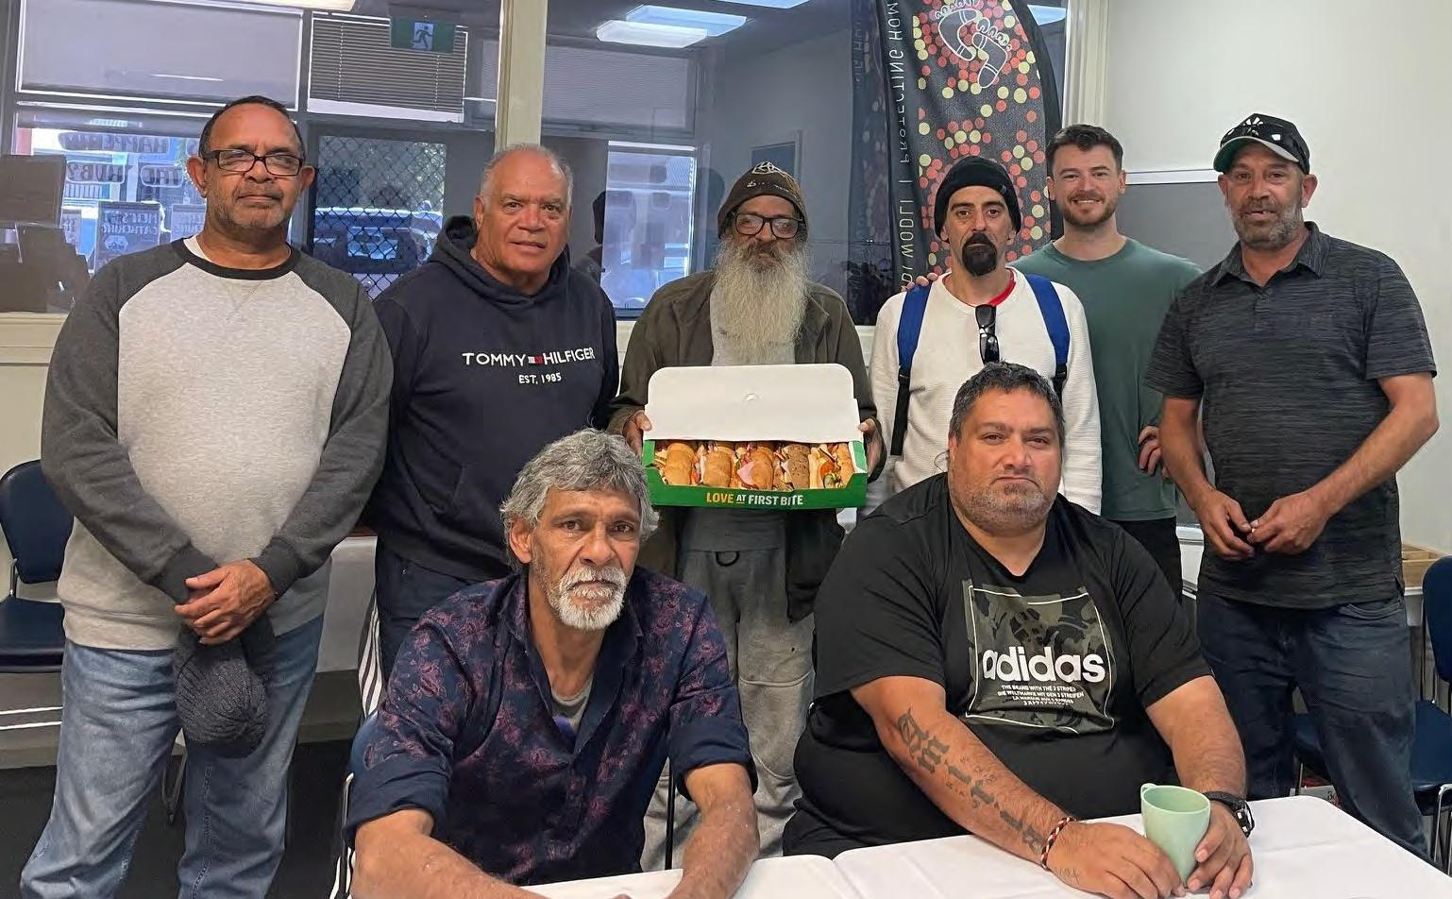
Food Security in Port Adelaide
Tiraapendi Wodli Men’s Group

Lived Experience Report

17th May 2024

Port Adelaide
Who participated, at a glance

Total number of participants | 10
Number of people who were not born in Australia | 0
First Nation participants | 9
People who identify as having a disability | 6

Age | 18-24 | 25-34 | 35-44 | 45-54 | 55-64 | 65+
 | 0 | 0 | 3 | 0 | 3 | 4

Gender | Male | Female | Gender diverse | Prefer not to say
 | 10 | 0 | 0 | 0

Employment Status | Full-time | Part- time/casual | Unemployed | Pensioner (Age or disability) | Carer | Studying | Retired/ no longer  working
 | 0 | 0 | 5 | 4 | 0 | 0 | 3

Key insights
- Knowledge of services – We need location specific information, in a place that is accessible to everyone on what local organisations and services are around, for what purpose and what they can offer.
- Peer support to access services – To overcome issues with shame and reluctance to access
services, people need to see people like them accessing services, either in advertising for services or by being introduced to a service by someone they trust / know. This might include men-specific services.
- Cultural awareness – do cultural awareness training. Recognise the trauma that many Aboriginal
people have experienced. Support opportunities for people to come together and have a yarn.

“People are coming into the city more and more as they crack down on alcohol and things in the communities, they move here. If they get pushed out of the city centre, then they moved to Port Adelaide. When they got pushed out of Port Adelaide they got moved to Elizabeth. Don’t just shift the problem, understand it and do something about it.”
(Why don’t men access services?) “It is because of their pride and feelings of shame. As elders we can help people. Show them the services, go with them and help them be comfortable.”

What’s happening in this community right now?
Our community is being impacted in the following areas right now:

Issue | Lived Experience reflections of the issue
Being able to afford food | Price of food.  Using food banks as a top up. Sometimes they have family staying and are looking after everybody. Port Adelaide is very family orientated.  Rent electricity, gas. Not much left after that is paid.  There are different clientele at food banks now - middle class. They might be in expensive cars but needing food support.  If you can get your veggies from a food hub, then you just have to buy your own meat and you have more money to do that.
Healthy Food | Different people in the house that don’t eat certain things - especially kids. Have to cater for everyone. Takeaway sometimes, Uber eats to get the food that people like.  Food at food banks is cheap but it’s sometimes out of date.  At Farmer Joe’s the fresh food is cheap but often the food is off a couple of days later.  Need vouchers so we can buy healthy food. Hampers sometimes don’t have healthy food in them, so it would be better if they had a voucher in them.  Sometimes the food delivered can be quite off / mouldy. Diabetics need specific foods.
Support | A lot of older people live by themselves and don’t have anybody visiting them. We had a couple of elderly people recently in our community who died and they weren’t found for a couple of days.  Support needed especially for elderly.  Aboriginal aged care is all full now. Aged care food packages are available but it’s difficult to access the services.  Younger people are ashamed. They haven’t been to these services and don’t know what to expect. Often they go to other families to get what they need, putting strain on the families.
Eating food I like / prefer | Kids can be fussy, need to be able to have choice to get the things they will eat.
Why don’t men access food services (or attend our conversations)? | Men will suffer in silence.  It is because of their pride and feelings of shame. As elders we can help people. Show them the services, go with them and help them be comfortable.  Ads on TV it is always women going to the places. Homeless women with kids in cars. Not men. They make assumptions about the role of men and their caring responsibilities.  Assuming it is only women who care for children and prioritising their access to services.
Access to food | Food banks run out of fruit and veg if you don’t get there early.  Not many services outside of working hours. Some meals available in the evenings, and some of them will help with groceries if you ask them.  Sometimes food deliveries get stolen from the front door if they are left unattended. One place makes sure they leave it with someone which is good.  Some places you need ID, or can only access every 3 months etc.  If you’re homeless you might not have the things you need to be able to access services.

Knowing what is out there | A lot of people don’t know where these places are. They only hear about them through word of mouth on the grapevine.  Not everyone has data and internet to find out what is out there or whether they are open or if they have run out of food.  Awareness of special things that are happening needs to be better (e.g. Christmas Hampers).
Transport | Transport to get there. Some don’t have cars. Hard to get bags/boxes of food home.  Some of the places are a long way out and it’s hard to walk there, especially if you are elderly.
Demand for services | Some challenges with people from the lands coming down and staying. Need somewhere for them to go. They often need to come here for medical and other services, then have nowhere to stay. They are asking at food places for food.  For locals sometimes they take away a bit from us. People are coming into the city more and more as they crack down on alcohol and things in the communities, they move here.  If they get pushed out of the city centre, then they moved to Port Adelaide. When they got pushed out of Port Adelaide they got moved to Elizabeth. Don’t just shift the problem, understand it and do something about it.

What’s needed to support people experiencing food insecurity

What is needed | How could it be delivered?
Supporting people to access services. | Older people could show younger people where to go so they are comfortable accessing services.
Services specifically for men. | Setup so men can talk to men. More men’s hubs. This is the only hub in metro SA like it. We would like to see others set up in other areas.  Need to see men like us in advertising for services so we feel like these are places we should access and are welcome to access.  Don’t make assumptions about women’s needs vs men’s needs. Men can be carers too. Advertising the places in a way that speaks to men so they feel comfortable going there and like it is for them.
Knowledge of services | Knowing what services are around so we can share it with community. Location specific information, in a place that is accessible to everyone on what local organisations and services are around, for what purpose and what they can offer.  The men’s centre could be a place to find out what is going on (and often is already the place people find out about things).  Could do a letterbox drop to help people find information on local services.
Transport to get to these places/ services. | Council does run some community buses.
Cultural awareness. | Do Cultural awareness training so you better understand our needs and context. Need to recognise and understand the traumatic history that many Aboriginal people have had. They are dealing with this trauma however they can.

Food and Culture | Sharing food in community and having a yarn is really important. You don’t know what is happening with people unless you can sit down and yarn.
A van in the park giving out hot soups or stews each day. | Local businesses could donate veg. Volunteers to cook and serve. Kids are living in the park while their parents are busy during the day. Make sure that these kids are getting at least one good meal a day.  People need someone to talk to, Sleeping bags, a Meal at night. Kids are the ones always suffering the worst.  With food vans you need a place to cook the soups, volunteers, transport. Could be government funded so it is a paid role. It can be unreliable to rely on volunteers who may have medical issues themselves and sometimes may not be able to show up.  Should have Aboriginal people to work it. Or work for the dole people.

Locally based services we access:
- Food hub in Lipson Street.
- Port Road - Puddle Jumpers.
- Northaven - Marmora Tce. Meals for people on Wednesdays.
- There is an area for kids to play at the Lighthouse food bank. They are putting computers in Lighthouse so kids can do their school work. There are free clothes. It is family orientated. Stuff for kids on Wednesday. Meal on a Sunday. Churches are good about not forcing you to stay for services. You can access the food and then
leave. They really make the effort to get to know you at Lighthouse.
- Romeo Foodland is cheap.
- Shopping around with catalogues. Checking where things are cheapest.
- Make meals and freeze them so there is something there for the kids when they are hungry. Plan for the week.
- Adelaide Day Centre do deliver food.
- Cooriello they make sure they leave it with somebody.
- Lighthouse has a list of food they have available, you tick the boxes for what you want and they go and pack it.
- The centre here can help you get the things you need (like an I.D.) and deal with Centrelink.
- Medical centre has a men’s group on Wednesdays.
- Alberton Primary breakfast club. Some schools even make lunch for them. Challenge is that some parents won’t share with the school that they are struggling.
- 4th or 5th Street.
- Tauondi college kitchen. All different ages of students. Used to be a meeting place, big mob but has declined. Aboriginal owned and operated. Held cooking courses. Computer classes.
- Men’s group at Henley High. Has expanded out beyond just Aboriginal kids. Gives them a community and somewhere to talk about things and learn life skills together. Cultural knowledge and identity is what we can give to our kids.

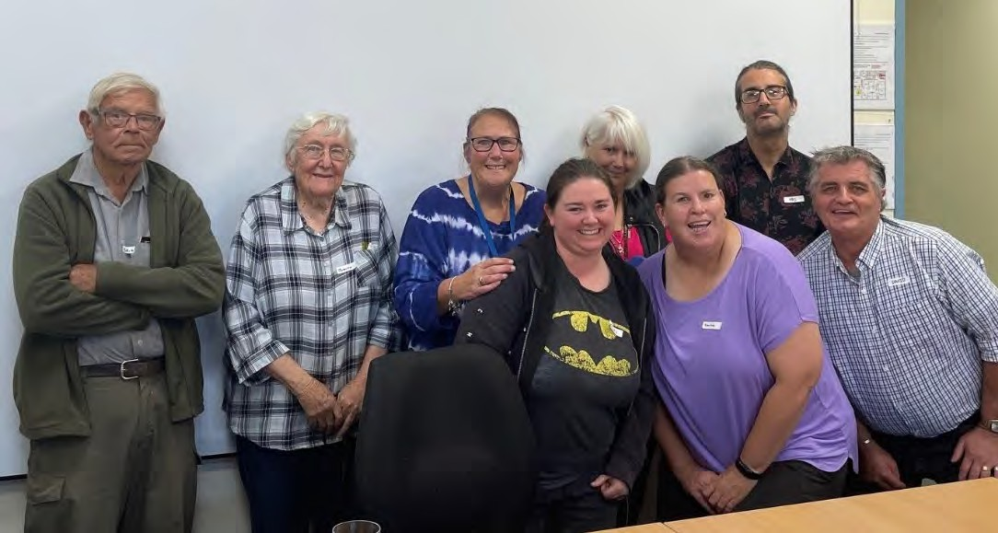
Food Security in Port Pirie

Lived Experience Report

15th May 2024

Port Pirie
Who participated, at a glance

Total number of participants | 12
Number of people who were not born in Australia | 0
First Nation participants | 0
People who identify as having a disability | 1

Age | 18-24 | 25-34 | 35-44 | 45-54 | 55-64 | 65+
 | 0 | 1 | 0 | 2 | 3 | 6

Gender | Male | Female | Gender diverse | Prefer not to say
 | 2 | 10 | 0 | 0

Employment Status | Full-time | Part- time/casual | Unemployed | Pensioner (Age or disability) | Carer | Studying | Retired/ no longer  working
 | 0 | 1 | 3 | 3 | 0 | 0 | 0

Key insights
- Challenge in Port Pirie with locally grown food and lead concerns. Very hard to get fresh food for food hubs.
- Supermarket rule changes have meant that there is much less food available at the food hubs. Supermarkets are throwing out more food rather than donating it.
- Knowledge of services – provide more information in accessible places for people to find out about all the services that are available.
- Coordinating between services – local services should meet regularly and communicate with each other to share resources and keep up to date on what they are doing.

“It’s demoralising to be struggling for food but if we could all band together, then maybe something would change.”

“Our clients have become very different over the years. Now it’s working families.”

What’s happening in this community right now?
Our community is being impacted in the following areas right now:

Issue | Lived Experience reflections of the issue
Being able to afford food | Rent/mortgage. Budget for bills. Might be left with $50 for food for the fortnight. Medication. I prioritise bills. Power is a lot now. Car & registration, insurance. School uniforms and fuel. Pension isn’t enough.  Gone are the days of low specials on say bread and milk. Supermarkets are ripping us off. It comes down to what is cheap and what is going to fill you up.  Our clients have become very different over the years. Now it’s working families. People on gaps waiting to get into Centrelink.  Working families now who can’t put food on the table. Asset rich and cash poor. The middle are struggling most as they can’t get benefits.  Can’t judge people by how they look, sometimes they got things when they were both working but now things have changed for them and they are now just hanging on by their fingernails.  Landlords can do what they like if you are in a house. Pets are difficult too. Electricity bill high. Has shower at swimming pool so its not on the bill.
Healthy Food | Eating a lot more pasta and rice as it goes further. Bread is easy to access but it’s not healthy and I’m sick of it. It’s full of sugar and preservatives.  Usually it’s just white bread that is available at hubs.  It’s very hard to get fresh food. We have bananas today but they are already on the turn so have to be used quickly.  I feel people are going to judge me because I’m bigger but it’s the bread and pasta that I have to eat, which are the cheaper options. Not healthy food.
Safe Food | Vegetarian, special dietary needs is harder to get food for. Woolworths do give us a lot of fish and plant based food and we are really lucky.  When we were getting ALDI’s bread we did have grain and brown bread and people wouldn’t take it. It might be different now though as people don’t have a choice.
Having a home / homelessness | People living in the caravan park in tents or homeless people might not be able to keep food.
Having a place to prepare / store food | Lots of people who come through the food hub live in caravans. They have no fridge. Some don’t even have a can opener.  There are no rentals available in town. Families are living in tents. The caravan park is full of drugs. There is no community kitchen in the caravan park.  People who are homeless don’t have anywhere to keep food or cook it.
Support | Not knowing what supports there are in Pt Pirie. When I moved here I did not know what supports were available.  Word of mouth is the most common way people are finding out about what is available.  Have clients who come in who are embarrassed, for the first time. People get to us and break down. Their stories are heartbreaking.  Never heard of Ask Izzy. Ask Izzy isn’t super local. More general.  Lots of older people have very basic phones who don’t have internet. 3G is now being obsolete, so they can’t access the internet to find out what support is out there.

Wellbeing | Important to have hygiene packs. It’s not just about basic food, but giving people something that makes them feel good.  Social connection at the food hubs. Very isolating to be in food insecurity.
Eating food I like / prefer | Special needs kids. Tolerant with some foods and others not. A lot of special needs kids in this area.  If you go to food hubs, there isn’t much for vegetarians.
Access to food | The Government have brought new laws in about best before dates and now ALDI won’t give us food and Coles have dropped it back to just bread. This has had a massive impact on what the food hub can offer to people. Now we have almost nothing available. Woollies are still If Woolworths were to pull out we’d close our doors.  ALDI are throwing out food that hasn’t gone out of date. Coles and Woollies are getting millions in profit and are throwing out food. They have a monopoly and so can do what they want. Why aren’t the supermarkets now allowed to give us this stuff?  New laws re food. Unless you have hot boxes or eskies then you can’t deliver food.  It can depend on the manager and their willingness to make sure that food does not get thrown out.  Asked Geoff Brock about changing the rule but he couldn’t do anything at the time when he was a minister. Supermarkets are really hurting people who are struggling.  People are bin diving at night to get things. Some people are risking their job to give people food that would otherwise be thrown out.  ALDI have pulled out of Second Bite now, which is where we get a lot of our food.  We get angry customers who are upset that we can’t offer so much food anymore but it’s out of our hands.  Have to be at Coles at 11am to collect the bread they do donate. If we happen to be 10-15 mins late then they won’t give it to us. Otherwise it goes to a lady for a farm.  There are a lot of kids not being able to have lunch to take to school. Going to school hungry.  Fred’s Van donate bread on a Sat closing from Bakers Delight but most of it goes to a man with donkeys.  If you don’t have transport then you can’t access services and if you’re on a bike you can’t carry much food home.  We are a not for profit. We have to pay for rent on the building, pay foodbank the price they ask for on the food. Then we have to pay for a truck from Adelaide to get the food here. Then have to up the prices to cover the costs. We used to get food from Whyalla Foodbank every second week, but they stopped us doing that.  Need a bigger parking area for the hub.
Community Gardens | Community garden stopped up here (it may still be running). We have issues with the lead in the air. We cannot accept food at the food hub that has been grown in Port Pirie.
Volunteering for food charities (or other things) | Can’t volunteer as a younger person as I can’t afford to take the time off work.  I started volunteering due to my medical issues. I’m looking for a job now as I can’t afford to be a volunteer now. It’s hard to find a job as Coles and Woolies want the young people.  Love working at the community centre to help other people.

Kerry Reed
2024-05-17 06:44:00
--------------------------------------------
Can I leave this out of the report?

Transport | No buses for the community out to the caravan park. Years ago they had a community bus but they stopped it.  Can’t afford petrol to get to the services. None deliver here. Meals on wheels are the only service that delivers but lots of people aren’t eligible for Meals on Wheels.
Information on services | Community members struggle to get accurate and info on what is out there. If I didn’t find out food hub I would have been in trouble.
Coordinating between services | Services are in the dark about what other services are doing.
 | Perception that some people shop with multiple different food providers and don’t need to. Sometimes they sell it on. There are a lot of people who come in who feel entitled.
The people who most need to be part of this conversation aren’t here. The people at the bottom.
Many are really shy and embarrassed.
Over 50s women are the biggest homelessness category in Australia.
Men accessing services | Men - men think they are supposed to shoulder all the burden. That they are supposed to support women and children.  It’s a topic that needs to be addressed. Many men have been taught from a young age to shoulder the responsibility. The thing that has changed recently is a lot of their marriages have broken up. There are more men accessing the hub now and the group of men that come has changed. A lot of guys with disabilities or kids who are younger and more elderly men.  Men don’t want to communicate. Harder as a dad to access benefits.

What’s needed to support people experiencing food insecurity
What is needed | How could it be delivered?
Perhaps someone needs to get a letter to say that they (supermarkets) have to give away food.
Help people who have children first.
At the hub we need to have more signage to tell people what supports are available in the area. | Need pamphlets up so people can see it easily.  At the Community Centre we have a noticeboard for things that are on.
Pet Food needs to be available too. | For a lot of people their pets are their family. Mental health.

Organisations working together to share the load and resources. Every service that is available here should be talking to each other (and referring to others). | Arrange a catchup between services soon.  At Ward House, people are allowed to use their phone to call other services.  Every service needs to know what others do and having regular check ins  / someone to coordinate between them.  The group felt that Council wouldn’t be the right people to coordinate this. There is a lady at Conference who is trying to get everyone together. Wesley Mission also maybe the right people to do this too?
Bring the kids in and the families will come. | Have a day with a movie, then the family will come too and know what we offer at the Hub.
Need to meet with the supermarket bosses to talk to them about how they should be supporting community. | Build relationships over time.
Government should give out more grants for people who are trying to help people.
Politicians should go out to Fred’s Van. See firsthand the real people who are not just numbers.
Locked the price of essential foods and fuel price. | This is already done for some other things like energy. The lack of a price cap is really hurting the poor.
Locally based services we access:
- Community centre.
- Centre pay helps to manage money / budget
- Local community members taking their own initiative to provide Community Hampers.
- St Vincent De Paul Sunday night hot meal / BBQ. (Fred’s van). They give out bread on a Sunday night too. Sometimes even perishable items in a bag. Other times you can make an appointment with them and get a food voucher.
- The hub, The community centre. Tasty tucker meals at the Food Hub.
- Stevie with bread from Bakers Delight. Doing something for the community of her own initiative. Not running an organisation.
- Church of England Church Friday nights, Cathedral. Hot meal, bread leftovers.
- Wednesday night Lighthouse church does something too.
- Community centre for fruit and veg. Mondays. Tuesdays and Thursdays bread.
- Foodbank delivered today (Tuesday).
- At the Hub we are lucky to get fruit and veg. We go through Second bite. Woolies have been great – others have mostly pulled out.
- Childcare does do a foodbank once a fortnight but only usually onions and potatoes. Whatever is in season. Apples, carrots, citrus. Pirie West.
- Local school have breakfast club. But doesn’t help the child for the whole day. They can also cook toast in the afternoon.
- Community garden on the Tce. When the gates are open anyone is able to take as much as they need. Relies on volunteers who are often getting on in age.
- The Haven has classes, tax, services.
- We make up food packs to help them put together a meal, with all the things you need in it, the meat and spices and ingredients. We make pictures of it all so they can follow it. So they don’t have to read something.
- The men’s shed
- There are free BBQs in the park.

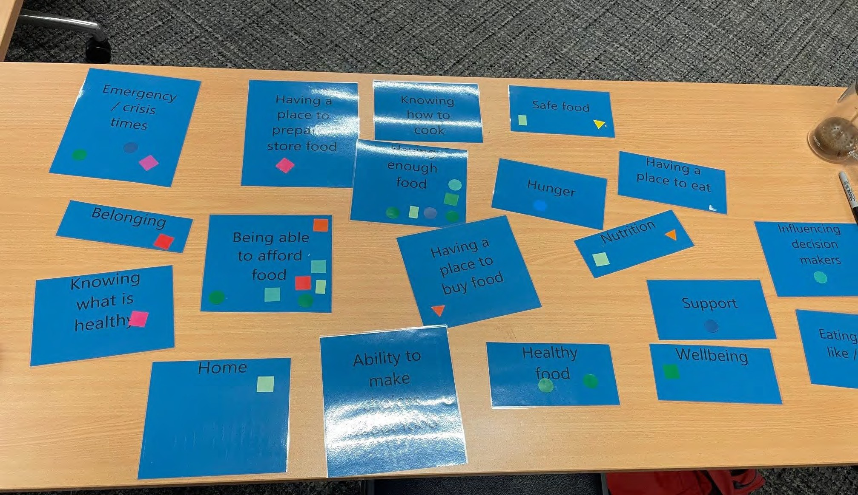

Food Security in Unley
(People from different locations around Adelaide)

Lived Experience Report

3rd May 2024

SACOSS, Unley
Who participated, at a glance

Total number of participants | 11
Number of people who were not born in Australia | 4
First Nation participants | 1
People who identify as having a disability | 8

Age | 18-24 | 25-34 | 35-44 | 45-54 | 55-64 | 65+
 | 1 | 2 | 1 | 5 | 0 | 2

Gender | Male | Female | Gender diverse | Prefer not to say
 | 1 | 8 | 2 | 0

Employment Status | Full-time | Part- time/casual | Unemployed | Pensioner (Age or disability) | Carer | Studying | Retired/ no longer  working
 | 0 | 4 | 4 | 3 | 4 | 3 | 1

Key insights
- Cost of living pressures and having to make choices between food and medications or health services.
- Need to support family members that the Government may not consider need to be supported (e.g. children over 18, friends/family in between housing situations)
- Delays in receiving income supports (e.g. jobseeker)
- Complications with domestic violence and risks of losing custody of children if the partner finds out they are struggling, as well as privacy, financial and safety concerns.
- Specific dietary needs not met at food banks.
- Healthy food is not affordable.
- Many food services are run by religious organisations, which can cause fear or risk of gender and sexuality stigma. Also can be difficult for people who have been a victim of abuse.
- Transport to food services can be a challenge due to disability, access to public transport or a car or the limited opening times of services. Public transport is often not ideal when you have health concerns, but it is expensive to have a car and pay for fuel.

What’s happening in this community right now?
Our community is being impacted in the following areas right now:

Issue | Lived Experience reflections of the issue
Being able to afford food | I am a single mum with 4 kids. My rent is $530 a week. I went back to study. I have $35 left a fortnight for petrol and food. I know that I am doing the right thing going back to study but the incentive to do so to improve your situation isn’t there.  The Governmentt doesn’t think that if your children are over 18 you should be supporting them, I get nothing for my two children who are over 18. The reality is they often cannot support themselves at that age.  I spent 8 weeks supporting my daughter after she lost her job due to broken wrist.  I am grateful for it, but Vinnies gave us 2x vouchers for the 5 of us. But prices at Vinnies are so high it’s not affordable to even buy one jumper.  I am a single mum, with a disabled child and disabled myself. We never had a lot of money but I was working. I’m now on income protection which will run out and it doesn’t cover everything we need.  I have Irregular, casual work. Unemployed. The extra pandemic payments allowed me to go and get my eyes tested. They found a degenerative eye condition. I have an uncertain future for my eyesight. Now that these payments have dropped again, I am not able to meet dietary needs or sometimes afford my medication.  I have experienced domestic violence and my ex-partner is not paying child support regularly. I have had issues where he was paying me a wage from his business, so on paper it looks like I had a large income but I didn’t even have access to the accounts. Centrelink found out and are making me pay back the supposed overpayment but I’ve never had access to that money.  Legal fees to fight these issues of child support are huge.
Emergency / crisis food | People might be in transition, and can’t find a rental. If you are supporting others who are in between places, then it can put extra strain on things.  There was a $5000 payment for those fleeing domestic violence. When I had to flee, Housing SA were amazing and funded bond and the first week’s rent. Needed police report though to get access previously, which I didn’t want to do as I knew my partner would know it was me and would come after me.  The amount of people who are homeless and don’t have the support network. Nobody should have to sleep in their car or on the street. Nobody should have to give up their pets.  There are drugs in lots of the food places and with people on the street so that is an extra issue to deal with.
Influencing decision makers | It’s a power issue, getting politicians to listen. Systemic advocacy for health.

Safe food | Food services don’t have food for celiacs. I have had to dumpster dive a lot. It’s tricky to have nice food and gluten free pasta. Some things I haven’t had for a long time.  Food bank is very limited for gluten free, lactose free. If you’re lucky they might have some, but you’re probably only allowed to take 1.  Fruit there is not nice, very brown. I can’t take home brown bananas to my kids, they won’t eat them.  For texture and food sensitivities, diabetic foods there isn’t much. What is there is often high salt content.  Accessing dietary requirements - good businesses go under because they are not funding to support people with celiac. In Europe they have funding for people with the diagnosis. Lots of businesses sell foods that aren’t gluten free and saying they are.
Healthy food | I am not able to afford the right food. Carbohydrates are much cheaper. I can get a $1 bag of pasta and a tiny bit of veg.  Stigmatised around diabetes as a lifestyle disease but it is about genetics and stress mostly.  Then health issues can be impacted by diet.
Accessing Support | As a single mum, I can’t advertise to my children that we are struggling or my ex will take my children away from me. I can’t go to places that look like we’re struggling.  Really important to note that all of these services are provided by religious charities. LGBTQI communities are often impacted by discrimination from religious people and so we don’t go to these places. Even if they are unlikely to discriminate, there is the fear that they will, and currently the way Sec. 51c of the Equal Opportunity Act is written, it means that they will be protected if they do discriminate against us.  I have a human right to food and to not be discriminated against. I should be able to show up as my full self to get food.  It is also challenging to have a church run service for people who have been abused. This might be triggering for them.  Even if the organisation aspires to not be discriminatory, there are still individuals and volunteers there who are protected if they do discriminate. I have to protect myself. And not expose myself to the risk. Marginalised communities get micro aggressions every day.  A common way that disabled children are excluded from school is by the school not providing disability support.  Even Foodbanks you often need to get referred to them from a church based service.  Financial counselling can go in the bin. I know how to manage my finances, I just don’t have enough money.  There can also be language/cultural barriers to seeking support. Some cultures may not feel comfortable asking for help or language may be an issue.  The burden to access crisis assistance is higher. In terms of rights to privacy, we need to go to places and tell our private business again and again. They

 | want to see tears. There is the deserving and undeserving poor and you have to prove you are deserving.
Eating food I like/need | After rent and bills, there is very little left for food. We can’t have foods we enjoy. Have to Zip pay if we have pizza and pay it off over time. I don’t go out or spend money on anything, I should be able to occasionally do something I like, like having pizza.
Nutrition | Dietary guidelines biased by food industry. Federal govt says we should follow these guidelines.  By making sure that people can get the food they need to look after their health, we won’t need to spend the $50m in diabetics medications in SA. What could we do with that if it wasn’t needed?
Being able to access food | Pathways at Modbury are great, but they opens at 10:00 and one day I went there and they had run out of food by 10:35. You are only allowed to visit once a fortnight and if they are mostly out of food, then you get not much for a lot of effort to get there and can’t go back for a fortnight.  Transport can be a barrier. Lower back and hip bursitis, Type 2 diabetes. Complex medical interactions. Getting in and out of car is bad. Carrying shopping is impossible. Even getting shopping from Coles delivery I need to find cheap delivery windows, which may not be convenient. I am the only driver in our house.  I have a really old car breaks down a lot, it is unreliable. COVID was tricky as I was trying to avoid crowds. If you have low immunity then public transport is too risky.  With the health issues that come up, you don’t want to be catching the bus. Then you get forced into living in the outer suburbs as its cheaper but makes transport harder.  Catching public transport to places at the right hours of business is challenging and unreliable. Disability access is hard too on public transport. If you need to be on time then it’s hard to catch public transport.
Gowing my own food | Not everyone can grow their own food, especially disabled people.

What’s needed to support people experiencing food insecurity
What is needed | How could it be delivered?
It would be better instead of getting a voucher to Vinnies, to instead get a letter to say you can get what you need (e.g. this person needs a jumper and whatever else).
Social interaction is important too over a meal. These places provide that an opportunity to be engaged with the community.
Change section 51c of the Equal Opportunity Act to ensure that LGBTQI+ are protected from discrimination.
We need safe avenues to get food. Not just church based services. | Need a way to get food that’s not religious based. Not voucher from religious to get into Foodbank.
I believe we should find ways to provide cheaper meat for its health benefits. For example, allowing more cows on farms.
Being able to avoid the processes and just grab what you need.
They know what to do about food poverty, they just keep seeking more and more information. When are they going to actually do something about it.
It doesn’t take much to enable people to uplift themselves through support.
Even if there is a higher income, the food will go up in price. The money doesn’t go to the producers. Cut out the big corporate companies.
Should be a concession on food. A way to get access to food at a concession price.
Need to know where things are. Info isn’t out there or ppl might not have access to internet to find out. Services change over time.

More government funding for these organisations that are supporting people.
These systems need to have better understanding of domestic violence situation and the tactics they use to control their victims. | Changing the legal system. (domestic violence for women). Fathers who don’t give child support should have to sell assets.  Child support and coercive control. Laws need to change so they have less control over how they pay (or don’t pay) child support.
Councils could be doing more in terms of food donations. Libraries and other council venues. Linking into local communities.
State Government could be making food outlets, remove things that are bad for health. Get rid of the unhealthy foods. Solve a lot of the problems.
We could have a non for profit food industry.
Raise the income support so people can afford the basic things.
Get rid of price gouging by supermarkets
Earlier diagnosis is important for Coeliac. I know kids that are malnourished and could be developing into healthy adults but are not being diagnosed. They will be a burden on the health system later in life.

Locally based services we access:
- Pathways at Modbury, wonderful run by church.
- Australian homelessness journal. Every day of the week they have somewhere you can go to get food. For example, first Tuesday of the month, at the Rundle St Grill restaurant they offer free meals. There is also a Japanese restaurant, and the Hari Krishna restaurant run a mobile kitchen, a couple of times a week in Hurtle square. The Journal tells you about where you don’t need to show health care cards, bureaucracy etc. Available through the Hutt St Centre or online.
- Glenelg meals is Rotary and not coming through Oz harvest.

- Threads together program. Anglicare. Provides end of season clothing from designer brands that would otherwise go to landfill.
- Started up something in our buy nothing group. Gave away surplus food we won’t eat from our hamper through that group. Conditions in it on what can be donated, then shoutout through group for donations. The box goes to whoever is in need for them to take what they need and then gets passed on to the next person in line. It comes back to me when it is empty to do another shoutout.
- Living Faith hamper.
- Grow free carts. Hyper local. Often within walking distance.
- Go Go Foundation.
- Hutt Street Centre is the hub for a lot of organisations and services and information.

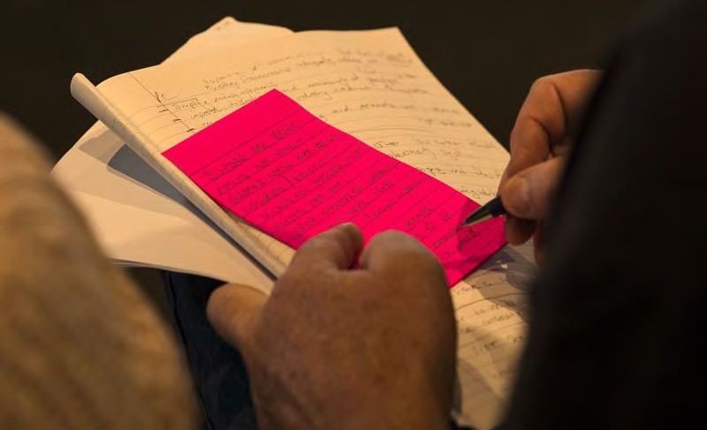

Food Security in Unley
(People from different locations around
Adelaide)
Lived Experience Report

30th May 2024

Unley (mixed locations)
Who participated, at a glance

Total number of participants | 2
Number of people who were not born in Australia | 2
First Nation participants | 0
People who identify as having a disability | 1

Age | 18-24 | 25-34 | 35-44 | 45-54 | 55-64 | 65+
 | 1 | 0 | 0 | 1 | 0 | 0

Gender | Male | Female | Gender diverse | Prefer not to say
 | 1 | 1 | 0 | 0

Employment Status | Full-time | Part- time/casual | Unemployed | Pensioner (Age or disability) | Carer | Studying | Retired/ no longer  working
 | 0 | 1 | 0 | 0 | 0 | 1 | 0

Key insights
- Universities have a responsibility to do more to support International Students who are struggling to access enough healthy food. They rely on them for their tuition fees so they should offer more support. There should be cheap food available on campus and better facilities in student accommodation to help people eat well, cheaply.
- Food support services need more reliable support than donations.
- There needs to be more “out of hours” cheap food options available.
- Better, more up to date and readily accessible information is needed about the food support services that are out there.
- Transport is expensive and challenging so more local services are needed or cheaper transportation.

“The university have a responsibility and duty to help students when they are in hard times.”

What’s happening in this community right now?
Our community is being impacted in the following areas right now:

Issue | Lived Experience reflections of the issue
Being able to afford food | International students and some migrants cannot get Centrelink benefits. If they lose work, they face multiple issues including paying their high rent and bills. The only thing they can cut is their food costs. Maybe eating just one meal a day.  Food is expensive to buy.
Supermarkets and waste | The big supermarkets are throwing away food every day. They only give very small amounts away.
Safe Food | Food for special diet need like lactose intolerance can be expensive and might need to be done without.
Having a place to buy food | There are no cheap options open late on weekends. If you work during the day then the only options are small expensive supermarkets.
Having a place to prepare / store food | Even if you can afford rent, it can be hard to find somewhere as there is so much competition.  Many students live in student accommodation which has very limited cooking facilities and they are very small so you can’t buy in bulk and store food. Often if there is a shared kitchen, it is not maintained well by the building manager.
Knowing about Supports | It is very hard to know what support is out there. You really have to search to find things and then ring around to find out if the information is still current. There is no reliable central place to find out – ask Izzy you still need to visit the individual websites.
Support services | Foodbank is a band aid, it is not solving the root problems. Even Foodbank is not cheap, you still need to pay for food.  Food is often expired or soon will be at these services.  Their opening hours are limited. If you are working it can be hard to get there.  Foodbank and similar organisations rely on donations for corporates, but this means the food is not always the freshest and they never really know how much food they will get. This is an unreliable way to support people who need help.  Many support services are run by Churches and so people who are Muslim or Hindu won’t go there for support.

Students and young people | Young people are doing it the hardest right now. A lot of mental health challenges. There are barely any young people’s groups around to support each other – only youth groups at churches.  International students are quite diverse. You cannot assume that if they are coming here to study and paying the high fees that they are rich. Some are supported by their families or by organisations on scholarships, but many are supporting themselves. Some come here to escape persecution in their home country. Many want to contribute and be part of the community here.  These students get no support from the Government – no Centrelink or Medicare or other supports. They are required as part of their VISA to study full time, but they also need to work to support themselves and pay their fees.  Universities rely on International Students tuition fees, but they do very little to support these students – no support for food. The breakfast session at UniSA is just tea and a biscuit and doesn’t run every day.  They encourage you into student accommodation but then there is no requirement of that accommodation to have good features to support students to live well.
Transport | Transport is the biggest challenge to get to support services. There is nothing available locally in Seaton.  It can take a long to time to catch public transport and it’s not that expensive, but it does add up over a month.  Petrol is very expensive and it is often not worth the cost of driving far to get cheaper food.

What’s needed to support people experiencing food insecurity
What is needed | How could it be delivered?
There could be food vouchers or coupons to support people to get a cheap meal. | It could be used at local restaurants and food places, which would also support local small businesses. This is similar to medications where you do a co-payment.  These local businesses are places that would be open anyway and are already making food so it is not an “extra” service that is required.
Universities should be required to provide certain food facilities at student accommodation if they house over a certain number of students (e.g. a cafeteria).
On campuses where they have over a certain number of students, they should be required to provide onsite food support services. | e.g. At Sydney Uni they have a food hub where students can shop.  At Monash they have a dinner every night. There is a co-payment of $6-$8 so you can get a cheap meal.  In America they pay for a food plan alongside their tuition fee and this gives them a buffet breakfast, lunch and dinner available.
Breakfast clubs (and lunch clubs) at schools should be funded and available every day, for anyone who wants to use it.

There should be more non- denominational peer groups for people in their twenties.
Locally based services we access:
- Harvest SA (although my access was limited)
- Foodbank
- Pirie Street, Salvos
- Marion Life (although mostly older people)
- Breakfast club at the primary school I work at.

