Disability Access and Inclusion Plan
(DAIP) Guideline
  - Guidelines for South Australian State Authorities
These guidelines are designed for State authorities to assist in preparing and developing Disability Access and Inclusion Plans (DAIPs). The guidelines contain contextual information and practical advice to guide State authorities to develop DAIPs relevant to the supports and services they provide.

Table of Contents

1. About these guidelines 3
2. Strategic context 3
3. Legislative requirements 5
4. Other legislation 6
5. Planning for your DAIP 7
6. The DAIP Template 11
7. Glossary of definitions and acronyms 12
Appendix One: DAIP Checklist 13
Appendix Two: Useful Resources 14
International 14
National 14
South Australia 14

About these guidelines
Developing a DAIP demonstrates that a State authority recognises the importance of inclusion and access for everyone, has a welcoming attitude towards a diverse range of people and has employees who are aware of the needs of people living with disability
Ensuring that the rights of people living with disability are upheld is the responsibility of the whole community. People living with disability should be able to access and participate in all aspects of our society, including using mainstream services and programs. Social inclusion is fundamental to a person’s quality of life and critical to achieving positive life outcomes across all areas.
These DAIP guidelines, and other resources within the DAIP toolkit, will assist State authorities to develop and implement a DAIP and meet the requirements set out in the Disability Inclusion Act 2018 (SA).
The guidelines also encourage consistency in presentation and reporting by providing a common methodology that reflects the current direction of disability policy — a rights-based approach that supports individual choice and control.

Strategic context
In 2018, the Disability Inclusion Act 2018 (SA) (the Act) was passed because the South Australian Government recognised that a stronger commitment to access and inclusion planning for people living with disability was needed.
The Act supports the United Nations Convention on the Rights of Persons with Disabilities (UNCRPD), acknowledging that people living with disability have the same human rights as other members of the community and that the State and the community have a responsibility to facilitate the exercise of those rights. The UNCRPD is underpinned by eight guiding principles based on respect, equality and non-discrimination and was ratified by Australia in 2008, and the Optional Protocol signed by Australia in 2009.
The National Disability Strategy (NDS) is a coordinated plan across all levels of government to improve the lives of people living with disability, their families and carers. The NDS is Australia’s response to the UNCRPD and is designed to ensure the principles of the UNCRPD are incorporated into policies and programs across Australia. Currently, the Commonwealth and State and Territory Governments are working towards developing a new national disability strategy for beyond 2020.
Areas of policy action under the NDS are:
- Inclusive and accessible communities
- Rights protection, justice and legislation
- Economic security
- Personal and community support
- Learning and skills
- Health and wellbeing.
Inclusive SA: State Disability Inclusion Plan 2019 – 2023 (the State Plan) was released on 31 October 2019. It was developed following community and sector consultation. The themes within the State Plan are:
- Inclusive communities for all
- Leadership and collaboration
- Accessible communities
- Learning and employment.
The State Plan is a requirement of the Act and sets a framework to support State authorities to implement the National Disability Strategy 2010–2020 (NDS).
The annual reporting against the State Plan will align the South Australian Government’s achievements against the NDS’s areas of policy action.

2.1 Strategic alignment of Disability Access and Inclusion Plans
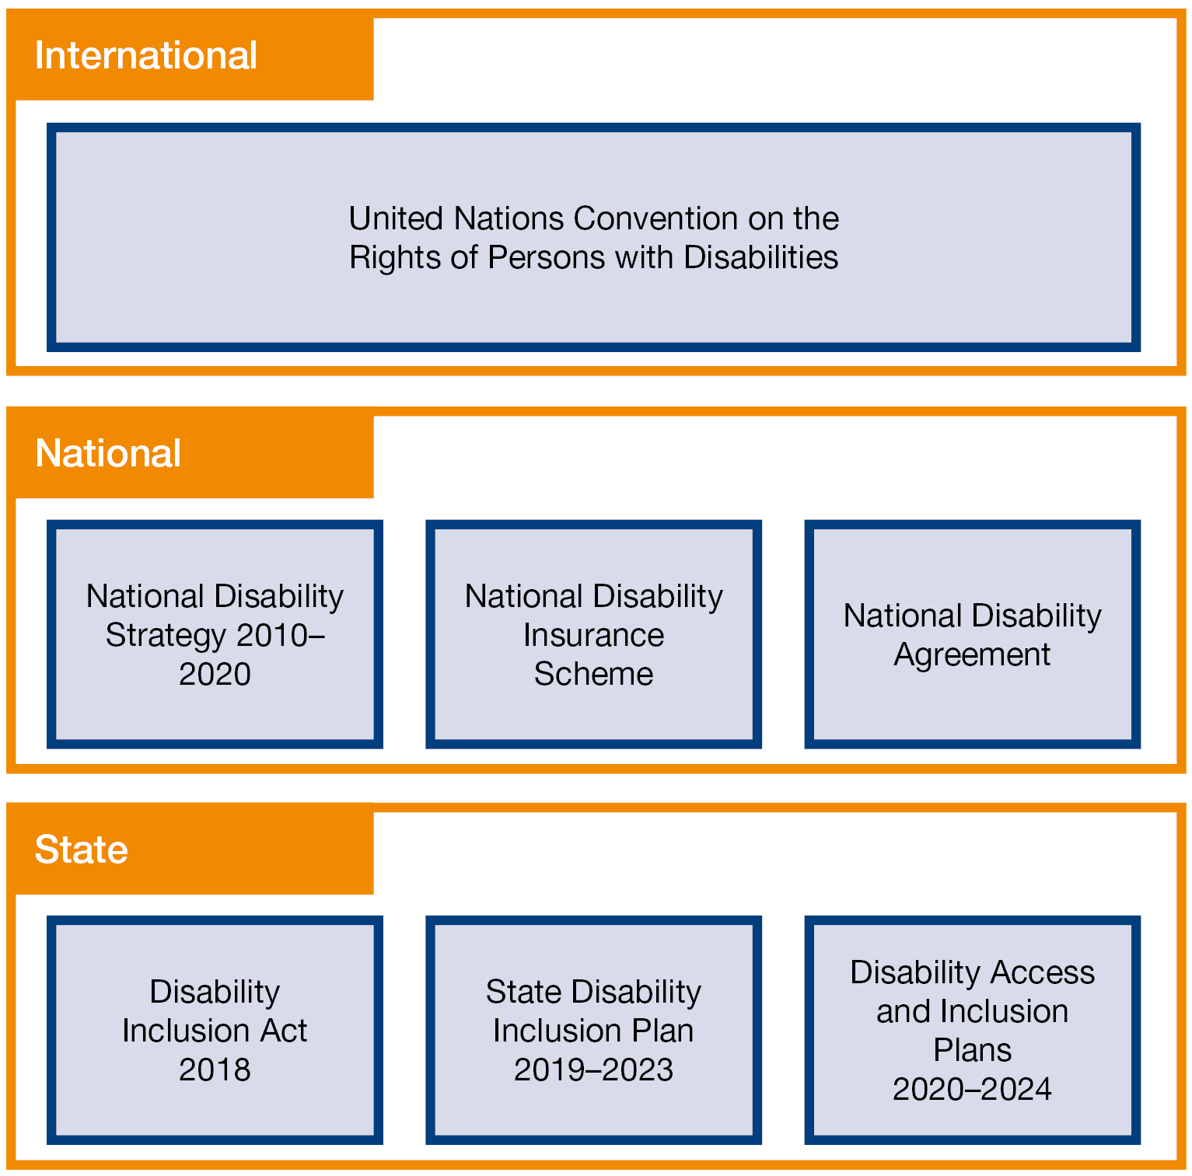

Legislative requirements
State authorities should refer to the Act, the Disability Inclusion Regulations 2019 (SA) (DI Reg) and the (Disability Inclusion (Transitional Arrangements) Regulations 2018 (SA) (Reg (Transitional)) to ensure all legislative requirements are met.
The following summary is not intended to be a substitute for legal advice. State authorities are encouraged to obtain independent legal advice relevant to their circumstances

A DAIP must acknowledge and address:
- The risks that relate to priority groups living with disability: women, children, Aboriginal and Torres Strait Islander people and culturally and linguistically diverse people (sections 9(2), (3), (4), and (5)).

A DAIP must:
- include measures to ensure that people living with disability can access mainstream supports and services provided by or on behalf of the State authority (section 16(3)(a))
- show how the State authority will give effect to the objects and principles set out in Part 5 of the Act (section 16(3)(b))
- show how the State authority will give effect to the State Plan (section 16(3)(c))
- include strategies to support people with disability in the following areas:
  - access to built environs, events and facilities
  - access to information and communications
  - address the specific needs of people with disability in programs and services
  - employment (section 16(3)(d))
- comply with published guidelines (the Toolkit) (section 12(1)(a)).

In developing a DAIP, a State authority must:
- meet consultation requirements, including a call for submissions from members of the public (sections 16(4)(b) and (c) and reg 9)
- seek the Minister’s approval if a State authority is a council and wishes to prepare a DAIP for more than one council (section 16(5))
- take reasonable steps to ensure that residents in each affected council area are kept informed in respect of the preparation of the DAIP if the State authority is a council and wishes to prepare a DAIP for more than one council (reg 10).

The Act and associated Regulations also set out reporting requirements for State authorities:
Action | Due date | Legislation
First DAIP published | 31 October 2020 | Reg (Transitional) r5(2)
Publish DAIP on website of State authority’s choosing | By 31 October 2020 for first DAIP | Act s16(7)
Notify Chief Executive (CE), Department of Human Services (DHS) that DAIP has been published (first DAIP only)  (This report and the one below can be combined) | After 31 October 2020 | Reg (Transitional) r5(4)
Report to CE, DHS on preparation of DAIP | Following publication of DAIP | DI Reg r9(4)
Annual Report on the operation of a DAIP to the CE, DHS (first report due 31 October 2021 for period 1 July 2020 to 30 June 2021) | 31 October each year | Act s17(1)
Conduct a DAIP review and provide a report on the review to the Minister | Every four years (minimum) | Act s18
Comply with requirements when making a variation to a DAIP | As required | DI Reg r11
Provide a report as specified by CE, DHS (this report may be forwarded to the Minister) | Upon request | Act s26
In accordance with the regulations, share prescribed information and documents with a recipient if you believe it will assist them to perform functions described in the Act | Upon request | Act s27

Other legislation
The Disability Discrimination Act 1992 (Cth) and the Equal Opportunity Act 1984 (SA) make disability discrimination unlawful and promote equal rights, opportunities and access for people living with disability. Disability discrimination happens when people living with disability are treated less fairly than people without disability and the discriminator fails to make reasonable adjustments to rectify the situation. It also occurs when people are treated less fairly because they are relatives, friends, carers, co-workers or associates of a person with disability.

Planning for your DAIP
It is recommended that State authorities align their DAIP actions with the four themes and associated priorities in the State Plan (where relevant). In doing this, State authorities demonstrate how their DAIP will give effect to the State Plan. State authorities will also be indirectly giving effect to the NDS and incorporating the principles in the Act and UNCRPD. State authorities are encouraged to follow these planning steps to ensure their DAIP meets legislative requirements.

5.1 Who is responsible for overseeing the planning process?
State authorities may choose to establish an advisory committee or working group with representation that could include staff, Local Government elected members, people living with disability, family members, representative bodies, service providers, influential ‘champions’, or interested community members.
Alternatively, a State authority may choose to allocate responsibility to a senior staff member or team within the authority

5.2 Know your business — list the information, services and facilities provided
Remember to include operational services that are also delivered through contracted third parties wherever possible.
Review current practices in all work areas to identify possible barriers to access and inclusion from both the perspective of community members and authority staff living with disability

5.3 Gather background information and ensure that existing information is current
Include statistical information about people living with disability in South Australia or your region and, if available, within staff or client groups.
Consider access issues identified by staff, service users, elected members or disability organisations.
Review previous DAIPs or other access initiatives and assess progress. This may involve identifying remaining barriers and strategies for addressing them.

5.4 Undertake community engagement, including consultation
It is a legislative requirement under the Act that authorities undertake consultation and call for submissions from members of the public before they finalise and publish their DAIP. Consultation may include surveys, forums/workshops, YourSAy website and engagement with targeted groups
Community engagement should take into consideration the diversity among people living with disability.
It is important to communicate with people using a variety of methods. Ensure that language used is appropriate and tailored to the audience, is easily understood and available in accessible formats. These may include Easy Read, Auslan, pictorial forms, large font, audible options, Braille, closed captions and VoiceOver.

5.5 Resources to assist in community engagement

Better Together
The South Australian Government has produced a guide to assist organisations to consult and engage with the community: Better Together: principles of engagement.

DHS Disability Engagement Group
The Department of Human Services Disability Engagement Group is used to obtain advice about disability issues. The group is a confidential contact list of people who have chosen to be available to provide independent advice on issues that are important to people living with disability in South Australia.
Consultations take place as needed. Members participate because of their interest and experience in areas related to disability. The group includes people living with disability as well as family members, carers and practitioners. Email: DHSDisabilityTalk@sa.gov.au

Local Government Act
The Local Government Act 1999 (SA) requires public consultation on a range of topics. Councils should refer to the Local Government Association Community Engagement Handbook for assistance with this process.

Australian Local Government Association (ALGA)
In October 2016, ALGA released the Disability Inclusion Planning—a Guide for Local Government as a resource to help councils navigate the NDS. The Guide notes that some states and territories have specific legislative and policy requirements regarding disability inclusion planning and that councils should consult these specific requirements for their jurisdiction in the first place.

5.6 Applying feedback and developing DAIP actions
Analyse the findings of the consultation and community engagement process in relation to the four themes and associated priority actions set out in the State Plan.
Identify strategies to overcome barriers, bearing in mind legislative requirements including the Disability Discrimination Act 1992 (Cth) (DDA), the Equal Opportunity Act 1984 (SA) (EOA), Building Code of Australia and associated standards and guidelines.
The Australian Human Rights Commission provides information about rights and legal responsibilities under the DDA and resources including standards and guides.
The South Australian Equal Opportunity Commission provides information about the EOA and training and assistance with complaints resolution.
Your DAIP provides an opportunity to be creative and implement innovative best practice initiatives. It is suggested that you refer to other organisations’ DAIPs to see how requirements have been addressed within their area.
Councils can also collaborate with other councils using a Local Government community of practice for information sharing and peer support. Section 16(5) of the Act allows councils to prepare and publish a joint DAIP subject to permission from the Minister for Human Services. Councils that are considering a joint DAIP should apply in writing to the Minister setting out the reasons why a joint DAIP is preferred.
Collaboration between agencies through a community of practice is encouraged.
Additionally, agencies can appoint a disability champion or access and inclusion officer to highlight and raise the profile of disability access and inclusion. A disability champion is someone who advocates for equal access and inclusion for people living with disability. The disability champion assists the authority to explore new ideas and promote good practice.
Actions can also be prioritised in line with planning and budgeting processes.

The DAIP should include, under the appropriate section:
- State authority’s goals: outcome
- How they will be achieved: action
- Who will do it: responsibility
- When it will be done: timeframe
- How success will be measured: measurable targets.

DAIP actions should be:

Specific:
- What exactly is your authority going to do?
- Are goals clear and well defined?

Measurable:
- How will your authority know when goals are reached?
- Can success be measured?

Achievable:
- Can your authority deliver results on time and within budget?
- Are all stakeholders in agreement with this?

Realistic:
- Will this action lead to the desired outcome with available resources, knowledge and time?

Timely:
- What is the deadline for achieving the target?
- Is this enough time?
- Is there general recognition that the actions are time-limited?

5.7 Implement monitoring, reviewing and reporting mechanisms
People living with disability, their families and representatives should be actively involved in the ongoing implementation, monitoring and review of DAIPs.

Determine:
- How your authority will monitor the implementation and progress of the DAIP
- If there will be a DAIP advisory group or a specified position with responsibility
- Measurable targets to assess the DAIP performance and success
- What information needs to be collected. Options might include gathering:
  - Quantitative information (For example, Australian Bureau of Statistics Disability Ageing and Carers: Summary of findings, census data, general social survey data, Australian Institute of Health and Welfare reports)
  - Information including employment figures, number and type of office modifications undertaken and complaints data
  - Qualitative information from people living with disability, their families and representatives to see whether they have experienced an improvement in access and inclusion as a result of the DAIP.

5.8 Finalise and promote the DAIP widely
Seek feedback from stakeholders on the draft DAIP and incorporate any changes.
When the DAIP is finalised and approved, it should be made available in a variety of accessible formats to all business units and the general public. These may include Easy Read, Auslan, pictorial forms, large font, audible options, Braille, closed captions and VoiceOver.
It is a legislative requirement that DAIPs be published on a website determined by your authority. Most State authorities have their own websites, and these are considered the most appropriate place for publishing a DAIP.
It should also be promoted through authority communications, staff induction and training, and other appropriate mechanisms.

5.9 Final steps
The Chief Executive, DHS must be notified that the DAIP has been published.
You must also report to the Chief Executive, DHS on the preparation of the DAIP. This information should form part of your DAIP (see section on DAIP Development in the DAIP Template).
Providing a copy of the published DAIP to the Chief Executive, DHS will meet these two requirements

The DAIP Template
The DAIP template can be accessed via the Inclusive SA website: www.inclusive.sa.gov.au
State authorities are encouraged to use the template to ensure consistency in presentation and reporting.
The template is available as a Word document to allow State authorities to brand the DAIP with each authority’s style and layout.

Glossary of definitions and acronyms

Best practice
A method or technique that has been generally accepted as superior to any alternatives because it produces results that are better to those achieved by other means or because it has become a standard way of doing things.

Built environs
Artificial structures, features, and facilities viewed collectively as an environment in which people live and work.

Commonwealth
The government of the Commonwealth of Australia – commonly referred to as the Australian Government or the Federal Government.

DAIP
Disability Access and Inclusion Plan prepared by State authorities for their own agency, department or council area.

DHS
The South Australian Department of Human Services.

Disability Engagement Group (DEG)
A DHS -led register that can be used by other government agencies or councils to obtain advice from people living with disability and the sector about disability issues

Local councils
A system of government in South Australia under which elected local government bodies (councils) are constituted under the Local Government Act 1999 (SA).

Mainstream
Products and services that are readily available to the general public, as opposed to being applicable only to a very specific subset of the general population.

National Disability Strategy (NDS)
National Disability Strategy 2010–2020 — a shared commitment by all governments to work together to improve the lives of Australians with disability by guiding governments and other organisations to build the wellbeing of people living with disability and their carers.

State authority
As defined in the Disability Inclusion Act 2018: an administrative unit (within the meaning of the Public Sector Act 2009 (SA), or a local council established under the Local Government Act 1999 (SA).

Toolkit
A suite of information documents that may include guidelines, templates and procedures to assist in the completion of a task

UNCRPD
United Nations Convention on the Rights of Persons with Disabilities — the convention is a human rights treaty that aims to change attitudes and approaches to people living with disability. It reaffirms that all people living with disability must enjoy human rights and fundamental freedoms

Universal Design
Universal Design involves creating facilities, built environs, products and services that can be used by people of all abilities to the greatest extent possible without adaptations

Appendix One: DAIP Checklist
Suggested Disability Access and Inclusion Plan Checklist
Task |  | Target date | Completed
1. | DAIP committee or working group convened (or senior staff member appointed) to oversee process
2. | State authority information, services and facilities identified
3. | Background information about people living with disability, previous action plans and initiatives compiled
4. | a. Community engagement strategy determined
 | b. Community engagement strategy implemented
5. | Incorporate findings (barriers and solutions) into draft DAIP
6. | Determine monitoring, reviewing and reporting mechanisms
7. | a. Seek feedback on draft DAIP from key stakeholders
 | b. Finalise DAIP, endorsement by Elected Members / Senior Executive
 | c. Promote DAIP to staff and community
 | d. DAIP progress reported in annual reports, website, newsletters

Appendix Two: Useful Resources

International
United Nations Convention on the Rights of Persons with Disabilities (and Optional Protocol)

National
Carer Recognition Act 2010
Disability Discrimination Act 1992
Disability standards for Accessible Public Transport
Disability standards for access to Premises – Buildings
Disability standards for Education
National Carer Strategy (PDF 1.2 MB)
National Disability Agreement
National Disability Insurance Scheme
National Disability Strategy 2010–2020
National Standards for Disability Services in Australia

South Australia
Better Together: principles of engagement
Carers Recognition Act 2005
Disability Inclusion Act 2018 (SA)
Disability Inclusion Planning—a Guide for Local Government
Disability Inclusion Regulations 2019 (SA)
Disability Inclusion (Transitional Arrangements) Regulations 2018 (SA)
Equal Opportunity Act 1984
Inclusive SA: State Disability Inclusion Plan 2019–2023
Planning Development and Infrastructure Act 2016
The 30-Year Plan for Greater Adelaide
Volunteering Strategy for South Australia 2014–2020 (PDF 530 KB)

State authorities should note that the Act and associated Regulations do not require immediate expenditure on capital works to make built environs accessible. State authorities are required to: - Apply principles of universal design in all new builds; and - Where possible and affordable improve existing accessibility using universal design principles.

