Community Service
Partnerships Information

What is Community Service?
Community Service is a sentencing option issued by the Youth Court. Community Service can also be undertaken as a result of an outstanding fine being converted to community service hours.

The Community Service Order (CSO) Program provides work activities/programs that support the community. This enables young people to:
- gain insight into the effects of their offending on others
- take responsibility for their actions
- develop employment opportunities and skills
- enhance a longer term connection with the community, and
- build self-confidence and experience a sense of achievement.
Work activities must be for the benefit of victims, the disadvantaged within the community, not for profit organisations or a Public Service administrative unit.
Educational/therapeutic/vocational programs may account for a percentage of community service hours.
What do I have to do?
If your agency is interested in participating in the CSO Program, a meeting will be arranged by staff to develop a plan which is feasible and beneficial for both parties.
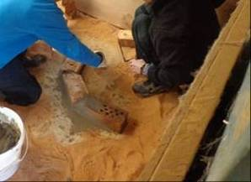
Depending on the type of program/work activities agreed upon, the CSO Program will supply the appropriate supporting documents and communicate with your staff on a regular basis.

Partnerships
Over 40 partnerships have been developed state wide in the CSO Program with young people attending at a number of metropolitan and country locations such as Limestone Coast, Port Pirie, Port Lincoln, Whyalla, Coober Pedy,
APY lands, Port Augusta, Murray Bridge and Riverland.
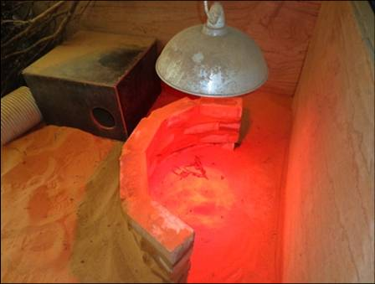
With the co-operation of organisations, the community becomes involved in the youth justice system. Maintaining strong partnerships within the community is integral to the success of the CSO Program and the completion of Orders for young people.
What are the types of programs and supervision required?
Each young person is assessed by CSO Program staff to determine the most appropriate work program/placement available and the amount of supervision required.

The CSO Program offers 3 types of work programs/placements:

Internal program -
work activities fully supervised by CSO Program staff either on the DCSI site or at a location nominated by the agency.

Semi-supported program - generally performed at the agency site facilitated by agency staff with CSO Program staff supervising the young person/group.

External program placement - young people are fully supervised by agency staff at the agency worksite (must be registered as a Child Safe Environment).
What kind of work activities/programs can the young people do?
Young people perform a range of work activities/programs of which currently include:
- growing produce and maintaining community gardens
- assisting charity stores/food banks
- landscaping
- animal welfare
- assist in aged care/homeless/Aboriginal/youth community centres
- maintaining zoos and wildlife parks
- graffiti removal
- general maintenance, building and restoration work
- tree planting and weed eradication.
The CSO Supervisor and staff will discuss with you a range of suitable work activities that can be performed.
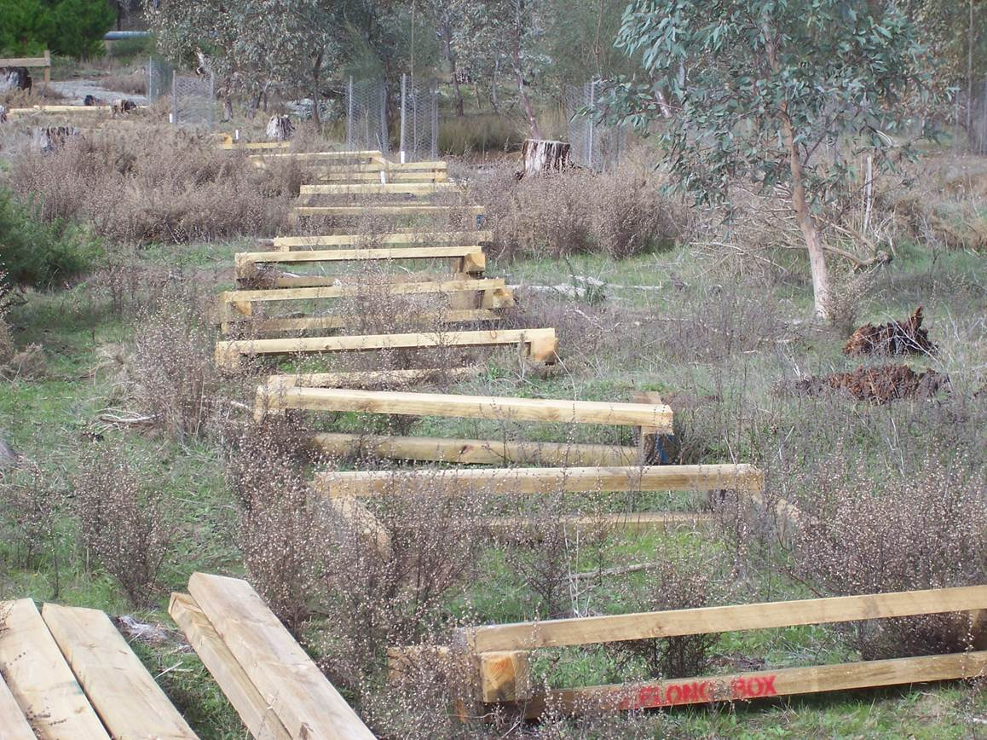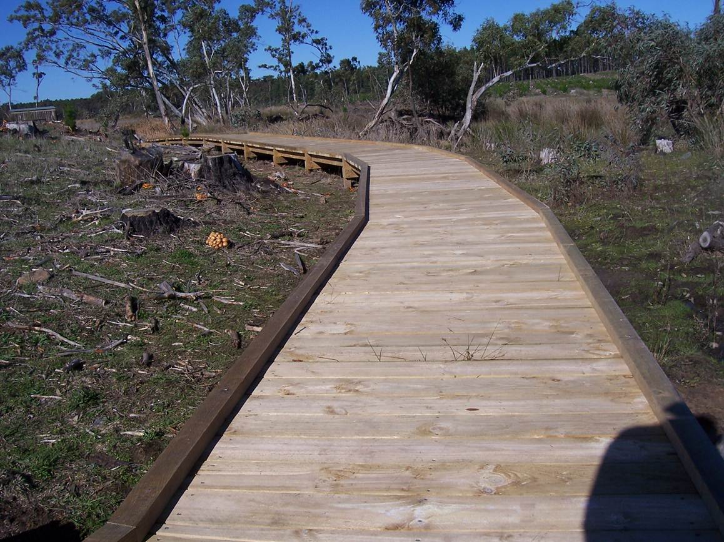

Responsibilities and Obligations
The Department for Communities and Social Inclusion (DCSI) is responsible for the supervision of the young person’s Order.
The agency is responsible for planning and negotiating the work with the CSO Supervisor/ staff to be carried out by the young people.
Service Delivery
To support the facilitation of work activities, the CSO Program has a range of documents developed to ensure that safety, consistency, efficient practices and communication is maintained. Every program/work activity is risk-assessed and has workplace and safe operating procedures attached.
The CSO Program prepares a Memorandum of Understanding with all agencies and local councils to inform of relevant legislation, program principles and aims, delivery and reporting, insurances, child safe environment requirements, privacy and safety standards.
How will the CSO Program keep in touch?
The CSO Supervisor and staff will contact you regularly to receive feedback and to discuss any issues that arise and future work options. The CSO staff will arrange dates for attendance and notify you of any changes that occur.
What if the young person has an accident?
In accordance with section 45 of the Youth Justice Administration Act 2016 (SA), death and bodily injury insurance cover for young offenders participating in the CSO Program is provided under the Government’s self-insurance arrangements.

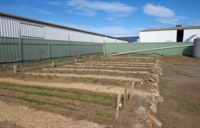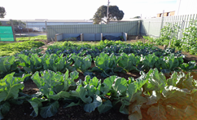
CSO Program Contact Details
Local CSO Program Ph:
CSO Program Operations Manager 08 8463 6491

