DHS Aboriginal Workforce Strategy 2021–2023

Contents
Acknowledgement to Traditional Owners 2
Message from the Chief Executive 3
Why an Aboriginal Workforce Strategy is necessary 4
Where are we now? 5
Our Journey 6
Our Achievements 7
Our Commitment to Action 9
Responsibilities and Governance 10
Aboriginal Workforce Strategy Action Plan 2021 – 2023 11

Acknowledgement to Traditional Owners
The Department of Human Services acknowledges and respects Aboriginal people as the state’s first people and recognises Aboriginal people as traditional owners and occupants of lands and waters in South Australia.
We acknowledge that the spiritual, social, cultural and economic practices of Aboriginal people come from their traditional lands and waters, and that the cultural and heritage beliefs, languages and laws are still of importance today.
We are committed to ensuring that the needs and aspirations of Aboriginal people are incorporated in the design, development, monitoring and evaluation of deliverable actions.
NOTE: For the purposes of this document, the term Aboriginal is used to refer to Aboriginal and Torres Strait Islander people within South Australia. This is not intended to exclude Torres Strait Islander people, or people who may identify as being of both Aboriginal and Torres Strait Islander descent.

Message from the Chief Executive
Improving the cultural, spiritual, and family wellbeing of Aboriginal people in South Australia and building strong, safe, resilient and stable communities is a key priority of the Department of Human Services (DHS).
We recognise Aboriginal people as the first Australians with unique cultures, languages and spiritual relationships to the land and seas and the inherent rights, laws, customs, religions, and traditions of Aboriginal peoples. It is this stewardship, built over thousands of years, that has created the remarkable country that we are fortunate to inhabit today.
Meeting the challenges of the future will require a workforce that reflects the community we serve. DHS plays an important role in addressing the disadvantage experienced by Aboriginal people in South Australia where high levels of poverty and disadvantage are experienced by many Aboriginal children, families and communities in South Australia on a daily basis. Employment is a crucial step out of these situations.
If we are to capably respond to the needs of the community, the representation of Aboriginal people in the department must increase and alongside of it, investing in building the cultural capabilities of our non-Aboriginal workforce is critical to ensure we can respond in a manner that is culturally responsive and safe.
DHS has identified four focus areas underpinning this workforce strategy:
- Creating more employment opportunities and entry pathways for Aboriginal people and continuing to increase Aboriginal representation across all divisions and salary levels.
- Retaining and supporting our existing Aboriginal employees in a culturally supportive workplace and improving career planning and training to build capabilities and enhance opportunities.
- Building a stronger succession pipeline and enabling more Aboriginal staff to progress into senior leadership roles.
- Building the cultural knowledge and capability of our no- Aboriginal staff.
The development of the DHS Aboriginal Workforce Strategy has been shaped by Aboriginal staff within the department and with significant assistance from the DHS Aboriginal Leadership Group and the DHS Reconciliation Committee.
Endorsed by the Executive Leadership Team (ELT), I am pleased to present the DHS Aboriginal Workforce Strategy 2021–2023 and I strongly encourage you all to engage with the specific employment initiatives detailed in this document.
Lois Boswell
Chief Executive

Why an Aboriginal Workforce Strategy is necessary
Evidence shows that increasing Aboriginal economic participation is fundamental to achieving sustained improvement across a range of indicators in education, employment, health and justice. Economic independence enhances the sustainability and viability of South Australian Aboriginal communities. It also increases Aboriginal employment, supports a more vibrant business sector, and encourages more investment and innovation across South Australia – South Australian Government Aboriginal Action Plan 2019–2020.
The gap between Aboriginal and non-Aboriginal South Australians on every measurable indicator is too wide. Aboriginal people do not enjoy the same levels of prosperity or outcomes in health, education, and employment.
It is incumbent on those who can effect positive change for Aboriginal people to do so.
DHS is committed to employing more Aboriginal staff, retaining and upskilling current Aboriginal staff and creating a culturally safe working environment to make our department an employer of choice for Aboriginal people.
Employment of Aboriginal people in the public sector has been directly linked to many benefits, including:
- improved access and outcomes for clients;
- increased cultural competency of service delivery; and
- better collaboration between government and Aboriginal people.
To achieve these benefits, we must set firm targets. We must be held to account and ensure that we consistently monitor and achieve our targets.
DHS has set a target of 4% for its workforce to be Aboriginal by the end of 2023 and an improvement year on year thereafter. The responsibility to achieve this target lies with all divisions and directorates and will be embedded into Executive Directors’ Performance Development Plans to further demonstrate the department’s commitment.
All areas within the department are encouraged to work closely with the Principal Aboriginal Workforce Consultant within People and Performance Division, to assist in developing specific recruitment and retention strategies for their areas.

Where are we now?
DHS has historically been one of the leaders across the public sector regarding Aboriginal employment. As of February 2021, our Aboriginal workforce stands at 2.9% compared to 2.13% for the South Australian Public Sector. The current spread of Aboriginal employees across DHS however varies.
While these statistics detailed below demonstrate a solid representation of Aboriginal employees in some divisions, overall, it highlights the need to look at the recruitment and retention initiatives for those divisions with less than 4% representation, in particular, our divisions providing services to Aboriginal clients.

Divisional workforce
From a total workforce of 3,075, 89 staff identify as Aboriginal or Torres Strait Islander.
Of those people, 62 are females and 27 are males. Classification range:
ASO | PO | OPS | WP | TRA
31 | 25 | 25 | 16 | 16

Division | Total | Aboriginal & Torres Strait Islander %
Disability Services | 1609 | 1.5%
Community Investment and Support | 525 | 0.6%
Community and Family Services | 349 | 12.9%
Youth Justice Services | 284 | 3.9%
People and Performance | 142 | 1.4%
Finance and Business Services | 84 | 0.0%
Strategic Policy and Reform | 48 | 2.1%
Office of the CE and Governance | 34 | 8.8%

Our Journey

Aboriginal Employment Strategy 2014–2016
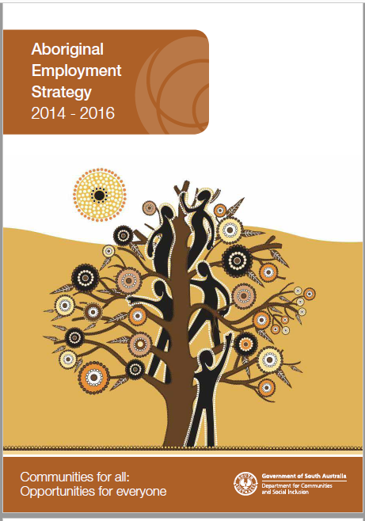
This Strategy builds on the considerable work already occurring across the department to recruit and retain Aboriginal people with the first Aboriginal Employment Strategy launched in 2014–2016.

DCSI Diversity and Inclusion Strategy 2017–2020
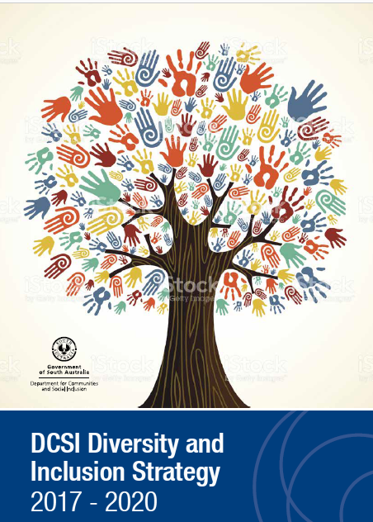
In 2017 Aboriginal employment initiatives were combined into the 2017–2019 Diversity and Inclusion Strategy which was the first of its kind across the South Australian public sector.

DHS Diversity and Inclusion Strategy 2020–2023
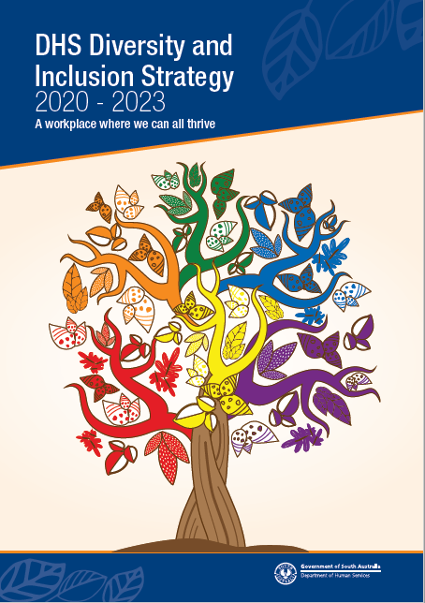
While the recently released DHS Diversity and Inclusion Strategy 2020–2023 references Aboriginal strategies, given the critical need to increase our Aboriginal workforce, a stand-alone Aboriginal Workforce Strategy is considered essential if the department is to meet its target.
In addition to the Diversity and Inclusion Strategy, the Aboriginal Workforce Strategy acknowledges the many employment related initiatives already in train across various areas within DHS. These include the work underway in the Youth Justice directorate to implement the actions within the Youth Justice State Plan 2020–2023 and the work in Strategic Policy and Reform directorate in addressing the Closing the Gap targets, the Overcoming Indigenous Disadvantage indicators and the development of a Cultural Competency Trauma training package for South Australia.

Our Achievements
Detailed below under the themes of Recruit, Develop, Collaborate and Retain, are just some of the various Aboriginal employment related initiatives already in place across the department.

Recruit
- Two senior Aboriginal appointments were created in 2019 to provide strategic policy and program advice and support across DHS. A Senior Manager, Aboriginal Practice and Programs position sits within the Strategic Policy and Reform division with responsibility for strengthening the links been DHS and Aboriginal communities and for influencing Aboriginal business into DHS policy and programs. The Principal Aboriginal Workforce Consultant within the People and Performance Division provides support to all divisions on best practice initiatives in achieving Aboriginal employment recruitment and retention strategies as well as providing cultural advice, support, and advocacy to the DHS Aboriginal workforce.
- As part of their Aboriginal Service Model in Accommodation Services, Disability Services have recently recruited several Aboriginal staff to deliver culturally services to Aboriginal people with disability.
- A dedicated Aboriginal Recruitment Guide was launched in 2020 designed to provide a practical guideline for DHS managers and staff involved in the recruitment and selection of Aboriginal people. It incorporates best practice employment principles to encourage the recruitment of Aboriginal people including identified Aboriginal positions.
- DHS actively participates in the South Australian Public Sector Aboriginal Traineeship Program, as part of the South Australian Government Aboriginal Affairs Action Plan 2019–2020, with 11 trainees employed through that Program. These trainees commenced employment in a variety of administrative roles while a further five Aboriginal trainees have recently commenced placement within Accommodation Services.
- DHS actively promotes the South Australian Aboriginal Employment Register, coordinated out of the Office of the Commissioner for Public Sector Employment (OCPSE) to fill vacancies across all business areas.

Develop
- Aboriginal employees are supported to achieve qualifications through DHS study provisions with up to 100 per cent reimbursement of study fees granted in addition to study leave.
- An online Aboriginal Awareness Program is mandatory for all staff to complete. In addition, a two-day mandatory Aboriginal Cultural Sensitivity and Respect training program has been coordinated via Stanton Institute, the department’s Registered Training Organisation. As of October 2020, over 85 per cent of DHS staff had completed the two-day training course.
- A refreshed Aboriginal cultural learning framework and supporting programs will be designed and procured in 2021.

Collaborate
- The Aboriginal Leadership Group was established in April 2020, with representation from across all divisions. Meeting bi-monthly, the Group has been designed to be a collective voice for senior Aboriginal staff within DHS and provide culturally sound advice to the ELT.
- Through the Aboriginal Leadership Group, DHS has created a Community Reference Group to ensure purposeful engagement occurs between a key government agency and community. The Reference Group aims build a strong engagement connection between DHS and key representatives of the Aboriginal community.
- The DHS Nunga Network was created to raise the profile and awareness of matters relevant to Aboriginal employees across all areas of DHS, and to provide a peer support and information sharing network for Aboriginal employees. Coordinated monthly, the forums are conducted virtually to allow all Aboriginal employees to participate, including those in regional and remote parts of South Australia.

Retain
- DHS is now a Reconciliation SA Gold member, the highest membership level available. Gold membership provides a range of reduced-price event access, exclusive information/resources and advisory support by the Reconciliation SA Executive team.
- DHS is currently completing an Innovate Reconciliation Action Plan (RAP).
- Each year DHS celebrates Reconciliation Week and NAIDOC Week with a diverse range of learning events and celebrations, including the DHS Chief Executive Award for Aboriginal Employee of the Year acknowledging an outstanding Aboriginal employee who has shown leadership and driven positive change both in the department and community. 2020 saw DHS provide an outstanding array of workshops, forums and celebrations throughout Reconciliation Week and NAIDOC Week.
- DHS offers flexible work arrangements to assist Aboriginal employees to better meet their work and family obligations. Employees are also able to access special leave with pay (cultural leave) to attend essential cultural and ceremonial activities.
- DHS continues, where appropriate, to provide cultural signage throughout its premises. Most recently work has commenced on developing a new cultural walk and connection space at the Kurluna Tapa Youth Justice Centre. Work is also underway on identifying appropriate Aboriginal naming and signage for the new training room facilities within Riverside.

Our Commitment to Action
Despite the many achievements to date, there is however, so much more that is needed to be done if we are to be a department of first choice for Aboriginal people.
The Aboriginal Workforce Strategy has identified four key objectives that DHS will meet by the end of 2023. The specific actions that underpin these objectives are detailed in the DHS Aboriginal Workforce Strategy 2021–2023 Action Plan.

Focus Area 1: Recruitment and employment pathways
We will create more employment opportunities and entry pathways for Aboriginal people and continue to increase Aboriginal representation across all divisions and salary levels. Our goal is to create a workplace reflective of the community we serve by having a dedicated, skilled Aboriginal workforce of at least 4%, with a year on year improvement.

Focus Area 2: Career development and retention in a culturally supportive environment
DHS encourages and supports a workplace environment that allows Aboriginal people to feel safe, secure and valued. Achievements in recruitment and employment pathways will only be effective if we can sustain our new workforce through our career development and retention strategies.
Aboriginal employees will be encouraged to become members of the DHS Nunga Network to assist in building strong relationships with other Aboriginal employees in DHS, participate in professional and personal development, and be involved in discussions for improving the culture and retention of Aboriginal staff.

Focus Area 3: Senior leadership and succession pipeline
Aboriginal employees are over-represented in the lower salary bands and under-represented in the higher salary bands and senior leadership roles. Building leadership potential is a key to future success for Aboriginal people.
DHS will provide ongoing leadership development opportunities for Aboriginal staff to support them to exercise their leadership potential in the department and their wider communities. We will also provide development opportunities and mentoring support and advice for Aboriginal staff seeking promotion.

Focus Area 4: Increased cultural knowledge and competency of non-Aboriginal staff
Building the cultural knowledge and competency of our non-Aboriginal staff is critical if we are to promote a positive working environment for our Aboriginal workforce. We will develop a Cultural Learning Framework setting out our clear expectations for staff to participate in activities to build their cultural knowledge and competence.

Responsibilities and Governance
Whilst there are “lead” areas for each initiative detailed in the DHS Aboriginal Workforce Strategy 2021–2023 Action Plan, achieving these initiatives must involve everyone. All employees, at all levels and across all classifications, are charged with doing their bit to improve Aboriginal employment outcomes and by doing so, ultimately improve the services we offer to our Aboriginal clients.
To ensure the success of this strategy, an Executive sponsor and champions for the Aboriginal Workforce Reference Group will be identified. Sponsors and champions will promote and support these employment efforts and initiatives, provide strategic direction and have oversight on DHS’ overall performance.
Regular input and advice from the DHS Aboriginal Leadership Group and the Diversity and Inclusion Reference Group will be sought and a half yearly report on progress made available. The DHS Aboriginal Workforce Strategy will be communicated to all staff via the DHS website and Intranet.
This Strategy has been developed in consultation with a range of key stakeholders across the department and the broader public sector. In particular, the input and expertise of the DHS Aboriginal Leadership Group and the Reconciliation Group is greatly appreciated.

Aboriginal Workforce Strategy Action Plan 2021 – 2023

Focus area 1 – Recruitment and employment pathways
Action | Measurable Targets | Lead
Strategy 1.1 — Increase Aboriginal employment to 4 per cent | 4 per cent target reached. Year-on-year improvement of Aboriginal staff employed. | Executive Directors
Strategy 1.2 — Develop specific recruitment campaigns targeting Aboriginal applicants particularly in Directorates with greatest need of Aboriginal staff. | Increased percentage of Aboriginal employment in areas that employ less than 4 per cent Aboriginal staff. | Directorates supported by Organisational Development
Strategy 1.3 — Continue to promote the South Australian Aboriginal Employment Register across DHS and annually increase the number of Aboriginal staff employed through it. | Number of positions filled through the the South Australian Aboriginal Employment Register. | Business Units/Organisational Development
Strategy 1.4 — Increase the intake of trainees through the South Australian Public Sector Aboriginal Traineeship Program via the Office of the Commissioner for the Public Sector. | Number of Traineeships.  Number of trainees retained. | Organisational Development / Business Units
Strategy 1.5 — Develop an Aboriginal Cadetship Program which provides up to 3 Aboriginal students with paid employment in a role that relates to an area of study relevant to DHS, for 12 weeks per year, up to three years. | Number of cadetships taken up. Successful completion of cadetships. | Organisational Development/Business Units.
Strategy 1.6 — Review opportunities for expanding the use of Aboriginal-identified roles across divisions. | Number of employees recruited directly into identified roles. | Human Resource Business Partnership / Business Units
Strategy 1.7 — Establish a pool of Aboriginal employees who have undertaken selection training and are available to sit on interview panels. | Number of recruitment processes with an Aboriginal panel member. | Human Resource Business Partnership / Organisational Development
Strategy 1.8 — Ensure all identified-Aboriginal roles are also advertised in Aboriginal-specific media (Koori Mail, National Indigenous Times) and Aboriginal networks (Turkindi Network, Reconciliation SA). | Increased applications for identified Aboriginal roles. | Organisational Development in conjunction with Business Units and Human Resource Business Partners.
Strategy 1.9 — Review all Aboriginal-identified role descriptions to ensure they are written in an appropriate manner that all community and candidates can connect with. | Increased applications for identified Aboriginal roles within DHS. | Human Resource Business Partnership / Business Units

Focus area 2 – Career development and retention in a culturally supportive environment
Actions | Measurable Targets | Lead
Strategy 2.1 — Support current Aboriginal staff to maximise their employment chances by developing and implementing workshops focused on job application and interview skills. | Workshop participation rate. | Organisational Development
Strategy 2.2 — Support up to 6 places annually for Aboriginal and non-Aboriginal staff to attend the Indigenous Mentoring course offered through Tauondi College. | Number of Aboriginal and non-Aboriginal employees completing the program. | Organisational Development / Business Units
Strategy 2.3 — Continue to support Aboriginal employees to achieve qualifications through DHS study provisions with up to 100 per cent reimbursement of study fees granted in addition to study leave. | Number of employees studying. | Business Units.
Strategy 2.4 — Coordinate the DHS Nunga Network for all Aboriginal employes in DHS. | Number of active members. | Organisational Development
Strategy 2.5 — Regularly review and monitor Aboriginal workforce data to provide an accurate profile of DHS Aboriginal workforce. | Accurate and up-to-date data at the end of each financial year. | Business Improvement and Technology

Focus area 3 – Senior leadership and succession pipeline
Actions | Measurable Targets | Lead
Strategy 3.1 — Promote participation for Aboriginal staff in the Certificate IV in Leadership and Management through Stanton Institute. | Number of Aboriginal employees who undertake the training. | Organisational Development
Strategy 3.2 — Annually nominate and fund a minimum of two Aboriginal employees to participate in the OCPSE Academy’s Aboriginal Frontline Leadership Program. | Successful completion rate of the program. Meet or exceed our allocation target. | Executive Leadership Team
Strategy 3.3 — Work with Divisions to actively identify and fund two Aboriginal staff to participate in the OCPSE Academy’s Next Executive Program. | Successful completion rate of the program. | Executive Leadership Team
Strategy 3.4 — Executive Director’s Performance Development Plans reflect the 4 per cent workforce target. | Successful completion rate of the program. | Executive Leadership Team

Focus Area 4 – Increased cultural knowledge and competence of our non-Aboriginal workforce
Action | Measurable Targets | Lead
Strategy 4.1 — Develop a cultural learning framework which sets out levels of programs from cultural awareness, safety and responsiveness through to, cultural competency for our staff. | Cultural Learning Framework developed.  Program development and facilitators sourced to deliver the programs commencing in the first half of 2021. | Organisational Development
Strategy 4.2 — Provide a series of workshops or forums for DHS Executive aimed at addressing cultural competence. | Number of executives who have successfully completed the training. | Organisational Development
Strategy 4.3 — Ensure all employees complete the online mandatory cultural awareness during the first six months of employment. | Number of staff who have successfully completed the training. | Executive Directors
Strategy 4.4 — Establish a Community of Practice for Aboriginal Employment and Learning specialists across the public sector to share ideas and resources. | Agency participation rates. | Organisational Development
Strategy 4.5 — Promote stories that celebrate the success of our Aboriginal employees and their achievements | Number of articles published. | Communications and Engagement
Strategy 4.6 — Promote and observe dates and events of significance to Aboriginal people and encourage all staff participation in culturally significant times of the year. | Number of dates and events promoted.  Participation levels of all DHS staff. | Communications and Engagement / Executive Leadership Team
Strategy 4.7 — Ensure representation from the DHS Aboriginal Workforce Reference Group on the DHS Diversity and Inclusion Reference Group to facilitate effective collaboration. | Shared targets are met. | Organisation Development

