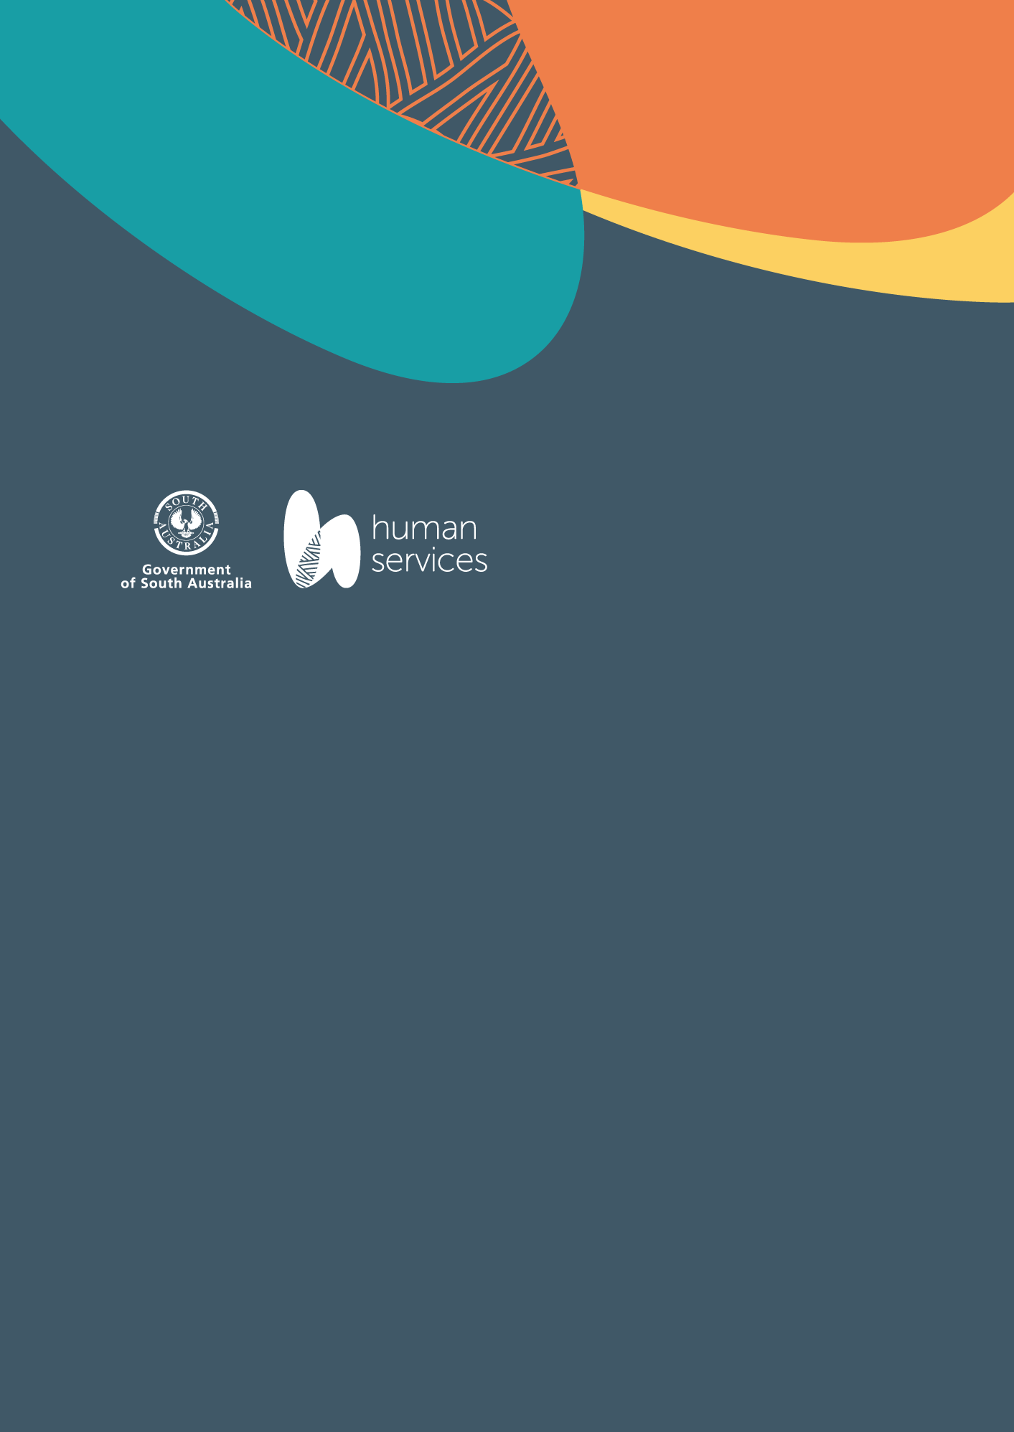

# 2025 SA Youth Action Plan - Life Skills Grant Round Guidelines

Grants up to $15,000 for projects commencing after 1 September 2025

Open Date: 9 April 2025

Close Date: 3.00 pm 4 June 2025

## The Department of Human Services

At the Department of Human Services our mission is to develop and implement modern, innovative, and relevant services across our entire community so all South Australians can be connected and included. Our programs and services aim to ensure South Australians are safe, empowered and connected in their communities.

The Department has three strategic priorities:

* Increasing inclusion, independence, and shared decision-making for all.
* Supporting our communities when it matters most.
* Delivering modern services for our communities.

## DHS support for young people in South Australia

There are more than 279,000 young people aged 12 to 25 years in South Australia. The Government of South Australia shares a vision with young people for a South Australia that is safe, inclusive and sustainable for all young people, now and into the future.

To support young South Australians to reach their full potential, DHS provides:

* Strategic direction and advice.
* Sector support and advocacy funding to the [Youth Affairs Council of South Australia](https://www.yacsa.com.au/), the peak body representing young people and the non-government youth sector in South Australia.
* Programs and services.
* Grants.
* Awards and recognition.

## SA Youth Action Plan

Through consultation to develop the [2025–28 SA Youth Action Plan](https://dhs.sa.gov.au/how-we-help/youth/sa-youth-action-plan), young people told us that they felt unprepared to begin adulthood and wanted more support through their transition to adulthood, especially around learning ‘life skills’.

The failure to provide support for vulnerable young people to live independently was described as putting young people at risk of various challenges, including poverty, insecurity, homelessness, involvement in the justice system, and long-term poor health outcomes.

The Government of South Australia, through the Department of Human Services (DHS), is providing SA Youth Action Plan grants for local councils and not-for-profit organisations working directly with young people across South Australia to develop initiatives which support young people to learn crucial life skills in preparation for independence.

## SA Youth Action Plan – Life Skills Grant Round

The SA Youth Action Plan (YAP) – Life Skills grants of up to $15,000 (GST exclusive) are available to eligible organisations working directly with young people in metropolitan and regional South Australia to develop new initiatives, or enhance the reach or capacity of existing initiatives which teach young people how to:

* Navigate government services, for example to obtain a birth certificate, Medicare card, Tax File Number.
* Create a resume and prepare job applications and for interviews.
* Maintain a healthy lifestyle and understanding nutrition and the health impacts of diet choices.
* Develop a budget, manage and avoid debt, and other financial literacy skills.
* Other practical ‘life skills’, such as changing a tyre, preparing meals, undertaking basic home maintenance.
* Support for delivery of Learners License driving programs for learners from the priority focus groups to gain on road driving experience.

Priority will be given to projects that specifically support young people experiencing vulnerability identified as Priority focus groups.

## 2025 SA Youth Action Plan – Life Skills Grant key dates

* This round is open between 9 April 2025 at 9.00 am and 4 June 2025 at 3.00 pm.
* Notification of outcome will be after 15 August 2025.
* Grant agreement period will start after 1 September 2025 and end 30 June 2027.

## Who can apply?

To be eligible to apply, organisations **must be:**

* A Council as described under the Local Government Act 1999 (SA), or
* An Aboriginal Community-Controlled Organisation (ACCO), or
* Not-for-profit organisation[1], or
* Social Enterprises[2]

ACCOs and Not for Profit Organisations must be incorporated under the South Australian *Associations Incorporation Act 1995*, or the *Corporations (Aboriginal and Torres Strait Islander) Act 2006*, or have evidence of comparable legal status, such as Australian Public Company limited by guarantee.

Social Enterprises must hold a current certification from [Social Traders](https://www.socialtraders.com.au/).

Unless you are Social Enterprise, **you may not apply** if you are an individual, sole trader, a for-profit organisation, a sport organisation, a private company, or a trust (except fixed trusts).

Organisations must:

* Be currently operating within South Australia, and recipients of the program/service/initiative are residents of South Australia.
* Be currently registered with a valid and eligible Australian Business Number (ABN).
* Have an Australian bank account in the name of the legal entity.
* Agree to the terms and conditions of the grant agreement.
* Work directly with young people.

Organisations must not:

* Have any outstanding contractual or financial obligations (acquittals, unpaid invoices) for any funded Department of Human Services projects/programs.
* Have licensed gaming machines in their facilities or hold a gaming machine license.
* Be educational institutions or related representative bodies (for example, schools and/or their parent or student associations, universities, colleges).
* Be Government agencies (Commonwealth or State Departments)

## Sponsoring an organisation to apply (Auspicing)

Not for profit community organisations that are not incorporated and/or do not have an ABN can be sponsored by an eligible organisation type or a local Council.

A [sponsorship agreement form](https://dhs.smartygrants.com.au/d/files/dlm/986d4ddae4c1b971da3f3caeb753c9ee2f21cc) is to be completed and signed by both organisations to confirm their sponsoring relationship and is to be uploaded in the application form.

The sponsoring organisation is responsible for:

* Submitting the grant application online.
* Entering into the grant agreement and accepts legal and financial responsibility for the grant.
* All aspects of the management of the grant including acquitting the funding.

## Priority Focus Groups

Funding is prioritised for projects that support young people experiencing socioeconomic disadvantage and other vulnerabilities and who may face additional barriers to accessing services such as:

* Young people at risk of homelessness.
* Aboriginal and Torres Strait Islander young people.
* Young people from culturally and linguistically diverse backgrounds.
* Young carers.
* Young people experiencing unemployment.
* Young people in contact or at risk of becoming in contact with the youth justice and/or the child protection systems.
* Young people from regional and/or remote SA.
* Young people with disability.
* Neurodivergent young people.
* LGBTIQA+ young people.

## Funding Opportunities for this Grant Round

One-off grants of up to $15,000 are available for eligible organisations working directly with young people that are in metropolitan and regional South Australia, with a target of 50% of grants being provided to rural and regional SA.

* Projects or short-term programs to support young people to build life skills. Example: employing a project officer or another provider to coordinate or deliver a new short term program including equipment required for the program. Training of volunteers.
* Intergenerational projects, mentoring, skill sharing. Example: workshops, demonstrations, practical learning sessions.
* Equipment purchases and resource development to support community programs for young people to develop life skills. Examples: IT equipment for young people to access web-based portals and digital literacy training, Meal planning and preparation, financial literacy and budgeting, home maintenance.
* Support for delivery of Learners License driving programs for learners from the priority focus groups to gain on road driving experience. Funding may support:
* Administration of the Learner Driver program.
* Volunteer recruitment, training, and scheduling to deliver Learner Driver program**.**
* Contribution to the lease or purchase (up to $15,000) of a low or no emission vehicle for learners to gain their required hours of driving experience only.
* Organisations applying for a vehicle must give evidence that they have the capacity to run the car including services and insurances for the funding period.
* Purchase of vehicles for other programs or service delivery will not be considered.
* Purchase of second-hand vehicles will not be considered.

## Ineligible Items and Projects

Grant funding cannot be used for the following items. If these items are included in the budget for your application, they will be removed from your funding request:

* Core business costs. That is, operational staff wages, rent, insurances, utilities, internet, websites, phones, phone systems and video conferencing, purchase or lease of buildings, land, vehicles (other than described above), or lease of IT equipment. Payment of volunteers, boards or committee members (including honorariums).
* Requests for the maintenance or upgrading of facilities.
* Payment for Driving lessons or driver licence testing.
* Marketing and administration costs above 10% of the total project value.
* Retrospective funding for items, services, or resources already paid for or purchased.
* Items to be purchased and distributed to individuals as prizes, awards, gifts, trophies, sponsorships, donations and reimbursements.
* First aid or emergency equipment, including defibrillators and first aid kits.
* Grants writer, auspice, audit fees, research projects, feasibility studies.
* Purely sport and/or recreational activities.

## Apply for this grant round

Complete the grant application and submit with attachments by 3:00pm, 4 June 2025. [Apply via the smarty grants portal.](https://dhs.smartygrants.com.au/2025SAYAPLifeSkills)

The application must be endorsed by two authorised signatories for the organisation (that is, Chief Executive, President, Chairperson, Treasurer, or Secretary).

When completing your application, it is recommended you consider:

* The assessment criteria that will be used to evaluate the need and merit of your proposal against other applications.
* Allowing enough time to complete and upload required documents: a [Project Plan](https://manage.smartygrants.com.au/d/files/dlm/f6ccdeb93b1537e5f927abe42ef164c691cb331) and if employing staff, the [Role Description](https://manage.smartygrants.com.au/d/files/dlm/d3971cde52b4e192c981367dfab8cbe1c1142f12).
* That your Budget clearly identifies the items the DHS funds will support if the application is successful. Budget allocated for the project must be realistic and quotes are to be uploaded.
* Including other sources of income for the project in your budget: other grants, government or organisational contribution or in-kind support.
* Providing letters of support or confirmation from any partner organisations of their commitment to the project.

## Applications must be submitted before 3.00 pm on 4 June 2025

We encourage you to complete and submit your application at least one hour before the round closes to avoid any unforeseen system issues that may impact your submission.

If you foresee difficulty meeting the deadline due to documents not being received in time or are experiencing technical issues, please contact us before the round closes for assistance.

If you do not submit your application by the deadline, your application will not be accepted.

## Assessment Panel and Criteria

The Assessment panel comprises DHS representatives and young people from the community.

The information included in your application is confidential, with staff and assessment panels bound by DHS policies and procedures.

The Assessment Panel assesses each application against the Assessment Criteria in Table 1. The matrix questions guide evaluation of each application for the need and merit of the proposal and establish if the community and /or organisation has the leadership capability, skills, and resources to deliver the desired outcomes.

Assessors will take into consideration the geographic funding distribution to ensure at least 50% of the funding is for projects delivered in regional and/or remote South Australia.

The Assessment Panel will make recommendations on funding allocations which will then be approved by the Minister for Human Services delegate, the Assistant Director, Social Inclusion Policy & Partnerships.

All decisions relating to the allocation of funding will be final.

Grant funding is very competitive and there will not be enough funds to support all applications submitted.

## Table 1. Assessment Criteria Matrix

### Capability and Capacity (30%)

* Review the capability and capacity of the proposed applicant to achieve the intended outcomes. Consider the skills of proposed staff as appropriate to the project.
* Existing programs and services being delivered to young people by the applicant organisation.
* Are there any partner organisations and what is their role?
* What financial or in-kind contribution will be made to the initiative?
* How will success be measured?

### Need of community / cohort / target group (30%)

* Review the application with reference to the applicant’s identification and understanding of their targeted community need, cohort and/or target group, and how their application will provide support. Consider alignment with the specific grant guidelines.
* Has the initiative been informed by young people?
* What is the initiative and what ‘Life Skills’ will be taught?
* Where will the initiative be delivered? Is this region experiencing disadvantage? (SEIFA).

### Impact or benefit to community (30%)

* Review the application with reference to the applicant’s identification of how their funds proposal will benefit their identified community.
* Will the initiative benefit young people who identify as being from one or more of the groups listed under ‘Priority Focus Groups?
* To what extent does the planned project address the community need identified?
* How will success be measured?

### Value for Money (10%)

* Review the application to ensure the funds align with their proposal and are reasonable for the activities being undertaken. Where appropriate, also review any included quotes
* How many young people are expected to benefit from the initiative?
* How will the initiative continue to benefit young people once the funded project is finished?

## Outcome Notification

All applicants will be notified of the outcome of their application by email after 15 August 2025. Unsuccessful applicants are encouraged to seek feedback on their application by emailing [YouthActionPlan@sa.gov.au](mailto:YouthActionPlan@sa.gov.au).

## Successful applications

Successful grant recipients will have their organisation name, Project title and funding allocation published on the DHS website.

You will receive an agreement detailing the terms and conditions of the funding provided.

All applicants will be required to sign this agreement and comply with all conditions, which include requirements to:

* Submit an online final report accounting for how the funding is spent (financial acquittal).
* Measure and report on the outcomes from the funded project (project evaluation).
* Have public liability insurance – a minimum of $1 million or as required in your agreement.
* Appropriately acknowledge the State Government of South Australia as a funding source for the project.
* Payment will be made in accordance with the terms and conditions of the funding agreement.

## Reporting Requirements

On project completion, you are required to submit an acquittal report via Smartygrants including a signed declaration confirming the allocated funds were spent in accordance with terms of the agreement. Copies of all receipts of purchases funded by this grant must be submitted.

## Communication

### If spending of the grant is affected

You must email [YouthActionPlan@sa.gov.au](mailto:YouthActionPlan@sa.gov.au) if anything is likely to affect the spending of the grant in accordance with the agreement.

### If you want to vary the contract

You must seek approval to vary the original grant agreement. This includes any:

* Changes to purchases (including change of supplier).
* Timeframes.
* Business activities, particularly if they affect the ability to complete the activities stated in the grant.

### If your contact or banking details change

You must also inform us, via email, of any changes to your:

* Organisation name.
* Nominated contact details of key contacts.
* Addresses (including emails).
* Bank account details.

## DHS Acknowledgement

The State Government of South Australia may be appropriately acknowledged as a funding source for the project.

You must not make, or permit to be made, a public announcement or media release about any aspect of the grant agreement without first giving reasonable notice, in writing, together with a summary of the proposed public announcement or copy of the media release, to the Minister through Grants SA staff.

## Who do I contact for further information?

Department of Human Services  
Phone: 8429 7737  
Email: [YouthActionPlan@sa.gov.au](mailto:YouthActionPlan@sa.gov.au)

## Application checklist

When submitting your online application, please:

* Submit one application per organisation;
* Attach extra information (if applicable) via the upload functions; and
* Lodge your application online by **3.00 pm, 4 June 2025**. No extensions will be granted.

1. [www.sa.gov.au/topics/family-and-community/community-organisations/types/not-for-profit-organisations](http://www.sa.gov.au/topics/family-and-community/community-organisations/types/not-for-profit-organisations).
2. Social Traders certification - <https://www.socialtraders.com.au>