# Homelessness Outcomes Framework

## Acknowledgement of country

DHS acknowledges and respects Aboriginal peoples as the state’s first peoples and nations and recognises them as traditional owners and occupants of land and waters in South Australia.

Further, it acknowledges that the spiritual, social, cultural and economic practices of Aboriginal peoples come from their traditional lands and waters, that they maintain their cultural and heritage beliefs, languages and laws which are of ongoing importance, and that they have made and continue to make a unique and irreplaceable contribution to the state.

## What is the Homelessness Outcomes Framework?

The Homelessness Outcomes Framework provides South Australian Specialist Homelessness Services (SHS) with a system-wide model of the outcomes that service partners are working toward to support those at risk of or experiencing homelessness, as well as the system enablers for those outcomes.

## Why a Homelessness Outcomes Framework

The Homelessness Outcomes Framework will allow DHS and its service partners to:

* Work to a shared vision of the client outcomes and system dynamics that contribute to a future where Homelessness is prevented or resolved.
* Understand what outcomes are occurring for people at risk of or experiencing homelessness, as progress toward that shared vision.
* Understand how well the service system is working to enable outcomes and identify opportunities to collaborate more effectively—with each other and with other service systems –to deliver people-centred and evidence-informed services.
* Better target data collection and analysis—both in terms of what is currently useful and what we should aspire to collect in future—by making clear links between service activities, using a common vocabulary to describe outcomes, and enabling development of relevant measures.
* Have stronger evidence to support strategic foresight about unmet need, capacity and capability investment, and innovation opportunities.

## Strategic context

### DHS Outcomes Framework

The Homelessness Outcomes Framework is aligned to the DHS Outcomes Framework, which sets out the high-level outcomes DHS seeks to achieve, as well as the ways the system enables those outcomes as a contribution to positive social impact (Figure 1).

The Homelessness Outcomes Framework alignment with the DHS Outcomes Framework provides a common outcomes vocabulary through which DHS can understand what impact SHS are working toward within the Department’s outcomes investment mix. The Homelessness Outcomes Framework and its relevant theories of change are also mechanisms through which DHS and its service partners can develop a clearer strategic outlook of how SHS fits within the broader human services landscape.

Figure 1: The DHS Outcomes Framework is shown as two large circles representing the Outcomes Enablers and Outcomes Clusters. There is a full description in the appendix. 


*Figure 1: The DHS Outcomes Framework. There is a plain text description in* *Appendix A*

### Closing the Gap

The DHS Outcomes Framework works with Closing the Gap as a strategic umbrella, with the intention that all DHS’s funded programs will consider how they contribute to the four Priority Reforms and the Targets/Socioeconomic Outcomes DHS are responsible for.

Embedded in this approach is the belief that enabling equity under Closing the Gap will contribute to a more socially just society for all South Australians. As shown below (Figure 2.), the Homelessness Outcomes Framework aligns with this strategic approach.

## How the Framework will be used

The Homelessness Outcomes Framework will help develop and embed partnerships and relationships between the Department and SHS. The Homelessness Outcomes Framework and the client- and system-level theories of change (Figures 2, 4 and 5)—which describe pathways toward client outcomes and system outcomes enablers—will provide a basis to continually improve both client outcomes and system maturity.

## Framework structure

The Homelessness Outcomes Framework builds upon the structure of the DHS Outcomes Framework, which has two main sections: outcomes, and outcomes enablers. These elements are further broken down into clusters and indicators that describe “what good looks like” and enable more detailed outcomes measurement.

The DHS-aligned Homelessness Outcomes Framework (Figure 2.) similarly describes “what good looks like” for homelessness clients, and the enablers that support those outcomes. It also positions Closing the Gap as a strategic umbrella, signalling that delivering equitable outcomes for Aboriginal people is a primary consideration – both in the outcomes sought for clients and in the way DHS and its partners work together as a service system.

## Homelessness Outcomes Framework (highest level graphic)

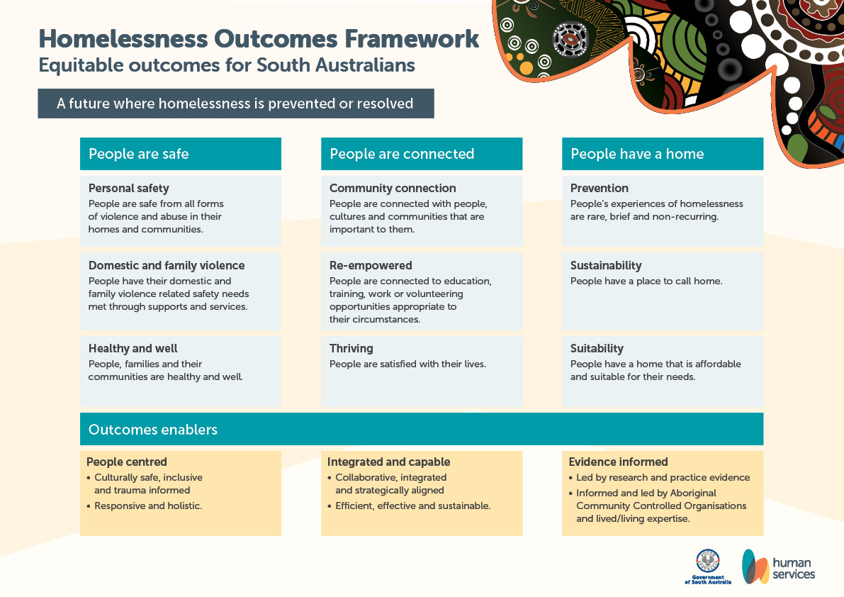

*Figure 2: The highest level of the Homelessness Outcomes Framework. There is a plain text description in* *Appendix A*

## Theories of Change

Taking the Homelessness Outcomes Framework’s high-level articulation of “what good looks like”, the client-level and system-level theories of change aim to describe the relationship between activities and outcomes in more detail, by outlining the:

* service activities that contribute to client outcomes and system outcomes enablers,
* short- to medium-term client outcomes that contribute to social impact (Client-level), and
* system preconditions for that impact (System-level).

The theories of change also outline the assumptions we believe to be the case for short- to medium-term outcomes to be possible, and the risks which may prevent or reduce the likelihood of these outcomes occurring.

Both theories of change describe distinct areas of purpose that scaffold targeted data collection. For the Client-level theory of change, this enables monitoring service activities and outputs (the space of ‘performance’) and understanding what change is occurring as a result (the space of ‘learning’). Similarly, the System-level theory of change describes the elements of system outcomes enablement that can be measured through data mechanisms (e.g., rubric scales).

### Wellbeing models

Consistent with the DHS Outcomes Framework, the Homelessness Outcomes Framework and its respective theories of change embed elements of Social and Emotional Wellbeing (SEWB) and the Social Determinants of Health (SDoH).

SEWB is model sensitive to the needs of Aboriginal and Torres Strait Islander peoples in which wellbeing is defined as the networked relationships of people with family, kin and community, as well as “connection to land, culture, spirituality and ancestry”.[1] The Homelessness Outcomes Framework and its theories of change emphasise the importance of a people-centred system that is culturally safe for Aboriginal and Torres Strait Islander peoples, and informed and led by Aboriginal Organisations and lived/living experience. These features are prerequisites for working toward client outcomes related to safety, connection and home, in a manner that is sensitive to the elements of SEWB for Aboriginal and Torres Strait Islander peoples.

The Social Determinants of Health outline socially alterable conditions, beyond individual genetic/biological factors, which contribute health and wellbeing. These social determinants include access to quality housing, education, social supports, employment opportunities, in addition to health care.[2] The Homelessness Outcomes Framework presupposes that providing people with access to the opportunities and resources they need will positively change their circumstances and improve their health and wellbeing.

DHS acknowledges that each Specialist Homelessness Service partner will not be directly working toward every outcome outlined in the Homelessness Outcomes Framework. Instead, the “Integrated and capable” outcomes enabler implies that, where a partner does not directly deliver activities to address a client’s presenting need, that partner will understand who within the system that client can be referred to. In this way the Homelessness Outcomes Framework is a system-wide framework which speaks to relationships within the system that are also crucial to support Social and Emotional Wellbeing and the Social Determinants of Health.

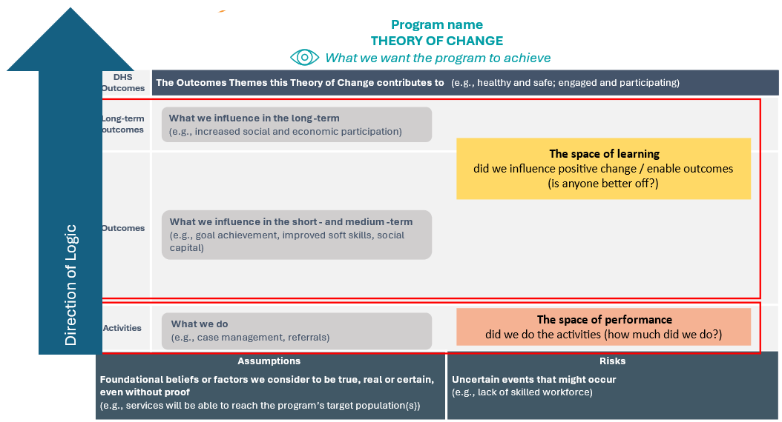

*Figure 3 Theory of Change logic:* clarifies how to read the logic of the Homelessness Outcomes Framework Client level and Systems-level theory of change (from bottom to top). The logic outlines the role of Outcomes as a space for learning and understanding, while Activities are the space for performance management.

### Key Clarifications

* The logic of the Client- and System-level theories of change moves vertically from the bottom of the page.
* The theories of change are system-wide and do not assume that SHS will deliver all the activities outlined in the theories of change, that all service partners are working directly toward every client outcome stated in the Client-level theory of change.
* The theories of change speak to the outcomes that SHS can directly contribute to or influence, to enable targeted measurement of impact.
* While the short-to-medium-term outcomes of the Client-level theory of change are represented as vertically linear, these groups of statements do not capture the complex real-life sequences by which change occurs for people. As such, the Client-level theory of change does not imply that change is either linear or that it happens identically for all people. Instead, the outcomes indicate some of the changes we assume are likely to happen for people because of the activities.
* The arrows connecting the short-to-medium term outcomes in the theories of change are not intended to imply direct causality. Rather, they outline plausible relationships between different changes.   
    
  For example, in the Client-level theory of change it is reasonable to assume that if people develop trust in service personnel, they are more likely to engage with that service in future. Even if this is not always the case given the variety of external factors clients experience outside the influence of SHS, we assume building trust and rapport with clients is possible and crucial for ongoing service engagement.   
    
  Similarly, in the System-level theory of change we assume that service relationships must be built at the community level before information and resources can be shared, noting that there may be other factors not described in the theory of change which prevent this sharing.
* Where the theory of change states an “increase” in something (e.g. increased connection education or economic participation), these shifts in people’s situation are only relevant where a client has those specific needs in their case plan, not all homelessness clients.

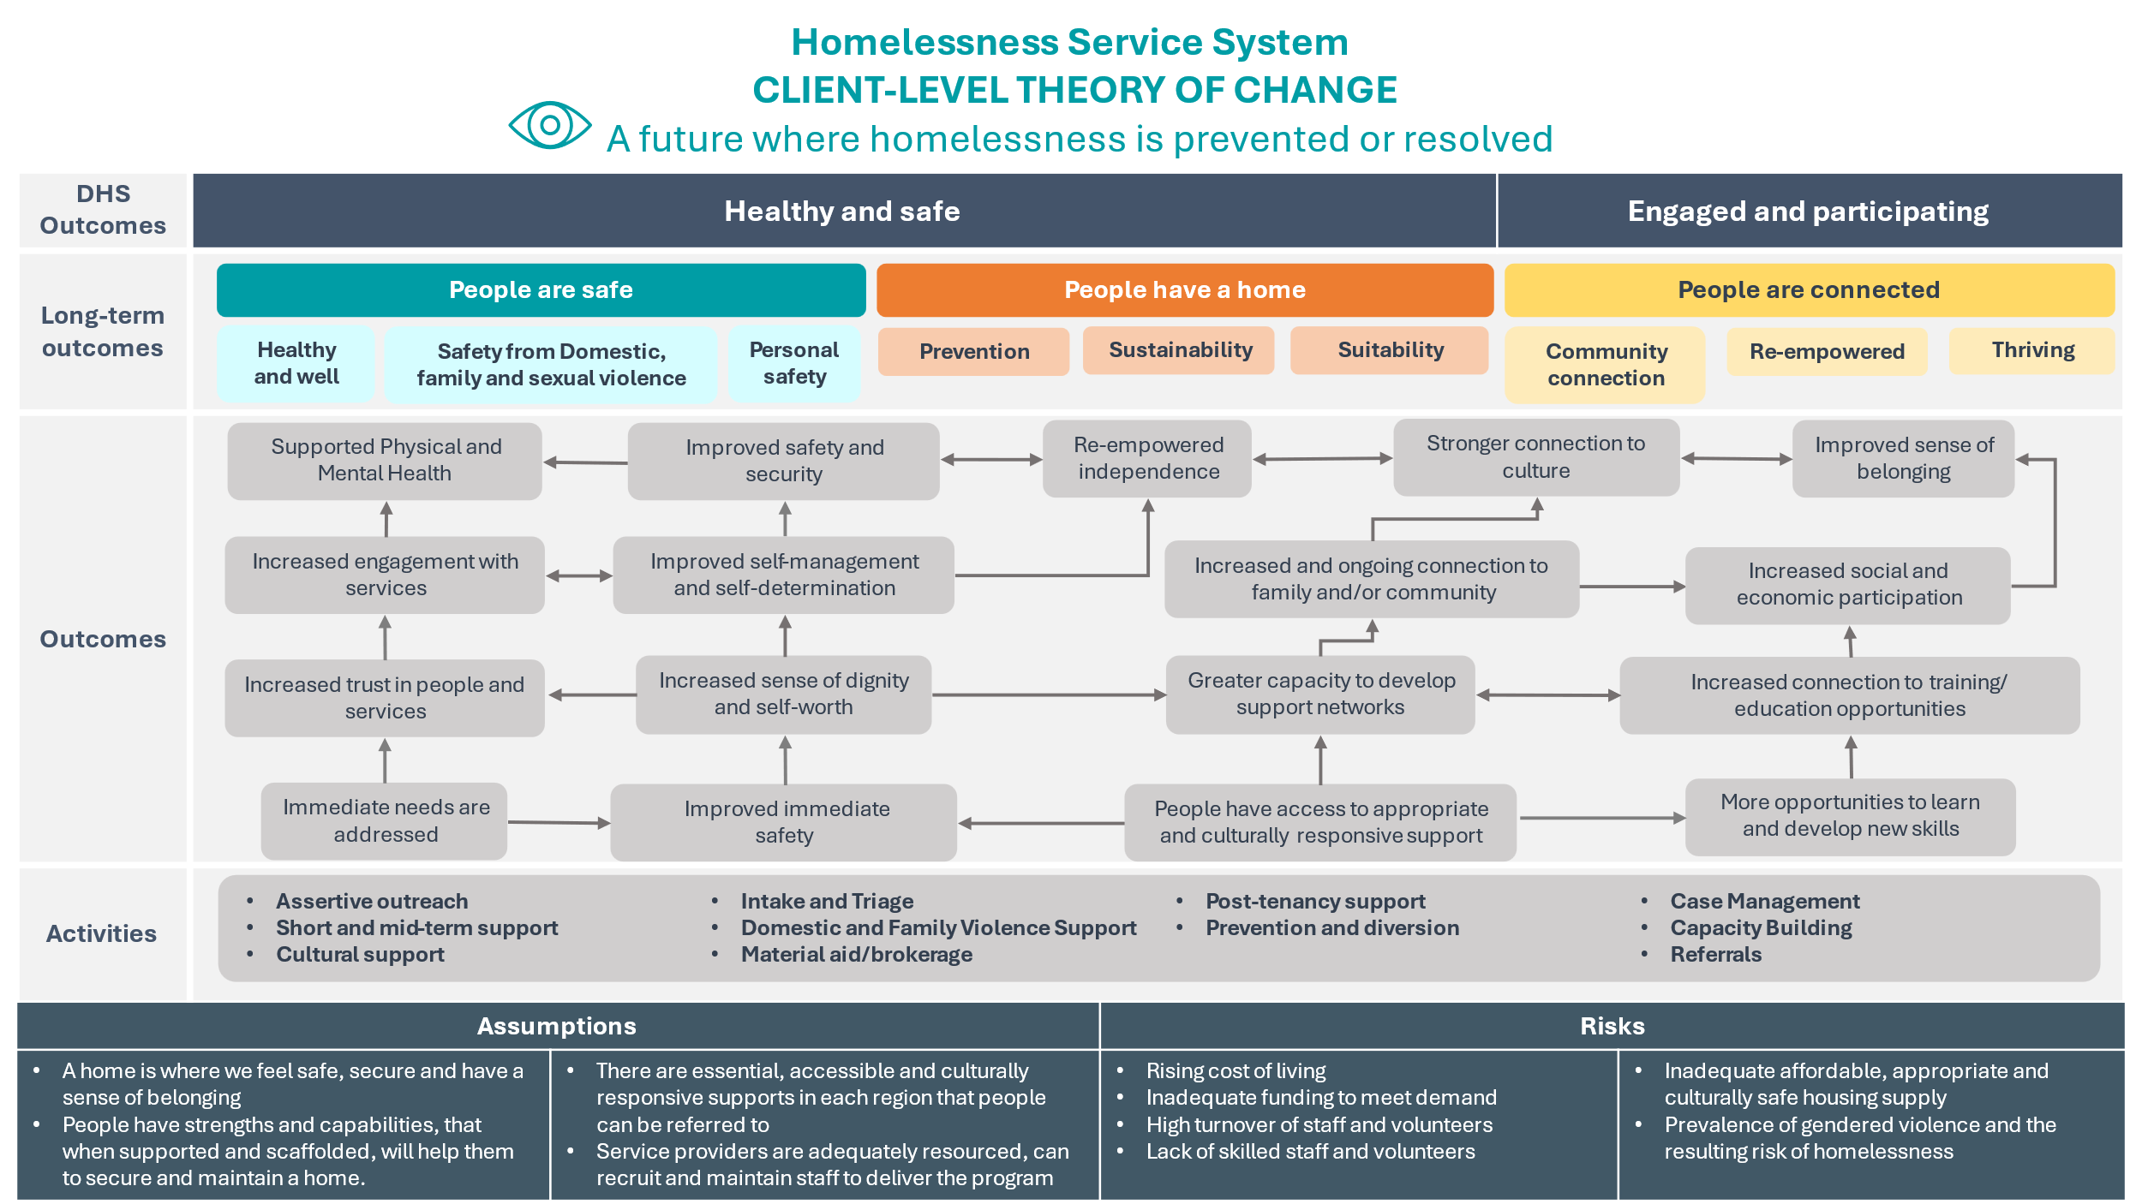

*Figure 4. Client-Level Theory of Change. There is a full plain text description in* *Appendix A*

This diagram shows the Theory of Change from assumptions and risks through to activities, short, medium, and long-term outcomes, and broader DHS Outcomes Framework outcomes. It recognises that homelessness services won’t deliver all activities or work directly toward every client outcome.

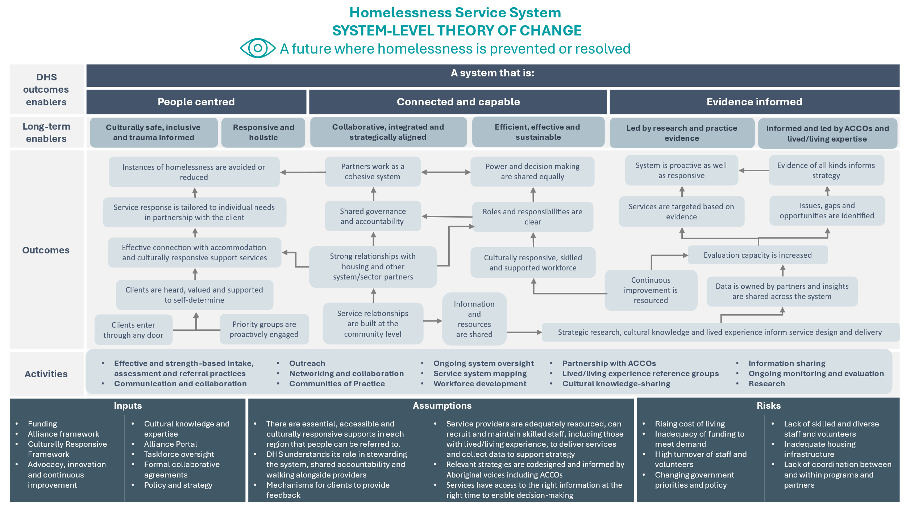

*Figure 5. System-Level Theory of Change. There is a full plain text description in* *Appendix A*

This image shows the system-level Theory of Change—from assumptions and risks to activities, outcomes over time, and broader DHS Framework outcomes. It reflects system-wide change and does not assume homelessness services deliver all activities shown.

## Appendix A – plain text descriptions of diagrams

### Figure 1: The DHS Outcomes Framework

The framework is represented as two large circles.

One circle shows Outcomes Enablers that the service system uses to enable outcomes. Outcome Enablers include; people-centred approaches, evidence-informed approaches and systematised alliances.

A second circle shows Outcomes Clusters and Themes that DHS seeks to achieve.

Clusters include; Thriving, Included strong and respected, Healthy and safe, Engaged and participating and Empowered.

Themes include; Self-directing, Flourishing, Included, Strong, Respected, Health and well, Safe and Secure, Engaged, Connected, Financially well, Self-advocating and Contributing.]

### Figure 2: The highest level of the Homelessness Outcomes Framework

The Framework is read from the bottom to the top.

The bottom section refers to the 3 broad Outcomes Enablers and associated elements:

* People-centred
  + Culturally safe, inclusive and trauma-informed
  + Responsive and holistic.
* Integrated and capable
  + Collaborative, integrated and strategically aligned
  + Efficient, effective and sustainable.
* Evidence-informed
  + Led by research and practice evidence
  + Informed and led by Aboriginal Community Controlled Organisations and lived/living experience.

The middle section includes 3 broad outcomes clusters:

* People are safe
  + Personal safety: people are safe from all forms of violence and abuse in their homes and communities.
  + Domestic and family violence: People have their domestic and family violence-related safety needs met through supports and services.
  + Healthy and well: People, families and their communities are healthy and well.
* People are connected
  + Community connection: People are connected with people, cultures and communities that are important to them.
  + Re-empowered: People are connected to education, training, work or volunteering opportunities appropriate to their circumstances.
  + Thriving: People are satisfied with their lives.
* People have a home
  + Prevention: People’s experiences of homelessness are rare, brief and non-recurring.
  + Sustainability: People have a place to call home.
  + Suitability: People have a home that is affordable and suitable for their needs.

At the top of the image is a vision statement that reads; "A future where homelessness is prevented or resolved”.

Closing the Gap is referenced at the top of the Homelessness Outcomes Framework, as the overarching strategic driver for the Homelessness Outcomes Framework.

### Figure 4: Client-Level Theory of Change

This Theory of Change is read from the bottom to the top.

#### Risks

#### Rising cost of living

#### Inadequate funding to meet demand

#### High turnover of staff and volunteers

#### Lack of skilled staff and volunteers

* Inadequate affordable, appropriate and culturally safe housing supply
* Prevalence of gendered violence and the resulting risk of homelessness

#### Assumptions

#### A home is where we feel safe, secure and have a sense of belonging

#### People have strengths and capabilities, that when supported and scaffolded, will help them to secure and maintain a home.

#### There are essential, accessible and culturally responsive supports in each region that people can be referred to

#### Service providers are adequately resourced, can recruit and maintain staff to deliver the program

#### Activities

* Assertive outreach
* Short and mid-term support
* Cultural support
* Intake and Triage
* Domestic and Family Violence Support
* Material aid/brokerage
* Post-tenancy support
* Prevention and diversion
* Case Management
* Capacity Building
* Referrals

#### Outcomes

* Immediate needs are addressed
* Increased trust in people and services
* Increased engagement with services
* Supported Physical and Mental Health
* Improved immediate safety
* Increased sense of dignity and self-worth
* Improved self-management and self-determination
* Improved safety and security
* People have access to appropriate and culturally responsive support
* Greater capacity to develop support networks
* Increased and ongoing connection to family and/or community
* Re-empowered independence
* More opportunities to learn and develop new skills
* Increased connection to training/education opportunities
* Increased social and economic participation
* Improved sense of belonging

#### Long-term outcomes

**Homelessness Outcomes Framework**

**People are safe:**

* Health and well
* Safety from domestic, family and sexual violence
* Personal safety

**People have a home:**

* Prevention
* Sustainability
* Suitability.

**People are connected:**

* Community connection
* Re-empowered
* Thriving

#### DHS outcomes

There are 2 main DHS outcomes:

* Healthy and safe
* Engaged and participating.

#### Vision

A future where homelessness is prevented and resolved.

### Figure 5: Homelessness Service System — System-level Theory of Change

This Theory of Change is read from the bottom to the top.

#### Inputs

* Funding
* Alliance framework
* Culturally Responsive Framework
* Advocacy, innovation and continuous improvement
* Cultural knowledge and expertise
* Alliance Portal
* Taskforce oversight
* Formal collaborative agreements
* Policy and strategy

**Assumptions**

* There are essential, accessible and culturally responsive supports in each region that people can be referred to
* DHS understands its role in stewarding the system, shared accountability and walking alongside providers
* Mechanisms for clients to provide feedback
* Service providers are adequately resourced, can recruit and maintain skilled staff, including those with lived/living experience, to deliver services and collect data to support strategy
* Relevant strategies are codesigned and informed by Aboriginal voices including ACCOs
* Services have access to the right information at the right time to enable decision-making

#### Risks

* Rising cost of living
* Inadequacy of funding to meet demand
* High turnover of staff and volunteers
* Changing government priorities and policy
* Lack of skilled and diverse staff and volunteers
* Inadequate housing infrastructure
* Lack of coordination between and within programs and partners

#### Activities

* Effective and strength-based intake, assessment and referral practices
* Communication and collaboration
* Outreach
* Networking and collaboration
* Communities of Practice
* Ongoing system oversight
* Service system mapping
* Workforce development
* Partnership with ACCOs
* Lived/living experience reference groups
* Cultural knowledge-sharing
* Information sharing
* Ongoing monitoring and evaluation
* Research

#### Outcomes

* Clients enter through any door
* Clients are heard, valued and supported to self-determine
* Effective connection with accommodation and culturally responsive support services
* Service response is tailored to individual needs in partnership with the client
* Instances of homelessness are avoided or reduced
* Priority groups are proactively engaged
* Service relationships are built at the community level
* Strong relationships with housing and other system/sector partners
* Shared governance and accountability
* Partners work as a cohesive system
* Information and resources are shared
* Culturally responsive, skilled and supportive workforce
* Roles and responsibilities are clear
* Power and decision making are shared equally
* Strategic research, cultural knowledge and lived experience inform service design and delivery
* Continuous improvement is resourced
* Data is owned by partners and insights are shared across the system
* Evaluation capacity is increased
* Services are targeted based on evidence
* Issues, gaps, and opportunities are identified
* Evidence of all kinds informs strategy
* System is proactive as well as responsive

#### Long-term enablers

* Culturally safe, inclusive and trauma informed
* Responsive and holistic
* Collaborative, integrated and strategically aligned
* Efficient, effective and sustainable
* Led by research and practice evidence
* Informed and led by ACCOs and lived/living expertise

#### DHS outcomes enablers A system that is:

* People centred
* Connected and capable
* Evidence informed

#### Vision

A future where homelessness is prevented and resolved.

1. National Strategic Framework for Aboriginal and Torres Strait Islander Peoples’ Mental Health and Social and Emotional Wellbeing (2017–2023), p.6.
2. World Health Organization. (2025) *Social Determinants of Health*, [https://www.who.int/health-topics/social-determinants-of-health#tab=tab_1](https://www.who.int/health-topics/social-determinants-of-health)