Domestic, Family and Sexual Violence Lived Experience Advisory Group

Self-Reflection Guide
We understand people with lived experience of domestic, family and sexual violence are strongly motivated to help others avoid the same experiences.
As a member of the Lived Experience Advisory Group (LEAG) you are not required to share the details of your own experiences, but you may reflect on these experiences to provide input and expertise into discussions and activities as part of the group. This may be uncomfortable and challenging at times. It is important you feel ready and safe to participate before you apply to join the LEAG.
This guide is designed for your use to consider your motivation for joining the LEAG and consider whether this is the right option for you. You do not need to share your answers with us, these questions are just for you to think about (alongside a support person if required) before you submit your expression of interest.

Areas of influence
Using your lived experience can occur in many ways. The below outlines the differing ways that domestic, family and sexual violence lived experience can influence.
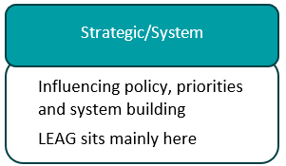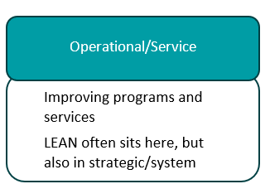
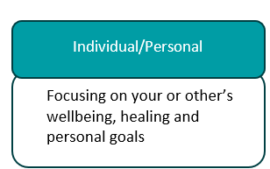
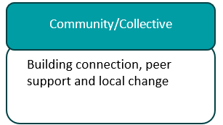
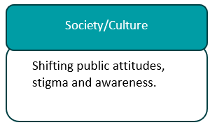

Step 1 - Reflecting on why you want to join the LEAG
It is important to consider why you want to join the LEAG and what your reasons are for participating.
Place an X next to all those reasons relevant to you in the right column. Once completed, look at where the majority of your reasons sit in the sphere of influence (second column).

Your reason for being involved | Category | Place an X next to those relevant to you
Raise awareness about experiences of domestic, family and sexual violence | Society/Culture
Reducing stigma | Society/Culture
Normalising domestic, family and sexual violence discussions and struggles | Society/Culture
Righting a wrong that happened to me or a loved one | Individual/Personal
Speaking up for my rights | Individual/Personal
Want to right a wrong that happened to a group of people | Community/Collective
Want to fill a gap in support or services | Community/Collective
Want to create a community connection | Community/Collective
Provide education to staff in the domestic, family and sexual violence sector, government or people without lived experience | Operational/Service
Want to make changes to a particular service or program | Operational/Service
Want to create systems change | Strategic/System
Ensure survivor voices shape priorities | Strategic/System
Improve safety, accessibility and cultural safety of responses for diverse victim-survivors | Strategic/System
Strengthen accountability of services and systems to victim-survivors | Strategic/System
Contribute to design of policies, pathways and resources that reduce harm and improve outcomes | Strategic/System
Influence prevention approaches that challenge attitudes, behaviours and drivers of violence | Society/Culture
Improve coordination between services (e.g., police, courts, health, housing and specialist supports) | Strategic/System
Help reduce re-traumatisation by improving how systems engage with victim-survivors (trauma-informed practice) | Operational/Service
Support Royal Commission activities are practical, safe and responsive to lived experience | Strategic/System
Represent perspectives that are often unheard (e.g. people in rural areas, people with disability, older people, LGBTQIA+ people, multicultural communities) | Operational/Service
Promote ethical lived-experience engagement (e.g. safety, choice, support, and appropriate recognition for contributions) | Operational/Service
Use my experience to support my own healing and growth (in a safe and supported way) | Individual/Personal
Regain a sense of agency by contributing to change that aligns with my values | Individual/Personal
Build confidence and skills (e.g. communication, advocacy, leadership) | Individual/Personal
Be part of something purposeful, while practicing my limits and boundaries | Individual/Personal
Improve service information and communication so it is clear, accessible and easy to find | Operational/Service
Test and improve processes so they are trauma-informed and respectful | Operational/Service
Strengthen feedback and complaints pathways so people feel safe to raise concerns and see improvements | Operational/Service

Where do your reasons sit?
Count up how many of your answers sit under each of the areas of influence (society, individual, community, operational or strategic).
Area of Influence | Total number of answers
Society/Culture
Individual/Personal
Community/Collective
Operational/Service
Strategic/System
If you have more that sit in the strategic/system area, then this might mean your current area of influence aligns with the LEAG.

Alternative ways to complete this reflection: Values + Motivation Map
If you prefer a more open-ended reflection (rather than using the table above), you can use this Values + Motivation Map. You do not need to share your answers with us.
Prompt | My notes
What I am hoping to change
(society, community, service, system/personal)
What matters most to me
(safety, justice, prevention, dignity, respect, healing)
What I can realistically offer
(skills, perspective, time, energy, limits and boundaries)
Then ask which area of influence fits my goals best right now

Step 2 - Reflection questions
The questions below are based on those specifically developed to support people with lived experience to reflect on and decide whether to participate in groups such as the LEAG. Take the time to reflect on each question.

Readiness
- What are my reasons for wanting to join the LEAG?
- Do I want to be a part of the LEAG? Or am I feeling like I should?
- Is this the most appropriate group for me to be a part of?
- Am I ready to talk about my personal experience if it is relevant/needed, and am I ready to hear others talk about their experiences if relevant/needed?
- Have I had sufficient time since my experience to feel ready and safe to be in conversations about domestic, family and sexual violence without it impacting my emotional wellbeing too much?

Resources & Support
- Do I have enough resources in place both personally and professionally to prevent my health and wellbeing are not negatively impacted by participating? (These can be formal supports such as workers or services and informal supports like family, friends and pets.)
- How will I manage the emotions when talking about family, domestic and sexual violence?
- What strategies will I use if someone reacts negatively or judgmentally to my expertise and experiences during the meetings?

Safety considerations
- Is it safe for me to be involved?
- Are there any ongoing risks posed by the person/s who caused me harm?
- Are there strategies that can be put in place to increase my safety?
- If I have any concerns about my safety, do I feel comfortable discussing these with the LEAG secretariat and working together with them to address the safety concerns?

Boundaries/privacy
- What are my personal limits regarding how much I am willing to share or contribute?
- Am I clear on other boundaries established by the LEAG Terms of Reference, for example, members cannot speak publicly on behalf of the LEAG?
- Am I clear about the limitations of this role?
- Can I commit the time needed to attend and prepare for LEAG meetings?
- Do I want to participate in the LEAG anonymously?
- Am I able to use my own name or do I want to provide a different name?
- Would I want my colleagues or family members to know I am involved in the LEAG?

Legal considerations
- Am I involved in any ongoing legal proceedings that may not allow me to be involved?
- Are there any potential legal consequences for me to participate?

Privacy
- What information am I ready to share and what information do I want to keep private?
- Do I want to participate in LEAG meetings using my own name or a pseudonym (made up name)?
- Is it ok for photos to be used of me in promotional materials or online?

Other considerations
- Are there people in my life who I think should be aware of my decision to participate in the LEAG? If so, what might they think or feel about my participation?
- How might my children or family feel about my decision to participate? How might my decision impact them?
- How might my community feel about and react to my decision to participate? How might their responses impact me?
- Are the next two years looking fairly predictable and stable for me to be able to participate?

Lamb K, Hegarty K, Amanda, Cina, Fiona, and the University of Melbourne WEAVERs lived experience group, Parker R. (2020) The Family Violence Experts by Experience Framework: Domestic Violence Victoria. Melbourne, Australia. The Family Violence Experts by Experience Framework Report. Acknowledgement The reason section has been expanded from LELAN SA materials for the purposes of the DFSV LEAG.

