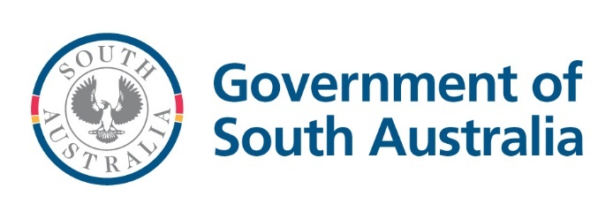

# Creating a secure food system in South Australia

## At a glance

* In a partnership between Preventive Health SA and the Department of Human Services (DHS), the ‘Creating a secure food system in South Australia’ project was commissioned to better understand South Australians’ experience of food insecurity, and to explore what is needed to ensure all South Australians can access enough safe and healthy food.
* Throughout the two stages of the project, 635 voices were heard representing people with lived experience of food insecurity, people working directly with people experiencing food insecurity and food systems stakeholders.
* The project highlighted that both the root causes of food insecurity and the current access to food and food relief are important priorities for the community and stakeholders.
* A range of suggested actions were identified, requiring multi-sector involvement from state and federal government, local government, food relief, researchers, the food supply chain and community sector organisations.

## What we’ve done

### Stage 1

The Centre for Social Impact Flinders were engaged to develop an evidence-based discussion paper which considered how best practice food systems in communities that experience high levels of food insecurity could be applied in the South Australian context. A total of 145 participants took part in the stakeholder workshops representing 124 organisations.

### Stage 2

The South Australian Council for Social Service and DemocracyCo were engaged to consult with people with lived experience of food insecurity to understand how food insecurity impacts their life and what tangible actions would benefit them the most. Just under 500 South Australians were engaged in this process, through an online public survey as well as community conversations and a community panel of people with lived or living experience of food insecurity.

## Next steps

Building on the investments that DHS already makes to support food security, DHS is developing a Social Supermarket Program to improve dignified access to affordable food and support connection to others and support services that they may need. This new initiative will enable the food relief sector to evolve their service models to ‘go beyond food relief’, towards support to addressing root causes of food insecurity.

DHS will continue to work with food systems stakeholders and the food relief sector community of practice to improve food security in SA.