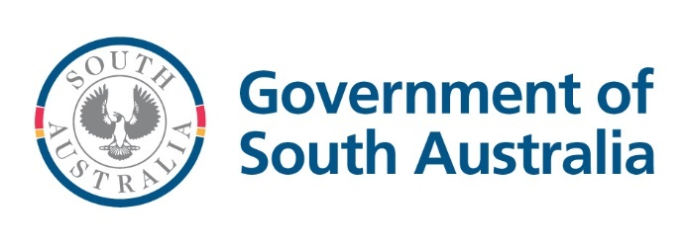

# Creating a secure food system in South Australia

An exploration of the evidence base and stakeholder’s experiences to create a food system that supports South Australians experiencing food insecurity.

2025

## Minister’s Foreword

"I am pleased to share the Summary Report — Creating a secure food system in South Australia. The evidence and outcomes from the Secure Food System Project are well highlighted.

The Summary Report is the outcome of work undertaken in partnership between the Department of Human Services and Preventive Health SA. This culminates a vision towards establishing a better understanding of South Australians’ experience of food insecurity, and what could help people better access affordable, nutritious food.

This work is important because we want to better understand how food insecurity impacts our community and what can be done to make it easier for people to access good food and enough food. It is important for government to lead this collective work and to truly know how the research and evidence affects people’s lives.

We cannot fully understand or achieve food security without the energy, insight and action of direct experience. This Report incorporates the voices of more than 600 people, including people with lived experience of food insecurity, people working directly with those experiencing food insecurity, and stakeholders from the food systems sector.

My sincere thanks to all those who have contributed to this Project, for their awareness, honesty, and continued commitment to improving access to healthy food.

I acknowledge and thank the Centre for Social Impact Flinders University, the SA Council of Social Service (SACOSS), and DemocracyCo, for delivering the respective stages of this Project on behalf of the government. I also thank the Project Advisory Group from the Department of Human Services and Preventive Health SA.

We heard many South Australians experience challenges and barriers to accessing safe and nutritious food. Two key themes emerged:

1. People want to access affordable, dignified and respectful food relief services that offer choice, as well as simpler ways to access nutritious and affordable food, and;
2. To make a meaningful impact on food insecurity in South Australia, we need to tackle the root causes of inequality which prevent people from getting enough healthy food.

We learnt a collaborative and cooperative multi-systems approach is needed to create a secure food system. We must also address the urgent need to optimise food relief services and other supports available in the community.

The release of this Summary Report and associated findings bring with it the opportunity to better align efforts that support people in our communities with cost-of-living pressures, and to improve their access to affordable food.

I am pleased to share this Summary Report and associated Project reports, which will provide a strong foundation for collective action required to keep building food secure systems.

I look forward to what is still to come and take this opportunity to call to action all those who have a part to play in enhancing our food systems. We remain steadfast in our commitment to achieving better access to safe, affordable and healthy food for all South Australians.

**Hon Nat Cook MP**  
Minister for Human Services

Minister for Seniors and Ageing Well

Contents

**Minister’s Foreword 1**

**Introduction 4**

The six dimensions of food security (based on the HLPE 2020)i 4

Summary of stage one and stage two process and deliverables 5

**Stage one – Food secure communities in South Australia 5**

Process 5

Deliverables 6

Key findings 6

Figure 1: A ‘system’ model of a secure food system 7

Figure 2: Key themes for a secure food system 7

**Stage two – Secure food systems for South Australia 8**

Process 8

**Deliverables 9**

Key findings 9

**Suggested actions 10**

**Acknowledgements 10**

**Summary of key themes (consolidated from Stages 1 and 2) 11**

Food Security Dimension: Availability 11

Food Security Dimension: Access 11

Food Security Dimension: Utilisation 13

Food Security Dimension: Agency 13

Food Security Dimension: Sustainability 15

Food Security Dimension: Stability 16

**Annexure A 17**

A description of the Figure 1 image 17

A description of the Figure 2 image: 18

## Introduction

Food security exists when all people, at all times, have physical, social and economic access to sufficient, safe and nutritious food which meets their dietary needs and food preferences[1]. There are six dimensions that contribute to creating food security: access, availability, agency, utilisation, sustainability, and stability.I. Both individual and population level factors can influence these, resulting in food insecurity. These factors include poverty, cost of living, individual health, the political and economic environment, and climate change.

To achieve a secure food system which addresses these six dimensions, comprehensive and multi-sector commitment is required, involving a range of sectors across state and federal government (including but not limited to, health, primary industries, human services, transport), local government, food relief, researchers, the food supply chain and community sector organisations.

### The six dimensions of food security (based on the HLPE 2020)i

#### Access

That all people have physical, economic, and social access and opportunity to food, including the individual or household income to purchase food.

#### Availability

That there is an ample supply of healthy, fresh, safe, desirable, culturally-suitable food, across the entire food supply chain.

#### Agency

That individuals and communities can make decisions for themselves about the food they purchase and consume, can advocate for themselves, and help shape the food system, including food relief and other services.

#### Utilisation

That all people have the necessary skills and facilities to store, prepare, cook, and, where applicable, grow food, and can share those skills with others.

#### Sustainability

That food systems (including the food relief system) are designed and resourced for long-term natural, social, and economic sustainability.

#### Stability

That systems and structures are in place to address crisis, shocks, and other drivers of food insecurity.

One in six (16%) people in South Australia reported being food-insecure in April 2023[2]. Many of these people have found themselves increasingly and regularly reliant on food relief services to provide the food they need to feed themselves and their families. Recent data also suggests that food insecurity may be growing, and that it may be affecting parts of the community that have been less likely to experience food insecurity in the past, such as younger people, and people in paid employment[3],[4]. Food insecurity can increase the risk of chronic conditions such as type 2 diabetes, hypertension, and some cancers in adults, and in children can result in poorer overall health and sub-optimal developmental outcomes[5],[6],[7].

Preventive Health SA and the Department of Human Services (DHS) partnered to commission a two-stage project to better understand South Australians’ experience of food insecurity and what could help them to access enough safe and healthy food. Throughout the two stages of the project, **635 voices were heard** representing people with lived experience of food insecurity, people working directly with people experiencing food insecurity and food systems stakeholders.

External consultants were engaged to deliver the project, as outlined below. Further detail on each stage is provided in the following sections.

### Summary of stage one and stage two process and deliverables

#### Stage one – 2023

Consultant: Centre for Social Impact Flinders (CSI)

* Review recent evidence relating to best practice food systems in communities that experience food insecurity
* Engage key food system stakeholders
* Produce discussion paper with suggested actions to inform policy and action

#### Stage two – 2024

Consultants: South Australian Council of Social Service (SACOSS) and DemocracyCo

* Design and lead engagement with community members with lived experience of food security
* Produce report with key themes from lived experience
* Produce synthesis report summarising and combining suggested actions from stages one and two consultation

## Stage one – Food secure communities in South Australia

The Centre for Social Impact Flinders (CSI) was engaged to develop an evidence-based discussion paper which considered how best practice food systems in communities that experience high levels of food insecurity could be applied in the South Australian context.

### Process

#### Evidence review

A rapid evidence review was undertaken to help establish how to achieve more equitable, sustainable, and nutritious food systems in South Australia. The review focused on communities that are at risk of, or are experiencing, high levels of food insecurity and built upon past work that has described food systems and/or food security in South Australia.

#### Stakeholder workshops and deliberation

Key food system stakeholders were invited to participate in a two-phase workshop project to review the findings of the evidence review and contribute to the development of outputs to demonstrate key actors, optimal actions, and policy approaches.

A total of 145 participantstook part in the stakeholder workshops. One hundred and twenty-four (124) organisations were represented at the workshops, including local, state and federal government, community organisations and for-purpose sector, representative groups and organisations, and researchers and educators.

### Deliverables

The key deliverable was an evidence-based discussion paper which included results of the evidence review and stakeholder workshops, and suggested approaches and opportunities to create healthy, equitable and secure food systems in communities experiencing high levels of food insecurity.

### Key findings

The discussion paper highlighted the complex, multi-systems approach needed to create a secure food system. Figure 1 was created to describe a ‘system’ model diagram of key actors and determinants needed to create a food secure system. Figure 2 summarises the key themes from stage one at a sector level.

### Figure 1: A ‘system’ model of a secure food system

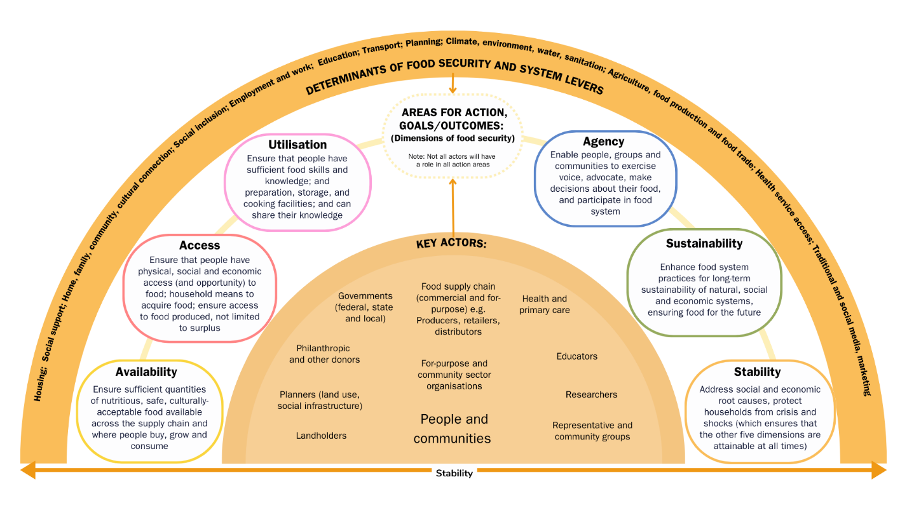

See Annexure A for an alternative description of Figure 1.

### Figure 1: Key themes for a secure food system

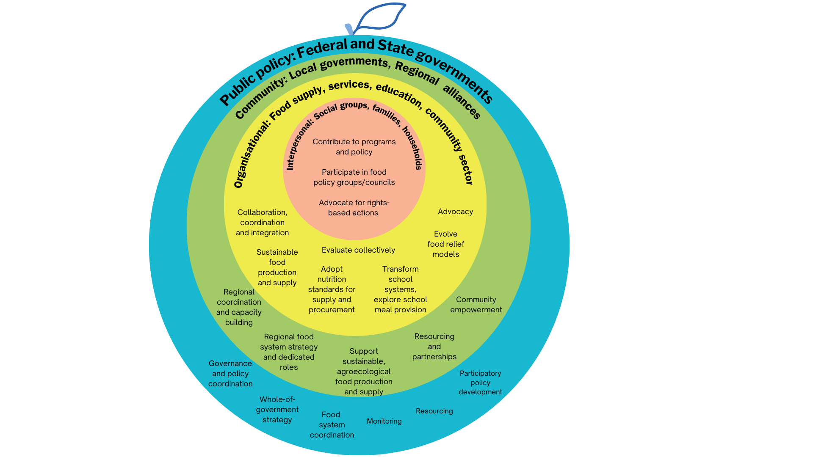

See Annexure A for an alternative description of Figure 2.

## Stage two – Secure food systems for South Australia

The South Australian Council for Social Service (SACOSS) and DemocracyCo engaged with people with lived experience of food insecurity to understand how food insecurity impacts their life and understand the tangible outcomes which would benefit them the most.

### Process

This process took a strengths-based approach, using a range of methods to engage key population groups.

#### Community survey

A public survey was developed and made available via the YourSAy platform to harness and generate the ideas of the public about initiatives they could do locally to contribute to the food security of all South Australians. There were 240 individual responses to the survey, including 130 people (54%) currently having trouble accessing safe and healthy food, and 173 (72%) who have ever had trouble accessing safe and healthy food.

#### Community conversations

A series of facilitated community conversations took place to understand how communities experience food insecurity. The community conversations attracted a wide range of participants, including substantial representation from groups most at risk of food insecurity. Of the 250 participants who attended the community conversations, 94 (38%) identified as having a disability, 59 (24%) were Aboriginal and/or Torres Strait Islander. Only 8 (3%) participants had full-time employment with 158 (63%) either unemployed or living on the pension.

#### Food security community panel

A community panel was established to consider how the results of the community survey and community conversations could be brought together and prioritised. Forty people recruited from the community conversations were invited to a deliberative forum on 29 June 2024 to consider the policy responses that would make the biggest difference to their lives. The panel used the opportunity to identify priority focus areas for a more food secure South Australia.

## Deliverables

A series of four reports were the key deliverables of stage two of the project:

* A report which summarised the results of the community survey.
* A report which summarised the results of the community conversations.
* A report which summarised the results of the community panel.
* A final report which bought together the results and suggested actions of stage 1 and stage 2 of the project.

### Key findings

Through the community survey and conversations, people with lived experience of food security provided unique and valuable insights into the challenges they face in obtaining adequate and appropriate food for themselves and their families. Key messages from the community included:

* People experiencing food insecurity choose between buying food and paying bills or medications, or are having to choose foods that don’t support good health.
* Many parents are skipping meals to put food on the table for their children.
* Parents want to provide a good start for their children. While schools play a key role in supporting children whose families are experiencing food insecurity, the services they offer are often inadequate or unreliable. There was strong interest in expanding existing school initiatives (for example, breakfast programs), foods in childcare and exploring new options such as school lunch programs.
* Many people experiencing food insecurity are also experiencing complex personal challenges, such as trauma, multiple physical and mental health difficulties, and substance abuse. These factors make it harder for people with low incomes to eat healthily and engage with food relief and financial services. Many feel judged and ashamed when seeking help from these services.
* Rising living costs means that people who have not previously needed to access food relief services before (for example, people with employment) are unable to buy enough food. When support is lacking, families and communities often help out, but those without such support are more affected by food insecurity.
* Access to and utilisation of supermarkets, food relief and financial support services can be difficult due to transport options, limited opening hours (especially outside of business hours) and limited ability to speak English.
* Many people don’t have access to the cooking facilities required to prepare foods provided from food relief, and the food provided is often not appropriate or desirable – fresh foods are often close to the end of their shelf life and it can be challenging to access foods that meet medical, dietary or sensory needs, particularly in remote areas.

## Suggested actions

In both stage one and stage two people wanted action on the root causes of food insecurity (low incomes and high living costs), improved availability of nutritious, fresh, suitable food, and improved access to food relief and food retailers. The need for more dignified, less stressful access to food relief was a dominant theme across stage one and stage two, but for people with lived experience, who often already interact with multiple, complex bureaucracies that can leave them feeling disempowered and inadequate – such as the income support and employment services systems – this need was felt very intensely.

A summary of themes synthesised from both stages, aligned to the six dimensions of food security, is presented on the following pages. These themes highlight what governments, and other stakeholders can do to make a difference to people living with food insecurity. While government action is required, governments can’t do it alone. Government, non-government, the community, and individuals all need to work together to develop approaches that complement each other.

## Acknowledgements

Thank you to the food system stakeholders who participated and provided valuable contributions and perspectives during stage one of the project.

A very special thank you to all the South Australians who participated in stage two of the project. The Government of South Australia acknowledges the individual and collective experiences of South Australians with lived experience of food insecurity and would like to recognise their courage in sharing their experiences and perspectives throughout this process.

The Government of South Australia would also like to acknowledge and thank the Centre for Social Impact Flinders University, SACOSS and DemocracyCo for undertaking this work on behalf of the government.

## Summary of key themes (consolidated from Stages 1 and 2)

Local communities and people with lived experience of food insecurity should be engaged across all domains of action.

### Food Security Dimension: Availability

#### Theme 1:Increase availability of nutritious foods in all locations

Increase availability of nutritious foods through ensuring equal availability of foods regardless of location, reducing food waste, and affordable farmers markets1

##### What’s happening

Recognising that many stakeholders are required to create a food system which supports equitable availability of nutritious food across South Australia, the SA Government co-ordinates a regular Community of Practice with the food relief sector and key agencies.

#### Theme 2:Increase availability of nutritious foods in food relief

Increase availability of nutritious foods in food relief including availability of foods for specialised diets (for example, gluten free)2.

##### What’s happening

Food relief agencies are encouraged to increase the availability of nutritious food relief by incorporating the following requirements and expectations within all food relief funding agreements:

1. following the principles of the SA Food Relief Charter and Nutrition Guidelines; and
2. requiring food relief agencies to report on the amount of kilograms food relief agencies procure and distribute each year

Theme 3: Transition public sector procurement preferences

Transition public sector procurement to preference healthy, local, sustainably-produced food.3

##### What’s happening

The procurement of healthy and locally produced food is prioritised through preferencing South Australian suppliers. This is supported through applying the SA Industry Participation Policy (SAIPP), and the inclusion of nutrition-based criteria when tendering for food and drink suppliers.

### Food Security Dimension: Access

#### Theme 4: Reduce cost of living pressures

Reduce cost of living pressures through a variety of means including increases to income support payments, action to combat rising rents and utility costs, and cap the price of staple and fresh food.1

It is recognised that income support and food pricing regulation fall within the remit of the Australian Government.

##### What’s happening

The Department for Human Services (DHS) has invested in food relief since 2018. DHS funds a range of food relief and food security providers to support South Australian’s in need to access food.

In response to cost of living pressures, DHS provides funding to non-government organisations to deliver services to assist South Australians to manage their cost of living expenses, help those experiencing financial stress and crisis and provide food security.

Additionally, concessions are provided for energy, water, sewerage, Cost of Living Concession, Emergency Services Levy (fixed property), and Medical Heating and Cooling. Key household concessions increased by 4.8% in 2024-25, in line with inflation.

Due to above-indexation increase to SA Water prices, water and sewerage concession customers will receive a further increase of up to $8 per quarter in 2024-25. Due to the above-CPI increase to SA Water prices, the water concession has been increased by 10.8% and the sewerage concession has been increased by 20.9%.

In 2024-25, with the Energy Bill Relief rebate, this provides total government concession relief of up to $1,437 for eligible pensioners who own their own home.

#### Theme 5: Improve physical access to nutritious foods

Improve physical access to nutritious foods (for example, through improving transport, delivery and location options).1

##### What’s happening

Increasing physical access to food is being achieved through:

* grants such as the Grants SA Addressing food security grants (2023)
* providing transport options through the SA Community Passenger Network.
* supporting establishment of new social supermarkets and increasing the capacity and infrastructure of existing social supermarkets.

#### Theme 6: Information about food relief is easily accessible

Information about food relief services is easily accessible, both in hard copy and online, including strengthening digital inclusion measures so that community members have access and ability to use online information resources.1

##### What’s happening

DHS provides financial support for Affordable SA, an online resource hub providing information on emergency relief, food and financial counselling services.

To support digital literacy, the Government of South Australia has published an ICT, Cyber Security and Digital Government Strategy Plan 2020–2025 that directs SA Government websites to publish content that is certified as compliant with the Web Content Accessibility Guidelines to improve digital inclusion.

SA Grants 2024 Digital Inclusion Grants: Bridging the Digital Divide offered grants of up to 20 thousand dollars to provide to community organisations to help overcome barriers to digital access and funded projects to:

* Purchase digital equipment for community use
* Improve the accessibility of websites or digital platforms
* Run workshops to teach digital skills and online safety
* Expand existing digital education programs

#### Theme 7:Increase access to nutritious food for children

Increase access to nutritious food for children through free universal school lunch programs and expanding existing free breakfast programs.1

##### What’s happening

The Government of South Australia supports children’s access to nutritious food through:

* the expansion of the free school breakfast program across South Australian public schools to 90% of the most disadvantaged schools in 2024; and
* grants such as the Department for Education Food security grants which provided $500,000 to 144 schools, preschools and education centres in 2024.

### Food Security Dimension: Utilisation

#### Theme 8: Improve people’s food preparation skills

Improve individual skills to grow1, prepare and cook3 nutritious food.

Increase dignified access to facilities and infrastructure which support growing1, preparing2 and storing2 nutritious food.

##### What’s happening

The Government of South Australia recognises the value of community-led, place-based initiatives, and supports communities to improve infrastructure and food literacy by providing a range of grants, including:

* Grants SA Addressing food security grants (2023); and
* Department for Education Food security grants

### Food Security Dimension: Agency

#### Theme 9: Engage with lived experience

Increase the voice and power of lived experience to engage with and shape government decision making, policy design and policy implementation

Meaningfully engage with community stakeholders and people with lived experience to influence/shape service development and delivery, and policy design.1

##### What’s happening

Agencies and networks are encouraged to follow the ‘Better Together Principles of Engagement’ during community engagement processes. Through the South Australian Food Relief Community of Practice, members are encouraged to represent their agency and the needs of the community they serve.

The following lived experience networks engage with their communities and encourage representation:

* Central Adelaide Local Health Network (CALHN) Lived Experience Workforce in South Australian Public Mental Health Services
* DHS Child Family Support Services (CFSS) Lived Experience Network (LEN) convenes a group of people of diverse ages, cultures and backgrounds who have lived or living experience of the CFSS
* Annual SA Youth Parliament Program, run by the YMCA, is run by young people for young people empowering them to drive positive change by bridging youth voices and opinions with political leaders and decision-makers
* DHS Youth, Disability and LBGTIQA+ Minister's Advisory Councils are made up of people from the community sharing ideas and experiences to help shape strategies and policies in South Australia

#### Theme 10: Support local community food system responses

Establish groups to organise local community food system responses, including in First Nations communities3

##### What’s happening

To support local responses from local government and community organisations, the Government of South Australia provides a range of grants, including:

* Preventive Health SA Strengthening our Culture community grants (available for Aboriginal communities in SA – 2024-2025).
* Grants SA Addressing food security grants (2023); and
* Department for Education Food security grants

#### Theme 11: Expand options for dignified food relief

Expand options for dignified food relief for all. For example, social supermarkets.1

##### What’s happening

DHS is expanding the Social Supermarket Program to provide dignified access to low-cost food in a retail-like setting. The service will be available to everyone; there will be no eligibility tests. Social supermarkets will offer access to social services aimed at helping people navigate food insecurity, foster community connections, and provide additional support or referrals where needed.

By shifting from traditional food relief to more sustainable and inclusive food retail models, South Australia aims to improve food security and empower anyone facing food hardship.

DHS is partnering on the Australian Research Council Linkage Grant to explore ways to create more opportunities for dignified food access

#### Theme 12: Review food relief eligibility requirements

Review food relief service eligibility requirements to remove complex and undignified processes.2

##### What’s happening

Food relief service providers that receive state government funding are required to follow the principles of the SA Food Relief Charter and Nutrition Guidelines (which includes Principle 3: delivering a service built on fairness, dignity and equity). A theory of change is being developed to support the food relief sector to move towards providing more dignified, universal access to food by removing eligibility requirements

#### Theme 13: Support the food relief sector to be more inclusive

Support the food relief and community service sector to be more inclusive, through increasing cultural appropriateness3 and building awareness of the compounding nature of poverty, trauma, racism and chronic health challenges2.

##### What’s happening

Food relief providers and community organisations are encouraged to support an inclusive food sector by following the principles of the SA Food Relief Charter, the Food Relief Good Practice Guide and the Nutrition Guidelines.

Supporting partnerships with universities and researchers to inform best practice relating to root causes of food insecurity (for example, poverty, trauma, housing and health barriers) informs inclusivity and improves cultural awareness in the food sector.

### Food Security Dimension: Sustainability

#### Theme 14: Improve sustainability of the food system

Improve sustainability of the food system through consideration of local food investment funds, creating sustainable urban food systems, reducing waste and transition to regenerative farming practices.3

##### What’s happening

It is acknowledged that many stakeholders are required to develop and implement strategies which ensure a sustainable food system.

Green Industries SA has developed a strategy to reduce and divert household and business food waste: [Valuing our Food Waste 2020–2025](https://www.greenindustries.sa.gov.au/resources/valuing-our-food-waste) and deliver a business sustainability program. These will assist SA businesses and industry sectors to accelerate sustainable change and transition to a more circular economy. In partnership with Foodbank SA and CSI Flinders, Green Industries SA is funding a new research project being undertaken by CSI Flinders to transform currently wasted harvest surplus into nutritious shelf-stable products for the food-relief sector.

The [Saveful app](https://www.greenindustries.sa.gov.au/saveful) ‘reverse engineers’ recipes to use up ingredients in the fridge and offer suggested substitutes to reduce household food becoming waste and save on grocery bills.

Stakeholders will continue to consider ways to incentivise food producers, wholesalers and retailers to donate surplus food amongst other strategies that help to reduce waste.

### Food Security Dimension: Stability

#### Theme 15: Back reliable food relief services with extended opening hours

Improve stability of the food relief sector through exploring approaches to secure consistent and reliable food relief services, with extended opening hours.2

##### What’s happening

The food relief sector and the State government will work together to explore alternative delivery models that increase the availability of food relief out of hours.

*1Identified as a suggested action in Stage 1 and 2 (Synthesis report).*

*2Identified as a suggested action in Stage 2 (Community Panel) only.*

*3Identified as a suggested action in Stage 1 (Evidence review and system stakeholders) only.*

## Annexure A

### A description of the Figure 1 image

A segment of an orange is displayed in the shape of a sunrise with the horizon line titled ‘Stability’

A first, inner dome describes the key actors:

1. Governments (federal, state, local)
2. Food supply chain (Commercial and for purpose), for example, producers retailers and distributors
3. Health and primary care
4. Philanthropic and other donors
5. For purpose and community sector organisations
6. Educators
7. Researchers
8. Landholders
9. Planners (land use, social infrastructure)
10. People and Communities

The next layer describes the six dimensions of food security and notes that that not all actors (described above) will have a role in all action areas: (from left to right):

#### Availability

Ensure sufficient quantities of nutritious, safe, culturally-acceptable food available across the supply chain and where people buy, grow and consume

#### Access

Ensure that people have a physical social and economic access (and opportunity) to food; the households means to acquire food ensure access to food produced and is not limited to surplus.

#### Utilisation

Ensure that people have sufficient food skills and knowledge; and preparation, storage and cooking facilities; and can share their knowledge

#### Agency

Enable people groups and communities to exercise voice, advocate, make decisions about their food and participate in food system.

#### Sustainability

Enhance food system practices for long term, sustainability of natural, social and economic systems, ensuring food for the future

#### Stability

Address social and economic root causes, protect households from crisis and shocks, which ensure s that the other five dimensions, described above, are attainable at all times.

The final outer dome (the orange peel) of the segment describes the determinants of food security and system levers:

1. Housing
2. Social support
3. Home, family, community and cultural connection
4. Social Inclusion
5. Employment and work
6. Education
7. Transport
8. Planning
9. Climate, environment, water and sanitation
10. Agriculture, food production and food trade
11. Health service access
12. Traditional and social media and marketing.

### A description of the Figure 2 image:

A round circle displayed as an apple with smaller circles inlayed to show the various levels of actors and enablers that need to work together to deliver systems level change.

The outer level is blue and represents Public policy. This is delivered by Federal and State governments and can have an impact through:

* Governance and policy coordination
* Whole-of-government strategy
* Food system coordination
* Monitoring
* Resourcing
* Participatory policy development.

The second layer, sitting inside the blue layer, is green and represents Community. This is Local governments and Regional alliances that can have an impact through:

* Regional coordination and capacity building
* Regional food system strategy and dedicated roles
* Supporting sustainable agroecological food production and supply
* Resourcing and partnerships
* Community empowerment.

The third layer, sitting inside the second green layer, is yellow and represents Organisations. This is food supply, services, education and community sector that can have an impact through:

* Collaboration, coordination and integration
* Sustainable food production and supply
* Adopting nutrition standards for supply and procurement
* Transformation of school systems and exploring meal provision
* Evolving food relief models
* Advocacy
* Evaluation.

The fourth, most inner layer, sitting within the yellow layer, is pink and represents Interpersonal groups which is social groups, families and households which can have an impact through:

* Contribution to policy and programs
* Participating in food policy groups and councils
* Advocating for rights-based actions.



1. High Level Panel of Experts 2020. *Food security and nutrition: building a global narrative towards 2030*. A report by the High Level Panel of Experts on Food Security and Nutrition of the Committee on World Food Security, Rome
2. Preventive Health SA 2023 *South Australian Population Health Survey*. SA Department of Health and Wellbeing, South Australia.
3. Foodbank and Ipsos, *Foodbank Hunger Report 2023, National Key Findings Report*, 25 September, 2023.
4. Melbourne Institute: Applied Economic & Social Research. 2022. Taking the Pulse of the Nation - TPPN 6, October 2022. The University of Melbourne & Roy Morgan, Melbourne.
5. McKay F H, Haines B C, and Dunn M, 2019. Measuring and Understanding Food Insecurity in Australia: A Systematic Review. *International journal of environmental research and public health*. 16(3): 476
6. Gundersen, Craig, and James P Ziliak. 2015, “Food Insecurity And Health Outcomes.” *Health affairs* (Project Hope) 34 (11), 1830-9. doi:10.1377/hlthaff.2015.0645
7. Gallegos D, Eivers A, Sondergeld P, Pattinson C. 2021, Food Insecurity and Child Development: A State-of-the-Art Review. *International Journal of Environmental Research and Public Health*.18(17):8990. doi: 10.3390/ijerph18178990. PMID: 34501578; PMCID: PMC8431639.