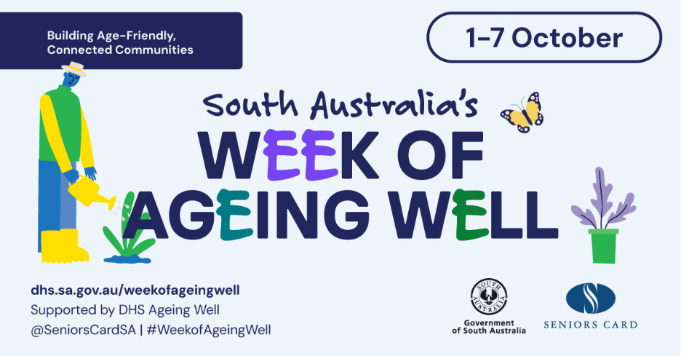

Week of Ageing Well 2026

Host Guide
Thank you for being part of this year’s Week of Ageing Well.

You already know how to run a great event.
This guide is here to help you connect your event to Week of Ageing Well and be part of a shared statewide effort.
Use it alongside the Communications Toolkit for quick, practical promotional tools.
Your usual event planning and approval processes stay the same.

About Week of Ageing Well
Week of Ageing Well takes place from 1 to 7 October each year.
It is a South Australian statewide initiative that encourages people of all ages to celebrate ageing well, connect and help create age-friendly communities. The 2026 theme is Building Age-Friendly, Connected Communities.
Week of Ageing Well is not just for older people. Ageing is part of everyone’s life, and age-friendly communities benefit people of all ages.

Key messages
- Small actions matter. A warm welcome, a shared piece of information or a quick check-in can help someone feel valued, visible and included.
- Age-friendly communities benefit everyone. They help people stay safe, well and connected as they age.
- Connection supports wellbeing. Staying connected to people, services and community life can help reduce social isolation.
- There are many ways to take part. Participation can be social, cultural, civic, creative or informal.
- Everyone has a role in building communities where people feel included, supported and able to contribute.

Who can host
You can host a Week of Ageing Well event as a council, library, community centre, club, service provider, local business, community group or other organisation.
We encourage you to make your event intergenerational where possible.

Key dates
- Week of Ageing Well: 1 to 7 October 2026
- Event registration opens 12 June 2026
- Event registration deadline 25 September 2026

Responsibilities of a host
As the host, you are responsible for planning and delivering your event.
Office for Ageing Well promotes Week of Ageing Well as a statewide initiative, but is not responsible for delivering individual events or meeting requirements linked to your event.
Please follow any legal, venue, local, organisational or group requirements that apply. This may include safety, accessibility, venue suitability, insurance, approvals, registrations or bookings, privacy and consent, food handling, speakers, activities and other event requirements.

Event ideas
Your event can be new or something you already run.
Make the link to Week of Ageing Well clear and show how your event supports connection, inclusion and ageing well.
Examples include:
- local services expo or information session
- “come and try” activity, such as dance and craft
- ‘ITea’ session (morning tea and technology)
- community walk or exercise session
- neighbourhood picnic or BBQ
- storytelling or local history session
- volunteer recruitment or showcase event
- arts and crafts workshop

Connection Challenge
This year’s Week of Ageing Well includes a simple Connection Challenge. The campaign encourages everyone to take one small action to make a new connection or to reconnect with someone.
This helps extend the message of Week of Ageing Well beyond the event and encourages people to strengthen local connections in everyday ways.
Sample actions to connect with others
- Phone or message someone you miss
- Invite someone to coffee, a walk or a local activity
- Check in with a neighbour you already know
- Share the Week of Ageing Well event calendar and attend an event together.

Register your event
Register your event on the Week of Ageing Well webpage to have it listed in the official calendar, making it easier for the community to find and attend as part of the statewide program.

Register your event here: Register an event | DHS by 25 September 2026. The earlier it is registered, the longer it will be included on the Week of Ageing Well Calendar of Events.

Promote your event
Use the Communications Toolkit to promote your event with ready-made content, images and key messages. These resources will be available for download from our website in July.

Connect your event to Week of Ageing Well
Use the essential elements below to put the purpose of Week of Ageing Well into practice and clearly connect your event to the statewide campaign.

Connection to the campaign
Use the Week of Ageing Well name in your event promotion and during your event.
Use the Communications Toolkit for ready-made promotional tools, including suggested wording, social media content and visual assets.

This year’s theme: Building Age-Friendly, Connected Communities.
Show how your event supports the theme by creating opportunities for people to come together, take part, share information, build local connections or feel more included in community life.
Suggested wording
Today is an opportunity to celebrate ageing, bring people together, strengthen local connections and help people feel included in community life.
Week of Ageing Well is not just for older people. Ageing is part of everyone’s life, and age-friendly communities benefit people of all ages.

This year’s key messages
Choose at least one key message to include in your welcome, slide, poster, program, table display or discussion.
- Small actions matter. A warm welcome, a shared piece of information or a quick check-in can help someone feel valued, visible and included.
- Age-friendly communities benefit everyone. They help people stay safe, well and connected as they age.
- Connection supports wellbeing. Staying connected to people, services and community life can help reduce social isolation.
- There are many ways to take part. Participation can be social, cultural, civic, creative or informal.
- Everyone has a role in building communities where people feel included, supported and able to contribute.

Connection Challenge
Invite each attendee to choose one small action to connect with someone after they leave. This helps carry the message beyond the event and supports everyday connection.
You can ask attendees to:
- choose one small action
- write it down or share it with someone, if they want to
- commit to following through.
- Sample actions to connect with people
- Phone or message someone they miss.
- Invite someone to coffee, a walk or a local activity.
- Check in with a neighbour they already know.
- Share the Week of Ageing Well event calendar and attend an event together.

Make your event welcoming
Create a welcoming environment for people of different ages, backgrounds and abilities.
Words matter. Please use respectful, age-positive language.
Avoid terms such as ‘elderly’, which can reinforce stereotypes. Instead, use terms like ‘older people’, or refer to people by name, role or community (for example, ‘club members’, ‘local residents’). See the Age Positive Communication Toolkit - Language Checklist for more examples.
Consider simple ways to make your event easy to access, comfortable and respectful for different people.
Useful sources
- Age Positive Communication Toolkit.
- Accessible and Inclusive Community Events Toolkit.

Collect and provide feedback
Feedback helps us understand whether Week of Ageing Well, the theme, key messages and connection activities were useful for participants and hosts. It is not an audit of your event or how it was delivered.

From July 2026, further information will be available via South Australia's Week of Ageing Well to:

- Access the Participant Feedback Survey, and share information with event participants.
- Complete the Host Feedback survey.

We also welcome outcome information and photographs that can be publicly shared, about how your event provided opportunities to Build Age-Friendly, Connected Communities.

Contact
For questions about Week of Ageing Well, event registration or promotional materials, contact: officeforageingwell@sa.gov.au.

Host checklist
Before your event |  | During your event |  |  | After your event
☐ | Choose a date between  1 and 7 October 2026. | ☐ |  | Acknowledge Week of Ageing Well in your welcome. | ☐ | Estimate attendance numbers.
☐ | Register your event by 25 September 2026. | ☐ |  | Share your chosen key message/s in your welcome, slides, displays or discussions. | ☐ | Complete the Host Feedback Survey, available on the Week of Ageing Well website from July 2026.
☐ | Promote your event using the Communications Toolkit. | ☐ |  | Invite attendees to choose one small action to connect with someone after the event | ☐ | Share approved photos, stories or videos (with consent).
☐ | Link your event to Week of Ageing Well and this year’s theme. | ☐ |  | Provide participants with access to the Participant Feedback Survey, available on the Week of Ageing Well website from July 2026. | ☐ | Store consent forms in line with your organisation/group’s process.
☐ | Choose the key message/s. | ☐ |  | Take photos, videos, quotes or stories only with consent.
☐ | Plan your Connection Challenge. | ☐ |  | (Optional) Give people a small card to write their connection action and take home.
 |  | ☐ | (Optional) Create a “connection wall” where people post their action before leaving.

