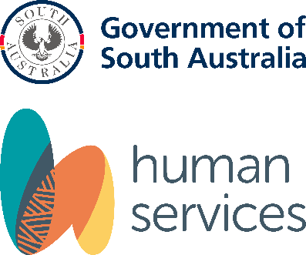

Child Safe
Risk Management Guide
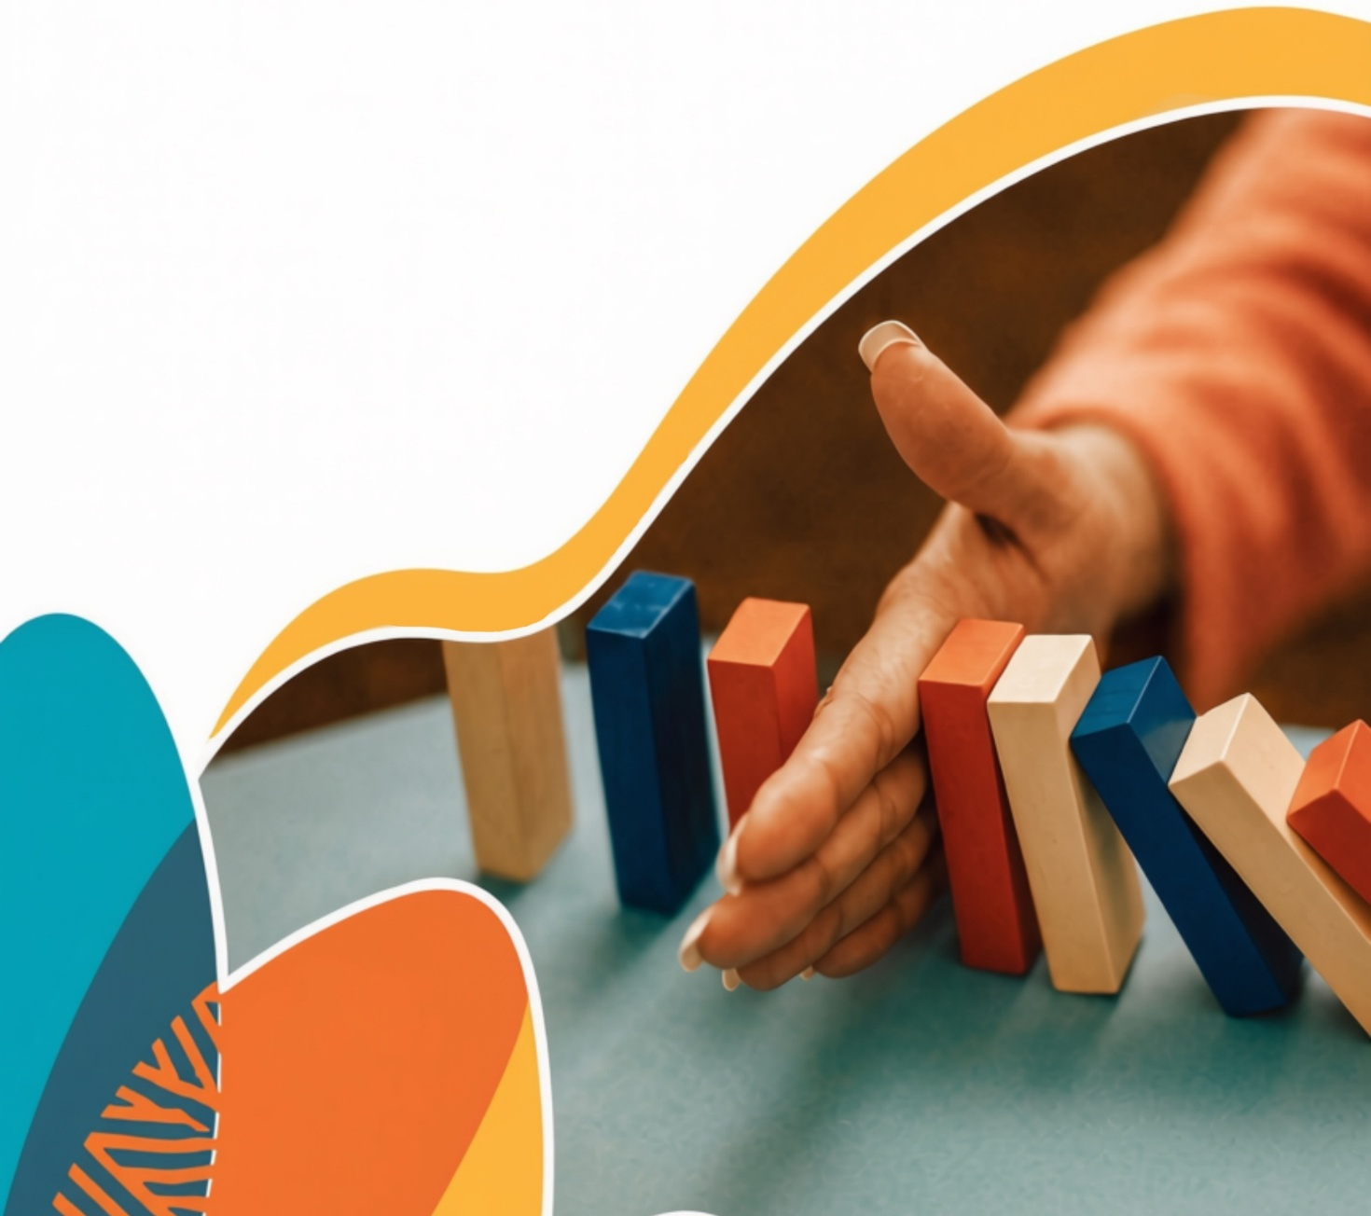
  - A guide for child-related
  - Organisations

Thank you to the NSW Office of the Children’s Guardian for allowing us to include information in this guide that originally appeared in their Risk Management and the Child Safe Standards Part 1 Responding to risk and Part 2 Identifying risk.
Thank you to the Victorian Commission for Children and Young People for allowing us to include information in this guide that originally appeared in their Child Safe Standards tools and templates.
We also thank the National Office for Child Safety for allowing us to include information in this guide that originally appeared in their Child Safety Risk Management Guide.

Stock images appear in this publication. These images are for illustrative purposes only, and people depicted in these images may not be associated with the publication’s subject matter.
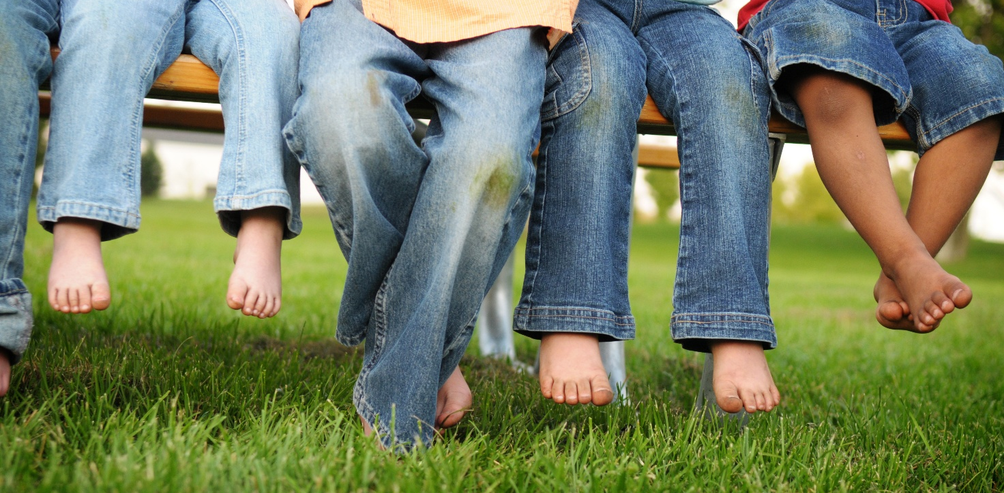 Version 1.0

Contents
Child Safe Risk Management Guide 1
Contents 3
Overview 5
Disclaimer 5
Definitions 6
Harm and risk of harm to children 6
Risks to children and indicators of harm 7
Physical abuse 7
Abusive behaviours 7
Indicators of harm 7
Psychological abuse 7
Abusive behaviours 7
Indicators of harm 7
Sexual abuse 8
Abusive behaviours 8
Indicators of harm 8
Neglect 8
Abusive behaviours 8
Indicators of harm 8
Grooming 9
Stages of grooming 10
Examples of grooming behaviours 10
Physical contact (some of these may also be sexual misconduct) 11
Special treatment 11
Gifts and benefits 11
Manipulating situations to be alone with a child 11
Breach of professional conduct 12
Public or secret meetings 12
Communication with a child for non-professional reasons 12
Desensitisation (some of these may also be sexual abuse) 13
Secondary employment 13
Influencing guardianship 13
Influencing other professionals or colleagues 13
What is risk management in a child related organisation? 14
Risk management 14
Risk management is not 14
Risk management and the National Principles 15
A practical understanding of risk management 22
Elements of effective risk management 22
Reflective questions 22
Developing a child safe risk management plan 23
Pathway to a robust CSRMP 23
Dimensions of risk 24
Situational risk 24
Vulnerability risk 24
Propensity risk 24
Organisational risk 25
Assessing risk step-by-step 26
Steps to effective risk management 27
Identify risks 27
Assess 30
Develop protective strategies 31
Publicise 32
Review 32
In review 33
Common reasons CSRMPs are not effective 33
Appendix 1: Child safe risk management plan template 35
Appendix 2: Risk matrices 37

Overview
Organisations that work with children have a responsibility to keep them safe from harm. All child related organisations will deal with some element of risk. This can include financial risk as well as work, health and safety (WHS) risks. Organisations also need to be aware of risks that may lead to the harm of children.
Child safety must be a priority. Managing child safety risks is key to preventing harm to children. This has a flow on effect of enhancing the community’s trust in your organisation and ensuring your organisation continues to provide services in the future.
The guide describes types of abuse and grooming behaviours, how to recognise offenders, and their motivations for offending. It also includes what risk management looks like and the steps needed to lessen risk. It will also take you through the steps to create a Child Safe Risk Management Plan (CSRMP) and explain why it’s valuable.
Risks must be considered in each individual organisational context and be monitored over time. Types of risk will vary across different organisations. For example, risks in a sports club will be different from those in a school or religious organisation. Different types of risks present different types of safety challenges and require different responses.
A CSRMP is different to a WHS plan because it isn’t about attempting to lessen risks associated with accidents and omissions, slips, trips and falls. Instead, it looks at how organisations can prevent children being exposed to abuse and resulting harm including, psychological abuse (also known as emotional harm), physical abuse, sexual abuse, grooming, misconduct and lack of appropriate care.
It’s important to remember that, unlike accident prevention, harm is sometimes deliberately inflicted, as well as being the result of errors being made by unskilled workers, or procedures not being followed.
Disclaimer
The information provided in this document is for guidance purposes only. Please always refer to the appropriate legislation to ensure you are meeting your child safe legal requirements and fair work obligations in South Australia.
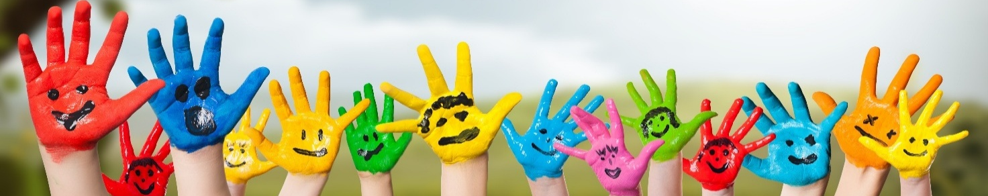Image: AdobeStock

Definitions
Abuse
Abuse against a child may take the form of sexual, physical ,psychological abuse or neglect. Refer to Risks to children and indicators of harm on page 7.
Child/children
Includes all children and young people under the age of 18 years.
Harm
Harm is the resulting effect to a child after they have been sexually, physically, mentally or emotionally abused or neglected.
Worker
Includes all staff, volunteers, work placement students, contractors, board/committee members, as well as business owners and managers.

Harm and risk of harm to children
Section 17 of the Children and Young People (Safety) Act 2017 defines ‘harm’ to mean physical or psychological harm (whether caused by an act or omission), including harm caused by sexual, physical, mental or emotional abuse or neglect.
Section 18 of the Safety Act states a child or young person will be ‘at risk’ if:
- they have suffered harm, or there is a likelihood they will suffer harm being of a kind against which ordinarily they should have been protected
- their parent or guardians are unable or unwilling to care for them, have abandoned them, cannot be found or are dead
- they are of compulsory school age but are persistently absent from school without explanation
- there is a likelihood they will be removed from the State for the purpose of:
  - a medical procedure that would be unlawful if performed in South Australia (including female genital mutilation)
  - taking part in a marriage that would be void or invalid under the Marriage Act 1962
  - taking part in an activity that would be illegal in South Australia
  - they are homeless or of no fixed address.

Risks to children and indicators of harm
Below are some examples of abusive behaviours and indicators that a child may have suffered harm from abusive behaviours.

Physical abuse

Abusive behaviours
- physical punishment such as pushing, shaking, shoving, punching, slapping, choking, burning, biting and kicking
- alcohol or other drug administration/misuse
- fabricated or induced illness.

Indicators of harm
- burns, bald patches on head, poisoning
- bruises or welts on face, back, bottom, legs, arms and inner thighs
- bruises or welts in unusual configurations or that resemble the object used to make the injury (finger marks, hand, iron, teeth, belt buckle)
- multiple injuries, old and new.

Psychological abuse

Abusive behaviours
- bullying, intimidation, shaming or name calling
- threatening or abusive language
- ignoring, isolating or frightening a child
- deliberately causing a child to witness traumatic events including domestic and family violence.

Indicators of harm
- not interacting with others
- regression in toileting behaviours
- hypervigilance
- obsessively eager to please or obey adults
- delay in reaching developmental milestones
- lacks trust and empathy.

Sexual abuse

Abusive behaviours
- grooming
- sexually touching a child
- penetration of the genital or anal area
- obscene messages, phone calls etc
- production, distribution or possession of child abuse material.

Indicators of harm
- injury to genital or rectal area
- discomfort in urinating or defecating
- bruising or injury to breasts, buttocks, thighs
- child discloses abuse
- fear of home, specific place or person
- deteriorating relations with adults/peers.

Neglect

Abusive behaviours
- lack of supervision
- not providing adequate nourishment, medical care, clothing or shelter
- lack of education
- lack of nurturing, encouragement and support.

Indicators of harm
- consistent lack of supervision
- child is regularly stealing food or eating food found on the ground or from bins
- consistently dirty and unwashed
- unattended health issues
- consistently inappropriate clothing for weather conditions
- inadequate or no shelter.

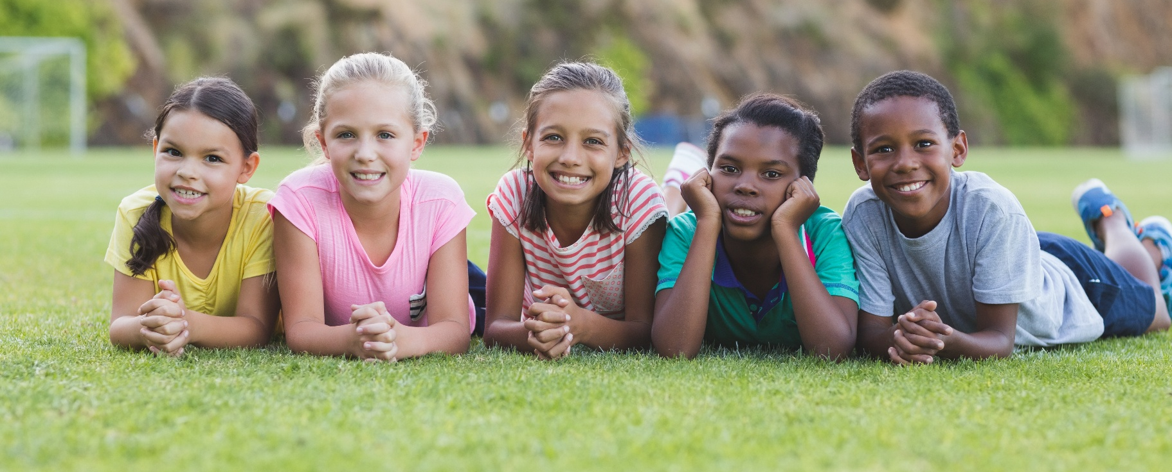
Image: AdobeStock

Grooming
Grooming is behaviour offenders use to manipulate children and adults with intent to abuse a child. Some actions perpetrators engage in, particularly grooming, are very subtle and don’t seem harmful of themselves. Rather, they are cumulative and only when viewed as a whole can it be seen that someone is preparing to harm a child. In other words, the potential harm can only be identified when a pattern of behaviour is revealed. This can only happen if the individual actions are recognised as a concern.
Not every action undertaken by adults working alongside children is grooming or abuse. This is why a Child Safe Code of Conduct is so important. It establishes a set of rules that adults must follow so any action that could potentially be grooming behaviour, is immediately addressed. Any breaches are reported and the isolated incidents can then be assessed against repeated breaches to reveal any pattern of behaviour.
Understanding grooming or recognising the signs that a child is being groomed can be difficult. Sometimes we only see a small incident that seems easy enough to brush off and we aren’t aware of the bigger picture. It can also be because we naturally want to believe a person’s actions towards a child and their co-workers are honest ones. We want to believe they are a caring person.
Determined offenders may be quite skilled at grooming children (and the caring adults in the child’s life for example parents, co-workers), to make sure they have access to children and that their abuse goes undetected.
Often when offences are brought to light, the caring adults in the child’s life can feel angry, exploited, betrayed and foolish for believing the offender was a good person. Yet, it was all part of the offender’s plan. They deliberately lied, hid their true intentions and pretended to be of good character. Offenders don’t want people to question their actions or report them. They would rather people excuse their behaviours and think things such as, ‘Oh, they’re good, it’s just a small rule they’ve broken. That’s just how they are. They’re like that with everyone.’
We don’t want to think the people we work with, friends, family members or the people in our community who we trust to care for our children, would harm them. Some people may therefore be reluctant to raise an allegation of unacceptable behaviour because they believe a person is acting in a way that is really in the best interests of the child. They may also be hesitant because making an allegation against a person, particularly when the person is highly regarded, can be very confronting. Establishing a culture of reporting in your organisation can help prevent grooming from occurring. Even small incidents such as a minor breach of your organisation’s Child Safe Code of Conduct should be reported. Refer to the Child Safe Code of Conduct Guide at https://dhs.sa.gov.au/how-we-help/ngo-and-sector-support/child-safe-environment/resources.
Understanding what grooming is, how it can occur and recognising the signs of grooming can help your organisation develop child safe policies that help to prevent it.

Stages of grooming
Offenders use grooming techniques to gain trust of the targeted child (and those around them) to slowly establish and maintain a sexual relationship with the child secretly, to avoid disclosure. Sexual grooming stages a perpetrator follows include:
- targeting the child - may target vulnerable children because they feel those children have fewer caring adults in their lives or less ability to report abuse
- building trust with the child and carers such as parents, guardians and co-workers
- isolating the child from family and friends
- sexualisation by desensitising the child to touch, nudity and sexual language, leading to sexual abuse
- controlling the child using secrecy, rewards, threats, shame and/or blame to continue abuse and avoid disclosure.

Examples of grooming behaviours
There are a range of behaviours that may suggest a person is grooming a child. Not every instance of these identified behaviours indicates grooming is occurring, but if they are in breach of your Child Safe Code of Conduct or policies, they should always be reported. Examples of grooming behaviours are provided below.

Physical contact (some of these may also be sexual misconduct)
- sitting a child on their lap
- engaging in activities that result in touching such as rough play, wrestling or tickling
- inappropriately touching a child while performing a legitimate task
- deliberately touching an inappropriate area but passing it off as ‘accidental’
- restricting, trapping, massaging, kissing or caressing a child
- taking photographs of a child on a personal device with or without a guardian’s knowledge or consent.

Special treatment
- showing favouritism, allowing a child to break rules
- consistently selecting one child for a demonstration and special treatment
- having a special (pet) name for a child
- allowing a child to access their smart phone, computer or tablet
- sometimes the special treatment might involve continually shaming a child to socially isolate them and leave them more vulnerable to harm.

Gifts and benefits
- giving a child or group of children gifts in secret, or at the exclusion of others
- paying for a child to attend events such as football games or concerts
- purchasing a phone for a child
- giving a child a personal gift such as a piece of jewellery
- encouraging a child to give them gifts.

Manipulating situations to be alone with a child
- transporting a child in a personal vehicle alone
- seeking information about the child’s movements and activities outside the professional setting
- finding reasons to contact the child outside of the professional setting such as delivering ‘missing’ homework or sharing computer games
- contacting a child directly rather than through their parent or guardian.

Breach of professional conduct
- spending time alone with a child in an area that doesn’t have natural surveillance, or in a locked room
- attending events not related to professional relationship such as birthday parties, sport events
- discussing intimate matters about the child such as the child’s sexuality, or their own sexuality
- discussing intimate personal matters with the child, including marriage breakdowns or other family concerns.

Public or secret meetings
- arranging to meet a child in a secluded or secret setting
- requesting a child visits their home
- visiting a child who is at home sick or alone
- meeting a child at the movies, for a meal or to go shopping
- inviting a child on holidays or overnight break.

Communication with a child for non-professional reasons
- phone calls, sending personal emails, texts, letters or communications via any social media or other online platform
- asking a child to send photographs
- talking to a child in peer group slang
- engaging a child in late night contact
- asking a child to keep the contact secret.

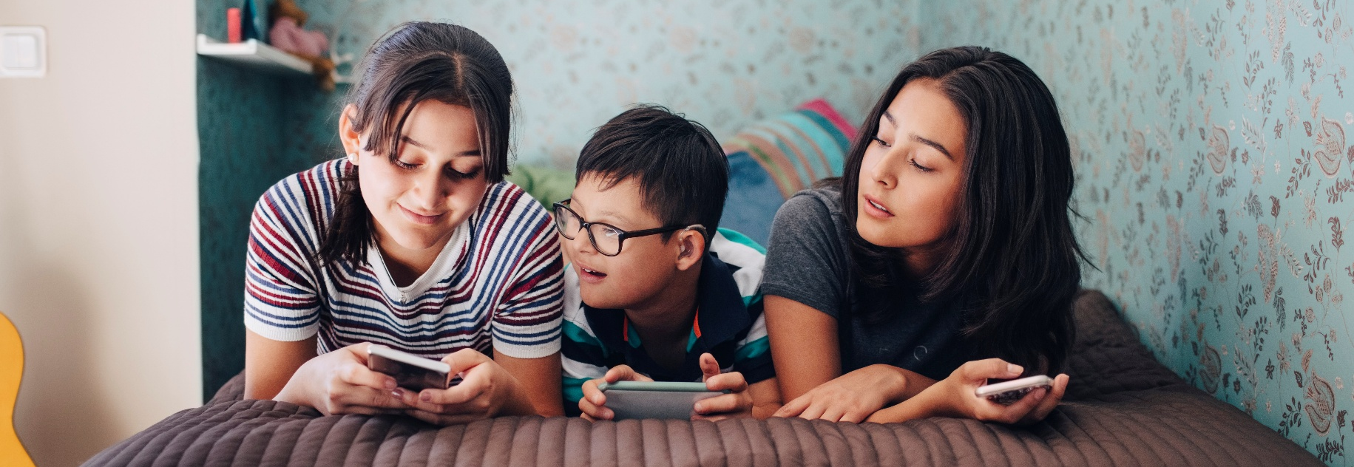
Credit: Canva

Desensitisation (some of these may also be sexual abuse)
- flattering, complimenting or flirting with a child
- flattering a parent, either personally or about their child
- suggesting they have a ’special relationship’ with a child
- talking openly about promiscuity (with adults or in front of children) in an effort to desensitise others to their behaviour
- telling jokes with sexual undertones
- exposing a child to pornography
- entering private areas such as change rooms unnecessarily or unannounced
- normalising their sexual behaviour to a child such as explaining their actions are normal when you ‘love each other’
- threatening a child not to disclose their relationship, including threat of violence (to the child, their family or guardians).

Secondary employment
- offering to babysit in breach of an organisation’s Child Safe Code of Conduct, or offering to care for children at low cost
- offering tuition or mentoring, particularly if this gives the person time alone with a child.

Influencing guardianship
- influencing the child’s family or relationship with their family
- manipulating a parent or guardian to make them believe they are a person of integrity or expertise
- making themselves appear invaluable to a child’s success and achievements
- undermining parental guidance
- telling a child their parents don’t understand them or their relationship
- telling a child they won’t be believed if they speak up
- seeking invitations to a child’s home for family functions.

Influencing other professionals or colleagues
- undermining other professionals in the organisation to deflect or disguise their own behaviour
- minimising breaches of your organisation’s Child Safe Code of Conduct as being trivial
- ignoring warnings about their breaches of professional conduct or boundaries
- encouraging others to breach professional conduct or boundaries as a way of minimising or deflecting their own breaches
- encouraging colleagues to believe a child has a crush of them, or blaming a child for unacceptable behaviour
- describing behaviour changes in the child victim as trivial or ‘just their age’.
Image: AdobeStock

What is risk management in a child related organisation?

Risk management
- reduces the likelihood of children being harmed
- means fewer children will have to live with the effects of harm
- makes your organisation less likely to attract offenders for fear of being caught
- gives workers confidence to work with children in a structured, safe way
- approaches risk in a structured, proactive way and not in a responsive way (after the harm has occurred)
- underpins your organisation’s development of child safe policies, procedures and codes of conduct.

Risk management is not
- about protecting the reputation of your organisation or its exposure to legal action and potential financial loss – although this is a potential benefit
- something introduced by leaders, intent on micromanaging
- about preventing adults in child related employment from offering meaningful experiences to the children they care for
- about having too many rules and discouraging adults to work with children
- having a plan sitting on a shelf that is never used.
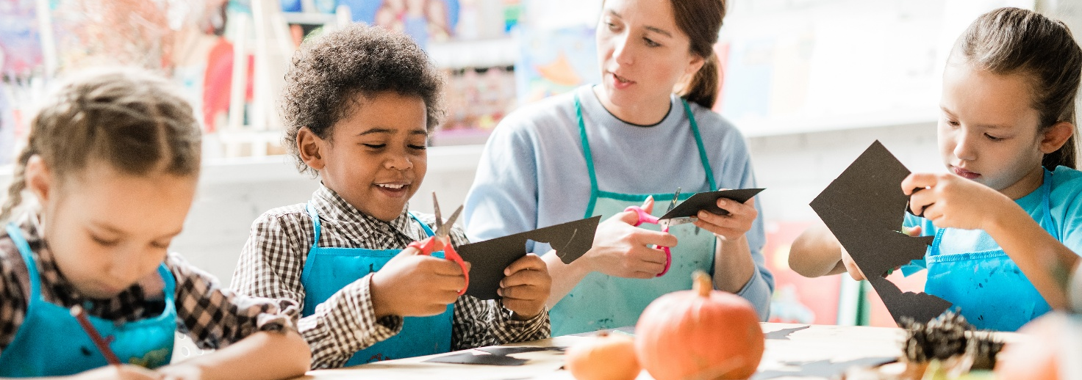
Image: AdobeStock

Risk management and the National Principles
If risk is not managed well, children can be harmed. Managing risk supports a culture of safety that includes communication, reporting, transparency and governance. A way to embed all these in your organisation is by using the National Principles for Child Safe Organisations as a framework. South Australia adopted the National Principles in 2021 and your organisation’s child safe policies should align with them.
The information below describes how each Principle is relevant when managing risk.
National Principle | Application to reporting
  Principle 1  Child safety is embedded in organisational leadership, governance and culture | How risk management applies to this principle  Risk management is a tool leaders of child-related organisations can use to improve their child safe practices. A core component of this principle states ‘Risk management strategies focus on preventing, identifying and mitigating risks to children.’  Leaders are responsible for ensuring children are safe in their organisations.  If it’s not applied  Leaders who don’t consider risk management to be a priority may not encourage a child safe culture where the children’s best interests are paramount.  When it’s applied  Risks are identified, controlled and responded to. Good organisational culture and governance make it easier for both adults and children to disclose abuse and harm if it occurs. The child safe actions of leaders are mirrored by other workers and children are safe.
  Principle 2  Children and young people are informed about their rights, participate in decisions affecting them and are taken seriously | How risk management applies to this principle  All children are vulnerable to harm because of their dependence on adults. For the most part, adults are physically stronger than children and have social power. This power imbalance is greater when organisations are:  - very strict and authoritarian  - closed to the outside world with little involvement from families or the community  - hierarchical and ordered where those in authority have significant and sometimes questionable power.  If it’s not applied  Children are more exposed to abuse and harm because they are not supported to be safe or to notify adults if abuse and harm occurs.  Children who are not empowered are more vulnerable as they can sense their views are not important. They may also feel they will not be listened to if they do disclose abuse and harm. In these cases, children are not safe.  When it’s applied  Children identify and perceive risks differently to adults. This is why it’s important to seek their views and opinions as part of the risk management process. When the views of children are factored into the creation of risk management plans, the plans are more effective and children are safe.
  Principle 3  Families and community are informed and involved in promoting child safety and wellbeing | How risk management applies to this principle  An organisation’s risk management strategy is strongest when it includes input from family and community members. An organisation’s increased understanding of the experiences and cultures of its stakeholders and the stakeholder’s increased understanding of the organisation, are themselves protective strategies.  If it’s not applied  Organisations that don’t involve families and communities are considered ‘closed’. Cultural characteristics that arise in closed organisations include:  - secrecy, where information sharing is restricted  - abuse of power, where people exert significant control over the lives and actions of those engaging with the organisation  - prioritisation of discipline, order and conformity over the wellbeing of individual children  - isolation from the outside world, including oversight authorities such as the police and welfare agencies  - failure to deal with concerns, suspicion or disclosures of abuse and general complaints.  When it’s applied  Risk management is more successful when families and communities are involved in organisations. It’s a two-way flow. When families have oversight of organisations, they can provide feedback to them, on what they feel is working well and what isn’t. Equally, organisations should consult with families on what makes their children safe. They should provide a Child Safe Code of Conduct so all stakeholders are aware of what rules the organisation has in place to reduce the risk of harm to children. Organisations can also let family members know if harm is reported so they can engage with their children and establish whether they have been harmed as well.
  Principle 4  Equity is upheld and diverse needs respected in policy and practice | How risk management applies to this principle  By supporting equity and diversity, risk management strategies can be tailored towards all the children your organisation interact with. This will ensure their specific needs and the risks some of these children face, are taken into account.  For example, some children with disability need help with personal or medical care. This may create a risk of harm within an organisation’s setting and the likelihood of detection may be reduced if a child doesn’t understand what is appropriate.  If it’s not applied  Children with intellectual disabilities, limited verbal communications or behaviour disorders are at higher risk of all forms of abuse. This is because they are often deliberately targeted for abuse by perpetrators who know it will be harder for these children to identify and name them.  Children who require support with personal care are also vulnerable. Sometimes this assistance is provided in private. If risk management strategies are not in place to support children in these situations, they are less likely to be safe.  When it’s applied  When equity and diversity are supported, vulnerable children will be safe because their needs are more likely to be met. This means they can recognise abuse and report it if it occurs and be given protective strategies to avoid it. It includes children who may have intellectual and physical disabilities, are from different cultural backgrounds, are very young, live in remote communities or have a history of trauma.  Children should feel culturally safe and know their family heritage is respected and supported.
  Principle 5  People working with children and young people are suitable and supported to reflect child safety and wellbeing values in practice | How risk management applies to this principle  An effective recruitment policy is vital for ensuring the appropriate workers are employed to work with children. It helps reduce the risk of hiring unsuitable persons to work with children. Once in the role, workers should be supervised and monitored when working with children.  If it’s not applied  The Royal Commission into Institutional Responses to Child Sexual Abuse found many instances where inappropriate workers had been hired by organisations. These people had then gone on to abuse and harm children. Some of these workers may have subsequently been identified had they been effectively supervised and monitored.  In environments where robust recruitment is not prioritised, children are not safe.  When it’s applied  A Working with Children Check (WWCC) is a screening tool that identifies those workers who have a record that indicates they may be a risk of harm to children. WWCCs should not be relied upon as the only screening tool, there are other screening checks such as National Police Check and reference checks that can be utilised.  Refer to the Child Safe Recruitment, Induction and Support Guide at https://dhs.sa.gov.au/how-we-help/ngo-and-sector-support/child-safe-environment/resources.
  Principle 6  Processes to respond to complaints and concerns are child focused | How risk management applies to this principle  Having robust reporting processes increases the likelihood children will report abuse, harm or any general complaints. When potential perpetrators realise there is more chance they will be identified, they may feel less inclined to commit abuse, or seek to work at that organisation.  All children need to be supported to understand their rights and what opportunities exist for them to report harm and other general complaints.  If it’s not applied  Some children, because of a perceived impact on their chances of success, may be reluctant to reveal abuse or harm and will need additional support. For example, children who are gifted musicians or athletes may be particularly dependent upon their teachers and coaches. In some cases, the financial stability of their family may even be reliant on the perpetrator. Sometimes priests and ministers hold power over children, as well as other adults in oversight roles. They can exploit their positions to avoid scrutiny and reduce repercussions for their actions.  Organisations where children don’t have access to a trusted adult, carry a higher risk of harm to children because they may feel they have no one to disclose abuse or harm to, if it occurs.  When it’s applied  Organisations that are safe and nurturing environments for children will prioritise child safety above their own reputations. They:  - take action in response to general complaints  - don’t conceal disclosures or allegations of abuse and harm, or adopt an approach of ‘damage control’  - prioritise the needs and safety of the child.  Organisations supporting children will seek to hear from all children in their care, including children with disability, in detention or with low self-esteem.  If children have faith that reporting processes will be fair and transparent, they are more likely to raise concerns.
  Principle 7  Workers are equipped with the knowledge, skills and awareness to keep children safe through ongoing education and training | How risk management applies to this principle  The practice of continually upskilling workers encourages a better understanding of risk and what is required to reduce the chances of abuse and harm occurring. Workers should be trained and supported to understand and implement the organisation’s child safe policies.  If it’s not applied  Workers who can’t recognise signs of abuse, or don’t know how to respond to it, risk exposing children to ongoing harm. This ‘bystander’ culture can also reduce the likelihood that children will speak up about safety concerns, or be believed if they do.  When it’s applied  Workers and leaders should have a good understanding of the strategies perpetrators use to access and abuse children. When they can recognise how and where abuse is occurring, they are better able to prevent it.
  Principle 8  Physical and online environments promote safety and wellbeing while minimising the opportunity for children and young people to be harmed | How risk management applies to this principle  Risk management strategies must be put in place to ensure children are safe in both physical and online environments. Organisations should attempt to make sure all their physical spaces where adults interact with children, have clear lines of sight so they’re easy for other adults to observe.  If it’s not applied  Children can be more at risk where there are increased opportunities for adults to be alone with children, including online. If specific protective strategies are not put in place, children are more at risk, especially in cases where a child is dependent on an adult for success. This can present opportunities for professional boundaries to be crossed.  When it’s applied  Organisations conduct site audits and have a Child Safe Code of Conduct that describes any situations that permit adults to be alone with children. Risk management plans should indicate the areas that are out of bounds for children. Adults should be supervised to reduce any opportunities for them to form relationships with children that can involve physical contact and inappropriate emotional closeness.
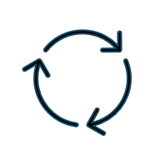  Principle 9  Implementation of the national child safe principles is regularly reviewed and improved | How risk management applies to this principle  The Royal Commission into Institutional Responses to Child Sexual Abuse heard from 8000 survivors of child sexual abuse aged between 7 and 93 years old. It identified over 4000 organisations where abuse occurred. It found that it takes an average of 23.9 years for a survivor to disclose abuse.  As a result of its research, the Royal Commission developed the Child Safe Standards to establish the essential components of a child safe organisation.  If it’s not applied  If organisations rely on outdated or ineffective protective strategies, children are more likely to be abused and harmed. If the Principles aren’t used as a framework, there is less opportunity for continual improvement of all key factors that keep children safe.  When it’s applied  The national child safe principles should guide what organisations need to do to be child safe. Organisations work to establish gold standard child safe practices, setting benchmarks to chart their progress. As a way of proactively addressing risk, they regularly review their risk management strategies and high-risk activities.
  Principle 10  Policies and procedures document how the organisation is safe for children and young people | How risk management applies to this principle  Effective child safe policies and procedures describe how your organisation manages child safety, including risk. This ensures risk management strategies are robust, properly implemented and fit for purpose. Anyone seeking to harm children is more likely to target organisations where child safety is not seen as a priority.  Implementing child safe policies and procedures creates an organisational culture that helps to prevent this from happening. In these environments, risk is minimised and proactively addressed.  Child safe policies should be reviewed annually and after critical incidents. As your organisation grows and its systems and processes change, you should also revisit your risk management plan to ensure it reflects all services you offer, and any potential risk to children they may carry.  If it’s not applied  Organisations are more vulnerable to abuse and harm occurring when they don’t make clear acceptable and unacceptable behaviour interactions between adults and children. It’s difficult to hold workers accountable to standards of acceptable behaviour when they are not clearly established.  In many organisations, where workers are close or have known each other for a long time, it can be difficult to question long-standing co-workers if grooming or abuse is suspected.  Missing or ineffective child safe policies and procedures can increase opportunities for perpetrators to abuse and harm children. Organisations may not have established acceptable child safe practices, clear professional boundaries, and mechanisms for identifying and reporting unacceptable behaviour.  When it’s applied  Having a Child Safe Code of Conduct that clearly describes acceptable and unacceptable behaviour means workers don’t have to make a judgement about whether abuse and harm is occurring. Workers only have to report that a rule has been broken.  Where internal procedures are applied consistently to deal with allegations of child abuse, all matters of concern are dealt with in a way that prioritises the best interests of children.
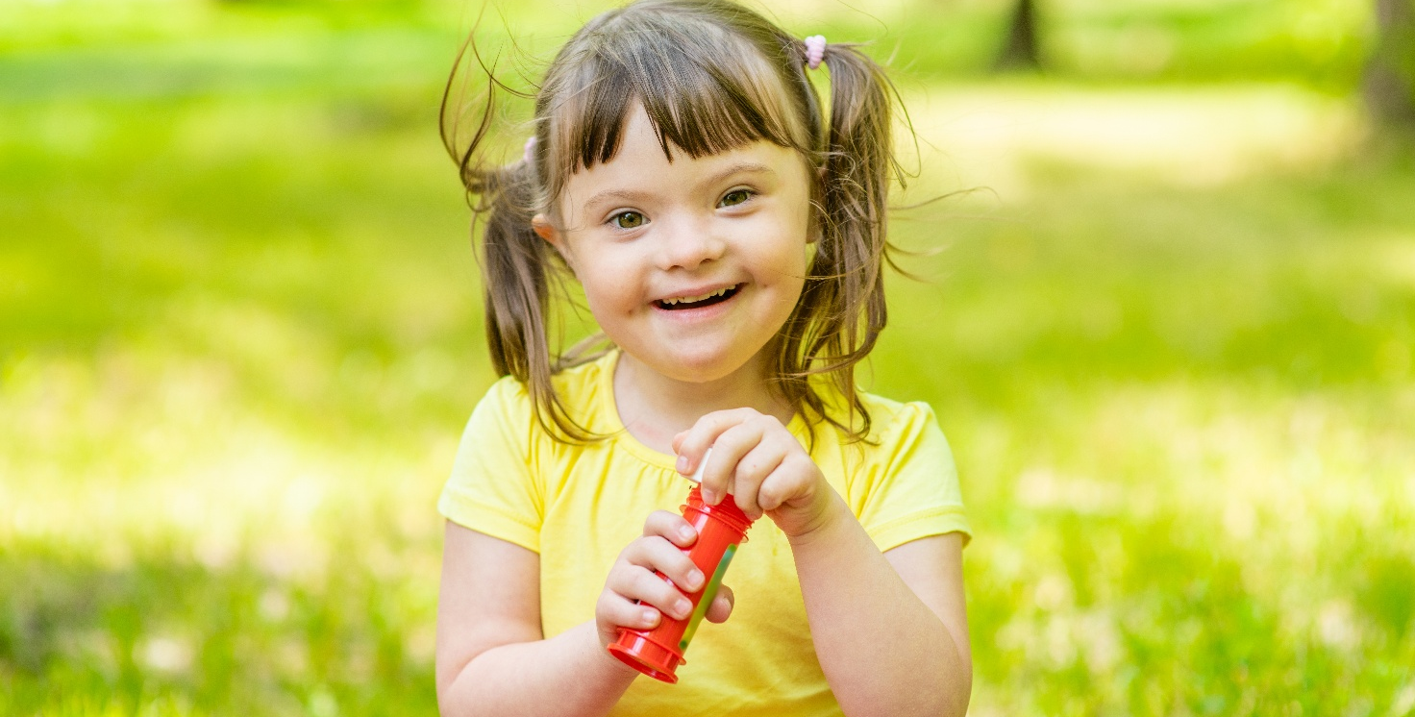
Image: AdobeStock

A practical understanding of risk management
In a child safe context, risk management involves identifying any risks in your organisation that may increase the likelihood of abuse occurring and a child being harmed. This includes poor professional practices or misconduct by workers, whether it be intentional or unintentional.
Risks to children include accidents and, in a child safe context, deliberate or unintentional harm and abuse perpetrated by adults or other children. Risk of accidents should be addressed in a work health and safety policy. This guide discusses risks of abuse and harm children can be exposed to, including lack of appropriate care. While physical injuries could be seen as work health and safety issues, they should also be assessed as instances of potential abuse.
Risk in this context is defined as unwanted outcomes – the opposite of your organisation’s desire to care for children.
Protective strategies are any actions taken to manage the impact of risk.

Elements of effective risk management
Consistency: Promoting transparent and applying a consistent risk framework across the entire organisation.
Flexibility: Ensuring a variety of approaches when identifying, responding to and controlling risk to accommodate the various range of activities across the organisation.
Accountability: Reinforcing risk accountability across every level of the organisation and modelling an understanding that keeping children safe is everyone’s responsibility.
Embedding a risk culture: Risk management is embedded in the culture, strategies, plans, decisions, operations, recruitment and business processes of the organisation.
Reviewing and monitoring: Regularly monitoring, reviewing and reporting risks.
Promoting education and awareness: Creating awareness and a positive attitude to risk management through education and training.

Reflective questions
- What have you done to identify risks to children in your organisation?
- How do you consider and demonstrate the National Principles through your risk management planning?

Developing a child safe risk management plan
Your organisation’s child safe risk management plan (CSRMP) should describe what you can do to prevent or lower the risk of abuse and harm occurring in your organisation. Having protective strategies in place also provides protection to workers and the organisation itself, in case there are potential allegations of abuse and harm. A good CSRMP means children, their families, communities, workers and the organisation all benefit.
Any approach to risk that prioritises children’s safety should focus on the following:
- child abuse and harm is not tolerated and must not happen
- the best interests of the child and their protection from abuse and harm is paramount
- children’s rights are understood and respected
- concerns about child safety raised by children, their parents or carers are treated seriously and acted on
- reporting instances of abuse and harm must not be obstructed.
Refer to Appendix 1: Child safe risk management template.

Pathway to a robust CSRMP
- identify the benefits and challenges of implementing a CSRMP
- gain the support and commitment of your leadership team
- establish a group to manage and coordinate the creation of your CSRMP – remember to think about ways to consult with children when creating your CSRMP
- investigate your environment, thoroughly explore all potential risks of abuse and harm that exist and begin to design your CSRMP
- document the protective strategies
- implement the protective strategies
- communicate the plan to your stakeholders
- monitor and regularly review the protective strategies – again remember to consult with children when reviewing your CSRMP.

Dimensions of risk
Risk of harm to children can be broken down into four dimensions.

Situational risk
An organisation’s physical and online environments may provide opportunities for abuse to occur including:
- adults being alone with children
- adults forming relationships with children that could involve physical contact and emotional closeness.
Physical and online environments can provide opportunities for grooming to occur. Grooming can progress past seemingly innocent behaviour, which by itself may not be harmful, to abuse. Additionally, adults given opportunities to form relationships with children that involve physical contact or emotional closeness, can cross acceptable professional boundaries.
Clear behavioural expectations around adult and child interactions should be set out in an organisation’s Child Safe Code of Conduct. The Child Safe Code of Conduct shouldn’t negatively impact on a child’s feeling of safety or their interactions with trusted adults.

Vulnerability risk
The characteristics of the children cared for may make them more vulnerable to abuse, including:
- age (some are more vulnerable to certain types of abuse at certain ages)
- physical or intellectual disability
- not feeling confident to speak up
- having experienced prior maltreatment
- out-of-home care arrangements or challenging home environments
- different cultural background.
Every child is vulnerable to abuse but some children are additionally vulnerable and may be more likely to be targeted. By identifying the factors that may increase a child’s vulnerability to abuse, organisations can better understand any barriers that may prevent them from disclosing abuse.

Propensity risk
This type of risk arises from the possibility of adults with an inclination (propensity) to abuse children. It could also arise from children within the organisation displaying harmful sexual behaviours.

Organisational risk
An organisation’s culture may make abuse more likely to occur or less likely to be dealt with, including:
- leaders not supporting or prioritising child safety
- an emphasis on power, aggression, strength and competition
- a lack of understanding or awareness of child abuse
- protection of an organisation’s reputation over the safety of a child
- unclear expectations around worker-child relationships
- not listening to and respecting children
- close-knit and longstanding relationships between co-workers
- children not having access to a trusted adult
- ineffective child safe policies and procedures
- inadequate recruitment and reporting processes.

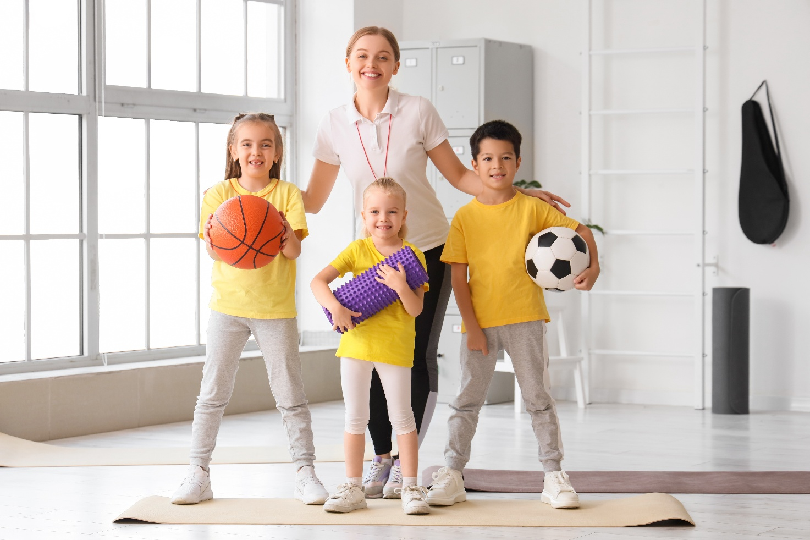Image: AdobeStock

Assessing risk step-by-step
Managing risk to keep children safe from abuse and harm is not unlike other standard risk management approaches. A risk assessment matrix is a helpful way to assess risk. Refer to Appendix 2 Risk Matrices.
The matrix asks the person assessing the risk to consider:
- likelihood of the risk occurring?
- if the risk occurred, how significant would the consequence be?
In gauging the risk of harm to children, the likelihood of risk carries a greater importance than in other risk assessment settings. This is because most people recognise that a single instance of abuse of a child could be rated in the highest category of consequence. This is why even events that are considered highly unlikely, should be included in your CSRMP.
The likelihood of a particular risk occurring will vary depending on the organisation. A risk rated as ‘likely’ to occur at an early education centre might only be rated as possible at a sports club. This is why your organisation needs to tailor its CSRMP to its unique environment. You must consider all settings in the organisations, and the risks associated with each.
Organisations that prioritise risk to children over financial and reputational risks to the organisation, understand that preventing abuse and harm to children will also address financial and reputational risk.
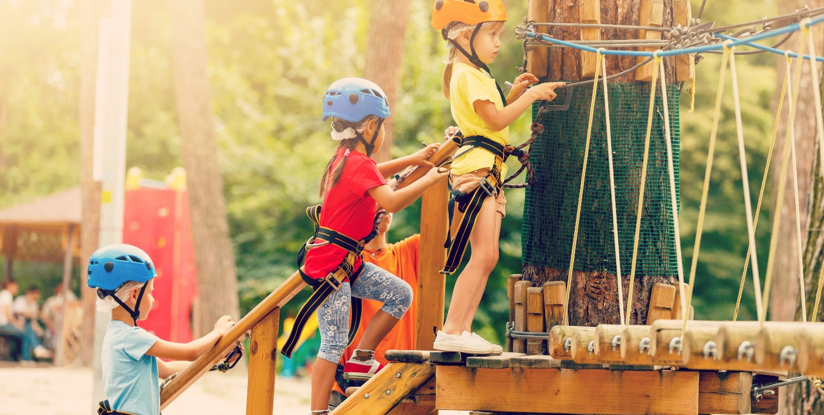Image: AdobeStock

Steps to effective risk management
You can use the following approach to help identify and assess risks in your organisation to create your CSRMP.
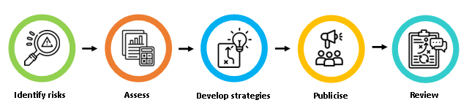

Identify risks
Referring to the dimensions of risk on page 24, identify all the different settings or activities in your organisation where persons work or interact with children. Even include worst case scenarios because if you don’t identify them, you can’t prevent them from happening.
In addition, you may wish to consider these questions to identify the risk:
- what could happen?
- how could it happen?
- where could it happen?
- why might it happen?
Consider the information and questions below and record your organisation’s child safety risks in the Identified risk column of the CSRMP template. Refer to Appendix 1: Child safe risk management template.

Your organisation’s physical environments (situational risks)
Consider whether there are any aspects of your organisation’s physical environment that may make it easier for child abuse or harm to occur or go undetected such as:
- isolated areas
- poorly supervised areas
- facilities such as classrooms, consulting rooms, sporting fields, change rooms, swimming pools, studios, vehicles etcetera that might increase the risk of abuse
- shared spaces where children attend with adults that are not from the organisation.

Your organisation’s activities (situational risks)
Some things to consider about the activities your organisation conducts:
- what are the different types of activities?
- where are they held?
- how often do activities occur and how long do they run for, such as a few hours, overnight?
- is there physical contact between children and adults?
- could activities provide opportunity that result in an emotional dependence by a child on an adult or worker?
- what supervision of adults and children is involved?
- is there travel to a venue or activity and how does this happen?
- does the activity take place at another organisation’s facility such as a rented hall, public sport facility, camp site?

Your organisation’s online environment (situational risks)
Consider if there are any aspects of your organisation’s online environment that may make it easier for child abuse or harm to occur or to go undetected such as:
- what platforms, software or other services do you use such as games, websites and social media platforms, for example Facebook and video conferencing platforms such as Zoom?
- how do people in your organisation engage with children online such as phone, text, messaging services?
- have you set clear expectations for behaviour by adults and children online?
- has your organisation shared information with children on how to stay safe online?
- what policies and procedures are in place to protect privacy?
- do you have clear processes in place to report online abuse?
- is activity by adults and children online supervised?

The children involved in your organisation (vulnerability risks)
What are the characteristics of the children in your organisation? Are there children who may be at increased risk of abuse or harm, including:
- from Aboriginal and Torrens Strait Islander backgrounds
- with disability
- from culturally and language diverse backgrounds
- who identify as LGBTIQ or are questioning their sexuality or gender
- with a history of trauma, abuse or neglect
- unable to live at home including being homeless or living in foster, residential or kinship care
- with a history of drug or alcohol dependence
- with mental or physical health issues
- are there other factors that may make some children involved in your organisation, more vulnerable to abuse or harm?

Your organisation’s people (propensity risks)
Who are the workers and/or members of your organisation?
- what sort of attitudes are held by people in your organisation about children?
- how do you manage inappropriate behaviour?
- are there any people with a history of harmful behaviour towards children?
- how do you recruit workers (staff, volunteers etcetera)?
- were all persons properly screened for appropriateness to engage with children before joining the organisation?
- is there a typical profile of the people attracted to a position in your organisation? Are there any challenges to child safety with this profile that need to be managed?
- do you engage third party contractors, work placement students? Have they been screened for appropriateness to engage with children?

Your organisation’s structure (organisational risks)
Consider how your organisation is set up and operates. Some organisational structures can increase the risk of abuse and harm such as:
- having a strong hierarchical structure
- encouraging deference to authority or unquestioning trust of leaders
- having a close-knit community where people have known each other for years or are family members
- services or facilities for children are not seen as a key part of the organisation’s business
- having people whose attitudes towards children are that they should be seen and not heard.

Your organisation’s culture (organisational risks)
Consider if attitudes and culture in your organisation increase or decrease the risk that child abuse and harm will be prevented, detected and or stopped.
Does your organisation have a culture that makes sure child safety is a priority?
Consider if people in your organisation:
- understand child abuse and harm and are aware of the signs
- see the prevention of child abuse and harm as everyone’s responsibility
- prioritise the safety of children over the reputation of the organisation
- listen to and empower children
- educate children about what is appropriate behaviour by adults
- understand how discrimination can cause harm to children and take action if it occurs
- take short cuts without thinking about the risks.

Assess
All organisations will have an element of risk, but in some circumstances, there will be a higher risk of child abuse and harm occurring. For example, we know that most abuse occurs when a child is alone with an adult or because there is a power imbalance between the adult and child that an adult exploits. It can also be because adults in the organisation are seen as more important than children.
Defining matters of high risk will vary in organisations and should be based on the services you provide.
Use Appendix 2: Risk matrices to assess the risk likelihood and consequence of each individual risk, then calculate the risk rating for each of your organisation’s identified risks. Record the information in your CSRMP. This will help your organisation prioritise which risks need immediate attention and protective strategies put in place to help reduce the risk from high to low.

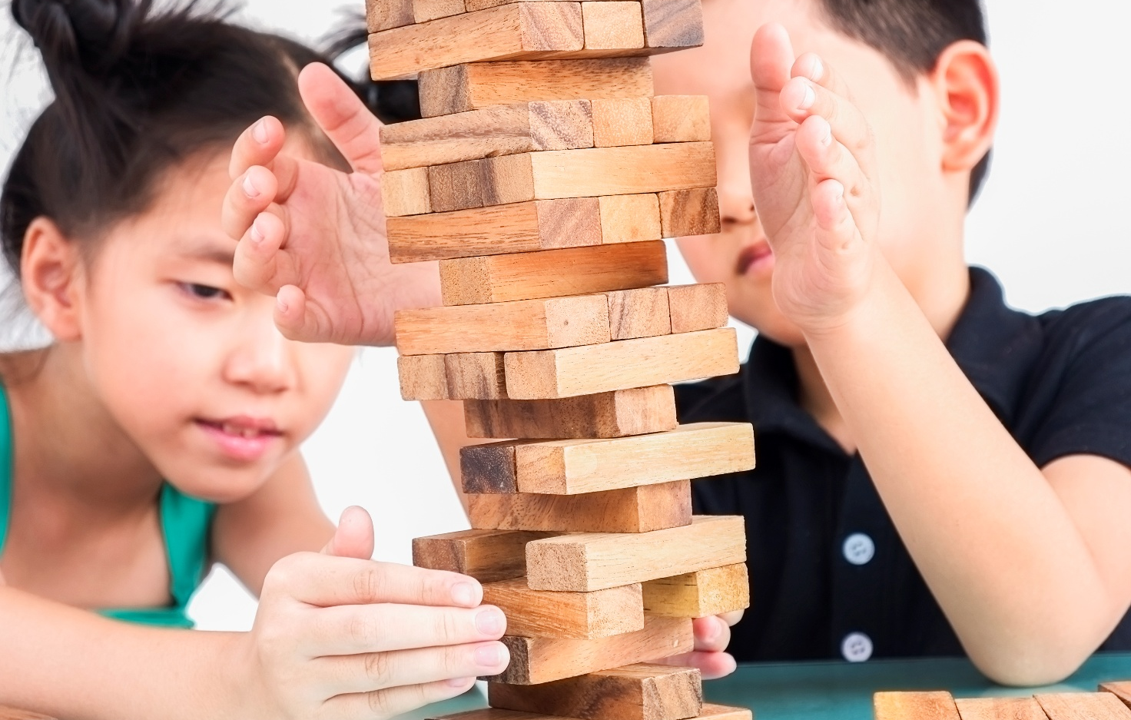
Image: Magnific

Develop protective strategies
Add to the CSRMP:
- any existing protective strategies you have for each identified risk
- determine if the existing protective strategies for a risk are enough to keep children safe
- if no existing protective strategies, or not enough strategies to keep children safe, add new strategies that will be put in place.
To help you establish your protective strategies, first consult the 10 National Principles for Child Safe Organisations. The National Principles provide direction and a framework. See some examples below:
Type of protective strategy | Examples | Principles applied
Physical barriers | Locks on doors to prevent access to secluded areas  Areas where adults and children interact have clear line of sight | 1, 8 and 10
Rules governing interactions | Adults are not allowed to be alone with children  Adults are not allowed to touch children in certain ways | 1, 5, 7 and 10
Rules governing behaviour | Adults are not allowed to contact children on social media or via online games  Adults are not allowed to shout at children | 1, 5, 7 and 10
Screening processes | Adults working with children must be suitable to do so with appropriate recruitment processes in place to ensure they are, including verifying a clear Working with Children Check, referee checks etc  Refer to the DHS Child Safe Recruitment, Induction and Support Guide at https://dhs.sa.gov.au/how-we-help/ngo-and-sector-support/child-safe-environment/resources | 5, 7 and 10
Protective behaviours | Children are given protective behaviour skills so they understand they can speak up if they feel worried, sad or angry | 2, 3 and 4
Governance | Leaders model the behaviour they expect from adults  Leaders make sure the Child Safe Code of Conduct is read and understood, and put robust child focussed reporting practices in place | 1, 6 and 10
In the National Principle column of the CSRMP, add which of the Principles have been applied to your strategies to minimise risk to children.
As part of the development of your CSRMP, include updating or developing any child safe policies and procedures to support the protective strategies in your CSRMP. This is to ensure transparency and provide your workers with clear guidance.

Publicise
Once your CSRMP is finalised it needs to be implemented. All persons working with children should be aware of it. Your publications and social media platforms can advise your stakeholders of it.
Remember the plan is intended to:
- create safe environments for children
- increase the effort needed for an offender to engage in inappropriate behaviour
- increase the likelihood of offenders being caught
- support children who report instances of abuse or harm
- remove all excuses for anyone engaging in inappropriate behaviour.

Review
Include on page 1 of your CSRMP the date your plan was implemented and also the date when it’s to be reviewed, to see where it can be improved. This can be every year and after any critical incidents, which are any instances where abuse and harm has occurred in your organisation.
Children should be consulted as part of this process. Your organisation should also research best practice in other organisations to see if new initiatives can make your plan even better.
A role title, or name, should be included on page 1 of the CSRMP as part of the review process so all stakeholders know who is responsible for it.

Tips for reviewing

Conduct an annual risk audit
Ensure there’s nothing you’ve missed when creating your CSRMP, or that’s changed since you implemented it.

Have regular inspections
Leaders can use spot checks to identify any weaknesses in the organisation’s CSRMP and consult with workers, parents, children, community members and, if possible, external consultants.

Look at current and past records for any incidents
When you update your risk management practices to ensure incidents aren’t repeated, your CSRMP is strengthened.

Meet with other child-related organisations
Share information, discuss best practice outcomes, ask them to review your CSRMP and offer to do the same for them.

Hold workshops with children
They are your key stakeholders and will often have insight into your CSRMP for a different perspective to adults.

In review
A CSRMP is an overarching document that describes how you intend to keep children safe in your organisation.
For you to create one that is suitable for your organisation, you must first understand the risks that can occur in the unique environment you work in. You must then take steps to reduce the chances of abuse and harm occurring, based on the information you’ve gathered. To do this you need to have a number of things in place:
- an understanding of the National Principles for Child Safe Organisations, ensuring each is implemented in your organisation
- child safe policies and procedures, including your CSRMP, that are publicised and understood
- a Child Safe Code of Conduct that is publicised and understood - you may want to think about having an age-appropriate version for children
- reporting processes that are accessible and understood by all your stakeholders, and included in your Child Safe Reporting Policy.

Common reasons CSRMPs are not effective
- they’re not very well prepared
- they’re very well prepared but they’re not used and no one knows about them
- they’re not reviewed:
- egularly and after critical incidents
  - when new activities or programs are commenced, or when other circumstances change such as the use of new equipment or buildings
- they address easy-to-fix risks but ignore the harder ones
- they rely too heavily on the Working with Children Check as a risk prevention strategy
- they fail to address critical aspects of child safety such as:
  - having effective policies and procedures in place including a Child Safe Code of Conduct. Refer to the Child Safe Code of Conduct Guide at www.dhs.sa.gov.au/how-we-help/ngo-and-sector-support/child-safe-environments/about-child-safe-policies/child-safe-policy-templates-and-guidelines.
  - allowing children the opportunity to participate in the decisions that will affect them
  - ensuring robust and transparent reporting systems are in place
- recognising the importance of strong and effective leaders.

Appendix 1: Child safe risk management plan template
Place your organisation’s name and logo here
Child safe risk management plan template
Note: This template can be used to create your Child safe risk management plan. Include what is relevant to your organisation and add any other details if necessary. Delete this note when development of plan is complete.
Nature of services provided to children by the organisation
Date plan completed | DD/MM/YYYY
Next review date | DD/MM/YYYY  or earlier if any critical incidents occur
Role responsible for review

Identified risk | Risk likelihood | Risk consequence | Risk rating | Protective strategies | National Principle
Think about the specific risks (physical, online, vulnerable children, your workers/members, structure, culture) that exist in in your organisation | Use Appendix 2, Risk matrices, to determine ratings |  |  | Include strategies:  - that are in place now that reduce risk  - new strategies to lessen the risk to children | Include the National Principles that apply

Appendix 2: Risk matrices
Place your organisation’s name and logo here
Risk matrices
Use the tables below to determine the risk likelihood and consequence rating for each of your child safety risks. Once you know the likelihood and consequence ratings, you can determine the risk’s rating using the Risk rating matrix.
Risk likelihood rating
The risk likelihood rating matrix is used to determine the chance of a risk event occurring.
Rating | Descriptions | Frequency
Almost certain | Event is likely to occur | Multiple times per year
Likely | Event will probably occur | Once per year
Possible | Event might occur | Once every 5 years
Unlikely | Event is unlikely to occur | Once every 10 years
Rare | Event may occur in exceptional circumstances | Once every 20 years

Consequence rating
The consequence rating matrix is used to determine the significance of possible consequences, if the risk occurred.
Rating | Effect on the child | Impact on the organisation (examples)
Major | Causing significant distress and harm | Child abuse or grooming occurred. Repeated inappropriate behaviour patterns by an adult or other child including bullying, psychological harm and sexual harassment.
Moderate (or Major)* | Causing the child distress | An isolated incident of bullying, psychological or physical abuse, minor physical punishment
Minor | Causing the child some upset or concern | One-off event of poor behaviour by an adult or other child, such as belittling the child
*Whether the impact is moderate or major depends on the organisation’s context
Determining the consequence of child safety risks can be challenging. Depending on the circumstances, any child safety risk can potentially result in more severe consequences.
The impact of certain actions on vulnerable children may be greater than on other children. For example:
- a one-off incident of physical harm on a child with a disability may have a more significant effect than on a child without a disability
- an instance of bullying may be considered a moderate level of impact, but if it’s re-occurring for the same child, it could cause significant harm. This means when increasing the likelihood of risk to an individual, you should consider whether to increase the consequence rating as well.
- any child safety risk can potentially result in severe consequences. For example, if expectations around conduct on social media are not set or conveyed to workers, it’s possible that unnecessary online contact occurs. While this could be harmless, this could facilitate grooming.
The consequences of an incident on a child can be complex and may even take years to surface. Therefore, when determining the consequence rating of any risk, it’s important to have an understanding of the children your organisation interacts with and the potential outcome that child safety risk may have. Where unsure, it’s best to err of the side of caution and increase the consequence rating.
Risk rating matrix
Once the likelihood rating and consequence rating are determined for a risk, use the matrix below to determine the risk rating.
Consequence
Likelihood |  | Minor | Moderate | Major
Likelihood | Almost certain | Medium | High | High
Likelihood | Likely | Medium | High | High
Likelihood | Possible | Low | Medium | High
Likelihood | Unlikely | Low | Medium | Medium
Likelihood | Rare | Low | Medium | Medium

Department of Human Services
Government of South Australia
For guidance only. Always refer to relevant South Australian legislation and obligations when applying child safe requirements.
www.dhs.sa.gov.au
Alternative formats
The information in this publication can be provided in an alternative format or another language upon request.

Principle 10 refers to making sure processes and procedures for how to implement and improve protective strategies are explained in your child safe policies.

