
Review of the South Australian SHS-Funded Homelessness System
June 2026

Stephanie Ross, Jindawayni Consulting
Amy Rust, Jindawayni Consulting
Nadia Di Girolamo, BetterStart Group
Jessica Dobrovic, BetterStart Group
Rhiannon Pilkington, BetterStart Group

Acknowledgements

Acknowledgement of Country
We respectfully acknowledge the Kaurna, Boandik, and Barngarla First Nations Peoples and their elders past and present who are Traditional Owners of the lands that are home to our campuses across South Australia.
We also acknowledge all First Nations peoples and lands across Australia with which we conduct business, their Elders, ancestors, cultures and heritage.
Sovereignty of these lands has never been ceded. It always was and always will be, Aboriginal land.
We are committed to social justice and equity.
Adelaide University acknowledges the historical impact of colonisation and its continuing effects and is committed to the Council for Aboriginal Reconciliation vision: ‘A united Australia which respects this land of ours; values the Aboriginal and Torres Strait Islander heritage; and provides justice and equity for all’.

Acknowledgement of Review Contributors
The authors acknowledge the workforce and stakeholders across the Homelessness, Domestic and Family Violence (DFV), Aboriginal Community Controlled Organisation and Aboriginal Community Controlled Health Organisation sectors who generously volunteered their time to contribute to this review. We also acknowledge the cultural knowledge and leadership that informed and shaped this report, and we recognise the lived experiences of homelessness and DFV that exist across the broader service sector. The authors also thank all South Australian Government agencies, staff and representatives who shared their time, expertise and insights as part of this review.
The Review Team acknowledges the valuable contributions of Professor John Lynch, Dr Alisa Willis, Dr Kylie Heneker and Lorraine McGrath, whose critical review and expert feedback strengthened the analysis and overall quality of the final report. Thanks are also extended to Anna Kalamkarian for her support in transcribing review engagements and for her insights, which informed the analysis of key themes.
We would also like to acknowledge SA NT DataLink and all of the data custodians and data managers from all government departments at State and Federal levels who have contributed to the development of the BEBOLD platform. The data analysis and interpretation included in the report are that of the authors and do not represent the views of any government agency.

Aboriginal and Torres Strait Islander data in this report
In this report, BetterStart has included data relating to Aboriginal and Torres Strait Islander clients. In line with Aboriginal Data Sovereignty principles, analysis and interpretation of Aboriginal-specific data has been interpreted in context and supported by Jindawayni Consulting.

Suggested citation
Di Girolamo N, Dobrovic J, Rust A, Ross S, Pilkington R. Review of the South Australian SHS-Funded Homelessness System. BetterStart Group, Adelaide University and Jindawayni Consulting, 2026.

Who we are: BetterStart Group
BetterStart Group is an interdisciplinary team trained in epidemiology, public health, psychology, allied health and social work. Our expertise spans the first 1000 days, early childhood education and care, child maltreatment, justice systems, housing and homelessness, mental health, substance misuse, domestic, family and sexual violence, and social and economic inequalities.
Our aim is to generate evidence that is useful to inform policy and practice and that can improve the health and wellbeing of children, young people, families, and communities.
For further information, please visit our website: https://adelaide.edu.au/research/betterstart-group/
Contact us via our Research Coordinator: jacqueline.aldis@adelaide.edu.au

Who we are: Jindawayni Consulting
Jindawayni is a 100% Aboriginal owned and led consultancy, based on Kaurna Country.
We work across Traditional Owner and Community engagement, strategic communications, and government relations, with a focus on complex social policy and service delivery.
Our work is grounded in cultural integrity and backed by established relationships with Community, Traditional Owners, government and the private sector. We are often engaged where issues are complex, contested, or where trust needs to be rebuilt.
We support organisations to engage respectfully, navigate complexity, and ensure Aboriginal voices are reflected in the decisions that shape their lives.
For further information, please visit our website: www.jindawayni.com.au
Contact us via contact@jindawayni.com.au

Terminology
Term | Definition
Alliance Model | Refers to the contracting and governance model introduced on 1 July 2021, under which multiple service providers operate within an Alliance consortium and are funded through a single contract, managed by a designated lead agency.
Alliance(s) | Referring to the 5 consortia of specialist homelessness service providers operating under the Alliance Model and funded through a single contract held by a lead agency. There are 4 homelessness Alliances based on geographic boundaries, and DFV Alliance based on service stream (DFV service provision).
Alliancing | Refers to the active collaboration between Alliance partners and the lead agency in accordance with the Alliance Model, encompassing shared governance, coordinated service delivery, and collective outcomes.
Anonymous Survey response (Quotes) | Refers to comments and responses provided in the Review’s anonymous Online Survey which was open to participation from the SHS workforce from frontline staff to executive level staff.
Cultural Governance | Governance arrangements that embed Aboriginal and Torres Strait Islander leadership, authority, decision making, and cultural accountability into system design, service delivery, and oversight.
Culturally Led Approach(es) | Approaches to service design and delivery that are led by Aboriginal and/or Torres Strait Islander people and grounded in community knowledge, cultural authority, and self-determination.
Directly Contracted Service | A specialist homelessness service that is funded directly by the South Australian Government outside of the Alliance Model, typically due to its specialist, statewide, or highly targeted function.
Domestic and Family Violence (DFV);  Domestic, Family and Sexual Violence (DFSV) | The Review recognises that contemporary understandings of DFV explicitly include sexual violence. Where the report refers to this broader concept, the term domestic, family and sexual violence (DFSV) is used. However, as DFV remains the standard terminology used within the Specialist Homelessness Service Alliances, this term is retained when referencing Alliance structures or Alliance specific practice.
Horizontal Governance | Horizontal governance operates across these structures, creating mechanisms for coordination, shared decision making and collective stewardship of the system as a whole. It enables actors at similar levels across organisations to work together to address issues that cut across service boundaries.
Lead Agency | The organisation within an Alliance that holds the primary contract with the South Australian Government and is responsible for contractual compliance, financial management, reporting, and coordination of Alliance partners.
Learning System | A structured, system-wide approach that continuously gathers, integrates and reflects on data, lived and living experience, cultural knowledge and practice insight to inform decision making, improve service quality and support ongoing system improvement. A learning system uses regular feedback loops to ensure that evidence and experience actively shape system stewardship, commissioning, governance and frontline practice over time.
Post-Alliance | Refers to the specialist homelessness system as it has been funded and structured from 1 July 2021 onward, following the introduction of the Alliance Model. Under this approach, most services are funded through Alliance contracts, with a small number of services continuing to be funded outside the Alliance structure (see Directly Contracted Services).
Pre-Alliance | Refers to the specialist homelessness system as it was funded and structured prior to 1 July 2021, when services were individually block funded by the South Australian Housing Trust (SAHT).
Relational commissioning and contracting | An approach to commissioning and contracting that centres on collaborative relationships between commissioners and providers, with a focus on shared outcomes, trust, transparency, and adaptability. It moves beyond transactional, compliance-driven models to enable joint learning, flexibility, and continuous improvement in complex service environments, such as homelessness systems.
Sector Participant (Quotes) | The term sector participant was used in quotes throughout the report as an overarching term to indicate a person who participated in either a 1:1 interview, group interview, or focus group. Interview and focus group participant quotes were not identified separately to reduce the risk of re-identification.
South Australian Housing Authority (SAHA) | Refers to the administrative authority established on 1 July 2018 following a machinery of government change, responsible for administering the functions of the South Australian Housing Trust and leading housing and homelessness policy, programs and service delivery.
South Australian Housing Trust (SAHT) | Refers to the statutory authority originally established in 1936 to provide public housing in South Australia, whose functions were administered through the South Australian Housing Authority from 2018, and under whose name the authority now operates.
System stewardship | Refers to the role of a central authority in overseeing, guiding and enabling a service system to function effectively as a whole. This includes setting a shared vision and outcomes, aligning policy, funding and governance levers, supporting collaboration across providers, monitoring system performance, and intervening where needed to address gaps, risks or unintended consequences, while not directly managing day-to-day service delivery.
Vertical Governance | Vertical governance refers to the structured lines of responsibility, decision making and accountability that sit within organisations and funding arrangements. These structures clarify roles, enable delegation and escalation, and support the delivery and oversight of specific services or programs.

Acronyms
Acronym | Definition
AAEH | Australian Alliance to End Homelessness
ABS | Australian Bureau of Statistics
ACCHO | Aboriginal Community Controlled Health Organisation
ACCO | Aboriginal Community Controlled Organisation
AHURI | Australian Housing and Urban Research Institute
ALT | Alliance Leadership Team
AMT | Alliance Management Team
AOD | Alcohol and Other Drugs
ASM | Alliance Senior Manager
ASSG | Alliance System Steering Group
AZP | Adelaide Zero Project
BEBOLD | Better Evidence Better Outcomes Linked Data platform
CALD | Culturally and Linguistically Diverse
DC | Directly Contracted (Services)
DCP | Department for Child Protection
DFV | Domestic and Family Violence
DFSV | Domestic, Family and Sexual Violence
DHS | Department of Human Services
DHW | Department for Health and Wellbeing
DVCL | Domestic Violence Crisis Line (also referred to as the DFV phone line)
EAP | Emergency Accommodation Program
FTE | Full Time Equivalent
FY | Financial Year
H2H | Homelessness to Home
KPI | Key Performance Indicator
KRA | Key Results Area
LEAN | Lived Experience Advisory Network
LEES | Lived Experience Engagement Service
LELAN | Lived Experience Leadership and Advocacy Network
LERG | Lived Experience Reference Group
LGBTQIA+ | Lesbian, Gay, Bisexual, Transgender, Queer/Questioning, Intersex, Asexual, Plus
MoG | Machinery of Government
NASHH | National Agreement on Social Housing and Homelessness
NGO | Non‑Government Organisation
NHHA | National Housing and Homelessness Agreement (superseded by NASHH)
PCBU | Person Conducting a Business or Undertaking
RoGS | Report on Government Services
SAHA | South Australian Housing Authority
SAHT | South Australian Housing Trust
SCHADS | Social, Community, Home Care and Disability Services (Award)
SHP | Supportive Housing Program
SHS | Specialist Homelessness Service(s)
SHSC | Specialist Homelessness Services Collection
SIF | Social Impact Framework
ToC | Theory of Change
WHS | Work Health and Safety

Contents
Review of the South Australian SHS-Funded Homelessness System 1
Acknowledgements 2
Suggested citation 3
Who we are: BetterStart Group 3
Who we are: Jindawayni Consulting 3
Terminology 4
Acronyms 6
Executive Summary 9
A brief look into the detail: what is driving system fragmentation? 16
Building a More Connected Homelessness System 21
The First 12 Months 24
Recommendations and Actions 26
1 Introduction 43
2 Background to the Alliancing Model in South Australia 54
3 The Current SHS system 60
4 Alliance Governance 68
5 Accessing the SHS System 80
6 Priority Areas of the Review 85
7 Service Demand and System Capacity 106
8 Practice in the SHS System 117
9 Workforce Capability and Conditions 124
10 Lived and Living Experience 133
11 Data, Outcomes and Accountability 143
12 Resourcing and Funding in the Sector 150
13 What This Means for Recommissioning 156
Appendices 159

Executive Summary
This review was commissioned by the South Australian Department of Human Services (DHS) to inform the recommissioning of Specialist Homelessness Services (SHS). It examines how current commissioning arrangements, established in 2021 under the South Australian Housing Authority (SAHA) Homelessness Alliance reforms, have been realised at a system level and identifies opportunities to strengthen coherence, equity, cultural safety, integration and outcomes across the homelessness system.
The scope of the Review is explicitly system level. It does not assess individual service or organisational performance. Instead, it focuses on the structures, governance and commissioning settings that have shaped how the homelessness system operates overall and how outcomes are produced for people experiencing or at risk of homelessness. Particular attention was given to priority areas identified in the Terms of Reference: Aboriginal people and communities, young people, people experiencing rough sleeping, place-based responses, and domestic, family and sexual violence.
Major review findings are summarised below, structured thematically to reflect both the key system issues identified and the areas where reform action is required.
How conclusions of this review were formed:
The findings of this review draw on extensive engagement across the sector:
- More than 200 individuals were engaged across 65 interviews and focus groups with the homelessness sector and government, including ACCOs, ACCHOs and Aboriginal staff.
- The Review was also supported by 292 survey responses from the homelessness workforce.
- More than 800 documents were submitted to the review team. These documents included policies and program documentation, and relevant public inquiries and reports, including the Royal Commission into Domestic, Family and Sexual Violence and Auditor-General’s reports.
Together, these inputs represent the evidence base upon which the Review conclusions were formed. The breadth of engagement and participation from the Homelessness sector reflects the lived experience and professional expertise alongside a deep commitment to working with people experiencing or at risk of homelessness to achieve better outcomes.

The current model is not well positioned to deliver a coordinated, system-wide response
The 2021 SAHA homelessness reforms were designed to transform the delivery of homelessness and DFV services across South Australia. Through the establishment of five Alliances, the reforms were to create a more integrated and collaborative service system, better positioned to respond to the needs of people experiencing homelessness. The ambition to invest in change for better outcomes was shared by the homelessness sector.
In practice, despite best intentions and considerable effort, the model has not achieved its intended outcomes. This reflects a combination of implementation challenges and underlying structural weaknesses. Key elements of the original design were not realised, including whole-of-system governance, shared data and outcomes frameworks, and the planned evaluation cycle of one evaluation every two years. Moreover, expectations of collaboration based largely on goodwill in the context of an escalating housing crisis created further barriers to meeting the ambition of Alliancing.
The transition to Alliancing in 2021 occurred rapidly and was not sufficiently supported through implementation. In the pursuit of establishing a new operating model, many long-standing relationships and ways of working were disrupted, with the significance of this disruption underestimated. As a result, the system's capacity to adapt to new structures and collaborative practices was constrained. These changes have had enduring implications for system cohesion, trust, and leadership, highlighting the importance of investing in relationships and change management as critical enablers of reform.
“We should all be working in partnership without having a contract or alliance to say, ‘This is what I’m doing together.’ It should be natural. The sector is fundamentally relational, and that takes effort and trust.” – Sector Participant
Figure 1 shows the transition from the past to the present system. Whilst the intent was to create system-wide collaboration, what has emerged is a system relying on resources, relationships and coordination within siloes rather than whole-of-system design.
Figure 1: Past and Present Homelessness System Architecture
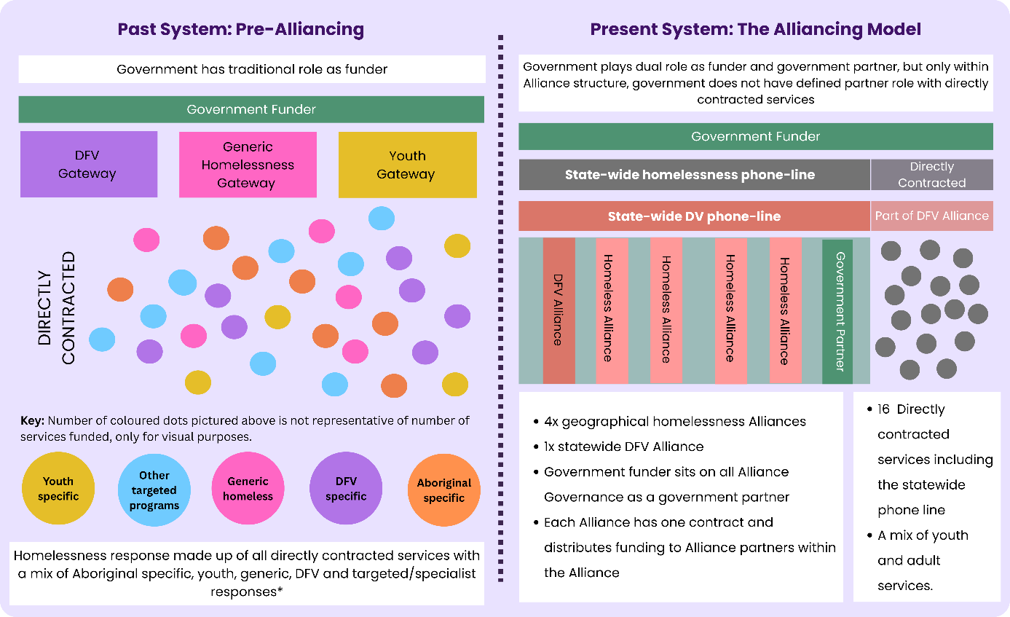
This review found examples where significant effort has been invested in establishing a new way of working through the Alliancing model. This included the development of new relationships, governance arrangements, leadership structures and approaches to service coordination, spanning individual organisational leadership through to frontline service delivery. Genuine commitment to collaboration was seen to result in coordination of responses, shared practice, and the creation of opportunities for more integrated support. However, these examples of progress were not seen across the system as a whole.
“At its best, you can see genuinely intentional practice that’s been brought together, co-designed, and is stronger than what existed before. At its worst, it’s a collection of things that used to happen and still sort of do, joined by a common narrative rather than genuinely joined by practice.” – Survey Response
While some partnerships and local arrangements demonstrated the potential of the model, these successes were not consistently realised. At a system level, the model has resulted in parallel subsystems with structural separation between Alliances and Directly Contracted Services rather than a coordinated whole. There is limited evidence of system-wide improved integration or outcomes.
“All Alliances are not created or governed equally. Service provision and experience can be significantly stronger in one Alliance than another, and that inconsistency is often felt as an impediment. There aren’t common structures or frameworks sitting across the system, so while one Alliance might be doing something effectively, there’s nothing to ensure consistency or alignment elsewhere.” – Sector Participant
Following the transfer of homelessness to DHS, the department has been expected to steward a system without the authority, tools or system architecture. These limitations predate DHS’s stewardship but continue shaping system performance and expectations. The Review finds the current model is not well positioned to deliver a coherent, equitable or sustainable system response. It recommends discontinuing the five-Alliance structure and applying Alliancing principles at a system level, supported by strengthened system architecture and the direct contracting of services.
Review findings are reflected in recommendations to address gaps in SHS system architecture through recommissioning and reform, responding not only to challenges that have emerged since the implementation of the Alliancing model but also to underlying system gaps that predate its introduction. Key elements of this approach include:
- Strengthened statewide stewardship by DHS (Recommendation 4, 4.1)
- Whole-of-system horizontal governance to support shared responsibility and strategic direction (Recommendation 3, 3.1)
- Implementing a contemporary, integrated, and culturally safe data system (Recommendation 13, 13.1), and;
- The application of relational commissioning and contracting principles to support a system that is responsive to localised need (Recommendation 6, 6.1)

The system is not consistently safe or effective, particularly for priority groups
In some cases, system conditions place clients at risk, with impacts most pronounced for priority groups. For Aboriginal people and young people, despite efforts by providers to grow culturally informed responses within individual Alliances, the system is experienced as not only ineffective but unsafe. Aboriginal people remain profoundly over-represented without Aboriginal-governed responses, enforceable cultural governance, or mechanisms to recognise and manage cultural risk at a system level. For many Aboriginal people, homelessness extends beyond the absence of housing and includes disconnection from family, kin, community, culture and Country.
Addressing these experiences requires reforms grounded in Aboriginal self-determination, cultural authority and Aboriginal-led decision making. Similarly, despite the efforts of youth services to advocate and coordinate responses, these efforts are unsupported at a system level. As a result, young people face inconsistent entry pathways, fragmented responses, and service environments that do not reliably support their developmental needs, safety or stability. These are structural failures that require urgent correction.
"Homelessness services frequently support people who have been let down by multiple systems prior to their experience of homelessness (and who still require support from these systems), yet we are continually expected to stretch resources, goodwill and workforce capacity beyond what should be expected to meet the demands and unwillingness of other services and systems to compromise or genuinely collaborate." – Sector Participant
This review found there is general consensus from providers that the data system further undermines safe and effective practice. The current Homelessness to Home (H2H) system cannot capture practice, risk, cultural context or outcomes. Services often rely on secondary systems, creating duplication and administrative burden. H2H was designed to align with the requirements of the National Minimum Dataset for homelessness services. However, stakeholders report its limitations restrict learning beyond key performance indicators and contractual obligations. As highlighted in the Auditors Generals report, there is an opportunity to move to a data system that supports learning, practice improvement and culturally informed decision making.
Review findings highlight a homelessness service system under significant strain. Throughout the Review, the homelessness workforce consistently demonstrated a strong commitment to supporting people experiencing or at risk of homelessness, often working collaboratively and responding flexibly despite constrained resources and system complexity. However, the Review finds that the homelessness system as a whole is not consistently functioning in a way that enables timely, coordinated and equitable responses. For Aboriginal people, young people and others experiencing multiple and intersecting forms of disadvantage, the consequences of these systemic shortcomings are particularly acute. Without decisive reform and investment to strengthen system coordination, prevention and integrated responses, avoidable homelessness and housing instability will persist, further entrenching inequity and increasing long-term social and economic costs.
“We have fantastic staff who are working hard with limited resources and capacity in a system that continues to struggle to address systemic issues.” – Sector Participant
Funding was raised in every interview, focus group and survey response undertaken as part of this review, not as a background influence but as a core determinant of how the homelessness system is currently functioning. While comparisons over time are complicated by changes to governance, commissioning and system oversight, stakeholders consistently identified a growing mismatch between system expectations and available resources. National funding data supports this; South Australia's homelessness funding has increased by approximately 8 per cent since 2018, compared with a national average increase of 47 per cent over the same period, while the average cost per client has increased by approximately 20 per cent.
In the context of rising workforce costs, demand, and growing service complexity, stakeholders reported that constrained resources have limited the sector's capacity to respond, invest in prevention and sustain innovation. Without reform, the system risks becoming increasingly focused on managing crisis rather than preventing it, with the consequences felt most by people facing the greatest barriers to housing stability and support.
Addressing these issues requires a deliberate shift toward safety, cultural authority that is meaningful across the service system and developmentally appropriate responses, particularly for groups for whom the system is currently unsafe. The path forward is highlighted in the following system level actions and approaches:
- Cultural governance at all levels of the system to ensure cultural authority, Aboriginal self-determination and cultural responsiveness are embedded across the SHS sector (Recommendations 3.1, 4.1, and 12.1)
- Culturally appropriate and responsive pathways for Aboriginal people (Recommendation 8.1), and developmentally appropriate pathways for young people (Recommendations 9 and 9.1)
- Collection of data that reflects the unmet homelessness service demand to support understanding of the true cost of delivering homelessness services and the delivery of an Aboriginal funding reform framework (Recommendations 7 and 7.1)

Inconsistent access pathways and structural barriers are driving system-level pressure
Based on the evidence available to the Review, the Alliancing Model has not created a more cohesive system, and elements of the system’s design have created structural barriers to access. While there has been progress within some individual Alliances and examples of excellent practice in Directly Contracted Services, at a system level, the Alliancing structure unintentionally created inconsistent system settings.
Entry points and eligibility thresholds vary significantly across regions, and the system lacks shared tools, processes and governance to support equitable access and consistent decision making, regardless of where a person seeks support. Stakeholders consistently described a service system under increasing pressure, with some attributing this to the combined impacts of the housing crisis and rising cost-of-living pressures. In this context, it is more important than ever to address inconsistent access pathways, variable eligibility and prioritisation practices, and unclear service scope to ensure the homelessness service system is enabled to provide coordinated, timely and equitable service responses.
“There’s a real commitment across services to be accessible and not turn people away, we meet people where they are and respond to really complex needs. But because the system is expected to respond to everyone, without clear boundaries around who it’s for or what it’s resourced to do, that gets stretched. In practice, inclusion becomes about getting through the front door, rather than being able to provide the level of support people actually need.” – Survey Response
Although collaboration within each Alliance has been driven at an operational and leadership level as a statewide response to DFV and homelessness, Alliances have drifted apart despite their interdependence, resulting in inconsistent and sometimes unsafe responses. Variations in access points, eligibility requirements, risk thresholds and practice expectations mean people are often bounced between specialist DFV homelessness services and specialist homelessness services. Without deliberate realignment, this separation will continue to undermine safe and effective responses to people experiencing DFSV and homelessness, particularly in the context of reform underway in the broader DFSV sector.
Finally, these challenges sit within a broader strategic gap. While the South Australian Government has demonstrated a clear commitment to strengthening the homelessness system, South Australia remains the only Australian jurisdiction without a dedicated homelessness strategy. A statewide homelessness strategy represents an opportunity to establish a shared vision, priorities and accountability across government and the sector. It would provide a mechanism to strengthen whole-of-government coordination, align investment and policy settings, and embed a shared approach to understanding demand, measuring outcomes and continuously improving the system. Without this broader strategic framework, the Specialist Homelessness Services (SHS) system continues to carry responsibility for crisis response, early intervention and prevention, without the coordinated policy, investment, and cross-sector architecture required to achieve these objectives.
Through its stewardship role, DHS is well-placed to lead the system reform and implement the system architecture required to create the conditions for a more equitable, responsive and continuously improving homelessness system. The recommendations that follow are designed to strengthen access, system alignment and stewardship:
- A state-wide Homelessness Strategy that sets out a clear vision for the homelessness system and how homelessness will be addressed in broader systems such as housing, health and justice (Recommendations 5 and 5.1)
- Alignment of homelessness reform with current reform already underway as part of the DFSV Royal Commission (Recommendation 2)
- A universal front door approach with statewide processes for access, triage and navigation across all SHS providers, underpinned by cultural and clinical governance (Recommendations 8 and 8.1).
- Develop a homelessness practice framework including Aboriginal-specific pathways and definitions of homelessness (Recommendations 10 and 10.1)
- A linked, whole-of-government homelessness data dashboard to improve visibility of pathways, demand and outcomes across service systems (Recommendations 14 and 14.1)
- Establishment of a statewide learning system to support continuous improvement across commissioning, practice and system design, integrating data, cultural knowledge, clinical insight and lived experience (Recommendations 15 and 15.1)

Workforce conditions are unsustainable and lived experience is not embedded
Workforce strain is structurally produced. High exposure to trauma, inconsistent access to supervision, unclear workload expectations and unrecognised cultural and clinical responsibilities have created unsafe and unsustainable conditions for many workers, particularly Aboriginal staff. These pressures reflect system design, not individual capability, and require addressing at a system level through a sustainable workforce strategy (Recommendations 17 and 17.1).
“The scope is so broad that essentially everyone at risk of homelessness becomes eligible, and we’re expected to work with everyone… which isn’t sustainable. Workloads are massive, burnout is high, and there’s a lot of turnover” – Sector Participant
Lived experience is not yet structurally embedded within the homelessness system. While there are examples of meaningful engagement, lived experience is inconsistently resourced, lacks clear authority, and is not systematically integrated into governance, commissioning, evaluation or system improvement. As a result, the homelessness system is often making decisions about people without consistently drawing on the expertise, insight and knowledge of those who have directly experienced homelessness and housing instability. Current approaches rely on multiple unconnected processes rather than a coherent system design, limiting the influence of lived experience on decision making and reform.
"I think lived experience needs to drive the system, policy and contract change; my observation has been that most agencies struggle to adopt change. Over the years, I have seen change been more successfully adopted when it was required through commissioning cycles!" – Survey Response
A statewide homelessness strategy provides an opportunity to co-design a long-term approach that positions lived experience as critical to a learning service system (Recommendation 5 and 5.1). For Aboriginal people, this should also recognise collective experiences, community voices and cultural authority, alongside individual lived experiences. This means moving beyond consultation towards the systematic collection, interpretation and application of lived experience insights to inform policy, commissioning, service design and continuous improvement. Grounded in trauma-informed, culturally safe and evidence-based approaches, this would strengthen the system's capacity to understand what is working, identify emerging issues and adapt over time in partnership with the people it exists to serve (Recommendations 18 and 18.1).

A clear and achievable path to reform
South Australia is unusually well positioned to undertake reform. The recommissioning process coincides with implementation of the response to the Royal Commission into Domestic, Family and Sexual Violence, aligned commitments under Closing the Gap, development of the Homelessness Outcomes Framework, and the transfer of homelessness stewardship to DHS. Collectively, these reforms create a rare opportunity to address longstanding structural issues through a coordinated and system-wide approach.
A reset is both necessary and possible. The Review found a system characterised by strong commitment, goodwill and relational trust across the sector. Gains made in some Alliances demonstrate the potential of collaborative ways of working to improve outcomes for people experiencing or at risk of homelessness. However, these gains have developed in the absence of cross-system architecture to support, scale and sustain approaches that improve outcomes.
“You can reform the homelessness system as much as you want, but it needs to be cross-sector and cross-system, otherwise people just fall through the gaps. And when they do enter the system, there needs to be a response wherever they present, rather than being pushed straight into homelessness services.” – Sector Participant
Future reform should learn from examples of success. DHS can work with the sector to build a system that is coherent, culturally safe and sustainable. This will require strengthened system stewardship, and the strengthening of leadership relationships across the sector to support collective ownership and shared direction. Through a homelessness strategy and horizontal governance, the system can establish the scaffolding needed to elevate cross-government homelessness priorities and accountabilities. This will support early intervention, prevention, and coordinated responses, and create the conditions for better outcomes for people experiencing or at risk of homelessness.
Importantly, the findings of this review are not occurring in isolation. They are consistent with, and reinforce, conclusions drawn through multiple previous reviews and inquiries, including the Auditor-General’s 2024 report into the management of homelessness services, prior reviews of the Homelessness to Home system, and the recent Royal Commission into Domestic, Family and Sexual Violence. While this review provides a more detailed and system-specific analysis of the current SHS context, the underlying issues are well established. The persistence of these findings across multiple processes indicates a system where evidence has not yet translated into structural reform. In this context, the priority is not further diagnosis, but implementation.
It is notable that in recent years, the sector has contributed extensively to major reviews and reform processes, including the Royal Commission into Domestic, Family and Sexual Violence, the Emergency Accommodation Program Review, repeated reviews of the Homelessness to Home data system, the Extreme Weather Response Review and the Homelessness Outcomes Framework development. Stakeholders consistently reflected a level of consultation fatigue, particularly where engagement has not led to visible or sustained change. Further engagement should therefore be targeted, time bound and clearly linked to implementation and a statewide strategy that sets out a plan for ongoing systemic learning and improvement. Without this, there is a risk of diminishing goodwill and undermining the sector’s capacity to support reform.
The purpose of recommissioning is not simply to redesign contracts or governance arrangements. It is to create the conditions for a homelessness system that is safer, more equitable, culturally governed and better able to respond to the needs of South Australians experiencing housing instability and homelessness. This review has found that the required expertise, commitment and leadership already exist across the sector. What has been missing is the system architecture needed to connect, support and sustain those strengths.
The opportunity now is not to build something entirely new, but to embed system architecture that enables a whole-of-system approach to achieving improved outcomes for people experiencing or at risk of homelessness. If implemented with care, cultural authority, and genuine partnership, the reforms outlined in this report provide a pathway toward a homelessness system where access is more consistent, responses are more coordinated, and outcomes are no longer determined by where a person presents for help, or who they are.

A brief look into the detail: what is driving system fragmentation?
This section examines the structural features of the current model that are driving fragmentation, inconsistency and system-level drift in the homelessness system.
The Alliancing Model was introduced with the intention of creating a more integrated, collaborative and outcomes-focused homelessness system. The Review found strong examples of collaboration, sector leadership and high-quality practice across the homelessness system. However, these examples have not resulted in the conditions required to effectively, equitably and safely support all people experiencing or at risk of homelessness.
What the Review finds is a system shaped by structural overspecification in some areas and profound under specification in others. These imbalances have produced inconsistent access pathways, disconnected governance structures, variation in practice, weak interfaces with DFV, youth, and housing systems, and limited visibility of demand and outcomes. These conditions have created inequity and operational drift, preventing the model from functioning as a coherent system.
The section below examines where the model was over-specified and under-specified, and how these structural imbalances have shaped the way the system operates in practice.
Overspecification: Where detailed system design limited flexibility
In this context, “overspecified” refers to areas where the model introduced rigidity through detailed structures or requirements, without the supporting system functions needed to work effectively to respond to client and community needs.
Contractual reform was introduced without the system functions needed to support it.
The Alliancing Model introduced a single contract per region, a lead agency and formal Alliance governance structures, but did not establish the system infrastructure needed to support shared accountability. The model assumed Alliance-level governance would be scaffolded by system-level governance through the Alliance System Steering Group (ASSG). As this system-level governance was never implemented, Alliances have operated without shared outcomes, data systems or evaluation cycles to guide decision making. As a result, governance arrangements exist in form but have limited capacity to influence system performance or outcomes.
Governance structures were highly defined, but their authority and impact were unclear.
The Alliance Leadership Team (ALT) and Alliance Management Team (AMT) were defined with mandatory and detailed membership and meeting requirements, while decision making authority, escalation pathways and connection to system-level stewardship were unclear. This resulted in governance activity without governance impact, with structures that were highly specified in form but unable to influence system direction or resolve system-level issues.
“The Alliance model has added governance and administrative layers without additional resourcing, increasing coordination and reporting requirements while reducing capacity for frontline service delivery.” – Survey Response
Service boundaries were rigid, without clear pathways between them.
Alliance boundaries were tightly specified by geography and service stream, including the creation of a separate DFV Alliance, but the pathways between these were not clearly articulated. This has made coordination across services more difficult in many cases, particularly for people whose needs do not align neatly with program or regional boundaries, including young people, Aboriginal people whose family, kinship and community connections often extend across administrative boundaries, and people with complex needs. The separation of DFV services has reinforced fragmentation, contributing to inconsistent access and unsafe or disconnected transitions. Without clear mechanisms to navigate across boundaries, the system has not consistently functioned as a connected statewide response.
Multiple access points were established without a shared approach to access.
The Alliancing model did not establish a clear, statewide approach to access. In its absence, individual services and Alliances developed different intake and triage processes, resulting in multiple entry points with varying thresholds, eligibility decisions and approaches to risk.
“I feel there’s a major gap in access to the system. People call what are meant to be entry points and are asked to leave a message or told to call another number, where they have to leave a message again. It feels terrible when someone calls you for support and you have to send them into that loop, knowing they’ll be left in limbo while in crisis. It doesn’t feel like a system that can provide the support they need.” – Sector Participant
The two statewide phone lines have operated without a clearly defined role, with use varying across services and Alliances. This lack of clarity, combined with inconsistent practice across Alliances and Directly Contracted services, resulted in uneven access pathways and limited the system’s ability to provide a coherent, equitable entry experience for people seeking help.
Reporting requirements were detailed but did not produce meaningful insight.
While reporting expectations were clearly defined, the underlying data system cannot capture key aspects of practice, including risk, cultural context or outcomes. Thus, services have relied on secondary systems to record information needed to work safely and effectively. This has increased administrative burden without improving system visibility. This has created administrative burden without generating meaningful insight, largely because system stewardship over data and evidence has been absent. DHS inherited the homelessness portfolio with a data system that remains inadequate, while management continues to sit with SAHT, despite multiple reviews and longstanding recommendations to develop improved system-wide data platforms.

Under-specification: Where key system elements were not clearly defined
Under-specification occurred where key parts of the system were not clearly defined. In these areas, the Model relied on local relationships, interpretation or goodwill rather than system settings. This contributed to variation across the system and meant that responsibilities were not always clearly held at a system level.
Cultural governance and Aboriginal-led decision making were not embedded in the system.
The model did not establish consistent mechanisms for cultural governance, Aboriginal-led design or recognition of cultural risk at a system level. As a result, Aboriginal people remain profoundly overrepresented in the system without the structural levers required to ensure culturally safe, Aboriginal-governed responses.
“Cultural safety, equity and inclusion need to be embedded across the system, not treated as add-ons or frontline responsibilities. Aboriginal-led solutions, shared accountability and genuine partnership with community are critical to achieving safe and equitable outcomes. Without system-level change in policy, funding and decision making, inequities will continue.”– Survey Response
The system lacked clear stewardship and a learning framework.
The governance and evaluation structures intended to support the model were not implemented from the beginning of the contract. Without these, the system has lacked a clear central stewardship function to align decision making, monitor performance or drive reform. There are also limited mechanisms to learn from data, practice or lived experience, meaning providers have often had to operate in isolation without structured opportunities to reflect, adapt or build collective capability.
There was no shared, statewide commissioning logic.
The Alliancing Model did not establish a statewide commissioning logic to define the scope of the SHS system, the role of specialist services or how homelessness, DFV and youth services should interface. Although eligibility included people who were homeless and at risk, which implied a role in prevention and early intervention, the model did not articulate what this role should be or how it should be delivered. Without a shared commissioning framework, services interpreted their remit differently, which contributed to drift, duplication and inconsistent eligibility decisions. The absence of statewide logic also limited DHS’s ability to align investment with system priorities or ensure equitable access across regions.
Pathways for young people were not clearly defined.
The system does not articulate how young people should access or move through the homelessness system, or what a developmentally appropriate response should involve. Without defined youth pathways, services developed their own approaches, resulting in inconsistent eligibility decisions, variable practice and environments that were not reliably safe or suitable for young people. This left young people navigating a system that was not designed around their needs and lacked the structures required to support stability, safety and developmental outcomes.
Integration between DFV and homelessness was not defined.
Despite the clear overlap between DFV and homelessness, the model did not establish how services should work together. The creation of a separate DFV Alliance without a corresponding integration framework resulted in two parallel systems with different access points, thresholds and practice expectations. This has contributed to drift between the sectors, inconsistent responses and unsafe handoffs, particularly for women and children moving between DFV and homelessness services.
The role of Directly Contracted services within the broader system was unclear.
Directly Contracted services have a clear understanding of their own purpose and program requirements, but the Alliancing Model did not define how these services should relate to Alliances or how the two parts of the system should work together. Governance and accountability structures were created for Alliances, but no equivalent mechanisms were established for Directly Contracted services, leaving them outside the formal governance architecture. Without a defined interface or shared governance mechanism, collaboration between Alliances and Directly Contracted services has been inconsistent, and opportunities for coordinated, holistic system responses have been limited. This lack of integration has contributed to duplication, gaps and fragmented pathways across the system.
“There’s a real silo between Alliances and Directly Contracted services. There’s no clear role, no shared processes, and we’re not part of how decisions get made or coordinated across the system.” – Sector Participant
Clinical governance and risk management expectations were not established.
Workers were expected to manage high levels of risk without consistent supervision structures, workload expectations or clinical governance. The model did not define minimum standards for supervision, risk assessment, case management or escalation. This left services to develop their own approaches, resulting in variable practice and unsafe conditions for both clients and staff. The absence of clinical governance also contributed to workforce strain and burnout.

Practice and outcomes frameworks were not in place, and not yet fully guiding practice
At the time the Alliancing Model was introduced, the system did not have a statewide outcomes framework or a shared practice framework to guide how services should work together. While a Homelessness Outcomes Framework now exists, and was developed with input from the homelessness sector, it’s application within the current system architecture and data environment is still evolving. Many outcomes are not yet supported by consistent measurement approaches, and there has been limited opportunity to translate the framework into practice expectations, commissioning settings or accountability mechanisms.
In the absence of consistent outcomes measurement and shared practice settings, Alliances have interpreted priorities independently, resulting in variability in practice, expectations and alignment across regions. Without these foundations, the system has not been able to operate as a fully coordinated whole.
The interface between homelessness and housing systems was not clearly defined.
When SAHA stepped away from direct stewardship of the homelessness system, the relationship between housing and homelessness was not redefined. This left a structural gap in leadership, pathways and coordination. The absence of a clear interface meant that homelessness services had limited influence over housing access, and housing policy and operational decisions were disconnected from homelessness system pressures. This weakened pathways out of homelessness and contributed to system-level drift.

Implications of the Alliancing Model for system design and service delivery
The over and under-specification of the system reflects the way the model was designed and implemented, rather than the commitment, expertise or effort of the sector. Recommissioning the SHS system will require a clear focus on system design including elements such as how the system is structured and governed, where responsibility for service and system coordination sits, and how commissioning settings can better support a more coherent, equitable and effective response to homelessness. This includes ensuring that future system design is informed by structured impact assessment, particularly for groups experiencing higher levels of risk. These findings have direct implications for the future design and commissioning of the homelessness system.

What this means for recommissioning
Based on the evidence, the current Alliancing Model is not recommended for continuation. It has not delivered the level of system integration, cultural governance, access equity or collective outcomes that were intended, and its structure is not well aligned with the needs of a contemporary homelessness system.
The shift to the Alliancing Model occurred rapidly and was not trauma-informed, despite expectations that the sector itself operates in this way. This disrupted established relationships, created instability in service delivery and contributed to ongoing workforce and system strain. These impacts were not systematically acknowledged or addressed and continue to influence how the system operates today.
This reinforces that the limitations identified in this review are primarily a function of system design and implementation, rather than a lack of sector capability or effort. While the model included elements of sector leadership, these were not consistently supported or embedded within the broader system architecture, limiting their effectiveness. Recommissioning must therefore take a deliberate, staged and relational approach, ensuring that form supports stability and consistent responses for people experiencing homelessness, rebuilds trust with the sector and enables sustainable system change.
At the same time, these findings do not reflect a lack of effort or commitment from the sector. Services have worked hard to make the model function, often navigating unclear structures and filling gaps through local relationships, collaboration and innovation. Stakeholders consistently identified these relationships as one of the key strengths to emerge from the model.
Recommissioning provides an opportunity to build on these strengths, not lose them. In particular, the collaborative ways of working that have developed across parts of the system can be strengthened and supported at a system level, rather than relying on localised effort to sustain them.
“Recommissioning is an opportunity to better align funding, systems and expectations with the realities of frontline work. Services would benefit from simpler data systems, more realistic KPIs, stronger collaboration, and greater flexibility to respond to fast-paced and complex client needs. Involving frontline staff and people with lived experience in recommissioning decisions would help ensure services are practical, effective, and focused on real outcomes.” – Survey Response
Reform will enable moving toward clearer shared accountability across the system, so that responsibility for outcomes is not held in isolated parts of the system, but collectively. Over time, this will support greater consistency in how people experience the system, helping to ensure that outcomes are not dependent on where someone first seeks help, but are more equitable across the State.
Clearer stewardship, stronger governance, improved data infrastructure and embedded cultural governance are system elements critical to enabling the system to function safely, consistently and sustainably.
The foundations for change already exist. The sector brings deep expertise, strong relationships, cultural knowledge and lived experience insight, alongside a clear commitment to improving outcomes for people experiencing homelessness.
With the right structures in place, there is a clear opportunity to build a system that not only supports better outcomes for people experiencing homelessness but also strengthens and sustains the workforce delivering these responses.

Building a More Connected Homelessness System
The proposed future system model builds on the strengths of the current homelessness system while addressing the structural drivers of fragmentation identified through this review. It represents a shift toward a more coordinated, relational and culturally governed system, underpinned by continuous learning and shared accountability. DHS shifts from a partner to a dual role as funder and system steward, coordinating the horizontal architecture to enable shared decision making, accountability and strategic direction. This architecture is underpinned by cultural and clinical governance, to enable safe and evidence-informed service delivery.
Shared and coordinated approaches can create a Universal Front Door to provide consistent, inclusive and developmentally appropriate access. Direct contracting of services supports place-based responses while ensuring comprehensive statewide coverage of targeted and specialist homelessness supports. Linked to all elements, a learning system enables ongoing monitoring, feedback and improvement, supported by training and communities of practice that build and sustain shared approaches over time.
Figure 2: Proposed System Model
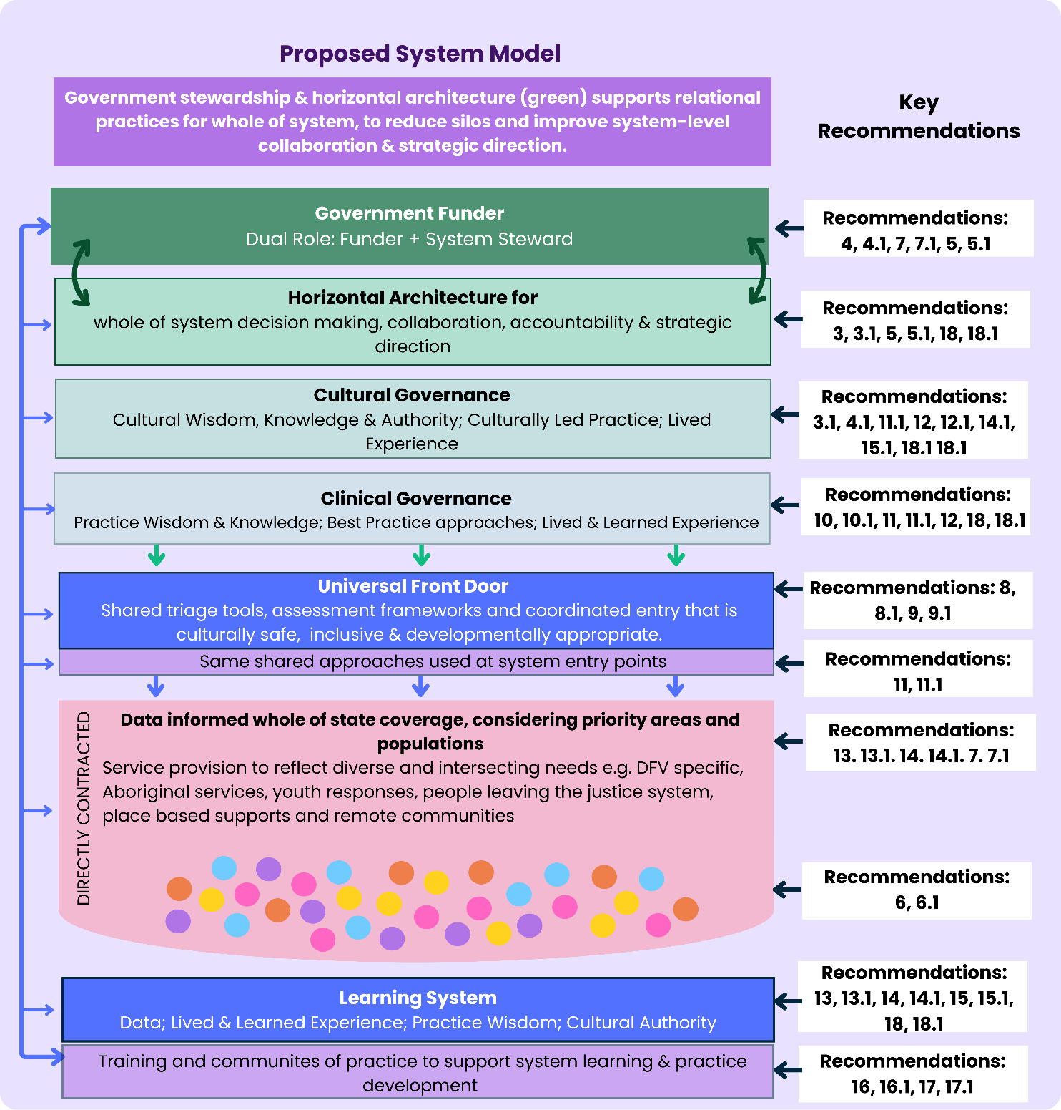
South Australia’s homelessness system has evolved over time, including through the introduction of Alliancing. While this has improved within region collaboration, the system remains fragmented, with inconsistent access, variable practice and limited coordination across service streams. The proposed model represents a fundamental shift from a service-led system, where responses depend on where people present, to a coordinated, whole-of-system approach designed around people, culture and long-term-outcomes.

The System in Transition
The current system is characterised by:
- Multiple entry points with inconsistent intake, triage and navigation
- Variation in practice, service responses and prioritisation
- Fragmentation between homelessness, housing, DFSV and other systems
- Limited visibility of unmet need, system demand and outcomes
- Inconsistent recognition of Aboriginal experiences and cultural governance
While stakeholders report that the Alliancing model has strengthened collaboration, these strengths appear to remain within alliances, while challenges remain at a system level. The proposed model establishes a more coordinated, consistent and accountable system, supported by shared governance, integrated practice and continuous learning.

How the Proposed System Works
The proposed model operates as an integrated system, where each component strengthens overall performance and outcomes. What follows is a description of the core system elements under the proposed model, and how these elements could work together to create a more coordinated and effective system.

1. Stewardship and Shared Accountability
Under the Alliancing model, government operated primarily as a funder and partner within Alliances. The proposed system establishes a stronger stewardship role, with responsibility for oversight and performance of the homelessness system as a whole. This includes cross-government responsibility for homelessness outcomes, coordinated planning and investment based on evidence of demand and unmet need.
Recommendations: 4, 4.1, 7, 7.1

2. Governance, Cultural Authority and Lived Experience
System governance is strengthened through horizontal system architecture and collaboration, Aboriginal cultural governance and lived and living experience. Aboriginal governance ensures, self-determination, cultural authority, data sovereignty and culturally informed decision making, while lived experience structures support ongoing system accountability and relevance.
Recommendations: 3, 3.1, 14.1, 15.1, 18, 18.1

3. A Universal and Coordinated Access System
A universal front door establishes consistent expectations for access, intake, triage and navigation across the system. People can enter through multiple pathways, including mainstream services, Aboriginal services and outreach, but experience a coordinated, ‘no wrong door’ system that reduces duplication and ensures consistent responses.
Recommendations: 8, 8.1, 9, 9.1

4. Consistent Practice and Integrated Responses
A statewide practice framework defines who the system supports and how, ensuring consistent decision making and service responses. This includes integrated responses to domestic and family violence, developmentally appropriate pathways for children and young people, and culturally safe approaches for Aboriginal people.
Recommendations: 10, 10.1, 11, 11.1

5. Place-Based and Equitable Commissioning
Commissioning is designed to reflect population need, regional context and the true cost of service delivery across metropolitan, regional and remote areas. This includes explicit Aboriginal funding equity, support for Aboriginal-led responses and mechanisms to ensure equitable service coverage across the state.
Recommendations: 5, 5.1, 6, 6.1

6. Data, Learning and Continuous Improvement
A contemporary and integrated data system, supported by linked cross-government datasets, provides visibility of demand, system pathways and outcomes. This is complemented by a statewide learning system that integrates data, cultural knowledge, clinical insight and lived experience to drive continuous improvement and system refinement.
Recommendations: 13, 13.1, 14, 14.1, 15, 15.1

7. Workforce Capability and Sustainability
A supported and capable workforce underpins the system, with investment in workforce planning, training, supervision and wellbeing. This includes a dedicated Aboriginal workforce strategy, cultural governance and training that embeds consistent, culturally safe practice across all services.
Recommendations: 12, 12.1, 16, 16.1, 17, 17.1

What This Delivers
The proposed system supports a shift from crisis response to coordinated, preventative and culturally informed service delivery. It enables:
- Consistent access regardless of where people present
- Culturally safe, Aboriginal-governed and Aboriginal-led responses
- Stronger early intervention and prevention pathways
- Integrated responses across homelessness, DFSV and related systems
- Evidence-informed decision making and targeted investment
- A sustainable, supported and capable workforce
- Ongoing learning and continuous system improvement
While the proposed model outlines the core system architecture required to deliver a more coordinated and effective homelessness system, not all recommendations sit directly within these structural elements. A number of recommendations operate as enabling conditions for reform, including those focused on sequencing and transition (Recommendation 1), alignment with broader DFSV reform (Recommendation 2), development of a statewide homelessness strategy (Recommendation 5), and strengthening the evidence base and cross-government investment approach (Recommendation 7). These elements are critical to establishing the policy, funding and implementation environment required for the model to function effectively. The full set of recommendations reflects both the structural changes required to redesign the system and the enabling conditions needed to support implementation over time.

The First 12 Months
Most of the Review’s recommendations sit in the medium to long term. This section focuses on what can start now, with DHS working alongside the sector as system steward. These early steps are about creating the right foundations so that longer-term reform can happen in a way that is stable and sustainable, with little disruption for people experiencing homelessness.

1. Take the time to get the transition right

Recommendation 1
The first step is confirming the commissioning transition path and committing to a 12-month rollover period. This reflects what was learned from the last transition and avoids moving too quickly again. Rolling over current contracts provides stability for services, while creating space to work with the sector on what the future system should look like. This also allows early work to begin on improving service coverage and addressing gaps over time.

2. Bring homelessness and DFSV reform together

Recommendation 2
The rollover period also gives time to properly align this review with the DFSV Royal Commission reforms and timeline. Both portfolios sit within DHS and overlap significantly, so it’s important that the two reforms move together. Taking a coordinated approach will help ensure that responses for people experiencing homelessness and/or domestic and family violence are consistent, connected and easier to navigate.

3. Start with Aboriginal cultural governance

Recommendation 3.1, 4.1
Cultural governance and Aboriginal-led decision making are not consistently built into the current system, stakeholders report it to be unsafe for Aboriginal clients experiencing homelessness, and staff. This is something that needs to be prioritised early, rather than waiting for later stages of reform. A practical starting point is establishing an Aboriginal cultural governance mechanism. This can support Aboriginal self-determination by setting clear expectations around cultural safety, support pathways for escalating concerns, and shape how the future system is designed.

4. Put the system foundations in place

Recommendation 3, 4
For the future system to work, the structure that holds it together needs to be in place early. This means establishing a shared approach to system-level governance, rather than having different parts of the system operating separately. Once this is in place, decisions can be made more consistently, and different parts of the system can work together more effectively instead of operating in isolation. Over time, this will help address the gaps and fragmentation that stakeholders have consistently described.

5. Gain a clearer picture of unmet need

Recommendation 6, 6.1
There is currently no clear, system-wide view of how many people are missing out on support, or what services are unable to provide within their current remit. While services consistently report growing waitlists and increasing complexity, this is not well captured in existing data. Making small, practical improvements to H2H or other system-wide data infrastructure to better capture unmet need, and sharing this information back with the sector, will help build a clearer picture of demand. This is essential for making the case for future investment in the homelessness sector and ensuring resources are directed where they are needed most.

6. Improve how people experiencing homelessness enter the system

Recommendation 8, 8.1
People experiencing homelessness currently have very different experiences depending on where they first seek help. Entry points, intake processes and thresholds can vary across services, which can mean people are asked to repeat their story, are assessed differently, or are redirected between services before receiving support. This can be confusing for people seeking help and can create risk when needs are not consistently identified or responded to.
Developing a more consistent approach to access, as outlined in the universal front door, is an opportunity to improve this. The universal front door is not a single physical entry point, but a shared way of working across the system, with consistent processes for intake, triage and navigation, to ensure equitable access and support for people experiencing homelessness regardless of where they first seek help. Starting this work early, and doing it with the sector, will help ensure people can access support in a way that is clearer, safer and more consistent, with access to culturally safe Aboriginal pathways where needed, no matter where or how they enter the system.

7. Strengthen workforce support and training

Recommendation 16, 16.1
Access to consistent, funded training was a strong and consistent theme across the Review. The sector highlighted the increasing complexity of client needs, and the need to feel better equipped and supported to respond safely and effectively.
Taking early steps to coordinate training at a system level is a practical way to respond to this. This can help ensure more consistent access to training across services, and support workers to build the skills and confidence needed to respond to multiple and complex needs. Over time, this will help strengthen practice across the system, while also signalling that workforce capability, support and sustainability are a priority.

8. Improve data and system infrastructure

Recommendation 13, 13.1
The need to improve H2H and the broader data system was one of the most consistent messages from the sector and has been raised in multiple previous reviews and reports. Making progress in this area early helps demonstrate that these concerns are being taken seriously. It also lays the groundwork for better planning, clearer visibility of demand, improved capture of Aboriginal experiences and culturally informed data, and a more informed system over time.
These steps create the conditions for the broader reforms in this report to be implemented in a way that is stable, supported and built with the sector. This reflects a more deliberate approach to reform, shaped by the priorities identified through sector engagement.

Recommendations and Actions
The following section provides a summary of each recommendation, including key rationale and high-level actions. Further detail, including full recommendations and detailed action plans, is provided in the accompanying appendices document. Timeframes for each recommendation are outlined below:
- Short: up to 12 months
- Medium: 1 to 2 Years
- Long: 3 to 5 Years
- Ongoing: Continued beyond the initial 3-to-5-year implementation period, supported by iterative learning. Some recommendations include both a defined timeframe and an ongoing phase, where core elements are delivered within the timeframe and refined through continuous learning.

Recommendation 1: Extend current contracts by 12 months to enable a deliberate and well-designed recommissioning process.
Short Term

Recommendation Outline
To support a deliberate and well-designed recommissioning process, DHS should extend current Alliance contracts for 12 months. This will provide the time and stability to embed relational commissioning approaches, co-design the future model with the sector and Aboriginal governance partners, strengthen governance arrangements, and position the system for long-term sustainability and improved outcomes.

Why this matters
The initial implementation of the Alliancing Model occurred rapidly, resulting in instability and unintended consequences across the homelessness system. A 12-month extension will stabilise the system and enable meaningful co-design and improved commissioning outcomes, while supporting alignment with DFSV Royal Commission reforms and cross-sector coordination.

What this involves
- Extending current Alliance contracts by 12 months
- Working with the sector and Aboriginal partners to co-design the future commissioning model
- Strengthening governance and partnership approaches
- Beginning to align commissioning with regional needs and service gaps.

Recommendation 2: Align homelessness reform with broader reforms arising from the DFSV Royal Commission.
Short term
Ongoing

Recommendation Outline
All recommendations from the Homelessness System Review should be aligned with reforms arising from the DFSV Royal Commission. Given both reform agendas sit within DHS and share significant areas of overlap, a coordinated approach is essential to ensure responses remain integrated, consistent and mutually reinforcing across the homelessness and DFSV systems.

Why this matters
Homelessness and domestic and family violence are deeply interconnected; however the homelessness system has not developed in line with contemporary DFSV practice. Without deliberate alignment, there is a risk of divergence between reform agendas, leading to fragmentation, duplication, and inconsistent service responses.

What this involves
- Establishing a coordinated implementation approach across homelessness and DFSV reform agendas
- Working with relevant DHS teams to align planning, delivery, and investment
- Monitoring alignment throughout design and implementation to ensure consistency.

Recommendation 3: Transition to a whole-of-system commissioning model that applies alliancing principles at a system level.
Short to Medium Term
Ongoing

Recommendation Outline
Transitioning from the current Alliance structure to a whole-of-system commissioning model will support a more coordinated and consistent approach across the homelessness system. This approach builds on the strengths of alliancing, including collaboration and shared ways of working, while applying these principles at a system level through relational commissioning and strengthened governance.

Why this matters
The current model has supported greater collaboration in parts of the system, and stakeholders identified strengthened relationships as a key positive. However, these benefits have largely remained localised, while the broader system continues to operate in fragmented ways. Fragmentation between Alliances and Directly Contracted services has limited system-level coordination, disrupted consistent approaches to practice and governance, and contributed to variation in how people experience support.
A system-level approach, supported by strengthened DHS stewardship, horizontal governance and relational commissioning creates the opportunity to build on what is working, while addressing these structural limitations. This supports a more consistent, equitable and culturally safe response across the State.

What this involves
- Establishing a system-level horizontal governance group to drive sector wide reform
- Implementing relational commissioning approaches, including support for consortia
- Strengthening DHS stewardship, including system-wide data and strategic oversight.

Recommendation 3.1: Embed formal Aboriginal decision making authority within the homelessness system through a statewide cultural governance mechanism.
Short to Medium Term
Ongoing

Recommendation Outline
Embedding a statewide Aboriginal cultural governance mechanism will support self-determination by ensuring Aboriginal decision making authority is consistently reflected across commissioning, system design and implementation. This supports Aboriginal leadership being present at a system level, rather than being dependent on local arrangements or informal relationships.

Why this matters
Current governance arrangements do not embed formal Aboriginal authority, resulting in inconsistent cultural governance and reliance on informal relationships. This has led to variable cultural safety and uneven inclusion of Aboriginal perspectives across the system. Embedding formal Aboriginal decision making authority is essential to ensure consistent, accountable and culturally informed system design and service delivery.

What this involves
- Establishing a statewide Aboriginal cultural governance mechanism with defined authority
- Ensuring this mechanism has representation from ACCOs, Aboriginal workers, and lived experience
- Embedding clear accountability for cultural governance across both government and services.

Recommendation 4: Strengthen and resource DHS’s stewardship role to lead a coordinated, system-wide approach to homelessness reform.
Short to Medium Term
Ongoing

Recommendation Outline
Strengthening and resourcing DHS’s stewardship role will support a more coordinated, system-wide approach to homelessness reform. This includes enabling DHS to take a clearer role in system leadership, while embedding Alliancing principles at a system level through relational commissioning, shared governance and consistent practice.

Why this matters
Under the current system, key stewardship functions have become unclear or diffuse, making it more difficult to provide consistent direction, respond to system pressures and support coordinated reform. Across the Review, stakeholders consistently described the need for clearer system leadership, with more defined roles and responsibilities across government, Alliances and service providers.
Strengthening stewardship at a system level is central to enabling the broader reforms outlined in this report, including improved coordination, stronger data capability, and more consistent, equitable and culturally safe service delivery.

What this involves
- Clarifying and resourcing DHS stewardship functions
- Strengthening system-wide governance and coordination
- Embedding relational commissioning approaches
- Improving data, monitoring and evaluation capability
- Leading core system elements such as strategy, workforce and practice development.

Recommendation 4.1: Embed Aboriginal cultural governance and stewardship within government and commissioning to ensure accountability for Aboriginal outcomes sits at a system level.
Short to Medium Term
Ongoing

Recommendation Outline
Aboriginal cultural governance should be embedded within system stewardship and commissioning, so that accountability for Aboriginal outcomes, cultural safety and Aboriginal-specific pathways is held at a system level, rather than resting with individual services or staff. This includes strengthening the connection between Aboriginal governance structures and government decision making, and ensuring cultural governance is consistently reflected across the system.

Why this matters
Current arrangements rely heavily on services, individual staff and informal relationships to respond to Aboriginal needs, with no consistently applied government stewardship function responsible for monitoring outcomes or ensuring Aboriginal cultural governance is embedded across the system.
Stakeholders described unclear accountability, inconsistent responses to cultural safety concerns, and limited visibility of Aboriginal experiences within system data. Aboriginal sector leadership is not currently embedded in a consistent or formalised way, resulting in variability in how Aboriginal priorities are reflected in commissioning, governance and service delivery. As a result, responsibility for Aboriginal outcomes is often carried at the frontline, without the authority or system levers needed to drive change.

What this involves
- Embedding Aboriginal governance within government decision making and system stewardship
- Strengthening oversight of Aboriginal service coverage, pathways and outcomes
- Improving visibility and use of Aboriginal data to inform planning and accountability
- Aligning data development and governance with Aboriginal data sovereignty principles.

Recommendation 5: Develop a statewide homelessness strategy to provide a clear vision, shared priorities, and coordinated system-wide action.
Short term
Ongoing

Recommendation Outline
Developing a statewide homelessness strategy will provide clear direction for the system, with shared priorities and a coordinated approach across government and the sector. The strategy should define how the system will prevent, respond to and reduce homelessness, strengthen integration with housing and broader systems, and establish clear roles, responsibilities and accountabilities across the sector.

Why this matters
South Australia does not have a statewide homelessness strategy and is the only jurisdiction in Australia without one, leaving the system without a unifying vision, clear priorities or coordinated whole-of-government action. While an outcomes framework exists, it cannot set broad strategic direction or define the policy and coordination settings required to guide system reform. Stakeholders consistently emphasised that homelessness is shaped by multiple interconnected systems, and that clearer responsibilities and coordinated responses are essential to preventing cycles of homelessness and disadvantage.
Developing a statewide strategy would provide a clear framework to align existing initiatives, define priority groups, and guide system reform, while embedding cultural governance and lived and living experience in its design.

What this involves
- Developing a statewide homelessness strategy with clear roles and responsibilities, in collaboration with the sector, Aboriginal organisations and people with lived and living experience
- Strengthening alignment across prevention, early intervention, crisis responses and housing pathways
- Establishing measurable outcomes and a clear implementation pathways.

Recommendation 5.1: Embed explicit Aboriginal equity, cultural governance and cross-system accountability within the statewide homelessness strategy.
Short term
Ongoing

Recommendation Outline
The statewide homelessness strategy should include explicit Aboriginal equity commitments, cultural governance requirements and cross-system accountability to address Aboriginal over-representation in homelessness. This should be supported by clear, measurable outcomes, defined agency responsibilities, and an implementation approach developed in partnership with Aboriginal communities, ACCOs and Aboriginal people with lived experience of homelessness.

Why this matters
There is currently no consistent statewide approach to addressing Aboriginal over-representation in homelessness, cultural safety or the cross-system drivers contributing to Aboriginal homelessness. As a result, Aboriginal priorities are often interpreted at a local or service level, with limited system-wide accountability or clear targets. Stakeholders described significant variation in how Aboriginal needs are understood and addressed, alongside fragmented pathways and inconsistent cultural safety across the system.
Embedding explicit Aboriginal equity commitments within the statewide strategy will provide a clear framework to align system action, define cross-agency responsibilities, and ensure Aboriginal governance and culturally safe responses are core elements of system reform.

Key Actions
- Establishing Aboriginal-specific outcomes, targets and accountability mechanisms within the strategy
- Defining cross-agency responsibilities across housing, health, justice, child protection and DFSV
- Embedding Aboriginal cultural governance and partnership with ACCOs in strategy design and implementation
- Strengthening Aboriginal-led responses and culturally specific pathways.

Recommendation 6: Design commissioning to reflect regional population need, local system contexts and the real cost of service delivery.
Short term
Ongoing

Recommendation Outline
Commissioning should be designed to reflect regional population characteristics, local service system contexts and the cost structures of delivering services in different locations. This should include place-based approaches that enable partnerships with ACCOs, specialist services and community-led organisations, and ensure equitable access to services across metropolitan, regional and remote areas.

Why this matters
The Review identified significant variation in service access, outreach capacity and specialist responses across regions. Under the current model, responsibility for service coverage has largely shifted to Alliances, despite providers not having the system-level authority or data required to ensure equitable access.
Stakeholders emphasised that local discretion alone cannot address structural service gaps, particularly in regional, remote and very remote areas where workforce, travel and outreach requirements substantially impact service delivery. Designing commissioning to reflect local need and context is essential to ensuring equitable, accessible and sustainable service responses across the state.

What this involves
- Using population data and local system mapping to inform commissioning design
- Ensuring funding reflects the true cost of regional and remote service delivery
- Co-designing commissioning approaches with regions, ACCOs and community organisations
- Supporting place-based partnerships that improve service coverage and access across the State.

Recommendation 6.1: Embed Aboriginal funding equity, cultural governance and Aboriginal-led responses within commissioning.
Short term
Ongoing

Recommendation Outline
Commissioning should explicitly embed Aboriginal funding equity, cultural governance and Aboriginal-specific service coverage, including support for place-based Aboriginal-led responses that reflect cultural obligations, kinship structures and mobility patterns. This should include funding models that reflect Aboriginal representation and cultural workload and ensure Aboriginal-led services and pathways are sustainably supported across the system.

Why this matters
Current commissioning approaches do not consistently reflect Aboriginal over-representation in homelessness, the complexity of cultural obligations, or the additional workload required to deliver culturally safe and relational practice. Stakeholders highlighted that Aboriginal-led and culturally grounded responses are often difficult to sustain within broader service models, with reliance on local expertise leading to variation in access and cultural safety
Aboriginal homelessness was consistently described as extending beyond housing, encompassing disconnection from family, kin, community, culture and country. Current commissioning settings do not adequately support these broader needs. Embedding Aboriginal funding equity and culturally informed commissioning is essential to ensure more consistent and culturally safe responses for Aboriginal people across the system.

What this involves
- Designing funding models that reflect Aboriginal representation, cultural workload and mobility
- Protecting and strengthening support for ACCOs and Aboriginal-led responses
- Supporting place-based, Aboriginal-led service models and partnerships
- Using data and Aboriginal governance input to guide service coverage and investment decisions.

Recommendation 7: Strengthen cross-government investment and accountability for homelessness, supported by a clear evidence base on unmet demand and system cost.
Medium Term
Ongoing

Recommendation Outline
Government should develop a coordinated, cross-sector approach to homelessness investment and accountability, underpinned by a clear evidence base on unmet demand and the true cost of delivering homelessness services. This will support more effective resource allocation, strengthen shared accountability across portfolios, and ensure investment decisions reflect system need and demand.

Why this matters
South Australia does not currently measure unmet demand for homelessness services in a consistent or reliable way. This limits the system’s ability to plan effectively, obscures the true level of demand, and weakens the case for appropriate investment. Stakeholders also emphasised that pressures on the homelessness system are often generated by other portfolios, yet funding and responsibility remain fragmented.
Without a clear evidence base and coordinated investment approach, the system continues to absorb unmet demand without the resources or accountability required to respond effectively. Strengthening evidence on unmet demand, alongside cross-government investment and accountability, is essential to ensure resources are targeted effectively and the system can meet current and future need

What this involves
- Quantifying unmet demand and service gaps across the homelessness system
- Strengthening data systems to reflect real unmet need
- Using evidence to inform investment decisions and funding priorities
- Establishing cross-government accountability for homelessness outcomes.

Recommendation 7.1: Establish an Aboriginal Funding Reform Framework to ensure equitable, transparent and culturally governed investment.
Medium Term
Ongoing

Recommendation Outline
Establishing an Aboriginal Funding Reform Framework will support more equitable, transparent and culturally governed investment across the homelessness system.
This framework would be developed in partnership with Aboriginal governance structures, ACCOs and relevant agencies, and support stronger alignment with Closing the Gap commitments and the National Agreement on Social Housing and Homelessness.

Why this matters
Stakeholders consistently reported that Aboriginal funding within the homelessness system has not grown in line with demand, cultural workload or the complexity of service delivery, and is insufficient to support culturally safe responses. Current commissioning practices can also disadvantage smaller ACCOs and Aboriginal-led services, particularly where matched funding or co-contribution requirements are applied. This limits the growth of Aboriginal-led responses despite their cultural authority and community trust.
There is also a need for greater transparency, consistency and Aboriginal involvement in funding decisions. A more structured approach to funding can support clearer alignment with community priorities, cultural governance and system need.

Key Actions
- Developing an Aboriginal Funding Reform Framework in partnership with Aboriginal governance structures and ACCOs
- Embedding more equitable and culturally informed funding approaches
- Removing structural barriers within commissioning processes that limit participation of ACCOs
- Strengthening transparency, accountability and Aboriginal involvement in funding decision making.

Recommendation 8: Establish a universal front door to the homelessness system to enable consistent, safe and equitable access.
Short term
Ongoing

Recommendation Outline
DHS should coordinate a universal front door into the homelessness system, underpinned by shared intake, triage and navigation processes supported by system-wide data, clinical governance and cultural governance.
This approach should establish consistent expectations for access and decision making across all services, while preserving multiple place-based entry points.

Why this matters
Access to the homelessness system is currently shaped by where people present, rather than what they need. The Review identified significant variation in intake, triage and prioritisation processes across services, resulting in duplicated assessments, inconsistent responses to risk, and fragmented pathways.
Stakeholders described unclear roles for existing entry points, including statewide phone lines, leading to mixed expectations and inconsistent use. As a result, people experiencing homelessness seeking support often navigate multiple services, repeat their story and experience variable cultural and clinical safety. Establishing a universal front door will create shared expectations for access, improve consistency in decision making, and support a more coordinated, person-centred system.

What this involves
- Developing a shared intake, triage and navigation framework across the system
- Ensuring consistent data, clinical and cultural governance at entry
- Aligning access pathways with DFSV reforms to avoid duplication
- Maintaining multiple entry points within a coordinated system.

Recommendation 8.1: Embed Aboriginal-governed and culturally specific access pathways within the universal front door.
Short term
Ongoing

Recommendation Outline
The universal front door should include Aboriginal-governed and culturally specific access pathways alongside universal entry points.
Aboriginal people should be able to enter the system through any pathway including mainstream services, Aboriginal services, outreach or community referral without being disadvantaged, re-prioritised, or required to repeat their story.

Why this matters
Access to the homelessness system for Aboriginal people is shaped by cultural obligations, kinship structures, mobility and trust in service pathways. These factors are not consistently recognised within current intake and data systems, contributing to inconsistent prioritisation, cultural risk and limited visibility of need.
Stakeholders emphasised that Aboriginal people often rely on culturally specific pathways, relational trust and community-based referrals, which are not consistently supported within the current system. Embedding Aboriginal-governed access alongside universal entry points is essential to ensure equitable, culturally safe and consistent access to services across the system.

What this involves
- Embedding Aboriginal governance across front door design and decision making
- Enabling access through multiple culturally relevant pathways
- Ensuring culturally informed intake, triage and navigation processes
- Improving data systems to capture Aboriginal pathways, needs and outcomes.

Recommendation 9: Design and implement developmentally appropriate access pathways for children and young people within the homelessness system.
Short to Medium Term
Ongoing

Recommendation Outline
The homelessness system should include developmentally appropriate help-seeking pathways for children and young people, aligned with the universal front door and broader system reforms including DFSV and child protection.
These pathways should be designed to ensure safe, accessible and coordinated responses that reflect the needs of children and young people across different settings and life circumstances.

Why this matters
Children and young people are currently navigating a homelessness system that is primarily designed around adult needs, resulting in pathways and environments that are not developmentally appropriate and, at times, unsafe. The Review identified inconsistent entry points, fragmented responses, and limited coordination across systems, particularly for young people experiencing overlapping needs such as domestic and family violence, child protection involvement or cultural obligations.
Without developmentally appropriate pathways, young people are at increased risk of harm, disengagement and long-term disadvantage. Establishing tailored pathways that reflect the needs of children and young people is essential to improving access, promoting safety and supporting better long-term outcomes.

What this involves
- Embedding youth-specific pathways within the universal front door model
- Aligning homelessness responses with DFSV, child protection and youth systems
- Incorporating lived experience of children and young people into design
- Ensuring responses are developmentally appropriate and safe.

Recommendation 9.1: Develop culturally safe, Aboriginal-led pathways for Aboriginal children and young people experiencing homelessness.
Short to Medium Term
Ongoing

Recommendation Outline
Developing culturally safe, Aboriginal-led pathways will support Aboriginal children and young people to access help in ways that are safe, connected and appropriate to their needs. This includes strengthening how the homelessness system responds to Aboriginal young people, particularly those experiencing domestic and family violence or interacting with child protection and youth justice systems.

Why this matters
Aboriginal children and young people are significantly over-represented across homelessness, child protection and youth justice systems, yet existing pathways are largely designed around mainstream, adult-oriented models. Access to support often relies on fragmented referrals and informal relationships, requiring young people to navigate multiple systems and repeat their story.
Age-appropriate pathways alone are not sufficient without culturally safe and Aboriginal-led approaches that reflect how Aboriginal young people seek support. Without this, systems risk reinforcing disconnection and failing to respond to the impacts of cultural obligations, family disruption, and intergenerational trauma. Developing culturally safe, Aboriginal-led pathways is essential to building trust, improving access and safety, and supporting stronger long-term outcomes.

What this involves
- Working with Aboriginal children, families, ACCOs and Aboriginal youth workers to co-design pathways
- Embedding Aboriginal-led entry points alongside broader youth pathways
- Strengthening connections across homelessness, DFSV, child protection and youth justice systems
- Supporting culturally grounded, trauma-informed and relationship-based responses.

Recommendation 10: Develop a homelessness practice framework to provide clear direction on who services support and how support should be delivered.
Short to Medium Term
Ongoing

Recommendation Outline
DHS should develop a statewide homelessness practice framework that clearly defines who homelessness services are intended to support, how different levels of need should be responded to, and the expectations and accountabilities for service delivery. The framework should support consistent decision making, clarify system boundaries, and strengthen coordination across homelessness, housing and related services.

Why this matters
The homelessness system currently operates without a shared understanding of who services are designed to support or how different levels of need should be responded to. This lack of clarity has resulted in significant variation in practice across the system, with providers making inconsistent decisions about eligibility, prioritisation and pathways. The broad remit of supporting both people experiencing homelessness and those at risk has further blurred system boundaries.
Stakeholders highlighted the absence of consistent practice expectations, decision points and clear pathways into other services, particularly for people whose needs fall outside the homelessness system. Establishing a statewide practice framework is essential to improving consistency, strengthening safety and equity, and ensuring more effective responses across the system.

What this involves
- Defining who homelessness services are designed to support
- Clarifying responses across crisis, early intervention and prevention
- Establishing consistent practice expectations and decision making processes
- Aligning pathways with housing and other service systems.

Recommendation 10.1: Ensure the practice framework includes Aboriginal definitions of homelessness, prevention and early intervention.
Short to Medium Term
Ongoing

Recommendation Outline
The homelessness practice framework should include clear Aboriginal-specific pathways and definitions of homelessness, prevention and early intervention that reflect Aboriginal experiences.
This should ensure Aboriginal people can access support before reaching crisis point and are connected to culturally safe, Aboriginal-led pathways.

Why this matters
Current definitions of homelessness and risk are too narrow to reflect Aboriginal experiences. Many Aboriginal people may be considered housed under mainstream definitions while experiencing overcrowding, unsafe environments, mobility between households or disconnection from family, kin, community and Country. As a result, Aboriginal people are often unable to access support until crisis point, limiting the effectiveness of prevention and early intervention responses.
Stakeholders emphasised the importance of culturally relevant definitions and pathways, alongside stronger access to Aboriginal-led prevention, tenancy sustainment and family support services. Embedding an Aboriginal lens within the practice framework is essential to improving access, supporting culturally safe responses and reducing avoidable homelessness.

What this involves
- Establishing Aboriginal definitions of homelessness, prevention and risk
- Embedding culturally informed pathways into intake and decision making
- Enabling access to support outside narrow mainstream eligibility criteria
- Strengthening connections to Aboriginal-led services and supports.

Recommendation 11: Establish a consistent, system-wide approach to DFSV practice across homelessness services.
Short to Medium Term
Ongoing

Recommendation Outline
The homelessness system should implement a unified approach to domestic and family violence (DFSV), including shared practice guidance, consistent expectations and system-wide learning structures.
This approach should align with broader DFSV reforms and ensure specialist DFSV expertise informs responses across all services, so people receive safe, consistent and appropriate support regardless of where they present.

Why this matters
The current separation of DFSV and homelessness responses has resulted in variation in practice, access and service quality across the system. Stakeholders highlighted that people experiencing DFSV may receive inconsistent responses depending on where they seek help, increasing risk and reducing access to appropriate support. At the same time, broader DFSV reforms are progressing separately, creating a risk of further fragmentation.
While there is a need for clearer role definition between systems, homelessness services remain a critical part of the response to DFSV. Greater clarity, alignment and shared practice expectations are therefore essential. Establishing a consistent, system-wide DFSV approach will improve safety, strengthen coordination and ensure more integrated responses across services.

What this involves
- Developing shared DFSV practice guidance and system-wide expectations
- Aligning homelessness responses with DFSV reforms
- Strengthening access to specialist DFSV expertise across services
- Improving consistency and coordination of responses across the system.

Recommendation 11.1: Require all services to demonstrate culturally safe responses to DFSV affecting Aboriginal people.
Short to Medium Term
Ongoing

Recommendation Outline
Government should require all services, through commissioning and contract arrangements, to demonstrate how they identify and respond to domestic and family violence (DFSV) affecting Aboriginal people.
This should include culturally informed practice guidance, workforce capability and partnership approaches that recognise kinship, coercive control, misidentification risks, and the impacts of colonisation and intergenerational trauma, supported by Aboriginal governance across the system.

Why this matters
Aboriginal women, children and families experience a disproportionate overlap between DFSV and homelessness, yet current responses are fragmented and often rely on mainstream pathways that do not reflect Aboriginal experiences or cultural safety. Stakeholders described significant variation in how DFSV affecting Aboriginal people is identified and responded to across the system, with limited requirements for Aboriginal-led pathways, consistent practice expectations or formal partnerships with ACCOs.
Embedding culturally safe DFSV responses within commissioning and practice is essential to improving consistency, strengthening safety and ensuring responses reflect Aboriginal knowledge, relationships and governance.

What this involves
- Embedding requirements in commissioning for culturally safe DFSV responses
- Strengthening partnerships with ACCOs and Aboriginal-led services
- Developing culturally informed intake, risk and referral pathways
- Ensuring Aboriginal governance informs decision making and responses.

Recommendation 12: Resource clinical and cultural governance to ensure safe, sustainable and accountable service delivery.
Short to Medium Term
Ongoing

Recommendation Outline
Commissioning should explicitly resource clinical and cultural governance functions to ensure services can meet work health and safety (WHS) obligations, including supervision, safe caseloads and psychosocial risk management.
This will enable consistent, high-quality practice and support a safe and sustainable workforce across the homelessness system.

Why this matters
The Review identified significant and avoidable risk within the homelessness workforce, including inconsistent supervision, limited cultural governance and unsafe caseloads. Current contracts do not adequately fund the governance functions required to meet WHS obligations, leaving organisations to absorb these costs or operate without sufficient support structures.
Stakeholders highlighted that high workloads, exposure to trauma and limited supervision are contributing to workforce strain and increasing risks for both staff and clients. Strengthening and resourcing clinical and cultural governance is essential to improving safety, supporting workforce wellbeing and ensuring consistent, accountable practice across the system.

What this involves
- Embedding funding for clinical and cultural governance within contracts
- Requiring consistent supervision, safe caseloads and risk management practices
- Strengthening workforce wellbeing and safety supports
- Aligning governance with system-wide frameworks and standards.

Recommendation 12.1: Resource Aboriginal cultural governance and workforce support to reduce cultural load and strengthen culturally safe practice.
Short to Medium Term
Ongoing

Recommendation Outline
Commissioning should explicitly resource Aboriginal cultural governance and workforce support within contracts, including cultural supervision, wellbeing supports and recognition of cultural responsibilities.
This will reduce reliance on informal and unpaid cultural labour, improve workforce wellbeing, and strengthen the quality and consistency of culturally safe practice across the system.

Why this matters
Aboriginal staff across the homelessness system carry significant cultural responsibilities, including supporting colleagues, engaging with community, and providing cultural advice. This work is often informal, unpaid and not recognised within current contracts or workforce structures. Stakeholders described this as contributing to increased workload, role strain and burnout, particularly in the absence of formal cultural governance and supervision.
Embedding and resourcing Aboriginal cultural governance within the system is essential to reducing cultural load, strengthening workforce wellbeing and ensuring culturally safe, sustainable practice.

What this involves
- Resourcing cultural supervision, mentoring and workforce wellbeing supports
- Recognising and funding cultural responsibilities held by Aboriginal staff
- Embedding cultural governance alongside clinical governance in contracts
- Strengthening workforce supports for trauma, racism and psychosocial risk.

Recommendation 13: Develop a contemporary, integrated and culturally safe case management and data system.
Short to Medium Term
Ongoing

Recommendation Outline
Government should act on long-standing recommendations to implement a contemporary, integrated and culturally safe case management and data system for the homelessness sector.
Where a new system is not feasible, H2H should be comprehensively redesigned to meet these requirements and support consistent practice, system stewardship and cross-government integration.

Why this matters
The need for a modern, integrated and culturally safe data system has been consistently identified across multiple reviews and consultations, yet progress has been limited.
The current H2H system is widely described as outdated and unable to capture key elements of practice, resulting in duplication, high administrative burden and limited visibility of client need, complexity and outcomes.
Stakeholders highlighted that current data limitations reduce the system’s ability to plan effectively, support integrated responses, or measure performance and impact.
A contemporary and integrated system is essential to enabling consistent practice, improving service coordination, strengthening system oversight and supporting more effective decision making across government.

What this involves
- Committing to a new or redesigned case management and data system
- Ensuring the system supports consistent, integrated practice and data capture
- Enabling operating capacity across government systems
- Aligning system design with DFSV and broader reforms.

Recommendation 13.1: Ensure the data system is co-designed and governed through Aboriginal cultural governance.
Short to Medium Term
Ongoing

Recommendation Outline
The redevelopment of the homelessness case management and data system should be co-designed with Aboriginal organisations and governed through formal Aboriginal cultural governance structures.
This should ensure the system reflects Aboriginal experiences of homelessness, supports culturally safe data practices, and aligns with Aboriginal data sovereignty principles.

Why this matters
Current data systems do not adequately capture Aboriginal experiences of homelessness, including kinship, mobility, cultural obligations and connection to Country. Stakeholders described important information being recorded informally or not captured at all, resulting in limited visibility of Aboriginal pathways, cultural safety and the impact of Aboriginal-led responses.
There were also concerns about how Aboriginal data is collected, interpreted and used without formal Aboriginal governance, creating risks of misrepresentation or harm. Embedding Aboriginal governance in system design and data use is essential to ensuring data is culturally safe, meaningful and supports improved planning, accountability and outcomes.

What this involves
- Co-designing the system with Aboriginal organisations under cultural governance
- Embedding Aboriginal definitions and ways of understanding homelessness
- Establishing culturally safe data collection and use practices
- Ensuring Aboriginal governance over data access, interpretation and reporting.

Recommendation 14: Develop a linked, whole-of-government homelessness data dashboard to understand pathways and drive system reform.
Long Term
Ongoing

Recommendation Outline
Government should develop a linked, deidentified homelessness pathways dataset and reporting dashboard, drawing on data across housing, health, mental health, child protection, justice, income support and DFSV systems.
This should support a shared evidence base across government, enabling improved planning, commissioning and long-term prevention.

Why this matters
Current data systems do not allow for a clear understanding of how people move between homelessness and other service systems, despite these intersections being critical to pathways into and out of homelessness. The absence of linked data limits the ability to identify drivers of homelessness, measure outcomes, quantify unmet need and target prevention efforts.
Stakeholders highlighted that without cross-system visibility, government cannot effectively plan, invest or hold systems accountable for outcomes. Developing a linked, deidentified dataset is essential to strengthening system oversight, enabling more effective decision making and supporting long-term prevention. This could also support evidence-based decision making enabling responsiveness funding shifts in response to need.

What this involves
- Developing a linked, cross-government homelessness dataset
- Enabling visibility of pathways across key service systems
- Embedding data insights into planning and commissioning
- Strengthening cross-agency accountability and collaboration.

Recommendation 14.1: Ensure the linked data dashboard reflects Aboriginal pathways and is governed through Aboriginal data sovereignty.
Long Term
Ongoing

Recommendation Outline
The linked homelessness pathways dataset and reporting dashboard should be designed to make Aboriginal pathways visible and be governed through Aboriginal data sovereignty principles.
This should ensure Aboriginal data is collected, interpreted and used in ways that support accountability, culturally safe reform and improved outcomes for Aboriginal people and communities.

Why this matters
Current data systems do not reliably capture Aboriginal pathways through homelessness and related systems, including housing, child protection, DFSV, youth justice and health. This limits visibility of unmet need, repeat system engagement and long-term outcomes, reducing the system’s ability to plan effectively or monitor progress against Closing the Gap commitments.
Stakeholders also emphasised the importance of Aboriginal control over how data is linked, interpreted and used, particularly given the risks of misrepresentation or harm. Embedding Aboriginal data sovereignty within the linked dataset is essential to ensuring data is meaningful, culturally safe and supports improved accountability and system reform.

What this involves
- Ensuring the dataset captures Aboriginal pathways and outcomes across systems
- Embedding Aboriginal governance over data design, access and use
- Aligning reporting with Closing the Gap and cultural safety priorities
- Using data to inform prevention, commissioning and accountability.

Recommendation 15: Establish a statewide learning system to drive continuous improvement across the homelessness system.
Medium Term
Ongoing

Recommendation Outline
DHS should establish a statewide learning system that integrates cultural knowledge, clinical insight, data intelligence and lived experience to inform ongoing system improvement.
This system should support coordinated learning across government and the sector, enabling continuous refinement of commissioning, practice and system design.

Why this matters
A high-performing homelessness system requires the ability to continuously learn, adapt and improve based on evidence and experience. Currently, there is no structured system for bringing together cultural knowledge, clinical insight, system-level data and lived experience to inform decision making. This limits the system’s ability to respond to emerging issues, improve practice and drive reform over time.
Stakeholders highlighted the absence of consistent feedback loops between frontline services, system data, governance structures and decision making processes. Establishing a statewide learning system is essential to strengthening stewardship, enabling evidence-informed decision making and supporting shared accountability across the system.

What this involves
- Designing a system-wide learning function integrating data, practice and lived experience
- Establishing feedback loops across frontline services, governance and commissioning
- Embedding evaluation and continuous improvement within system operations
- Aligning learning processes with DFSV and broader reforms.

Recommendation 15.1: Embed Aboriginal governance and ways of knowing within the homelessness system learning function.
Medium Term
Ongoing

Recommendation Outline
The statewide learning system should be underpinned by Aboriginal cultural governance and data sovereignty principles, ensuring Aboriginal ways of knowing inform system learning, evaluation and continuous improvement.
This will ensure that definitions of safety, wellbeing and effective support reflect Aboriginal experience and guide system reform.

Why this matters
Current system learning processes rely primarily on administrative data, reporting and informal feedback, with limited structured inclusion of Aboriginal knowledge, lived experience or cultural governance. Stakeholders highlighted that Aboriginal perspectives are often included inconsistently, depending on individual relationships rather than formal governance structures.
Without Aboriginal leadership in system learning, there is a risk that outcomes continue to be defined through mainstream measures that do not reflect Aboriginal experiences, cultural obligations or community priorities. Embedding Aboriginal governance and ways of knowing within the learning system is essential to ensuring system improvement is culturally informed, accountable and responsive to Aboriginal communities.

What this involves
- Embedding Aboriginal governance over system learning and evaluation
- Ensuring Aboriginal participation from ACCOs, workers and lived experience
- Incorporating Aboriginal knowledge alongside data and clinical insight
- Aligning learning processes with Aboriginal definitions of safety and wellbeing.

Recommendation 16: Re-establish centralised core training to ensure consistent workforce capability across the homelessness system.
Medium Term
Ongoing

Recommendation Outline
DHS should re-establish centrally delivered core training across the homelessness system, covering critical areas such as cultural safety, domestic and family violence (DFSV), children and young people, and inclusion.
This will support consistent practice capability across services and strengthen system-wide responses.

Why this matters
Effective service delivery depends on a capable and consistent workforce. However, access to training currently varies across organisations, leading to uneven capability and inconsistent practice. Stakeholders highlighted that current contracts do not adequately resource the full range of essential training, resulting in gaps in workforce development.
Re-establishing centralised core training will support consistent standards, strengthen workforce capability and improve service quality across the system.

What this involves
- Re-establishing centrally delivered core training across key practice areas
- Ensuring training access is consistent across all services
- Implementing ongoing feedback to refine training delivery
- Supporting broader workforce capability development through sector collaboration.

Recommendation 16.1: Establish mandatory Aboriginal cultural safety training across the homelessness system.
Medium Term
Ongoing

Recommendation Outline
Aboriginal cultural safety training should be centrally delivered and mandatory for all homelessness services, government staff and governance bodies.
Training should be developed and delivered in partnership with Aboriginal organisations, trainers and people with lived and living experience to ensure consistent, culturally informed practice across the system.

Why this matters
Aboriginal people are significantly over-represented within the homelessness system, yet cultural capability across services remains inconsistent. Stakeholders described uneven access to training, with cultural safety often treated as optional or limited to one-off cultural awareness sessions. This contributes to variability in practice and increases the risk of culturally unsafe or inappropriate responses.
Aboriginal staff are frequently relied upon to provide informal cultural guidance without recognition or resourcing, contributing to additional workload and cultural burden. Establishing mandatory, high-quality cultural safety training is essential to creating a consistent baseline of knowledge, strengthening practice and ensuring culturally safe, respectful and effective service delivery across the system.

What this involves
- Developing and deliver mandatory Aboriginal cultural safety training
- Partnering with Aboriginal organisations and trainers in design and delivery
- Tailoring training for different roles across the system
- Monitoring uptake, quality and impact of training.

Recommendation 17: Develop a comprehensive workforce plan to support sustainability, capability and system delivery.
Medium Term
Ongoing

Recommendation Outline
DHS should develop a comprehensive homelessness workforce plan to ensure the sector is sustainable, appropriately resourced and capable of delivering high-quality services.
This should include strategies for recruitment, retention, workforce wellbeing, capability development and a dedicated Aboriginal workforce strategy.

Why this matters
Delivering a high-performing homelessness system depends on a skilled, supported and sustainable workforce. Stakeholders highlighted significant workforce pressures, including high turnover, increasing complexity of need, workforce shortages and evolving industrial obligations. These pressures are affecting service quality, workforce wellbeing and system capacity.
There is currently no coordinated, long-term workforce strategy to address these challenges or to ensure the workforce is equipped to deliver the scale and complexity of reform outlined in this review. A comprehensive workforce plan is essential to support recruitment, retention and capability building, strengthen cultural safety, and ensure the system can meet current and future demand.

What this involves
- Developing a statewide workforce plan with sector and workforce input
- Addressing recruitment, retention and workforce wellbeing
- Strengthening capability development and supervision
- Including a targeted Aboriginal workforce strategy.

Recommendation 17.1: Embed a dedicated Aboriginal workforce strategy within the homelessness workforce plan.
Medium Term
Ongoing

Recommendation Outline
The homelessness workforce plan should include a dedicated Aboriginal workforce strategy that sets out how the system will recruit, retain, support and develop Aboriginal workers, leaders and organisations over time.
This should recognise cultural responsibilities, build capability across metropolitan, regional and remote areas, and support Aboriginal leadership and system development.

Why this matters
The homelessness sector is experiencing significant workforce pressures, including turnover, burnout and increasing complexity of client need. These pressures are particularly pronounced for Aboriginal staff. Stakeholders described Aboriginal workers carrying additional responsibilities related to cultural governance, community relationships and supporting Aboriginal clients, often without formal recognition, support or remuneration.
At the same time, Aboriginal workforce pathways remain limited, with insufficient opportunities for leadership development, career progression and long-term employment. Strengthening the Aboriginal workforce is essential to improving culturally safe service delivery, supporting workforce sustainability and enabling future Aboriginal leadership and system reform.

What this involves
- Developing a dedicated Aboriginal workforce strategy within the workforce plan
- Strengthening recruitment, retention and career pathways for Aboriginal staff
- Recognising and resourcing cultural responsibilities and leadership roles
- Supporting place-based workforce development across regions.

Recommendation 18: Embed lived and living experience across the homelessness system through a staged, evidence-informed approach.
Medium to Long Term
Ongoing

Recommendation Outline
DHS should work with existing lived experience groups to review national and international evidence on lived and living experience models, and co-design a long-term approach to embedding lived experience across the homelessness system.
This should include participation in system stewardship, service design, practice and continuous improvement.

Why this matters
Current lived experience structures are limited in size, representation and influence, and do not consistently impact system decision making. Stakeholders highlighted that existing mechanisms often lack a clear remit, formal authority or structured pathways into governance, commissioning and service design processes. Homelessness presents unique challenges for lived experience engagement, as experiences are often episodic or non-recurring, requiring approaches that differ from other sectors such as mental health.
A staged approach is needed to strengthen existing structures and co-design a long-term model that supports meaningful, ongoing participation. Embedding lived experience across the system is essential to ensuring services remain responsive, person-centred and grounded in real experience.

What this involves
- Strengthening and clarifying the role of existing lived experience structures
- Reviewing evidence on effective lived experience models
- Co-designing a long-term lived experience approach
- Embedding lived experience across governance, services and system improvement.

Recommendation 18.1: Embed Aboriginal-led participation within lived and living experience structures.
Medium to Long Term
Ongoing

Recommendation Outline
The future lived and living experience approach should include Aboriginal-led participation structures and culturally safe ways for Aboriginal people, families and communities to shape the homelessness system.
This should ensure participation reflects Aboriginal ways of knowing, kinship, community and cultural obligations, and enables meaningful influence on system design and reform.

Why this matters
Current lived experience structures do not consistently reflect Aboriginal perspectives or culturally appropriate ways of participating. Stakeholders described Aboriginal people often being expected to engage through mainstream processes that may not feel safe or appropriate, particularly given experiences of trauma, racism and disconnection from services.
Homelessness for Aboriginal people is often experienced collectively and relationally, shaped by family, kinship, community and culture. Individualised approaches to lived experience do not fully capture these realities. Embedding Aboriginal-led participation is essential to ensuring Aboriginal voices shape system design, improve accountability and support culturally safe, effective system reform.

What this involves
- Establishing Aboriginal-led participation structures within lived experience models
- Ensuring culturally safe and community-based participation approaches
- Supporting diverse Aboriginal voices, including young people, families and Elders
- Embedding Aboriginal influence across governance, commissioning and system design.

- Introduction
  - Terms of Reference
This independent review was funded by DHS to inform the recommissioning of Specialist Homelessness Services. It examines how current commissioning arrangements, established under the 2021 SAHA Homelessness Alliance reforms, are functioning at a system level, and identifies opportunities to strengthen system coherence, equity, cultural safety, integration and outcomes across the homelessness system.
The scope of the Review is explicitly at the system level. It does not assess the performance of individual services or organisations. Instead, it focuses on the structures, conditions and commissioning settings that shape how the homelessness system operates and how outcomes are produced for people experiencing or at risk of homelessness. Consistent with this approach, quantitative analysis drawn from H2H data has been used selectively to support and contextualise qualitative findings. This analysis is exploratory and is not intended as a measure of performance.
As the Review is focused on informing future commissioning, the services in scope included those directly relevant to DHS-funded homelessness responses. This included Alliance-funded services, Directly Contracted services (including statewide programs), and relevant government agencies or representatives. Services or organisations that do not receive DHS homelessness funding were not within scope, nor were broader human services systems outside the homelessness commissioning framework.
Analysis is guided by four priority areas identified by DHS:
- Young People: The extent to which the system responds to the developmental and safety needs of young people and reduces pathways into homelessness.
- Aboriginal People and Communities: Whether services are culturally safe and responsive, and contribute to making homelessness rare, brief and non-recurring for Aboriginal individuals and families.
- People Experiencing Rough Sleeping: How effectively people experiencing rough sleeping can navigate the system and achieve sustained housing outcomes.
- Place-based Responses: The extent to which services are shaped by and responsive to the strengths, needs and contexts of local communities.
These priority areas provide a lens through which system equity, access and inclusion are examined. The Review also considers the needs of other population groups, including older people, people with disability, LGBTQIA+ communities, and culturally and linguistically diverse communities, as part of a broader commitment to inclusive and equitable service design.
Domestic, family and sexual violence is recognised as a key driver of homelessness and is considered throughout the Review, including in relation to the findings and reform directions of the South Australian Royal Commission into Domestic, Family and Sexual Violence (July 2025). This reflects the interconnected nature of these systems and the need for coordinated, safe and consistent cross-system responses.
Given the significant over-representation of Aboriginal and Torres Strait Islander peoples within the homelessness system, particular attention is given to how system design, governance arrangements and commissioning settings influence access, cultural safety and outcomes for Aboriginal individuals, families and communities.
Within this context, the Review aims to:
- strengthen a homelessness system that responds to diverse and changing individual needs
- ensure services are culturally safe, clinically informed and community driven, with particular focus on priority groups
- support self-determination by strengthening the role of Aboriginal community-controlled organisations and First Nations leadership
- foster a commissioning approach that is flexible, adaptive and enables innovation in service delivery
The Review has been undertaken in partnership between Jindawayni Aboriginal Consulting and BetterStart Group at the Adelaide University. Its findings will inform recommendations for the future strategic direction of homelessness services in South Australia, including alignment with broader system reforms and the role of DHS as system steward.

1.1.1 Deliverables
The Review will deliver:
- A comprehensive report outlining findings, recommendations, and a roadmap for improvements.
- A strategic action plan for DHS to consider in improving its commissioning models and aligning them with the Homelessness Outcomes Framework and Closing the Gap.
- Specific recommendations to enhance future models of recommissioning for the SHS.
- Detailed recommendations for strengthening Aboriginal voice, lived experience participation, and cultural and clinical governance.

  - Meet the Review Team
 | Amy Rust, Owner and Managing Director, Jindawayni Consulting  Amy is a proud Kokatha woman from South Australia with decades of experience in politics, government and the for-purpose sector. Amy specialises in Aboriginal engagement, cultural governance and strategic communications. She works with clients to cut through bureaucracy, build trusted relationships and make sure Aboriginal voices are central to decision making. She currently serves on the boards of Environmental Justice Australia, Flourish Australia and the National Homeless Collective, and is a member of the South Australian Suicide Prevention Council and the South Australian Film Corporation’s First Nations Advisory Group. During her time at the First Peoples' Assembly of Victoria, Amy led engagement initiatives that significantly increased community enrolments and participation. She helped strengthen representation through innovative campaigns and events that built momentum for Treaty.
 | Stephanie Ross, Principal Consultant, Jindawayni Consulting  Stephanie is a proud Meroni – Gooreng Woman and is Jindawayni’s Principal Consultant leading our culturally grounded projects. Stephanie has much experience in community engagement and organising from her time working on the Victorian Treaty process when she managed the all-Aboriginal engagement team in every corner of the State. Her career spans the mental health, sports, and arts sectors, where she has led programs that strengthen community participation, cultural connection, and wellbeing across diverse settings. With experience in project management, government relations, and cultural governance, Stephanie approaches every challenge with integrity, empathy, and a focus on creating real impact
 | Jessica Dobrovic, Translational Research Specialist, BetterStart Group  Jessica has over a decade of experience working in the non-government sector. She has intimate knowledge of the human services landscape in South Australia, well-developed quantitative data analysis skills across a range of software platforms, and extensive experience with qualitative research methods. Jessica was the Data Analyst for Australia’s first social impact bond to address homelessness and was part of the support team that achieved the first quality by name list of people experiencing homelessness outside of North America. She was awarded the Channel 7 Young Achiever of the year 2020 (Create Change Award) and SA Social Worker of the Year 2021 (Agent of Change Award). Jessica’s research focuses on investigating drivers of disadvantage in young people and families, and the impacts of homelessness.
 | Nadia Di Girolamo, Systems, Policy and Practice Specialist, BetterStart Group  Nadia is an Occupational Therapist with extensive experience working across the community and human services sectors in client-facing, project management, and leadership roles. Working alongside communities, Nadia has developed a strong understanding of how social systems influence access to services and outcomes for people experiencing disadvantage. Her experience spans homelessness, disability, aged care, clinical governance, service design and implementation, and data translation. Nadia has led initiatives to improve equity in service access, including designing a free Occupational Therapy program for people experiencing disability who were homeless or vulnerably housed. She brings a systems-focused approach, combining clinical experience, service design, and data informed practice.
 | Associate Professor Rhiannon Pilkington, Co Director, BetterStart Group  Rhiannon is an Associate Professor of Epidemiology and Public Health with the BetterStart Group in the School of Public Health. She is an epidemiologist with expertise in translational research, epidemiologic research methods, data linkage, and the analysis of large, population datasets. Rhiannon's work involves collaborating with government and non-government agencies across human services, the early years, justice, child protection, health, and education to bridge the gap between research and practice. Rhiannon is also the University co-lead for the Thriving Families SA initiative.

  - The Review process
The Review was guided by principles outlined by DHS, including alignment with Closing the Gap, implementation of the Homelessness Outcomes Framework, and embedding lived experience and Aboriginal leadership throughout. These principles shaped both the methodology and the sequencing of engagement activities.
The Review was undertaken through a staged “funnel” approach, progressing from system-level analysis to targeted engagement. The Review Principles (Table 1) guided how this approach was applied in practice. This approach ensured early system insights directly informed later engagement, strengthening the relevance and credibility of findings.
Table 1: Review Principles as provided in initial sector consultation.
Review Principle | Definition
Collaborative and inclusive | The Review will be undertaken in partnership with the sector, ensuring diverse voices shape findings and recommendations
Respectful and culturally responsive | Aboriginal leadership, knowledge, and ways of working will be respected and embedded throughout. Cultural safety will guide every stage of the Review.
Evidence-informed and transparent | Findings will draw on both service data and direct service experience, with clear processes and transparent decision making.
Practical and action-oriented | The Review will focus on generating recommendations that are achievable and able to be progressed.
Clients as a compass | The Review will emphasise the translation of system-level improvements into tangible benefits for clients, recognising them as the ultimate stakeholders.

These principles set the foundation for an inclusive engagement process. In-person engagement was undertaken where possible, and all interviews were recorded in line with ethics and governance processes, enabling the Review to capture operational, organisational and system level perspectives. Figure 3 outlines the staged “funnel” approach, where early activities (ethics, planning and desktop review) established a baseline understanding of the system, informing engagement through the survey, focus groups and interviews.
Figure 3: Approach to sector engagement
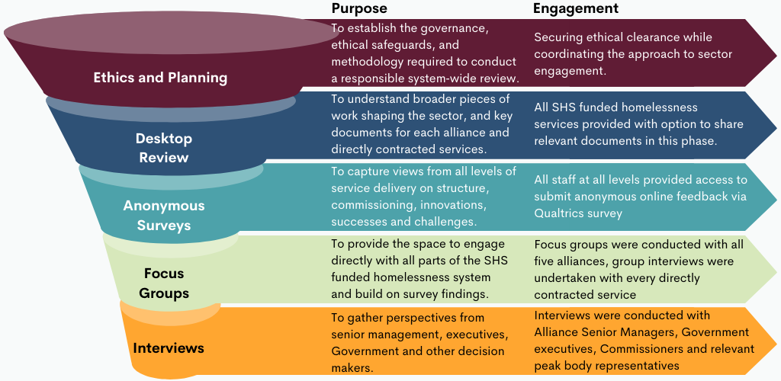
As a commissioning-focused systems review, the analysis concentrated on how the homelessness system operates as a whole and how its individual components contribute to overall function. With the ecosystem comprising both Alliances and Directly Contracted services, the Review explored each element using methods appropriate to their distinct structures and purposes.

For the Alliances:
The review sought to understand how effectively the Alliancing model is delivering on its intended benefits and where risks or opportunities are emerging. This included assessing how the methodology functions in practice, the extent to which collaboration is enabled or constrained, and how well Alliances respond to the needs of diverse individuals and groups across different geographic and demographic contexts. Consideration was also given to system outcomes, governance arrangements and the strength and clarity of leadership and cultural governance structures that shape Alliance functioning.

For the Directly Contracted Services:
The Review focused on how these programs connect to and interact with the broader homelessness system, and the purpose they serve within the overall commissioning landscape. This included examining the role and scope of Directly Contracted services, their priority population groups. The Review also considered the benefits and challenges created by operating independently of Alliances, including implications for integration, pathways, system coherence and service impact.
    - Aboriginal-Led Engagement, Jindawayni Consulting
Jindawayni Consulting led all Aboriginal‑specific engagement for the Review, undertaking extensive discussions with Aboriginal workers, ACCOs, ACCHOs, community members and Aboriginal leaders across metropolitan, regional and remote South Australia. Across the Review period, Jindawayni facilitated more than twenty Aboriginal‑specific engagements, including individual interviews, yarning sessions, group discussions and targeted conversations with ACCOs and Aboriginal staff within NGOs. These engagements were conducted using culturally grounded methods that prioritised safety, trust, relational accountability and respect for cultural authority.
The engagement sought to understand how current system structures, commissioning arrangements and service models affect Aboriginal organisations, workers and clients, and to identify where cultural governance, accountability and decision making could be strengthened. This ensured that lived realities, cultural obligations and systemic experiences of Aboriginal people were reflected in the Review’s findings and recommendations.
Insights from this work shaped the Review’s analysis of system structures, commissioning arrangements and governance settings, ensuring Aboriginal perspectives informed the interpretation of findings and the Review’s broader analysis. The approach was guided by Aboriginal governance principles, cultural respect and trauma-informed practice, with a focus on creating culturally safe, purposeful and transparent engagement processes.
In addition to Aboriginal‑specific engagements, Jindawayni participated in over fifty broader system engagements across Alliances, Directly Contracted services, government departments and peak bodies. This ensured that Aboriginal perspectives were integrated into system‑level discussions and that cultural governance was applied across the Review’s broader qualitative dataset.
Before any Aboriginal‑related insights, narratives or data were shared for the Review, Jindawayni applied an Aboriginal Data Sovereignty process to ensure that information was interpreted, contextualised and transferred in a way that upheld cultural integrity and protected community knowledge. This included reviewing raw engagement material, identifying cultural risk, ensuring appropriate interpretation of Aboriginal perspectives, and determining what information could be ethically shared for system‑level analysis.
Some Aboriginal organisations and individuals chose not to participate, and this decision was respected in accordance with cultural protocols and principles of self‑determination. This Aboriginal‑led process ensured that Aboriginal voices were governed, interpreted and represented through cultural authority, strengthening the validity, cultural safety and integrity of the Review’s findings relating to Aboriginal people and communities.
    - Lived Experience and the Review
The Review recognises that lived experience is central to effective and ethical system design. This includes not only people who have encountered housing insecurity or homelessness, but also the substantial practice-based lived experience within the homelessness workforce.
Direct engagement with people currently accessing services was not undertaken. This reflects the commissioning focused scope and timeframe of the Review, which posed significant risks of tokenism and limited the Review’s ability to engage safely, meaningfully and with sufficient depth across the diverse groups who interact with the homelessness system. Ensuring culturally safe, trauma informed, and equitable engagement across young people, Aboriginal and Torres Strait Islander communities, people experiencing DFSV, people from culturally and linguistically diverse backgrounds, LGBTQIA+ communities, carers, people with disability and many others would have required far more time and resourcing than the Review’s parameters allowed.
In consideration of the above, the Review engaged with existing lived experience groups and mechanisms within the SHS system that have established governance and safeguarding for ethical participation. The Review team also acknowledges the Homelessness and DFSV workforce holds substantial lived experience. Both DHS and the Review Team remain committed to the meaningful inclusion of lived experience in the SHS system and have considered how lived experience priorities can be integrated into future commissioning practices.
    - Ethics
Ethical approval for this review was provided by the University of South Australia (now Adelaide University) Human Research Ethics Committee under approval number 207471.
    - Data Limitations
The quantitative data analysis for this review draws primarily on service data from H2H, supplemented by national benchmarking sources such as the Report on Government Services (RoGS). This analysis was used to explore trends over time and to support qualitative findings, not to assess individual provider performance. While H2H does not capture the full depth and complexity of the sector’s work or the outcomes experienced by people using homelessness services, it remains the most comprehensive system-wide dataset available. A full list of data limitations is provided in the Appendices (Appendix 8 of the Appendices document), with each limitation cross-referenced to the relevant figure or table.
  - Strategic Contexts
This review is situated within a range of strategic contexts that shape its findings and recommendations. The overview below highlights key national and state-level strategies, reforms and policy settings most relevant to the Review. These provide context for system drivers and the environment for future commissioning decisions. Further detail is available In Appendix 3 of the Appendices document.
    - Royal Commission into Domestic, Family and Sexual Violence
In August 2025, South Australia released the final report of its historic Royal Commission into Domestic, Family and Sexual Violence, titled With Courage: South Australia’s vision beyond violence. The Commission was established following increasing public concern, including the deaths of four women in a single week in 2023, and was tasked with examining the State’s prevention, intervention, crisis, justice and recovery responses to DFSV. The Commission enquiry was delivered over a 12-month period, culminating in a 700-page final report that contains 136 recommendations, accompanied by a Voices report featuring lived-experience testimony from hundreds of people.
The report found that South Australia’s DFSV system had become fragmented, under-resourced and crisis-driven, with survivors often retraumatised when seeking help and lacking consistent pathways through services. To lay the foundations for generational reform, the State Government immediately committed to several structural recommendations, including establishing a standalone ministerial portfolio for DFSV, creating a government steward, developing a statewide strategy and embedding accountability mechanisms across senior leadership.
Due to the intersectional nature of homelessness and domestic, family and sexual violence, as well as the SHS sector providing specialist domestic violence homelessness support, the report included 2 specific recommendations that relate to the Review. These are outlined below. Other intersecting recommendations are referenced in subsequent chapters where relevant.
Recommendation 23
The South Australian government’s review of the Alliance model be informed by the views set out in this report, and by direct engagement with the domestic, family and sexual violence sector.
Government Response to Recommendation:
The South Australian Government accepted this recommendation in full.
Recommendation 24
The South Australian government:
a. disentangle funding for domestic, family and sexual violence services from homelessness services and funding streams.
b. provide a significant and sustained uplift in funding for the domestic, family and sexual violence sector. This uplift should reflect the long-term service needs of victim-survivors, service stability and workforce development.
Government Response to Recommendation:
The South Australian Government accepted this recommendation in part stating, “Existing services will be stabilised and expanded where appropriate, but domestic and family violence funding will remain connected with homelessness funding. Service providers will have access to flexible funding to provide practical and tailored support that sits alongside homelessness services and funding”.
    - Cultural Safety, Cultural Governance and Cultural Capability
Aboriginal and Torres Strait Islander peoples are significantly over-represented within the homelessness system within South Australia. This reflects broader structural issues including barriers to housing, justice system involvement, child protection interactions, intergenerational trauma and ongoing economic disadvantage. These factors influence how Aboriginal people enter homelessness and the kinds of responses needed to resolve it.
Cultural safety and cultural governance are related but different concepts. Cultural safety refers to whether Aboriginal people feel safe and respected when accessing services. Cultural governance refers to the role Aboriginal organisations and communities play in shaping system decisions, policies and structures that affect Aboriginal people. While culturally safe service delivery is crucial, it is strengthened when Aboriginal organisations also have influence over governance and system settings.
Cultural safety within the South Australian homelessness system is understood as a structural and relational concept defined by Aboriginal and Torres Strait Islander peoples and communities. It speaks to who holds authority, who shapes decisions, how power is exercised, and whether system settings genuinely enable Aboriginal people to feel safe, respected and heard. Cultural safety is therefore embedded in governance structures, workforce capability, service design and accountability mechanisms.
Understanding cultural safety in this broader sense provides an important foundation for examining how the homelessness system operates in practice. This includes considering how governance arrangements, commissioning models and service boundaries influence the experiences of Aboriginal people navigating homelessness services and the extent to which Aboriginal leadership and community knowledge are reflected in system decision making.
    - Closing the Gap
The National Agreement on Closing the Gap (the National Agreement), signed in July 2020, is a formal partnership between the Australian Governments and Aboriginal and Torres Strait Islander people to address systemic inequality and improve life outcomes through structural reform. The agreement recognises that achieving equitable outcomes requires governments to fundamentally change the way they work with Aboriginal and Torres Strait Islander people and communities.
The National Agreement sets out 19 national socio-economic targets across areas including housing, education, justice, child protection, health and employment. It is structured around four Priority Reforms designed to shift how governments operate. These reforms require government to enter into genuine partnerships and shared decision making with Aboriginal and Torres Strait Islander people, strengthen and invest in the Aboriginal Community Controlled sector, ensure government institutions operate in culturally safe and accountable ways, and improve access to and sharing of data so that Aboriginal communities and organisations have the information needed to make informed decisions at a regional level.
These reforms are directly relevant to the South Australian homelessness system. Aboriginal and Torres Strait Islander peoples are significantly over-represented in homelessness, and pathways into homelessness are often linked to housing insecurities, justice involvement, DFSV, child protection and broader structural inequalities. The National Agreement includes specific targets relating to housing and justice, both of which intersect within homelessness and post-release pathways.
In this context, the National Agreement provides an important framework for assessing whether current governance, commissioning and service delivery arrangements are aligned with its structural intent. For this review, the Priority Reforms focused on shared decision making, strengthening the Aboriginal Community Controlled sector and improving culturally safe institutions were particularly relevant in examining whether the homelessness system’s design, governance and commissioning arrangements reflect these commitments. This includes considering the extent to which Aboriginal leadership is embedded in decision making, whether Aboriginal Community Controlled Organisations (ACCO) are adequately supported to lead responses, whether system settings promote cultural safety in practice, and whether data is used in ways that strengthen accountability and continuous improvement.
South Australia’s Closing the Gap Implementation Plan 2024–2026 outlines how the State intends to implement these commitments.
    - SA Homelessness Alliance System Initial Governance Review
The SA Homelessness Alliance System Initial Governance Review was commissioned by the South Australian Housing Authority as an independent review of Alliance governance during the first 18 months of operation of the Alliancing Model. Conducted prior to the commencement of the second contract period, the review focused on governance arrangements across the homelessness alliance system and is highly relevant to the current recommissioning review.
The Initial Governance Review highlighted the importance of governance clarity, system leadership, shared outcomes, Aboriginal governance and voice, lived experience participation, and stronger mechanisms for coordination across the homelessness system. The findings of the current Review build on this earlier work and extend beyond governance to consider commissioning, access, cultural authority, workforce capability, data, system stewardship and service integration.
There is strong alignment between the findings and recommendations of both reviews, particularly in relation to governance, system leadership, shared outcomes, Aboriginal governance and voice, lived experience participation, and mechanisms for coordination across the homelessness system. The consistency of these findings across reviews undertaken at different stages of the Alliancing Model suggests that many of the key issues affecting the homelessness system have been identified for some time.
    - System Contexts and Dependencies Beyond Review Scope
While the Terms of Reference focus on DHS-funded homelessness services, experiences of homelessness are shaped by multiple interconnected services and systems. While the Review cannot make recommendations beyond its Terms of Reference, the following contexts are essential for understanding the Review’s findings and how broader system settings shape homelessness as a social issue.

Homelessness 2 Home (H2H) Database
As H2H remains under SAHT management following the transition of homelessness services to DHS, system capability, data structure and reporting functionality continue to be shaped by external governance, resourcing and prioritisation decisions. At the time of this review, a business case is underway to consider the future development of H2H. Decisions arising from this process will directly influence the capacity of the homelessness system to strengthen outcome measurement, accountability and system learning. Findings in this Review should therefore be interpreted in the context of both current H2H functionality and anticipated future changes.

National Policy and Funding Settings
South Australia’s homelessness system is shaped by national policy, funding and reporting settings that determine the scale, duration and permitted uses of funding and prioritise nationally consistent indicators for accountability. These arrangements, including the National Agreement on Social Housing and Homelessness, the Report on Government Services and the Specialist Homelessness Services Collection, influence how States can respond to rising demand, adapt service models, manage workforce pressures and define system success. While they support transparency and comparability across jurisdictions, they can also constrain flexibility, limit the visibility of local service models and system complexity, and create misalignment between national requirements and State reform priorities, reducing the effectiveness of local commissioning and system redesign efforts.

Housing System, Investment and Supply
While housing and homelessness now sit in separate government portfolios, the two systems remain deeply interconnected and interdependent in achieving safe and effective outcomes for people and communities. The effectiveness of homelessness funding is closely linked to investment in housing supply across public, community and private rental markets. Where housing availability and throughput are constrained, homelessness services require increased funding to deal with longer support periods, higher service intensity and reduced exit pathways. In the absence of commensurate investment in housing, homelessness funding is required to absorb structural pressures that it cannot resolve on its own.

Domestic, Family and Sexual Violence
Domestic, Family and Sexual Violence (DFSV) sits under both national and State funding arrangements and has its own best practice approaches that may sit outside of homelessness best-practice responses. While DFSV and Homelessness are tangibly linked, these different approaches can be at odds without clarity of practice and clear frameworks to bridge the gap.

Other State and Federal Government Systems including Health, Child Protection; Disability and Justice
Homelessness is often described as the cumulative outcome of gaps or failures across multiple service systems, including health, child protection, disability and justice. While these systems play a significant role in shaping pathways into and out of homelessness, there is currently no overarching interagency policy or shared accountability framework that clearly defines their responsibilities in preventing homelessness or sustaining housing outcomes.

SCHADS Award and Industrial Conditions
Industrial conditions set through the SCHADS Award establish minimum pay, classifications and entitlements that directly determine the baseline workforce costs within the SHS sector. Recent decisions by the Fair Work Commission have introduced significant reforms to the Award, including increases to minimum wage rates and a new integrated classification structure, reflecting the long-standing gender-based undervaluation within the sector.
While these changes represent an important recognition of the value of care and community services work, they are expected to substantially increase workforce costs for service providers. Sector peak bodies have highlighted that without corresponding adjustments to government funding and indexation, organisations will be required to absorb rising costs within existing contracts, creating significant pressure on service sustainability.
These settings sit outside the control of the SHS system but materially shape workforce affordability and service capacity.

Indexation and Real-Terms Funding Pressures
Indexation arrangements that do not keep pace with CPI result in a gradual erosion of the real value of workforce funding over time. As labour costs continue to rise due to industrial settings and inflation, the gap between indexation supplementation and actual cost growth reduces the capacity of SHS providers to maintain staffing levels and conditions. This creates structural pressure on workforce sustainability even in the absence of service expansion.

Higher Education and Training Systems (VET, TAFE and University)
Higher education and training systems determine the volume, skill mix and preparedness of the workforce entering the SHS sector. Curriculum content, placement availability and funding incentives influence whether graduates are equipped for homelessness and DFSV practice, and whether supply keeps pace with demand. These factors directly affect workforce availability and the level of induction, supervision and on-the-job capability building required within SHS services.

- Background to the Alliancing Model in South Australia
This chapter provides context to the introduction of the Alliancing model in South Australia, including the pre-Alliancing system, the policy intent behind the shift, and the key features of the model’s design. It describes how the model was adapted from the Glasgow Alliance approach and implemented through a rapid tendering and transition process with limited overlap from the previous system. The chapter also highlights how commissioning settings, including broadly defined service expectations, shaped the integration of youth and Aboriginal responses within Alliances and influenced how the model has been established in practice.
  - What is Alliancing?
Alliancing in human and community services refers to a collaborative contracting and governance approach in which government partners and multiple community organisations form a partnership to deliver services under a single, collective agreement.
Alliancing draws on principles of relational commissioning and traditional consortia arrangements, emphasising collaboration, trust building, shared responsibility and problem-solving. From a commissioning perspective, it seeks to reduce the traditional “arm’s length” separation between government and providers, replacing compliance driven contracting with joint ownership of outcomes and more integrated governance .
While not formally described as relational commissioning, the Alliancing model incorporates many aligned features, including long-term partnerships, shared decision making structures, and incentives for collaboration through common priorities, goals, and governance structures.
For the purposes of this report, the following terminology and definitions are being used:
Term | Definition
Alliance Model | Refers to the contracting and governance model introduced on 1 July 2021 in South Australia, under which multiple service providers operate within an Alliance consortium and are funded through a single contract, managed by a designated lead agency.
Alliance(s) | Referring to the 5 consortia of specialist homelessness service providers operating under the Alliance Model and funded through a single contract held by a lead agency. There are 4 homelessness Alliances based on geographic boundaries, and one DFV Alliance based on service stream (DFV service provision).
Alliancing | Refers to the active collaboration between Alliance partners and the lead agency in accordance with the Alliance Model, encompassing shared governance, coordinated service delivery, and collective outcomes.
  - Pre-Alliancing
Prior to July 2021, homelessness services in South Australia were block funded and Directly Contracted by The South Australian Housing Trust (SAHT) and later the South Australian Housing Authority (SAHA). Most providers operated under longstanding funding arrangements that had largely been rolled over since 2010, with limited system redesign. Under this model, SAHT/SAHA determined priority groups, allocated block funding, prescribed service models, and monitored performance primarily through service-level outputs, with limited mechanisms to drive system-level redesign or shared accountability.
    - Management of Housing and Homelessness in South Australia
SAHT was established in 1936 as the statutory authority responsible for the provision of public housing in South Australia. For an extended period prior to 2018, the Trust’s functions were administered through Housing SA, which operated as a division within the relevant State department.
On 1 July 2018, SAHA was established following a machinery of government change, combining Housing SA, which was responsible for public housing service delivery, and Renewal SA, which led urban renewal and development functions. The South Australian Housing Trust did not cease to exist as a statutory body; however, all of its functions were administered through SAHA, which became the public-facing authority for housing, renewal and homelessness activities.
The establishment of SAHA was framed as enabling a more integrated, whole-of-system approach to housing supply, asset management and renewal, including stronger links between public housing and urban development.
It was under SAHA’s stewardship that the Alliancing model within the SHS system was proposed, designed and implemented. SAHA continued to manage the SHS system under the Alliance model until 1 July 2024, when responsibility for homelessness policy and system management transferred to the DHS. At the same time, the South Australian Government announced that the authority would revert to operating under the South Australian Housing Trust name (SAHT), reflecting a renewed policy emphasis on public housing provision.
  - The Inception of the SHS Alliance Model
In 2021, SAHA introduced an Alliance-based contracting model for the homelessness sector. This shift was intended to support more integrated service delivery, aligning with approaches emerging in other jurisdictions that emphasised stronger collaboration between providers, government and local communities. The model was informed in part by a 2019 visit by South Australian representatives to Scotland, where Glasgow had begun reforming its homelessness system through Alliancing.
“Alliancing was moved through very quickly, without meaningful consultation or co-design. It drew on the Glasgow model, but the way it was developed and implemented here was very different.” – Sector Participant

In the South Australian Context, Alliancing was underpinned by 20 Alliancing Principles which were defined as follows:
1. | The success of the Alliance is shared by all participants and is based on achieving the Alliance Outcomes. A “win–lose” mentality is not acceptable. |  | 11. | All participants will meet the minimum standards for each KPI and KRA and the Alliance Outcomes.
2. | Participants maintain a peer relationship in which each participant has an equal say in Alliance Leadership Team decisions. |  | 12. | Risks and responsibilities are shared and managed collectively by participants, including the performance of individual activities.
3. | Disputes are avoided through a no-blame culture |  | 13. | Participants contribute “best-in-class” resources.
4. | Participants act consistently with the Alliance Principles. |  | 14. | Participants commit to developing a culture that promotes collaboration, innovation and outstanding performance.
5. | Participants empower the ALT and AMT to make decisions and take action. |  | 15. | All financial and commercial transactions are conducted on a fully open-book basis.
6. | Participants commit to a communication culture and to transparency in all dealings with one another |  | 16. | Participants share information openly and do not withhold ideas.
7. | Communication between participants is open, direct and honest to support informed decision making. |  | 17. | Each participant commits to ensuring that all participants understand project documentation.
8. | Participants demonstrate ethical and responsible behaviour at all times. |  | 18. | Participants identify learnings and share and build capability.
9. | Decisions, processes and systems are adopted on a “Best for Outcomes” basis. |  | 19. | Cultural competency and Aboriginal Community Controlled Organisation involvement is to be strengthened throughout the life of the Alliance
10. | Lived experience is embedded in the Alliance; |  | 20. | Any other principles agreed by the ALT and approved by the Authority from time to time.

  - Tendering for SHS Alliances in South Australia
The move to Alliancing was intended to provide greater flexibility and enable innovation and more responsive service delivery through shared governance structures. The model established four regionally based partnerships aligned to ABS Statistical Area Level 3 boundaries, along with a statewide DFV Alliance. The tender process required consortia to demonstrate how proposals would deliver integrated service responses, stronger collaboration and improved outcomes for people experiencing homelessness. The tendering specified the following client and system outcomes:
Client Outcomes | System Outcomes
• People are safe and able to sustain long-term housing  • Fewer people experience homelessness  • People are rapidly rehoused to reduce the length of time they are homeless  • People do not experience repeat homelessness; and  • Increase economic and social participation for people with capacity. | • Services are easy to access, effective and joined-up  • Lived experience is used to guide service and system development and implementation  • Increase in client satisfaction with the services provided through the homelessness system; and  • Overall funding can be shown to be used in a far more effective way

Alliances were expected to prioritise strengths-based, housing-led and tenancy-sustainment approaches, alongside a stronger focus on early intervention and prevention. They were also encouraged to:
- develop creative and innovative solutions
- work collaboratively across government and non-government sectors
- proactively identify and address service gaps and barriers; and
- adopt data informed, whole-of-system ways of working
    - Funding and Evaluation
Funding allocations across the four regional Alliances and the statewide DFV Alliance were informed by the 2020–21 geographic distribution of SHS funding, adjusted for census population data, homelessness prevalence, existing regional resource profiles, and, for the DFV Alliance, 2019 ABS Recorded Crime data and historical SHS DFV client demand. These data sources formed the baseline funding profile at the commencement of the Alliancing model .
“And then the tender model came out, and we all kind of had to scramble to understand it. We knew alliancing would require additional resources… the cost of governance and collaboration, but we didn’t have that. So, we had to muddle through and figure out our governance, our decision making, and how we would operate.”- Sector Participant
The Alliance tender proposed a six-year contract structured around 2-year evaluation cycles. These were intended to assess the effectiveness of Alliancing as a systems approach, and support continuous improvement of the Alliancing model over time, acknowledging that system maturity takes time.
    - Service streaming in the Alliance Model
When the Alliance Model was introduced, geographical divisions and DFV specialist service functions were retained. However, Aboriginal and Youth specific services were expected to be incorporated within Alliances, a shift from the previous system where these services were directly contracted.
While the documentation expressed a preference for consortia that included an Aboriginal Community Controlled Organisation (ACCO), it did not set clear expectations about the role, authority, or level of participation required. The most explicit direction stated that Alliances should “develop and sustain partnerships with appropriate organisations, particularly Aboriginal community-controlled organisations, to facilitate cultural capability”. Evaluation criteria gave preference to proposals that included an ACCO partner.
“The original tender talked about bringing Aboriginal organisations into case management and embedding that more deeply, but that hasn’t really happened in practice.”– Sector Participant
For youth service provision, the tender identified “children and young people (under 25)” as one of the priority groups that Alliances were expected to include within their service planning. Both children and young people, and Aboriginal and Torres Strait Islander peoples, were explicitly referenced within the mandated service activities. Beyond these references, however, the tender did not set out further expectations, specificity or minimum standards for how Alliances should respond to the distinct needs of these groups.
The mandated service categories included:
- Brokerage, transport and cultural support services for Aboriginal people
- Brokerage and case management services for vulnerable young people
- Youth transitional accommodation with a focus on education, employment and training
This meant that while youth and Aboriginal groups were named in the documentation, the commissioning framework did not articulate how Alliances should embed tailored responses, engage specialised providers, or ensure consistent, developmentally-appropriate or culturally safe practice for these groups across regions. Consequently, the depth and nature of youth-specific service delivery have varied, shaped more by local capability, partner composition and historical service footprints than by clear commissioning intent.
  - The Transition to SHS Alliancing in South Australia
The Alliancing model in South Australia was adapted from the Glasgow Alliance to End Homelessness, with initial inspiration drawn from South Australian representatives visiting and engaging with the Glasgow model in 2019. However, the transition to Alliancing in South Australia differed significantly in both timing and approach.
In contrast to the approach in Glasgow, the model was progressed rapidly in the South Australian context. While there was engagement with the sector during 2020, this was largely focused on preparing providers for the procurement and tender process, rather than a concerted co-design process to develop the Alliancing model. There was limited opportunity to collectively define system architecture, test assumptions, or work through potential implementation risks, and no formal co-design process with people with lived experience.
Procurement followed, with successful tenders announced in April 2021 and new Alliancing arrangements commencing in July 2021. This represents a relatively compressed transition from policy intent to implementation. This approach contrasts with the Glasgow experience, where Alliancing was developed over several years through structured co-production, detailed preparation, and a phased implementation process.
    - The Experience of the Glasgow Alliance Model
In Glasgow, the development of the Alliance model began several years prior to contract award. A 2016 strategic review concluded that “more of the same won’t do”, prompting a shift toward a whole-of-system approach. In 2017, joint commissioning arrangements were agreed, supported by a series of co-production workshops involving government, providers and people with lived experience. These sessions informed the development of a detailed prospectus (‘Your City, Your Home’), which became the basis for procurement.
A bespoke procurement process was then undertaken across 2018 and 2019, including dialogue phases with bidders, before the Alliance contract was formally awarded in 2020. Following contract award, Glasgow implemented a phased mobilisation approach between 2020 and 2023. During this period:
- Alliance governance structures were established and refined
- an operating model and strategic plans were developed
- a central team and infrastructure were created
- system redesign activities were initiated
Importantly, existing homelessness services continued to operate outside of the Alliance model during this time, allowing the new model to be developed and tested alongside ongoing service delivery. This approach was supported by time-limited establishment funding to enable transition and infrastructure development.
Despite this extensive preparation and staged implementation, the Glasgow Alliance was formally concluded in 2023, with responsibility for homelessness services returning fully to the previous system.

Lessons from Glasgow
The Glasgow experience highlights that, even with significant upfront design, co-production and a phased transition, alliancing is complex and challenging to implement in practice. While there was strong initial motivation for alignment around a shared purpose of acting in the “best interests of people using services”, this became more difficult to sustain over time, particularly as financial and operational pressures emerged.
Challenges in governance and decision making, including ambiguity around roles, delegated authority, and the dual role of government as both commissioner and Alliance partner, contributed to slowed progress and tension within the model. Financial requirements, including expectations of year-on-year efficiencies, further strained relationships and introduced mistrust regarding how risk and responsibility were shared. In addition, the procurement approach and resulting “in group / out group” dynamics fragmented the provider market, affecting trust and broader system cohesion.
Finally, while the principles of alliancing were widely supported, there was insufficient clarity and agreement on how these would be translated into operational practice. Overall, the Glasgow review indicates that successful alliancing is highly dependent on clear system architecture, well-defined roles and authority, sustained investment in relationships and trust, and sufficient time and resourcing to support implementation. The disbanding of the Alliance model in Glasgow in 2023 reflects the high level of challenge in enabling these conditions and the subsequent successful implementation of alliancing to achieve better outcomes for people experiencing or at risk of homelessness.
    - The South Australian Transition to Alliancing
In South Australia, successful Alliances were announced in April 2021 and commenced operations on 1 July 2021, allowing approximately two months for mobilisation. However, the go-live date coincided with the cessation of services delivered by unsuccessful tenderers, with no overlap or service continuity period between the pre-Alliancing and Alliancing service models.
Another significant shift introduced on 1 July 2021 was the move away from traditional government–provider arrangements toward Alliances being largely responsible for their own performance management and for distributing funding among Alliance partners under open book accounting principles.
“When we talk about the tender process, we’re not just talking about procurement, we’re talking about the whole system change. From announcement through to contracting, organisations had very limited time to get their heads around what this actually meant.”– Sector Participant
Alliancing was intended to create flexibility and support sector-led practice, enabling services to tailor responses to local communities and adapt to changing needs. However, there was no documented plan for a phased or capacity building transition to these new responsibilities. The way Alliancing was implemented in South Australia had impacts on the way the model was able to function and operationalise, discussed further in the next chapter.
  - Chapter Summary
This chapter outlines the origins and design of the Alliancing Model introduced in South Australia in 2021, including its intended shift toward greater collaboration, flexibility and shared accountability. However, the rapid implementation and limited transition planning have had lasting impacts on system cohesion, workforce continuity and service delivery. These early decisions continue to shape the structure and functioning of the homelessness system and underpin many of the systemic challenges identified through this review.
- The Current SHS system
This chapter examines the structure of the current SHS system and how the Alliancing Model is operating in practice. It outlines the key service elements across the system, including Alliances, Directly Contracted services and statewide phone lines, and how they interact. Drawing on stakeholder feedback and survey findings, it explores the extent to which Alliancing has strengthened collaboration within Alliances, while highlighting more limited coordination across Alliances and with Directly Contracted services. The chapter also examines the impacts of the implementation and commissioning approach, including effects on workforce continuity and the sustainability of targeted responses for Aboriginal communities and young people. Finally, it considers how model design, including geographic and service stream boundaries, has contributed to system silos, variability in service coverage, and outcomes for people experiencing homelessness.
  - The System Structure
The SHS system depicted below was managed by SAHA/SAHT until the 1st of July 2024 when management of the homelessness portfolio was transferred to DHS. The structure of the DHS funded SHS system has remained largely unchanged since the implementation of Alliancing in 2021. It comprises 5 homelessness Alliances, 16 Directly Contracted services, and two statewide phone lines, which are discussed in further detail below.
Figure 4: DHS funded SHS system
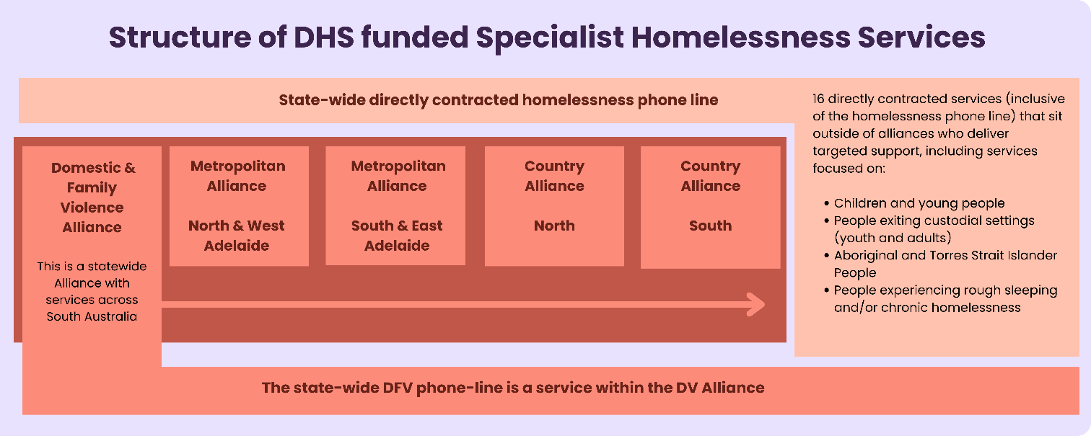
    - The Alliances
There are 5 homelessness Alliances. Four are geographically distributed 1) Metropolitan North and West; 2) Metropolitan East and South; 3) Country North; and 4) Country South. The fifth homelessness Alliance is the DFV Alliance, which is statewide. Alliances are comprised of multiple agencies that work together under a shared contractual model to deliver homelessness services. Each Alliance is coordinated by a lead agency that holds the contract with government and distributes funding to Alliance partners using transparent open-book accounting.
Stakeholders were asked throughout the Review to reflect on the benefits and challenges of Alliancing, and the outcomes the model has produced in keeping with its original intent. They consistently described a range of benefits for relationships and collaboration within Alliances, although these were reported to varying extents across different contexts. However, there were fewer concrete examples of system-level outcomes or measurable improvements attributable to Alliancing, particularly when compared to pre-Alliancing.
The following sections outline key findings on how the Alliancing model is functioning across relationships, system coordination, ACCO inclusion and outcomes.

Strengthened Relationships within Alliances
Stakeholders consistently reported that relationships within Alliances are generally strong, with many noting that partnerships have formed that did not exist prior to Alliancing. This was particularly evident within the homelessness Alliances in country and regional areas, where cross-regional relationships have improved and enabled smoother client movement between locations within country Alliance geographic boundaries. Within the statewide DFV Alliance, it was reported that relationships were already well established before Alliancing, but stakeholders agreed that metro-regional connections have been strengthened through being part of a statewide structure.
The impact on relationships has extended into positive impacts on other areas. Survey respondents noted there are instances where improved relationships have directly led to a reduction in duplication and supported better service coordination for people with complex needs. Multiple stakeholders commented on the shift to shared accountability within individual Alliances, which incentivises collaboration and in the right circumstances leads to better outcomes for clients.
“The Alliancing model has strengthened shared-problem solving between organisations that sit within the same Alliance…supporting improved referral pathways within Alliances and increased opportunities for joint responses”.” – Survey Response
Stakeholders valued the clarity and efficiency created by having a single point of coordination through the Alliance Senior Manager (ASM) for each Alliance. They reported that the ASM role reduced the need to navigate multiple individual relationships across the homelessness system and offered a clearer channel to engage with a whole Alliance or region. ASM to ASM relationships were also reported to be strong, with ASMs regularly meeting together with DHS to discuss system level issues in a shared forum.
“The ASM role has meant you work closely with other ASMs across Alliances. While the role varies across contexts, ASMs have become a key coordination layer in the system, sharing information on what each Alliance is doing, identifying opportunities to work together, and acting as a collective voice across the sector.” – Sector Participant

Cross-Alliance Collaboration and Coordination
Whilst relationships within individual Alliances were consistently reported to be a strength, these gains have not extended horizontally across the system. Stakeholders commonly reported that connections between Alliances remain limited, with ASMs often the only group with a formal opportunity to connect through monthly meetings with DHS.
Collaboration was also uneven across operational levels. Frontline practitioners across Alliances were not reported to systematically interact or share practice knowledge, with collaboration largely confined to within individual Alliances. Similarly, stakeholders reported that middle managers have limited structured opportunities to resolve shared operational issues arising across Alliances or regions. At a governance level, stakeholders observed that the Alliance governance groups such as the Alliance Leadership Team (ALT), rarely communicated with their counterparts in other Alliances. This pattern was reinforced consistently in stakeholder feedback:
“Alliances have limited ability to refer people who are moving between communities, which disrupts continuity of care. Cases are closed, waitlisted and reopened, and there’s limited ability to access housing options like transitional and supportive housing properties across regions. This reflects a broader breakdown in relationships between services, with collaboration often confined within Alliance boundaries rather than operating across the system.” -Survey Response
These findings were also reflected in the anonymous staff survey. Respondents were asked to consider a series of statements exploring collaboration at three levels: 1) between DHS-funded SHS providers at a local regional level 2) between regions, and 3) across the sector as a whole.
Figure 5 shows that as the scope of collaboration broadens from local to system-wide, a higher proportion of survey respondents reported weak collaboration. Neutral responses remained relatively consistent across all three levels.
Figure 5: Anonymous online staff survey response summary, collaboration with SHS services
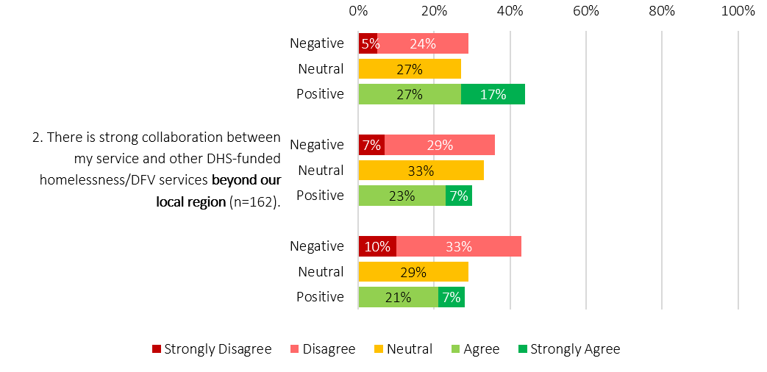
1. There is strong collaboration between my service and other DHS- funded homelessness/DFV services within my local region (n=164).
3. DHS funded services (including DFV) collaborate as a whole sector to elevate practice and system level concerns (n=163).

The impact of the implementation process
Although the implementation of Alliancing occurred 5 years ago, it was evident through consultations that the pace of commissioning and the way implementation occurred has had lasting consequences for the foundational underpinnings of the Alliance model in the SHS system.
While the intent behind Alliancing was generally supported, stakeholders reported that implementation was experienced as inconsistent with the relational and “for best outcomes” principles underpinning the model. Furthermore, the undesirable impact of the competitive tender process on relationships both between providers, and with providers and government cannot be understated. Stakeholders consistently described that this process created conflict and fractured existing relationships across the sector. These impacts were not short-lived, with limited evidence that trust has been fully rebuilt since implementation. This contributed to early instability in the model, as stakeholders who were expected to continue working together at a system level were instead navigating disrupted trust and relationships.
“We are still hearing the impacts of the transition being talked about across the sector more than four years on” – Survey Response
Stakeholders consistently reported that the two-month window between tenders being awarded and implementation was too short to support a safe and orderly shift to the Alliancing Model. There was no structured transition plan between outgoing and incoming service providers. Apart from one Alliance, partnerships were largely composed of organisations already delivering services prior to Alliancing. Where membership remained largely the same, Alliances were expected to recalibrate service models toward a unified approach. Where service delivery shifted to new or different partners, Alliances needed to stand up substantial infrastructure quickly, including establishing service footprints and hiring staff. This resulted in minimal continuity strategies for the workforce, contributing to the loss of experienced staff, organisational knowledge and practice capability across the sector. The accelerated transition also caused disruptions in service delivery for clients during the switchover.
“There was never really an opportunity to go back to the drawing board. It felt more like rolling existing services into a new structure, rather than designing something fundamentally different.” – Sector Participant

Alliance Relationships with ACCOs and other Aboriginal Services
Although the tender process encouraged Alliances to partner with ACCOs, the absence of firm requirements limited the ability of SAHA to influence Alliance composition, particularly in regions where only a single tender was submitted. In these situations, the limited specification of expectations reduced the levers available to support culturally governed or specialist service responses.
Gaps in collaboration with ACCOs remained evident across parts of the system, particularly in Alliances without a formal ACCO partner or where Aboriginal-led and culturally governed responses for Aboriginal and Torres Strait Islander people were not well embedded. Aboriginal engagement undertaken by Jindawayni Consulting identified that, in the absence of stronger system-level mechanisms, collaboration with ACCOs often relied on individual relationships rather than structured partnership arrangements. Where partnerships were strong, Aboriginal perspectives were more likely to influence service responses and local decision making. However, where relationships were weaker, or where Aboriginal organisations were not formal Alliance partners, Aboriginal input was more likely to occur through advisory or informal consultation processes or, in some cases was absent altogether.
There was also considerable variation in how Alliances understood and implemented partnership approaches with ACCOs and Aboriginal services. Some Alliances were described as operating collaboratively with shared accountability, integrated practice and ongoing engagement, while others continued to operate more independently under Alliance structures. This inconsistency contributed to differing levels of Aboriginal influence over decision making and uneven culturally governed responses across regions.
“Aboriginal self-determination should be embedded in commissioning design, with Aboriginal organisations funded to lead rather than participate in models that do not work for their communities.”- Survey Response
Examples of stronger practice were identified where long-term partnerships with ACCOs, shared service delivery approaches and sustained community engagement had strengthened trust, continuity of support and cultural responsiveness for Aboriginal clients navigating multiple systems. These approaches were more likely to support culturally informed practice and stronger connections between homelessness services, community and Aboriginal support pathways.
“Ideally, Alliances would have evolved over time so that there was an ACCO partner. In practice, that evolution has not occurred consistently, and in some cases Alliances have remained representative rather than shifting toward a deeper partnership model that provides cultural guidance and leadership”- Sector Participant

Service Streaming, Targeted Responses and Service Coverage
The decision to divide Alliances geographically and by DFV service stream has had consequences for how equitably the system responds to homelessness and for consistency of service coverage across the state.
Although it was inferred in the tendering process that services should consider how they will deliver responses to a range of client groups, in the absence of clear minimum expectations for service delivery coverage, Alliances have understandably formed with high levels of variance across them. Several structural mechanisms intended to support a coordinated system, such as a shared data, were not implemented as designed and it is unclear whether individual Alliances were intended to have oversight over system coverage in their region. As a result, there is currently no systematised process or data feedback loop that would support Alliances to understand service gaps in their region in order to fill them. This has allowed variation between Alliances to widen over time.
Specialist and targeted responses such as assertive outreach for rough sleepers, Aboriginal-led and youth responses, which were part of the pre-Alliance system service offering, were not safeguarded through the tender process. Many Alliances reported that the service delivery remit they had pre-Alliancing continued as usual once they entered an Alliance. This has contributed to variability in cultural safety and the loss of dedicated targeted responses in some regions. Differences in service models, geographic contexts and partner mixes now shape uneven client experiences across the State. Many stakeholders referred to this as a “postcode lottery,” where the practice approach, availability of services and diversity of choice in service provider for clients depends on the region or even service through which they enter the system.
“Alliancing is trying to operate across very different service contexts, but one model does not fit all. In some cases, clients are expected to travel to access support rather than services reaching them. People often make repeated contact to get assistance, and some are effectively ‘shopping’ between areas to find support. I think these challenges have become more evident since Alliancing was introduced.” – Survey Response
The uniform Alliancing model does not fully account for the differing realities of metropolitan and regional South Australia and has not adapted to the challenges faced by regional and remote providers. Country and statewide Alliances face additional constraints that are less prevalent in metropolitan areas. Stakeholders reported that large distances, thin markets, workforce scarcity and seasonal pressures make Alliancing feel poorly suited to regional and remote contexts.
Open-book accounting, a core principle of Alliancing, was also described as operating unevenly across contexts. Country Alliances reported a limited ability to collaborate or share resources in the way the model assumes in metropolitan settings. In metropolitan settings, pooled funds can often be redirected in ways that still benefit the same client population. In regional Alliances, however, geographic dispersion means that funding redirected in one location may offer no benefit to clients elsewhere, limiting the practical value of shared financial decision making.

Outcomes for People experiencing Homelessness and system improvement
While the aim of Alliancing was to create a more cohesive and navigable system response for people experiencing homelessness, there was limited consensus from stakeholders on what Alliancing has achieved from a system perspective, and whether it has translated into improved outcomes for people experiencing homelessness.
To support system improvement, Key Results Indicators (KRAs) were introduced in Alliance contracts to define and measure system-level outcomes and were intended to be contractually meaningful rather than aspirational. These were only part of the Alliance contracts and did not apply to Directly Contracted services. Though KRAs remain in Alliance contracts, stakeholders reported these have often proved unworkable in practice. Several indicators relied on outcomes outside the control of Alliances, such as rapid rehousing in the context of limited housing supply, while others used subjective or undefined concepts that could not be measured consistently. The absence of a case management system capable of supporting KRAs reporting further undermined their utility. As a result, KRAs did not function as a reliable performance mechanism and contributed to confusion about expectations rather than strengthening accountability.
The DHS Homelessness Outcomes Framework may provide a foundation for refining future performance measures across the homelessness system. Over time, there may be potential to align future performance measures with the Outcomes Framework, using its outcomes and indicators to inform measurable and system-wide approaches to accountability, provided the necessary data systems, governance arrangements and implementation supports are in place. We explore the DHS Homelessness Outcomes Framework further in Section 11.2 below.
    - Directly Contracted Services
There are 16 Directly Contracted services across the State. These are individual programs, projects or initiatives funded through DHS SHS funding and form a key part of the broader homelessness service ecosystem. They may be place-based or statewide, and typically provide more specialised or targeted responses for specific groups or community needs. Examples include youth custodial services, DFV services for children and young people and remote community services.
“Directly Contracted services play an important role in providing consistency, specialist expertise and coverage across regions, particularly where services require standard practice, legislative alignment or 24/7 availability. These models can support equity of access and ensure critical responses are available regardless of location.” – Survey Response
Directly Contracted services operate outside the Alliance structure and are therefore largely absent from Alliance governance arrangements (unless an organisation holds both an Alliance partnership and a separate Directly Contracted program), despite operating in the same regions and often holding specialist expertise. Many of these services pre-date the Alliancing model and have continued to operate alongside it, rather than being fully integrated into the new structure.
This structural separation appears to limit how well different parts of the system connect. Stakeholders reported that there are no systematised mechanisms to support collaboration and coordination between Alliances and Directly Contracted services. As a result, engagement remains largely ad hoc and relationship-driven, limiting the flow of information and coordination across the system. This can reinforce silos around key Alliance-held resources such as Transitional Housing Properties (THP) and Supportive Housing Property (SHP) allocations. In turn, this raises questions about the potential impact on both client-level and system-level outcomes if the homelessness system is not operating in a coordinated and complementary way.
“Both Alliance and Directly Contracted models serve important but different roles within the system. However, stronger connection and collaboration between them is needed for the system to operate as a true alliance model.” – Survey Response
This lack of integration is also reflected in how the role of Directly Contracted services is understood across the system. While these services described themselves as having distinct client groups and specialist practice models, Alliances were less consistent in how they articulated their purpose within the broader SHS system. Figure 6 illustrated how this was supported by findings from the anonymous staff survey which indicated that more than half of respondents (53%) did not understand the role or purpose of Directly Contracted services. A further 33% were neutral, and only 15% reported that the role was clear.
These findings reflect uncertainty about the contribution of Directly Contracted services, pointing to a broader systemic gap in how roles, functions and interdependencies are defined and communicated.
Figure 6: Anonymous online staff survey response summary, purpose of Directly Contracted services
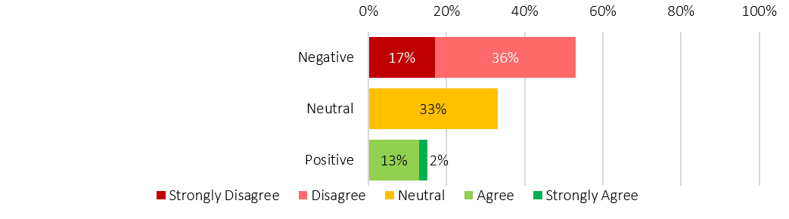
It is clear within the SHS ecosystem which services are funded as Directly Contracted or statewide services, their purpose, and the client cohorts or needs they are intended to serve (n=156)

    - State-wide phone lines
There are two phone lines in operation across the State, one for homelessness and one for DFV. While these services function as the only 24-hour entry points to the system, similar access and triage functions are also carried out at the Alliance level, by Alliance partner agencies and by Directly Contracted services. Each has developed its own processes, tools, decision making criteria and communication materials. This creates multiple and potentially competing entry points into the system, contributing to ambiguity around where and how people should seek assistance.
“The strength of a phone line is that it can operate 24/7 and respond to higher volumes, helping connect people to the services they need.” – Sector Participant
Consistent with this, the Review found that the purpose of the two phone lines is not clearly understood across the sector, including how they are communicated in public-facing materials. For example, on the DHS website, the phone lines are presented as centralised access points providing information, advice, system navigation, intake and triage at all hours. In contrast, most Alliance websites describe the homelessness phone line as an “after hours service”, and several do not reference it at all. This inconsistency is significant, as the homelessness phone line fills a critical gap outside business hours when most in-person services are unavailable.
The reliance on phone-based access as the primary statewide entry point may also create barriers for some groups. Stakeholders noted that people with diverse communication needs, including young people who may prefer web-based or text-based modalities, and people who are deaf or hearing impaired, may find it more difficult to access support through phone lines alone. This also raises questions about where responsibility for accessible entry points sits within the system, and whether requirements for inclusive, multi-modal access should be more explicitly defined through commissioning.
Differences in how the two phone lines are funded also appear to shape how they operate within the system. The DFV crisis line is delivered as part of the DFV Alliance, while the homelessness phone line is delivered through a direct contract and sits outside the Alliance structure. Although this distinction may appear minor, it results in materially different operating conditions.
As part of the DFV Alliance, the crisis line is embedded within Alliance governance and benefits from shared decision making, communication channels and networked relationships. In contrast, the homelessness phone line is structurally separate from Alliance governance and coordination mechanisms. Stakeholders indicated that this separation has contributed to a lack of clarity about the role and remit of the homelessness phoneline, as well as gaps in system-level communication regarding referral pathways, service capacity, and intake processes. These gaps can lead to duplication for clients and limit the effectiveness of system navigation.
Prior to Alliancing, the SHS system also included a dedicated youth phone service. Under the Alliancing model, this function was absorbed into the general homelessness phone line. Stakeholders reported that initial attempts to maintain a youth-specific pathway were not sustained, and that youth access pathways have not been re-established at a system level. This further reflects broader challenges in maintaining clear, tailored entry points within a system that has become more generalised and fragmented in its access arrangements. Stakeholders emphasised the importance of developmentally appropriate pathways for young people, aligned with established approaches to youth homelessness that prioritise safety and wellbeing.
“Local service presence and community connections are highly valued because they’re client-facing. Centralised access points, like phone lines, can’t always offer the same relational, person-centred support as place-based services… you really need both” – Sector Participant
Overall, these findings show that the purpose and function of the phonelines have not been clearly defined or consistently integrated within a whole-of-system design, with differences in structure and limited evolution since implementation contributing to ambiguity in how they operate and are understood across the sector.
  - Chapter Summary
The findings in this chapter show that while the Alliancing Model has strengthened relationships and collaboration within individual Alliances, it has not resulted in a cohesive or coordinated system response.
The evidence indicates that the current commissioning model, comprising the five Alliances, Directly Contracted services and statewide phone lines, is not functioning as an integrated system and is not achieving its intended purpose. Structural features of the model, combined with the pace and approach to implementation, have produced variability in service delivery, limited system integration, and ongoing gaps in coordination between Alliances, Directly Contracted services and statewide phone lines.
As a result, access to services and client experiences vary across regions, and may not consistently respond to diverse needs, indicating that the system is not delivering consistent or equitable responses for people experiencing homelessness.
- Alliance Governance
Note on language: Responsibility for homelessness services has transferred from SAHA (now SAHT) to DHS. However, as this section examines governance and contracts originally designed by SAHA, references to SAHA are retained when discussing the original model. DHS is referenced where the discussion relates to the current system in which DHS is the funder.
The Alliancing model governance architecture was intended to support a more connected and collaborative homelessness system, with clear mechanisms for shared decision making, system stewardship and accountability. In practice, the governance model has not been implemented as intended. Key elements of the design, particularly those intended to support cross-system coordination have not been established, while other parts have evolved over time to respond to operational needs. Cultural governance was also not embedded in a consistent way. These factors have shaped how governance operates in practice. Stakeholders described ongoing challenges with clarity of roles, decision making and accountability, and limited opportunities to work collectively on system-wide issues. This section examines how the governance model was intended to operate, how it has functioned in practice, and the implications for system stewardship, cultural governance and the effectiveness of the Alliancing model.
  - Governance Structures
Figure 7 shows how different governance structures were intended to work in different ways, which can be thought of as:
- Vertical governance: focused on clear lines of responsibility, decision making and oversight within organisations and funding arrangements; and
- Horizontal governance: intended to support coordination, shared problem solving and collective stewardship across Alliances and the system as a whole.
Figure 7: Vertical and Horizontal Governance lines of responsibility
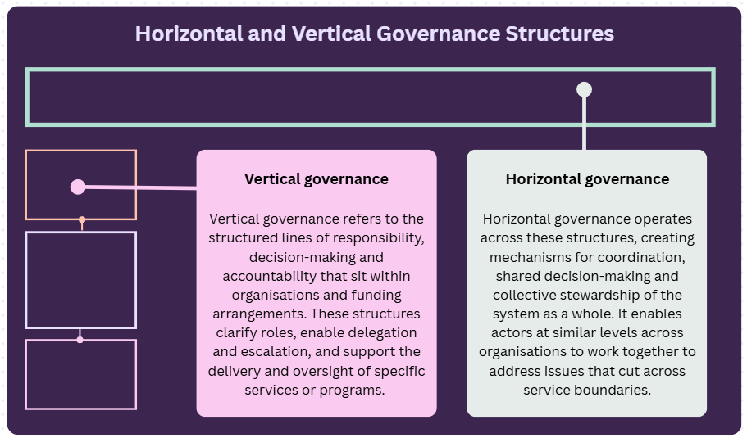
Although SAHA designed the Alliancing Model with horizontal and vertical governance elements, the governance structure has not been implemented to fidelity. Whilst the vertical governance elements were implemented in Alliances as intended, the primary horizontal element of the Alliance System Steering Group (ASSG) did not come to fruition and remains absent in existing governance. These differences are illustrated in Figure 8. The function and impact of current governance arrangements are further explored in the rest of this chapter.

Figure 8: Originally intended Alliance Model Governance and Implemented Alliance Model Governance
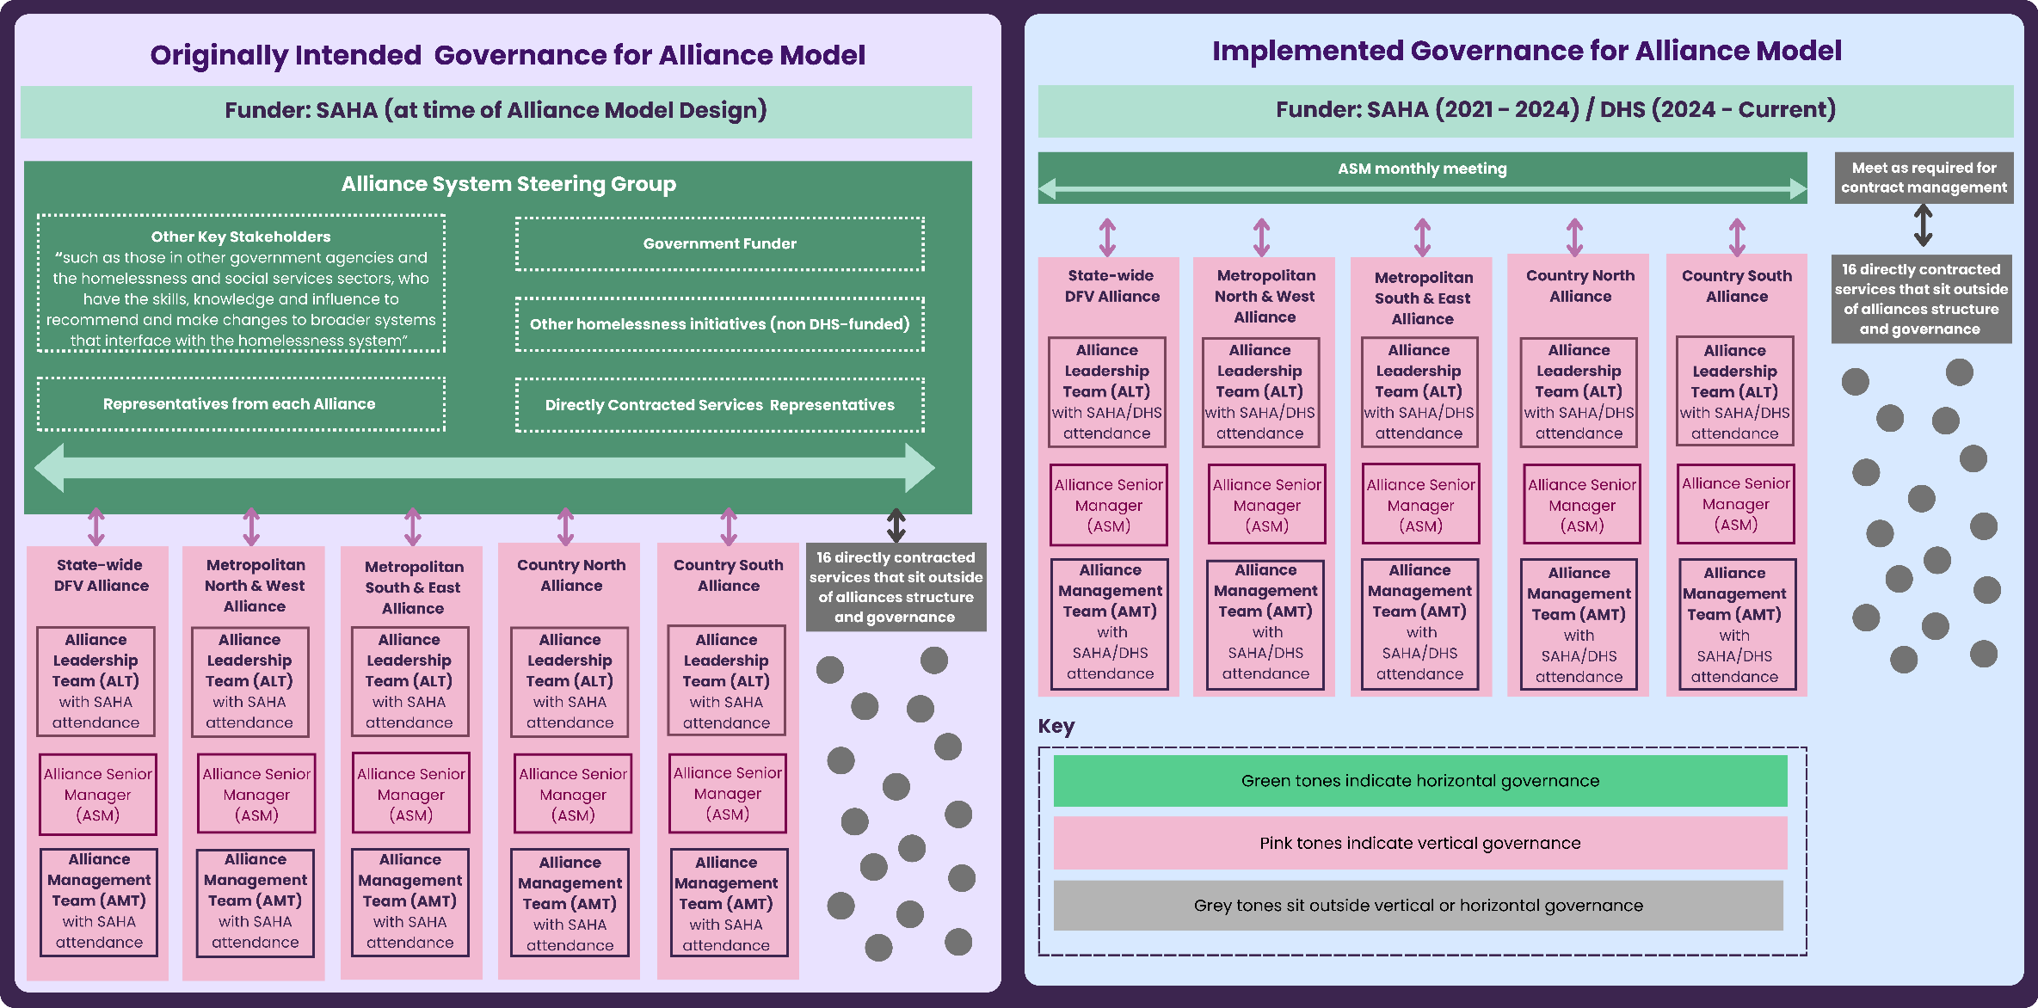

  - Horizontal Governance
    - Purpose and implementation
The ASSG was designed by SAHA as the primary horizontal governance mechanism for the Alliance model. The Future Directions of Homelessness document states that Alliancing was meant to support “transition to an integrated service response … across the homelessness and domestic and family violence sector, and other services that support people to address the causes of homelessness including health and wellbeing, housing, justice and correctional services” . Despite its central role in enabling this integration, the ASSG was not embedded into the system and remains absent.
The ASSG was designed to enable the homelessness system to mobilise the new Alliancing model including monitoring system performance toward achieving outcomes; facilitating cross-sector capability building; embedding common operational practices; and promoting practice alignment across regions. Its membership was intended to include representatives from SAHA, each of the 5 Alliances, Directly Contracted services and additional stakeholders from other government agencies and the wider social services sectors, recognising that homelessness intersects with multiple systems.
Alliance contracts specified that SAHA was responsible for establishing the ASSG and maintaining this governance function. Stakeholders reported that while early attempts were made to establish the ASSG, the group did not become operational before being discontinued. Reasons provided included unclear purpose, limited leadership within the group and the effects of trauma and fractured relationships following the transition to Alliancing. Political pressures added to this instability, while tension created by the new Alliancing model and the fallout from the implementation process made early collaboration unrealistic for organisations that had just experienced major change and loss.
“It got disrupted for a range of reasons... So the original intent of ASSG was really around Alliances working together and probably direct homelessness services but.… it just became a place where there was lots of dispute conversations, as opposed to something which was really around: “How do we build this Alliance system?”….We can’t underestimate the impact on how disruptive the Alliancing [transition] was … And so it was a big ask to ask people to just jump into being cooperative straight away”. -Sector Participant
Stakeholders emphasised that the absence of a shared governance forum has had lasting implications for how Alliances connect with one another.
“That system-level connector is what’s missing. Aside from government, there is no consistent mechanism bringing Alliances together. Information is often partial, and connections are limited.” – Sector Participant
    - Stewardship by design
System stewardship involves setting direction, maintaining oversight, and ensuring the system functions as a coherent whole to achieve equitable and effective outcomes. It includes shaping policy, defining standards, monitoring performance, and intervening where needed to support consistency, accountability and continuous improvement across the system.
Within the original design of the Alliancing model, the ASSG was intended to be the primary mechanism through which this stewardship function would be exercised at a whole-of-system level. It was designed to provide collective oversight, align priorities, and enable coordinated planning, integration and system development. No equivalent mechanism has been introduced to enable the stewardship role, with implications for how stewardship is exercised across the system.
    - Stewardship in the current system
The absence of the ASSG, or an alternative horizontal governance function, has left the homelessness system without a clear mechanism for whole-of-system stewardship. As a result, the structures required to support collaboration, consistency and system level accountability were never fully operationalised, yet contractual expectations were not amended to reflect this reality.
Alliances have been expected to deliver against an architecture that did not exist in practice, while Directly Contracted services continue to operate under different contractual and accountability settings. This misalignment has shaped how roles and responsibilities have played out across the homelessness system.
This gap is significant because contractual expectations for Alliances were set on the assumption that the full governance model, including the ASSG, would be in place. Documentation makes clear that responsibility for establishing this horizontal governance layer sat with SAHA. There is no evidence that this element of the model was formally reviewed. The planned 2x2x2 evaluation framework was also not implemented, limiting the system’s ability to understand performance and identify structural issues early.
While DHS and other SA Government agencies maintain their own internal governance structures, including executive-level forums between Chief Executives, these mechanisms sit outside the formal Alliancing model. While they provide important oversight within government, they do not bring together Alliances, Directly Contracted services and cross-government partners in a shared horizontal governance structure. As such, their existence does not materially alter the analysis of governance gaps within the Alliancing model or the consequences of the ASSG not being implemented.
DHS has implemented a monthly meeting with Alliance Senior Managers (ASMs) following its assumption of responsibility for the SHS system. However, this forum does not operate as a whole-of-sector governance mechanism as they it does not include Directly Contracted services. As a result, the homelessness system remains structurally divided between Alliances and Directly Contracted services, with no formal mechanism to connect these components.
In practice, the absence of horizontal governance has resulted in stewardship expectations falling disproportionately onto individual Alliances. However, system stewardship requires whole-of-system oversight, clear authority and an enabling environment to act. Individual Alliances do not hold this level of authority, nor are they resourced to perform system-wide stewardship functions. This has created ambiguity about roles and responsibilities and resulted in expectations on Alliances that cannot be fully realised within their remit.
“The governance structure itself is therefore an area where responsibility is unclear. In some respects, it feels unreasonable to expect partner organisations to resolve issues that sit at this level of complexity … and where it is ultimately unclear who holds governance responsibility” -Sector Participant
A broader limitation within the original alliancing design was that expectations for cultural governance were implied but not structurally defined or consistently embedded across the homelessness system. To date there has been no clearly defined mechanism to embed whole-of-system Aboriginal governance or cultural authority. Investment in reform must consider establishing a clear mechanism for Aboriginal leadership, cultural accountability and culturally governed influence over system-level decision making.
The cumulative effect of the existing architecture is a system without a clearly defined, culturally governed or consistently enacted stewardship function. Responsibilities for stewardship are distributed without the necessary authority, resourcing or accountability to support them. This has contributed to fragmentation, limited system integration, and reduced capacity to drive coherent, equitable and system-wide responses to homelessness.
    - Future Stewardship
Currently, stewardship responsibilities are dispersed across the system without clear authority, role definition or system-level support.
“In terms of alignment, the question becomes: whose job is it to push this? Because it is not just a DHS issue. It is about trust, the health of the sector, and how coordination occurs across the sector. At the moment, it feels like a bit of a no-man’s-land”- Sector Participant
Stakeholders were clear throughout the Review that system stewardship should sit with Government as the funder, rather than being informally distributed across Alliances and other system actors. This reflects government’s unique role in setting system direction, establishing enabling conditions, allocating resources and maintaining accountability across the system as a whole.
While the Alliancing model is intended to support shared decision making and collaborative ways of working, stewardship of a system that responds to fundamental human needs, such as housing, safety and wellbeing, must remain a core government responsibility. This role is not about directing service delivery, but about ensuring that the system operates as a coherent whole, with the structures, authority and safeguards required to support shared responsibility. The stewardship role includes providing clear and consistent system direction, designing and sustaining governance structures that enable shared decision making across the sector, and ensuring that accountabilities are aligned with authority at a system level. It also includes strengthening the system’s ability to coordinate across providers and service types, and to respond collectively to emerging pressures, risks and opportunities.
A central component of this role is the development of a system-wide learning capability. This includes bringing together data, lived experience, cultural knowledge and practice insight to understand what is happening across the system, identify areas of risk or inequity, and support continuous improvement over time. It also supports more informed commissioning, evaluation and reform.
Critically, stewardship must also include Aboriginal cultural governance as a core component of system oversight and decision making. In the absence of a formal statewide cultural governance mechanism, responsibility for Aboriginal outcomes, cultural safety and Aboriginal-specific pathways has often fallen to individual services or Aboriginal staff rather than being coordinated across the system. Meeting the ambition of effective stewardship requires government to ensure Aboriginal governance mechanisms are directly connected to oversight, accountability and strategic decision making processes, with cultural authority informing system direction, learning and reform.
Fulfilling this role requires a step change in capability. Effective system stewardship cannot be absorbed into existing contract management functions, and will require dedicated resourcing to build on the existing infrastructure and expertise within DHS. Without this investment, the system will continue to rely on informal, diffuse arrangements that limit its ability to act strategically, respond to emerging risks and sustain reform over time.
“It’s DHS’s job to get a whole-of-government response to homelessness… then DHS needs to support the sector to engage in a whole-of-community response. To be clear, that piece isn’t happening right now and it’s not funded.” –Sector Participant
Beyond this, effective stewardship will require sustained collaboration with the sector and other system partners to build the broader foundations of a high-performing system. This includes investing in workforce capability, embedding consistent practice approaches, strengthening cultural safety, and setting a clear long-term direction for the homelessness system in South Australia. These elements are critical to ensuring that system design, practice and outcomes remain aligned over time.
These elements are foundational to a high-performing and sustainable service system. Without clear stewardship, appropriate resourcing, and a deliberately designed system architecture, the ambitions of relational commissioning, including trust, transparency and collective problem solving, will remain difficult to realise in practice. Strengthening and resourcing government stewardship is therefore critical to restoring system coherence and enabling the homelessness system to deliver safe, equitable and effective responses at a statewide level.
“I genuinely believe that real leadership looks a lot like the values behind Alliancing. Leading in a way that centres people requires humility and a willingness to work closely with others. You cannot assume you always have the right answer. That is the kind of leadership our homelessness system needs and deserves. People accessing our services need and deserve that..” -Sector Participant
  - Vertical Governance
    - Purpose
Within each Alliance, vertical governance structures support joint strategic and operational decision making. These structures apply only to Alliances. Directly Contracted services, as sole providers, do not have equivalent arrangements. These structures remain largely unchanged since the Model’s inception.
Each Alliance includes three core governance elements:

Alliance Leadership Team (ALT)
The ALT is the peak strategic and governance body, intended to comprise CEOs from partner organisations. It sets direction, provides strategic oversight, and ensures accountability in line with the Alliance Agreement and Management Framework. The ALT is ultimately accountable to the funder. The government funder (SAHA at establishment, now DHS) is a voting member. The ASM reports to the ALT but is not a voting member.

Alliance Senior Manager (ASM)
The ASM provides Alliance-wide leadership across management, planning, and administration rather than frontline delivery. The role implements ALT decisions, oversees delivery of strategic plans, and ensures operational alignment. Reporting to the ALT, the ASM connects strategic governance with day-to-day operations across partners via the AMT.

Alliance Management Team (AMT)
The AMT provides cross-agency operational leadership to support the Alliance functioning as a unified system. Members are drawn from partner organisations at executive or operational levels. The AMT supports the ASM to implement ALT decisions and maintain collaborative management. The government funder is also a voting member.
    - Current Function
Documentation (such as contracts and tender documents) and stakeholders agree that vertical governance was designed to enable shared decision making, transparency, and collective direction. Stakeholders also largely agreed that it has supported relationship building and collaboration within Alliances. However, despite a consistent design, there is significant variation in how governance functions within each Alliance. Differences were attributed to a variety of reasons including the challenges of geography, Alliance organisational composition, and the maturity of each Alliance.
A consistent theme was scope drift across governance roles, particularly for the ALT and ASM roles. Stakeholders consistently reported that governance forums have increasingly focused on operational problem solving rather than strategic stewardship. This was observed across all Alliances, with governance bodies engaging in service delivery issues and individual advocacy. This blurring of role and intent has appeared to have reduced the strategic oversight functions that this model of governance was meant to provide.
“At the AMT level, there’s a disconnect. AMTs are looking to ALTs to deal with strategic issues like housing and the relationship with SAHT, but there’s a kind of ‘no, it sits upwards’ and ‘no, it sits downwards’ dynamic happening.” – Sector Participant
The ALT, intended as the central strategic decision making body, was reported as having inconsistent authority. Alliance partner organisations remain accountable to their own boards, values and business models, which can constrain decision making or raise conflicts of interest. There were also tensions described in relation to the impacts of certain decisions on organisations, particularly for large multi-service providers when compared to smaller organisations who may only specialise in homelessness. Limited Aboriginal representation in Alliances was also described to create power differentials in decision making.
“At the Alliance table, there is significant variation in decision making authority. Some organisations are relatively small, while others are represented by senior managers or executives from large not-for-profit organisations with very broad portfolios. This creates variability in both decision making capacity and strategic thinking across Alliances.” -Sector Participant
The ASM role was widely described as the “lynchpin” of each Alliance, but also the most significantly expanded beyond its original intent. While formally responsible for implementing strategy, ASMs now operate as system connectors, advocates, and regional coordinators. This expanded scope is often unsupported, with limited administrative or analytical capacity. The role is heavily dependent on individual capability and relationships, and vacancies have significant impacts on Alliance functioning.
The governance structure was also widely reported to impact statewide and country Alliances differently from metropolitan Alliances. For Alliances covering large geographic areas, the frequency of in-person meetings, extensive reporting requirements and collective decision making processes were described as impractical and disconnected from day-to-day service realities.
These challenges were compounded by the way funding was structured under the Alliancing model. Total funding remained the same in absolute terms as pre-Alliancing, despite the introduction of new, mandatory governance responsibilities through the ALT and AMT. As a result, the time, administration and coordination required to operationalise vertical governance had to be absorbed within existing budgets, effectively shifting the cost of governance onto service delivery. This burden fell disproportionately on statewide and country Alliances, where participation required significant travel, accommodation and time away from core roles. This was in contrast to metropolitan Alliances that could meet in person with minimal cost. The absence of dedicated resourcing undermined the ability of vertical governance to function as intended and contributed to inconsistent implementation across the State.
There were varied perceptions about how Alliance governance contributed to system outcomes. The anonymous online survey of SHS staff sought views on whether Alliancing governance was supporting a shared vision and purpose for the system, client-led decision making, improved client experience and evidence-informed practice.
Survey results reflected Figure 9 show that 21-38% of staff strongly disagreed or disagreed, and 24-32% were neutral in response to statements about the positive impacts of Alliancing governance. This pattern suggests a broader lack of clarity or confidence regarding how effectively Alliancing governance is functioning, and points to uncertainty in the workforce about the model’s impact on system-level outcomes.
Figure 9: Anonymous online staff survey response summary, Alliance governance
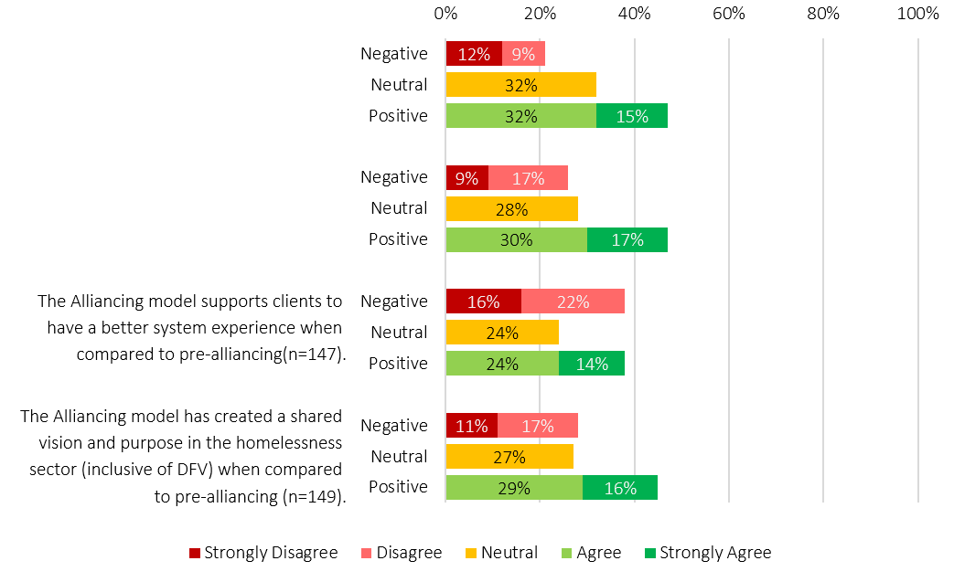
The governance of the Alliance in your local region keeps clients at the heart of decision making (n=151).
The governance of the Alliance in your local region supports evidence-based decision making about service delivery (n=152).

    - Decision Making Authority and Membership
Under current Alliance contracts, the government funder participates in ALT and AMT governance as a member with formal voting rights. This role has remained unchanged in the transfer of homelessness services to DHS.
The inclusion of the Government funder in vertical governance forums such as ALT or AMT is consistent with relational contracting practices that work on the premise of shared decision making and responsibility. However, how decision making authority was embedded in the vertical governance structure substantially limits how shared this authority can be. Alliance Contracts require the presence of the government partner for any ALT decision to be made and mandates unanimous agreement among those present. This effectively gives government a veto over all strategic decisions. As the AMT is accountable to the ALT, these constraints flow through to operational decision making as well.
Stakeholders reported that the transfer of homelessness commissioning from SAHA to DHS changed perceptions of government’s role as a partner. Although government participation, authority and voting rights in governance forums remained unchanged, stakeholders described having a clearer sense of what SAHA brought to the table as a partner, particularly access to information, assets and decision making levers within the public housing system. The relationship between housing and homelessness was viewed as integral to outcomes, and the shift of homelessness out of the SAHA portfolio was seen to weaken these connections. Whilst stakeholders were not suggesting that homelessness return to the SAHT portfolio, there was strong consensus that clearer governance and structural mechanisms into SAHT are needed to ensure housing and homelessness can work together as interconnected systems.
“Housing Trust- we rely on that relationship a lot. We rely on public housing for a lot of the community we support. It makes sense for the asset to be close to supports, not delivered by the same teams, but close to them. I think we've lost opportunity and probably the potential for outcomes as a result of that move.” -Sector Participant.
While the transition to DHS was broadly welcomed, stakeholders described DHS as more distant from the housing system and were unclear about the distinction between its role as a partner and its role as a contract manager. Although DHS’s broader service remit includes areas with strong crossover to homelessness, such as DFSV, disability and youth justice, these linkages were not perceived to be systematically leveraged to support people at risk of homelessness. These unrealised opportunities, combined with the weakening of housing–homelessness connections, have highlighted the need for clearer stewardship, stronger cross-government coordination and a closer alignment between what government expects the system to deliver and the levers it uses to support those outcomes. Ensuring DHS’s stewardship of the homelessness system strengthens the connections between homelessness to housing, and leveraging services already under DHS’s remit will be critical to enabling the recommended new model.
    - Aboriginal leadership and Governance
The lack of clear expectations related to ACCO partnerships and cultural governance during commissioning has corresponded to considerable variability in the implementation of ACCO partnerships and cultural governance. As a result, cultural governance is absent as a structural concept in vertical governance.
Although Alliances were encouraged to partner with ACCOs the commissioning model did not clearly define what these partnerships should involve or how they should be supported. Without defined roles, authority or dedicated resourcing, ACCO involvement developed differently across regions, shaped largely by local relationships, organisational capacity and the way partnerships were formed during commissioning processes.
“Aboriginal self-determination should be a non-negotiable principle in future commissioning, with Aboriginal organisations funded to lead, not participate on unequal terms” – Survey Response
These differences have had a direct impact on how Aboriginal leadership and cultural knowledge are embedded within the homelessness system. In some regions, ACCOs are active partners in service delivery or hold formal roles within Alliance structures. Elsewhere, engagement is more limited, occurring through informal relationships, advisory input or consultation initiated by mainstream partners. Stakeholders noted that in some Alliances, Aboriginal governance is not built into the formal structure at all, with engagement occurring only when issues arise rather than through ongoing, embedded processes.
Where ACCOs are not formal partners, Aboriginal perspectives are often sought through community organisations, Aboriginal staff within mainstream services or existing local networks. While these connections can support culturally informed practice, stakeholders emphasised that relying on informal or ad hoc engagement leads to inconsistent incorporation of Aboriginal perspectives. Stakeholders also highlighted that, despite expectations to partner with ACCOs, no dedicated funding was provided to support ACCOs to take on broader cultural governance responsibilities within Alliances. This lack of resourcing affects the extent to which cultural authority, accountability and cultural safety has been embedded and sustained over time.
Collectively, these findings point to a broader structural gap within the alliancing model. In the absence of clearly defined cultural governance arrangements and consistent expectations for Aboriginal decision making, cultural authority has been applied unevenly across the State, resulting in Aboriginal knowledge being central to some parts of the system while remaining peripheral in others.
“From a cultural perspective, I don’t think this work can occur without strong Aboriginal voice, relationships and genuine partnership with Aboriginal organisations and leaders in the community. At the same time, the question remains about who ultimately holds responsibility for ensuring that systems work toward these outcomes. That responsibility must sit with government. The capacity to challenge issues is limited if there isn’t a broader sector-wide clinical and cultural governance structure”- Sector Participant.
    - Accountability, Monitoring and Compliance
The Alliance model explicitly shifted some traditionally government led functions away from the funder and towards individual Alliances through contracting as part of the reform. These contracts have remained largely unchanged since their design by SAHA in 2021.
Under the Alliance contracts, SAHA retained responsibility for contract management, system level oversight and leadership of system structures including benchmarking and the setting of whole-of-system expectations. Alliances remained responsible for delivering contracted services and achieving client outcomes as they had pre-alliancing. However, additional Alliance responsibilities included managing vertical governance through the ALT and AMT, achieving system-level outcomes and self-performance monitoring. The Alliance model requires Alliances to monitor their own performance, identify underperformance and develop corrective actions, yet the government funder participates in the same governance forums responsible for these decisions.
New financial administration responsibilities were also introduced. Instead of government managing multiple contracts, a single Alliance contract was issued, with Lead Agencies for each Alliance responsible for receiving and distributing funding to partners, maintaining transparent financial records and ensuring administrative costs remain within contractual limits. This shift streamlined SAHA’s contracting workload, reducing the number of contracts it managed and transferring significant performance management responsibilities to Alliances.
Stakeholders were unclear how the contract management functions retained by the government partner differed from, or interacted with, the performance management responsibilities assigned to Alliances, creating ambiguity about where accountability ultimately sat.
    - Cultural Safety
A significant gap in the current vertical governance and performance management framework is the absence of cultural safety requirements within KPIs or performance frameworks. Without defined indicators or accountability mechanisms, cultural safety is often treated as a practice aspiration rather than a core governance responsibility. This has contributed to an environment in which Alliances are not consistently required to demonstrate culturally safe practice, monitor cultural risk or meaningfully report on Aboriginal outcomes. In practice, approaches to culturally safe practice have depended heavily on local leadership, organisational commitment and the presence of Aboriginal voices within Alliance structures, rather than on consistent system expectations.
“Cultural safety, equity and inclusion must be embedded across the entire housing and homelessness system, not treated as add-ons or responsibilities of frontline staff alone. Aboriginal-led solutions, shared accountability and genuine partnership with community are critical to achieving safe and equitable outcomes for children, young people and families.” – Survey Response
However, stakeholders also emphasised that the introduction of cultural safety KPIs alone would not address the broader governance gap. In the absence of Aboriginal cultural governance within vertical governance arrangements, performance against cultural safety measures would continue to be interpreted and assessed primarily through non-Aboriginal governance processes. This creates a risk that decisions relating to cultural safety, accountability and remediation occur without appropriate cultural authority or Aboriginal decision making influence. In this context, the absence of formal cultural governance arrangements represents a broader system risk, limiting Aboriginal influence over the standards, responses and accountability processes that affect Aboriginal clients and communities.
The absence of these measures within performance management frameworks also limits DHS’s ability to enact effective system stewardship, as the Department lacks the levers required to monitor cultural risk, support accountability and drive system-wide improvement.
  - Chapter Summary
The Review finds that although vertical governance structures were implemented to fidelity, the horizontal governance foundations of the Alliancing model were never established. The absence of horizontal governance, combined with the drift of vertical governance into operational territory, the lack of embedded cultural governance, and ongoing ambiguity about government’s role, has collectively constrained the model’s ability to function as intended. Alliances have been expected to deliver against a system architecture that was only partially implemented, while DHS has inherited stewardship responsibilities without the resourcing or levers required to enact them.
Strengthening governance, including cultural governance, is therefore essential to restoring system coherence and enabling the homelessness system to operate as a unified, accountable and high-performing system.

- Accessing the SHS System
This section examines how people enter and move through the SHS system, focusing on the structural features that shape visibility, navigation and access to support. It explores how system design elements, including multiple entry points, varied intake and triage practices, and inconsistent application of the “no wrong door” approach, influence people’s ability to find the right help at the right time.
Drawing on stakeholder feedback, system documentation, and service data, the Review found that fragmented access pathways, inconsistent public-facing information, and limited alternative service options contribute to confusion for clients, inefficiencies for services and pressure on homelessness providers to hold clients whose needs extend beyond their remit. These findings illustrate how access architecture and system settings directly affect equity, client experience and the overall functioning of the SHS system.
  - How People Access the SHS System
Access is a multidimensional concept that encompasses the conditions enabling people to obtain the care, support and safety they need. System design plays a critical role in shaping client experience and outcomes, particularly in homelessness, where intersecting social, economic, cultural and structural factors are at play.
The SHS system in South Australia is designed to support people who are experiencing homelessness or are at risk of homelessness. People can enter the system through a variety of entry points including through presenting in person or contacting by phone any of the Alliances or Directly Contracted services, contacting one of the two state-wide phonelines, or through referral to any of the aforementioned services, by a third party.
    - The No Wrong Door Approach
The SHS system in South Australia operates on a “no wrong door” approach, a principle consistently referenced by stakeholders throughout the Review. In practice, no wrong door approaches are intended to ensure that people can enter a service system through any point and receive the information, assessment, guidance or direct support they need without being turned away. This does not mean that every entry point must provide the full response a person requires. Rather, it reflects a system-wide commitment that people will not be left without assistance and will be supported to navigate to the right place.
Across the Review, stakeholders described applying the no wrong door approach in markedly different ways. For some, “no wrong door” was interpreted to mean that everyone was eligible for support, regardless of whether homelessness services were the most appropriate response. Others understood it as an obligation to assist people into alternative pathways when homelessness was not the correct or primary need. Many stakeholders also emphasised that “no wrong door” includes the expectation of warm or assisted referrals, where the service already in contact with a person actively facilitates the connection to the next service, staying involved in the handover rather than simply providing contact details and sending the person away. However, in practice, stakeholders frequently observed clients presenting after being given only a phone number or address by another Alliance or service, rather than being supported through a warm referral.
These variations point to a broader structural issue. While the principle of no wrong door is widely understood, there is no shared, system-wide definition or set of expectations to guide its consistent application. This limits its effectiveness in supporting equitable and seamless access.
    - A System of Doors
The SHS system includes multiple doors into the system underpinned by the no wrong door intent. At the core are two statewide 24 hour phone lines, one for homelessness, and one for DFSV. Each Alliance also has their own central phoneline or lists the phone numbers of their partner organisations on their websites, and clients can present in person to any service within their operating hours whether they are an Alliance service, or a Directly Contracted one.
Information about these access points is presented inconsistently. The two statewide phone lines are framed on government websites as the formal entry to the system, while Alliance and Directly Contracted service entry points are absent. Alliance websites display a range of approaches- some highlight the homelessness phoneline, while others do not include it at all, and those that do usually describe it as after-hours support rather than as a central access and triage door.
From a client perspective, this creates confusion. People cannot easily determine where to start, what the different entry points are responsible for, or what type of support they can expect. While the system is underpinned by a ‘no wrong door’ principle, inconsistent visibility of entry points increases the likelihood that people will contact services that are not best placed to respond, resulting in repeated assessments, information duplication and redirection.
“We come into one service and do an intake, then go to another open door and do another intake and get placed on a waiting list. Then we go to an Alliance and do another intake, then somewhere else and do another one again. How many intakes do we have to do just to get into the system?” - Sector Participant
From a system perspective, this also creates inefficiencies. Without a clearly defined access pathway, enquiries that could be triaged or resolved through centralised functions are instead distributed across multiple services. This increases administrative burden and limits the effectiveness of system-wide coordination.
“A whole-of-sector intake process and pathway would help support a more coordinated response across the system, rather than people moving from one Alliance to the next. It would also reduce the need for people to repeatedly retell their story and needs.” – Survey Response
The current access arrangements are not well aligned with the original intent of Alliancing to simplify entry and improve navigation. The dynamics of multiple entry points have contributed to avoidable confusion, duplication and inefficiency, and have undermined the system’s ability to provide a clear, navigable and equitable pathway into support.
    - The Pressure to Hold Clients
Stakeholders described that the interaction between the no wrong door approach and the realities of multi-sector service responses has intensified service creep and blurred clarity about who homelessness services are expected to support. In a system where people often require coordinated responses across mental health, AOD, health, justice, child protection and housing, the limited availability of alternative pathways means homelessness providers frequently feel compelled to hold clients whose needs sit outside their intended remit.
This creates a paradox for homelessness services. In practice, homelessness services can become the default point of support, even when another system is better placed to lead a response.
“How can you operate a no wrong door approach when you’re the only door that’s open?” – Sector Participant
Stakeholders described situations where other services withdrew once homelessness became visible, or where reconnecting people to previous supports became difficult due to eligibility criteria, capacity constraints or service thresholds in other sectors.
Unlike other service areas, where risk thresholds and scope are more clearly defined and supported by system-level safeguards, homelessness services described having limited capacity to determine when a situation exceeds what can be safely managed within their role. This places workers in a position where they must continue to provide support in potentially unsafe circumstances, or withdraw from engagement without confidence that appropriate supports will be available elsewhere. Stakeholders reported feeling like they have limited practical ability to say ‘no’. When adverse outcomes occur, scrutiny often focuses on why homelessness services did not intervene further, despite the absence of shared responsibility across the broader service environment.
“Homelessness is often a catch-all for people with multiple, intersecting needs. Services are then left trying to manage high levels of complexity while also supporting staff to deal with trauma and burnout.” – Sector Participant
There is significant room for positive change in terms of how responsibility for homelessness is distributed across government systems. Without coordinated, whole-of-government action, the homelessness system will remain burdened with meeting the needs that require other service involvement, while lacking the authority, resources and system support to ensure the required cross-system service responses.
  - Who is Accessing the SHS System?
Analysis of H2H data provides insight into who is accessing SHS-funded homelessness services and how engagement with the system is evolving over time. While this reflects only those able to access services, rather than total need, it highlights patterns of service use relevant to recommissioning decisions about system scope, design and future investment.
In South Australia, Specialist Homelessness Services are funded to support individuals and families who are experiencing, or at risk of homelessness. People experiencing homelessness include those sleeping rough, staying in cars, using emergency accommodation, or temporarily staying with family, friends or acquaintances without a secure housing arrangement. People at risk of homelessness include individuals and families living in insecure or unsafe housing conditions, on informal or short-term arrangements, or facing eviction, tenancy breakdown or other circumstances that place their housing stability at risk.
    - Patterns of access over time
Table 2 presents selected characteristics of people who accessed SHS-funded homelessness services in the most recent financial year. Women accounted for six in ten (59.5%) clients, while men accounted for four in ten (39.9%). Aboriginal and Torres Strait Islander peoples were over-represented, comprising approximately 3 in 10 (27.4%) people accessing services despite comprising 2.4% of the total South Australian population in the latest census. This over-representation reflects ongoing structural inequities and differences in access to safe, appropriate housing and support pathways, reinforcing the importance of embedding Aboriginal self-determination through cultural governance, culturally safe pathways and equitable funding within future system design.

Table 2: Selected characteristics of SHS funded homelessness service clients, by FY 2024-25
Characteristic | FY 2024-25
Characteristic | n | %
Gender
Male | 7,376 | 39.9
Female | 10,995 | 59.5
Other* | 104 | 0.6
Age Group
0 to 9 | 2,814 | 15.2
10 to 14 | 1,036 | 5.6
15 to 17 | 1,101 | 6.0
18 to 24 | 2,460 | 13.3
25 to 34 | 3,587 | 19.4
35 to 44 | 3,582 | 19.4
45 to 54 | 2,247 | 12.2
55 to 64 | 1,105 | 6.0
65 plus | 543 | 2.9
Aboriginal
Aboriginal and/or Torres Strait Islander | 5,063 | 27.4
Neither | 13,412 | 72.6
Culturally and Linguistically Diverse
Yes | 1,617 | 8.8
No | 16,858 | 91.2
Experience Disability
Yes | 2,756 | 14.9
No | 15,719 | 85.1
Repeat Client
Yes | 11,674 | 63.2
No | 6,801 | 36.8
Total | 18,475 | 100.0
* The H2H database records client sex as “Male”, “Female” or “Other”. Gender is not captured, which means the Review is unable to provide an overview of gender diversity among people accessing Specialist Homelessness Services.
A year by- year table showing selected characteristics is available in the Appendices (separate document) as well as definitions of how characteristics were defined. These are system level- observations drawn from the SHS dataset, which captures only part of overall sector activity. For further information on limitations see Appendices.

We also examined whether the demographic profile of people accessing SHS-funded homelessness services changed between FY2018/19 and FY2024/25 (see Appendix 10 of Appendices document) for data tables).
There was a small decline in the proportion of clients recorded as children aged 0–17 accessing SHS-funded homelessness services, from 30.1% in FY2018/19 to 26.8% in FY2024/25. Similarly, the proportion of clients aged 18–25 declined slightly, peaking in FY2020/21 at 15.9% and by FY2024/25, approximately one in seven people accessing services (13.3%) were aged between 18 and 24. Despite these small proportional declines in children and young people accessing homelessness services, children still make up nearly 1 in 3 clients and young people 1 in 7 clients. These patterns highlight the importance of developmentally appropriate pathways and youth-specific responses within the homelessness system.
In contrast, the proportion of clients identified as Culturally and Linguistically Diverse increased steadily over time, rising from around one in fourteen clients (7.1%) in FY2018/19 to almost one in eleven (8.8%) by FY2024/25, reflecting a 23.9% relative increase. The proportion of clients reporting disability also increased across the period, growing from approximately one in nine (10.9%) to around one in seven (14.9%), reflecting a 36.7% relative increase.
Patterns of repeat engagement shifted over time. The proportion of clients who had previously accessed SHS-funded homelessness services increased early in the period, peaking in FY2020/21 at 74.1%, before declining in subsequent years. By FY2024/25, nearly two-thirds of people accessing homelessness services (63.2%) had received SHS support at least once since 2011. That two-thirds of clients have previously accessed SHS-funded homelessness is indicative of system pressure shaped by sustained engagement with repeat clients. For clients, returning for support can reflect longer periods of instability or repeated cycling through services before achieving a sustained housing outcome.
“From a continuity of care perspective, we just don’t have the capacity. People keep coming in, and we don’t have the resources to provide the kind of long-term, intensive support that some clients need. There are cases where we’ve been able to do more of that work and seen real breakthroughs, but most of the time it’s simply not possible.” – Sector Participant
  - Chapter Summary
The data in this chapter reflects only those who are able to access SHS funded homelessness services, and should therefore be interpreted as a partial view of demand. Despite this, it provides the best available view of who the system is currently reaching and can inform recommissioning decisions related to service scope, access and system design. The concentration of service use among priority groups, alongside sustained levels of repeat engagement, highlights the ongoing persistence of need within the system. For repeat clients, it often reflects overlapping needs and barriers that require longer, more intensive support to address safely and effectively.
Current access approaches are inconsistent and not supported by the system-wide structures and consistent communication needed to ensure safe, equitable and coordinated responses. Variation in how no wrong door is interpreted makes it hard for people to understand where to go and for services to operate with clarity and consistency. These issues are compounded by limited alternative support pathways in other systems, which can leave homelessness services carrying responsibilities that extend beyond their remit and without the authority, resources or governance supports required to manage them safely.
Addressing these challenges will require a more coordinated, statewide approach to access and accountability. This includes establishing a universal front door underpinned by consistent intake and triage, shared data and strong clinical and cultural governance, clarifying who homelessness services are designed to support and how they should respond, and strengthening whole of government investment and stewardship to ensure the system can meet demand.
These elements form the foundation for a homelessness system that is easier to navigate, more equitable, and better positioned to prevent, respond to and reduce homelessness across South Australia.

- Priority Areas of the Review
While access to the homelessness system is shaped by a wide range of intersecting social, health, economic and cultural factors, this section focuses on the priority areas identified in the Terms of Reference. Key themes include examining how risk, demand and system constraints are experienced in practice across the identified priority areas, the use of both population group and system-level lenses to reflect where pressures are most visible, and the integration of multiple evidence sources to address gaps in what administrative data reflects.
The priority areas presented in this section reflect the Review Terms of Reference rather than the full extent of structural inequities present within the system. Broader access barriers affecting other population groups are addressed throughout the report, including in relation to service practice, system design and data limitations.
  - Culturally Safe and Representative Data
Understanding how certain population groups experience the homelessness system requires consideration of what is and is not visible within current data systems. While system-level data provides important insights into patterns of service use, there are often limitations in what information is recorded, or how it is recorded.
The issues outlined below relate to how measures and outcomes are accounted for in the homelessness system, rather than to the experiences of any single priority group. They are set out here as a shared framing for all priority areas that follow.
Engagement during the Review highlighted significant gaps in the visibility of Culturally and Linguistically Diverse (CALD) and LGBTQIA+ communities. The National Specialist Homelessness Services Collection (SHSC) does not include fields for LGBTQIA+ identity, meaning that service access, experiences and outcomes for these communities remain largely unmeasurable. For CALD communities, the ABS minimum dataset requires four fields: country of birth, main language spoken at home, English proficiency, and non-Aboriginal and/or Torres Strait Islander identification. While H2H captures three of these fields, they are rarely used collectively to report on service pathways or outcomes for CALD clients. Stakeholders also identified missing information such as visa status, which is critical for understanding access to services for recently arrived communities.
Similar measurement gaps apply to homelessness outcomes for Aboriginal and Torres Strait Islander people. System stakeholders raised concerns about the capacity of H2H to capture cultural context, identity, risk and diversity required to understand culturally safe and equitable service delivery. While national and state frameworks recognise the importance of culturally informed practice, current homelessness data systems do not provide a reliable mechanism for measuring cultural safety or Aboriginal-specific outcomes. This is despite clause 32(a) of the National Agreement on Social Housing and Homelessness (NASHH), which requires jurisdictions to develop Aboriginal-specific outcomes frameworks to supplement the National Outcomes Framework. Based on available documentation and current homelessness outcomes settings in South Australia, there does not appear to be such a framework. This limits the system’s ability to demonstrate progress, equity and accountability in relation to homelessness experienced by Aboriginal people.
Stakeholders described H2H as rigid and task-based, limiting its capacity to record cultural obligations, kinship relationships, connection to Country, community authority, or the relational work central to supporting Aboriginal clients. As a result, culturally informed practice is either recorded inconsistently through internal systems or not documented at all. Services also reported being assessed against KPIs focused on the proportion of Aboriginal clients, rather than on the cultural safety, appropriateness or effectiveness of support provided. This reinforces a logic that privileges access and throughput over safety, connection and sustained wellbeing.
Collectively, these limitations constrain the system’s ability to identify inequities, understand outcomes and ensure responses are culturally safe and effective. The priority areas that follow therefore draw on administrative data, qualitative evidence, lived and living experience, and governance analysis undertaken as part of the Review to examine population-specific experiences and broader system conditions where current data settings do not adequately capture risk, safety or outcomes.
  - Aboriginal and Torres Strait Islander Communities
Nearly 1 in 3 SHS-funded homelessness services clients are Aboriginal and Torres Strait Islander peoples, reflecting ongoing over-representation related to entrenched structural inequalities. For the SHS system in South Australia, ensuring culturally safe and responsive service delivery remains one of the most significant challenges facing the homelessness sector. This review examines how commissioning arrangements, governance structures, access pathways and service models influence experiences of homelessness support, safety and engagement for Aboriginal individuals, families and communities. Evidence gathered for the review indicates that these settings can either mitigate or compound risk depending on how they are designed and implemented.
The structure of the current homelessness system can create barriers for Aboriginal people because it is not aligned with Aboriginal patterns of mobility, kinship responsibilities and community connections. Stakeholders highlighted that fixed service boundaries, Alliance service regions and program eligibility settings often do not reflect these realities. As a result, barriers can arise when people move between regions, stay with extended family or seek support in locations tied to family, safety or cultural obligations rather than their recorded residential address. Concerns were also raised regarding access to Aboriginal specific housing pathways, particularly when clients are required to verify Aboriginal identity in order to access services or housing responses. While these processes may serve administrative purposes, they create additional hurdles for Aboriginal people already experiencing hardship and may undermine cultural safety and accessible pathways.
In some areas, stakeholders identified that funding parity for Aboriginal organisations was an example of a key enabler of culturally safe and effective service delivery. Funding that reflects the proportion of Aboriginal people accessing services was described as foundational to supporting Aboriginal Community-Controlled Organisations and strengthening culturally governed responses. In addition, funding parity was seen as enabling more meaningful partnership with mainstream services and improving the visibility, accessibility and safety of support for Aboriginal people within the system.
“Funding parity for Aboriginal people should be fundamental to homelessness system design. Mainstream organisations can support delivery of Aboriginal specific services in a culturally safe, equitable and inclusive way, working in partnership with Aboriginal leaders, organisations and communities.”– Survey Response
Cultural safety within the homelessness system is not only shaped by service models and governance arrangements, but also by workforce conditions. Aboriginal workforce pressures, including cultural load, limited structural support, and reliance on a small number of workers, were consistently identified as key factors shaping cultural safety, service continuity and overall system effectiveness.
“Aboriginal staff continue to carry a high cultural load, with limited systemic support. Current funding and policy settings do not always allow the flexibility needed to deliver culturally responsive, healing-focused outcomes.” – Sector Participant
Homelessness for Aboriginal people is often experienced in relational and cultural terms, including connection to family, community, culture and Country. Service models often do not align with these realities. The sections below examine how current SHS settings operate for Aboriginal people and where structural change is required.
    - System Experience and Safety
Aboriginal stakeholders consistently described experiences of homelessness services as highly variable, shaped by geography, service entry point and the presence, or absence, of Aboriginal leadership within local service systems. In some settings, culturally safe practice was associated with strong relationships with Aboriginal organisations or Aboriginal workers. In others, Aboriginal people experienced pathways that were inconsistent, fragmented or culturally unsafe.
Trust was identified as central to whether Aboriginal people engage with homelessness services at all. For people who have experienced racism, child removal, criminalisation or repeated system harm across housing, child protection and justice systems, reluctance to engage with mainstream services was often described as a rational response. In these contexts, the absence of Aboriginal-specific entry points or culturally governed pathways can result in delayed access, repeat presentation, or continued reliance on unsafe informal arrangements.
Cultural safety was consistently described as extending beyond frontline practice to include governance, commissioning and escalation processes across the system. Stakeholders noted that where Aboriginal perspectives and cultural authority are not reflected within these arrangements, cultural risk is more likely to remain unidentified until harm occurs. This reinforced the view that culturally safe service delivery is shaped not only by frontline interactions, but by the broader structures that influence decision making, accountability and system responses.
“Cultural training often focuses on awareness rather than equipping staff to challenge colonial policy settings, address systemic racism or exercise discretion in culturally responsive ways. Non-Aboriginal staff may lack the confidence or authority to push back on unsafe system rules, while Aboriginal staff can carry significant cultural load and experience moral distress when navigating systems that harm their communities.” – Survey Response
    - Aboriginal Experiences of DFSV and Homelessness
Stakeholders also emphasised the importance of Aboriginal-led, culturally governed DFSV and homelessness pathways that can be accessed from any entry point in the system, including warm transfer arrangements, shared risk assessment processes and Aboriginal-specific referral pathways coordinated across DFSV services, homelessness services and ACCOs. Embedding these pathways structurally, rather than relying on informal relationships or individual practice, was consistently identified as important to improving safety, reducing repeat homelessness and strengthening accountability for meeting the needs of Aboriginal women and families. Aboriginal stakeholders highlighted that the intersection of domestic, family and sexual violence (DFSV) and homelessness often carries additional layers of complexity that are not consistently recognised within current system responses. Experiences of DFSV cannot be separated from the impacts of colonisation, intergenerational trauma and systemic racism, which continue to influence patterns of violence, help-seeking and trust in services.
For Aboriginal women and families, safety is relational and connected to kinship obligations, cultural connection and community dynamics. Stakeholders described situations where limited culturally safe accommodation options, inconsistent coordination between DFSV and homelessness services, and the absence of Aboriginal-led support pathways contributed to repeat presentations and extended periods in unsafe or temporary housing. These experiences reinforced the importance of coordinated, culturally informed and Aboriginal-led approaches across both homelessness and DFSV responses.
    - Access, Pathways and Navigation
Current access arrangements within the SHS system were reported to be poorly aligned with Aboriginal patterns of mobility, kinship responsibilities and community connection. Fixed geographic service boundaries and Alliance regions do not consistently reflect where Aboriginal people live, move or seek support, particularly for families moving between communities or regions for safety, cultural obligations or family support.
Stakeholders raised concerns that eligibility rules, intake assessments and prioritisation processes often rely on narrow, individualised definitions of homelessness that do not adequately capture overcrowding, cultural obligations or temporary displacement within extended family or kinship networks. Kinship structures often extend beyond the nuclear family definitions used within housing policy and administrative systems, influencing how overcrowding, household composition and support needs are recognised within the homelessness system. As a result, Aboriginal homelessness may remain under-recognised, and people may only become eligible for support once they reach crisis point.
“There is a limited availability of culturally specific support, particularly for Aboriginal children and young people. While some services exist, they are often overstretched and not all staff feel confident identifying when cultural support is needed. This can lead Aboriginal people to feel misunderstood or reluctant to engage with services” – Sector Participant
Access to Aboriginal-led services, Aboriginal case management or culturally appropriate housing options varied significantly by region, creating inequitable experiences depending on where a person presents. These issues were compounded by inconsistent Aboriginal-specific pathways and an absence of system level cultural governance and accountability mechanisms across the State.
Ongoing gaps in Aboriginal-specific housing pathways and culturally appropriate housing responses were identified across the broader housing system. Available housing options did not always reflect Aboriginal experiences of mobility, kinship obligations, overcrowding, connection to community or culturally safe living environments. Several participants noted that homelessness services alone cannot improve outcomes where appropriate housing pathways and housing models for Aboriginal people are limited or unavailable.
Overcrowding and reliance on temporary accommodation within extended family networks continue to be common experiences for Aboriginal people at risk of homelessness. These living arrangements, while culturally grounded, are often not captured within administrative definitions of homelessness, resulting in significant housing instability remaining under-reported and under-recognised.
In relation to DFSV, stakeholders emphasised that Aboriginal women and families should be able to access assistance through any entry point in the system without needing to formally identify themselves as experiencing domestic or family violence or navigate multiple disconnected services. Participants described separation between DFSV services, homelessness services, ACCOs and other supports as creating additional barriers, particularly where disclosure of violence carries cultural, safety or child protection concerns. Repeated retelling, referral breakdowns and expectations that women independently navigate multiple systems were identified as key barriers to safe engagement. Collectively, these findings highlight how current access arrangements and eligibility settings do not consistently align with Aboriginal experiences of mobility, kinship and safety.
    - Accountability and Authority
A consistent finding across the Review was the absence of formal Aboriginal decision making authority within homelessness system governance. While cultural safety is frequently referenced within contracts and policy documents, there are limited mechanisms requiring Aboriginal leadership to influence commissioning decisions, service design or system oversight.
Where Aboriginal governance arrangements are informal or advisory only, cultural risk is more likely to be managed reactively rather than proactively. Responsibility for identifying and responding to cultural issues often falls to individual Aboriginal workers or local relationships instead of being embedded within broader accountability arrangements. As outlined earlier in this chapter, current homelessness data and outcomes frameworks also do not provide a culturally governed or meaningful way to understand outcomes for Aboriginal people, further limiting system accountability.
This governance gap is particularly evident at the intersection of DFSV and homelessness, where coordination frequently depends on informal relationships rather than structured pathways. Drawing on Indigenous-led practice internationally, stakeholders pointed to DFSV reforms in Aotearoa New Zealand that demonstrate the value of culturally governed, whānau-centred approaches integrating risk assessment, warm referral and holistic support across systems. These models demonstrate how culturally governed DFSV and homelessness responses can be embedded structurally rather than relying primarily on individual worker knowledge or goodwill. Collectively, these findings reinforced stakeholder views that culturally safe coordination requires governance, accountability and decision making arrangements that are formally embedded across the system.
    - Implications for Commissioning and System Design
The findings above demonstrate that improving outcomes for Aboriginal people experiencing homelessness cannot be achieved through service-level adjustments alone.
“For Aboriginal people, current frameworks do not adequately embed Aboriginal-defined outcomes, nor does it reflect cultural ways of understanding home, safety and stability.” – Survey Response
Commissioning settings must embed Aboriginal governance, ensure equitable access to Aboriginal-led pathways, and align system design with Aboriginal concepts of family, mobility and safety.
“Recommissioning of homelessness services must be grounded in genuine partnership with Aboriginal Community-Controlled Organisations. Aboriginal people are significantly overrepresented in homelessness, and ACCOs hold lived experience, cultural authority and specialist knowledge shaped by the ongoing impacts of colonisation and systemic harm. ACCOs must be meaningfully involved in design, governance, delivery and evaluation — not as stakeholders consulted after decisions are made, but as equal partners from the outset. Without this shift, the system will continue to replicate harm rather than deliver culturally safe and effective outcomes.” – Survey Response
Without these changes, responsibility for managing cultural risk will continue to sit with individual services and workers rather than with the broader system. The absence of Aboriginal specific contractual requirements means cultural governance remains disconnected from performance frameworks, funding decisions and accountability mechanisms. Embedding Aboriginal authority, alongside sustained investment in Aboriginal workforce and service capability, is essential to ensuring the homelessness system operates safely, equitably and in line with commitments to self-determination and Closing the Gap. As outlined earlier, there is a clear need for Aboriginal-led, culturally governed DFSV and homelessness pathways that can be accessed from any entry point in the system, including warm transfer arrangements, shared risk assessment processes and Aboriginal-specific referral pathways coordinated across DFSV services, homelessness services and ACCOs. Embedding these pathways structurally, rather than relying on informal relationships or individual practice, was consistently identified by stakeholders as important to improving safety, reducing repeat homelessness and strengthening system accountability for Aboriginal women and families.
  - Young People
Young people were identified as a key priority area through stakeholder engagement, consistent with the Terms of Reference. Stakeholders widely reported that since the introduction of Alliancing, young people’s access to and visibility within the system response has reduced, alongside a decline in developmentally appropriate, youth-specific pathways. As a result, many young people are now navigating a service system primarily structured around adult needs.
This shift has significant implications for safety and outcomes. Current system settings are not consistently aligned to the developmental needs of young people and can create barriers to access, delay engagement and increase the risk of prolonged or unsafe experiences of homelessness. As a result, young people are more likely to experience gaps in support at critical transition points, including family breakdown, leaving care and early adulthood.
Analysis for this section draws on administrative data, anonymous staff survey results, and targeted BEBOLD linked-data analysis examining patterns of system contact for young people engaged with Specialist Homelessness Services, compared to a general youth population. BEBOLD figures are introduced here and used throughout the section to illustrate duration, repeat engagement and intersection with other service systems.
    - System Experience and Safety
Stakeholders consistently described homelessness as a significant source of harm for children and young people. Frequent moves, unsafe accommodation, and exposure to adult-oriented service environments were described as compounding trauma already linked to family violence, family breakdown, child protection involvement and disrupted education.
For younger children accompanying adults, services were described as prioritising immediate housing resolution without consistent attention to children’s developmental needs. For unaccompanied young people, particularly those aged 16–25, stakeholders highlighted blurred boundaries between youth services, adult homelessness responses and statutory systems, increasing safety risks and undermining stability.
The attrition of targeted youth responses since Alliancing was widely raised. Youth-specific accommodation options: crisis, transitional and supported long-term models were described as extremely limited, leaving young people to access adult pathways poorly suited to their developmental stage or risk profile. Access challenges were reported as particularly acute for young people with intersecting needs, including Aboriginal and Torres Strait Islander young people, LGBTQIA+ young people, CALD communities, and those with Child Protection or Youth Justice involvement.
    - Access, Pathways and Navigation
Access to homelessness support for young people was described as highly dependent on how youth-specific responses are structured within regions. While youth-focused services and expertise continue to exist across the system, stakeholders reported these responses are not consistently embedded or defined within all regional service contexts.
Structural differences in youth-specific responses became evident when examining how support is delivered in practice. While Directly Contracted services were described as having clear practice scope and risk thresholds, Alliances were reported to operate through varied program-level approaches rather than shared, system-wide youth frameworks. This has resulted in significant variation in access and response quality depending on where a young person presents. These inconsistencies have safety implications for young people, who often present with higher levels of risk and can be subject to mandatory reporting to child protection. Stakeholders described that a young person in one region may receive a specialised youth response, while a young person in another region is managed through adult homelessness pathways, purely due to variation in design.
There was consensus that effective youth homelessness responses require relational, developmental and often therapeutic practice. Youth work was consistently described as more time-intensive than adult responses, requiring extended engagement, family work, brokerage and coordination across systems.
Our approach is priority number one: create safety for the young person. Then we can help them recognise what feels unsafe and try to explore how to keep them safe while bringing family in where we can. And I think it moves beyond just like listening to a young person's voice to actual like- we’re the adults, we’re the professionals, where’s our accountability to the child? If someone is making this child unsafe, actually, why isn't it addressed with them? So, we have that conversation with the adults impacting that lack of safety for a child. That accountability is part of keeping the young person safe.” - Sector Participant
However, staff survey data indicates a remaining tension between perceived capability and structural capacity.
Figure 10: Anonymous online staff survey response summary, responding to children and young people
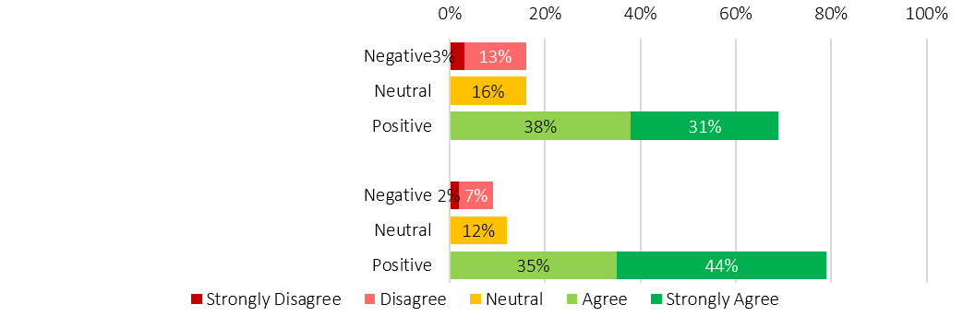
My service can respond flexibly to meet the unique needs of children and young people, whether they present alone or as part of a family (n=202).
Staff have the tools and support to respond to the unique needs of children and young people (n=200).
While approximately 70–80% of staff reported confidence in their capability to respond to children and young people, that at least 1 in 5 staff did not report having capacity to respond to the needs of young people, is concerning. Stakeholder engagement highlighted that this capacity sits alongside structural constraints, including limited youth-appropriate accommodation, erosion of youth-specific pathways and increasing reliance on adult models of care. These conditions may also contribute to longer engagement periods, repeat presentation and constrained exit options.
“I don’t think any person experiencing homelessness who entered the system seven years ago and entered again now would say the service is working better. And I would be very surprised if young people didn’t say it’s not working as well as it once did.”- Sector Participant
The Review Team undertook targeted analysis comparing young people who had SHS support periods with young people in the general population who did not. The purpose of this analysis was to better understand how young people move through the system, the types of services they come into contact with, and the patterns that emerge across health, education and justice related systems. This analysis did not aim to quantify outcomes in a causal sense, but rather to identify how system contact may reflect underlying circumstances, compounding experiences or unmet needs.
The Better Evidence Better Outcomes Linked Data (BEBOLD) platform was used to construct two groups to enable investigation of the system contacts for young adults in contact with specialist homelessness services in comparison to a general population of young adults of the same age.
The groups were:
- Group 1 Youth SHS: Individuals who accessed any SHS-funded service in the calendar years 2018 through to 2022 and were aged 18-25 years at the beginning of their first support period within that calendar year.
- Group 2 All SA Youth: A comparison group drawn from the general population of people born in South Australia, representing individuals aged 18-25 years from 2018 through to 2022.

Important things to know about the analysis
We analysed linked administrative data spanning the 2018–2022 calendar years. Due to delays in data linkage, the SHS dataset includes only those individuals who were already recorded in SHS before 31 December 2022. This means we do not hold data on new clients who had their first SHS support period after this date.
Although Appendices (See Appendices 11–13 in the Appendix document) includes all analyses by year, we have focussed on presenting key messages based on the average proportion of the population with each experience or characteristic across the years 2018-2022.

How to interpret these findings
The findings reflect a picture of system-level experiences and are not an analysis of system performance.
This study has not been designed to assess how the change to Alliancing may have influenced client pathways and system contacts. See Appendices 11-14 in appendices document to view analyses investigating changing patterns pre and post the introduction of the Alliancing model. The analysis is descriptive, meaning it aims to show what has happened for young people as recorded in various government systems, rather than explain why it happened. In practical terms, this means:
- We map patterns of service use and interactions across systems
- We describe what those patterns look like for different groups
- We do not draw conclusions about cause and effect (for example, we cannot say that one service contact led to another)
- We do not evaluate the impact of specific programs or reforms
Figure 11 BEBOLD Analysis Infographics 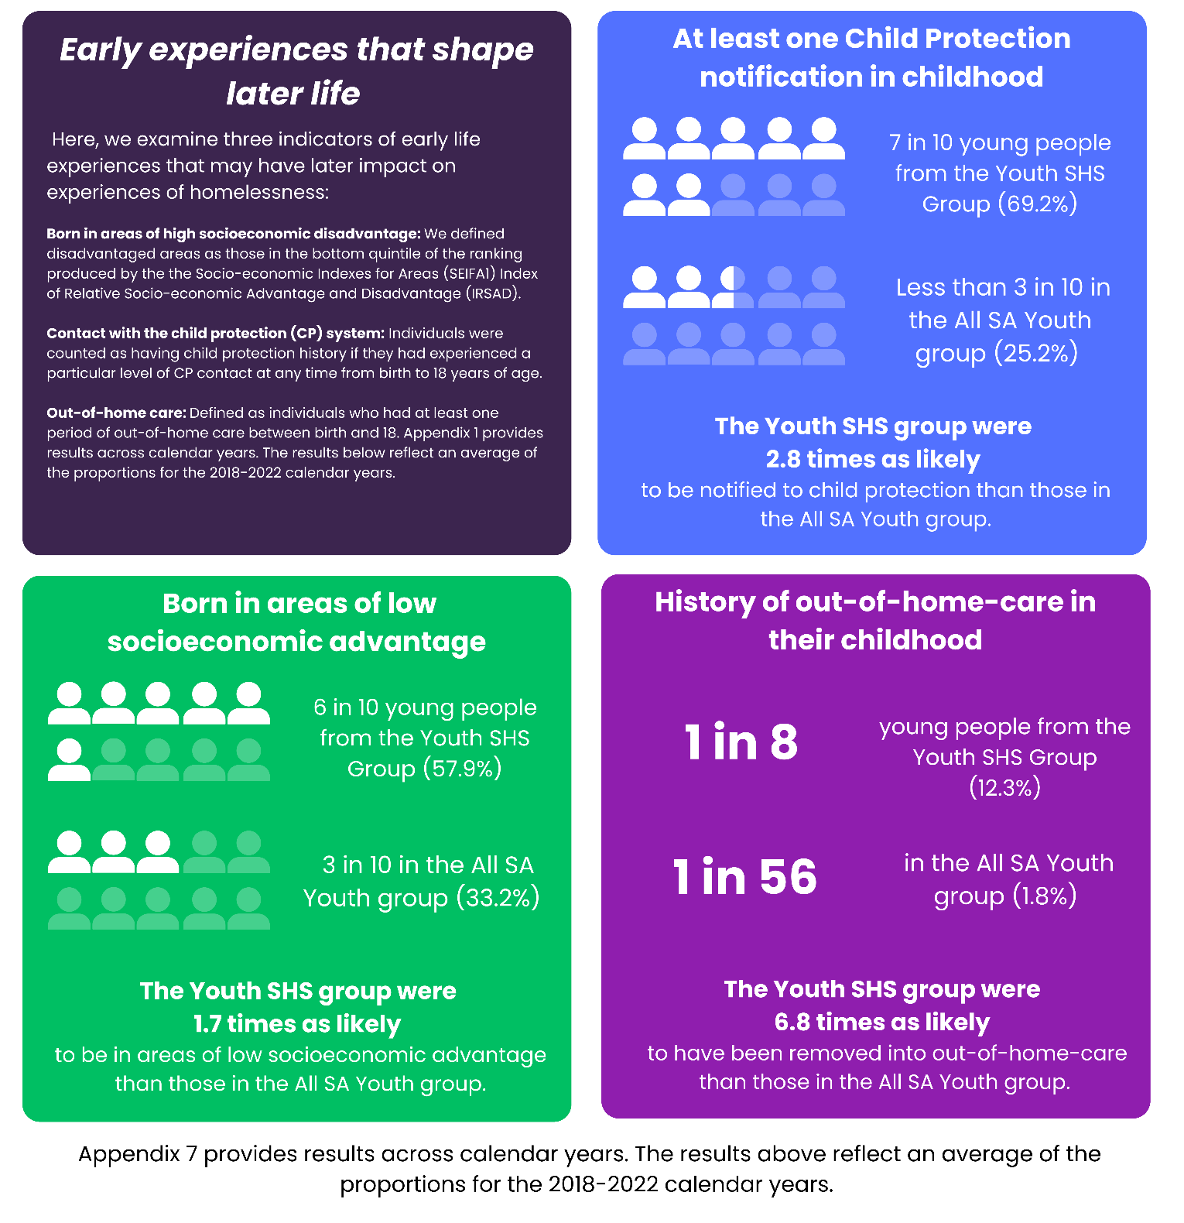
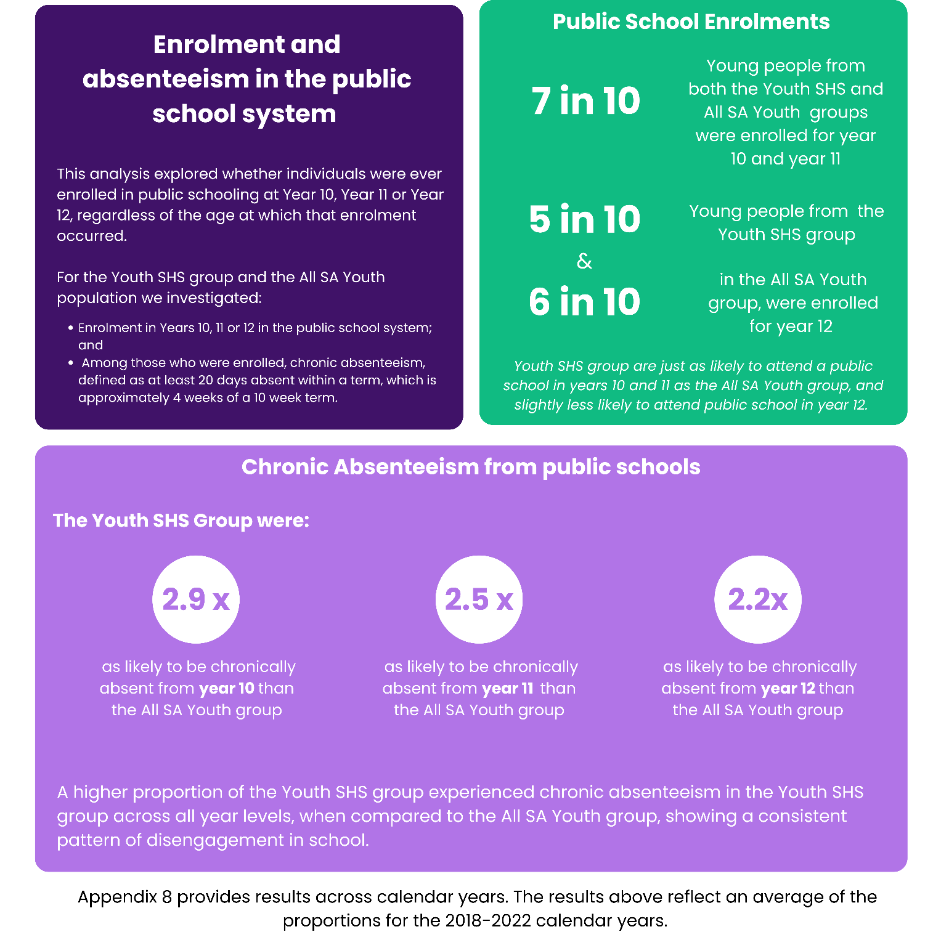
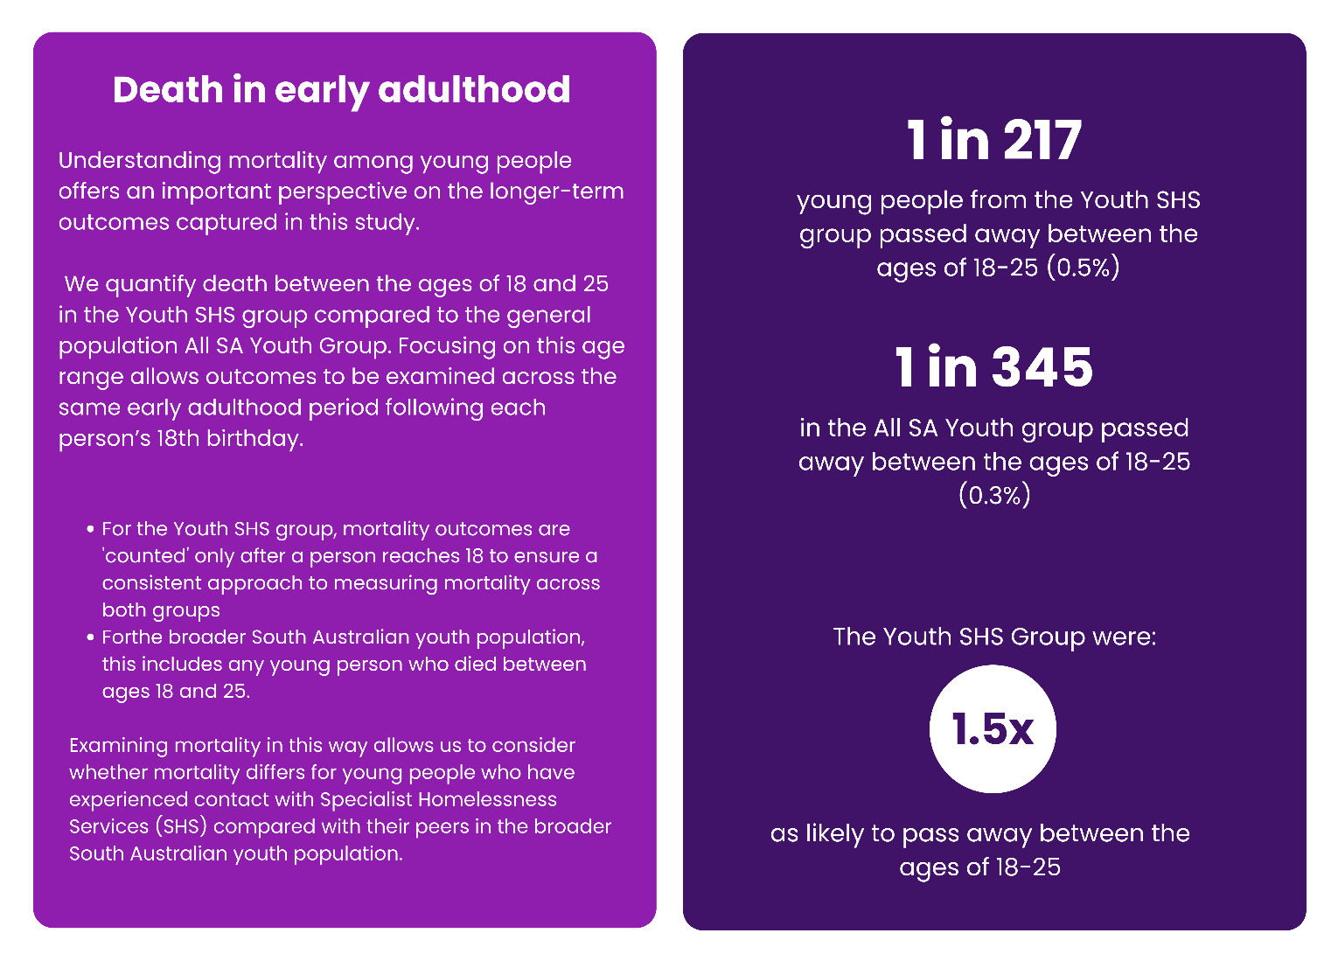
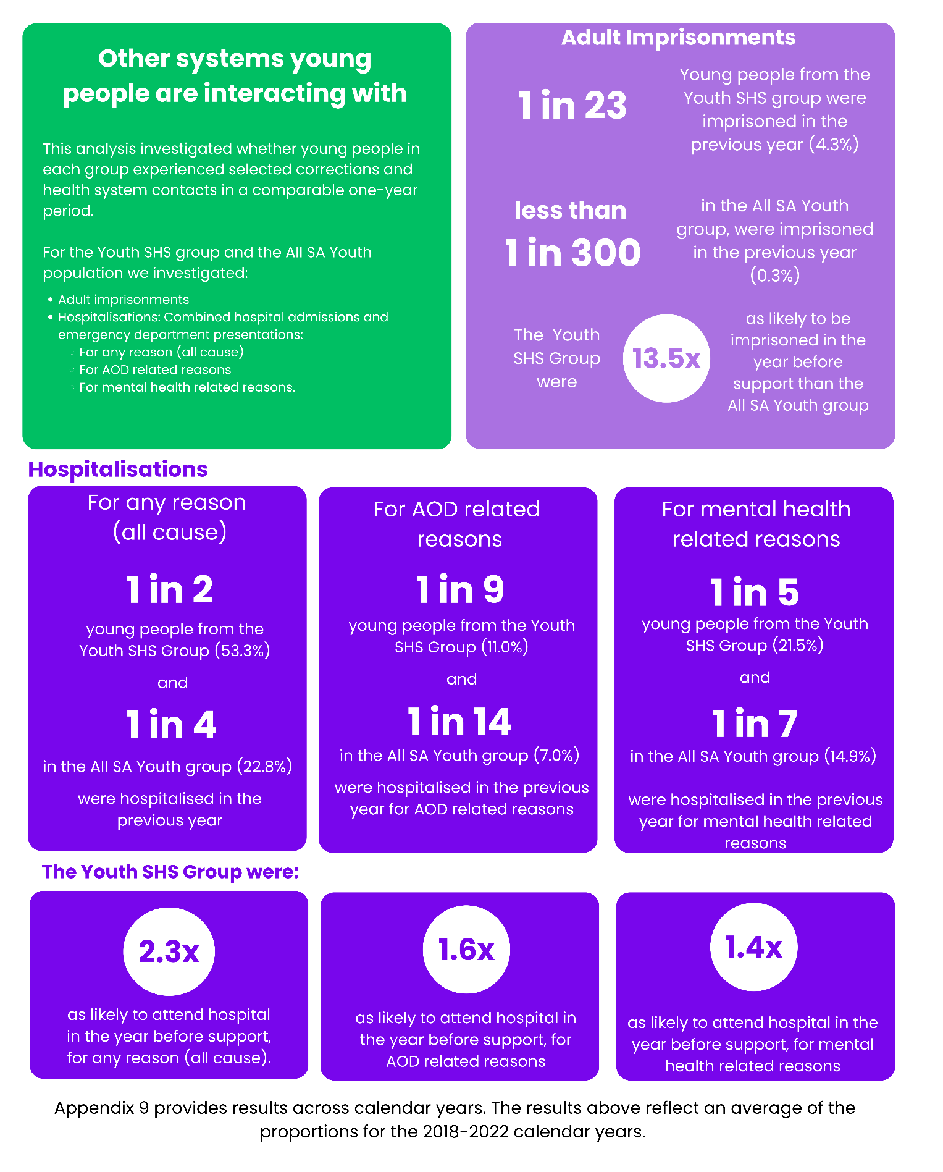
Stakeholders consistently identified the absence of system-level coordination to guide consistent youth responses across regions. Responsibility for children and young people experiencing homelessness is dispersed across homelessness, child protection, education, health and justice systems, without shared governance or accountability frameworks. As a result, homelessness services frequently absorb responsibility for risk management, coordination and support in the absence of clear ownership by other systems, despite having a limited remit and resourcing to address the intersecting needs that contribute to homelessness risk. In the absence of consistent involvement from other service systems, this shifts responsibility onto homelessness services beyond their intended scope. This contributes to variation in practice and increases the likelihood of young people cycling through services or transitioning into adult homelessness.
The following BEBOLD linked-data analysis illustrates the extent to which young people engaging with SHS are already experiencing intersecting system contact prior to their homelessness service access.

Intersecting experiences of disadvantage
The graphics in Figure 12 demonstrate the co-occurrence of system contacts. These recorded contacts included:
- All-cause public hospital emergency department presentation or admission in the previous year
- AOD related public hospital emergency department presentation or admission in the previous year
- Those who had been in Out-of-Home-Care at any time in their childhood
- Adult imprisonment for any reason in the previous year
- Mental health related public hospital emergency department presentation or admission in the previous year
Interpreting the results
- For the Youth SHS group, the results represent the average proportion of the population who had a particular type of service contact in the 12 months before their SHS support period (contacts 1,2,4 and 5).
- For the All SA Youth comparison group, the results reflect the average proportion of the population who had a particular type of service contact in a selected 12-month period (contacts 1,2,4 and 5).
How to read (using 2022 Youth SHS Figure in Figure 12 as an Example):
The bar graph on the left side of the figure shows that, of all individuals in the Youth SHS group (n=3,351),
- 53.7% of the Youth SHS group an all-cause ED presentation and/or was admitted to hospital in the previous year
- 10.3% of the Youth SHS group had an AOD-related ED presentation and/or hospital admission in the previous year
- 12.3% of the Youth SHS group had been in Out-of-Home-Care at any time in their childhood
- 3.4% of the Youth SHS group had been imprisoned in the previous year, for any reason
- 20.0% of the Youth SHS group had a mental-health related ED presentation and/or hospital admission in the previous year
The column graph illustrates the combinations of system contacts aligned with the shaded circles below them and are presented in order of population size. For example:
- Start by looking at the first column - this represents the most common pattern and shows that 41.4% of all individuals in the Youth SHS group aged 18 to 25 in 2022 were not experiencing any of these system contacts.
- Then look at the second largest column – 28.3% experienced one characteristic – attending hospital in the previous year, for any reason.
- The third column from the left – 8.0% experienced two characteristics - attending hospital in the previous year, for any reason, and attending hospital for mental health related reasons.
These intersecting experiences follow similar patterns across years. The 2018 view is available as Appendix 14 in the Appendices document.
Figure 12: Combinations of characteristics of Young People in contact with SHS (Youth SHS) compared to All SA Youth Populations from the 2022 calendar year.

2022 Youth SHS (n=3,351)
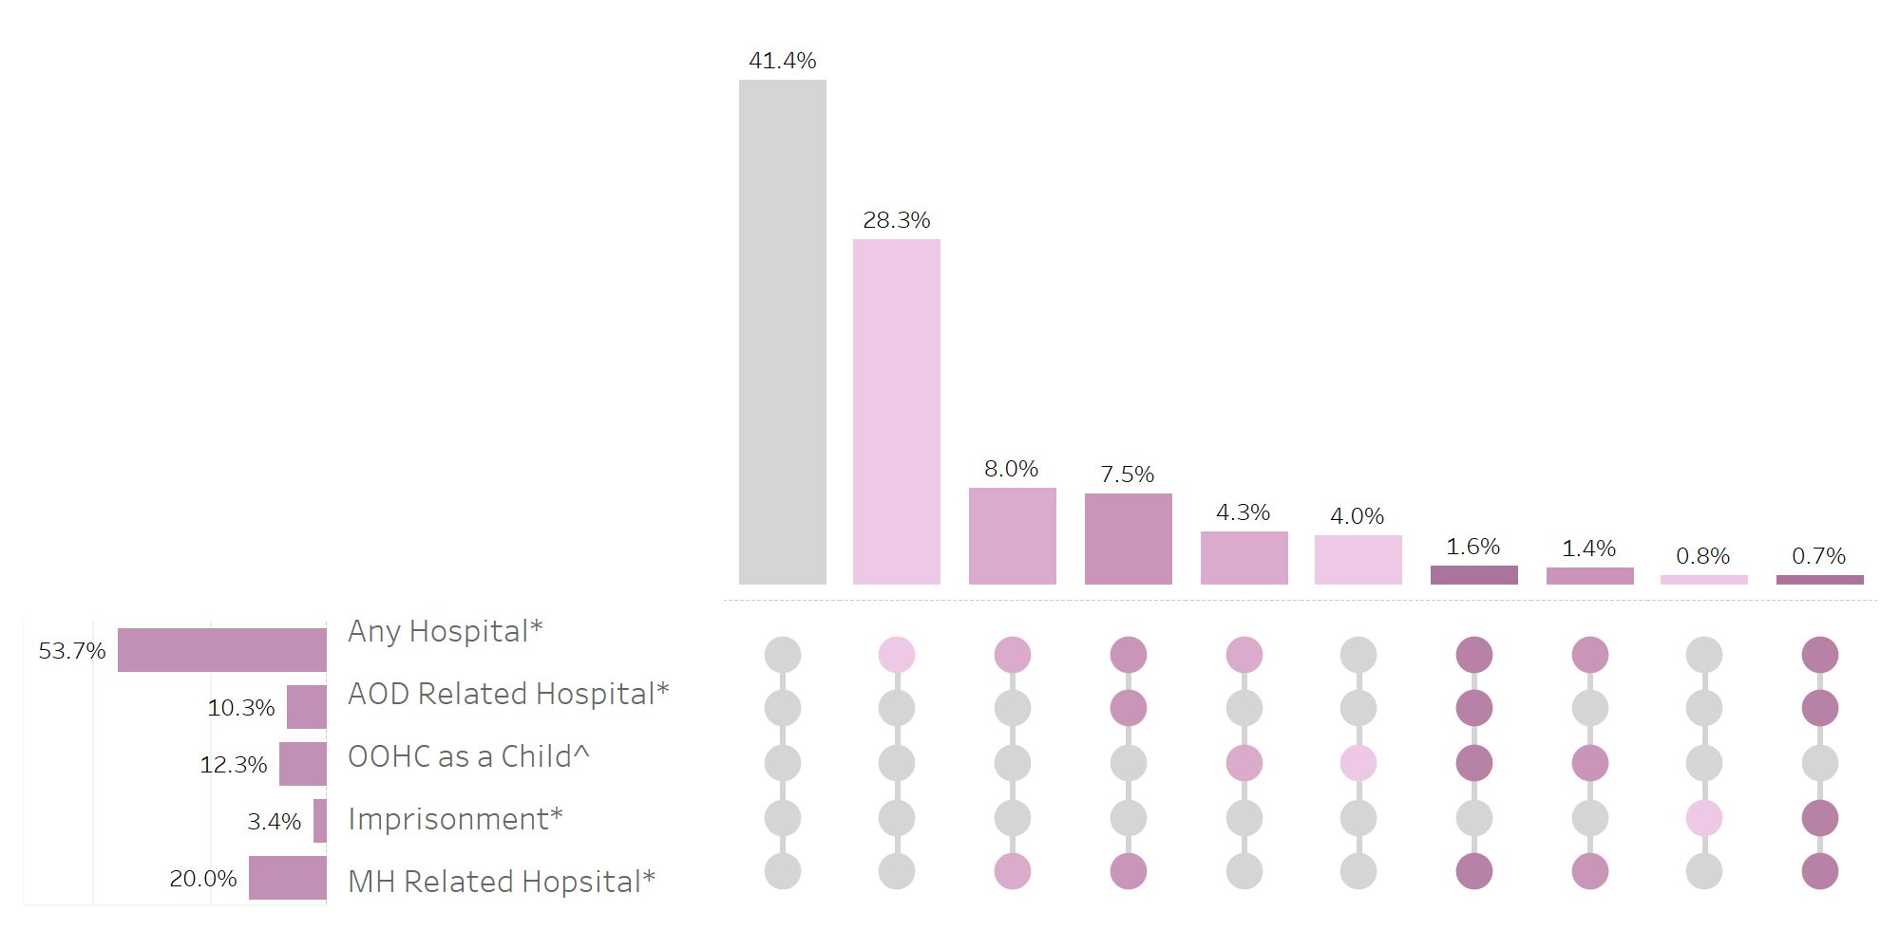
- All SA Youth (n=146,815)
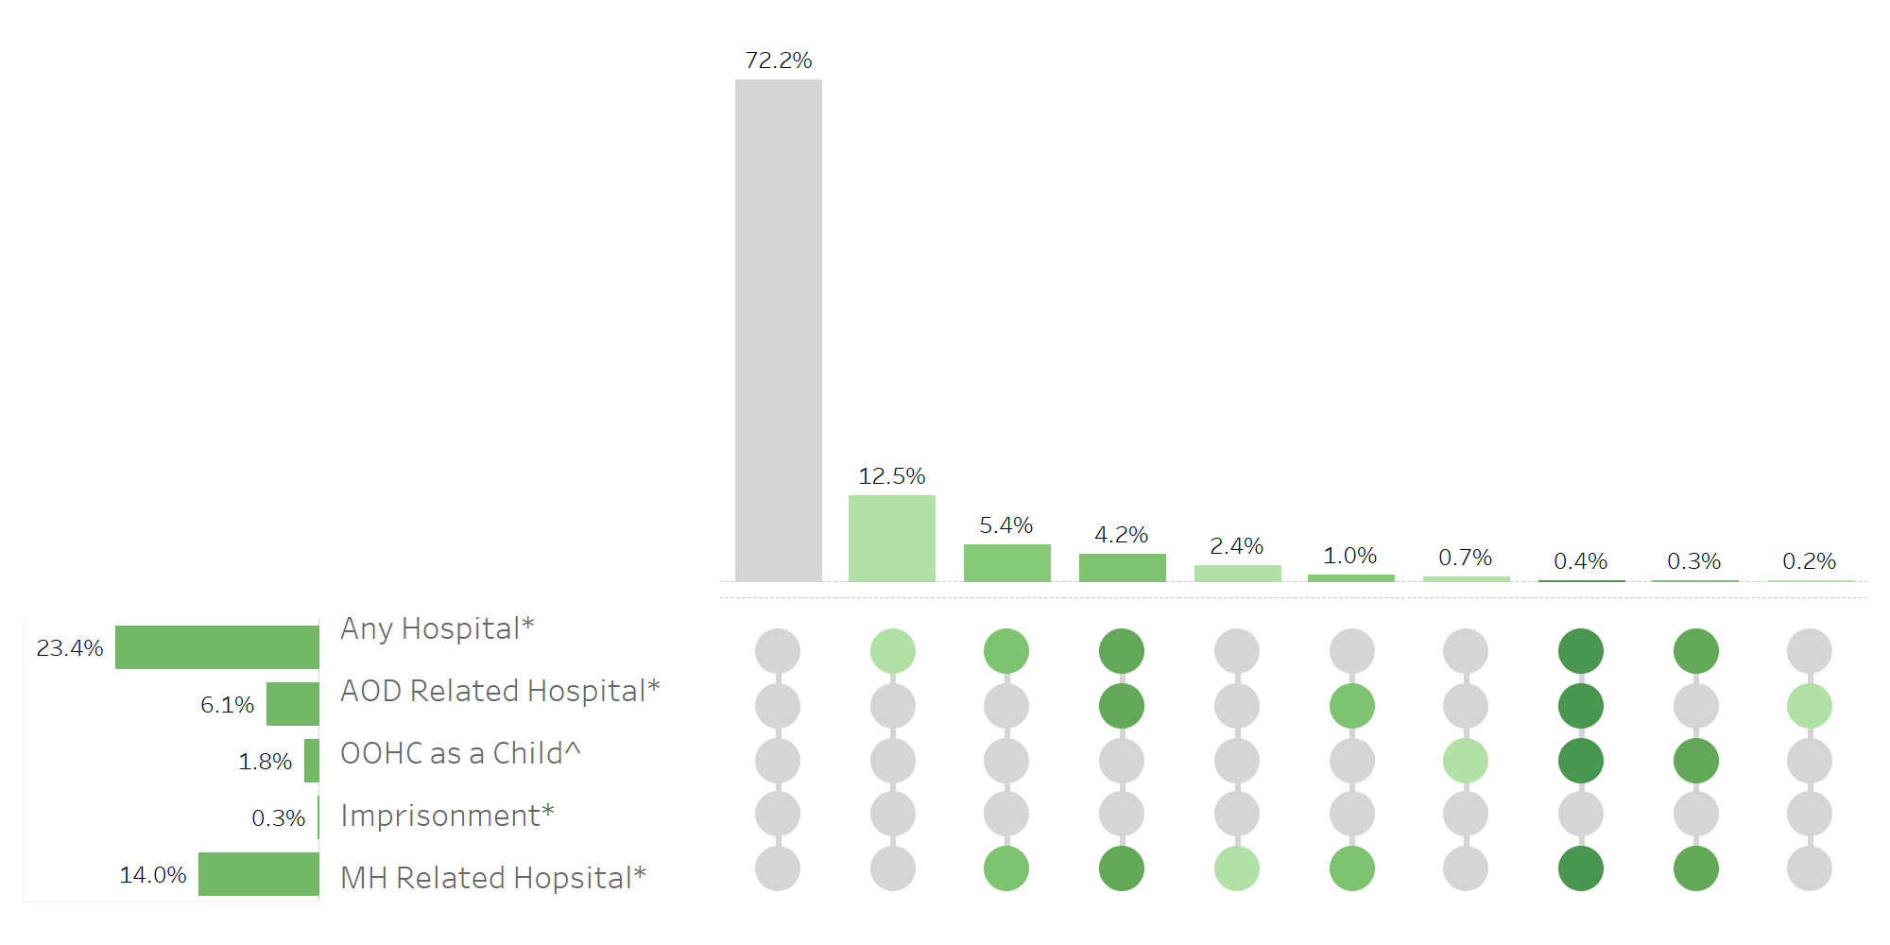
*Any Hospital, AOD related Hospital, MH Related Hospital and Imprisonment reflect system contact in year prior to 2022. ^Care Leaver reflects contact with the OOHC system between 16-18 years of age.
Key messages from this analysis show that young people accessing SHS are significantly more likely to experience multiple, overlapping service interactions, indicating higher underlying vulnerability that extends beyond housing need.
    - Implications for Commissioning and System Design
Children and young people represent a substantial and sustained source of demand within the SHS system, accounting for approximately one in 2.5 clients aged under 25 in the most recent financial year (Table 2). However, recorded demand is likely understated due to inconsistent recording of children across services and over time.
Current commissioning settings do not reflect the true cost or complexity of youth homelessness responses. Youth services require longer engagement, higher brokerage, transitional accommodation and 24/7 staffing requirements, yet funding remains largely task-based and aligned to adult service models. These misalignments limit the system’s ability to deliver safe, developmentally appropriate exits from homelessness for young people.
Strengthening commissioning settings to mandate developmentally appropriate practice, protect youth-specific pathways, resource and recognise the relational work at the core of youth responses is essential to preventing the entrenchment of youth homelessness into adulthood.
  - People Experiencing Rough Sleeping
Rough sleeping represents one of the most visible and acute expressions of homelessness, carrying significant risks including exposure to violence, theft, environmental hazards, deteriorating mental and physical health, and markedly increased mortality. While homelessness extends beyond rough sleeping, the presence and persistence of people sleeping rough is widely used as an indicator of system pressure, reflecting housing availability, access barriers and service capacity.
In SA, assertive outreach functions are the primary structural entry point for people sleeping rough. As people who sleep rough do not always present to services, outreach plays a core system role by identifying people, initiating engagement, undertaking triage and enabling access to case management and accommodation. Assertive outreach is integral to access, visibility and equity for people experiencing the highest levels of risk.
    - System Experience and Outreach Capacity
Stakeholders consistently described assertive outreach as central to improving safety and engagement for people sleeping rough. Where outreach capacity is strong, pathways into assessment, case management and housing can be activated earlier and more safely. Outreach enables workers to meet people where they are, establish trust over time and address acute safety needs alongside longer-term pathways. Examples of effective place-based coordination were identified, including the Homeless to Health initiative and the Adelaide Zero Project’s By Name List, which has expanded beyond the CBD. The Adelaide Zero Project is a collective impact initiative designed specifically to address rough sleeping through a coordinated, system-level response. Established in 2018, it applies the Advance to Zero methodology, including a shared By Name List that provides real-time visibility of people sleeping rough and supports coordinated outreach, housing and service responses aimed at reducing and ultimately ending rough sleeping.
This approach has begun to expand beyond the Adelaide CBD, including through the Port Adelaide Enfield Zero Project, with emerging interest in applying this approach in regional areas. This represents an example of extending place-based coordination and enabling more directed responses to people experiencing rough sleeping outside the inner city. However, stakeholders emphasised that these initiatives are not yet supported through system-wide design, limiting equitable access to coordinated responses across regions. This is despite recognition that outreach approaches were viewed as particularly important for people who distrust formal systems and/or who have had previous harmful service experiences.
“Where we have been able to strengthen data and service coordination, we are seeing reduced churn and better housing sustainment outcomes. Initiatives like the Adelaide Zero Project and practice changes within Alliances demonstrate that improvement is possible, even within existing system constraints.” – Sector Participant
However, stakeholders emphasised these initiatives are not yet supported through system-wide design, limiting equitable access to coordinated responses across regions. There was broad agreement that demand for outreach far exceeds capacity, despite recognition that outreach approaches are particularly important for people who distrust formal systems or who have had previous harmful service experiences. Many stakeholders reported that increasing crisis demand, static funding and workforce constraints have reduced the frequency, flexibility and reach of outreach responses, particularly in regional and remote areas where distance, travel time and small teams constrain service delivery.
In addition, people sleeping rough often experience multiple needs requiring coordinated responses across homelessness, health, mental health, AOD, justice and housing systems. Stakeholders reported service coordination for rough sleepers is largely driven by individual relationships rather than formal mechanisms. As outreach capacity declines, people sleeping rough may remain in unsafe situations for longer periods, with limited access to consistent support.
    - Access, Pathways and Navigation
As discussed, access to the homelessness system for people sleeping rough is heavily mediated through assertive outreach. Stakeholder views on outreach changes post-Alliancing were mixed. Some described improvements in outreach coordination, while others reported a dilution of specialist outreach responses and a shift toward more generalist models.
H2H data was examined to explore changes in outreach over time, acknowledging known limitations in visibility (see Appendix 8 of Appendices document). Analysis focused on:
- The number of individuals sleeping rough at entry,
- The total volume of recorded outreach contacts
- The number of people receiving at least one outreach contact, and
- Geographic patterns of outreach delivery.
Table 3 shows that the number of people sleeping rough at entry has increased steadily since FY2018/19, while the total volume of recorded outreach and the number of people receiving outreach contacts have declined.
Table 3: Rough Sleeping and assertive outreach, by individuals, service units and financial year
Financial Year | n of individuals sleeping rough at entry** | Total service units of assertive outreach provided | Individuals who received at least one service unit of assertive outreach
2018-19 | 2349 | 1,512 | 450
2019-20 | 2269 | 1,767 | 567
2020-21 | 2132 | 2,178 | 451
2021-22* | 2110 | 852 | 353
2022-23 | 2426 | 996 | 394
2023-24 | 2488 | 618 | 280
2024-25 | 2578 | 792 | 341
* The blue shaded area indicates the period in which the Alliance model commenced and continued.
**Excludes individuals in Emergency Accommodation.

Stakeholders cautioned against interpreting this trend as a simple reduction in activity. Many described significant outreach work occurring before consent is obtained and therefore this work would not be recorded in H2H, particularly during early trust-building. Others highlighted that rising crisis demand has reduced capacity for preventative outreach. However, there remains uncertainty about whether declining recorded outreach reflects structural capacity constraints, data visibility limits, or a combination of both.
Geographic analysis of outreach delivery highlights uneven system capacity across metropolitan, regional and remote areas. Figure 13 and Table 3 show that prior to Alliancing, regional services delivered a higher proportion of recorded outreach than metropolitan services. Post-Alliancing, this pattern reversed, with metropolitan services accounting for an increasing share of outreach activity. Over the full period from FY2018/19 to FY2024/25, the total volume of units of outreach (denoted by the dotted line) declined. This can be interpreted alongside the changing pattern of where outreach services are delivery. Compared to 2018/19 when outreach service delivery was relatively even between metropolitan and regional areas, the total share of outreach activity is now dominated by metropolitan outreach service delivery. Remote services continued to account for a small proportion of total outreach service delivery, reflective of both total service footprint and the higher costs of service delivery in remote areas.
Figure 13: Units of assertive outreach by Metro, Regional and remote agencies, by financial year*
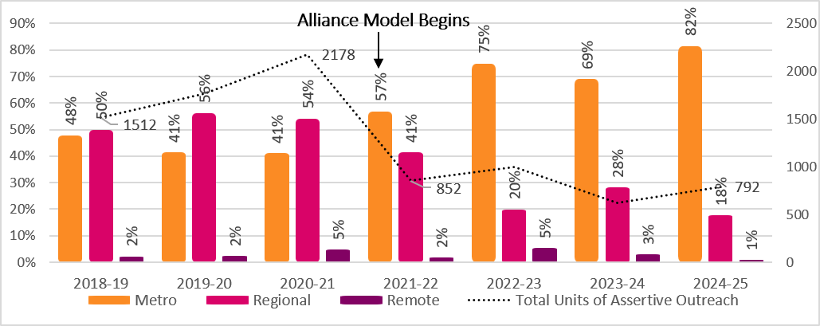
* Less than 1% of service units were excluded from the figure each financial year. These units were delivered by statewide agencies and therefore could not be allocated to a specific geographic category for this visual.
These patterns are broadly consistent with stakeholder descriptions of the specialist role of remote outreach and the structural constraints faced by services in regional and remote areas.
“We need a different approach to assertive outreach. Rather than pushing service responses for people experiencing chronic, long-term rough sleeping, many of whom have been let down by services, we need funding that allows us to build trust by meeting basic needs and walking alongside people who do not readily engage with traditional service models.” – Sector Participant
Stakeholders emphasised that reductions in outreach capacity have disproportionate impacts on Aboriginal people sleeping rough, particularly in regional and remote areas. Figure 14 shows changes in where the larger share of outreach for Aboriginal clients was delivered over time, alongside an overall reduction in total units of assertive outreach (dotted line). This is in the context of assertive outreach playing a role as a critical cultural interface reliant on relational, trust-based engagement. These findings point to the need for a more coordinated and systematised approach to outreach, access and pathways, alongside strengthened data infrastructure and system-level learning to support consistent, equitable and evidence-informed responses for people sleeping rough.
Figure 14:Units of assertive outreach for Aboriginal clients by Metro, Regional and Remote agencies and fin year
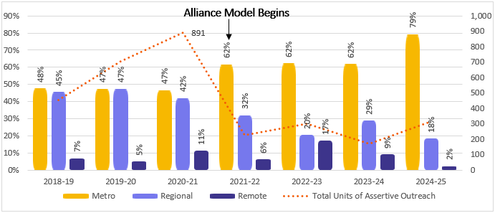

6.4.3 Implications for Commissioning and System Design
Current funding settings do not align with the intensity, persistence and cost profile of supporting people experiencing rough sleeping. Assertive outreach is funded as if equivalent to standard case management, despite the substantially greater time required for engagement, coordination and crisis response. These pressures are amplified in regional and remote contexts due to distance, thin markets and limited infrastructure.
Housing shortages further constrain exits from rough sleeping, forcing reliance on emergency accommodation despite safety concerns, refusals, and discriminatory practices that disproportionately affect Aboriginal people sleeping rough in non-metropolitan areas. Services frequently absorb unfunded brokerage, transport and crisis costs to manage risk in the absence of safe alternatives.
Data limitations may be distorting demand visibility. Early engagement work with people sleeping rough is often not recorded as it is prior to consent, meaning the scale and intensity of outreach is undercounted and not reflected in funding allocations.
“Every community struggles with inflow. We need to prevent people experiencing rough sleeping in the first place rather than keep building a system that picks people up once they’ve already fallen off the cliff.”- Sector Participant
Collectively, these factors highlight rough sleeping as a worsening demand pressure. Commissioning settings must recognise the true cost of assertive outreach, fund longer and more intensive support periods, provide alternatives to motel-based emergency accommodation, invest in specialised outreach teams and incorporate geographic loadings for regional and remote delivery. Without these changes, system capacity to reduce and prevent rough sleeping will remain constrained.
  - People Experiencing Domestic and Family Violence
DFV is a significant driver of homelessness, and homelessness services play a critical role in supporting people who are homeless or at risk due to violence. In South Australia, the specialist homelessness response to DFV is primarily delivered through the statewide DFV Alliance, alongside a small number of Directly Contracted services. DFV is used to reflect the scope of the statewide DFV Alliance, which is contracted for domestic and family violence services, while DFSV is used where broader system interactions are relevant, including services funded separately for sexual violence.
Across the Review, stakeholders identified that for victim-survivors, timely access to safe housing, coordinated support and trauma-informed responses are critical to both immediate safety and longer-term outcomes. Limited data visibility, inconsistent cross-system collaboration and structural separation between DFV and general homelessness responses have reduced shared understanding and coordination across the system. In practice, it was apparent these gaps can delay access to appropriate support, increase risk at critical points of crisis, and contribute to inconsistent service experiences for victim-survivors. These conditions directly shape who can access support, how safely, and with what degree of integration, with implications for equity, effectiveness and outcomes.
    - System Experience and Safety
Stakeholders consistently emphasised that DFSV responses are required from specialist services and the broader homelessness system. Experts noted that individuals experiencing homelessness and violence may not seek DFV-specific support at the time of presentation, even when violence is present. There was a strong theme that system responses must uphold client safety irrespective of what service is accessed. Victim-survivors are often dealing with highly complex circumstances, including fear, stigma, and competing priorities such as housing or children’s needs. In these circumstances, safety relies on the capacity of all services to recognise risk, respond appropriately and coordinate support to address the spectrum of needs. This reinforces the need for a system-wide capability uplift, consistent with reform directions emphasising shared responsibility for DFSV responses.
    - Access, Pathways and Navigation
The creation of a standalone, statewide DFV Alliance was described as reinforcing structural separation between DFV-specific responses and general homelessness services. Over time, this has contributed to parallel systems with different assumptions about scope, eligibility and responsibility. For clients, this can result in confusion, repeat assessments, and difficulty navigating pathways between services at times of crisis.
“… eligibility is unclear and inconsistent across services, so people don’t know what they can access, and even between homelessness and DFV services it can be difficult to refer or move people between supports.” – Sector Participant
General homelessness services often reported limited specialist capability to respond to high-risk DFSV situations, alongside uncertainty about eligibility decisions when referrals to DFV-specific services were declined. DFV services, in turn, described their primary role as assessing and managing safety and risk, rather than responsibility for broader homelessness pathways. This dynamic has contributed to fragmented access and difficulty delivering integrated responses for people whose needs span both DFSV and homelessness.
Despite these challenges, some stakeholders described unintended benefits arising from the statewide DFV Alliance, particularly where coordination across regions supports people to flee safely.
“In regional areas, the statewide Alliance has helped build stronger relationships between services. If you’ve got a question, you can pick up the phone and speak to another service. It’s also helped when clients need to flee, for example from Port Lincoln to Adelaide, that coordination has worked well.– Sector Participant
H2H data was analysed to examine the extent to which DFV-related support occurs across the system. Figure 15 shows that while the overall number of SHS support periods have declined since FY2021/22, approximately one third of all support periods remain DFV-related, a proportion that has remained relatively stable over time.

Figure 15: Proportion of support periods that were DFV involved, by financial year
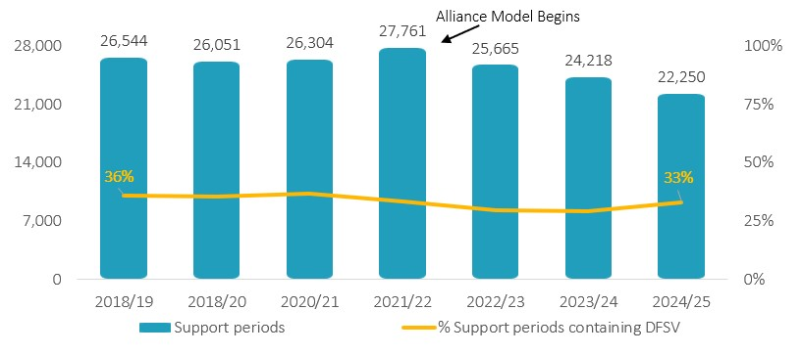

Figure 16 demonstrates that one quarter to one third of DFSV-related support periods continue to be delivered by non-DFV-specific services. For example, in 2024/25 of 7,307 DFSV-related support periods, 5,551 or 76% were delivered by a DFV-specific agency and 24% were delivered by non-DFV specific homelessness services.
Figure 16: Proportion of DFSV involved support periods that were supported by DFV agencies, by financial year
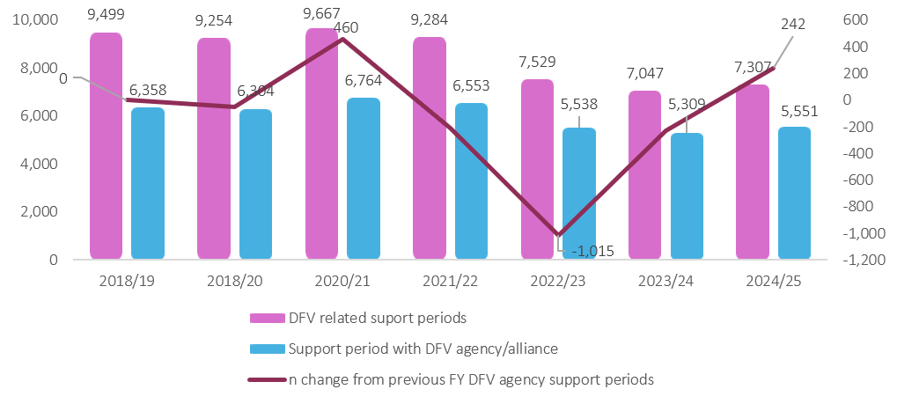
These findings demonstrate that responding to DFSV is a shared system responsibility, regardless of organisational or program boundaries. However, the true prevalence of DFSV among SHS clients is likely underestimated as DFSV indicators in H2H only capture instances where violence is a presenting issue or explicitly addressed. This shared system responsibility is reinforced by previous analysis of DFV Alliance clients which found that 61.8% presented with a co-occurring homelessness need, demonstrating the extent to which these experiences intersect in practice .
    - Implications for Commissioning and System Design
Stakeholders consistently identified misalignment between DFSV demand and how responses are funded within the homelessness system. Although DFSV is a high-risk, specialist domain, homelessness funding has historically absorbed a substantial proportion of DFSV response without funding levels reflecting the intensity, urgency or complexity of the work. Inadequate emergency accommodation funding was raised as resulting in homelessness services absorbing unfunded brokerage, coordination and crisis management to meet safety needs. For clients, this could mean limited access to appropriate crisis options and increased reliance on short-term or unsuitable arrangements. Funding gaps were particularly evident in emergency accommodation and specialist responses for women, children and young people leaving violence.
“There is a gap between the level of risk and complexity presented by people experiencing DFV and the way the homelessness system is resourced and supported to respond. Services are managing high-risk situations without sufficient workforce support, training or supervision, within a system that also faces shortages in safe housing, limited after-hours responses and constrained access to therapeutic supports. These pressures are compounded by fragmentation across services, resulting in repeated storytelling, service handovers and, at times, disengagement.” - Survey Response
While homelessness and DFSV responses cannot be fully disentangled, meeting contemporary DFSV need requires investment in building broader homelessness system capacity to respond to DFSV where and when people need this support. This would be enabled by clearer role and responsibility definition, and shared governance and practice expectations across the specialist-DFV and homelessness services.
  - Place-based Approaches
Place-based approaches were consistently described through survey responses and stakeholder engagement as locally grounded, collaborative ways of working that respond to the specific needs, strengths and constraints of a community, rather than applying uniform service models. They were commonly understood as working where people are located, including homes, temporary accommodation, public spaces and community settings, and adapting responses to local demographics, cultural contexts, mobility patterns and housing conditions.
Where place-based approaches were described as working well, they were characterised by strong collaboration, informal problem-solving and locally led partnerships. Examples included assertive outreach models, locally coordinated responses to rough sleeping, and community-led accommodation initiatives leveraging relationships with housing providers, local councils, philanthropic organisations and private landlords. Stakeholders noted that these approaches were particularly effective for people who disengaged from services, distrust formal systems or require sustained relational support. At the same time, respondents highlighted that place-based practice is unevenly supported by current system and funding arrangements, often relying on individual effort, local goodwill and informal coordination rather than being consistently enabled at a system level.
    - System Experience and Safety
Stakeholders described place-based responses as contributing to safer and more responsive experiences for people experiencing homelessness, particularly where services were visible, trusted and embedded within local communities. Outreach-based and community-anchored models were seen as reducing barriers to engagement and supporting earlier intervention for people who would not otherwise access formal services. Where place-based infrastructure has weakened over time through service consolidation, loss of co-location or withdrawal of local presence, stakeholders reported growing isolation for both clients and services. In these contexts, people experiencing homelessness may face limited or distant access points, increasing reliance on crisis responses and reducing opportunities for sustained, relational support.
    - Access, Pathways and Navigation
Place-based approaches were seen as critical to navigating local pathways effectively, particularly in contexts where housing availability, transport, safety and service coverage vary significantly. Stakeholders emphasised that local relationships often enable more timely problem-solving, such as negotiating short-term accommodation, supporting access to informal housing or coordinating responses across services in real time.
Despite this, current commissioning settings were described as constraining place-based navigation. Strict eligibility criteria, boundaries and standardised housing pathways were reported to limit capacity to respond flexibly to local complexity. In some cases, respondents noted that pathways designed for metro areas do not translate effectively to other settings, forcing services to work around system rules in order to meet local need.
    - Implications for Commissioning and System Design
While place-based approaches are widely valued and actively practiced, they are not consistently supported through current commissioning and system design settings. Funding models based primarily on client volume do not account for the realities of place-based work, particularly in regional and remote areas where costs associated with distance, travel, freight, thin markets and limited infrastructure are significantly higher.
Regional Alliances reported drawing on service delivery funding to maintain basic governance and coordination functions, reducing resources for frontline work, training and local innovation. As one sector participant noted:
“When you’re talking with your Alliance about where funding is going to be split, it is really tricky because in a metro area if money is taken from this organisation but goes to another, your clients can still access it. When it’s a broader geography, it doesn’t work that way.” - Sector Participant
Current funding and governance arrangements do not adequately reflect the diversity of local contexts across South Australia. A genuinely place-based homelessness system requires commissioning approaches that include geographic loadings, flexible funding mechanisms and governance models capable of responding to the operational realities of metropolitan, regional and remote communities. Without these settings, inequity is likely to remain embedded, particularly for Aboriginal communities who are disproportionately located in regional and remote areas and rely on culturally governed, locally led pathways that are not adequately resourced under existing arrangements.
“Across regional areas, the vast geographical spread of services combined with the time and cost of travel to meet governance and coordination requirements takes funding and capacity away from frontline service delivery.” - Survey Response
  - Chapter Summary
Across the priority areas identified in the Terms of Reference, spanning population groups, experiences of homelessness and system-level constructs, the analysis highlights consistent pressures in how the system operates. While each area brings a different focus, patterns point to the influence of system settings on how support is accessed and delivered, while also manifesting in different ways across priority areas. Variations in entry points, pathway design, service availability and workforce capacity shape how people engage with the system and the consistency of support they receive. As a result, common structural features produce a wide range of experiences, with differences in access, safety and continuity evident across contexts.
This reinforces the role of the priority areas as a structured way of examining system function within the scope of the Review. The recurring issues identified have direct implications for commissioning, particularly in how funding models, service expectations and coordination mechanisms are designed to support more consistent, responsive and effective homelessness services.
- Service Demand and System Capacity
This section examines how service demand and system capacity are interacting within South Australia’s SHS system, and what this reveals about the system’s ability to respond effectively. Using available data alongside stakeholder insights, it explores how patterns of presentation, duration of engagement and repeat contact have shifted over time, and how system design and capacity constraints shape how demand is experienced and managed.
Demand, in this context, refers to how people present to the homelessness system and how frequently they engage over time, while system capacity refers to the system’s ability to respond within existing resources, structures and operating arrangements. Changes in presentation volume, length of engagement and repeat contact link these concepts and influence both service workload and the system’s ability to support timely exits.
While H2H does not capture all demand experienced by the sector, its consistent structure over time enables examination of system-level trends. The purpose of this section is not to assess data completeness, but to interpret observable patterns as signals of how demand and capacity interact, particularly where service data and stakeholder experience align or diverge.
  - System-Level Demand Patterns
At a high level, the data shows a system supporting fewer people overall but doing so for longer periods of time. Since the introduction of the Alliancing model, both recorded presentations and the number of unique individuals accessing SHS have declined, while average support duration has increased. A growing share of system effort is concentrated among clients with prolonged engagement.
Interpreted alongside duration and repeat engagement trends, this data may reflect changes in system flow and throughput, including the influence of eligibility thresholds, coordination and pathways. The overall conclusion is that fewer people are entering the system, but those who do remain engaged for longer.
Figure 17 illustrates this trend, showing a sustained decline in both the number of people accessing support and the total number of support periods delivered. Interpreted alongside duration and repeat engagement trends, this data may reflect changes in system flow and throughput, including the influence of eligibility thresholds, coordination and pathways. The overall conclusion is that fewer people are entering the system, but those who do remain engaged for longer.
Figure 17: Number of support periods, and number of individuals supported, by financial year
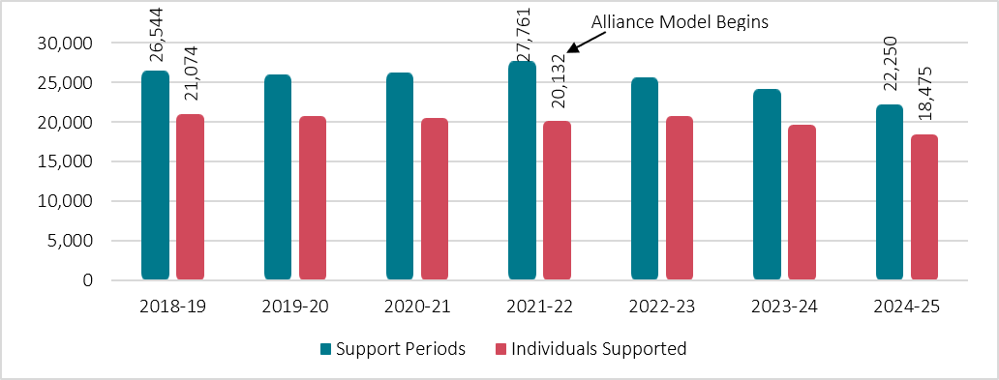
Note that some measures that follow differ from those published in the RoGS due to differences in data definitions and methods; full data limitations are outlined in the Appendices (Appendix 8 of the Appendices document).
  - Duration of Engagement and Concentration of System Effort
Figure 18 illustrates how system capacity is increasingly absorbed by longer engagements. While the number of individuals accessing services has decreased, total support days increased through much of the period.
Figure 18: Average days of support per support period, per person, by financial year
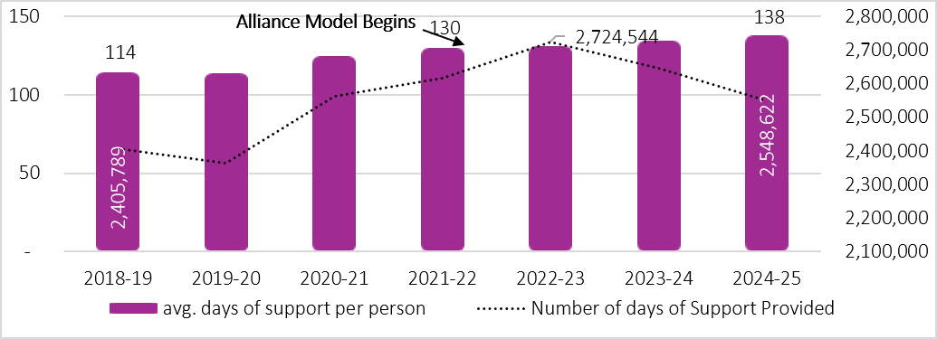
This pattern is reinforced by Table 4 which shows the distribution of average support days across clients. Over time, the proportion of people receiving very short periods of support has declined, while the proportion engaged for ten to twelve months has increased substantially. By FY 2024–25, approximately one in six clients accounted for close to half of all support days.
Stakeholder feedback suggests that increasing concentration of system effort is also associated with growing complexity of need, placing additional pressure on services operating within existing funding and workforce capacity.
"We are not funded for supporting complex cases. We need to do our best with the little we have." – Survey Response
How to read Table 4: Each row includes the number of individuals who received that number of support days within the row. The total days column includes the number of support days those individuals accounted for, for that financial year. For example, the top row shows that 1,971 individuals (9% of all individuals) accessing support in FY 2018-19 received 6,622 support days collectively (0.3% of all support days). The shading in Table 4 illustrates distribution, with darker cells indicating higher proportions of individuals or support days. This is intended to highlight patterns and concentration of service use over time.

Table 4: Clients of the SHS funded homelessness system, by age and financial year.
 |  | 2018-19 |  |  |  | 2019-20 |  |  |  | 2020-21 |  |  |  | 2021-22 |  |  |  | 2022-23 |  |  |  | 2023-24 |  |  |  | 2024-25
 |  | No. of individuals |  | Total SHS support period days |  | No. of individuals |  | Total SHS support period days |  | No. of individuals |  | Total SHS support period days |  | No. of individuals |  | Total SHS support period days |  | No. of individuals |  | Total SHS support period days |  | No. of individuals |  | Total SHS support period days |  | No. of individuals |  | Total SHS support period days
 |  | n | % | n | % | n | % | n | % | n | % | n | % | n | % | n | % | n | % | n | % | n | % | n | % | n | % | n | %
a month or less | 1 wk or less | 1,971 | 9 | 6,622 | 0.3 | 1,905 | 9 | 7,346 | 0.3 | 1,373 | 7 | 4,865 | 0.2 | 1,205 | 6 | 3,663 | 0.1 | 1,105 | 5 | 3,630 | 0.1 | 1,047 | 5 | 4,119 | 0.2 | 1,028 | 6 | 3,485 | 0.1
a month or less | 1-2 wks | 1,336 | 6 | 14,460 | 0.6 | 1,674 | 8 | 17,308 | 0.7 | 1,319 | 6 | 14,288 | 0.6 | 1,193 | 6 | 12,904 | 0.5 | 1,325 | 6 | 14,358 | 0.5 | 975 | 5 | 10,876 | 0.4 | 995 | 5 | 10,831 | 0.4
a month or less | 2 wks - 1 mth | 2,499 | 11 | 56,625 | 2 | 2,487 | 12 | 55,945 | 2 | 2,613 | 13 | 59,912 | 2 | 2,395 | 12 | 54,007 | 2 | 2,696 | 13 | 59,544 | 2 | 2,164 | 11 | 48,438 | 2 | 1,969 | 11 | 43,623 | 2
1-3 month | 1-2 mth | 3,839 | 18 | 172,405 | 7 | 3,722 | 18 | 167,075 | 7 | 3,631 | 18 | 163,047 | 6 | 3,302 | 16 | 149,727 | 6 | 3,338 | 16 | 147,974 | 5 | 3,547 | 18 | 158,850 | 6 | 3,092 | 17 | 141,667 | 6
1-3 month | 2-3 mth | 2,436 | 11 | 181,906 | 8 | 2,280 | 11 | 169,310 | 7 | 2,187 | 11 | 162,395 | 6 | 2,206 | 11 | 163,415 | 6 | 2,292 | 11 | 171,442 | 6 | 2,500 | 13 | 186,053 | 7 | 2,067 | 11 | 153,287 | 6
3-6 months | 3-4 mth | 1,683 | 8 | 176,286 | 7 | 1,651 | 8 | 172,544 | 7 | 1,788 | 9 | 187,400 | 7 | 1,628 | 8 | 169,762 | 7 | 1,692 | 8 | 177,815 | 7 | 1,622 | 8 | 170,322 | 6 | 1,545 | 8 | 161,944 | 6
3-6 months | 4-5 mth | 1,396 | 6 | 188,196 | 8 | 1,240 | 6 | 166,688 | 7 | 1,224 | 6 | 165,064 | 6 | 1,384 | 7 | 186,443 | 7 | 1,322 | 6 | 176,996 | 7 | 1,190 | 6 | 159,660 | 6 | 1,245 | 7 | 167,634 | 7
3-6 months | 5-6 mth | 963 | 5 | 158,949 | 7 | 897 | 4 | 147,630 | 6 | 947 | 5 | 156,272 | 6 | 976 | 5 | 161,822 | 6 | 994 | 5 | 162,552 | 6 | 937 | 5 | 153,297 | 6 | 902 | 5 | 148,161 | 6
6 months - 1 year | 6-8 mth | 1,411 | 7 | 294,379 | 12 | 1,301 | 6 | 272,619 | 12 | 1,331 | 6 | 279,825 | 11 | 1,619 | 8 | 340,687 | 13 | 1,534 | 7 | 320,547 | 12 | 1,335 | 7 | 276,635 | 10 | 1,389 | 8 | 290,034 | 11
6 months - 1 year | 8-10 mth | 1,099 | 5 | 294,073 | 12 | 939 | 5 | 251,601 | 11 | 940 | 5 | 251,942 | 10 | 1,415 | 7 | 378,827 | 14 | 1,087 | 5 | 292,344 | 11 | 936 | 5 | 251,591 | 10 | 941 | 5 | 252,819 | 10
6 months - 1 year | 10-12 mth | 2,441 | 12 | 860,471 | 36 | 2,627 | 13 | 931,601 | 40 | 3,157 | 15 | 1,116,221 | 44 | 2,809 | 14 | 991,125 | 38 | 3,377 | 16 | 1,195,902 | 44 | 3,433 | 17 | 1,223,496 | 46 | 3,302 | 18 | 1,174,910 | 46
 | Total | 21,074 | 100.0 | 2,404,372 | 100.0 | 20,723 | 100.0 | 2,359,667 | 100.0 | 20,510 | 100.0 | 2,561,231 | 100.0 | 20,132 | 100.0 | 2,612,382 | 100.0 | 20,762 | 100.0 | 2,723,104 | 100.0 | 19,686 | 100.0 | 2,643,337 | 100.0 | 18,475 | 100.0 | 2,548,395 | 100.0

These trends show that system effort is increasingly focused on a smaller group of clients with prolonged engagement. This has direct implications for system throughput and flexibility, as capacity tied up in long-term engagement reduces the system’s ability to respond flexibly to new presentations.
The Review also considered how these changes in system use are reflected in client housing outcomes at entry and exit over time, in the figures below. These figures represent the change in the proportion of clients in each housing category between entry and exit within each financial year. Positive values indicate an increase in the proportion of clients exiting in that housing type compared to entry, while negative values indicate a decrease.
Figure 19 shows that across financials years, from entry to exit, there is consistent movement away from more acute forms of homelessness, such as rough sleeping and couch surfing, toward more stable housing outcomes, including renting and rent-free accommodation.
While this pattern is consistent across all years, the level of change from entry to exit has reduced over time. In the context of constrained housing supply and limited exit pathways, the data suggests that services continue to have impact under increasingly challenging system conditions, with reduced gains reflecting broader structural constraints rather than a reduction in service delivery with desired outcomes.
Figure 19: Proportion change in client housing outcomes from entry to exit, within each financial year
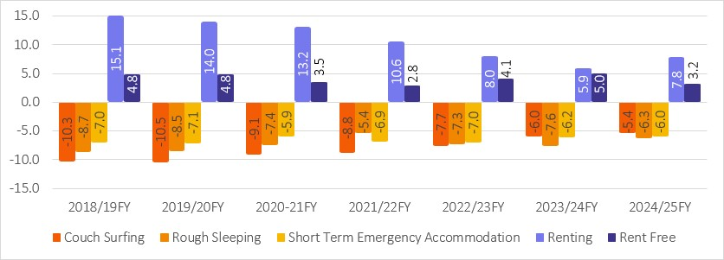
Figure 20 shows that for Aboriginal clients, the overall pattern broadly mirrors system-wide trends, with consistent movement from entry to exit away from more acute forms of homelessness, such as rough sleeping and couch surfing, toward more stable housing outcomes, including renting and rent-free accommodation. While positive movement is still evident, the rate of change has slowed, reflecting that services are operating within tightening system constraints and reduced access to appropriate housing pathways.
These shifts were more pronounced in the earlier years and became less evident over time, reflecting the increasing difficulty of securing sustained housing outcomes. This occurs in the context of limited access to culturally appropriate housing options and stakeholders concerns regarding the availability of culturally safe, community-led responses to support sustained long-term exits from homelessness.

Figure 20: Proportion change in housing outcomes from entry to exit for Aboriginal clients, within each fin year
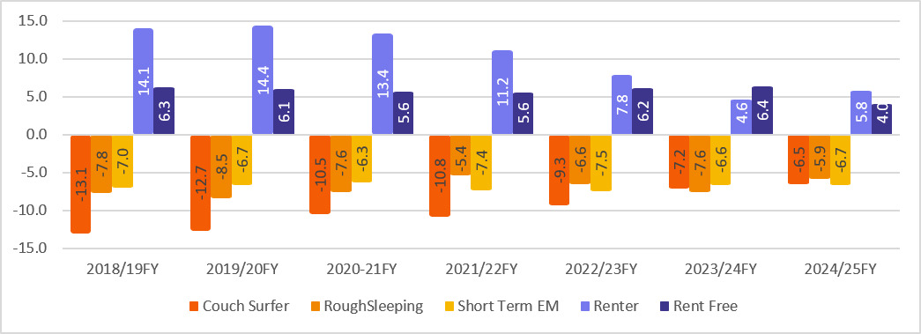
Figure 21 shows that for young people aged 15-24 years there has been a stronger shift in outcomes over time with larger reductions in exits to couch surfing and more pronounced increases in transitions to renting and rent-free accommodation compared to the broader population as per Figure 19.
While results indicate that services are supporting substantial movement toward more stable housing outcomes for young people, similarly to the previous evidence, the magnitude of change has reduced over time. These patterns highlight the importance of maintaining a clear focus on youth-specific responses, as early movement toward stable housing may play a critical role in preventing longer-term and more entrenched experiences of homelessness.
Figure 21: Proportion change in housing outcomes for young people aged 15-24 from entry to exit, within each fin year.
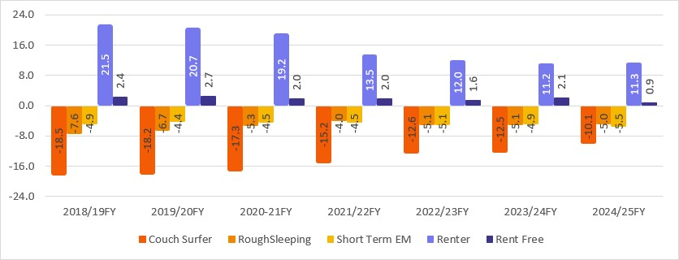
The Review also explored whether people were presenting with more issues over time. Analysis found no clear or consistent increase in the number of presenting issues in the post-Alliancing period, suggesting that rising pressure is shaped more by duration and persistence than by increased recorded complexity alone. Detailed analysis of number of issues is provided in Appendix 15 of the Appendices document.
    - Patterns of Repeat Engagement
Repeat engagement patterns provide additional insight into how people cycle through the system. As outlined in South Australia’s Homelessness Outcomes Framework, the system aims for homelessness to be rare, brief and non-recurring. One indicator that sheds light on meeting this ambition is the pattern of how often individuals return to SHS-funded services within a single financial year.
Figure 22 shows that the proportion of people with repeat engagement (two or more support periods within a financial year) increased steadily up to FY 2021–22, peaking at approximately 30% of clients, before declining to 17% in subsequent years (see appendices document (separate document) for data limitations).
This pattern coincides with the introduction of Alliancing, although this analysis does not enable causal attribution. Broader social and economic pressures, including the COVID period and cost-of-living impacts, occurred alongside these changes. Nevertheless, the rise-and-decline trajectory provides insight into how repeat engagement and system cycling are changing over time.
Aboriginal stakeholders emphasised that repeat engagement patterns may understate actual service cycling for Aboriginal clients due to reliance on kinship networks, limited access to culturally safe housing options and differing thresholds for re-engagement with services.
Figure 22: Proportion of return support periods within a financial year, by individuals.
Alliance Model Begins
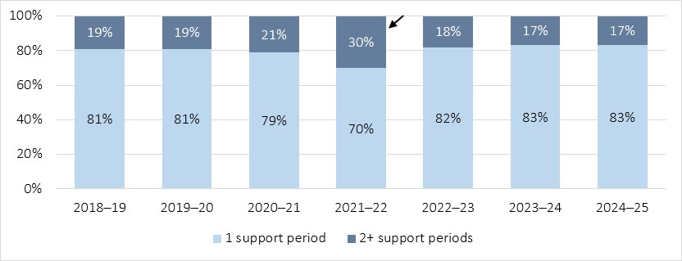
  - Housing Related Pressures Shaping Demand
Housing availability remains a central determinant of system demand and capacity. Although housing supply sits outside the scope of this review, it was raised consistently as a primary influence on how long people remain engaged, how often they re-present and the system’s ability to support exits.
Analysis of the delivery of housing-related service units shows that fewer people are receiving housing support overall, while service effort per person has increased, particularly for prevention and long-term responses. Put simply, housing-related support is becoming more concentrated and resource intensive, with fewer clients receiving support overall, but those who do requiring more service effort, particularly in prevention and longer-term housing.
Table 5 shows trends in the number of clients receiving service units delivered across prevention, long, medium- and short-term housing responses over time. For example, the number of service units delivered to support long-term housing increased by n=19,505 over the period (48,388 in 2018/19 to 67,893 in 2024/25), representing a 40% increase, while the number of clients receiving these services declined by n=856, representing an 11% decrease, indicating a substantial increase in long term housing service units per person.
Table 5: Housing support units delivered, by unit type, individuals, service units and financial year*
Financial Year | Prevention |  | Long term Housing |  | Medium term/transitional housing |  | Short term/ emergency housing
Financial Year | n people | n service units | n people | n service units | n people | n service units | n people | n service units
2018-19 | 4,793 | 35,935 | 7,660 | 48,388 | 4,327 | 96,310 | 6,888 | 19,326
2019-20 | 5,136 | 47,313 | 8,578 | 61,027 | 5,427 | 122,345 | 7,412 | 22,130
2020-21 | 4,905 | 62,671 | 8,565 | 76,141 | 5,778 | 153,155 | 7,203 | 25,577
2021-22 | 4,460 | 54,599 | 9,170 | 68,229 | 5,635 | 137,633 | 5,936 | 20,017
2022-23 | 4,790 | 60,756 | 8,875 | 74,421 | 6,414 | 150,466 | 6,265 | 23,127
2023-24 | 4,482 | 58,937 | 7,319 | 70,738 | 6,240 | 143,234 | 5,779 | 21,127
2024-25 | 4,179 | 56,910 | 6,804 | 67,893 | 5,579 | 137,186 | 5,680 | 18,034
* The blue shaded area indicates the period in which the Alliance model commenced and continued.
Figure 23 further illustrates that the average number of housing-related service units delivered per client has increased substantially for prevention and long-term housing support, while remaining relatively stable for short-term accommodation. This indicates that housing-related engagement is becoming more resource-intensive for those who receive it. Housing-related service activity remains disproportionately concentrated in metropolitan areas, despite demand being experienced across diverse geographic contexts.
“Securing a housing outcome has increasingly become the responsibility of the case manager, rather than housing providers or housing officers. Clients are getting stuck in emergency and crisis accommodation. For clients with complex needs, including family violence, AOD and mental health, they are losing the depth of support needed to maintain safety and sustain housing, resulting in people either returning to the system or not exiting at all.” – Survey Response
Figure 23: Average housing service units per person, by financial year
Alliance Model Begins
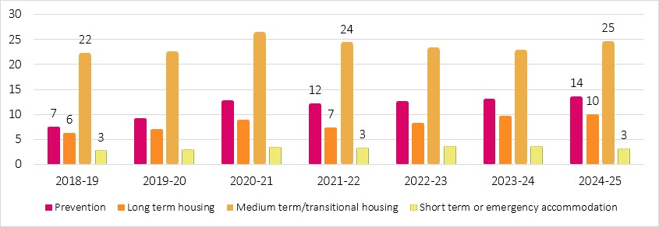
Structural constraints to housing were also described by Aboriginal stakeholders who highlighted housing pressures are often experienced differently by Aboriginal clients, particularly in regions with limited culturally appropriate housing options. Extended periods in temporary accommodation, repeat presentations and reliance on overcrowded living arrangements were frequently identified as common outcomes.
  - System-Wide Funding and Capacity Constraints
Stakeholders consistently described system-wide funding pressures that limit capacity to respond effectively. Current funding levels were widely seen as insufficient to meet demand, with crisis responses structurally dominating because longer-term and preventative work cannot be adequately resourced within existing settings.
"There is a growing expectation that the homelessness sector should not only respond to crisis, but reduce demand and unmet need. But homelessness is driven by systemic factors: poverty, rising living costs, the housing crisis, and the ongoing impacts of colonisation. Homelessness services alone cannot solve these issues. It reflects a failure across multiple systems, and people are too often passed from one system to another, facing barriers that make things worse rather than better." – Survey Response
Figure 24 presents staff survey results on funding adequacy and flexibility, showing strong consensus that current funding settings do not support demand, innovation or prevention.
Figure 24: Anonymous online staff survey response summary, funding
Current funding levels are appropriate to meet the demand for homelessness/DFV services in my local region (n-163).
Funding is used to trial, and evidence innovative ways to address gaps or needs of specific client groups (n=155).
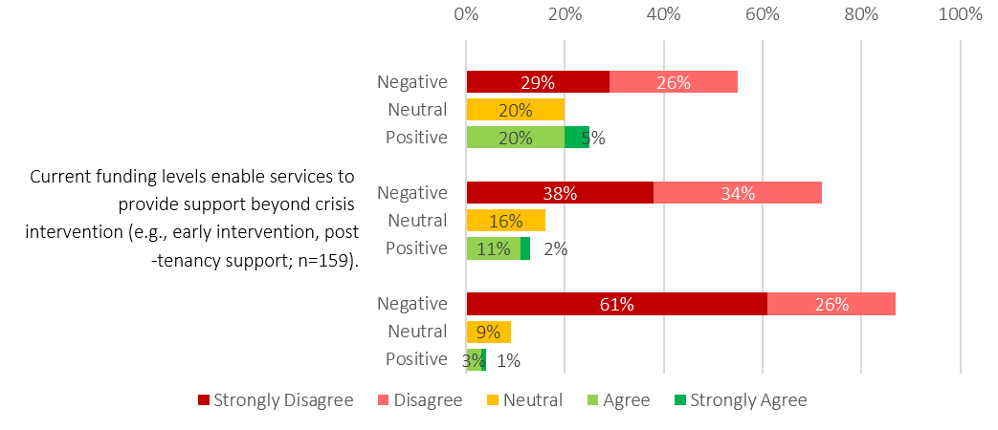
Stakeholders also identified limited access to brokerage and flexible client support funding as a significant constraint on service responsiveness. Brokerage was frequently described as an important mechanism for responding to immediate needs, addressing barriers to housing stability and supporting tenancy sustainment. However, many services reported relying on philanthropic grants, donations and external funding sources to provide brokerage, limiting their ability to respond flexibly to emerging needs.
"There is very limited funding for brokerage and client support, with services often reliant on external funding and donations to meet these needs." – Survey Response
There was also growing interest in lived experience and peer roles. However, stakeholders highlighted that these functions remain inconsistently funded, mirroring broader patterns in which essential system functions are assumed rather than resourced. The implications of this gap for the sustainability and influence of lived experience participation are explored in the “Lived and Living Experience” section.
  - Structural Funding Drivers
Funding constraints are not episodic but structural, shaping how system capacity is exercised and where effort is concentrated. Three funding elements were repeatedly identified as amplifying system pressure:
    - Legacy contracts
Longstanding contracts rolled over for decades with minimal review disproportionately affect Directly Contracted services, many of which deliver highly specialised responses to priority groups. Static funding, short rollover periods and outdated KPIs undermine workforce stability and long-term planning. As a result, many providers are operating at ongoing deficit and without the certainty required to plan, invest in their workforce, or embed prevention-focused and innovative responses. Staff also reported organisations frequently absorbed unfunded costs to meet homelessness and DFSV demand, reinforcing a view that the system is structurally under-resourced.
“Our funding is atrocious, and it’s getting harder to deliver a quality service. Our base funding hasn’t been reviewed for over a decade… we’ve only ever received CPI, but in that time, we’ve absorbed ERO wage increases, cost-of-living pressures, portable long service leave, everything. It’s becoming untenable. We run in deficit every year, and we are only able to keep providing this support because our organisation subsidises us significantly. Without that, I don’t see how we could safely support the people we work with.” – Sector Participant
    - Activity-based funding
Activity-based funding models prioritise what can be counted over what contributes to sustainable exits, undervaluing relational, preventative and long-term work. This narrows the system’s definition of success and limits the evidence available to support more effective commissioning that recognises the intensive support required by people with more complex needs, including young people, Aboriginal clients, people experiencing DFSV, and those sleeping rough.
    - Crisis and Prevention Responses
Current funding settings are structurally weighted toward crisis responses and generally do not recognise the different causes, trajectories or geographic realities of homelessness, which limits the system’s ability to respond flexibly to the presenting needs of individuals.
“Our sector continuum of care is severely underfunded. We stretch our funding to do non-crisis work like prevention and early intervention, but at the great cost of our crisis services that are insanely underfunded and under resourced.” – Anonymous Survey Response.
Stakeholders consistently described a structural tension: crisis responses are already underfunded and operate as the “catch-all” when other systems fail, yet shifting resources toward prevention within existing funding risks destabilising crisis responses. It was broadly seen that effective prevention requires dedicated additional investment rather than redistribution within an already constrained system.
“New resources need to go into making the system more effective… not just putting more ambulances at the bottom of the cliff… if you don’t build a better system, you’ll just get the same results with more and more people seeking support from a system that doesn’t work.” – Sector Participant
  - Chapter Summary
These findings reflect a system where engagement is increasingly concentrated among fewer clients, with longer periods of support. These patterns are shaped by underlying demand, housing market pressures, and system design, with implications for access, coordination and commissioning.
Longer periods of engagement among priority groups such as people experiencing DFSV, young people and people sleeping rough, as well as the increases in people sleeping rough, reflects structural constraints on exits, including housing availability, uneven outreach capacity and reliance on external systems. These pressures are experienced differently by Aboriginal people where cultural safety, trust, and access to appropriate housing further shape engagement and outcomes.
While the data cannot definitively distinguish between unmet demand and structural factors such as coordination challenges or system design, the convergence of evidence across demand, duration and repeat engagement suggests that current system pressure reflects the interaction between need, system capacity and broader constraints, rather than a reduction in underlying demand.
The Review also identified widespread concerns regarding current funding arrangements. Stakeholders described a system operating under sustained resource pressure, with funding settings that necessarily prioritise crisis responses, reinforce activity-based measures of success and constrain investment in prevention, early intervention and long-term outcomes. Legacy funding arrangements, workforce pressures and the increasing reliance on providers to absorb unmet demand were seen as further limiting the system’s capacity to respond effectively.
Overall, the findings point to a system that continues to achieve positive outcomes despite significant structural constraints, but which faces increasing difficulty supporting timely and sustainable exits from homelessness.
- Practice in the SHS System
Stakeholders reported that the scope and purpose of the SHS system has become increasingly unclear, with services operating without shared parameters about who the system is intended to support or how eligibility should be interpreted. While there are strong examples of innovative, culturally informed practice across the sector, these are not consistently supported or scaled. In the absence of statewide practice guidance or system-level frameworks, local discretion has shaped access, decision making and expectations in ways that vary across the State.
This chapter examines how these conditions have shaped day-to-day practice, including variation in intake and triage, eligibility interpretation, risk management and cultural safety. It highlights how the lack of shared practice foundations contributes to inequity, inefficiency and workforce pressure, and identifies the elements required to establish a coherent and consistent practice framework for future commissioning.
  - Practice as a system function
The Review found considerable practice variation across the SHS system. Some practice is strong, culturally informed and grounded in deep professional expertise, and there are pockets of innovation that demonstrate what is possible when the right conditions are in place.
At the same time, the Review identified areas where practice is inconsistent or unsafe. These differences do not reflect a lack of commitment or capability within the workforce. Rather, they are produced by the absence of shared practice frameworks, cultural governance, statewide tools and coordinated access settings that would enable good practice to be applied consistently across the system. As a result, strong practice is not yet systematised, and the innovations that are working well are not embedded within a broader practice framework.
Practice is not simply the sum of local decisions made by individual services. It is a core system function that requires shared frameworks, clinical and cultural governance, and system level infrastructure to operate consistently and safely.
“I strongly believe that the only thing that truly changes outcomes for individuals is quality practice. If we can’t get practice right, then all the work across government and the investment we put in won’t achieve what it’s intended to. With strong practice, support by good cultural and clinical governance, great outcomes will follow.”- Sector Participant
The Alliancing model assumed that shared practice would develop over time, supported by the ASSG, acknowledging shared practice is not the same as clinical governance. Shared practice refers to common tools, processes and expectations, whereas clinical governance requires formal structures for oversight, accountability, risk management and quality assurance.
The ASSG was not operationalised, and neither the original nor the current governance model include mechanisms to embed or oversee clinical or cultural practice. No alternative structures were created to fill this gap. As a result, practice has developed within individual Alliances, and in some cases at the level of individual organisations, while Directly Contracted services have maintained separate approaches. Clinical and cultural governance are therefore among the weakest parts of the current system, with practice shaped by local capability and decision making rather than shared expectations and practice improvement.
    - Intake, triage and prioritisation
Variation in eligibility was interpreted as one of the clearest practice differences described across the system. Stakeholders were confident about working with people who were homeless but noted that the inclusion of the phrase “and at risk of homelessness” significantly reduced clarity about the system’s scope. The breadth of this definition was widely viewed as making almost anyone potentially eligible, which created uncertainty about who the system is intended to support and contributed to variation in how eligibility was interpreted and applied in practice.
Stakeholders highlighted that this lack of clarity can impact equity and inclusion for clients, and create an expectation that services need to respond broadly across a wide range of needs, which can affect the quality and consistency of support, particularly for those requiring more intensive responses. These reflections highlight the sector’s strong commitment to equity and inclusion, and its ongoing efforts to balance this ambition within system settings that do not always provide clear guidance on scope or prioritisation.
“True equity and inclusion are difficult to achieve within a homelessness system where the client group and service scope are not clearly defined. Services are expected to respond to everyone who presents, regardless of need, acuity or eligibility, resulting in extremely high client volumes. This demand limits the ability to provide equitable responses based on need, as time, resources and service intensity must be spread thinly across a large cohort. As a result, inclusion becomes focused on access at the front door, rather than on meaningful, tailored support that addresses individual circumstances.” Survey Response
Across the system, stakeholders also reported using different intake tools, applying different triage principles and making access decisions in different ways. There were also differences in how demand was managed, including the use of waitlists, and whether interim support was provided.
This variation is not intentional or designed. It reflects local responses to an absence of shared guardrails for how access, demand and prioritisation should operate. The Alliancing model assumed that shared practice would develop over time at both a system level and within individual Alliances, yet no mechanisms were created to support or monitor this. As a result, people with similar needs may experience different access outcomes depending on where they enter the system.
The statewide 24/7 phonelines illustrate this challenge. They operate as a soft front door, providing information, triage and referral. However, there are no unified practice structures linking the phonelines’ approaches to assessment with those used by Alliances and Directly Contracted services. As a result, intake functions less as a standardised system process and more as a series of locally determined practices.
These findings highlight that access is being shaped not only by the number of entry points, but by how consistently those entry points operate. Strengthening shared intake and triage practice through clearer guidance, common frameworks and aligned decision making would support a more equitable experience of access, regardless of where a person enters the system.
“There is also a need to document delegations of authority more clearly, including how decisions are made, what sits within scope, and what sits outside scope. At present, nearly everything tends to sit in scope. I am conscious that there is high reliance on trust in how the system currently operates, and that this significantly shapes how work is done”- Sector Participant
    - Culturally Safe and Culturally Led Practice
Culturally led and culturally safe practice is not embedded consistently across the SHS system. There is no shared cultural framework, no system level guidance and no structural mechanisms to ensure that cultural safety is enacted in practice. As a result, responses vary significantly between services. Some draw on Aboriginal knowledge, kinship networks and culturally grounded practice, while others rely on generic models that do not reflect Aboriginal understandings of safety, stability, mobility or wellbeing.
Stakeholders noted that Aboriginal staff often carry substantial cultural load, providing guidance, translation, brokerage and cultural support without formal recognition, time or resourcing. This places responsibility for cultural safety on individuals rather than the system and contributes to uneven practice across the State.
Cultural safety is also not consistently embedded in commissioning or governance. Alliance contracts and governance structures provide few tangible levers to support cultural accountability, and there are limited mechanisms requiring services to demonstrate culturally safe practice. This is reflected in significant variation across both Alliances and Directly Contracted services in how cultural safety is interpreted and applied. Cultural harm also remains largely invisible within data, reporting and performance frameworks.
Existing KPIs relating to Aboriginal communities focus primarily on the percentage of clients who identify as Aboriginal or Torres Strait Islander and access a service. This reflects a service output rather than a measure of safety or outcomes and does not assess whether services are culturally safe or culturally accountable. The Homelessness Outcomes Framework includes the expectation that people have access to appropriate and culturally safe support, but this is not reflected in contracts, nor is there a mechanism to measure whether Aboriginal people experience the system as culturally safe.
There is no Aboriginal-led assurance mechanism, independent cultural safety auditing process or formal requirement for Alliances or Directly Contracted services to demonstrate cultural governance. This affects both Aboriginal staff operating within a highly colonised service system and Aboriginal clients navigating those same structures. Without clear accountability measures or culturally governed oversight, cultural safety is not consistently recognised as a core system outcome and cultural harm is not routinely identified or addressed as a form of risk. This contributes to ongoing cultural load, workforce burnout and unsafe practice across the system.
    - DFV and Homelessness Interface
Practice differences between DFV and homelessness responses are embedded in the design of the SHS system. the Future Directions for Homelessness report positioned general homelessness services as operating from a housing first approach (stability as the foundation), while DFV specific responses are guided by safety first principles (risk mitigation as the foundation). Both approaches are well-established and reflect strong practice foundations, however they do not always align in application within the current system.
In practice, homelessness and DFV experiences are often interconnected, and clients frequently move between or have needs spanning both streams. The absence of a shared framework to guide how housing and safety priorities should be balanced can limit how effectively these practices operate together, resulting in uncertainty about where clients should be situated and how readiness, risk and client preference should inform prioritisation.
Example:
A client living regionally is engaged with DFV and homelessness services where they are living because they are delivered by the same organisation. The client chooses to leave the region to flee their perpetrator and enters another service region. The person is then assessed as not currently experiencing DFV, and is assessed as lower risk than previously, meaning they don’t meet the threshold to stay in DFV crisis accommodation. They stay with a family member and present for homelessness support but because they have temporary shelter, they are put on a waitlist for homelessness support. The person is not actively receiving support for their experience of homelessness or DFV*. *this example has been paraphrased to protect confidentiality.

This example illustrates how, without clear integration mechanisms, the two approaches can operate in tension rather than complementarity A person’s safety risk may fall below DFV thresholds, while their housing need is deprioritised under homelessness criteria, resulting in no coordinated response. Importantly, this does not reflect a lack of capability or intent within either practice approach, but rather the absence of shared structures to support how these approaches work together around the person.
The interface between DFV and homelessness is also shaped by broader structural factors. Limited housing availability constrains the ability of homelessness services to operate in accordance with housing first principles. In practice, this often results in services shifting toward managing risk and interim safety, despite not being designed or resourced to deliver specialist DFV responses. This creates an implicit blending of approaches, where services are neither fully operating as housing first nor equipped to provide consistent safety-first support.
The coexistence of housing first and safety-first approaches is not inherently problematic. Each reflects a necessary and well-established response to different dimensions of need. Stakeholders across both domains consistently emphasised a shared commitment to centring the needs, preferences and safety of the person. However, in the absence of shared practice frameworks, aligned assessment and triage processes and clearly defined pathways between streams, the strengths of each approach are not always able to complement one another in practice. Strengthening the interface between these models is therefore critical to supporting more integrated, person-centred responses and ensuring that people with overlapping homelessness and DFV needs do not fall between service responses.

Where Collaboration Occurs and Where It Breaks Down
Collaboration was strongest in regions where one organisation delivered both the general homelessness response and the DFV response. In these locations, services often shared workers, risk frameworks and practice approaches, resulting in more integrated responses. The only distinction for services was which program was recorded as the lead agency in H2H. Importantly, these examples of collaboration demonstrate how coordinated homelessness and DFV practice can be strengthened and scaled across the system.
Collaboration was more challenging where different providers delivered the specialist DFV response and the general homelessness response in a region. Stakeholders described examples of tension, role confusion and differing views about who should work with which clients. Both specialist DFV services and general homelessness services reported feeling overworked and under resourced, which contributed to pressure regarding responsibility for clients. Each part of the system used different tools and thresholds to determine risk and eligibility. Specialist DFV services used the domestic and family violence risk assessment to determine allocation, prioritising clients with the highest assessed safety risk. General homelessness services reported that although DFV was highly prevalent among their clients, they often did not feel equipped to provide the level of specialist support required to address trauma and ongoing safety concerns.
“The current service split brings strengths, with each service contributing its own expertise. However, it can also create fragmentation in practice, different priorities, KPIs, funding cycles and decision making authority mean the burden of integration often falls back on providers. Handovers between DFV and homelessness pathways are harder than they should be, and escalation pathways for complex cases can be unclear.” – Survey Response
Stakeholders noted that even when a client was not at immediate safety risk, the impacts of DFV often required specialised, coordinated and holistic support. This support is critical for sustaining housing outcomes and reducing harm. However, services reported that it was frequently difficult to secure this level of support, particularly where collaboration between the DFV and homelessness systems was limited by structural silos. The impacts of this fragmentation fall most heavily on Aboriginal women and families, whose safety, kinship obligations and cultural needs require consistent, culturally governed pathways across DFV and homelessness
Figure 25 shows that survey findings reflect this variation. Staff were divided on whether the two parts of the system work together to coordinate support for clients with both DFV and homelessness needs, with roughly equal numbers agreeing and disagreeing to the statement. The results for staff from Directly Contracted services are not shown in the figure, but when examined separately they showed noticeably lower agreement. Only one in five Directly Contracted services staff (23%) agreed that coordination occurs, none strongly agreed, and the remaining 78% were neutral or disagreed. These findings point to a divide in how collaboration is occurring across the system, particularly for clients who require coordinated DFV and homelessness responses.
Figure 25: Anonymous online staff survey response summary, collaboration for dual client need

When clients have both homelessness and DFV needs, services work together to provide coordinated support (n=165).

Identity and Role of DFV Services Within the SHS System
Structural misalignment and role uncertainty have contributed to DFV and homelessness responses operating more like parallel systems within the SHS environment, despite being intended as a unified system. Stakeholders described specialist DFV homelessness services as often experiencing the system as operating around them rather than with them, which reinforced a sense of separation from the broader SHS system.
Some of this also reflects structural constraints. H2H, the statewide data system, was implemented in 2011 and has not evolved in line with contemporary DFV practice. As discussed later in the report, it does not consistently capture and analyse DFV presentations in a meaningful way. Key elements such as risk, safety, coercive control and the dynamics of different forms of DFV are not recorded consistently, which limits system visibility of DFV related need.
However, the structural divide has also shaped how services understand their identity and role. Stakeholders described specialist DFV services as viewing themselves primarily as DFV providers operating within a homelessness environment, rather than as homelessness services with a specialist DFV function. This reflects a long history of DFV services being expected to respond to a wide range of needs beyond homelessness, often with limited resourcing. Over time, there have been limited opportunities for DFV capability to develop across the wider SHS system. Stakeholders noted that collaboration between DFV and homelessness workers could support shared learning and distribute workload more effectively, but that current structures do not consistently enable this.
These service identity dynamics have important implications for Aboriginal women and families, who require culturally governed, coordinated pathways across DFV and homelessness responses to ensure safety, trust and continuity. Stakeholders emphasised that the current separation makes this more difficult to achieve consistently.
Addressing the challenges to achieving a more integrated and structurally supported joint approach to DFSV and homelessness, will require consideration of how the design and operation of the homelessness system can better support intentional alignment and reduce existing silos.
“What we’ve done in South Australia over a long period of time is expect that the money that comes through the homelessness sector to respond to domestic, family and sexual violence will do it all. What the State’s expected them to do is to provide anything to anyone who experienced the violence. DFV responses in homelessness should be providing therapeutic case management services and accommodation for women and children who are homeless, and other parts of the larger system response should be doing the rest” – Sector Participant
    - Working with Risk
Working with risk is a central component of homelessness service delivery. Risk in the homelessness system takes multiple forms. It includes immediate physical safety concerns, psychological and emotional harm, cultural harm, risks to children and young people, risks to workers and risks created through service interactions. Risk also arises when people are not accurately understood, assessed or supported, which can lead to poor outcomes, and avoidable escalation. These forms of risk have significant implications for people’s wellbeing.
Stakeholders consistently described working with risk, but reported varying levels of comfort and confidence. Directly Contracted services more consistently demonstrated strong practice models that supported them to work with higher levels of risk and complexity. Within Alliance structures, these strong approaches were present in some areas but were not consistently visible across the whole system.
“So just to circle back to the risk part… how you respond, it depends on a service’s risk appetite. If you keep a low risk appetite, you push the risk out of your building. We hold a higher risk appetite, so we recognise the risk, but we work with it” – Sector Participant
The Review found that the interpretation of risk is not consistent and is shaped by how services understand their role, capability and responsibility. Variation occurs in how risk is managed and in whether it is recognised at all. The example below illustrates how the same presenting situation can be interpreted in fundamentally different ways depending on practice capability and available guidance.
Example Scenario: A family presents to a homelessness service with English as a second language.
Response 1 → Risk is externalised to another service.
Service identifies that the family does not speak English and does not have anyone who can interpret. The service is not able to understand the family, and determines they are unable to safely provide a service within their current capability. They give them a phone number for a multicultural service nearby for the family to go to instead.
Response 2 → Risk is present but interpreted as low.
Service identifies that the family does not speak English and proceeds with service delivery using informal communication strategies- a combination of Google Translate and gestures to convey information to the client. This approach is used throughout the family’s service journey. In the absence of clear practice guidance for working with people with English as a second language, this approach may be understood as presenting low risk, as communication is perceived to be occurring.
Response 3→ Risk is recognised and actively mitigated.
Service identifies that the family does not speak English and engages an accredited phone interpreting service. The service completes the initial intake with an interpreter and explores the family’s cultural needs and preferences for future engagement, such as same-gender workers. The service seeks to ensure accredited interpreting support is available for ongoing interactions. The service understands the absence of language access and culturally appropriate service delivery as posing significant risk to the family and their outcomes.

This example illustrates how differences in recognition of risk can lead to very different service responses, and reinforces the need for clear system level guidance to support safe, consistent and culturally appropriate practice. Stakeholders also highlighted the absence of clear system level risk escalation pathways. Several noted that they previously relied on the Exceptional Needs Unit within DHS to support clients with acute, high risk or cross-system needs, but reported that access to this mechanism has become increasingly limited.
In the absence of clear escalation pathways, complex client issues are often raised through Alliance governance forums or escalated directly to departmental executives. This has contributed to governance structures taking on a more operational role, with decision-makers responding to individual cases rather than system settings.
The Review also identified a lack of shared learning mechanisms to support practice development. There are currently no sector wide communities of practice, cross-Alliance learning forums or structured opportunities for reflective learning, despite the complexity of the work. This limits the system’s ability to build collective expertise, reinforce consistent approaches to risk and develop a shared understanding of quality practice.
These findings reinforce the need for commissioning arrangements that resource and embed shared practice expectations and provide the architecture required for consistent, high quality service delivery, including practice frameworks and learning systems.
  - Chapter Summary
Stakeholders described how people’s experience of the system is often shaped less by their needs and more by the door they enter. While there are examples of strong and culturally informed practice, these approaches are not consistently embedded across the system. As a result, access, eligibility decisions, intake processes, triage and risk management often differ depending on where a person seeks support.
Cultural safety was identified as a major area of concern. Stakeholders reported that culturally safe and culturally led practice is not consistently supported by system-wide frameworks, accountability mechanisms or governance structures. Aboriginal staff often carry substantial responsibility for cultural guidance without formal recognition or resourcing, and there are limited mechanisms to assess or assure cultural safety across the system.
The Review also identified challenges in the interface between homelessness and domestic and family violence responses, as well as significant variation in how risk is understood, assessed and managed. There is a clear need for a more deliberate and consistent practice architecture across the SHS system, including a shared practice framework, stronger clinical and cultural governance, consistent risk management approaches and system-wide mechanisms for practice development and continuous learning to support safe, equitable and high-quality service delivery.
- Workforce Capability and Conditions
A sustainable and effective homelessness system relies on a workforce that is skilled, supported, and operating within conditions that enable safe and consistent service delivery. Workforce capability and workforce conditions are therefore central considerations for future commissioning. The design of funding arrangements, service structures, governance mechanisms, and performance expectations directly influences the environments in which staff work, the risks they carry, and the system’s ability to attract and retain a highly capable workforce.
This chapter examines the factors affecting the SHS workforce in South Australia, with attention to structural and commissioning settings that shape day-to-day practice. It explores working conditions, psychosocial hazards, recruitment and retention pressures, remuneration, workforce capability, and cultural safety. Particular focus is on the Aboriginal workforce, recognising both the essential expertise Aboriginal staff bring and the additional structural load they carry within the system due to the living impact of colonisation and obligations to community.
  - Working Conditions
The working conditions within the SHS system reflect the cumulative impact of trauma exposure, systemic constraints, and structural commissioning decisions that shape the day-to-day experience of frontline staff.
While the workforce is often described as experiencing vicarious trauma, stakeholders in this Review emphasised that direct trauma is also a common and under-acknowledged reality. Workers frequently encounter unsafe client presentations, high-risk environments, unpredictable behaviours, systemic injustice and crises that carry physical and psychological danger.
“There are some strong workers and relationships, but those systems and cultures aren’t embedded, they often rely on individuals. People are so stuck in crisis response that they don’t have the time or capacity to step back, build relationships, or work collaboratively. Most are under constant pressure just to get through the day-to-day work.” – Sector Participant
National evidence strongly reinforces these experiences. The AHURI Final Report No. 455 on workplace trauma found that trauma exposure is “an almost universal experience” in social housing and homelessness work. Survey findings showed that: 90% of workers reported moderate-to-high levels of vicarious trauma, and 61% reported one or more symptoms of burnout. The report also highlighted repeated exposure to violence, aggression, suicidal ideation, and self-harm among clients, alongside cumulative workplace trauma, compassion fatigue, and significant day-to-day emotional impacts.
The Alliancing model was intended to strengthen practice networks, promote collaborative learning, and support integrated responses. In theory, these structures could mitigate some psychosocial hazards by reducing isolation, strengthening peer to peer supervision and improving coordinated practice.
However, stakeholders reported that in practice, the Alliancing model has sometimes reinforced silos rather than dissolved them. Examples include divisions between the DFV SHS workforce and non-DFV SHS workforce, inconsistent governance, unclear roles, and variable practice across partner organisations. Consequently, Alliancing has not consistently delivered the protective factors, collaboration, shared learning, integrated risk management, that might buffer workforce harm. Despite these challenges, stakeholders also noted that there are examples of strong and effective practice across the system, particularly at a local level.
“A lot of really good work is happening at the frontline, particularly at a local level, through things like reference groups and informal collaborations.” – Sector Participant
    - Recruitment, Retention and Remuneration
Throughout the Review, stakeholders consistently described recruitment and retention as significant challenges for the sector. These issues were attributed to several factors, including the complexity and demanding nature of the work, the gap between remuneration and the skill level required, and high rates of burnout and staff turnover.
Although not within the scope of this review, stakeholders also raised broader workforce pressures such as Social Worker Registration and Portable Long Service Leave, which they felt compound existing challenges. The SCHADS Award Review, while similarly out of scope, was frequently referenced because of its relevance to staff remuneration.
While this review did not examine the specific composition of the South Australian SHS workforce, national studies provide a useful context. These studies describe the SHS workforce as predominantly female, highly skilled, and well educated . In South Australia, the workforce is primarily employed by non-government organisations, with most staff remunerated under the Social, Community, Home Care and Disability Services (SCHADS) Award, reflecting broader national practice across the social and community sector. The high proportion of women employed under the SCHADS Award is one of the reasons SCHADS was included in the Fair Work Commission’s recent major review, which examined five awards to determine whether occupations in feminised industries have been historically undervalued due to gender.
Stakeholders emphasised that work within the specialist homelessness sector is complex and often conducted in high pressure environments. Staff frequently support individuals and families who present with multiple co-occurring health and social issues, and many situations involve heightened risk.
“People presenting to homelessness services often have multiple co-occurring needs… There’s not enough support for high-risk clients, and that pressure sits directly with staff. Workers supporting these clients need more training, supervision and system support, but these are not consistently available.” – Survey Responses
Although formal qualifications are not universally mandatory, stakeholders explained that roles commonly require specialist professional skills, advanced problem-solving abilities, high levels of professional capability, and multidisciplinary expertise. Common pathways into the sector include social work, community services, youth work, counselling, psychology, and a range of VET and tertiary qualifications.
Stakeholders also highlighted that remuneration under the SCHADS Award has significant implications for recruitment and retention. Many staff possess qualifications and experience that are valued across other sectors, yet the pay available within homelessness services is often lower.
As a result, the sector struggles to attract and retain the skilled workforce required. These perspectives are echoed in research by AHURI, which notes that although formal qualifications may not be required, the nature of the work is not commensurate with the pay and contract insecurity, suggesting a mismatch between skill demands and award structures. This issue is further compounded by funding constraints, including limited indexation of contracts, which is explored in more detail in the funding section of this report.
“The homelessness sector has done a lot of good work; people are here for the right reasons and want better outcomes. But the level of demand and expectation on services means the system has become quite segmented.” – Sector participant
The current cost of living pressures has intensified these challenges. Stakeholders reported that some workers have considered leaving the sector for higher paying roles, while others have taken additional employment in industries such as retail or hospitality to supplement their income. Concerns were also raised about the potential impact of changes to the SCHADS Award. While proposed adjustments may improve pay relativity and better reflect the complexity of the work, stakeholders noted that without corresponding increases to homelessness contract funding, providers may face additional financial strain. This could result in a reduction in overall staffing levels because the same funding would need to cover higher wage costs. In practical terms, this may lead to fewer full time equivalent positions, even if the changes attract more skilled candidates.
Recruitment and retention pressures are further intensified in regional and remote areas, where services face structural workforce constraints that differ markedly from metropolitan contexts. Stakeholders described persistent difficulties attracting and retaining qualified staff, limited access to specialist supervision, and fewer opportunities for training, professional development and peer support. Small teams often carry broader responsibilities with fewer escalation options, increasing workload intensity and heightening the risk of burnout. In some locations, the absence of alternative services means regional workers manage higher levels of crisis presentation and on-call responsibility, often without the protective factors available in larger service environments. These pressures are particularly acute for the Aboriginal workforce in regional and remote communities, who frequently carry additional cultural load in contexts where staffing is thin and community expectations are high.
“We’re finding it really difficult to recruit to a lot of our positions. It’s not because the roles aren’t needed, we have vacancies we can’t fill. While the organisation itself is well regarded, broader factors, including negative media about the region, are affecting our ability to attract staff.” – Sector Participant
Future commissioning will need to account for these regional and remote workforce realities to ensure safe, sustainable and culturally grounded service delivery across the State.
    - Psychosocial Hazards and Inconsistent Safety Measures
While homelessness services are required to implement measures to prevent and manage psychosocial harm, stakeholders consistently described a range of structural and systemic factors outside their control that significantly impacted the physical and psychological wellbeing of the workforce. These factors included a persistent lack of role clarity, chronic exposure to trauma and crisis, experiences of organisational or systemic injustice, violence and aggression from clients, extreme workload pressures and time constraints, and the emotional load of supporting clients when systemic barriers prevented meaningful progress.
Stakeholders in this review described the homelessness system as the “last resort” for clients whose primary needs lie outside homelessness services. Unlike other sectors, for example, NDIS providers who can decline unsafe work, homelessness services felt they rarely can say no. This creates a paradox: supporting clients while absorbing unsafe levels of risk, or declining and risking severe consequences. Either pathway places disproportionate responsibility on SHS workers and contributes directly to moral injury.
Stakeholders also reported that protective measures, such as clinical supervision, reflective practice, structured debriefing, and manageable caseloads, were not applied consistently across the sector. In areas where funding was thin, clinical supervision in particular was described as a role that could not be reliably funded within the Alliance contracts and was often subsidised through individual partner organisation overheads. This contributed to inconsistent access to essential support structures, despite the high-risk nature of the work.
There was also a strong sense that SHS organisations, particularly those operating within Alliance arrangements, were expected to “service everyone.” While the definition of a client as a person “experiencing homelessness” was clear, the inclusion of those “at risk of homelessness” was perceived as creating an extremely broad eligibility threshold. Without clearer boundaries or mechanisms to decline inappropriate referrals, workers described feeling compelled to respond to anyone who presented for assistance. Combined with longstanding “open door” practices, this resulted in high caseloads with no caps, and differing parts of the system carrying varying, and sometimes unsafe, levels of risk.
“The scope is so broad that almost everyone at risk of homelessness is considered eligible, and services feel expected to work with everyone. This isn’t sustainable. Workloads are high, burnout is common, and there’s significant turnover. There are also inconsistent views about eligibility across homelessness and DFV services, with different rules and requirements, so people often don’t know what they can access.”– Survey Response
While these psychosocial hazards affect the workforce broadly, they are not experienced evenly. The Review found that cultural safety presents a distinct and significant dimension of workforce wellbeing, particularly for Aboriginal staff.
    - Culturally Safe Workplaces
We asked SHS-funded staff about cultural safety, equity and inclusion. Figure 26 shows that overall, over half of staff felt strongly that their workplace was culturally safe (61% strongly agreed) and that clients receive an equitable service regardless of characteristics such as cultural background or sexual orientation (63% strongly agreed). Staff were less likely to report that they had the tools to respond to diverse and intersecting client needs, though around 1 in 4 (25%) still strongly agreed they had the tools to do so. The pattern and proportion of responses did not change notably for staff with lived experience of homelessness and/or DFSV. However, Aboriginal staff reported different experiences. For example, 25% of Aboriginal staff responded that their workplace was not a culturally safe place to work (data not shown), compared with 5% of all respondents. The findings point to a clear gap between overall perceptions of cultural safety and the experiences reported by Aboriginal staff, suggesting that positive general perceptions do not necessarily translate into consistent cultural safety across the workforce. Stakeholders emphasised that these differences reflect structural issues rather than individual experiences, including inconsistent cultural governance, unclear expectations for culturally safe practice and limited authority for Aboriginal staff within organisational decision‑making.
“… some aspects of cultural safety feel more performative than meaningful. While frameworks and language are in place, they are not consistently translated into practice that centres Aboriginal voices and builds trust.” – Sector Participant
Rather than reflecting a uniformly safe environment, the results indicate that Aboriginal staff may be navigating challenges that are not visible in aggregated survey responses. This highlights the need to examine cultural safety not only through broad staff feedback, but also through the perspectives of Aboriginal staff who may experience workplace culture, decision‑making processes and organisational practices differently.
Qualitative comments reinforce this pattern. Staff described cultural safety as something that often depends on individual leaders, organisational commitment or the presence of Aboriginal staff within teams. This points to cultural safety remaining uneven across the SHS system, and suggests that stronger structural supports, clearer accountability mechanisms and culturally informed governance arrangements may be required to ensure safe workplaces for Aboriginal staff.
Without these structural levers, cultural safety remains dependent on individual leaders or local relationships, creating variability and risk across the SHS workforce.
“While structures intended to support cultural safety are in place, genuine implementation is often limited by the absence of Aboriginal staff, a crisis-focused model of care, and a lack of client-led decision making. Addressing this requires moving beyond ‘tick box’ approaches and investing in Aboriginal leadership, relationships, and long-term, strengths-based support.”– Survey Response
These findings indicate that cultural safety must be treated as a core workforce requirement, supported by clear standards, Aboriginal governance and system‑level accountability.
Figure 26: Anonymous online staff survey response summary, cultural safety, equity and inclusion
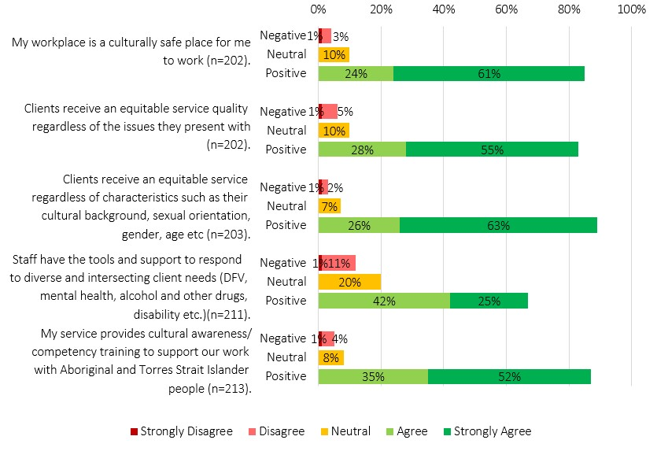
Cultural safety is not experienced consistently across the homelessness workforce. Aboriginal staff described carrying several roles at once, including cultural guidance, community liaison and frontline practice, often without formal recognition or support. They also highlighted the need for structural supports such as cultural supervision, Aboriginal workforce forums, Aboriginal leadership pathways and clear mechanisms for raising concerns about culturally unsafe policies, environments or practices.
Staff noted that existing wellbeing supports, including Employee Assistance Programs, do not align with Aboriginal concepts of social and emotional wellbeing. This creates a mismatch between the support Aboriginal staff need and the support currently available.
Survey responses showed a clear gap between Aboriginal and non‑Indigenous staff in their experience of cultural safety. Aboriginal respondents were more likely to report that cultural safety was limited or absent in their workplace, while non‑Indigenous staff were more likely to view their workplace as culturally safe. This points to broader issues in workforce capability, structural racism and the lack of effective accountability mechanisms to ensure culturally safe environments.
Stakeholders also raised concerns about the cultural capability of non‑Aboriginal staff, both in responding to clients and in creating culturally safe environments for Aboriginal colleagues. They noted the need for clearer expectations and accountability for behaviours such as lateral violence, which can occur in colonised systems and workplaces.
These experiences highlight that workforce safety is shaped not only by organisational practices, but also by the broader system settings in which services operate. This underscores the need to examine the upstream commissioning and governance structures that influence psychosocial risk.
    - Psychologically Safe Systems
While NGOs are the formal PCBUs (Persons Conducting a Business or Undertaking) under WHS law, stakeholders emphasised that governments also play an important upstream role in shaping the psychosocial conditions in which the SHS workforce operates.
Under sections 16 and 19 of the Model WHS Act, duty holders include any party whose decisions materially influence how work is carried out. In this context, commissioning decisions, funding levels, KPIs, and service design structures can inadvertently contribute to psychosocial hazards, such as chronic workload pressures, limited capacity to resource supervision, clinical or cultural governance, and system architectures that require extensive multi-agency coordination without the necessary supports. This does not suggest intentional harm but rather reflects that certain system-level decisions can have downstream consequences for worker safety, wellbeing, and role clarity, especially in highly pressured and resource-constrained environments.
There is a clear need to ensure that commissioning frameworks, KPIs, and funding conditions do not create foreseeable psychosocial risk, and that NGOs are adequately resourced to meet their WHS obligations, including those relating to cultural safety.
While this review is not asserting that the current commissioning arrangements have created unsafe conditions, stakeholders did identify early indicators of system instability that, without appropriate safeguards, could affect the workforce over time. The inclusion of this analysis is therefore intended to support a forward-looking discussion about the role of government in shaping system-level environments that promote psychological safety and sustainable practice. As the system moves into the next commissioning cycle, the opportunity exists to strengthen upstream safeguards to ensure that organisations, and their workforces, are able to meet WHS expectations safely, consistently, and sustainably. For example, being specific in tendering processes about funding for clinical and cultural FTE, training, risk reporting systems etc.
  - Training and Workforce Capability
Review findings indicate that workforce capability is a critical enabler of safe, effective and sustainable service delivery within the SHS system.
The ability of workers to respond confidently to complex client needs, navigate multi-system interfaces and operate in high-risk environments depends on access to ongoing training, structured supervision and opportunities for professional development. These elements are central to commissioning because they influence whether organisations can maintain and develop the skills required to meet service expectations.
    - Training Access and Opportunity
Stakeholders reported that capability development has become increasingly inconsistent across the sector. Prior to the introduction of the Alliance model, SHS providers accessed a dedicated training fund administered by government, which supported sector-wide capability building and ensured broad access to foundational and specialist training. Under the Alliance model, this fund was absorbed into core contract funding. Stakeholders described that this shift resulted in fewer coordinated training opportunities and placed additional pressure on individual organisations (particularly smaller NGOs) to resource training from already constrained budgets.
“There are still significant gaps in workforce capability that affect how effectively services can respond to clients. Early identification is a key challenge, particularly where people present with overlapping needs such as mental health or behavioural concerns. Without consistent training and clear screening approaches, staff may miss key indicators or feel unsure how to ask sensitive questions safely.”– Survey Response
They also noted that whole-of-workforce training, such as cultural safety training, was often financially and operationally challenging because crisis-driven services cannot release all staff at once to attend them. When training was centrally organised, staff could attend flexibly with minimal disruption to frontline service delivery.
    - Generalist and Specialist Knowledge
Frontline workers and leaders emphasised that high-quality homelessness practice requires a deep understanding of multiple systems, including housing, health, mental health, domestic and family violence, child protection, disability, legal processes and income support.
Workforce turnover across SHS system has resulted in newer staff entering the system with limited foundational knowledge in these areas. This gap was reinforced by reports of stakeholders frequently needing to explain basic processes, such as emergency accommodation pathways or housing applications, to other workers. Review findings also indicate that shifts toward more generalist staffing models, combined with Alliance model transition-related attrition, have contributed to the erosion of specialist knowledge across the system. Some stakeholders reflected that specialist roles and teams, such as outreach, culturally specific responses, health-related roles, DFV or youth specialist, have been reduced, integrated into broader structures (e.g. DFV Alliance) or retained primarily within a small number of Directly Contracted services. This has placed additional pressure on generalist staff to hold diverse specialist knowledge without structured supports or access to subject matter expertise.
Multidisciplinary teams were widely identified as a valuable way to strengthen capability, enhance integrated responses and reduce reliance on generalist knowledge. However, review findings indicate that without consistent access to supervision, training and professional development, multidisciplinary capability is difficult to sustain and may lead to widening differences in practice confidence and skill across the workforce.
Aboriginal stakeholders emphasised that cultural knowledge is a specialist capability in its own right, yet it is not consistently recognised, resourced or embedded within current structures.
As Aboriginal-specific roles have been reduced or absorbed into broader teams, responsibility for cultural guidance has increasingly fallen to a small number of Aboriginal staff. This perpetuates cultural load, places additional pressure on those workers and contributes to inconsistent cultural safety across the system. This also means that cultural capability is being treated as an informal add‑on rather than a core specialist function that requires dedicated roles, training and system‑level support.
    - Workforce Capability Structures
Homelessness work is inherently high risk. Staff support people experiencing crisis, trauma, violence, complex health needs and system failures, often in unpredictable environments. These pressures are intensified when workers do not have access to consistent, reliable structures that support their capability, confidence and psychological safety. Across the Review, stakeholders were clear that safe and effective practice depends not only on individual skill, but on the system providing the right scaffolding around the workforce.
Organisations and Alliances described a wide range of internal approaches to induction, supervision, training and day-to-day practice support. This variability does not reflect shortcomings within individual organisations. Rather, it highlights the absence of system-level mechanisms that ensure all workers have access to the same core supports, regardless of where they work. Without shared expectations and consistent capability structures, practice develops unevenly, specialist knowledge is lost, and workers face greater exposure to psychological harm.
Stakeholders emphasised that the effectiveness of any future practice framework will depend on the capability structures that sit around it. Clinical supervision, cultural supervision, reflective practice, access to specialist advice and opportunities for shared learning were all described as essential to safe homelessness practice, yet these supports are not consistently funded or available across the system. In many services, particularly smaller NGOs, these functions rely on organisational goodwill rather than dedicated commissioning requirements.
There was strong agreement across the Review that strengthening systemwide workforce capability structures is essential to improving client outcomes and safeguarding workers. Stakeholders were clear that these supports cannot be delivered through organisational goodwill or absorbed within existing budgets. Functions such as supervision, practice support, induction and access to specialist expertise require dedicated funding and explicit commissioning requirements. Without this, they inevitably compete with frontline service delivery and are the first to be compromised when resources are tight. Stakeholders also highlighted the importance of shared learning environments, including communities of practice, to maintain specialist capability and reduce reliance on informal knowledge transfer across the system.
Strengthening these structures would provide the consistency, safety and professional support required for workers to deliver high-quality services and manage the psychological risks inherent in homelessness work. It would also create the conditions for the future practice framework to be implemented effectively and sustainably under the next commissioning cycle.
  - Chapter Summary
The Review found a workforce carrying significant and avoidable risk. Homelessness work is inherently high-risk, but the system is amplifying that risk through inconsistent supervision, uneven cultural safety, variable capability structures and commissioning settings that do not resource the functions required to keep workers safe. Staff are managing trauma exposure, escalating complexity, unclear boundaries, high caseloads and system failures without the clinical, cultural or structural supports needed to do this work safely or sustainably.
These pressures are system-level gaps: the absence of funded clinical and cultural governance, inconsistent access to training and specialist expertise, and commissioning arrangements that do not account for the WHS obligations placed on providers. Aboriginal staff in particular are carrying disproportionate cultural load and navigating environments that are not consistently culturally safe.
Across the Review, there was strong agreement that the system cannot deliver safe, high-quality practice without dedicated investment in the structures that underpin workforce capability. This includes reliable supervision, cultural governance, safe workload expectations, consistent induction, core training and a coordinated approach to workforce planning. Strengthening these foundations is essential to reducing preventable harm, improving cultural safety, stabilising the workforce and enabling the future service model to operate as intended.

- Lived and Living Experience
The Review was guided by the Terms of Reference requirement that lived and living experience be central to ethical, culturally responsive and effective system design. This includes both the perspectives of people who have experienced homelessness and the substantial practice-based lived experience embedded within the homelessness workforce itself.
This chapter explores the opportunity to build on existing frameworks and initiatives to embed lived experience within governance and system design, and to consider integrated approaches to lived experience to support continuous learning and improvement.
Direct engagement with people currently experiencing homelessness was not undertaken for this review. Given the commissioning-focused scope and accelerated timeframe, meaningful engagement with people in active crisis would have carried unacceptable risks of tokenism and harm without appropriate trauma-informed scaffolding. To ensure lived experience remained central, the Review engaged with the existing mechanisms for Lived Experience engagement with the governance and safeguarding required for ethical participation. For clarity, this chapter uses the following distinctions:
Table 6: Lived Experience Terms and Meanings
Term | Meaning in the Review
Living Experience | People who are currently experiencing homelessness, or who have only very recently exited. Requires additional safeguards, trauma informed scaffolding and supports for ethical participation
Lived Experience | People who have experienced homelessness in the past and have had time and distance from the trauma. As one stakeholder described it: lived experience is “speaking from a scar, not a wound.”
Peer Work | A defined workforce role where lived experience is intentionally and therapeutically used. Distinct from general living and lived experience participation.
  - Overview of Lived and Living Experience in the SHS System
At a system level, the Lived Experience Engagement Service (LEES) and the Lived Experience Reference Group (LERG) remain the primary structured mechanisms for lived and living experience input. The LEES remit is described as building sector capacity by delivering lived experience training and leading projects that generate lived experience insights. The LEES also coordinates the LERG to support meaningful participation.
The Review also found significant lived and living experience of homelessness and/or DFSV within the workforce. Almost half of respondents who completed the demographic section of the anonymous online survey reported their own lived experience of homelessness and/or DFSV. However, sector understanding of their purpose, authority and use remains uneven, and processes for translating lived experience insight into system-level action are not consistently embedded.
In practice, lived experience input often informs individual practice or local initiatives, but rarely travels into governance, commissioning or strategic decision making. Across the SHS-funded system, lived and living experience participation mechanisms are fragmented, often dependent on organisational maturity or individual champions and not designed as core program, organisation or system infrastructure. Some organisations collect post-service feedback, others use validated wellbeing tools, and many incorporate client stories into practice narratives. Yet these insights rarely translate into meaningful service development or system-level learning.
“Current Lived Experience mechanisms focus more on individual practice involvement than on embedding lived experience in governance, service design, or strategic decision making.” - Survey Response.
In regional and remote contexts, participation carries additional risk. Small communities heighten fears of identifiability and reprisal, and culturally mismatched engagement processes can silence participation rather than enable it. These barriers do not reflect a lack of insight, but an absence of safe and trusted structures.
    - Cultural Safety and Equity in Lived Experience
Aboriginal stakeholders were clear that current lived experience structures are not culturally safe or appropriate. Previous attempts to establish an Aboriginal LERG did not hold, raising broader questions about whether Western governance models such as reference groups are an appropriate or culturally grounded way for Aboriginal lived experience to influence system design. The lack of Aboriginal representation within the current LERG further reinforces this gap.
Aboriginal lived experience was described as relational, community embedded and grounded in cultural authority rather than individual testimony. Western governance models such as reference groups do not adequately reflect Aboriginal concepts of safety, reciprocity or accountability. Authentic engagement therefore requires Aboriginal-led governance, space for storytelling, reciprocity, collective decision making, recognition of cultural obligations and clear safeguards around confidentiality, consent and appropriate debriefing, alongside remuneration that recognises both lived experience and cultural load.
Without Aboriginal-led structures and governance authority, lived experience risks becoming tokenistic and perpetuating the very inequities it seeks to address. While these patterns describe how lived experience is currently structured at a system level, workforce insights provide further context on how this is experienced and operationalised in practice.
  - Workforce Insights on Lived Experience
Across the workforce, there is strong commitment to embedding lived and living experience more meaningfully. That intent, however, is consistently undermined by crisis-driven service environments and a lack of resourcing, governance and protected time.
Without clear system-wide structures or funded roles, responsibility for lived experience engagement often falls to individual staff members, who carry the work informally and without recognition. Providers described struggling to establish or sustain engagement mechanisms when immediate client needs consistently overshadow broader improvement or development activity.
“I started a client reference group myself a few years back, but it was not recognised or supported therefore it became an added responsibility on me that I was unable to uphold ongoing.”- Survey Response.
Issues relating to compensation and recognition also remain unresolved. While the Alliancing tender documentation identified that “lived experience is used to guide service and system development” as a commissioning expectation, progress toward this in practice has been uneven. A lived experience framework was released by the LEES in 2023; however, awareness and operational use of the framework across the sector remain limited.
Stakeholders also highlighted weaknesses in feedback loops. Opportunities to communicate back to clients about how their insights informed decisions were described as ad hoc or absent, weakening confidence that lived experience input leads to meaningful change.
“Opportunities to feed back to clients about how their input has influenced change are inconsistent at best, particularly at a service or system level.” - Survey Response.
Anonymous survey results reflected this inconsistency. Approximately half of respondents (55%) reported that their organisation had mechanisms to engage lived experience in service-level decision making, and a similar proportion (60%) indicated they had clear processes for collecting client feedback. Just over half (55%) reported understanding the role of the Lived Experience Reference Group (LERG), indicating a significant lack of shared understanding across the system.
Resourcing concerns were more pronounced. Figure 27 shows that over half of respondents (55%) did not think that the system is adequately funded to embed lived experience. Staff who identified as having lived experience themselves expressed similar views on authenticity but were more likely to report resourcing concerns, with six in ten (62%) disagreeing or strongly disagreeing that resourcing is sufficient. Among Directly Contracted services, more than eight in ten respondents (84%) indicated that lived experience engagement is not adequately supported. These findings point to a consistent gap between intent and implementation.
Figure 27: Anonymous online staff survey response summary, lived experience
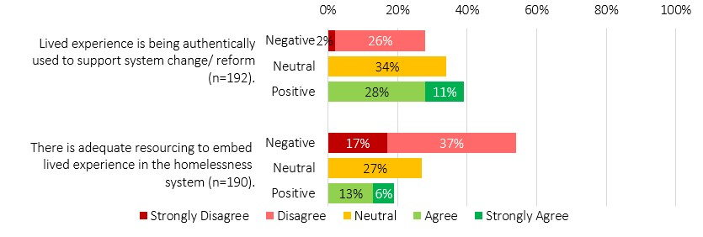
While lived and living experience is widely valued in principle, the homelessness system lacks the clarity, consistency and resourcing required to embed it safely and meaningfully. This gap reflects the absence of a homelessness-specific implementation framework embedded across Alliances and Directly Contracted services, alongside limited investment in the trauma-informed scaffolding required for ethical and culturally safe participation.
  - Embedding Lived Experience Across the SHS System
Building on the current state described above, this section examines the conditions required to embed lived experience consistently and at scale across the system.
Although lived and living experience mechanisms exist across parts of the SHS funded homelessness system, they are not yet supported by clear, resourced, trauma-informed and culturally safe structures capable of operating at scale. As a result, the system cannot consistently or ethically draw on lived experience to inform system improvement.
    - The LEES Lived Experience Framework
The Lived Experience Framework for South Australia’s Housing and Homelessness System, released in 2023, provides an evidence-informed foundation for embedding lived experience more meaningfully. The framework distinguishes between “content experts” (professionals with formal training and tools) and “context experts” (people with lived experience of homelessness), asserting that robust system understanding emerges only when these perspectives are brought together in genuine partnership. Grounded in principles of empathy, accountability, inclusion and equity, the framework shifts the emphasis from consultation alone toward co-production and shared decision making.
Importantly, the framework recognises that authentic lived experience integration requires enabling conditions, including attention to power imbalances, professionalised lived experience roles and consistent remuneration at individual, organisational and system levels. While the framework establishes a clear conceptual scaffold, sector awareness and operationalisation remain uneven, presenting a significant opportunity for more deliberate and consistent implementation.
    - Learning from Mental Health
Stakeholders frequently pointed to the mental health system as an example of where lived experience and peer work frameworks are more mature, supported by clearer governance, role definitions and a stronger evidence base. However, stakeholders were also clear that these models cannot be directly transferred into homelessness contexts.
“We need to think carefully about what evidence-based lived experience involvement looks like in homelessness. We can’t simply copy mental health approaches, because homelessness is often episodic rather than an ongoing recovery journey. The challenge is how to engage lived experience in ways that are relevant, appropriate, and do not risk re-traumatisation when people are not on a continuing recovery trajectory.” – Sector Participant
Homelessness differs fundamentally from mental health in its patterns of crisis, mobility and engagement. Lived experience approaches in homelessness must therefore be designed specifically for this context, incorporating appropriate safeguards, cultural safety and trauma-informed scaffolding, rather than relying on models developed for systems with fundamentally different trajectories and assumptions.
    - Peer Work
As with lived and living experience more broadly, the sector is still in the early stages of defining what homelessness-specific peer work looks like. While there are emerging examples of good practice, these are largely shaped by individual organisational policies, risk appetite and internal support structures rather than consistent, system-wide standards.
Stakeholders consistently emphasised that peer work is a distinct and specialised role that is often misunderstood within the homelessness context. A peer worker is not simply a person with lived experience employed in a general support role; rather, peer work is the intentional and therapeutic use of lived experience. It requires dedicated supervision, reflective practice, safeguards against re-traumatisation and organisational scaffolding.
These requirements carry additional funding, training and governance implications that are not reflected in current service contracts, creating tension between the recognised value of peer work and the realities of frontline service delivery. As one stakeholder summarised the sector’s position: “Absolutely — but how do we fund it, and how do we do it safely and consistently?”
“There’s a real need to invest in peer work, but that takes resources, training, supervision, support. It’s not something you can just add in without funding behind it. Alliances have said they’d like to see it happen, but again, resourcing is the barrier.” – Sector Participant
While there was strong interest in developing a peer workforce, uncertainty remains about where peer roles should sit within the SHS funded homelessness system. A single peer embedded within an organisation may become isolated or constrained, while centralised peer roles risk being disconnected from frontline practice in the absence of clear governance arrangements.
Stakeholders identified the unique value peers bring in explaining the “hidden rules” of the homelessness system, providing grounded empathy and trusted communication that complements case management—particularly during crisis responses. Potential peer roles were identified across aftercare, tenancy sustainment, mental health navigation, crisis de-escalation and cross-system advocacy, where experiential insight can enhance, rather than replace, traditional practice.
    - Remuneration and Funding
Stakeholders were clear that the SHS funded homelessness system is not currently resourced to embed lived experience governance, co-design or peer roles at scale. Outside of LEES, service delivery contracts do not provide the time, staffing, funding or direction required to roll out lived experience frameworks or integrate lived experience leadership consistently across Alliances and Directly Contracted services.
Current funding settings also limit the system’s ability to support the diversity of lived experience voices required for ethical and culturally legitimate engagement. While youth, Aboriginal and Torres Strait Islander, disability-specific and culturally diverse perspectives are essential, the system does not resource the infrastructure needed to sustain multiple groups, support safe participation, or coordinate their contribution meaningfully.
“We’re not funded or resourced well enough to embed lived experience when most of the system is focused on responding to growing demand. Expecting this to happen without proper investment and infrastructure simply isn’t realistic.”– Sector Participant
These gaps have practical consequences. LEES is funded at a scale that constrains its ability to govern multiple reference groups or maintain diverse and ongoing participation. Similarly, the remit of the LERG requires broader representation and capability development than its current contract resources allow, resulting in limited scope for training, progression or system leadership.
The Constellation Project’s Lived Experience Practice Framework provides a clear example of what well-resourced participation can look like. The framework shifts from consultation to a “co-pilot” model, embedding lived expertise within governance and system decision making. It includes structured remuneration, payment for preparation and debriefing, travel costs, and recognition of the emotional labour involved in lived experience participation.

Figure 28: Types of Contribution and Payment Rates Table: The Constellation Project.
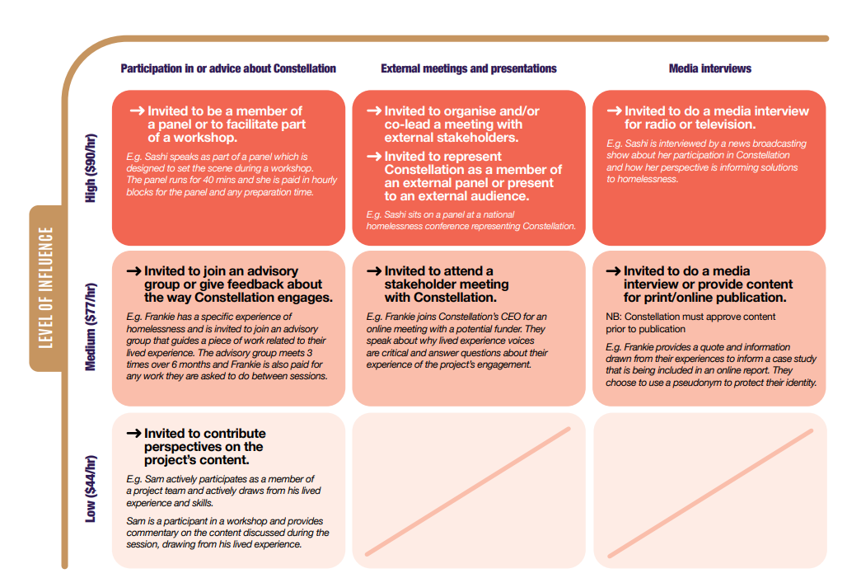
This model highlights the gap between best practice and the current resourcing of lived experience engagement within the homelessness system.
    - What it Takes to Embed Lived Experience Safely and Meaningfully
Embedding lived experience in the homelessness system offers deep value but doing so safely and meaningfully requires strong scaffolding. Lived experience exists along a continuum, ranging from feedback and advisory input through to peer support, co-design and system governance. Peer support sits at the most intensive end of this continuum and relies on mature frameworks, clear role definitions, resourcing, training pathways and governance structures that safeguard both participants and workers. Without these foundations, the system risks placing responsibility on individuals that it is not structurally prepared to hold.
Best-practice lived experience models emphasise trauma-informed approaches, ethical and transparent remuneration, structured workforce pathways and clear mechanisms for cultural and psychological safety. These principles, well established in peer work research, require investment in training, supervision, reflective practice, role clarity and layered participation options, allowing people to contribute in ways that align with their readiness and wellbeing. Critically, lived experience involvement must be embedded across commissioning, service delivery, design and governance, rather than confined to isolated consultations.
Where lived experience engagement is inadequately resourced or structured, the risks are substantial. Tokenism arises when people are invited to contribute without the scaffolding or follow-through needed to ensure their input is respected, acted upon and communicated back. Repeatedly asking individuals to recount distressing experiences without appropriate compensation, debriefing, or clarity about purpose creates foreseeable risks of re-traumatisation. These risks are heightened in regional and remote communities, where anonymity cannot be assured and participation may compromise personal or community safety.
Authenticity is further challenged by the diversity of homelessness experiences. No single reference group can represent youth, Aboriginal and Torres Strait Islander communities, people with disability, victim survivors of DFSV and culturally diverse groups simultaneously. Group-based models will not suit all populations or contexts, yet the system has not developed a layered participation model capable of holding multiple voices in parallel.
Recruitment and sustainability pose additional challenges. In the absence of consistent, funded outreach, LEES currently relies on email, flyers and informal networks, contributing to inconsistent participation and a limited pipeline for lived experience leadership development. While LEES staff mitigate risks through trauma check-ins and follow-up support after difficult discussions, these practices demand time, expertise and resourcing that are not uniformly funded across the system.
Governance and independence remain unresolved. Stakeholders described unclear pathways for how lived experience insights are elevated into decision making, how influence is exercised, or how concerns can be escalated safely. Many argued that lived experience governance should not sit within a single service provider, but instead be held through an independent, sector-wide mechanism led by people with lived experience. While there is no consensus on where such governance should sit, whether within DHS, at Alliance level, or through an independent body, there is strong agreement that any model must carry authority, and psychological safety.
“There is an underlying expectation that lived experience is embedded in practice, but without the scaffolding needed for authentic engagement… We see lived experience written into contracts, but without the funding or recognition of what it takes to do this work safely… Mental health has a recovery trajectory; homelessness is episodic. We need evidence about what lived experience involvement looks like in homelessness, not just models imported from other systems.” — Sector Participant
These findings highlight a central tension: the system genuinely values lived experience and seeks to embed it more meaningfully, but current funding, governance and workforce frameworks are not yet capable of supporting this safely or consistently. Without investment in role clarity, scaffolding, training pathways, remuneration, cultural legitimacy, independence and trauma-informed structures, lived experience involvement risks remaining symbolic rather than becoming a transformative driver of system change.
  - What Lived Experience System Infrastructure Could Look Like
Across South Australia, adjacent systems demonstrate more mature and structured approaches to lived experience leadership. The Lived Experience Leadership and Advocacy Network (LELAN) operates as a statewide peak body embedding lived experience expertise into governance, strategy and policy across mental health and social systems. Similarly, the Lived Experience Advisory Network (LEAN) provides a formal mechanism for embedding the expertise of domestic, family and sexual violence victim survivors into policy and service design. These models demonstrate how lived experience can function as a strategic system voice rather than an ad hoc or transactional consultation mechanism. While these approaches provide important lessons, their role within homelessness-specific governance and commissioning remains limited.
South Australia does not need to reinvent the wheel to build a high-functioning lived experience system infrastructure. Elements of good practice already exist across the State, from post-service client feedback processes to place-based lived experience initiatives. However, these insights remain fragmented within individual programs and are not yet connected through a coherent, statewide system capable of supporting continuous improvement. While the LEES Lived Experience Framework provides a contemporary, evidence-informed foundation, it has not yet been embedded or operationalised at scale. The core challenge is therefore not the absence of lived experience insight, but the absence of system infrastructure to connect, interpret and elevate this insight into system-level learning, design and policy.
Consultation highlighted a broad range of system improvements that people with lived experience wish to inform. These included workforce and service quality expectations, such as trauma-informed practice, empathy and consistency across SHS and SAHT, as well as structural and policy issues. Participants described the “hidden rules” of navigating housing systems, the need for navigators, stigma at intake, gaps in transitional housing and aftercare, and the importance of lived experience influencing policy work, not just frontline service delivery. Systemic reform priorities raised also extended to transitional housing accountability, drug-use policies, housing allocation processes and broader housing market settings. Together, these insights demonstrate a clear appetite for lived experience to shape system design and policy, not merely program-level practice.
“At the moment, lived experience isn’t consistently embedded across the system. It’s not meaningfully informing service design, delivery or evaluation, and that’s a significant gap. There needs to be stronger, structured ways to involve people, including paid roles and co-design so that services are actually shaped by those most affected.” – Survey Response
Internationally, many high-functioning lived experience learning models exist. Scotland offers a particularly relevant example, given its conceptual influence on the early development of South Australia’s Alliance approach. The All in for Change Team operates as a hybrid group of lived experience leaders and practitioners and is structurally linked to Scotland’s Homelessness Prevention and Strategy Group, which includes senior government decision-makers across housing, health, justice and local authorities. This model embeds lived experience expertise directly into governance and strategy, providing real-time insight into system performance. Its effectiveness lies in integration rather than periodic consultation: lived experience leadership functions as a core component of continuous improvement, not a parallel or standalone activity.
A similar approach could be adapted within South Australia’s SHS funded homelessness system by building on foundations that already exist. The LEES Lived Experience Framework offers a clear conceptual scaffold for how lived experience governance, participation and leadership can operate within homelessness. Integrating top-down policy insight, bottom-up client voice and an independent lived experience stewardship function would allow the system to move from fragmented mechanisms toward a coherent, trauma-informed and culturally legitimate learning architecture.
Figure 29 illustrates how these elements, many of which are already emerging through LEES, LERG and individual agency-level initiatives could be connected into a statewide lived experience system infrastructure.

Figure 29: Lived Experience System Infrastructure
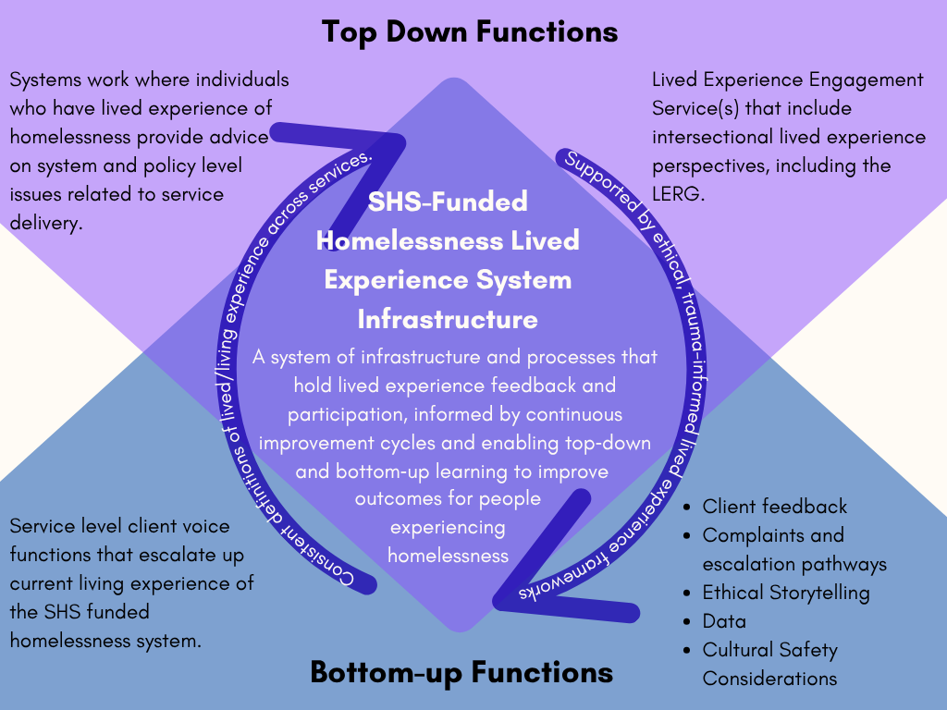
Establishing such a system would allow South Australia to shift from patchy and informal engagement toward an integrated and accountable approach to lived experience leadership. A structure that unites policy insight with lived expertise, held within an independent governance mechanism and supported by stable resourcing, clear pathways for influence and culturally safe participation, would create the conditions for genuine continuous improvement.
In doing so, it would position lived experience as a sustained driver of system stewardship and reform, rather than a symbolic or episodic consultation activity. Realising this shift will require deliberate investment and clear system design, as reflected in the lived experience recommendations outlined in this review.
“Lived experience plays a vital role in shaping a responsive and effective homelessness system. It brings insights into the real barriers people face and helps design solutions that work in practice, not just on paper. At the moment, it’s not consistently embedded across the system. To strengthen this, lived experience should be built into service design, governance and evaluation, with proper resourcing and compensation so people can genuinely participate in decision making.”– Sector Participant
Realising this shift will require deliberate, staged development. This includes working with existing lived experience groups to review national and international evidence on effective models in homelessness, and to co-design a long-term approach that embeds lived experience across system stewardship, service delivery and continuous improvement. Strengthening foundational feedback mechanisms and clarifying the role of existing structures will be a critical first step, alongside developing a more coherent, representative and authoritative model over time.
  - Chapter Summary
This chapter finds that while lived and living experience is widely valued across the SHS system, it is not yet supported by the governance, resourcing or infrastructure needed to shape system design or commissioning. As a result, it remains largely embedded in local practice rather than influencing system-level decisions. This matters because the system cannot fully understand client pathways, identify barriers or improve outcomes without structured, culturally safe and scalable mechanisms. This weakens commissioning and risks reinforcing approaches that do not reflect lived reality.
These findings point to the need for staged reform that strengthens current mechanisms and co-designing a longer-term model that embeds lived experience in system stewardship, service delivery and continuous improvement.
- Data, Outcomes and Accountability
Data is a critical enabler of effective system stewardship and commissioning. In South Australia, the current homelessness data environment (H2H) does not provide a reliable or complete picture of demand, service delivery or outcomes. As it is currently structured and resourced, the system cannot consistently demonstrate need, measure impact, or inform evidence-based investment decisions. At a fundamental level, this limits the system’s ability to produce a clear and reliable picture of the scale and nature of homelessness in South Australia. While these limitations are widely recognised, and work is already underway to explore improvements to the Homelessness to Home (H2H) system, the system continues to rely on administratively burdensome and fragmented tools. Without sustained investment in contemporary data systems and analytic capability, these constraints will continue to limit the system’s ability to quantify unmet need, demonstrate outcomes and support system-level improvement. This section establishes the case for system-level data reform, including redevelopment of core data systems and enhanced capability for integrated, outcome-focused analysis.
  - The National Agreement on Social Housing and Homelessness (NASHH)
As outlined in the Strategic Contexts section, the National Agreement on Social Housing and Homelessness (NASHH) establishes nationally agreed objectives, outcomes and reporting requirements for homelessness services. A central focus of the Agreement is improving transparency, data quality and the use of evidence to support system performance and continuous improvement. These requirements directly shape South Australia’s homelessness data environment, as they inform what service providers are required to record within the State’s case management system (H2H), which contributes to South Australia’s reporting to the SHSC.
However, the current data architecture does not consistently support the capture or reporting of this information in a way that reflects the complexity of homelessness service delivery. As a result, there is a disconnect between national expectations and what the system is currently able to demonstrate through available data collection.
  - The DHS Homelessness Outcomes Framework
The DHS Homelessness Outcomes Framework, introduced in mid-2025, sets out a shared, system-wide model for improving outcomes for people at risk of or experiencing homelessness. It presents an aspirational vision for preventing and resolving homelessness and is intended to help the sector understand people’s experiences, how services contribute to outcomes and where collaboration and system improvements are required. The Framework includes nine outcome indicators, a client-level Theory of Change and a system-level Theory of Change and aligns with the broader DHS Outcomes Framework to promote consistent, outcomes-focused practice across the Department.
The Framework is designed to describe progress toward both client outcomes and system maturity. It also aims to strengthen relationships between DHS and Specialist Homelessness Services by establishing a shared outcomes vocabulary and clearer expectations about what the system is working to achieve. While it references alignment with the National Agreement on Closing the Gap, the Framework focuses on high-level aspirations rather than detailing the data requirements or measurement structures needed to monitor culturally specific outcomes.
As the Framework is newly introduced, the Review did not assess its practical implementation. However, stakeholder feedback indicates that it remains in an early stage of development and is not yet operationalised across the system. There was considerable uncertainty across the sector about how the Framework’s components will translate into practice, how outcomes will be measured, and how DHS will embed it within the broader system. The system infrastructure needed to support the Framework’s intent is still developing.
“The Outcomes Framework… must have an implementation project attached to it, currently it is theoretical. There needs to be data systems, guidance and enabling infrastructure to bring it to life.”– Survey Response
  - Alignment with National Agreements
The DHS Homelessness Outcomes Framework reflects local priorities and aligns with the broader DHS Outcomes Framework; however it differs in scope and intent from NASHH’s national outcomes and data requirements. NASHH Schedules C and D emphasise the need for nationally consistent, strengthened data systems, including improved measurement of homelessness, more frequent population estimates using administrative data, and the development of linked datasets that support person-centred analysis. While the DHS Homelessness Outcomes Framework outlines the use of data and evidence for system learning, it does not provide detail on its alignment with national data development priorities, including cross-system data linkage or integrated datasets. Given the need for services to meet both Commonwealth and State funding and reporting requirements, this lack of alignment may need to be addressed to ensure complexity and reporting burden is not added for services required to operate across both Commonwealth and State frameworks.
  - Machinery of Government Change – Data Impacts
Following the Machinery of Government changes on 1 July 2024, responsibility for the Homelessness to Home (H2H) database transferred to DHS. This transition occurred within the context of an existing system with known limitations in functionality and alignment with current outcomes frameworks.
While stewardship responsibility now sits with DHS, H2H continues to be hosted and technically maintained by the South Australian Housing Trust. This creates a separation between system ownership and control of data infrastructure, system development and extraction capability. In practice, this limits DHS’s ability to independently access, analyse or adapt homelessness data to support system oversight, planning and reform.
  - Homelessness to Home Database (H2H)
As outlined in the Strategic Contexts section of the Review, H2H is South Australia’s statewide client and case management system for the homelessness sector. Introduced in 2011, it is the accredited system used to generate all data required for the national SHSC. Since its implementation, H2H has remained hosted and technically maintained by the South Australian Housing Trust.
Multiple technical assessments and sector reviews have consistently found the system to be outdated and no longer fit for purpose, with limitations in reflecting day-to-day practice, supporting information sharing, capturing client complexity, identifying unmet need and representing the nuances of domestic and family violence.
These limitations were strongly reinforced through engagement for this Review, with stakeholders describing the system as administratively burdensome, duplicative and misaligned with contemporary service delivery. A central limitation of H2H is its inability to adequately capture the complexity and nature of homelessness practice. Stakeholders reported that the system does not reflect key elements of their work, including the intensity and duration of support, assertive outreach, DFV risk and safety dynamics, youth-specific and therapeutic responses, cultural context, and relational practice outside structured case management.
“H2H is such a terrible tool to use that it disincentivises case managers from fully outlining client complexity… you combine this with a high caseload, and it means case managers will struggle and things get missed.” — Survey Response
The Review acknowledges that a dedicated H2H Review and business case is underway and does not seek to replicate that work. Instead, this section focuses on how H2H functions in practice and how well the tool aligns with current outcomes frameworks, including the NASHH National Outcomes Framework, national SHSC reporting requirements and the DHS Homelessness Outcomes Framework.
In examining these frameworks, a deeper structural issue becomes visible. While the NASHH and the DHS Homelessness Outcomes Framework emphasise outcomes, particularly around prevention, system effectiveness, cultural safety, and client wellbeing, in contrast, H2H is designed to collect information on activities and support periods (outputs), not outcomes.
This misalignment creates an ongoing barrier to linking day-to-day data collection with outcomes-based system expectations. It is a key factor limiting South Australia’s ability to meet national and State requirements related to outcomes measurement, unmet need and system performance.
Services reported that data collected for compliance purposes can oversimplify or misrepresent service delivery and outcomes.
“Some of the KPIs create false data. You are meeting a KPI because you have to. It’s not a true reflection of the breadth of work you’re doing with clients...” — Survey Response
Survey results (Figure 30) reinforce these findings. A majority of respondents did not believe H2H reflects the work undertaken with clients or captures outcomes beyond contractual requirements, and many identified a lack of alignment with the DHS outcomes framework. These perceptions were consistent across service types, indicating that limitations in H2H are experienced across the system.
In summary, the current data system does not provide a reliable representation of practice, outcomes or service impact. This constrains the system’s ability to measure performance, demonstrate effectiveness or inform commissioning decisions, and reinforces the need for investment in modernising South Australia’s homelessness data infrastructure.

Figure 30: Anonymous online staff survey response summary, data and outcomes
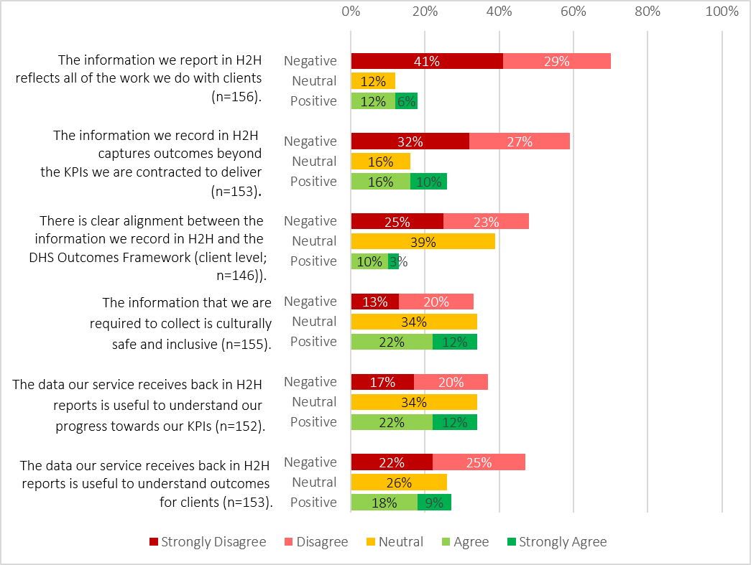
  - Unmet Need
Although NASHH requires South Australia to report on unassisted requests, unmet need and related demand measures, stakeholders consistently reported that the current system substantially underrepresents both the scale and nature of unmet need. Gaps in H2H data capture and inconsistent recording practices limit visibility of actual demand and constrain understanding of whether system capacity is sufficient to respond. Key limitations in how unmet need is captured include:
- Unmet need is significantly underreported: Stakeholders consistently reported that current reporting underrepresents both the scale and nature of unmet need across the homelessness system. Gaps in H2H data capture and inconsistent recording practices limit visibility of demand and constrain understanding of system capacity.
- H2H cannot capture early or brief contacts: Much of the work that reflects unmet need, such as outreach, early engagement, brief assessments, short term assistance and informal waitlists cannot be or is not recorded in H2H due to system limitations and the administrative burden of data entry.
- National unmet need measures cannot be met: While NASHH requires jurisdictions to report on unmet demand through unassisted requests and unmet service needs, the DHS framework does not include equivalent client or system level indicators. As a result, South Australia currently lacks the capability to report unmet need in line with national requirements.
- Definitions obscure actual demand: Under national definitions, unmet need is only recorded where no assistance is provided, and a request is entered into H2H. In practice, many people receive minimal advice or partial support that is not recorded or is classified as assistance with ongoing unmet need, masking the true level of unmet demand.
- Multiple entry points are not integrated Key access points, including Homeless Connect, Alliance-based intake services and referral phone lines, manage significant demand that is not integrated with H2H. As a result, substantial service activity is excluded from demand and unmet need data.
- Regional and remote demand is largely invisible: Current reporting does not reflect regional service realities, including dispersed service models, workforce limitations and mobility between communities. As a result, significant portions of demand are not captured.
- Informal waitlists conceal pressure on services: Many service providers rely on informal or external waitlists and only create H2H records once a client progresses to case management or provides consent. These early contacts are often the clearest indicators of unmet need but remain invisible in official data.
“We rely on external spreadsheets to manage waitlists because H2H doesn’t capture early contact or people waiting for support. These are used to track engagement, brief support and when people are no longer active, requiring multiple staff and several hours each week to maintain.” – Survey Response
- Systemwide analysis is not possible: Incomplete capture, inconsistent recording practices and fragmented data architecture limit the State’s ability to analyse unmet need at a system level. As noted by the Auditor General, this constrains demand mapping, outcomes monitoring and confidence that services are reaching those with the highest need.
- Unmet need is obscured at multiple system points: Gaps occur at Intake, brief contact, triage, external waitlists, and non-H2H entry points (such as phone lines and Alliance-based front doors). These cumulative omissions compound invisibility and make it difficult to understand true demand.
Without comprehensive, accurate, systemwide data, South Australia cannot reliably identify where people are missing out on support, assess the effectiveness of service responses or direct investment where it will have the greatest impact. As a result, the State does not yet have the data foundations required to measure, plan for or respond effectively to the true level of homelessness demand and unmet need.
  - Data Feedback, Accountability and Stewardship
Across the Review, stakeholders described a data environment characterised by limited visibility, weak feedback loops and an absence of system level analysis. These gaps affect not only the quality of data collected but also the ability of DHS, Alliances and services to use data for learning, accountability and decision making. The combined result is a system that produces large volumes of administrative data but lacks the resourcing, capability, structures and governance needed to transform that information into insight, stewardship or improved outcomes.
    - Data feedback loops
Sector engagement consistently highlighted that services and Alliances receive minimal feedback on the data they enter into H2H. Providers are unable to access or interrogate their data in real time, limiting their ability to explore trends or understand service performance. As a result, many organisations maintain internal databases to analyse client profiles, activities and outcomes, with 85 per cent of survey respondents reporting the use of secondary systems.
Stakeholders also noted that H2H does not reflect the full scope or complexity of service delivery, particularly work undertaken outside formal case management. Combined with the administrative burden of data entry and the output focus of KPI reporting, this weakens confidence in the value of data collection and reduces its usefulness for service improvement.
“We need to invest in understanding the story behind the numbers, not just the outcomes reported. For example – why do so many clients return to services repeatedly over an extended period, sometimes spanning 10 years? This suggests systemic issues beyond homelessness that contribute to repeat experiences. Without deeper analysis, KPIs risk oversimplifying complex needs and don’t help us design services that break the cycle.” -Sector Participant
Administrative constraints were also reported across both DHS and the sector. Many services lack the time, resources or expertise to analyse their data, and some rely on external consultants who may not fully understand H2H or the complexity of homelessness service delivery.
    - Accountability
At present, the homelessness system does not have the analytic capacity to interpret the data it collects. As a result, data is not used to shape decisions, design models or allocate resources based on need. The lack of analytic insight undermines commissioning goals, contributes to KPIs that do not reflect the actual work of services, and limits DHS’s ability to hold organisations to account in a context where the true nature of service delivery is poorly captured.
    - Data use in system stewardship
Under the NASHH, the Housing and Homelessness Ministerial Council (which includes all State and territory housing ministers) provides joint oversight of national housing and homelessness policy, with a core function of supporting evidence informed decision making. This positions DHS as the State steward of the homelessness system and implies there is a role for DHS to hold as the data steward. However, DHS currently lacks the analytic workforce, tools and system capability required for such stewardship and cannot adequately interrogate or leverage H2H or SHSC datasets. This creates a fundamental constraint on the State’s ability to generate system insights, and to use evidence to drive reform or coordinate responses.
Stakeholders also noted that no whole of government mechanism exists to integrate or use data across interconnected systems such as health, justice, child protection or housing. This limits the ability to understand drivers, pathways and system interactions that contribute to homelessness, reducing opportunities for prevention, early intervention and coordinated responses. The absence of cross system data governance further compounds the challenges described above, reinforcing a fragmented and reactive system rather than one guided by shared insight and strategic stewardship.
  - Implications for Data, Accountability and Stewardship
These findings highlight that current data limitations are not isolated technical issues, but structural constraints on the effectiveness of the homelessness system. The absence of fit-for-purpose data infrastructure, analytic capability and coordinated governance limits the system’s ability to understand demand, measure outcomes and support informed decision making at both service and system levels.
Addressing these challenges will require deliberate investment in modernising core data systems, strengthening analytic capacity and enabling integrated, system-wide data use. These reforms are essential to support effective stewardship, improve accountability and ensure that future commissioning is guided by a clear and complete understanding of need, outcomes and system performance.
They also represent a critical opportunity to respond to longstanding sector feedback on the limitations of H2H. In a context where providers have participated in multiple reviews and consultations over time, investment in data reform will be an important step in demonstrating that these concerns have been heard and acted upon, and in rebuilding confidence that data systems can support, rather than constrain, frontline practice.
  - 11.9 Chapter Summary
The findings in this chapter show that the current data, outcomes and accountability architecture is not fit for purpose and does not support effective system stewardship. H2H is unable to capture the complexity of client need, practice, risk and cultural context, resulting in limited visibility of outcomes, unmet demand and system performance. As a result, data functions primarily as a reporting mechanism rather than a tool for learning, improvement or decision making.
These limitations weaken both service-level and system-level accountability. Without reliable and meaningful data, the system cannot accurately assess what is working, where gaps exist, or how outcomes vary across groups and regions. This is particularly evident in relation to Aboriginal experiences, where current data structures do not adequately reflect cultural context, pathways or outcomes, limiting the system’s ability to support culturally informed planning or meet Closing the Gap commitments.
The absence of integrated, system-wide data capability also constrains cross-sector coordination and long-term planning. Current data collection and limited feedback loops mean that key drivers of homelessness and opportunities for early intervention remain poorly understood. This reinforces a reactive, crisis-driven system and limits the ability of DHS to fulfil its stewardship role.
These findings highlight the need for fundamental reform of the data and accountability architecture. This includes investment in a contemporary, integrated and culturally safe case management system; development of linked datasets to understand pathways across systems; and the establishment of a statewide learning system to embed continuous improvement and shared accountability. Strengthening data governance and embedding Aboriginal data sovereignty and cultural governance across all components will be critical to ensuring the system can generate meaningful insight, support equitable outcomes and inform long-term system reform.

- Resourcing and Funding in the Sector
Throughout the Review, funding and resourcing emerged not simply as operational considerations, but as fundamental influences on service capacity, system performance and the delivery of homelessness responses. Two overarching challenges were consistently identified. First, overall funding levels have not kept pace with increasing complexity and workforce pressures. Second, the way funding is structured and distributed does not align with the work required to deliver effective homelessness responses, particularly under the Alliancing model. Across the Review, core system functions such as coordination, cultural leadership and governance were identified as central to system effectiveness, yet largely unfunded. In practice, funding intended for frontline delivery is routinely diverted to sustain system-level work, while administrative and compliance demands continue to grow. These dynamics shape service capacity, system stewardship and the balance between crisis response and prevention.
  - National and Structural Funding Settings
National and structural system features, including national reporting frameworks, intergovernmental funding arrangements and the financial impacts of the Machinery of Government (MoG) changes, shape the context for understanding the system-specific funding pressures discussed in this section. These settings influence the overall level of investment in homelessness services, the flexibility of funding, and the extent to which resources can be adapted in response to sector-reported increasing demand, client complexity and workforce pressures. Industrial conditions, including SCHADS Award reforms addressing long-standing gender-based undervaluation, are also increasing baseline workforce costs, with implications for service capacity where funding has not kept pace.
“There has been no ‘new’ investment in the homelessness sector for a long time, leading to a steady tightening of service delivery capacity across the system. Without further investment, there are limited opportunities for innovation or for services to be as responsive as they could be. There is also a distinct lack of funding to support people to transition out of homelessness.” – Survey Response
    - Report on Government Services Data (RoGS)
The RoGS provides annual, nationally comparable information about the equity, effectiveness and efficiency of government services in Australia. The homelessness data within RoGS presents an opportunity to contextualise South Australia's expenditure, activity and cost structures relative to other jurisdictions. All RoGS figures cited below are adjusted to 2024–25 dollars to enable a like-for-like comparison over time. The Report’s Appendices (located in a separate document) provides further details on how the $ were generated.
Table 7 shows that across all States and territories, total recurrent expenditure on Specialist Homelessness Services has increased over the past seven years. However, South Australia has experienced the smallest growth in real expenditure, increasing by only 8% between 2018–19 and 2024–25. This stands in stark contrast to Queensland’s 151% increase and the national average of a 47% increase over the same period.

Table 7: RoGS -Total Recurrent Expenditure on SHS Homelessness’ Services, by State/Territory and financial year
 | Unit | NSW | Vic | Qld | WA | SA | Tas | ACT | NT | Aust
2018-19 | $m | 294.5 | 420.7 | 183.7 | 95.0 | 84.9 | 38.7 | 29.7 | 45.8 | 1,193.3
2018-19 | $m | 305.9 | 452.7 | 188.2 | 98.2 | 84.2 | 40.5 | 30.4 | 46.9 | 1,247.0
2020-21 | $m | 308.7 | 595.8 | 191.8 | 105.7 | 97.5 | 40.4 | 31.3 | 56.2 | 1,427.2
2021-22 | $m | 363.7 | 594.4 | 191.9 | 114.9 | 106.3 | 45.9 | 39.0 | 62.4 | 1,518.6
2022-23 | $m | 349.4 | 551.0 | 233.1 | 122.3 | 102.6 | 50.7 | 38.7 | 68.2 | 1,515.9
2023-24 | $m | 328.1 | 538.7 | 325.8 | 125.5 | 95.8 | 54.6 | 37.4 | 72.8 | 1,578.7
2024-25 | $m | 331.8 | 526.7 | 460.4 | 167.1 | 91.5 | 54.6 | 36.4 | 86.5 | 1,754.9
% Change 2018-19 to 2024-25 | % | 13% | 25% | 151% | 76% | 8% | 41% | 23% | 89% | 47%
While all jurisdictions showed a temporary uplift during 2021–22 and 2022–23 (reflecting COVID-19 and related emergency responses), South Australia’s funding trajectory remains markedly flatter than other states. This relatively low growth relative to national trends highlights that South Australia has had limited capacity to expand or adapt its homelessness responses as other financial and housing pressures have intensified.
Table 8 presents the average cost per client across jurisdictions. In South Australia, the estimated cost of service delivery per client in 2024–25 is almost identical to that recorded in 2020–21, the year immediately preceding the introduction of the Alliancing model. Prior to Alliancing, South Australia’s average cost per client sat above the national average. Since 2022–23, it has fallen below the national average, positioning South Australia as the third least expensive jurisdiction after New South Wales and Victoria.
Table 8: RoGS -Average Cost per client, by State/Territory and financial year
 | Unit | NSW | Vic | Qld | WA | SA | Tas | ACT | NT | Aust
2018-19 | $ | 4,004 | 3,726 | 4,263 | 3,821 | 4,325 | 5,849 | 7,803 | 4,752 | 4,110
2018-19 | $ | 4,347 | 3,926 | 4,367 | 3,936 | 4,379 | 6,292 | 7,332 | 4,566 | 4,293
2020-21 | $ | 4,373 | 5,647 | 4,652 | 4,318 | 5,239 | 6,145 | 7,794 | 5,553 | 5,129
2021-22 | $ | 5,312 | 5,846 | 4,614 | 4,651 | 5,898 | 6,582 | 10,241 | 6,179 | 5,569
2022-23 | $ | 5,108 | 5,602 | 5,126 | 5,000 | 5,285 | 7,594 | 9,815 | 6,741 | 5,540
2023-24 | $ | 4,833 | 5,284 | 6,674 | 5,023 | 5,117 | 8,183 | 9,344 | 7,220 | 5,637
2024-25 | $ | 4,892 | 5,010 | 8,416 | 6,447 | 5,206 | 8,628 | 8,686 | 8,250 | 6,073
% Change 2018-19 to 2024-25 | % | 22% | 34% | 97% | 69% | 20% | 48% | 11% | 74% | 48%
Stakeholders consistently reported that this relatively low average cost has not been achieved through new investment or reduced demand, but through workforce effort, adaptation and the reallocation of existing resources. This pattern suggests that South Australia is delivering homelessness services at comparatively low unit cost in the context of rising complexity and sustained pressure.
Table 9 shows administrative expenditure as a proportion of total SHS expenditure. South Australia experienced a substantial increase in administrative costs in the period immediately preceding the introduction of Alliancing, after which administrative expenditure remained consistently high. In recent years, administrative expenses have accounted for approximately 10–14% of total SHS expenditure, the second-highest proportion nationally after the Northern Territory.
Table 9: RoGS -Proportion of funding used for administrative expenditure, by State/Territory and financial year
 | Unit | NSW (b) | Vic (c) | Qld (d) | WA (e) | SA (f) | Tas (g) | ACT | NT (h) | Aust
2018-19 | % | 3.2 | 1.0 | 7.1 | 2.0 | 5.2 | 3.4 | 2.5 | 2.2 | 3.0
2018-19 | % | 3.2 | 1.0 | 7.1 | 2.0 | 5.2 | 3.4 | 2.5 | 2.2 | 3.0
2020-21 | % | 3.7 | 0.9 | 3.0 | 2.0 | 14.1 | 3.6 | 2.8 | 10.4 | 3.2
2021-22 | % | 3.3 | 0.9 | 2.7 | 2.3 | 13.8 | 3.3 | 3.4 | 13.0 | 3.3
2022-23 | % | 4.8 | 1.0 | 2.3 | 3.1 | 12.7 | 3.2 | 4.1 | 26.2 | 4.3
2023-24 | % | 4.6 | 1.0 | 2.0 | 3.5 | 12.7 | 5.3 | 3.4 | 19.3 | 3.9
2024-25 | % | 4.0 | 1.0 | 2.8 | 2.6 | 10.2 | 6.0 | 3.7 | 13.0 | 3.5
This sustained administrative load equates to roughly one-tenth of total SHS funding being allocated to administration rather than direct service delivery. In a context of comparatively low overall expenditure growth, this places additional pressure on frontline capacity and limits the system’s ability to absorb increasing demand without further strain on services and workforce.
RoGS data presents a consistent picture. South Australia has maintained relatively low growth in homelessness expenditure while delivering services at low average cost and carrying a comparatively high administrative burden. This combination raises significant questions about the sustainability of current funding settings, the balance between administration and direct service delivery, and the system’s capacity to meet long-term outcomes expectations without structural reform.
These findings reinforce the need for greater system-wide coordination in access, triage and navigation, consistent with the proposed universal front door. This includes coordinating a universal front door into the SHS system, underpinned by system-wide data collection, clinical governance and cultural governance, to set consistent expectations for access, triage and navigation while preserving multiple place-based entry points.
Implementation will require a shared intake and triage framework, supported by common tools, governance and data standards applied across all SHS providers, with structured, evidence-based prompts responsive to client characteristics and presenting needs.
    - Funding through the NASHH
Against this backdrop of comparatively low expenditure growth, sustained administrative burden and increasing system pressure, the funding environment created through the National Agreement on Social Housing and Homelessness (NASHH) becomes a critical structural lever.
Understanding the scale and limitations of NASHH funding is essential for interpreting how South Australia can resource homelessness responses over coming years. The 2024-25 RoGS data reflects a transitional "funding dip," likely the result of expiring COVID-19 emergency measures crossing over with the establishment phase of the new National Agreement on Social Housing and Homelessness (NASHH) in May, 2024. While the broader $9.3 billion agreement prioritizes "bricks and mortar" infrastructure, it also includes an increase in Commonwealth homelessness funding, rising to $400 million nationally. For South Australia, the influence of this agreement is outlined in the Bilateral Schedule, which secures $24.26 million in specified homelessness funding for 2024-25, scaling to $26.39 million by 2028-29. Because this requires dollar-for-dollar State matching, it effectively "locks in" a baseline of ongoing support.
However, the NASHH also introduces heightened expectations in relation to data reporting, transparency and accountability without providing dedicated funding for the system stewardship, data infrastructure or analytic capability required to meet these obligations. This is not a limitation unique to the agreement, but reflects a broader pattern in national funding models, where service delivery is prioritised while enabling system infrastructure is assumed rather than resourced.
Stakeholders consistently reported that a significant proportion of the NASHH funding uplift is likely to be absorbed by unavoidable cost pressures already affecting the sector. These include CPI increases, SCHADS award adjustments, the introduction of portable long service leave, and rising insurance and operating costs. In this context, the NASHH uplift is expected to stabilise existing service capacity rather than enable expansion or redesign of responses.
Despite additional investment from the NASHH, it is clear targeted, additional investment in system stewardship, data capability and governance infrastructure is required. These are areas that are now subject to increased expectations but remain largely unfunded. Without this complementary investment, the system risks entering the next reform phase with greater reporting burden, limited adaptive capacity and unaddressed growing pressure on services and workforce.
    - Funding Interfaces Between Housing and Homelessness Systems
The funding architecture of South Australia’s housing and homelessness systems is shaped by cross-portfolio arrangements that allocate responsibilities for housing supply, tenancy management, emergency accommodation and specialist homelessness responses across different parts of government. These interfaces influence system efficiency, equity and accountability, particularly at points where households move between housing and homelessness services.
Following the July 2024 MoG changes, responsibility for specialist homelessness services transferred to DHS while core housing functions including public housing, emergency accommodation and a range of accommodation-based programs remained with SAHT. This configuration provides the current operating context for recommissioning and reinforces the need for deliberate coordination and shared visibility across portfolios.
Stakeholders consistently described a recurring sequence in which a household exits public housing, presents to specialist homelessness services, enters emergency accommodation, and in some cases later re-enters public or community housing. This sequence: eviction → emergency accommodation → homelessness response → re-entry into housing, does not imply that prevention was achievable within current system constraints. However, it highlights points of interaction where shared visibility of risk, clearer escalation pathways and earlier coordination could reduce avoidable system inflow and expenditure.

Figure 31: Cycle Diagram, Funding and Support Loop in Current System Structure
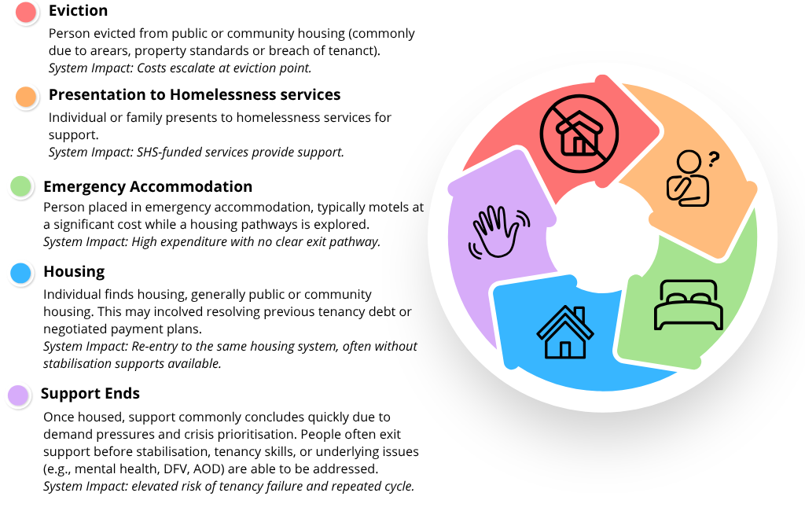
Because responsibility for different stages of the housing–homelessness continuum is distributed across portfolios (i.e. homelessness, housing, DFSV, health, child protection, justice), no single part of government currently holds full visibility of, or accountability for, the lifecycle costs associated with movement between housing, emergency accommodation, specialist homelessness services and other critical systems. Stakeholders consistently observed that this fragmentation impedes coordinated decision making at critical intervention points and reinforces a system response that is weighted toward crisis rather than prevention.
“Mental health, AOD and health are the biggest friction points when trying to support clients with complex co-morbidities. Between these areas, it can become a cycle of exclusionary eligibility criteria, where no service is ultimately able to provide support.” – Sector Participant
Effective recommissioning cannot assume seamless coordination between housing, homelessness, health and other adjacent systems in the absence of deliberate investment. This is particularly pertinent given the increasing reliance on adjacent systems such as health, DFSV and child protection, where housing supply constraints limit exit pathways. Where the mechanisms required to enable coordination, shared visibility and escalation are not explicitly resourced, responsibility for managing system interfaces is implicitly shifted onto services without the authority or leverage to resolve them.
"The Alliance model introduced additional governance, coordination and collaboration requirements without corresponding resourcing. In regional areas, increased travel and participation costs further reduced the funds available for frontline service delivery." – Survey Response
From a funding and commissioning perspective, the evidence points to the need for immediate investment in cross-portfolio coordination, strengthened data sharing and clearer escalation mechanisms across housing, homelessness, health, DFSV child protection and other system interfaces. It also highlights the importance of stewardship capacity capable of tracking and responding to lifecycle costs, repeat service use and patterns of system churn. Over the longer term, enabling investment is required to support tenancy sustainment, early intervention and joint accountability frameworks that reduce reliance on crisis responses and improve system flow.
Without this system level resourcing, recommissioning risks reinforcing existing churn patterns, embedding avoidable cost and complexity into the next phase of the homelessness system rather than enabling more effective and sustainable responses. Addressing these structural funding and coordination gaps will require deliberate investment in cross-portfolio stewardship, shared data and escalation mechanisms, alongside longer-term reforms to tenancy sustainment and early intervention. These system conditions underpin the commissioning and stewardship recommendations set out in this review, which are designed to shift investment away from crisis response and toward a more preventative, coordinated and sustainable system.
  - Chapter Summary
The findings in this chapter show that current resourcing and funding settings are not aligned with demand, service delivery realities or system design, and are contributing to structural strain across the sector. Funding has not kept pace with increasing complexity of need, workforce pressures and rising costs, resulting in a system operating at or near capacity while relying on services to absorb unmet demand and risk.
Existing arrangements prioritise activity over outcomes and do not reflect the intensity or diversity of support required. This has reinforced a crisis-driven model, constrained prevention and early intervention, and limited the system’s ability to respond flexibly across groups and regions. Funding settings also fail to adequately account for regional delivery costs or the resources required for culturally safe and Aboriginal-led responses.
These pressures are reflected in workforce strain, uneven service coverage and variable client pathways. Without a clear picture of unmet demand or the true cost of service delivery, the system remains constrained in its ability to plan and prioritise investment If funding levels and structures remain unchanged, existing pressures are likely to persist, constraining service capacity, increasing workforce strain and reinforcing a crisis-driven system with limited ability to prevent or reduce homelessness.
These findings highlight the need for a more evidence-informed approach to funding. This includes building a clearer understanding of unmet demand and system costs; redesigning commissioning to reflect population need and service contexts; and strengthening DHS stewardship to better align funding, policy and system priorities.

- What This Means for Recommissioning
Across the sector, there is strong evidence of expertise, commitment, organisational capability, collaboration and trust. However, these strengths are currently compensating for structural gaps they cannot resolve. Through strong system stewardship the homelessness system can shift from one that relies on local relationships, goodwill and individual effort, to one that is intentionally designed, resourced and governed to deliver positive outcomes for people experiencing or at risk of homelessness across South Australia.
  - Building the foundations for system reform
The Review highlights several critical lessons about how the system has been structured and where this has constrained its ability to deliver positive outcomes.
First, structure without system architecture cannot deliver system-wide coordination. The Review found strong examples of collaboration, coordination and leadership within Alliances, demonstrating the potential of Alliancing principles to support more integrated ways of working. However, these successes were not consistent across the system. The Alliancing model introduced formal structures and contractual arrangements, but without the system functions needed to support them. As a result, collaboration has developed unevenly and often within contractually defined geographic boundaries, rather than across the system as a whole. This highlights the importance of Recommendations 3, 3.1, 4, 4.1, 5, 5.1, 6, 6.1 ,7, 7.1, 17, 17.1 which establish the governance, stewardship and system architecture required to support coordination beyond organisational or geographic boundaries.
Second, cultural governance and safety must be embedded structurally, not assumed in practice. The absence of formalised cultural governance has resulted in inconsistent approaches to cultural safety and placed disproportionate responsibility on Aboriginal staff and organisations. This is a system design issue that requires system-level solutions. This finding underpins the Review's recommendations for formal Aboriginal cultural governance, Aboriginal decision-making authority and Aboriginal-led pathways, recognising that cultural safety requires structural accountability as well as frontline practice (Recommendations 3.1, 4.1, 6.1, 7.1, 8.1, 12.1, 16.1).
Third, local collaboration cannot substitute for system-level design. While many Alliances and Directly Contracted Services have built strong relationships, these have not translated into consistent system-wide responses for people experiencing homelessness. In the absence of shared frameworks, approaches, and coordination mechanisms, access, practice and decision making continue to vary depending on where people present for support. This reinforces the need for recommissioning to establish shared statewide approaches to access, practice and accountability, rather than relying on localised arrangements to create consistency (Recommendations 8, 8.1, 10, 10.1, 11, 11.1, 16).
Fourth, undefined system functions create inconsistency and drift. Core elements of the system including access pathways, practice expectations, cultural and clinical governance, and service interfaces were not clearly defined at the outset of the Alliance Model. This has resulted in variation across South Australia and placed responsibility for system functioning onto individual providers. Recommissioning provides an opportunity to clarify these functions through shared practice frameworks, clearer service interfaces and consistent expectations across the system (Recommendations 8, 8.1, 9, 9.1, 10, 10.1, 11, 11.1, 12, 12.1).
Finally, data, learning and feedback are core infrastructure. Without a fit-for-purpose data system and structured learning processes, the system lacks visibility of demand, unmet need, outcomes and risk. This limits the ability to plan, adapt and improve over time, and constrains both accountability and reform. Recommissioning provides an opportunity to establish the learning infrastructure required to support continuous improvement, ensuring that data, lived experience, cultural knowledge and practice insight are translated into system improvement over time. (Recommendations 7,7.1, 13, 13.1, 14, 14.1, 15, 15.1, 18, 18.1)
The findings of this Review reflect a sector that is committed to achieving better outcomes despite significant structural constraints. Recommissioning provides an opportunity to harness this collective expertise and commitment, translating existing strengths into a more coordinated, equitable and sustainable system for all South Australians affected by homelessness.
  - What recommissioning must deliver
Recommissioning must move beyond a focus on service configuration alone and establish the core system architecture required for a contemporary, coordinated and consistent homelessness response, regardless of where an individual presents. This includes clearly defining how the system is designed to operate as a whole, not just how individual services or alliances are funded or delivered.
At a minimum, this requires:
- Clear system stewardship: Government must take an active role in overseeing system performance, setting direction and ensuring alignment across policy, funding and service delivery.
- Embedded cultural governance and Aboriginal decision making authority: Cultural safety must be supported by formal structures, not reliant on informal relationships or individual capability
- Shared governance and accountability at a system level: Governance structures must extend beyond individual organisations and Alliances, enabling coordination, decision making and shared responsibility across the system.
- A consistent and coordinated approach to access, practice and pathways: People should experience the system as equitable, responsive and consistent, regardless of where they enter.
- A contemporary data and learning system to support decision making: The system must be able to understand demand, monitor outcomes and adapt over time, supported by continuous feedback from data, practice and lived experience.
Underpinning all elements is a capable and supported workforce, with training, communities of practice and workforce development mechanisms required to sustain shared approaches over time.
  - Implementing reform and building system capacity
Recommissioning provides an opportunity to work with the sector to implement many of the reforms identified through this review, particularly those related to stewardship, governance, accountability and system design. These reforms will start to improve consistency, accountability and system functioning in the short term. However, the Review also identifies a range of foundational system functions that are currently under-resourced. Establishing and sustaining these functions will require additional investment alongside reform of commissioning and system architecture.
Services consistently report that they are at or near capacity. This pressure is not always visible in system-level data, but is reflected in longer periods of support, increasing complexity of need, and growing strain on the workforce. In practice, demand is being managed through extension of effort, rather than expansion of capacity.
"… there are very limited options for innovation or for services to be truly as responsive as they could be due to a lack of adequate resourcing, staffing and funding... Organisations are under unprecedented pressure, and frontline staff are having to hold caseloads well over the recommended number of clients just to keep the waitlist low and manage demand... This additional pressure on staff is creating a higher risk of burnout, and leaving teams overwhelmed with a lack of suitable exit options for people experiencing homelessness." – Survey Response
DHS as system steward will need to monitor the risk that additional burden is placed on service providers without additional investment. Reform needs to be prioritised and implemented in stages over time, with explicit decisions made about the use of limited resources. In this context, recommissioning must be accompanied by a clear recognition of the true cost of delivering a safe, effective and equitable homelessness system, including not only service delivery, but the system infrastructure that underpins it.
Importantly, the investment required is not limited to frontline service delivery. The Review identified a range of essential system functions including coordination, cultural governance, learning infrastructure, workforce development and stewardship that are central to system cohesion and function but have historically been under-resourced.
While many of the reforms identified through this review can begin through recommissioning and stronger system stewardship, sustainable system transformation cannot continue to rely on extending effort, goodwill and workforce capacity beyond what can reasonably be sustained. A contemporary homelessness system requires investment not only in services, but in the infrastructure that enables those services to function effectively as part of a coordinated whole.
  - Building from strengths, not starting again
South Australia's homelessness sector already possesses many of the strengths required for reform. Across the Review, stakeholders consistently identified examples of strong local relationships, collaboration and workforce expertise as key assets within the current system. The challenge is not creating these strengths, but ensuring they are supported by the architecture required to sustain and scale them.
"You can write a really pretty contract, but that's not where good commissioning comes in. It's all about the relationships you build, the work you do, how the sector collaborates and works together, bolstering each other, shifting, moving, and sticking by what the scope is, what the practice is, and being willing to hold that line." – Sector Participant
Recommissioning should build on what is working while addressing the structural gaps identified throughout this review. Given the scale of change required, implementation should be staged, relational, and aligned with broader cross-system reform activity, ensuring that trust, service continuity and sector capability are maintained throughout transition.
With the right stewardship, governance and investment, the strengths that already exist across the sector can be supported to deliver lasting system change.

Appendices
Copies of appendices 1 to 15 are available upon request.

Appendix 16: Alternative text for figures

Figure 1: Past and Present Homelessness System Architecture
Figure 1 compares the homelessness service system before and after implementation of the Alliancing Model. Prior to Alliancing, government-funded a large number of directly contracted homelessness, Domestic and Family Violence (DFV), youth, Aboriginal-specific and specialist services that operated independently. Under the Alliancing Model, services are organised through four geographical Homelessness Alliances and one state-wide DFV Alliance, with government participating in Alliance governance, and there remain 16 Directly Contracted Services not included in any Alliance. The model was intended to support system-wide collaboration and coordination. However, the figure illustrates that collaboration and coordination largely occur within Alliance structures rather than through an integrated whole-of-system design ensuring coordination across Alliances and Directly Contracted Services.

Figure 2: Proposed System Model
The figure presents a layered model of the future homelessness system. Government operates as both funder and system steward, supported by horizontal architecture that enables whole-of-system decision making, collaboration and accountability. Cultural governance and clinical governance underpin a Universal Front Door that provides consistent entry, triage and assessment processes across all services access points. Directly contracted services deliver statewide and specialist responses to diverse population groups and needs. A learning system supports continuous improvement across all components. The figure also aligns key review recommendations with each layer of the model.

Figure 3: Approach to Sector Engagement
The figure presents a funnel-shaped engagement process consisting of five stages that progressively narrowed the focus of inquiry. The stages are Ethics and Planning, Desktop Review, Anonymous Surveys, Focus Groups, and Interviews.
In order of largest to smallest stage of the funnel:
- Ethics and Planning established the governance, ethical safeguards and methodology required to undertake the review.
- Desktop Review examined sector documents and information provided by homelessness services.
- Anonymous Surveys gathered feedback from staff across all levels of the homelessness system regarding service delivery, commissioning, innovations, successes and challenges.
- Focus Groups engaged Alliance and directly contracted service representatives to explore themes emerging from the survey findings.
- Interviews gathered perspectives from senior managers, government executives, commissioners and sector representatives.
Findings from each stage informed the activities and analysis undertaken in subsequent stages.

Figure 4: DHS-Funded SHS System
The figure presents the structure of the DHS-funded Specialist Homelessness Services system. The system comprises five Alliances: the state-wide Domestic and Family Violence Alliance, the Metropolitan Alliance (North and West Adelaide), the Metropolitan Alliance (South and East Adelaide), the Country Alliance (North), and the Country Alliance (South).
A state-wide homelessness phone line operates across the system. The state-wide domestic and family violence phone line operates within the Domestic and Family Violence Alliance. In addition to the Alliances, 16 directly contracted services provide targeted support outside the Alliance structure. These services focus on children and young people, people exiting custodial settings, Aboriginal and Torres Strait Islander peoples, and people experiencing rough sleeping and/or chronic homelessness.

Figure 5: Anonymous online staff survey response summary, collaboration with Domestic and Family Violence services
The figure presents staff survey responses regarding collaboration at three levels: within local regions, between regions, and across the homelessness sector as a whole. Perceptions of collaboration were strongest at the local level, where 44% of respondents agreed or strongly agreed that there was strong collaboration between their service and other DHS-funded homelessness and domestic and family violence services within their local region. Twenty-nine percent disagreed or strongly disagreed, while 27% were neutral.
For collaboration beyond the local region, positive responses decreased to 30%, while negative responses increased to 36%. Neutral responses remained relatively stable at 33%. Sector-wide collaboration received the lowest ratings. Twenty-eight percent agreed or strongly agreed that DHS-funded services collaborate as a whole sector to elevate practice and address system-level concerns, while 43% disagreed or strongly disagreed. Twenty-nine percent were neutral. The figure shows that perceptions of collaboration become less positive as the focus shifts from local relationships to system-wide collaboration, while neutral responses remain relatively consistent across all three levels.

Figure 6: Anonymous online staff survey response summary, purpose of Directly Contracted services
The figure presents staff survey responses to the statement that the role, purpose and intended client cohorts of Directly Contracted services are clearly understood within the Specialist Homelessness Services system.
More than half of respondents (53%) disagreed or strongly disagreed with the statement, indicating that the role of Directly Contracted services is not clearly understood across the system. One-third of respondents (33%) were neutral, while 15% agreed or strongly agreed that the role and purpose of these services were clear. Overall, the figure highlights significant uncertainty across the sector regarding the function and contribution of Directly Contracted services.

Figure 7: Vertical and Horizontal Governance lines of responsibility
The figure contrasts two forms of governance within the homelessness system. Vertical governance refers to structured lines of responsibility, decision-making and accountability that operate within organisations and funding arrangements. These structures clarify roles, support delegation and escalation, and enable oversight of services and programs.
Horizontal governance operates across organisations and governance structures. It supports coordination, shared decision-making, collective stewardship and collaborative problem-solving on issues that extend beyond individual organisations or service boundaries.

Figure 8: Originally intended Alliance Model Governance and Implemented Alliance Model Governance
The figure compares the governance structure originally designed for the Alliancing Model with the governance structure that was ultimately implemented. The intended model included both vertical and horizontal governance. Vertical governance was provided through governance arrangements within each Alliance. Horizontal governance was intended to occur through an Alliance System Steering Group that brought together Alliance representatives, government funders, directly contracted services, other homelessness initiatives and key stakeholders to support coordination, collective decision-making and system stewardship.
In the implemented model, Alliance-level governance structures were established as intended, including Alliance Leadership Teams, Alliance Senior Managers and Alliance Management Teams. However, the Alliance System Steering Group was not established, resulting in the absence of the primary intended system-wide horizontal governance mechanism. Instead, coordination occurs through meetings involving Alliance Senior Managers. The 16 directly contracted services remain outside Alliance governance structures and participate separately through contract management arrangements. The figure concluded that vertical governance was implemented as designed, while the intended horizontal governance architecture was not fully realised.

Figure 9: Anonymous online staff survey response summary, Alliance governance
The figure presents staff survey responses to four statements about the impact of Alliance governance on system outcomes. Across all four statements, responses were mixed. Between 21% and 38% of respondents disagreed or strongly disagreed that Alliance governance supports evidence-informed service delivery, client-led decision making, improved client experience, or a shared vision and purpose for the homelessness sector. Between 24% and 32% of respondents selected a neutral response, while positive responses ranged from 38% to 47%.
The strongest positive response related to client-led decision making, where 47% agreed or strongly agreed that Alliance governance supports keeping clients at the heart of decision making. The weakest positive response related to client experience, where 38% agreed or strongly agreed that the Alliancing model supports clients to have a better system experience than prior to Alliancing. The figure shows mixed levels of confidence in the effectiveness of Alliance governance and suggests ongoing uncertainty regarding its impact on system-level outcomes.

Figure 10: Anonymous online staff survey response summary, responding to children and young people
The figure presents staff survey responses to two statements regarding services for children and young people.
Most respondents reported that their service has the tools and support needed to respond to the unique needs of children and young people, with 69% agreeing or strongly agreeing and 16% disagreeing or strongly disagreeing. Similarly, 79% agreed or strongly agreed that their service can respond flexibly to the unique needs of children and young people regardless of family composition, while 9% disagreed or strongly disagreed.
The results indicate strong confidence in the capability and flexibility of individual services to respond to children and young people. However, these findings should be considered alongside broader concerns identified elsewhere in the review regarding the system's overall capacity to support youth-specific responses.

Figure 11: BEBOLD Analysis Infographics

First Infographic: Earlier Experiences that Shape Later Life
The figure presents findings from BEBOLD analysis comparing young people who accessed Specialist Homelessness Services (SHS) with the broader South Australian youth population. Young people who received SHS support were more likely to have experienced child protection involvement, socioeconomic disadvantage and out-of-home care during childhood. Compared with the broader youth population, they were 2.8 times as likely to have received a child protection notification, 1.7 times as likely to have been born in an area of low socioeconomic advantage, and 6.8 times as likely to have experienced out-of-home care. The findings highlight the strong relationship between homelessness service use and earlier experiences of disadvantage.

Second Infographic: Enrolment and Absenteeism in the Public School System
The figure presents BEBOLD findings comparing public school enrolment and attendance outcomes for young people who accessed Specialist Homelessness Services (SHS) and the broader South Australian youth population. Enrolment rates were similar in Years 10 and 11, but lower for the Youth SHS group in Year 12. Young people who received SHS support also experienced higher levels of chronic absenteeism, being 2.9 times more likely to be chronically absent in Year 10, 2.5 times more likely in Year 11, and 2.2 times more likely in Year 12. These findings point to higher levels of educational disengagement among young people who accessed homelessness services.

Third Infographic: Death in Early Adulthood
The figure presents BEBOLD findings comparing mortality outcomes between young people who accessed Specialist Homelessness Services (SHS) and the broader South Australian youth population between the ages of 18 and 25.
Among the Youth SHS group, 1 in 217 young people (0.5%) died between the ages of 18 and 25, compared with 1 in 345 young people (0.3%) in the broader South Australian youth population. Young people who received SHS support were 1.5 times as likely to die in early adulthood than their peers.

Fourth Infographic: Other Systems Young People are Interacting With
The figure presents BEBOLD findings comparing justice and health system contact among young people who accessed Specialist Homelessness Services (SHS) and the broader South Australian youth population. It found that young people who received SHS support were substantially more likely to have been imprisoned in the previous year, with 4.3% (1 in 23) imprisoned compared with 0.3% of the broader youth population. This equates to a rate 13.5 times higher than the broader South Australian youth population.
Young people who received SHS support were also more likely to have been hospitalised in the previous year. Hospitalisation for any reason was recorded for 53.3% (1 in 2) of the Youth SHS group compared with 22.8% (1 in 4) of the broader youth population. Hospitalisation for alcohol and other drug related reasons was recorded for 11.0% (1 in 9) of the Youth SHS group compared with 7.0% (1 in 14) of the broader youth population. Hospitalisation for mental health related reasons was recorded for 21.5% (1 in 5) of the Youth SHS group compared with 14.9% (1 in 7) of the broader youth population. The findings indicate that young people who accessed homelessness services experienced higher levels of contact with justice and health systems than their peers in the broader South Australian youth population.

Figure 12: Combinations of characteristics of Young People in contact with SHS (Youth SHS) compared to All SA Youth Populations from the 2022 calendar year
The figure compares the prevalence and combinations of five types of system contact among young people who accessed Specialist Homelessness Services (SHS) and the broader South Australian youth population: any public hospital presentation or admission, alcohol and other drug related hospital contact, out-of-home care, adult imprisonment, and mental health related hospital contact.
In both groups, the most common pattern was having none of these recorded contacts. However, young people in the Youth SHS group were substantially more likely to experience one or more forms of system contact, and more likely to experience multiple contacts concurrently.
Among the Youth SHS group, hospital contact was the most common characteristic experienced by 53.7%. and for 8% this occurred alongside mental health related hospital contact, for 4.3% this occurred along with out-of-home care, and for 9.1% this occurred alongside alcohol and other drug related hospital contact. By comparison, a greater proportion of the broader South Australian youth population had no recorded contacts, and fewer experienced multiple overlapping forms of disadvantage. The figure highlights the higher prevalence and co-occurrence of health, justice and care system contact among young people who accessed homelessness services.

Figure 13: Units of assertive outreach by Metro, Regional and remote agencies, by financial year
The figure shows changes in the distribution and volume of assertive outreach between FY2018/19 and FY2024/25. Prior to Alliancing, regional services delivered a higher proportion of recorded outreach than metropolitan services. Post Alliancing, this pattern reversed, with metropolitan services accounting for an increasing share of outreach activity. Over the same period, total outreach delivery declined from 2,178 units in FY2020/21 to 792 units in FY2024/25.

Figure 14: Units of assertive outreach for Aboriginal clients by Metro, Regional and Remote agencies and financial year
The figure shows changes in the distribution and volume of assertive outreach delivered to Aboriginal clients between FY2018/19 and FY2024/25. Prior to Alliancing, outreach activity was distributed relatively evenly between metropolitan and regional services. Following implementation of the Alliancing Model, metropolitan services delivered an increasing share of outreach, while regional and remote services delivered a smaller proportion of activity. Total outreach delivery also declined over the period, from a peak of 891 units in FY2020/21 to approximately 300 units in the most recent year.

Figure 15: Proportion of support periods that were Domestic, Family and Sexual Violence (DFSV) involved, by financial year
The figure shows the total number of Specialist Homelessness Services support periods and the proportion related to DFSV between FY2018/19 and FY2024/25. Total support periods increased slightly to a peak of 27,761 in FY2021/22 before declining to 22,250 in FY2024/25. Over the same period, the proportion of support periods relating to DFSV remained relatively stable, ranging from approximately one-third to just over one-third of all support periods. These results indicate that DFSV-related support has remained a consistent component of homelessness service delivery despite a decline in overall support periods.

Figure 16: Proportion of Domestic and Family Violence (DFV) involved support periods that were supported by DFV agencies, by financial year
The figure compares the total number of DFV-related support periods with the number delivered by DFV agencies between FY2018/19 and FY2024/25. Across the period, DFV agencies delivered between one-quarter and one-third of DFV-related support periods. In FY2024/25, 5,551 of 7,307 DFV-related support periods (76%) were delivered by DFV agencies. Similar patterns were evident across previous years. These results demonstrate that responses to domestic, family and sexual violence are delivered across the homelessness system and are not confined to specialist DFV services.

Figure 17: Number of support periods, and number of individuals supported, by financial year
The figure compares the number of Specialist Homelessness Services support periods with the number of individuals supported between FY2018/19 and FY2024/25. Following implementation of the Alliancing Model, both measures declined over time. Support periods decreased from a peak of 27,761 in FY2021/22 to 22,250 in FY2024/25, while the number of individuals supported declined from 20,132 to 18,475 over the same period. The chart shows that service activity and the number of people accessing support both reduced, with the decline in individuals supported suggesting fewer people entered the system.

Figure 18: Average days of support per support period, per person, by financial year
The figure shows the average number of support days per person alongside the total number of support days provided between FY2018/19 and FY2024/25. Average support duration increased from 114 days in FY2018/19 to 138 days in FY2024/25. Over the same period, the total number of support days provided remained relatively stable, peaking at 2.72 million days in FY2022/23 before declining slightly to 2.55 million days in FY2024/25. The results indicate that homelessness services were increasingly providing longer periods of support to a smaller number of people.

Figure 19: Proportion change in client housing outcomes from entry to exit, within each financial year
The figure shows the change in housing outcomes between service entry and exit across financial years from FY2018/19 to FY2024/25. Across all years, there are clients consistently moving away from rough sleeping, couch surfing and short-term emergency accommodation between service entry and exit, although the magnitude of positive change generally declined over time. However, the increase in the proportion of clients each year exiting to renting and rent-free accommodation also decreased from an additional 15.1% exiting to renting in 2018/19 FY to an additional 7.8% exiting to renting in 2024/25.
The results suggest that homelessness services continued to support movement towards more stable housing outcomes, and the reduction in the proportion of clients moving to positive outcomes should be considered in the context of constrained housing supply and limited exit pathways.

Figure 20: Proportion change in housing outcomes from entry to exit for Aboriginal clients, within each financial year
The figure shows the change in Aboriginal client housing outcomes between service entry and exit across financial years from FY2018/19 to FY2024/25. Across all years, there were positive reductions in Aboriginal clients consistently moving away from rough sleeping, couch surfing and short-term emergency accommodation between service entry and exit, and there were positive increases in clients exiting into renting or rent-free housing.
However, the positive changes reduced over time. For example, in 2018/19 FY an additional 14.1% of Aboriginal clients exited to renting accommodation compared to 5.8% additional Aboriginal clients moving to renting accommodation from service entry to exit in 2024/25 FY.
The results should be interpreted in the context of worsening rental and housing supply which has flow on effects to the ability for services to support positive housing exit pathways.

Figure 21: Proportion change in housing outcomes for young people aged 15 to 24 from entry to exit, within each financial year
The figure shows the change in housing outcomes for young people aged 15 to 24 between service entry and exit across financial years from FY2018/19 to FY2024/25. Across all years, the proportion of young people experiencing rough sleeping, couch surfing and short-term emergency accommodation decreased between entry and exit, while the proportion exiting to renting and rent-free housing increased.
The largest positive changes were consistently observed for renting, ranging from a positive change from entry to exit of 24.1 percentage points in 2018/19 FY to 11.3 increase in the 2024/25 FY. Improvements in rent-free housing ranged from 2.4 in 2018/19 FY to 0.9 percentage points in 2024/25 FY. Positive changes to housing outcomes from entry to exit reduced over time, reflecting system-wide challenges with housing supply

Figure 22: Proportion of return support periods within a financial year, by individuals
The figure shows the proportion of individuals with one support period compared with two or more support periods within a financial year between FY2018/19 and FY2024/25. The proportion of clients with repeat engagement increased from 19% in FY2018/19 to a peak of 30% in FY2021/22 before declining to 17% in FY2023/24 and FY2024/25. Correspondingly, the proportion of clients with a single support period decreased to 70% in FY2021/22 before increasing to 83% in the most recent years.

Figure 23: Average housing service units per person, by financial year
The figure shows the average number of housing service units delivered per client between FY2018/19 and FY2024/25 across four categories: prevention, long-term housing, medium-term transitional housing and short-term emergency accommodation. Prevention and long-term housing service units increased over the reporting period, while medium-term transitional housing remained the largest category. Short-term emergency accommodation remained relatively stable.

Figure 24: Anonymous online staff survey response summary, funding
The figure presents staff survey responses regarding the adequacy of current funding levels. Across all three statements, negative responses exceeded positive responses. The strongest disagreement related to whether funding levels are appropriate to meet local demand for homelessness and domestic and family violence services, with 87% of respondents disagreeing or strongly disagreeing. Similarly, 72% of respondents disagreed or strongly disagreed that current funding supports prevention and early intervention activities and 55% disagreed or strongly disagreed that current funding enables innovation, service improvement and the use of evidence-informed approaches.

Figure 25: Anonymous online staff survey response summary, collaboration for dual client need
The figure presents staff survey responses to the statement that, when clients have both homelessness and domestic, family and sexual violence (DFSV) needs, services work together to provide coordinated support. Responses were divided, with 36% of respondents disagreeing or strongly disagreeing, 27% reporting a neutral view, and 37% agreeing or strongly agreeing that services work together to provide coordinated support.

Figure 26: Anonymous online staff survey response summary, cultural safety, equity and inclusion
The figure presents staff survey responses regarding cultural safety, equity and inclusion. Most respondents agreed or strongly agreed that their workplace is culturally safe (85%), that clients receive equitable service quality regardless of the issues they present with (83%), and that clients receive equitable service regardless of characteristics such as cultural background, sexual orientation, culture or age (89%). Most respondents also agreed or strongly agreed that cultural awareness and competency training supports their work with Aboriginal and Torres Strait Islander people (87%). Positive responses were lower in relation to staff having the tools and support needed to respond to diverse and intersecting client needs, with 67% agreeing or strongly agreeing and 20% reporting a neutral response.

Figure 27: Anonymous online staff survey response summary, lived experience
The figure presents staff survey responses regarding lived experience participation in the homelessness system. Responses were mixed on whether lived experience is being authentically used to support system change and reform, with 39% agreeing or strongly agreeing, 34% reporting a neutral view, and 28% disagreeing or strongly disagreeing. Responses were more negative regarding resourcing, with 55% disagreeing or strongly disagreeing that there is adequate resourcing to embed lived experience in the homelessness system, compared with 19% who agreed or strongly agreed.

Figure 28: Types of Contribution and Payment Rates Table: The Constellation Project
The figure presents a framework for lived experience participation developed by The Constellation Project. Participation activities are organised across three levels of influence: low ($44 per hour), medium ($77 per hour) and high ($90 per hour).
At the low level, participants contribute perspectives and feedback based on their lived experience. At the medium level, participants join advisory groups, provide feedback on organisational activities, attend stakeholder meetings and contribute to publications. At the high level, participants facilitate workshops, lead or co-lead meetings, represent organisations at external events, and participate in media interviews and public presentations. The framework demonstrates how increasing responsibility, influence and representation are matched with higher rates of remuneration and recognition of lived experience expertise.

Figure 29: Lived Experience System Infrastructure
The figure presents a proposed statewide lived experience system infrastructure for the homelessness sector. At the centre is a homelessness lived experience system that supports feedback, participation and continuous improvement to strengthen outcomes for people experiencing homelessness.
The model combines top-down functions, where people with lived experience contribute advice on system and policy issues, with bottom-up functions, where client experiences and feedback are escalated from service-level interactions. Lived Experience Engagement Services, including the Lived Experience Reference Group (LERG), support participation across the system.
Client feedback, complaints and escalation pathways, ethical storytelling, data, and cultural safety considerations inform the infrastructure. The model is supported by ethical, trauma-informed lived experience frameworks and enables feedback to be shared across services and governance structures.

Figure 30: Anonymous online staff survey response summary, data and outcomes
The figure presents staff survey responses regarding Homelessness to Home (H2H) data collection, reporting and outcomes measurement. Across most measures, negative responses exceeded positive responses. Half to over two-thirds of respondents disagreed that information reported in H2H reflects all work undertaken with clients (70% disagreed), captures outcomes beyond contractual requirements (59% disagreed), or aligns with the DHS Outcomes Framework (48% disagreed). Views were more mixed regarding whether required data collection is culturally safe and inclusive, and whether H2H reporting is useful for understanding progress towards KPIs and client outcomes.

Figure 31: Cycle Diagram, Funding and Support Loop in Current System Structure
The figure illustrates a recurring cycle between housing and homelessness systems. The cycle begins with eviction from public or community housing, followed by presentation to homelessness services for support. People may then enter emergency accommodation while housing pathways are explored, before securing public or community housing. Support commonly ends after housing is obtained, often before long-term stabilisation has occurred, increasing the risk of tenancy failure and a return to the beginning of the cycle.
The figure identifies system impacts at each stage, including escalating costs following eviction, expenditure associated with emergency accommodation, and the risk of repeated cycling through housing and homelessness systems when ongoing support needs remain unresolved.

Royal Commission into Domestic, Family and Sexual Violence. (2025). With courage: South Australia’s vision beyond violence (Final Report). Government of South Australia. https://www.royalcommissiondfsv.sa.gov.au/__data/assets/pdf_file/0006/1174695/With-Courage-Report.pdf
Department of the Premier and Cabinet. (2025). South Australian Government response to the Royal Commission into Domestic, Family and Sexual Violence. Government of South Australia. https://www.dpc.sa.gov.au/__data/assets/pdf_file/0011/1216973/RCDFSV-SA-Government-Response.pdf
Government of South Australia and SAACCON. 2024. Closing the Gap: South Australia’s Implementation Plan 2024-2026. Retrieved from: https://www.agd.sa.gov.au/__data/assets/pdf_file/0009/1096758/SA-Closing-the-Gap-Implementation-Plan-24-26.pdf
Tually, S. 2022, SA homelessness alliance system initial governance review, Reflections and recommendations short report no. 1, Period: first 18 months of operation, for the SA Housing Authority, CSI Flinders – SA Housing Authority Partnership, CSI Flinders, Adelaide.
Australian Business Lawyers and Advisors. 2026. FWC hands down landmark decision that overhauls SCHADS Award. Retrieved from: https://ablawyers.com.au/resources/articles-downloads/
Amplify Alliance. 2026. Fair Wage Rise Must Be Matched by Fair Funding, Peak Body Warns. Retrieved from: https://amplifyalliance.org.au/fair-wage-rise-must-be-matched-by-fair-funding-peak-body-warns/
University of Melbourne. (n.d.). Relational contracting and service commissioning. School of Social and Political Sciences, Australian Welfare and Work Lab. https://arts.unimelb.edu.au/school-of-social-and-political-sciences/our-research/australian-welfare-and-work-lab/about/relational-contracting-and-service-commissioning
South Australia’s Homelessness Alliances: Part B Specification, Government of South Australia (no date).
Annexure 2. South Australia’s Homelessness Alliances- Region Specific Information, Adelaide North; Adelaide South; Country North; Country South.
Annexure 2. South Australia’s Homelessness Alliances- Specific Information, Domestic and Family Violence Alliance.
South Australia’s Homelessness Alliances: Part B Specification, Government of South Australia (no date).
South Australia’s Homelessness Alliances: Part B Specification, Government of South Australia (no date).
Rocket Science. 2024. Glasgow Alliance to End Homelessness: Lessons learned review. Retrieved from: https://glasgowcity.hscp.scot/publication/glasgow-alliance-end-homelessness-lessons-learned-review-rocket-science
Department of Human Services. (n.d.). Future directions for homelessness. Government of South Australia. https://dhs.sa.gov.au/__data/assets/pdf_file/0018/170118/Future-Directions-for-Homelessness.pdf
Australian Bureau of Statistics. (2022). South Australia: Aboriginal and Torres Strait Islander population summary. Retrieved from: https://www.abs.gov.au/articles/south-australia-aboriginal-and-torres-strait-islander-population-summary.
Dobrovic J, Di Girolamo N, Montgomerie A, Bradshaw T, Lynch J, Pilkington R, (2024). Analysis of Specialist Homelessness Services Data to support the Domestic and Family Violence Safety Alliance. Adelaide: BetterStart Health and Development Research Group, The University of Adelaide.
Department of Human Services (2024). Homelessness Outcomes Framework. Retrieved from: https://dhs.sa.gov.au/how-we-help/homelessness/homelessness-data-and-directions-in-South-Australia/homelessness-outcomes-framework
South Australian Government, Department of Human Services. (2020). Future directions for homelessness. https://www.dhs.sa.gov.au/__data/assets/pdf_file/0018/170118/Future-Directions-for-Homelessness.pdf
Batterham, D., Barnes, E., Hartley, C., Flanagan, K., Veeroja, P., Robinson, C., & Mackelprang, J. (2026). Workplace trauma on the social housing and homelessness frontline (AHURI Final Report No. 455). Australian Housing and Urban Research Institute Limited. https://www.ahuri.edu.au/research/final-reports/455
Australian Housing and Urban Research Institute. (2023). Building an effective Specialist Homelessness Services sector workforce (Policy Evidence Summary, October 2023). https://www.ahuri.edu.au/sites/default/files/documents/2023-10/PES-409-Building-an-effective-Specialist-Homelessness-Services-sector-workforce.pdf
Council to Homeless Persons & RMIT Workforce Innovation and Development Institute. (2024, August 8). SHS Workforce Analysis Report. https://chp.org.au/publication/widi-shs-workforce-analysis-report/
Cortis, N., & Blaxland, M. (2024). Australia’s social and community services workforce: Characterisation, classification and value. UNSW Social Policy Research Centre. https://www.unsw.edu.au/research/sprc/our-projects/australias-social-and-community-services-workforce
Fair Work Commission. (2025). [2025] FWCFB 74: Gender-based undervaluation – priority awards review (AM2024/19–23, AM2024/25, AM2024/27). https://www.fwc.gov.au/documents/resources/2025fwcfb74.pdf
Australian Housing and Urban Research Institute. (2023). Building an effective Specialist Homelessness Services sector workforce (Policy Evidence Summary, October 2023). https://www.ahuri.edu.au/sites/default/files/documents/2023-10/PES-409-Building-an-effective-Specialist-Homelessness-Services-sector-workforce.pdf
Cortis, N., & Blaxland, M. (2024). Australia’s social and community services workforce: Characterisation, classification and value. UNSW Social Policy Research Centre. https://www.unsw.edu.au/research/sprc/our-projects/australias-social-and-community-services-workforce
Australian Housing and Urban Research Institute. (2023). Building an effective Specialist Homelessness Services sector workforce (Policy Evidence Summary, October 2023). https://www.ahuri.edu.au/sites/default/files/documents/2023-10/PES-409-Building-an-effective-Specialist-Homelessness-Services-sector-workforce.pdf
Rent Right SA. (2023). Lived Experience Engagement Service: Lived Experience Framework, Suth Australia’s Housing and Homelessness System. https://www.syc.net.au/assets/images/Lived-Experience.pdf
The Constellation Project. (2024). Lived Experience Practice Framework. https://theconstellationproject.com.au/wp-content/uploads/2024/05/20240710-Constellation-LivedExperienceFramework.pdf
LELAN. (2026). LELAN: Dignity, Autonomy & Human Rights. https://www.lelan.org.au/
Embolden. (2026). Lived Experience Engagement. https://embolden.org.au/lived-experience-engagement
Rent Right SA. (2023). Lived Experience Engagement Service: Lived Experience Framework, Suth Australia’s Housing and Homelessness System. https://www.syc.net.au/assets/images/Lived-Experience.pdf
Homelessness Network Scotland. (2025). Change Team: We are all in, are you? https://homelessnetwork.scot/change-team/#:~:text=All%20in%20for%20Change%20and%20The%20Change%20Team&text=It%20is%20driven%20by%20a,a%20very%20informal%20working%20approach.
Scottish Government. (2025). Homelessness Prevention and Strategy Group. https://www.gov.scot/groups/homelessness-prevention-and-strategy-group/
Commonwealth of Australia. (2024). National Agreement on Social Housing and Homelessness. https://federalfinancialrelations.gov.au/sites/federalfinancialrelations.gov.au/files/2024-06/nashh-final.pdf
Department of Social Services. (2025). Transparency Portal: Results Outcome 4 – Housing. https://www.transparency.gov.au/publications/social-services/department-of-social-services/department-of-social-services-2023-24-annual-report/part-2---annual-performance-statements/results-outcome-4-%E2%80%93-housing

