

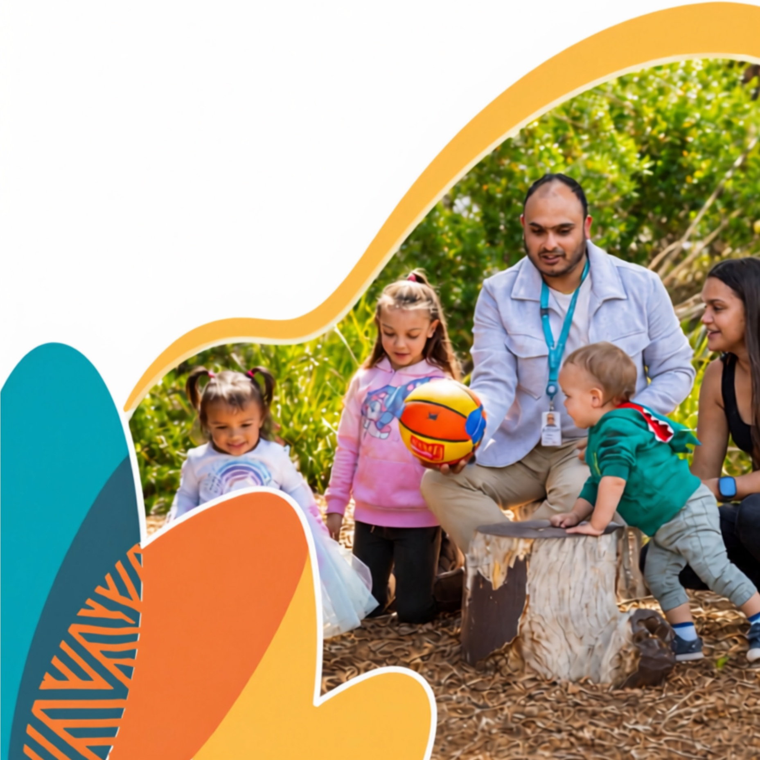
Child Safe

Code of Conduct Guide
  - A guide for child
  - related organisations

We thank the NSW Office of the Children’s Guardian for allowing us to include information in this guide that originally appeared in their Understanding and Developing a Child Safe Code of Conduct and their Child Safe Code of Conduct template.

Stock images appear in this publication. These images are for illustrative purposes only, and people depicted in these images may not be associated with the publication’s subject matter.
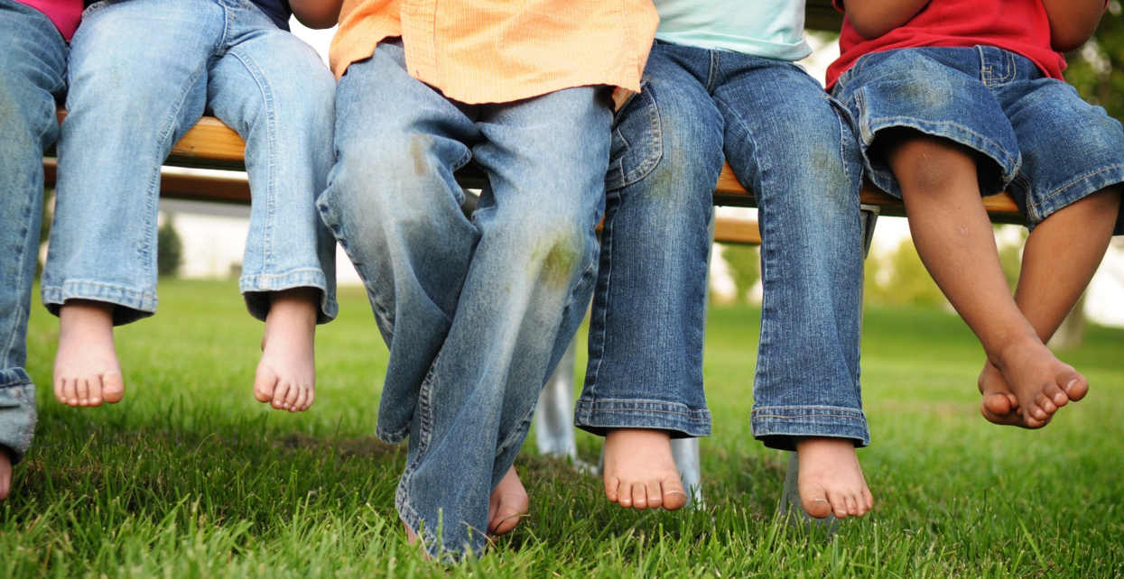 Version 1.0

Contents
Contents
Contents 3
Overview 5
Definitions 6
An effective CSCC 7
Consultation 7
Use clear language 7
Read, understand and sign 7
Communication 8
Educate 8
Review 8
Components of your CSCC 9
Define the purpose and scope 9
Reflective questions 9
Define child abuse and harm 9
Reflective questions 9
Respond to risks adults may pose to children 9
Reflective questions 9
Include child safe behaviours 10
Reflective questions 10
Outline internal and external reporting obligations 11
Reflective questions 11
Outline offences for not acting to protect children or report abuse 12
Reflective questions 12
Specify consequences for breaches of the CSCC 12
Reflective questions 12
Include a date for review 13
Reflective questions 13
Acceptable, unacceptable and concerning behaviours 14
Acceptable behaviours 14
General 14
Specific 15
Physical contact with children and nudity 15
Acceptable physical contact 16
Unacceptable physical contact 16
Travelling alone with a child 17
Interacting with others 18
Acceptable 18
Unacceptable 18
Technology and social media 18
Unacceptable or illegal behaviours 18
Alcohol, recreational drugs and child abuse images 19
Unacceptable or illegal behaviours 19
Gifts and benefits 19
Unacceptable or illegal behaviours 19
Out of hours work and secondary employment 19
Concerning behaviours 20
Appendix 1: Child Safe Code of Conduct Template 21
Appendix 2: Behaviours that constitute child abuse 27

Overview
A Child Safe Code of Conduct (CSCC) is a key document in an organisation’s efforts to keep children safe. It helps manage risks to child safety that may arise through workers interacting with children. The purpose of a code of conduct is to establish a clear set of rules and expectations that’s in line with your organisation’s culture and values. Having clear rules and expectations of how workers are expected to interact with children helps to prevent child abuse and harm. It also encourages reporting of inappropriate behaviour and creates positive expectations for the behaviour of all workers in your organisation.
A CSCC:
- provides workers with a clear guide on the behaviour that is expected of them, and of behaviours that are unacceptable or concerning
- provides guidance so workers are not left to recognise unacceptable or concerning behaviour on their own
- outlines the likely action your organisation will take if there is a breach of the code
- is applicable to all workers working or volunteering in your organisation. An age-appropriate code of conduct may also be developed for children, especially those aged between 13 and 18.
This guide aims to help you build your own CSCC. It explains what should be in it, behaviours that may be included, both acceptable and unacceptable and how these behaviours may be tailored to your type of organisations. A CSCC template is provided (Appendix 1) that you can use to create a CSCC specific to your own unique environment.
Disclaimer: The information provided in this document is for guidance purposes only. Please always refer to the appropriate legislation to ensure you are meeting your child safe legal requirements and fair work obligations in South Australia.

Definitions
Abuse – abuse against a child may take the form of sexual, physical, psychological abuse or neglect. Refer to the Child Safe Policy Guideline: Descriptions of abuse and indicators of harm - (www.dhs.sa.gov.au/how-we-help/ngo-and-sector-support/child-safe-environments/about-child-safe-policies/guide-to-writing-or-reviewing-your-child-safe-policy#indicators-of-harm)
Child/children – includes all children and young people under the age of 18 years
Harm – Harm is the resulting effect to a child after they have been sexually, physically, mentally or emotionally abused or neglected.
Worker – includes all staff, volunteers, work placement students, contractors, board/committee members, as well as business owners and managers.


Image: AbdobeStock

An effective CSCC
The most effective CSCCs are those that are based on risk of harm to children and specific to each unique organisation. The following factors will assist you in creating an effective CSCC.
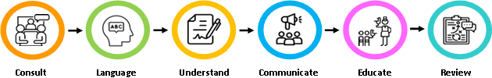

Consultation
Establish a group to develop your CSCC. Think about ways you can consult with children and communities as part of the process.

Use clear language
A CSCC should be easy to read and understand. For example:
- I will treat all children with respect by listening to their needs, remaining calm and using positive, non-offensive language
- I will not disrespect children by yelling, swearing or engaging in any abusive or intimidating behaviour.
Write the CSCC using plain English and avoid using vague statements, difficult words or long sentences. Use direct language and define words like ‘appropriate’. It can be helpful to use work-related examples to highlight key messages.
Poor example: Maintain appropriate boundaries with children.
Better example: Do not spend time alone with a child in a secluded environment and always ensure you are in the direct sight of another worker.

Read, understand and sign
It’s common practice for all workers to be required to read, understand and sign your CSCC on engagement with your organisation. You should keep a copy of the signed document or have them sign a register.
Where possible, training should be offered so all workers understand the purpose of the CSCC and the rules in contains. It can be offered as part of their induction or as one-off training for people newly engaged by the organisation. Workers should also be given regular reminders of the content of the CSCC if concerns arise, as part of performance reviews and via ongoing training for workers.

Communication
Your CSCC will work best when it’s widely accessible to all stakeholders including workers, children, families and communities. Organisations are increasingly providing age accessible CSCCs for children that describe unacceptable behaviours by workers. Some organisations also create different CSCCs for different sectors of their workforce depending on how they interact with children.
Ways to communicate your CSCC include social media, worker induction, agenda item at meetings and posters. Importantly, leadership within your organisation should model the behaviour they expect from workers.

Educate
Explain to children in age-appropriate ways, that a CSCC is in place to keep them safe and talk about acceptable and unacceptable interactions between workers and themselves. Also let children know the ways they can report a concern if a worker makes them feel unsafe.

Review
Your CSCC should be reviewed regularly and after any critical incidents. Remember to think about ways to consult with children when reviewing your CSCC. It can empower them and lets you know what makes them feel safe or unsafe.
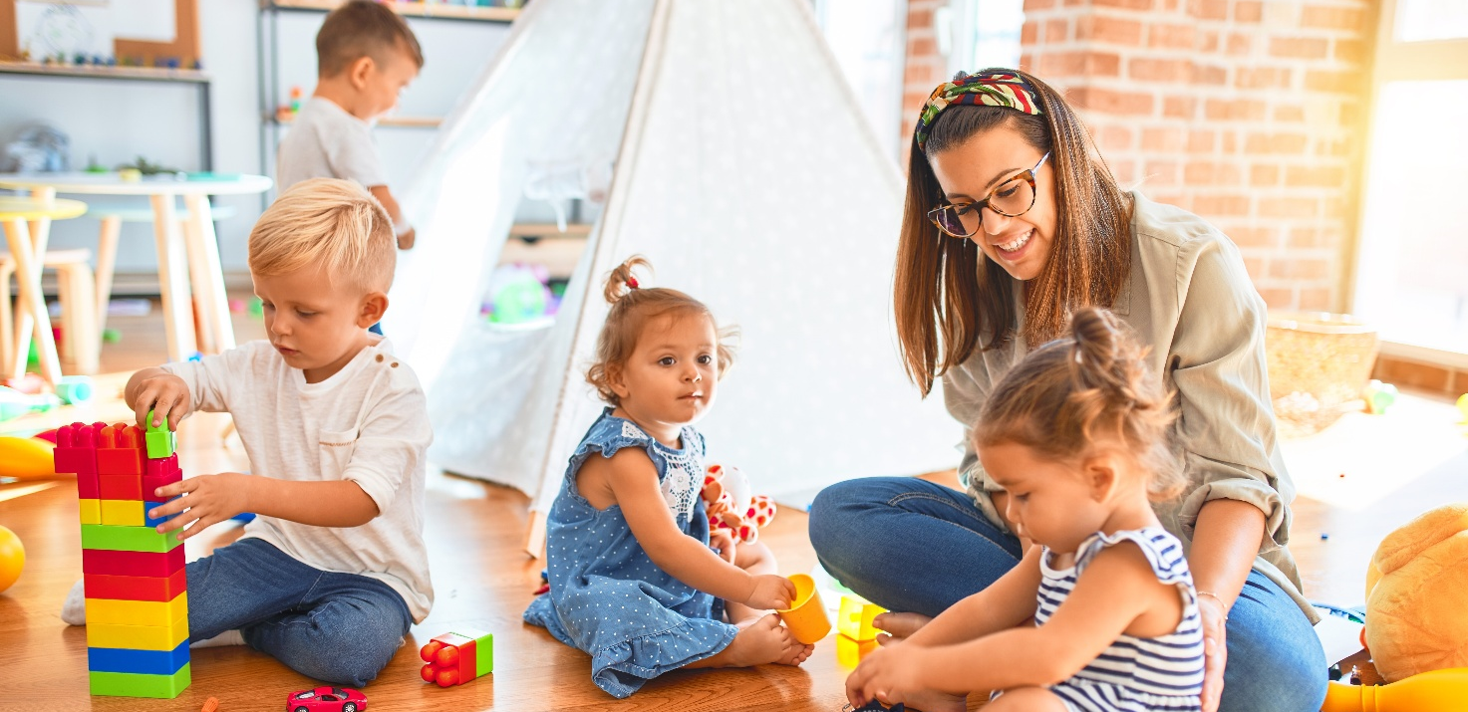 Image: AbdobeStock

Components of your CSCC
There are different parts to a CSCC and the table below explains the purpose of each part. It also includes some reflective questions you can ask to see if your organisation is meeting accepted standards.

Define the purpose and scope
Child safe organisations are committed to creating and maintaining an environment that promotes the safety of all children. Your CSCC should include your aim to protect children and reduce the risk of abuse and harm to them. It should encourage all workers to be responsible for promoting the safety, wellbeing and empowerment of children by providing them guidance on how to safely interact with children.

Reflective questions
- How do our values show our organisation’s commitment to keeping children safe?
- How do our leaders set expectations about how workers should behave towards children?

Define child abuse and harm
Defining abuse and harm helps to clarify the range of behaviours that are unacceptable. A good CSCC should describe the various forms of abuse and examples of specific behaviours within those definitions. Refer to Appendix 2: Behaviours that constitute child abuse.

Reflective questions
- What risks to child safety may arise if a CSCC is not implemented in our organisation?
- Is there are form of child abuse that is more likely to occur in our organisation?
- How can we be alert to, and manage this higher risk?

Respond to risks adults may pose to children
Child Safety Risk Management Plans should identify concerning behaviours and risks to child safety. Refer to Child Safety Risk Management Guide at www.dhs.sa.gov.au/how-we-help/ngo-and-sector-support/child-safe-environments/about-child-safe-policies/child-safe-policy-templates-and-guidelines. A CSCC should describe these behaviours as being unacceptable.

Reflective questions
- Does our Child Safety Risk Management Plan identify instances of potential risk to children by adults?
- Have we included any unacceptable behaviours in our CSCC?

Include child safe behaviours
Include child safe behaviours that are consistent with your organisation’s culture and values. All organisations providing services to children should have a CSCC that details behaviour with or towards children that is acceptable, unacceptable, as well as concerning. Behaviours that are of concern in some organisations, may not be in others. These behaviours give children the confidence to speak up if they’re being harmed or have concerns about their, or their friends’ safety. It also demonstrates to parents and carers that your organisation takes child safety seriously.
A CSCC can also cover other behaviours an organisation considers necessary to help set expectations regarding adult interactions with children. These can include forbidding the use of alcohol, unacceptable language, gifts, illicit drugs and smoking.
Your CSCC needs to be specific enough to enable workers to identify behaviours they should and should not engage in. It should assist them to respond to identified risks to child safety. It also needs to be general enough to cover multiple situations.

Reflective questions
- What is the nature of the services our organisation provides?
- What types of behaviours should our organisation support to help keep children safe?
- What kinds of behaviours do children think need to be encouraged in our organisation?
- What kinds of behaviour do children in our organisation consider unacceptable?
- What types of behaviours should our organisation consider unacceptable or concerning?
- How do they fail to align with our organisation’s culture and values?
- Are there some types of behaviours that would normally be unacceptable but aren’t in our context because of the nature of the services we provide? For example:
  - a sport where physical contact is necessary, or physical restraints in an environment where they are authorised and required
  - how are limits on these types of behaviours set in a way that respects child safety?
- Have we set behavioural expectations in a way that does not negatively impact on children’s interactions with trusted and caring adults?

Outline internal and external reporting obligations
Organisations focussed on child safety foster a culture where the reporting of unacceptable behaviour and abuse is encouraged. A CSCC should clearly explain that if a worker recognises any unacceptable behaviours, a report must be made. There should also be a process in place to respond to concerns raised about the conduct of senior management and board members where relevant, to ensure there is no conflict of interest in the reporting process.
Incidents of abuse or harm to a child must be reported as per your organisation’s Child Safe Reporting Policy in the first instance. Other unacceptable or concerning behaviours should be reported to the person in the organisation responsible for managing breaches of the CSCC.
In some cases, a breach may also need to be reported to another external agency such as:
- behaviours that may amount to criminal conduct should be immediately reported to SA Police
- a serious criminal offence, child protection information, disciplinary or misconduct information must be reported to the Department of Human Service Screening Unit via the organisation’s online portal
- for organisations that provide services to children using NDIS funding, a report may also need to be made to the NDIS Quality and Safeguards Commission.
Organisations should have a Child Safe Reporting Policy to support its CSCC, that describes in greater detail the complaints and allegations required to be reported externally. Refer to the Child Safe Reporting Obligations Guide at www.dhs.sa.gov.au/how-we-help/ngo-and-sector-support/child-safe-environments/about-child-safe-policies/child-safe-policy-templates-and-guidelines.

Reflective questions
- How does our organisation embed a culture of reporting?
- How does our organisation make workers aware of their internal and external reporting obligations?
 Image: AdobeStock

Outline offences for not acting to protect children or report abuse
Your CSCC should note there are fines and criminal offences for failing to report child abuse and protect a child from abuse.
It’s a breach of the Children and Young People (Safety) Act 2017 if a mandated reporter does not report reasonable suspicion of harm or risk of harm to a child, direct to the Child Abuse Report Line on 13 14 78. Penalty is $10,000.
It’s a criminal offence if an adult worker fails to report child sexual abuse by another worker to the police, or fails to protect a child from sexual abuse by another worker. Prison terms apply (Criminal Law Consolidation Act 1935).

Reflective questions
- Are our workers and leaders aware there are penalties or criminal offences if workers fail to act to protect children or report abuse?
- Are our workers aware of how to report concerns?
- Does our organisation make it clear how workers can take preventative action to prevent and report abuse?
- How do we ensure the child safe messaging in our CSCC is regularly reinforced with our workers?

Specify consequences for breaches of the CSCC
Workers should know how your organisation will respond if workers breach the CSCC. For example, how they will be subject to disciplinary or management action. The CSCC should describe what form this action will take. It may include things such as formal warnings, increased supervision, appointment to another role, suspension or termination of employment with the organisation.
Having clear processes and transparent responses to breaches will mean workers will feel more confident to report their concerns because they know that any incident will be investigated fairly.

Reflective questions
- What actions should our organisation take in response to a breach of our CSCC?
- Are there limitations on what actions our organisation can take?
- What avenues need to be followed to ensure appropriate managerial or disciplinary actions are taken?
- What else needs to be considered in terms of employment law, fairness, transparency and confidentiality?

Include a date for review
Your CSCC should be reviewed regularly or after critical incidents and updated. The date of the last review should be noted in the document. It should also state which person or position in the organisation is responsible for ensuring the next review takes place.
Considerations should be given to engaging children and young people in the creation and review process. Children can offer unique insights into what truly makes them feel safe, ensuring your CSCC is practical, relevant and genuinely effective rather than just adult-designed. The involvement of children promotes empowerment, builds trust and creates a culture where children feel heard and respected, leading to better prevention and reporting of harm.

Reflective questions
- How frequently is our CSCC reviewed?
- How often are workers reminded of its content?
- How does our organisation incorporate our CSCC into induction and ongoing training of workers?
- How does our organisation include children in the development and review of our CSCC?
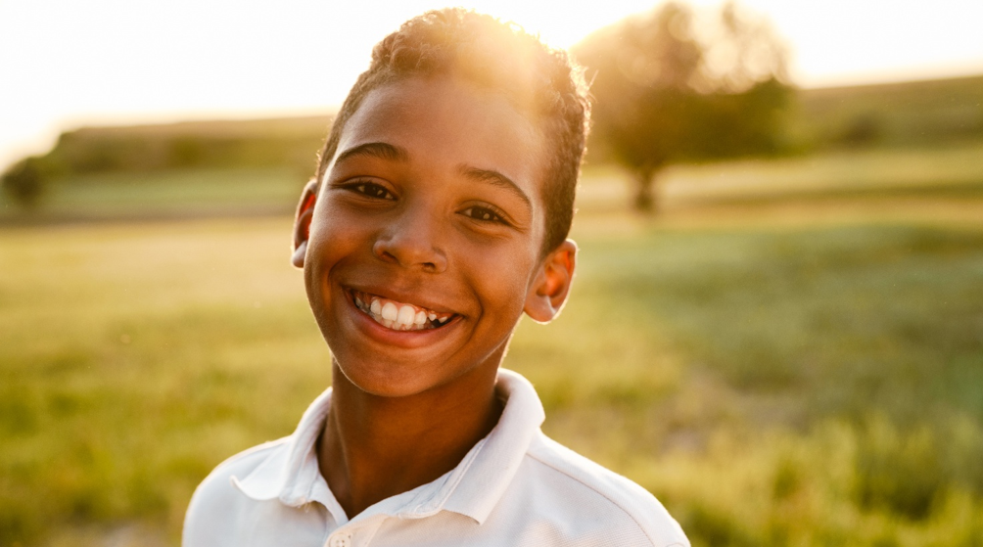 Image: AdobeStock

Acceptable, unacceptable and concerning behaviours
Organisations should create a Child Safe Risk Management Plan (CSRMP) in an attempt to identify all activities or scenarios where there may be a risk of harm to children in their interactions with adults in your organisation. Your organisation’s leaders should oversee the task, however all stakeholders including children, should be invited to participate. Refer to the Child Safe Risk Management Guide to create your CSRMP at www.dhs.sa.gov.au/how-we-help/ngo-and-sector-support/child-safe-environments/about-child-safe-policies/child-safe-policy-templates-and-guidelines. You can then use the plan to set clear expectations around acceptable and unacceptable behaviour in your CSCC to help manage or lessen those risks.
Unacceptable behaviours are behaviours that constitute a breach of your CSCC (misconduct). This includes behaviour that may constitute a criminal offence (criminal conduct).
Concerning behaviours are those that on their own may not necessarily be a breach of your CSCC. However, when considered together with other similar behaviours, they may demonstrate an overall pattern of behaviour that indicates potential risk to the safety of children, such as grooming. For more information on grooming, refer to the Child Safe Risk Management Guide at www.dhs.sa.gov.au/how-we-help/ngo-and-sector-support/child-safe-environments/about-child-safe-policies/child-safe-policy-templates-and-guidelines.
Below are examples of behaviours you may wish to include in your CSCC, including acceptable, positive behaviours that keep children safe as well as unacceptable and concerning behaviours. Additional examples of unacceptable behaviours as they relate to the different categories of child abuse are provided in Appendix 2. You can use it to identify behaviours you may want to include in your CSCC following your risk analysis.

Acceptable behaviours

General
- adhering to relevant Australian and South Australian legislation, peak body requirements and organisational values, child safe policies and other organisational and employment policies including those that cover discrimination, bullying and harassment
- acting with integrity by raising concerns with management if risks to child safety are identified anywhere in the organisation
- reporting and acting on any complaints or concerns around behaviour, or observed breaches of the Child Safe Code of Conduct
- reporting any concern, allegation, disclosure or suspicion of child abuse to the relevant authority or person.

Specific
- listening to and valuing children’s ideas and opinions
- welcoming all children, their families and carers by being inclusive
- listening to children and responding to them appropriately
- working with children in an open and transparent way, so other adults always know what work you are doing with children
- taking all reasonable steps to protect children from abuse such as completing all induction and compulsory training
- respecting the privacy of children and their families by keeping all information regarding child protection concerns confidential, and only discussing information with the relevant people
- following the organisation’s reporting procedures as described in our Child Safe Reporting Policy
- treating all children with respect, regardless of race, colour, sex, gender identity, sexual orientation, language, religion, political or other opinion, health status, national, ethnic or social origin, culture, ability or other status
- reporting any conflicts of interest such as an outside relationship with a child, babysitting arrangements or any other formal or informal relationships with a child that exist outside the organisation’s setting
- dressing in clean, appropriate clothing and following any dress code standards or guidelines including avoiding clothing that is revealing or that includes offensive language or pictures
- working within a team, despite any differences, to ensure the needs of the child and their family remain the paramount focus.

Physical contact with children and nudity
Your organisation needs to specify situations where physical contact with children is either acceptable or unacceptable. This will differ from one child-related organisation to the next.
Workers in some organisations like day care centres or disability services will be responsible for providing personal care and assisting children with things like toileting. Workers in other child-related organisations like schools and sports clubs would not need to assist (in most cases) with personal care and it would be unacceptable to do so.
Alternatively, some sports and dance instructors may be required to physically support a child to help them safely and correctly swim, dance or perform other activities. You must be very clear of the expectations of workers in these situations. The worker asking the child’s permission prior to touching would be considered a requirement. If the child refuses permission, the worker should look at alternative ways to correct posture or relieve injury. In addition, you may also expect that physical contact can only be done in public areas so other adults have oversight of the kind of contact that is being made. Adults should also be encouraged to intervene if they feel a child is being touched by another person inappropriately or without a valid reason.

Acceptable physical contact
- assisting to develop sports or dance skills or techniques
- preventing or treating an injury
- meeting requirements of the sport
- showering or toileting assistance to children with a disability.

Unacceptable physical contact
- any unnecessary or unwanted touching with hands, other body parts or objects
- corporal punishment such as smacking or other forms of physical discipline
- initiating, permitting or requesting unacceptable physical contact with a child such as massages or kisses
- facilitating situations that unnecessarily result in close physical contact with a child such as wrestling or tickling
- undertaking a task of a personal nature for a child if hey can do it for themselves such as dressing, feeding, personal grooming or toileting
- pressuring a child to have unnecessary physical contact.
Some organisations will require children to access change rooms and you should consider additional advice for acceptable behaviour by adults in this situation. These can include:
- not insisting children access change rooms if they are not comfortable doing so (and recognising that continued refusal may be an indicator that the child is being abused or is afraid of being abused)
- providing a private space for children to undress, shower and toilet that has appropriate supervision while respecting the child’s privacy
- discouraging adult nudity in front of children if change rooms are shared with the general public.
 Image: AdobeStock

Travelling alone with a child
Sometimes there are valid reasons for a worker having to transport a child where they may be left alone with them. These situations can be described in your CSCC and may include that it can only happen with:
- consent of child’s parent or carer
- consent of organisation’s leaders
- an understanding by the parents, management and where age-appropriate the child, on what route is being taken and what mode of transport is being used (private car, taxi or bus)
- a clear reason given for the requirement of the transport
- information on which worker is with the child and if the journey together happens routinely.
Your organisation may choose to record the licence details of workers transporting and registration information of their vehicles. It should also be noted that smoking in a vehicle with a person under 16 years is illegal in South Australia.
 Image: AbdobeStock

Interacting with others
The language and manners your workers use when interacting with children should reflect the core values of your organisation.

Acceptable
- using positive, non-offensive language
- remaining calm
- listening carefully and addressing issues with a positive and helpful attitude.

Unacceptable
- using offensive language such as swearing, using racial, cultural, homophobic or sexist slurs
- being abusive or intimidating such as yelling, moving into another person’s personal space, finger pointing, talking over the top of others
- passive aggressive behaviour such as purposely ignoring, isolating or dismissing others
- making physical or psychological threats to harm another person.

Technology and social media
The use of technology and communication devices can be a positive thing. Many learning tools, interactive games and activities are available online. Leaders should ensure there are robust procedures around the use of company owned and personal communication devices. Your CSCC should describe how devices should be used in your organisation.
You may wish to note in your CSCC that any inappropriate use of social media will be reported to the relevant authorities including Department for Child Protection and/or the eSafety Commissioner.

Unacceptable or illegal behaviours
- using a computer, mobile phone or other device in a way that is inconsistent with the organisation’s Child Safe Policy or other relevant policies
- communicating (including online) with a child about romantic, intimate or sexual feelings
- engaging in unauthorised contact with a child online for the purpose of developing a sexual relationship
- sexual comments, conversations or communications with a child online
- using a computer, mobile phone, camera or other device to exploit or harass a child
- using a camera to record a child while they are dressing, bathing or using the bathroom
- using private text messages to communicate with a child where open communication is possible.

Alcohol, recreational drugs and child abuse images

Unacceptable or illegal behaviours
- providing children with alcohol, drugs, tobacco or pornography
- working or attempting to work while intoxicated or under the influence of illicit drugs
- drinking alcohol, taking illicit drugs, possessing or distributing pornography while working with children including on field trips, excursions or any other offsite work
- taking explicit photos of children
- showing children pictures, animations, images or websites of an inappropriate or adult nature
- discussing with children, topics of an adult or sexualised nature, including telling adult jokes.

Gifts and benefits
Any personal giving or receiving of gifts in your organisation, particularly giving gifts to children, should follow a formalised process. Approval should be given by management, gifts are recorded, and giving and receiving gifts is monitored. Robust procedures are essential because in some cases the giving of gifts or benefits to a child, can be an indicator that an adult is grooming a child by trying to form a special relationship with them. Additionally, giving one child special treatment can cause a child to feel isolated or leave other children feeling resentful.

Unacceptable or illegal behaviours
- giving a child gifts, food, cigarettes, money, attention or affection in exchange for sexual activities or images
- offering a child gifts, food cigarettes, money, attention or affection with the intention of making it easier to access the child for sexual activity
- being alone with a child when there is no professional reason for doing so
- an adult asking a child to stay at their home or vising the child at their home, where there is no professional reason for these activities to occur.

Out of hours work and secondary employment
An organisation can specify what is acceptable or unacceptable in terms of secondary employment. This can include tutoring, mentoring, sports massage and babysitting. Analyse the risk associated with permitting workers to engage in activities with children outside your service. Consider the impact if one of your workers, in a secondary employment capacity, was responsible for any of the following against children involved with your organisation:
- crossing of professional boundaries
- allegations of misconduct
- disagreements or ‘fallings out’ with families
- serious accidents or incidents
- incidents of abuse.
Your CSCC should include what is acceptable around workers visiting children at home or children visiting a worker’s home (or having contact with them elsewhere). When, where and under what conditions is it acceptable or is it unacceptable in all circumstances.
Also consider under what, if any, circumstances a child would be permitted to stay at the home of a worker, recognising there may be occasions where children might stay overnight due to travel arrangements, or sleepovers with the worker’s own child. Situations to be avoided include opportunities for the worker to have one-on-one time with the child in a personal setting, as this increases the risk of harm to the child. Your CSCC should clearly state where overnight stays are acceptable and where they are not.
Rules must be clear with no exceptions and should be applied regardless of how ‘nice’ the worker is, how long they have worked for the organisation or how well liked they are by children, families and other workers.

Concerning behaviours
Concerning behaviours on their own may not necessarily constitute a breach of the CSCC but together may indicate a pattern of behaviour that poses a risk to the safety of children. Concerning behaviours include:
- showing favour to one child over another
- having conversations about hurting a child with other adults
- an adult asking a child to keep a secret, including a relationship with an adult such as, a worker encouraging a child to spend time alone with them and instructing the child not to tell others about it.

Appendix 1: Child Safe Code of Conduct Template
Place your organisation’s name and logo here
Child Safe Code of Conduct
Instructions
This sample template provides basic content to get you started. Follow these steps to develop your own Child Safe Code of Conduct.
- Add your organisation’s name and logo at top of page.
- Read the highlighted Notes for extra guidance.
- Referring to information provided in this guide, adapt the content provided in the sample to suit your organisation as it relates to your activities.
- Ask people across your organisation to review and provide feedback.
- Delete the Notes and these instructions when finished.
- Share this document across you organisation and make sure it’s easily available on your website and in your premises for everyone who accesses your services and events, including children, parents, carers and families.

Commitment to child safety
Note: Outline your organisation’s commitment to child safety.
We are committed to supporting the safety of all children with a zero-tolerance approach to abuse and harm. This includes a culture where preventing and reporting abuse and harm is encouraged and supported.
All workers are responsible for promoting the safety, wellbeing and empowerment of children. This includes understanding and responding to children’s diverse needs and cultural considerations.
Our Child Safe Code of Conduct sets out how we expect workers in our organisation to behave around children to help prevent abuse and harm in our physical spaces and online. Our Child Safe Code of Conduct identifies:
- ‘I will’ child safe behaviours that we consider acceptable
- ‘I won’t’ behaviours that we consider unacceptable.
Engaging in unacceptable behaviour is a breach of our Child Safe Code of Conduct and will result in disciplinary action.
Types of child abuse and harm
Child abuse takes many forms. It can include psychological, physical and sexual abuse, grooming, misconduct and lack of appropriate care as defined below.
Psychological abuse (also known as emotional abuse)
Includes bullying, threatening and abusive language, intimidation, shaming and name calling, ignoring and isolating a child, and exposure to domestic and family violence.
Physical abuse
Includes physical punishment, such as pushing, shoving, punching, slapping and kicking, resulting in injury, burns, choking or bruising.
Sexual abuse
Includes the sexual touching of a child, grooming, and production, distribution or possession of child abuse material.
Grooming
A process where a person manipulates a child or group of children and sometimes those looking after them including parents, carers, teachers, colleagues and leaders. They do this to establish a position of ‘trust’ so they can then later sexually abuse the child.
Misconduct
This is unacceptable behaviour that may not be as severe as abuse but could indicate that abuse is occurring and would often be in breach of an organisation’s Child Safe Code of Conduct. Examples include showing a child something inappropriate on a phone, having inappropriate conversations with a child, or a worker sitting with a child on their lap.
Lack of appropriate care
This includes not providing adequate and proper supervision, nourishment, clothing, shelter, education or medical care.
Acceptable and unacceptable behaviours in our organisation
Note: Use this section to set the acceptable and unacceptable behaviours in your organisation. Make sure the topics and approaches are in line with your Child Safe Policy and Child Safe Risk Management Plan.
The list of acceptable and unacceptable behaviours below are in relation to interactions of all workers, with children who interact with our organisation’s services, locations or activities.
Note: ‘I will’ – list positive worker behaviours that are consistent with your organisation’s culture and values. You may need to amend or expand on the list below to cover specific situations that relate to your organisation’s unique setting, services and activities that involve children.
I will:
- treat all children with respect
- uphold the rights of the child and always prioritise their needs
- make sure the needs of all children remain the paramount focus of any decision making
- listen to and value the ideas and opinions of all children and respond to them appropriately
- welcome all children and their families and carers, and ask them to participate in decisions around child safety
- actively promote safe and inclusive practices for all children, including those with diverse needs, circumstances and backgrounds, including children with disability
- adhere to the organisation’s child safe policies, procedures and practices
- participate in all compulsory child safe training
- include a child’s parent or carer in any direct online communication or correspondence with a child
- when transporting a child at work, take all reasonable steps to ensure at least two adults are travelling with the child at all times, or put in place a suitable arrangement between my organisation and the parents or carers of the child - if the child is alone, they must sit in the back seat of the vehicle
- advise the organisation of any out-of-hours contact with any children in the care of the organisation or who interact with our services, make sure there is a valid reason for this contact and ensure parents or carers are also aware of this contact
- take all reasonable steps to protect children from abuse and harm, and report any concerns, suspicions or disclosures of abuse and harm – see Internal and external reporting obligations on page <insert page number>
- report any conflicts of interest such as a relationship with a child that is outside the organisation, to management
- raise concerns with the leadership team if risks to child safety are identified
- take a child seriously if they disclose abuse or harm and follow the correct procedure for responding to a disclosure
- respect the privacy of children and their families and keep all information about child protection concerns confidential
- make sure breaches of the Child Safe Code of Conduct and any instances of concerning behaviour from workers are reported immediately.
Note: ‘I won’t’ – list the types of behaviour your organisation considers unacceptable in relation to children who are interacting with your organisation. You may need to amend or expand on the list to cover specific situations that relate to your organisation’s unique settings, services and activities that involve children.

I won’t:
- condone or participate in unsafe, harmful or abusive behaviour towards children, including psychological, physical and sexual abuse, grooming, misconduct or lack of appropriate care
- ignore or disregard any concerns, suspicions or disclosures of child abuse
- exaggerate or trivialise child abuse issues
- criticise or denigrate a child
- use hurtful, discriminatory or offensive behaviour or language with children
- verbally assault a child, or create a climate of fear
- deliberately prevent a child from forming friendships
- engage in unwarranted and inappropriate touching involving a child
- be alone with a child without supervision or adequate risk management in place
- have contact after hours with children who interact with the organisation
- encourage a child to communicate with me in a private setting, including online, via phone or on social media
- give personal gifts or benefits of any kind to a child unless direct permission has been given from the parent or carer and the organisation
- share details of sexual experiences with a child
- use sexual language or gestures in the presence of children
- show sexual, violent or other inappropriate images to a child
- take videos or images of children interacting with the organisation or under the care of the organisation on a personal device without permission from the child, parent or carer and the organisation
- share videos or images of children on social media without consent
- fail to report information to the Child Abuse Report Line or SA Police if I know a child has been abused or harmed (see Internal and external see reporting obligations below).

Concerning behaviours
Note: List the types of behaviours your organisation considers may be of concern.
Concerning behaviours are behaviours that on their own may not constitute a breach of our Child Safe Code of Conduct but when viewed together may indicate grooming behaviour. I understand the following types of behaviour may be of concern:
- showing favour to one child over others
- having a special (pet) name for a child
- babysitting children who interact with the organisation, without prior consent from the organisation (babysitting outside the organisation is only allowed in exceptional circumstances when the child and their family or carer is known to have a pre-existing relationship with the worker outside the organisation)
- participating in the lives of children who interact with the organisation, outside the service without a valid reason
- crossing professional boundaries with the children in our care
- spending time alone with children
- showing a preference for spending time with children rather than adults.

Internal and external reporting obligations
Note: If your organisation has a separate Child Safe Reporting Policy (or Child Safe Policy) that contains the relevant reporting information, you should refer to it here and include a link to the document.
All workers, children, families and community members are encouraged and supported to speak up about all concerns and breaches of our Code of Conduct. Children, families and community members can report breaches verbally to any worker or to <insert name of role> on <enter phone number> or via email to <enter email address>.
Workers must report all breaches, no matter how small the breach is. It’s only when we have records that show a pattern of behaviours that we may identify that grooming is occurring. Workers must follow all internal and external reporting obligations set out in our organisation’s Child Safe Reporting Policy [add in link here to your organisation’s Child Safe Reporting Policy].
Criminal offences for not acting to protect children
Some breaches of the Child Safe Code of Conduct may need to be reported to SA Police or the Child Abuse Report Line in the first instance.
It’s a criminal offence if an adult worker fails to report child sexual abuse by another worker to SA Police. The maximum penalty is imprisonment for 3 years. It’s also a criminal offence if an adult worker fails to protect a child from sexual abuse by another worker. The maximum penalty is imprisonment for 15 years (Criminal Law Consolidation Act 1935 s64a & s65).
It’s an offence if a mandatory reporter does not report a suspicion a child is, or may be at risk of harm to the Child Abuse Report Line. The maximum penalty is $10,000 (Children and Young People (Safety) Act 2017 s31).
Penalties for workers who breach our Child Safe Code of Conduct
Workers who breach our Child Safe Code of Conduct but do not commit a criminal offence may still be subject to disciplinary action. This can include increased supervision, appointment to a different role, additional training, suspension or termination of employment from the organisation.
Concerning behaviour
If a worker shows patterns of concerning behaviour but does not commit an offence, this may result in increased supervision and/or additional training. If these behaviours of concern continue, the worker may be subject to disciplinary action, including appointment to a different role, suspension or termination of employment from the organisation.
Agreement to abide by the terms of the Child Safe Code of Conduct
I have read and agree to abide by the terms of this Child Safe Code of Conduct.
Name of worker
Role in organisation
Signature
Date
Review of Child Safe Code of Conduct
Date document reviewed
Date of next review
Person responsible for next review
If there are any critical incidents, this document will be reviewed immediately.
Signature of responsible person
Date

Appendix 2: Behaviours that constitute child abuse
This appendix lists unacceptable behaviours (misconduct) and concerning behaviours as they relate to the different types of child abuse.
Your CSCC does not have to list all these types of behaviours. They may be grouped into different categories or referred to generally based on your risk analysis. The list below will help you identify which behaviours your CSCC should focus on to prevent abuse in your organisation’s unique environment.
Unacceptable behaviours
General
- condoning or participating in behaviour with a child that is illegal, unsafe or abusive
- ignoring or disregarding any concerns, suspicions or disclosures of child abuse
- exaggerating or trivialising child abuse issues
- using hurtful, discriminatory or offensive behaviour or language with a child
- failing to report information if someone knows, believes or reasonably ought to know that a child has been abused
- trivialising the subject of child abuse, such as telling jokes that make light of children being hurt
- using unacceptable language or telling unacceptable stories or jokes in front of children.
Physical abuse
- hitting, striking, punching, kicking or slapping a child
- engaging in rough physical games
- throwing items or using items to hurt a child
- dragging or pushing a child
- threatening to hurt a child through words or gestures, regardless of whether the person actually intends to apply force
- using hostile force towards a child and/or a pattern of hostile or unreasonable and seriously inappropriate physical conduct.
Sexual abuse
- sexual touching of a child
- sexual contact with a child
- masturbating in front of a child or exposing genitals
- possessing or creating child abuse material
- sharing sexually explicit photos of a child
- exposing a child to pornography or other indecent material
- giving a child gifts, cigarettes, alcohol, food, money, attention or affection in exchange for sexual activities or images
- not respecting the privacy of a child when they are using the bathroom or changing clothes
- communicating (including online) with a child while they are dressing, bathing or using the bathroom
- comments that express a desire to act in a sexual manner with a child
- using sexual language or gestures in the presence of children
- sexual comments, conversations or communications with a child.
Emotional abuse
- teasing a child
- yelling at a child
- bullying a child
- persistent criticism and discrediting a child
- persistent rejection of, or hostility towards a child
- refusing to acknowledge a child’s worth and the legitimacy of their needs
- deliberately preventing a child from forming friendships
- depriving a child of essential stimulation and responsiveness
- encouraging a child to engage in destructive, antisocial behaviour
- exposing a child to family violence
- making a child feel worthless, unloved, alone or frightened.
Neglect
- depriving a child of necessities such as food and drink, clothing, critical medical care or treatment, or shelter
- failing to protect a child from abuse (such as failing to report abuse when a child discloses it or when a worker has reasonable belief of harm, or observes harm)
- exposing a child to a harmful environment (such as an environment where there is illicit drug use or illicit drug manufacturing)
- failing to adequately supervise a child, resulting in injury or harm.
Ill-treatment
- making excessive and/or degrading demands of a child
- disciplining or correcting a child in an unreasonable and seriously inappropriate manner
- seriously inappropriate and/or degrading comments or behaviour towards a child
- repeated hostility towards a child
- seclusion and other types of restrictive practices
- locking a child in a room
- pushing a child to train or perform when they are injured.
Grooming
- engaging in unauthorised contact with a child online for the purpose of developing a sexual relationship
- using a computer, phone, camera or other device to exploit or harass a child
- unacceptable personal communication that explores sexual feelings or intimate personal feelings with a child
- sharing details with a child of one’s own sexual experiences
- inappropriately extending a relationship with a child outside of work
- giving a child special attention or isolating them from peers with the intention of making it easier to access the child for sexual activity
- making close physical contact, like inappropriate tickling and ‘play’ wrestling.
Failure to prevent/report abuse
- an obvious or very clearly unreasonable failure to respond to information indicating another adult working at the organisation poses a risk of abusing a child
- knowing or believing a child has been abused and not reporting it to authorities (or not reporting in circumstances where the person should reasonably have known).



Department of Human Services
Government of South Australia
For guidance only. Always refer to relevant South Australian legislation and obligations when applying child safe requirements.
www.dhs.sa.gov.au
Alternative formats
The information in this publication can be provided in an alternative format or another language upon request.

